Materials Benchmark Authoring

From Paper PDF to Review-Ready Enhanced Harbor Tasks

STATUS  Proposed |  | OWNER  MatBenchGuard / qa-review |  | LAST UPDATED  August 3, 2026

Authors | Codex; MatBenchGuard project team
Reviewers | Independent Review Agent; materials-science reviewer
Related docs | Authoring, Review, and Repair Skills
Scope | PDF to paper-Gold-centered RESULT_ENHANCED Paper2Arm task.

1. Abstract
The system treats materials-science task authoring as an evidence-backed compilation pipeline. It freezes the PDF, uses UniParser to create paper/paper.md, builds a ledger for parameters, condition groups, Gold, and resources, and then enumerates several computational-science candidates. Only candidates that pass Q0, Gold applicability, resource closure, and affordable enhanced-checkpoint gates are compiled into Harbor packages.
The core guarantee is prove authorability before generating the package. Success is not a green local checker; it is PASS + RESULT_ENHANCED from an independent materials-benchmark-review. If no candidate qualifies, the system fails closed as NO_ENHANCED_CANDIDATE instead of deferring defects to large-scale Repair.

2. Goals and Non-Goals
Goals | Non-goals
Trace the paper question, method, parameters, Gold, and condition signature. | Do not invent unreported cutoff, mesh, timestep, model, or solver values.
Produce enhanced tasks with 60–80% Gold and 20–40% result checks. | Do not rerun DFT/MD/training or scan full large trajectories in the checker.
Express resources by stable filename and identity, independent of deployment paths. | Do not deploy resources to Bohrium/Playground or allocate Trisol IDs.
Publish only independently reviewed candidates; make failures replayable. | Do not create, inspect, run, hash, or cite solution/; do not use Repair as routine finishing.

3. Background and Problem Statement
material_v2_question contains 1,878 packages across 134 themes; the reviewed_passed comparison set contains 1,029 packages. Structural conventions are strong: ten core files are universal, nine instruction sections appear in about 98–100% of passed packages, outputs are mainly CSV/JSON, and the base image is almost uniform. However, resource methods, target policies, scoring tiers, paths, and bundle mappings have substantial historical drift.
Among 1,860 legacy final decisions, prominent hard-failure signals included 546 CHECKER_CORE_TASK_UNASSESSED cases, 142 unavailable indispensable inputs, and 100 invalid scientific targets. Current v3 Review is Baseline-first, but the distribution still argues for Q0 and asset closure before authoring, Gold freeze before checker generation, and a real low-cost result checkpoint during candidate selection.

4. Proposed Architecture
The pipeline separates scientific evidence, candidate selection, package compilation, and independent acceptance.
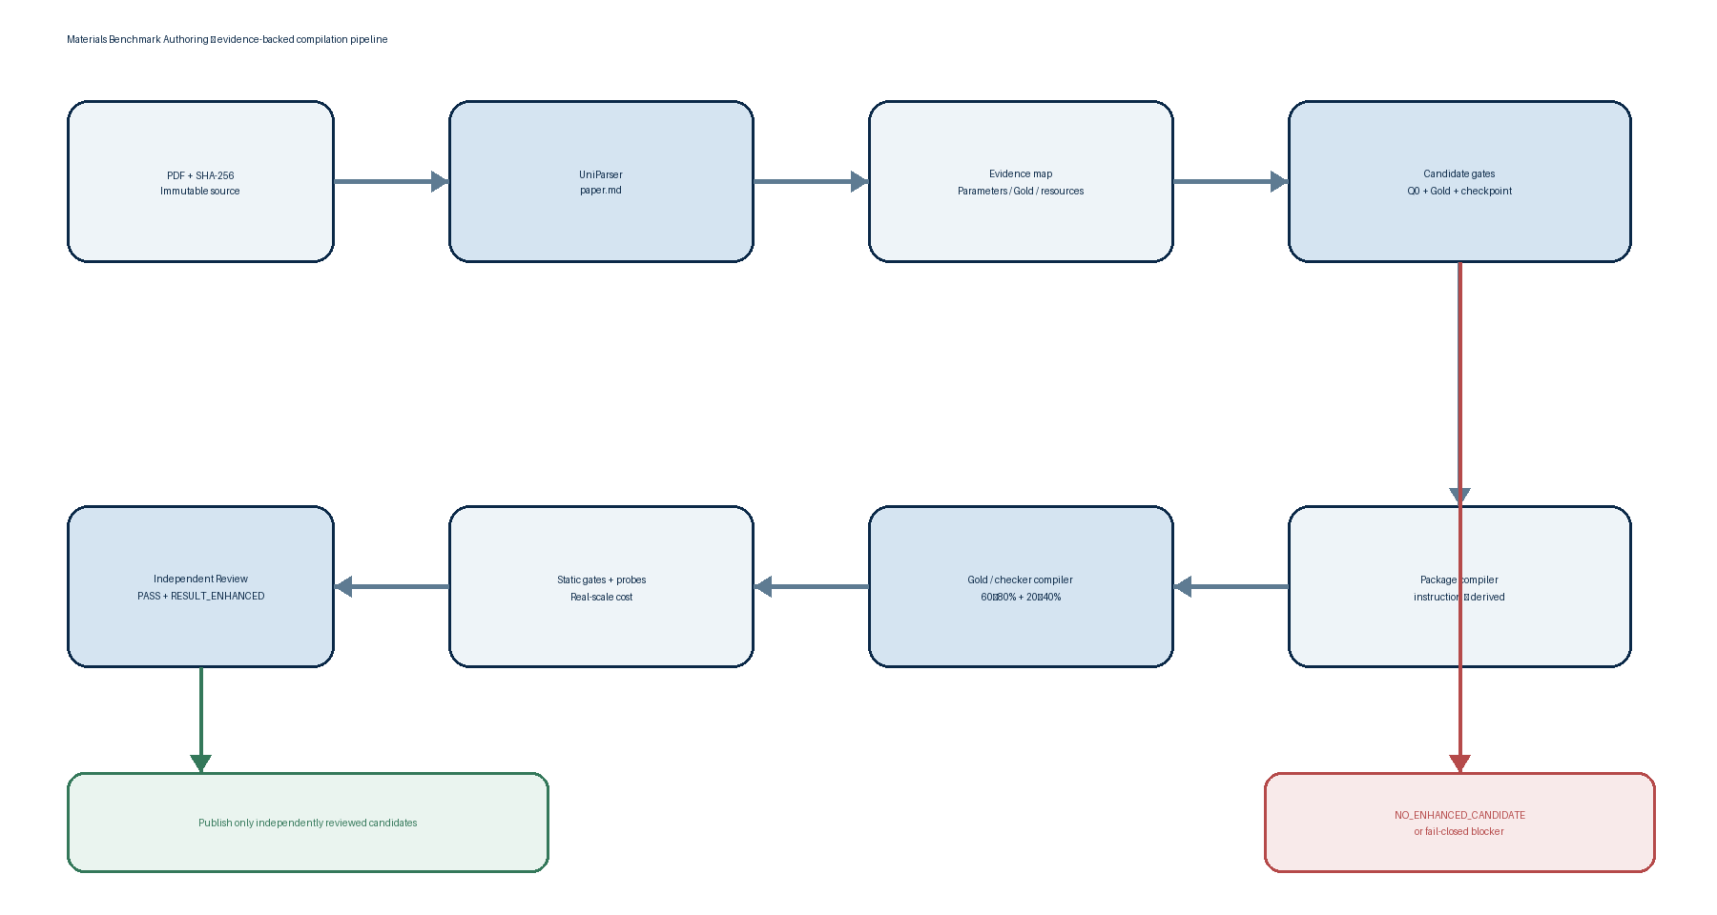
Figure 1. Evidence-backed Authoring compilation pipeline. Red is a fail-closed authoring exit; green accepts only independently reviewed enhanced candidates.

Core components

Component | Responsibility | Primary storage | Failure behavior
Source Freezer + UniParser Adapter | Freeze PDF hash; choose digital/OCR flags; create paper.md; record token and parse quality. | processing/source + authoring_record.json | BLOCKED_SOURCE_PARSE if load-bearing equations, tables, or captions are missing.
Evidence Mapper | Extract system, method, four parameter classes, condition groups, Gold candidates, resources, and workflow edges. | external authoring_record.json | Do not enter candidate selection while a core claim lacks a locator.
Candidate Gate & Selector | Enumerate at least three candidates when possible; gate lexicographically on Q0, Gold, resources, workflow, and checkpoint. | candidate_records | NO_ENHANCED_CANDIDATE if all fail; emit no weak package.
Package + Gold/Checker Compiler | Write instruction first, synchronize JSON/TOML/tests, and freeze Gold, tolerance, weights, and hidden references. | processing/candidate + evidence | Return to evidence mapping on condition mismatch, path coupling, or guessed values.
Validators + Independent Review Bridge | Run schema, probe, and cost gates; use independent Review to decide publishability. | validation logs + independent_review | Local pass is not scientific approval; Review failure returns to Authoring.

5. Request Lifecycle
1. Accept the PDF, stable paper_id, task name, and optional resources; create an external processing workspace.
2. Compute PDF SHA-256; use UniParser digital or OCR mode; inspect equations, tables, captions, and units.
3. Build the paper evidence map; classify parameters as PAPER_FIXED, SOLVER_SEARCHABLE, TARGET_DEFINING, or INDISPENSABLE_ASSET.
4. Enumerate candidates and run Q0 first; bind each to condition groups, Gold, resources, workflow, and checkpoint.
5. Select only an enhanced-feasible candidate; write a self-contained instruction, then derive steps/manifest/resources/task.
6. Freeze Gold and tolerance; generate a 60–80% Gold plus 20–40% result-check checker; run Baseline, risk-matched, and real-scale cost probes.
7. Run authoring/package/Harbor static validation and independent Review; publish only PASS + RESULT_ENHANCED.

6. API and Data Contracts

Primary data contract: authoring_record.json

Field | Type | Required | Description
source | object | Yes | PDF path/hash, UniParser token/flags, and paper.md path; never the API key.
parse_quality | object | Yes | Text/equation/table/caption completeness and blockers.
candidate_records | array | Yes | Q0, Gold, resources, checkpoints, and SELECTED/REJECTED decision for each candidate.
parameter_records | array | Yes | Four parameter classes plus three unique-value booleans that expose hidden fixation.
condition_group_records + gold_records | arrays | Yes | Complete signatures, target mapping, policy, applicability, and provenance.
enhancement + probe_records | objects | Yes | Gold/result weights, result checks, five Baseline probes, and at least one enhanced probe.
checker_cost_record + independent_review | objects | Yes | Real-scale cost and final verdict/quality_tier/publishable; validator runs the complete materials-core-review/3.3 artifact and package-aware consistency checks.

Contract guarantees
The authoring record is the single external source of truth for authoring decisions; the Harbor candidate stores only solver/reviewer package files. Publish validation runs the complete materials-core-review/3.3 validator and its package-aware tier, weight, and tolerance checks; legacy lowercase scoring_tier cannot bypass this gate.
• instruction.md precedes all derived views; tests cannot add public requirements.
• Every target, condition, resource, workflow, and output ID is unique and closed; resource records, resources.json, mapping types, bundled filenames, and files must agree.
• Bundled authoring files live at resources/<filename>; instruction uses filename only; deployment locator is late-bound. Output paths are canonical below /app/outputs; paper_id cannot be a path or the reserved solution name.
• Source hash, parse flags, Gold provenance, tolerance boundary, and the complete external Review artifact support audit and replay; four-field Review stubs are rejected.
Schema and implementation:
.cursor/skills/materials-benchmark-authoring/: assets/authoring_record_template.json and scripts/validate_authoring_record.py.

7. Consistency, Idempotency, and Replay

Concurrent work is isolated by authoring_id; the design adds no global lock or dispatcher. Human prompts coordinate publishing and corpus_review_tracking.json updates. Source PDF, evidence, and candidate are never silently overwritten to manufacture a latest version.
Scenario | Expected behavior | Reasoning
Same PDF submitted again | Reuse a complete parse for the same hash; issue a new authoring_id for a different hash. | Prevents stale paper.md from being paired with a new PDF.
Parse, Gold, or resource write fails | Emit no publish candidate; record blocker and last successful stage. | Fail closed so partial evidence is never treated as complete.
Checker probe, cost, or Review fails | Keep candidate and evidence; revise from the corresponding upstream layer; do not publish. | Keeps the repair loop inside the authoring workspace.
Rules or Harbor schema change | Capture Skill/Review versions; rerun static validation and independent Review. | Historical PASS does not automatically remain publishable.

8. Security and Privacy Considerations

• Read UNIPARSER_API_KEY from the environment only; never store it in the Skill, record, logs, or package.
• Do not record Authorization headers, pre-signed URLs, or reusable credentials; retain only task token and non-sensitive flags.
• Paper PDF, parsed Markdown, hidden Gold, and references may have licensing constraints; check access, distribution, and retention separately.
• Hidden Gold, exact tolerances, and checker implementation stay out of instruction; submission requirements remain fully public.
• Any solution path component is excluded recursively from Authoring, Review, and Repair; Harbor scaffolding must use --no-solution.

9. Operational Readiness
Signal | SLO or alert | Owner | Launch gate
Review first-pass enhanced rate | Pilot target at least 80%; every failure has a cited gate and evidence. | Authoring + independent Review | Required
Gold/condition/resource closure | 100% closed at review-ready; any dangling ID blocks. | Authoring validator | Required
Checker correctness probes | Five Baseline plus at least one enhanced probe pass; retain per-component reward. | Checker author | Required
Checker cost | At most 32 CPU or 1 H100 and 600 s; real-scale; no primary recomputation. | Review operational gate | Required
UniParser quality | Load-bearing text/equation/table/caption all PASS; otherwise reparse or block. | Source/parse owner | Required

10. Alternatives Considered

Alternative | Why it was considered | Why it was not selected
One-shot LLM: PDF to full package | Fast and low-call-count. | Gold, conditions, resources, and checker are generated together, so errors can self-certify and are hard to localize.
Author Baseline, then route everything to Repair | Reuses existing Repair capability. | Contradicts the goal of reducing Repair and exposes defects only after package generation.
Hard-code /app/resources paths in instruction | Direct in-container convention. | Couples the scientific prompt to Playground, Bohrium, and local mount details.
Rerun the full primary computation in checker | Appears hardest to game. | Exceeds cost budgets; prefer result invariants and offline references over duplicate solving.

11. Open Questions
1. Should new tasks publish into material_v3_question or a new authoring-generated corpus? Recommendation: keep them in independent processing until a human decides.

2. Who owns resource_unique_key to Playground/Trisol ID deployment mapping? Recommendation: authors declare stable identity; deployers add locator.

3. When should the Paper2Arm schema 1.3 profile migrate to Harbor 1.4? Recommendation: retain the corpus profile and use harbor check for drift detection.

4. Figure-digitized Gold needs a separate policy for allowed tools, dual review, and uncertainty recording; until then unauditable figure values cannot be PAPER_DIRECT.

12. Decision and Next Steps
Adopt the evidence-backed compiler architecture and use `.cursor/skills/materials-benchmark-authoring/` as the M1 implementation. The initial version includes the workflow, references, solution-free template, authoring record, package validator, and positive/negative contract tests. Publish requires a complete Review 3.3 artifact, package-aware consistency, canonical output paths, closed resources, and a checker within the CPU/single-H100 budget. The next priority is forward-testing real papers across task types, measuring first-pass Review performance, and tightening gates exposed by failures.
Milestone | Deliverable | Exit criteria
M1 | Authoring Skill, schemas, solution-free scaffold, static validators, and System Design. | Skill validator plus negative draft and positive review-ready smoke tests pass.
M2 | Forward-test 3–5 real PDFs across DFT, MD, and model fitting. | Each evidence ledger closes; independent Review failures are reproducible and produce gate revisions.
M3 | Stabilize resource deployment mapping and independent Review handoff. | Filename-only instruction works locally and in Playground without prompt edits.
M4 | Batch Authoring pilot and first-pass metrics dashboard. | Enhanced first-pass target is met; Repair demand falls without Gold or resource regressions.

Use footnotes for definitions, assumptions, or terms that need precision without interrupting the main narrative.

