Gregory Szymanski

Prof. L. Tatum

Final Project

CIS/STA 3920

I decided to write a loop in R that would output the classification error rate for different widths of the lag window when using k-nearest neighbors. I picked two different methods to make this classification. The first one is K-nearest neighbor classification for the set from training set. It divides the data set into two parts, training and test sets. The prediction is made based on the training set and error is calculated based on the test set. The second one is K-nearest neighbor cross-validatory classification from training set. Here we don’t divide the data set into the training and test sets. We use the whole data set to make the prediction. I used for this assignment the Iris data set. All the functions used here I got from the Class package.

1. Data Set - Iris Data Set

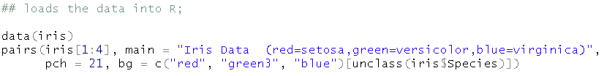

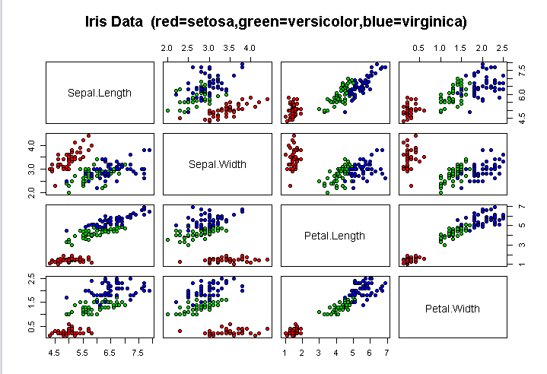

1. The normalization wasn’t required in this case, because the measurement range is the same for all the attributes of the flowers. I did it to develop a good habit.

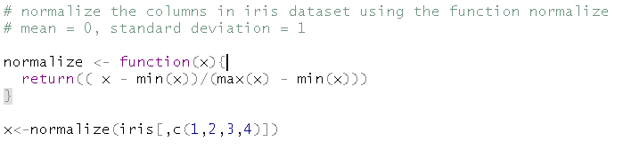

3)

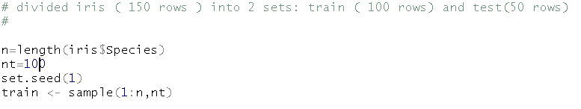



4)

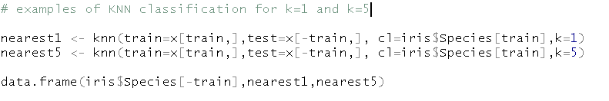

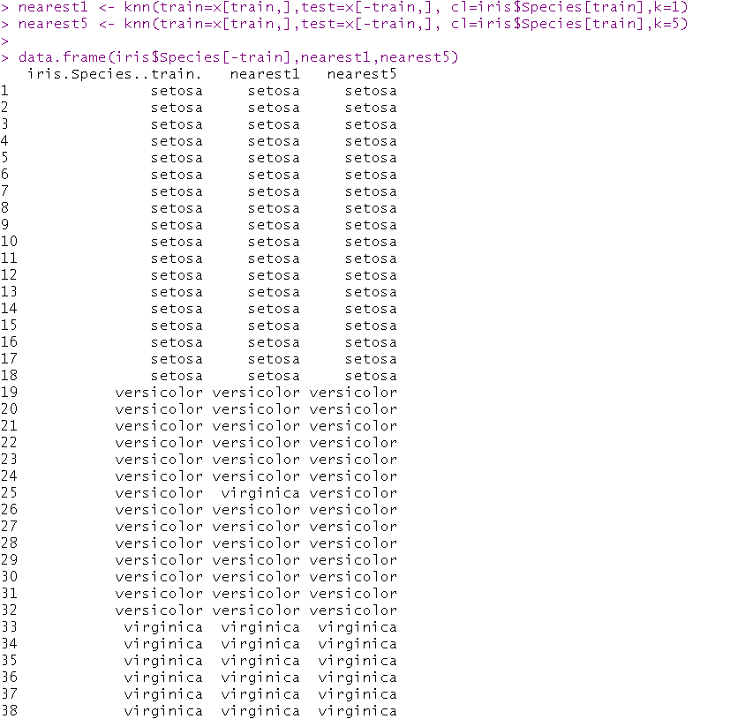

5) K-nearest neighbor classification for the set from training set.

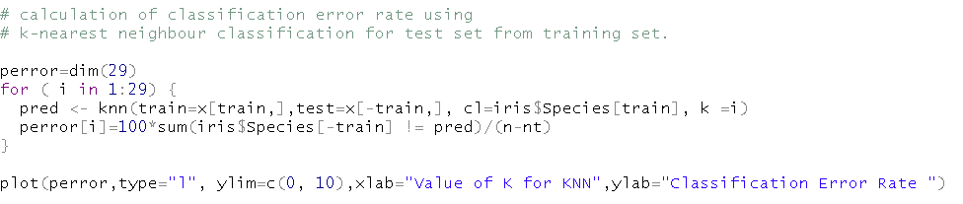

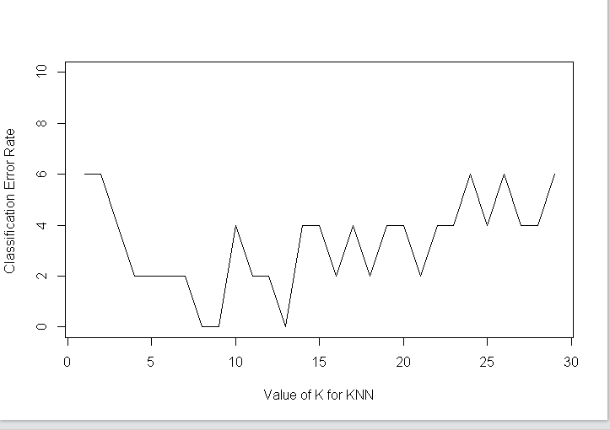

6) K-nearest neighbor cross-validatory classification from training set.

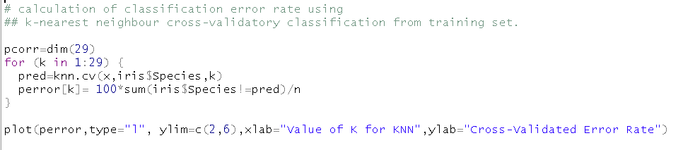

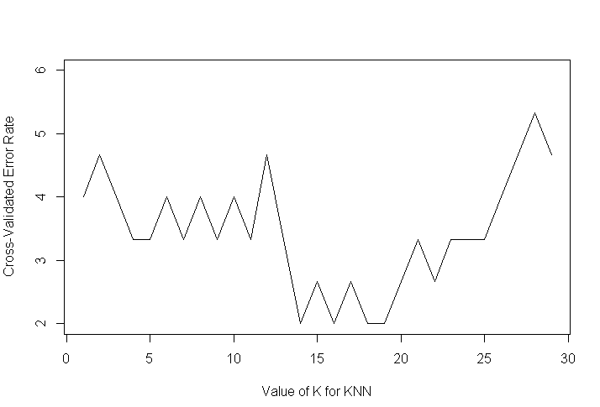

Both graphs are similar to a U shape. This is an example of Bias trade-off in which low values of k produces a model with low bias and high variance and high value K, produces a model with high bias and low variance. The best model is found somewhere in the middle of the graph because it appropriately balances bias and variance.

In the K-nearest neighbor classification method the minimum error range is somewhere in the interval of (8,14). In this interval the error is close to 0.

In the K-nearest neighbor cross-validatory classification method the minimum error range is somewhere in the interval (14,19). In this interval the error is close to 0.