1.賴機器人Channel secret :fd992488416e202095dfa8d28d053992

Channel access token (long-lived)

2YnfFy6Rf+qkkuWedKQHRfJ21Qh/Ztvp6Mx3BXz26tcEwvIQ4QAxrIoHS5Shno37Gpr0d021ZiYMVP7z2FMdRgzE+VKAluhCPA1mchUnBLnAnjAkzS9kkFxGI02rjQECninRwLJ74nJN+lbuAM9+7wdB04t89/1O/w1cDnyilFU=

2.

-ngrok config add-authtoken 2Q0OFNvIXPlMQdxb31aeMorrlxC_T7FT5gJNnbTAe6R55Aq

-ngrok http 80

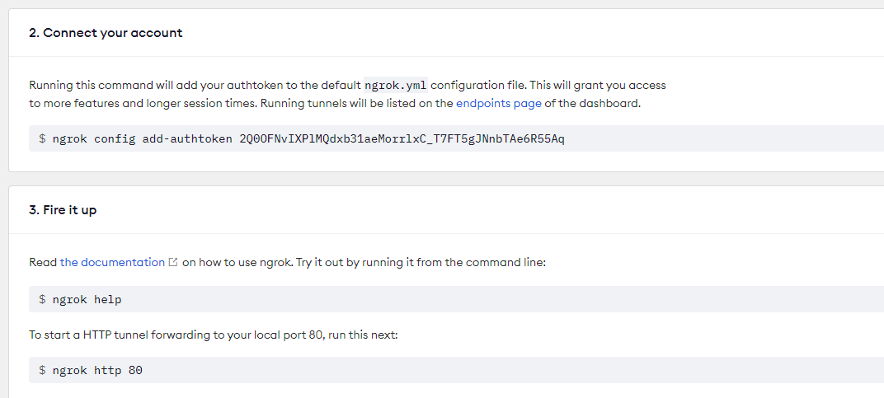

3.

https://91d6-140-127-32-5.ngrok-free.app

