**Feedback Retrieval System for Hotels**

**ABSTRACT**

Feedback retrieval system for hotels basically helps all the hotels to collect feedback from people.The user enters his details first and checks the information of the hotel and gives the feedback in form of suggestions and rating.The user will also post the complaints which will be further improved by the management of the hotels.

Users can also view the feedbacks given for other hotels and choose the hotels.

**REQUIREMENT SPECIFICATION**:

This database consists of 4 Entites namely Persons,Hotels,Services,Feedback and 3 relationships i.e.,

Person:entity set contains the information of the person who gives feedback.

Attributes:pid(primary),name,contact,mail.

Hotels:It is an entity set which contains the information of all the hotels.

Attributes:Name,Hid(PRIMARY),name,contact,address.

Services:It is an entity which provides the information of services provided by the Hotel.

Attributes:hid,sid,rooms,food,gamezone,ambience.

Feedback:It helps in collecting the feedback from persons.

Attributes:fid(primary),complaints,suggestions,rating.

**Cardinalities:**

1.Checks:Person checks the information of hotels.

2.Provides:Services provided by the hotel.

3.Gives:Feedback given by the user for a particular hotel.

The cardinalities are Person(Many)-hotels(Many),Person(one)-feedback(many).

This helps the organisation to improvise their hotels.

**ER DIAGRAM:**

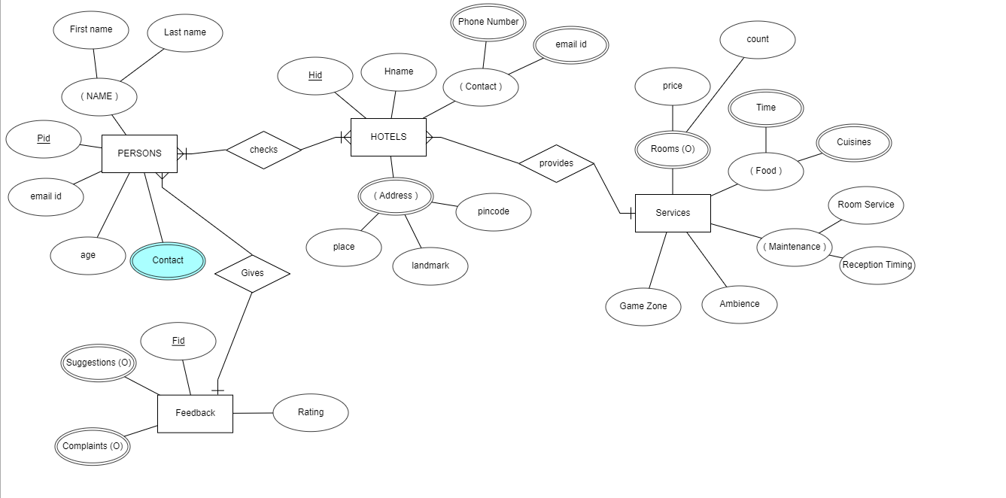

**DML COMMANDS:**

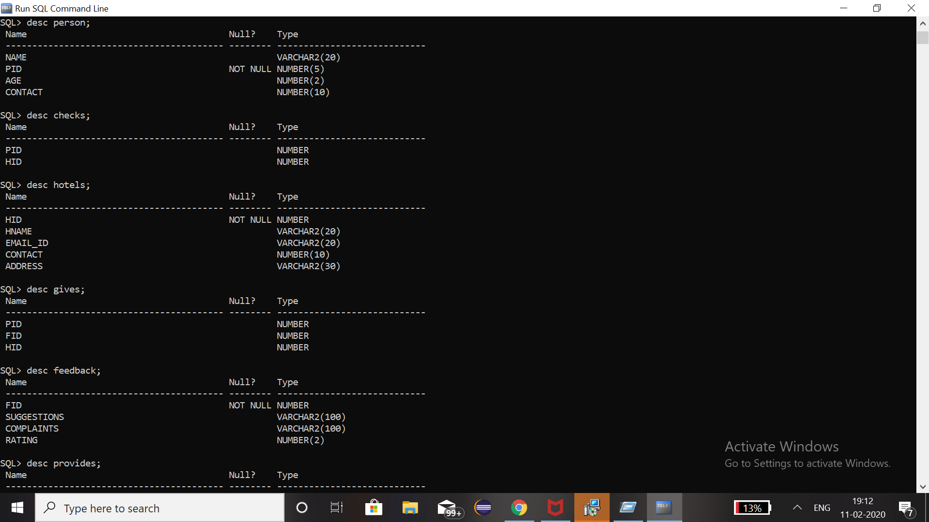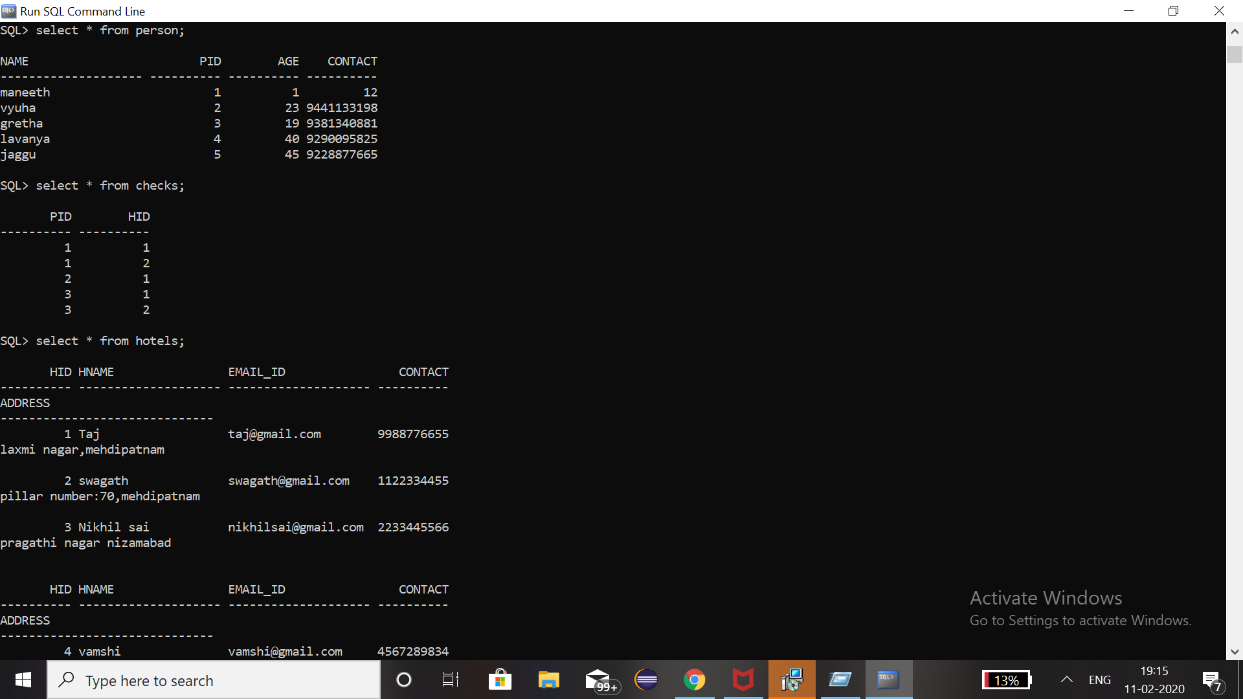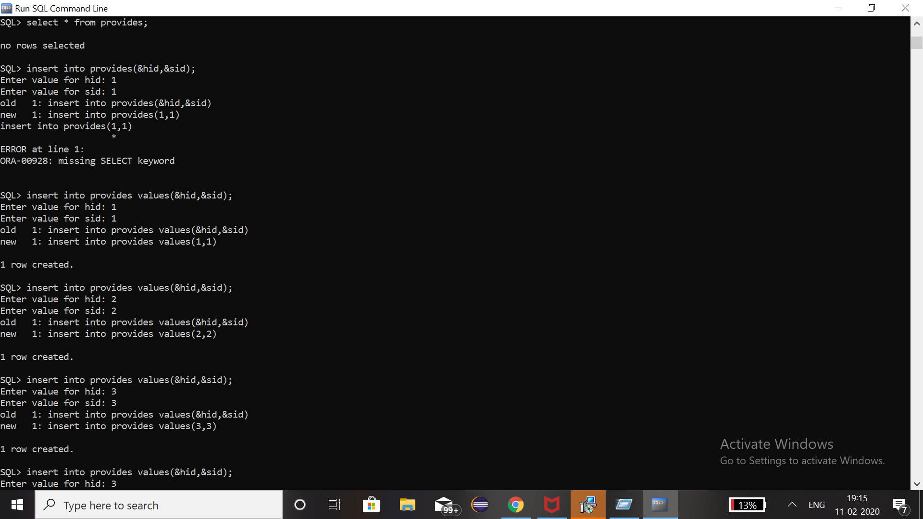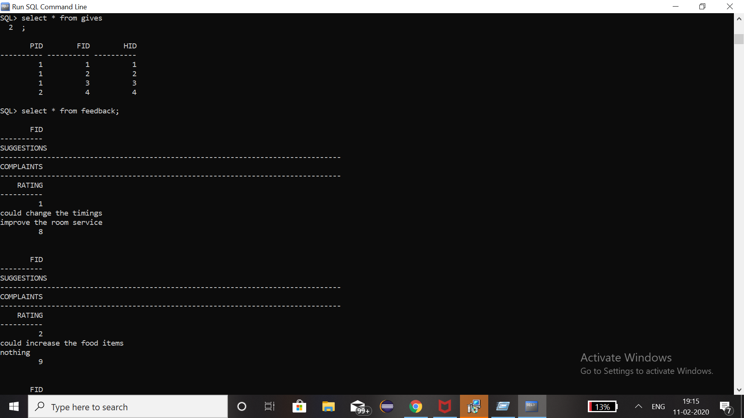

**.**

**.**

**.**

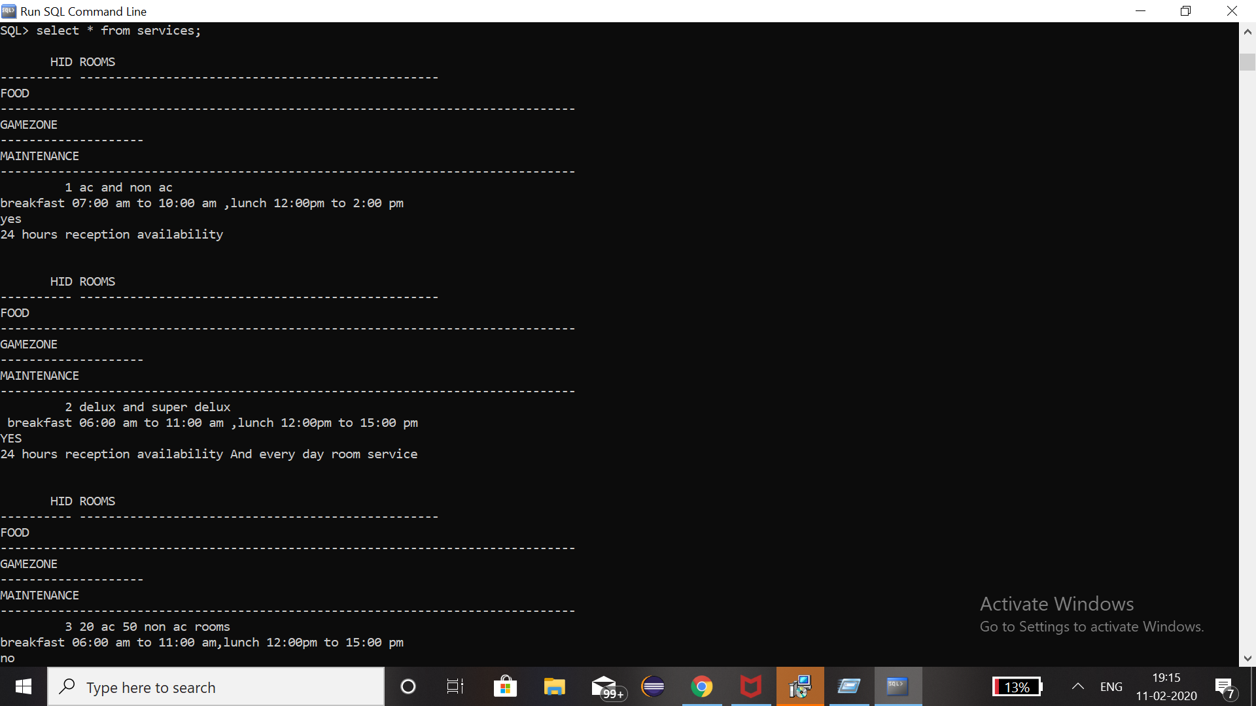**.**



**DDL COMMANDS:**