

**User Manual**

Subway System Simulator



# **Introduction**

**1.1 Purpose:**

 The main idea of the project is to develop a safe subway system simulator as a transport system for the public. As this is used as a mode of transport by the public, Safety is the most important regarding the project. This project have four systems. Train system, Track system, Dispatcher system and Fault layer. Train system displays the information regarding all the trains. Track system displays information about any issues at any particular section or switch. Dispatcher system displays the information about sections and switches working conditions, any difficulties of any track or trains, Emergency stop button to stop the entire system. Fault layer is an intermediate layer for the other systems to transfer the data.

**1.2 Description:**

**The main objective of this project is to develop simulator of the train system which will run automatically without driver. On the client side the system will run on windows/mac/Linux whereas updates about trains schedule information will be taken care on server side. The main goal of this project would be development of a website which supports desktop application.**

# **Structure and Navigation**

The overall structure of the application is relatively simple, as shown in the following diagram.

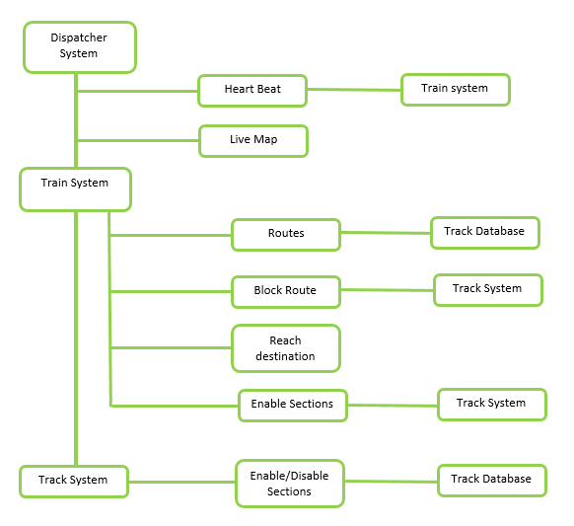

Basically our system consists of 4 actors which are trains, tracks, dispatcher and fault layer system.

* When start button is pressed each train will start from a random location.
* System have a schedule, all the trains have particular destination at a particular point of time.
* Each individual train contacts track system sending the information like train number, from station and to station. Now the track sends the different routes available for the given source and destination stations.
* The train now selects a route and sends it to the track system to block all the sections in between stations.
* After receiving acknowledgement that the route is blocked for that particular train which also includes that the switch is set to the desired direction.
* Train starts accelerating and travels through the blocked sections and reaches the destination decelerating.
* The previous sections used by the train will now be enabled which can be used by other trains if necessary.
* The train always sends heart beat to dispatcher for every 3 seconds. If at all dispatcher did not receive any heart beat then entire system gets stop.
* When information is transferred between the systems, there is a fault layer which may corrupt the data or fail to send the data or send information without any change.
* Dispatcher system displays the current position of the train continuously.

User instructions:

The ui is simple.we have the start and emergency stop button on the right bottom and a reset button to reset all the trains .we have a dynamic table which on top right which shows the details of train like its source destination no of stations, train speed ,section numbers etc..we can start and stop the particular train individually.

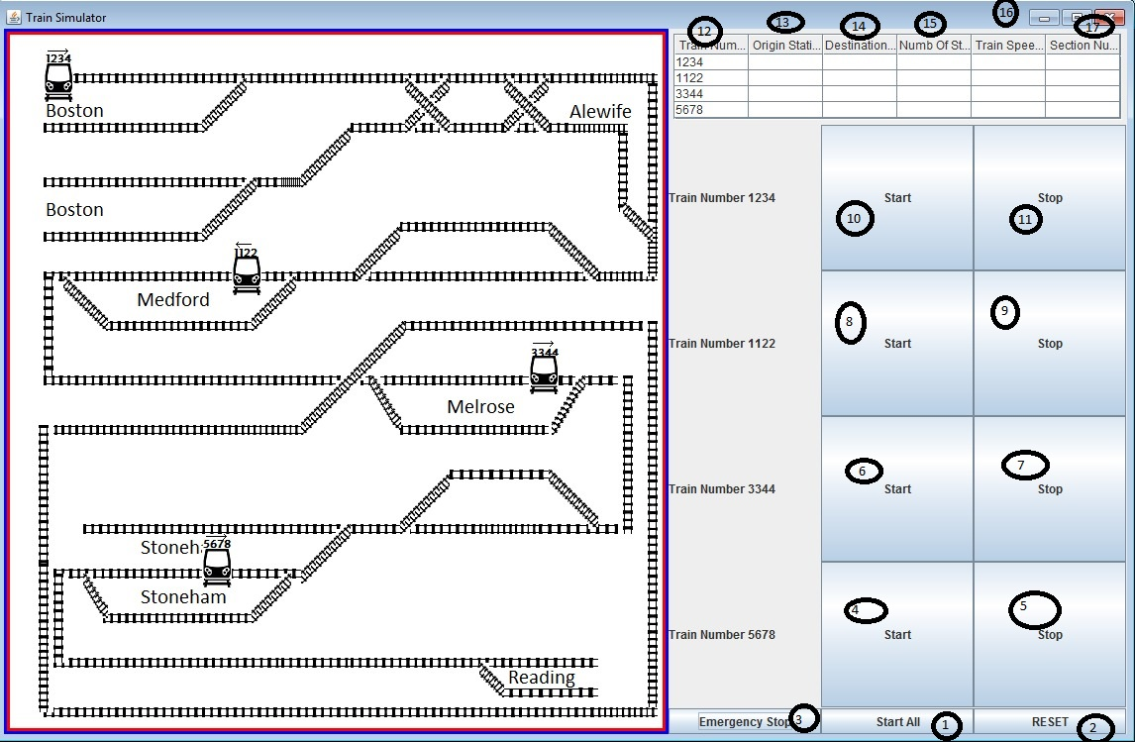

This simulator for subway system is simple to use and the user instructions are given below:

1. STARTALL: This button is used to start all the 4 passenger trains.
2. RESET: This button is used to reset the simulator to default state.
3. EMERGENCY STOP: This button is used to stop all the trains in an emergency situation.
4. START (5678): This button is used to start train 5678.
5. STOP (5678): This button is used to stop train 5678.
6. START (3344): This button is used to start train 3344.
7. STOP (3344): This button is used to stop train 3344.
8. START (1122): This button is used to start train 1122.
9. STOP (1122): This button is used to stop train 1122.
10. START (1234): This button is used to start train 1234.
11. STOP (1234): This button is used to stop train 1234.
12. TRAIN NUM: This column represents the respective train number.
13. ORIGINAL STN: This column represents the station from where the train started.
14. DESTINATION: This column represents the destination of the particular train.
15. NUMBER OF STN: This column represents no of stations between source and destination of the particular train
16. TRAIN SPEED: Indicates individual speed of the train
17. SECTION NUMBER: This gives particular station where train is travelling.