Write a C/C++ program to identify whether input line is comment or not.
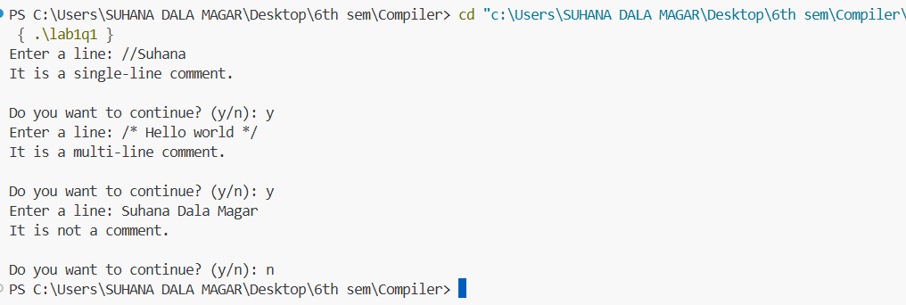

Write a C/C++ program whether given input is valid identifier or not.
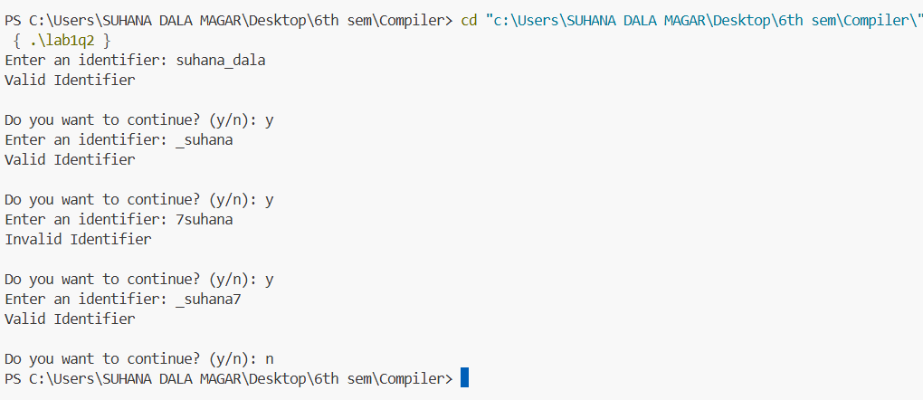

Write a C/C++ program to simulate lexical analyzer for validating operator (Arithmetic, Relational, Logical and Assignment).
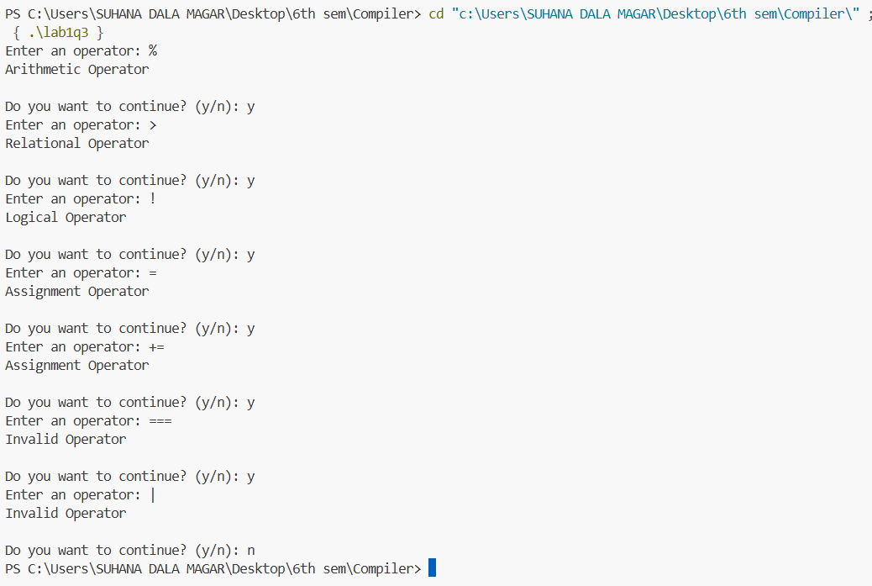

Write a C/C++ program to check whether the given input is keyword or not. (In case of C language)
