- Write a C program to implement DFA for accepting all strings ending with 00 over an alphabet {0,1}.
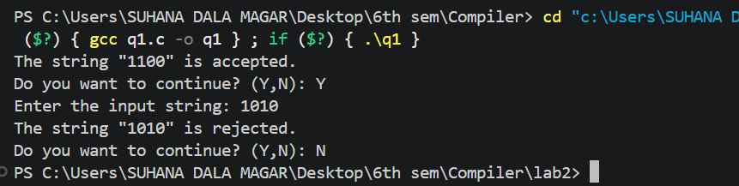

- For accepting even number of 0's and even number of 1's.
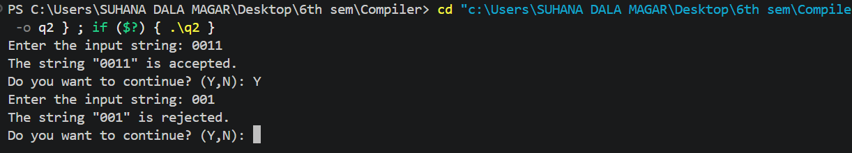

- Write a C program to recognize strings under a*, a*b+, and abb.
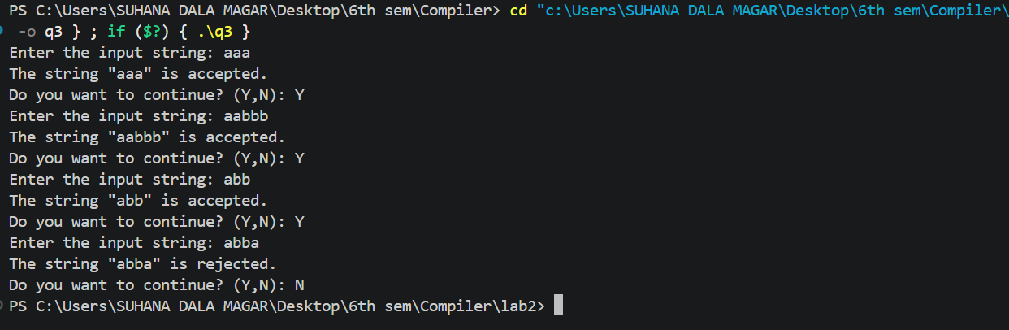

- Write a program to implement design of lexical analyser to recognize token (identifier, keyword, operator, constant and special symbol) etc.

