**Important Instructions for the**

**School Principal**

**(Not to be printed with the question paper)**

1. This question paper is strictly meant for use in school based SA-I, September-2012 only. This question paper is not to be used for any other purpose except mentioned above under any circumstances.
2. The intellectual material contained in the question paper is the exclusive property of Central Board of Secondary Education and no one including the user school is allowed to publish, print or convey (by any means) to any person not authorised by the board in this regard.
3. The School Principal is responsible for the safe custody of the question paper or any other material sent by the Central Board of Secondary Education in connection with school based SA-I, September-2012, in any form including the print-outs, compact-disc or any other electronic form.
4. Any violation of the terms and conditions mentioned above may result in the action criminal or civil under the applicable laws/byelaws against the offenders/defaulters.

**Note:**

**Please ensure that these instructions are not printed with the question paper being administered to the examinees.**

Page **1** of **16**

|  |  |
| --- | --- |
| **I, 2012** |  |
| **SUMMATIVE ASSESSMENT – I, 2012** | **SC2-015** |

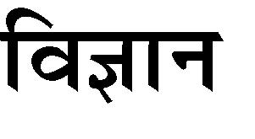

|  |  |  |
| --- | --- | --- |
|  | **/ SCIENCE** |  |
|  | **X / Class – X** | |
| **3** | **90** | |
| **Time allowed : 3 hours** | **Maximum Marks : 90** | |

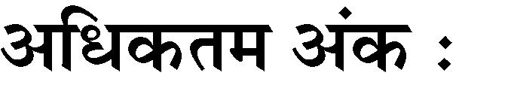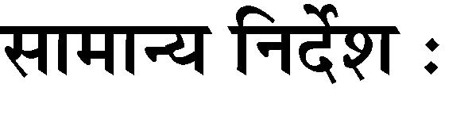

(i)



(ii)



(iii)

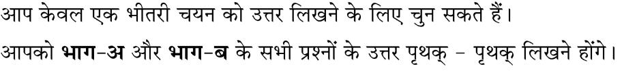

|  |  |  |  |
| --- | --- | --- | --- |
| (iv) |  |  |  |
| (v) | **1** | **3** |  |
| (vi) | **4** | **7** | **30** |
| (vii) | **8** | **19** | **50** |
| (viii) | **20** | **24** | **70** |
| (ix) | **25** | **42** |  |

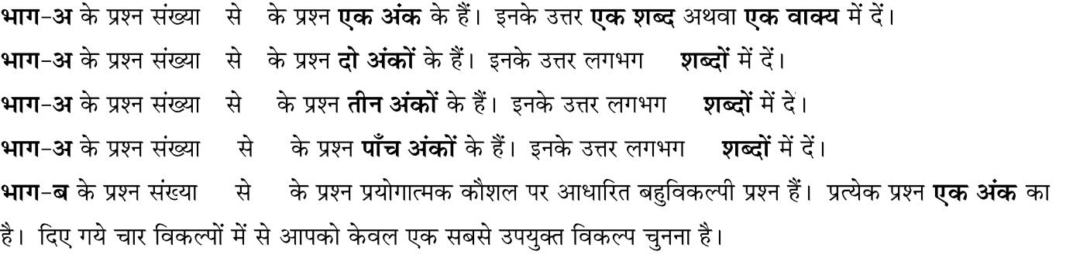

**General Instructions :**

1. The question paper comprises of **two Sections, A** and **B**. You are to attempt both the sections.
2. **All** questions are **compulsory**.
3. There is no overall choice. However, internal choice has been provided in all the five questions of five marks category. Only one option in such questions is to be attempted.
4. **All** questions of **Section-A** and **all** questions of **Section-B** are to be attempted separately.
5. Question numbers **1** to **3** in **Section-A** are **one mark** questions. These are to be answered in **one word** or in **one sentence**.
6. Question numbers **4** to **7** in **Sections-A** are **two marks** questions. These are to be answered in about **30 words** each.
7. Question numbers **8** to **19** in **Section-A** are **three marks** questions. These are to be answered in about **50 words** each.
8. Question numbers **20** to **24** in **Section-A** are **five marks** questions. These are to be answered in about **70 words** each.
9. Question numbers **25** to **42** in **Section-B** are multiple choice questions based on practical skills. Each question is a **one mark** question. You are to select one most appropriate response out of the four provided to you.

Page **2** of **16**

**/ SECTION - A**



**1.** **1**

Mention the angle between a current carrying conductor and magnetic field for which the force experienced by this current carrying conductor placed in magnetic field is largest ?

1. 

Name the sensory receptors found in the nose and on the tongue ?

1. 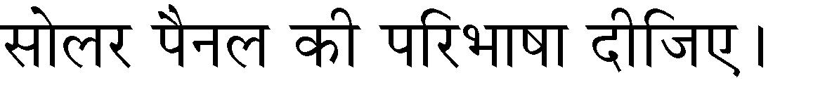

Define a solar panel.

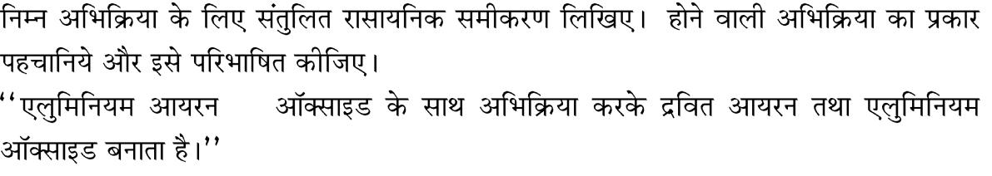

**4.**

III

Write the balanced chemical equation for the following reaction and identify the type of reaction and define it.

‘Iron III oxide reacts with Aluminium and gives molten iron and aluminium oxide’.



**5.**



(a)

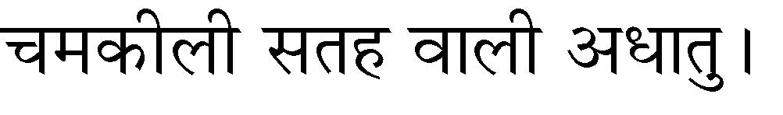

(b)



(c)

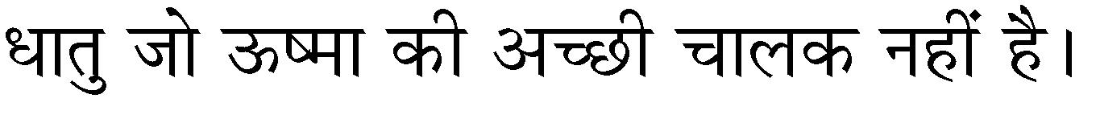

(d)

Name the following :

1. A metal which is preserved in kerosene
2. A lustrous coloured non metal
3. A metal which can melt while kept on palm.
4. A metal, which is a poor conductor of heat.

**6.** 800 W 6 30 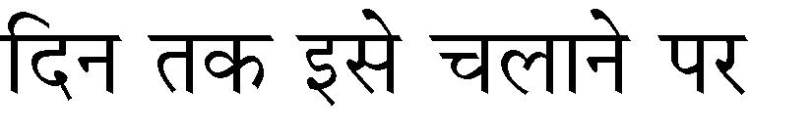` 3.00

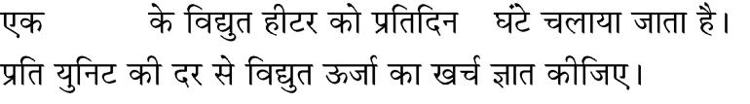

An electric heater rated 800 W operates 6 h/day. Find the cost of energy to operate it for 30 days at ` 3.00 per unit.



**7.**



Draw magnetic field lines produced around a current carrying straight conductor passing through cardboard. How will the strength of the magnetic field change, when the point where magnetic field is to be determined, is moved away from the straight wire carrying constant current ? Justify your answer.

**1**

**1**

**2**

**2**

**2**

**2**

Page **3** of **16**

**8.**

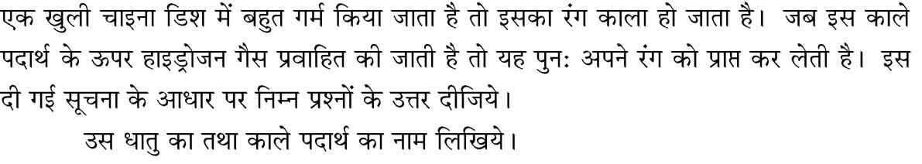

(i)



(ii)

A reddish brown coloured metal, used in electrical wires, when powdered and heated strongly in an open china dish, its colour turns black. When hydrogen gas is passed over this black substance, it regains its original colour. Based on the above information answer the following questions.

1. Name the metal and the black coloured substance formed.
2. Write balanced chemical equations for both the reactions.



1. (a)

(b)

H2 S Cl2  2 HCl S



(c)

**3**

**3**

1. Give an example for a combination reaction which is exothermic.
2. Identify the oxidising agent, reducing agent in the following reaction. H2 S Cl2  2 HCl S
3. Name the phenomenon due to which the taste and smell of oily food changes when kept for a long time in open. Suggest one method to prevent it.

|  |  |  |  |
| --- | --- | --- | --- |
| **10.**(a) |  |  | **3** |
| (b) | pH | | |
| (c) |  |  |  |

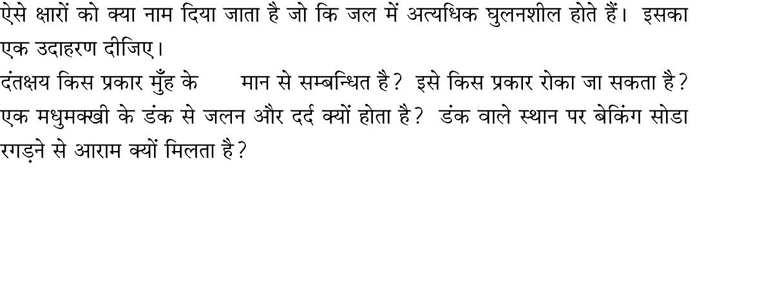

1. Write the name given to bases that are highly soluble in water ? Give an example.
2. How is tooth decay related to pH ? How can it be prevented ?
3. Why does bee sting cause pain and irritation ? Rubbing of baking soda on the sting area gives relief. How ?

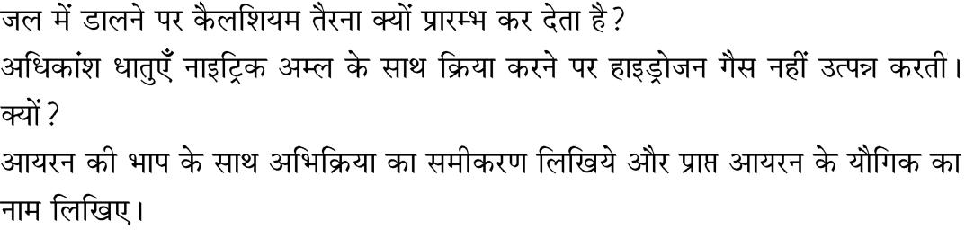

**11.** (a) **3**

(b)

(c)

1. Why is calcium starts floating when added to water ?
2. Most of the metals do not give hydrogen while reacting with nitric acid. Why ?
3. Write equation for the reaction of iron with steam. Name the compound of iron obtained.

Page **4** of **16**

**12.** (a) ‘*l*’ ‘r’ 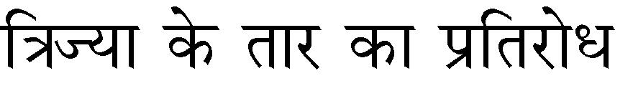10 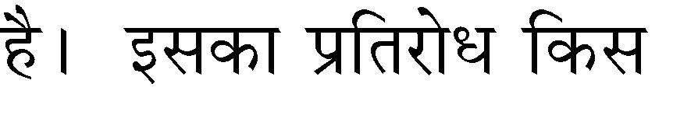

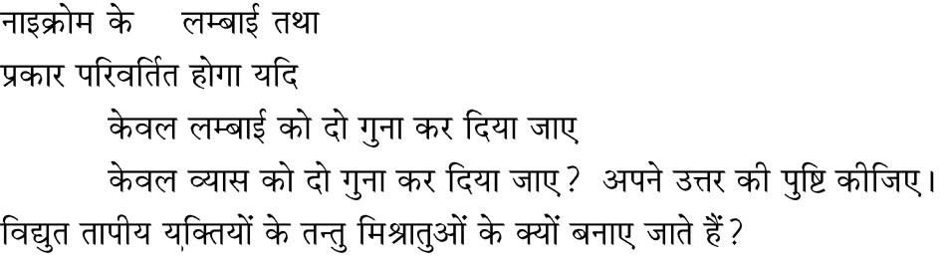

(i)

(ii)

(b)

1. Nichrome wire of length *l* and radius ‘r’ has resistance of 10 . How would the resistance of the wire change when :
   1. Only length of the wire is doubled ?
   2. Only diameter of the wire is doubled ? Justify your answer.
2. Why element of electrical heating devices are made up of alloys ?

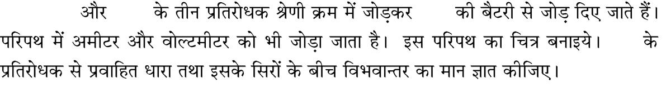

|  |  |  |  |  |  |  |  |
| --- | --- | --- | --- | --- | --- | --- | --- |
| **13.** | 5 |  |  | 15 |  | 30V |  |
|  | , 10 |  |  |  |

10

**3**

**3**

Three resistors of 5 , 10 and 15 are connected in series and the combination is connected to battery of 30V. Ammeter and voltmeter are connected in the circuit. Draw a circuit diagram to connect all the devices in proper correct order. What is the current flowing and potential difference across 10 resistance ?

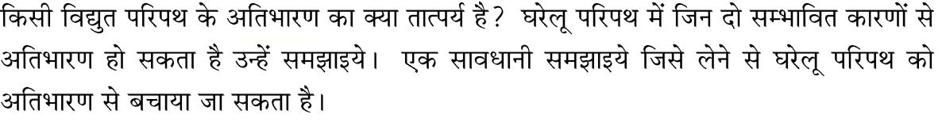

**14.**

What is meant by overloading of an electrical circuit ? Explain two possible causes due to which overloading may occur in household circuit ? Explain one precaution that should be taken to avoid the overloading of domestic electric circuit.

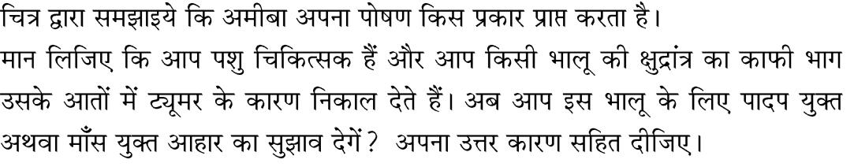

1. (a)

(b)

1. Explain with the help of diagram, how amoeba takes its nutrition.
2. Assume that you are a veterinary surgeon and you had removed a good length of the small intestine of a bear that was suffering from a intestinal tumor. Now, would you suggest a plant based or an meat based diet for the bear after its recovery ? Give reason for your answer.

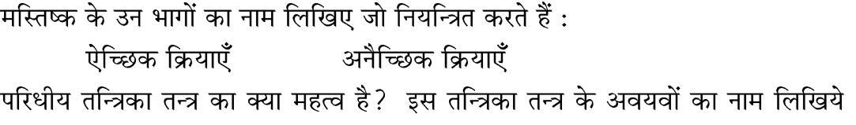

1. (a)

(i) (ii)

(b)



**3**

**3**

**3**

1. Name the part of brain which controls
   1. voluntary action,
   2. involuntary action.
2. What is the significance of the peripheral nervous system ? Name the components of this nervous system and distinguish between the origin

Page **5** of **16**

of the two.



**17.** **3**

Describe an activity to illustrate the phenomenon of phototropism and explain why does this occur.



**18.** **3**

Draw schematic labeled diagram of box type solar cooker.

Name two components of solar cooker which are responsible to increase the temperature inside the solar cooker. Explain their function.



**19.**

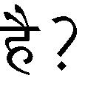

Explain geothermal energy. How can it be harnessed to produce electrical energy ?



|  |  |  |  |
| --- | --- | --- | --- |
| **20.**(a) | AB | A | B |

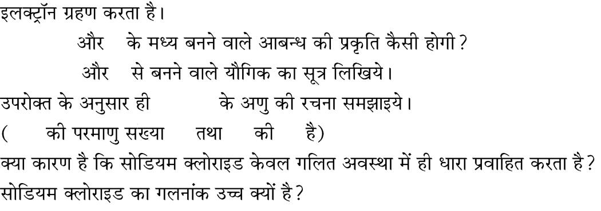

1. AB

(ii) A B

(b) Mg Cl2

Mg 12 Cl 17

(c)

(d)

1. In the formation of compound between two atoms A and B, A loses two electrons and B gains one electron.
   1. What is the nature of bond between A and B ?
   2. Suggest the formula of the compound formed between A and B.
2. On similar lines explain the formation of Mg Cl2 molecule.
3. Common salt conducts electricity only in the molten state. Why ?
4. Why is melting point of NaCl high ?

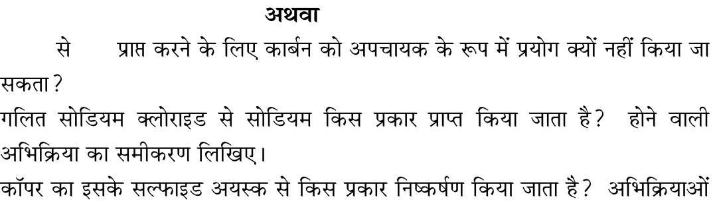

**3**

**5**

**/ OR**

1. MgO Mg

(b)

(c)

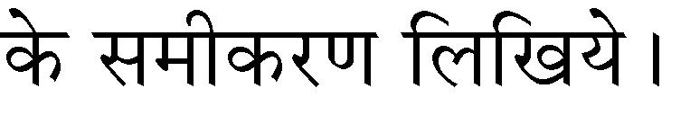

1. Carbon cannot be used as reducing agent to obtain Mg from MgO. Why ?
2. How is sodium obtained from molten sodium chloride ? Give equation of the reactions.
3. How is copper obtained from its sulphide ore ? Give equations of the

Page **6** of **16**

reactions.

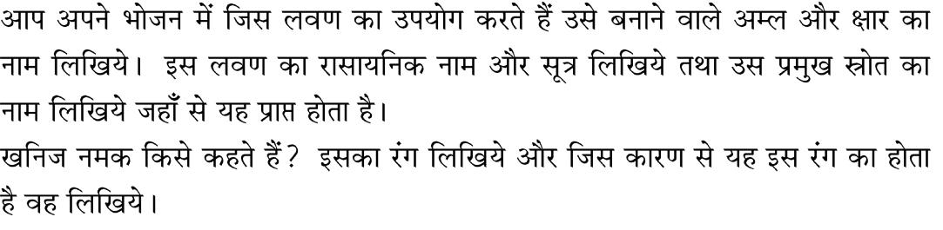

1. (a)

(b)

(c)



1. Identify the acid and the base whose combination forms the common salt that you use in your food. Write its formula and chemical name of this salt. Name the source from where it is obtained.
2. What is rock salt ? Mention its colour and the reason due to which it has this colour.
3. What happens when electricity is passed through brine ? Write the chemical equation for it.
   * **OR**

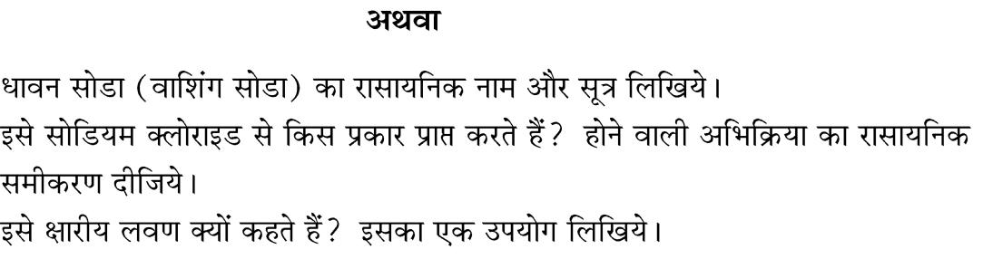

(a)

(b)

(c)

1. Write the chemical name and chemical formula of washing soda.
2. How is it obtained from sodium chloride ? Give equations of the reactions.
3. Why it is called a basic salt ? Give its any one use.

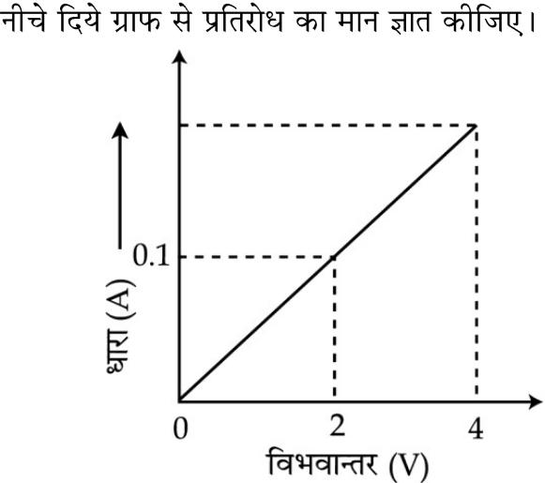

1. (a)

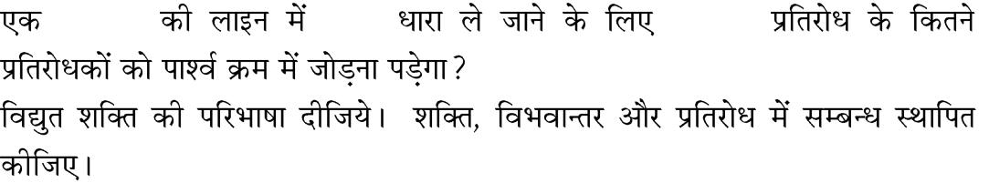

|  |  |  |  |
| --- | --- | --- | --- |
| (b) | 220 V | 5 A | 176 |

(c)

1. Calculate the resistance of the wire using the graph.

**5**

**5**

Page **7** of **16**

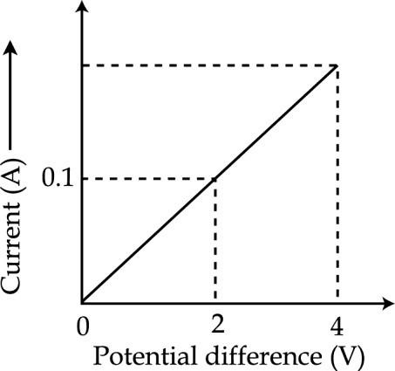

1. How many 176 resistors in parallel are required to carry 5A on a 220 V line ?
2. Define electric power. Derive relation between power, potential difference and resistance.
   * **OR**

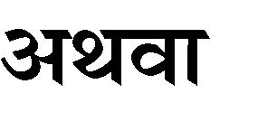

|  |  |
| --- | --- |
| (a) | R1, R2, R3 |
| (b) |  |
| (c) | 5 A |

1. 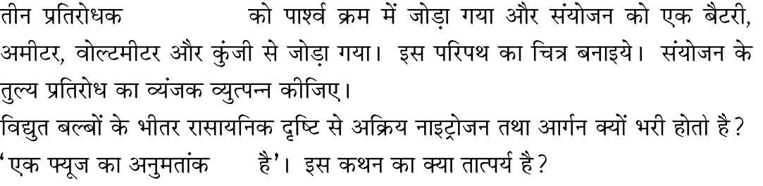Three resistors R1, R2 and R3 are connected in parallel and the combination is connected to battery, ammeter, voltmeter and key. Draw suitable circuit diagram. Obtain an expression for the effective resistance of the combination of resistors in parallel.
2. Why are electric bulbs filled with chemically inactive nitrogen or argon ?
3. What is meant by the statement that the rating of a fuse in a circuit is 5 A ?

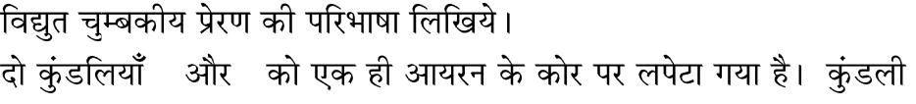

**23.** (a) **5**

(b) P S P 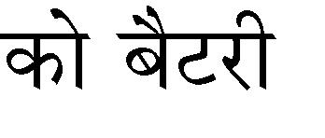

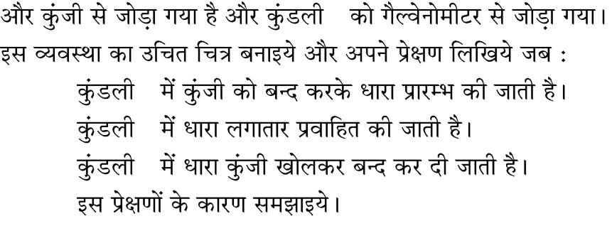

S

* 1. P
  2. P
  3. P

1. Define electromagnetic induction ?
2. Two coils P and S are wound over the same iron core. Coil P is connected to battery and key and the coil S is connected to galvanometer. Draw a suitable diagram of this arrangement and write your observations when :
   1. Current in the coil P is started by closing the key.
   2. Current continues to flow in coil P.
   3. Current in coil P is stopped by removing the key. Explain the reason for such observations.

Page **8** of **16**

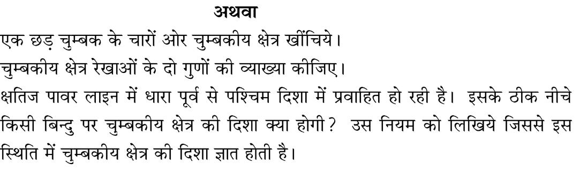**/ OR**

(a)

(b)

(c)

1. Draw magnetic field lines around bar magnet.
2. Explain any two properties of magnetic field lines.
3. A current through a horizontal power line flows in east to west direction. What is the direction of magnetic field at a point directly below it ? State the rule which is used to find the direction of magnetic field in this case.

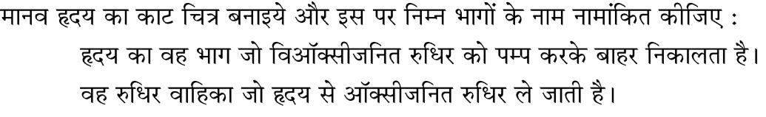

**24.** **5**

(a)

(b)



(c)

Draw the diagram of sectional view of human heart and on it name and label the following parts :

1. The chamber of the heart that pumps out de-oxygenated blood.
2. The blood vessel that carries away oxygenated blood from the heart.
3. The blood vessel that receives de-oxygenated blood from the lower part of our body.
   * **OR**



(a)

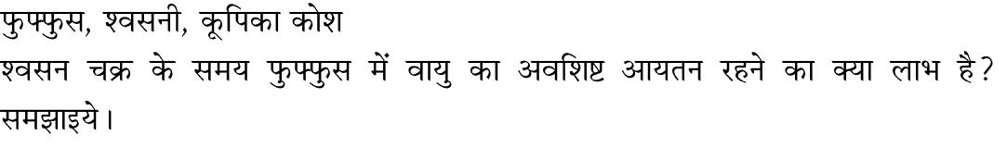

(b)

1. Draw the human respiratory system and label the following – lung, bronchi, alveolar.
2. During breathing cycle what is the advantage of residual volume of air in lungs ? Explain.



**/ SECTION - B**

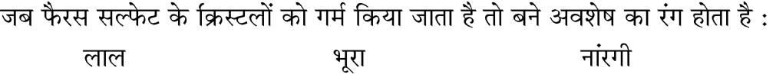

**25.** **1**

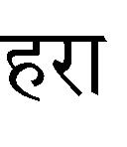

(a) (b) (c) (d)

When ferrous sulphate crystals are heated, the colour of the residue formed is :

(a) red (b) brown (c) orange (d) green



**26.** **1**

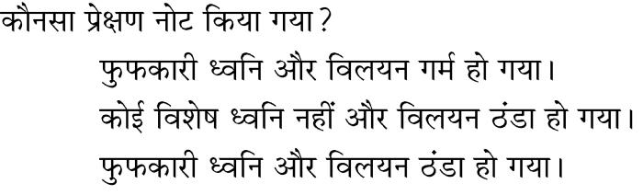

(a)

(b)

(c)

Page **9** of **16**



(b)

tap water

(d)

dilute NaHCO3 solution

(d)

A small amount of quick lime is taken in a beaker. Water is added slowly to the beaker. Which of the following observations were noted ?

1. Hissing sound and the solution becomes hot
2. No characteristic sound and solution turns cold
3. Hissing sound and the solution becomes cold.
4. No characteristic sound and the solution becomes hot.

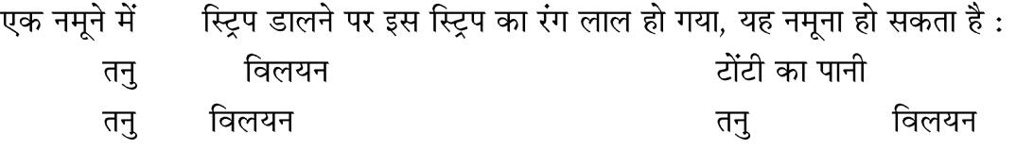

|  |  |  |  |
| --- | --- | --- | --- |
| **27.** | pH |  |  |
| (a) | NaOH | (b) |  |
| (c) | HCl | (d) | NaHCO3 |

The colour of pH strip turned red when it was dipped in a sample. The sample

could be :

(a) dilute NaOH solution

(c) dilute HCl solution

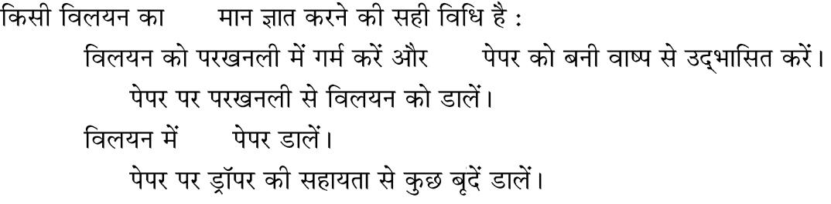

**28.** pH

(a) pH

1. pH

(c) pH

1. pH

The correct method of finding pH of solution is to :

1. heat the solution in the test tube and expose the pH paper to the vapours formed.
2. pour solution from the test tube on pH paper
3. drop the pH paper into the solution
4. add a drop of solution on the pH paper using a dropper.

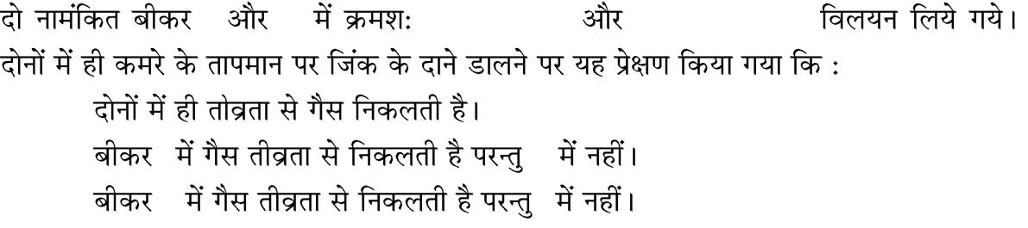

|  |  |  |  |
| --- | --- | --- | --- |
| **29.** | I | II | 10 mL HCl10 mL NaOH |
| (a) |  |  |  |
| (b) | I |  | II |
| (c) | II |  | I |

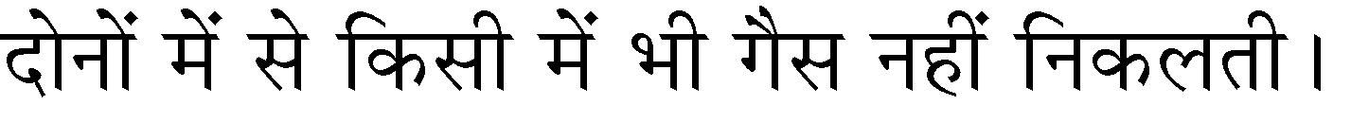

(d)

10 mL of HCl and 10 mL of NaOH solutions are taken in two separate beakers labelled I and II respectively. On adding Zinc granules to both, it is observed that at room temperature

1. Gas is evolved vigorously in both
2. Gas is evolved vigorously in beaker I and not in the beaker II
3. Gas is evolved vigorously in beaker II but not in the beaker I
4. No gas is evolved in either of the two beakers

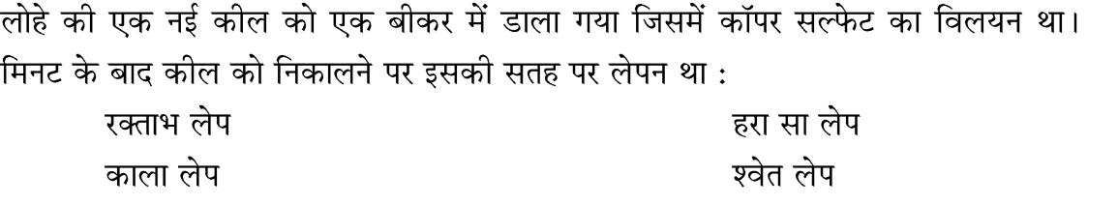

**30.** 15

(a) (b)

(c) (d)

**1**

**1**

**1**

**1**

Page **10** of **16**

|  |  |  |  |  |  |
| --- | --- | --- | --- | --- | --- |
|  | A new iron nail is placed in a beaker containing aqueous copper sulphate | | | | |
|  | solution. When the nail is taken out after 15 minutes, its surface is coated with | | | | |
|  | (a) | reddish deposit |  | (b) | greenish deposit |
|  | (c) | black deposit |  | (d) | white deposit |
| **31.** |  |  |  |  |  |
|  | (a) |  |  | (b) |  |
|  | (c) |  |  | (d) |  |
|  | A piece of granulated Zn was dropped into copper sulphate solution. After | | | | |
|  | some time the colour of solution changed from | | | |  |
|  | (a) | light green to blue |  | (b) | blue to colourless |
|  | (c) | light green to colourless |  | (d) | blue to green |
| **32.** | 2A |  | 10 | 5 V | 20 |
|  |  |  |  |  | 8 |
|  |  | 8 |  |  |  |

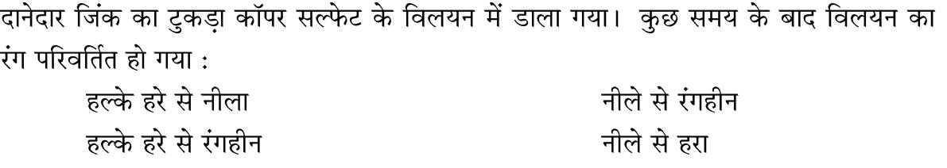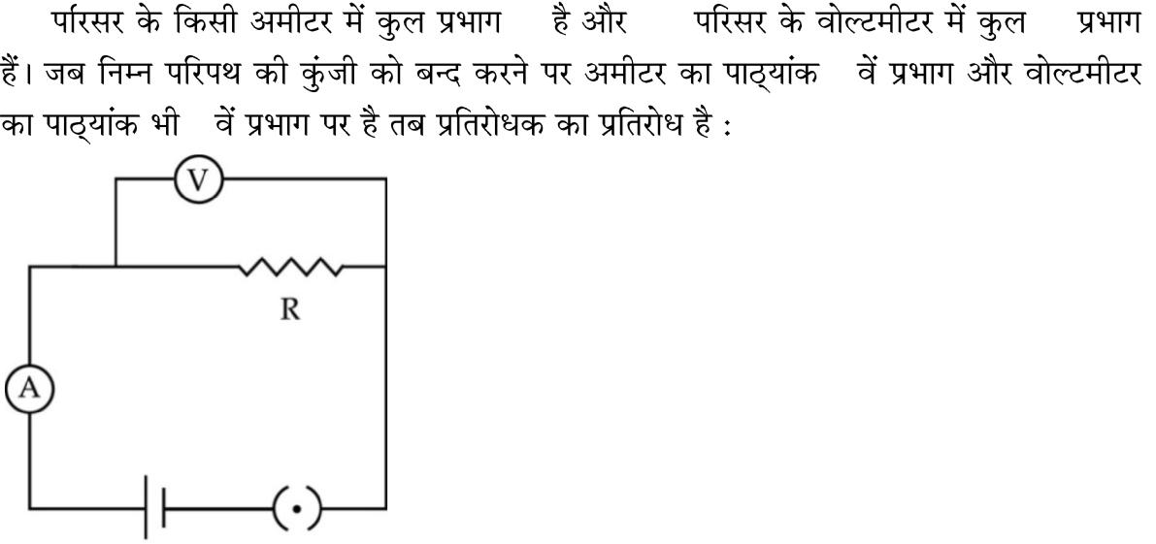

|  |  |  |  |  |  |  |  |
| --- | --- | --- | --- | --- | --- | --- | --- |
| (a) | 1.25 | (b) | 2 | (c) | 0.75 | (d) | 1.5 |
| The number of division in ammeter of range 2A is 10 and voltmeter of | | | | | | | range |

5 V is 20. When the switch of the circuit given below is closed, ammeter reading is at 8th division and voltmeter reading is at 8th divisions. The value of resistance of resistor is –

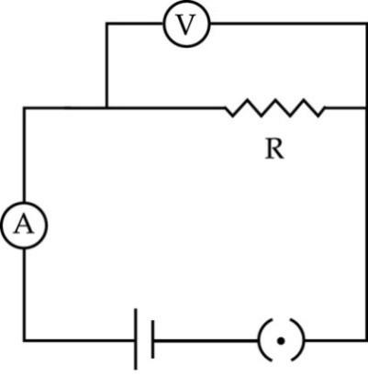

**1**

**1**

|  |  |  |  |  |  |  |  |
| --- | --- | --- | --- | --- | --- | --- | --- |
| (a) | 1.25 | (b) | 2 | (c) | 0.75 | (d) | 1.5 |
| **33.** |  |  |  |  | / |  | **1** |
| (a) |  |  |  | (b) |  |  |  |
| (c) |  |  |  | (d) |  |  |  |

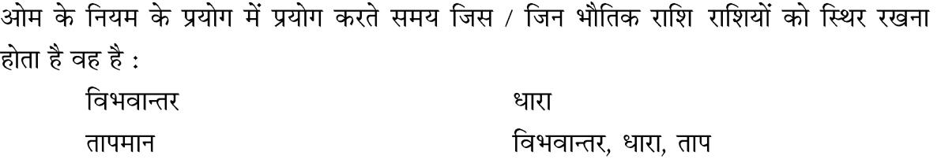

Page **11** of **16**

In Ohm’s law experiment, the physical quantity/quantities which is/are to kept constant while doing experiment is/are :

|  |  |  |  |
| --- | --- | --- | --- |
| (a) | potential difference | (b) | current |
| (c) | temperature | (d) | potential difference, current, temperature |
| **34.** |  |  | R1, R2 R1>R2 |
|  | A, B, C |  |  |

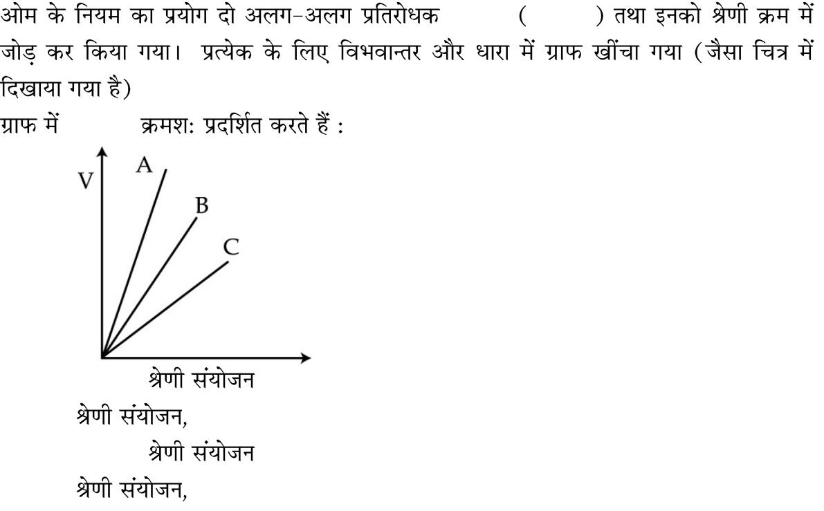

1. R1, R2,

|  |  |
| --- | --- |
| (b) | R2, R1 |

1. R2, R1,

|  |  |
| --- | --- |
| (d) | R1, R2 |

Ohm’s law experiment is performed separately with individual resistors R1, R2

[R1>R2] and series combination of R1, R2. Graph is plotted between potential

difference (V) and current (I) as shown in figure for each case : Identify which one is for R1, R2 and combination of resistors ?

In the graph A, B and C respectively represents

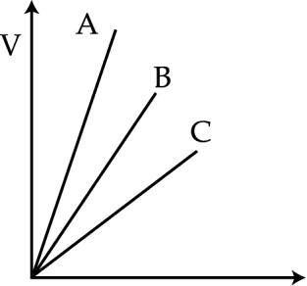

* 1. R1, R2 and series combination

1. series combination, R2, R1
2. R2, R1 and series combination
3. series combination, R1, R2

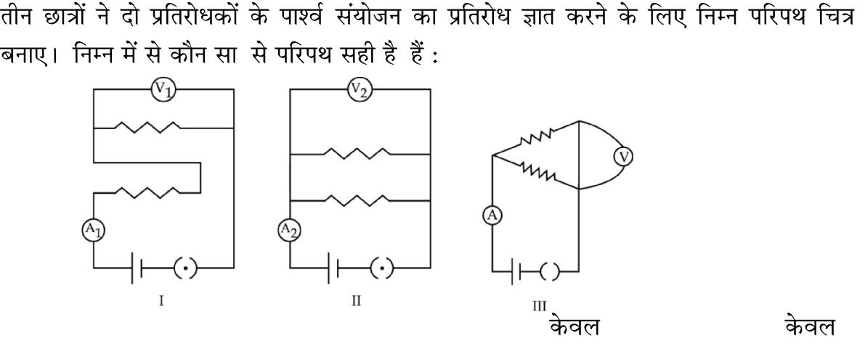**35.**

/ /

**1**

**1**

(a) I, II (b) II, III (c) II (d) I

Page **12** of **16**

Three students drew following circuit diagrams to find resistance of parallel combination of two resistors.

Correct circuit diagram/diagrams are –

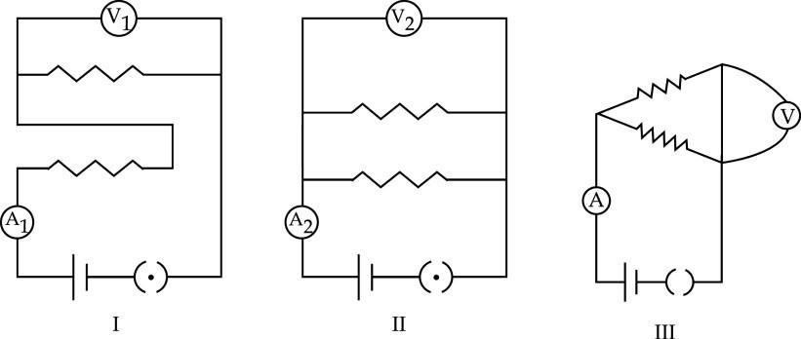

(a) I, II (b) II, III (c) II only (d) I only

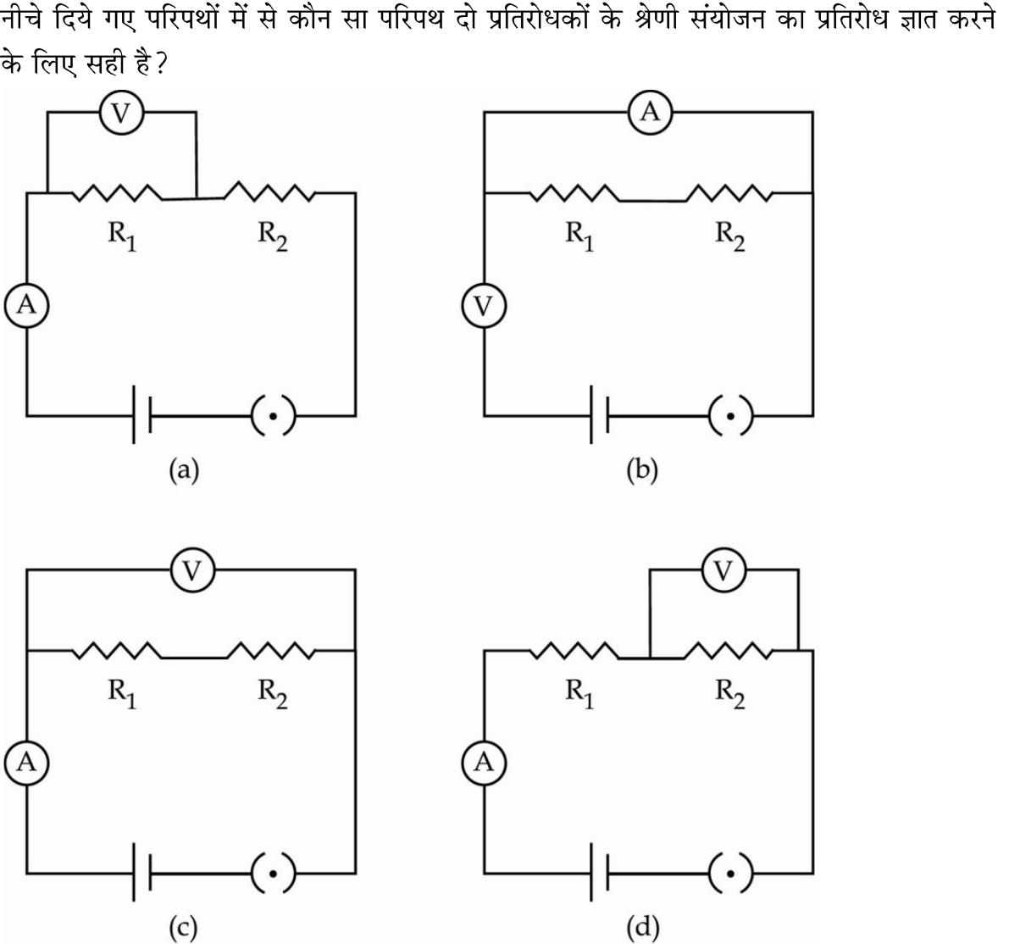

**36.** **1**

The circuit diagram shown below is used to find the effective resistance of two resistors in series. Which circuit diagram represents correctly ?

Page **13** of **16**

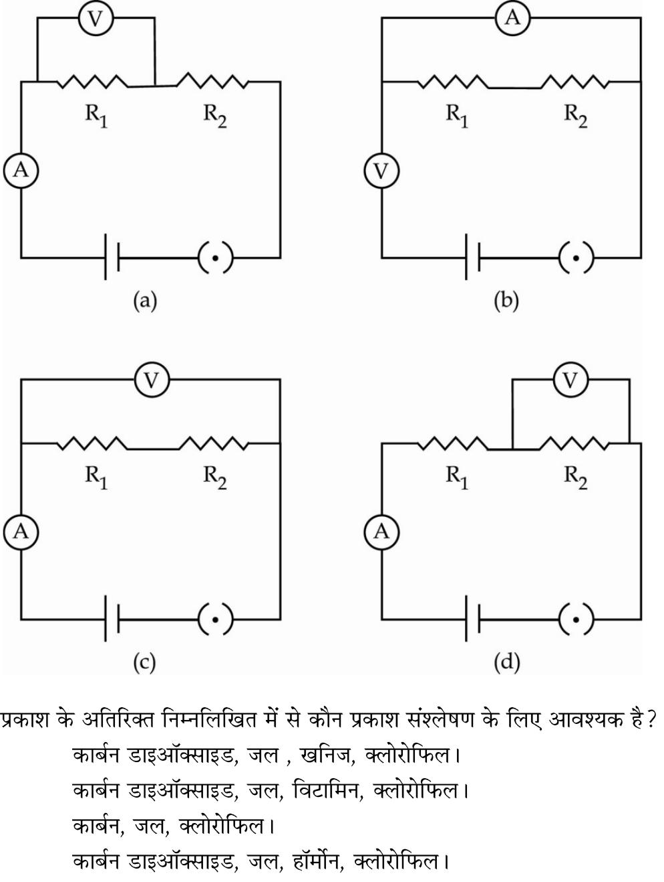

**37.** **1**

(a)

(b)

(c)

(d)

Other than light, which of the following are also essential for photosynthesis ?

1. carbon di-oxide, water, minerals, chlorophyll
2. carbon di-oxide, water, vitamins, chlorophyll
3. carbon, water, minerals, chlorophyll
4. carbon di-oxide, water, hormones, chlorophyll



**38.** **1**

Page **14** of **16**

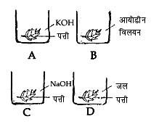

(a) A (b) B (c) C (d) D Which of the following set-up will give a positive result for starch test after boiling the leaf in alcohol ?

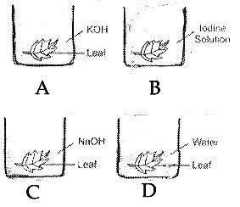

|  |  |  |  |  |  |  |  |
| --- | --- | --- | --- | --- | --- | --- | --- |
| (a) | A | (b) | B | (c) | C | (d) | D |
| **39.** |  |  |  |  |  |  | **1** |
| (a) |  | (b) |  | (c) | (d) |  |  |
| The stomatal opening is controlled by guard cells. If the stomatal opening is to | | | | | | | |
| remain open how should the guard cells be ? | | | | |  |  |  |
| (a) | stretched | (b) | swollen | (c) | rigid (d) | shrunk |  |
| **40.** |  |  |  |  |  |  | **1** |
| (a) |  |  |  |  |  |  |  |
| (b) |  |  |  |  |  |  |  |
| (c) |  |  |  |  |  |  |  |
| (d) |  |  |  |  |  |  |  |

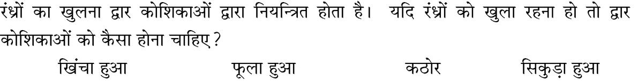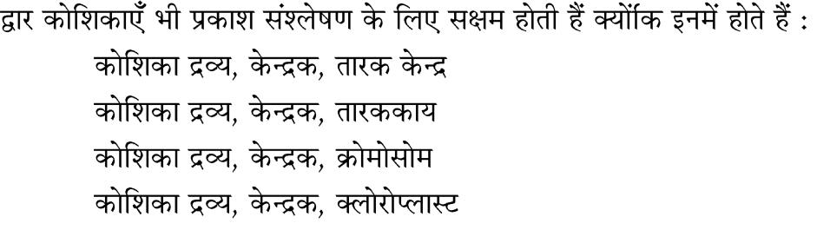

The guard cells are also capable of photosynthesis because they have :

1. cytoplasm, nucleus, centrioles
2. cytoplasm, nucleus, centrosome
3. cytoplasm, nucleus, chromosomes
4. cytoplasm, nucleus, chloroplasts

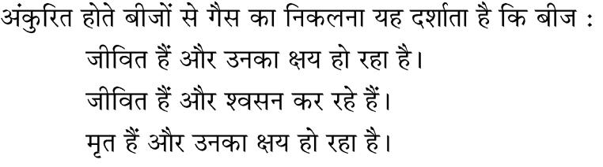

**41.** **1**

(a)

(b)

(c)

Page **15** of **16**

(d)

The gas released from germinating seeds indicate that the seeds are :

|  |  |  |  |
| --- | --- | --- | --- |
| (a) | alive and decaying | (b) | alive and respiring |
| (c) | dead and decaying | (d) | alive and decomposing |
| **42.** |  |  | **1** |

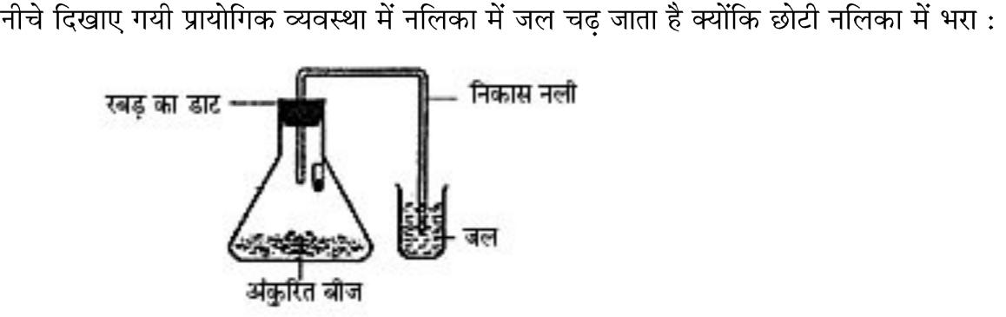

|  |  |
| --- | --- |
| (a) | CO2 |
| (b) | CO2 |
| (c) | CO2 |
| (d) | CO2 |

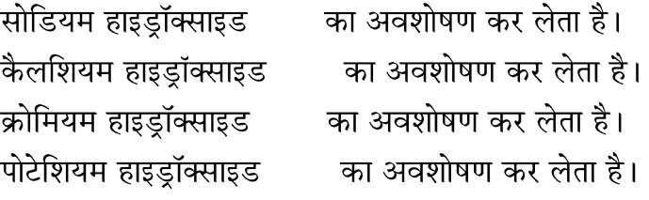In the experimental set-up shown in the figure, water is found to rise in the delivery tube because :

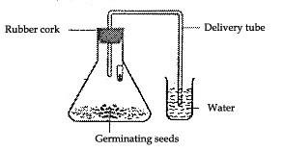

1. sodium hydroxide kept in the small test tube absorbs CO2
2. calcium hydroxide kept in the small test tube absorbs CO2
3. chromium hydroxide kept in the small test tube absorbs CO2
4. potassium hydroxide in the small test tube absorbs CO2
   * o O o -

Page **16** of **16**