Mail Merge Add-in
User Guide
Version 2.4.0 · August 2026
SUNSHINE SACHS

Overview
The Mail Merge Add-in lets you send personalised bulk emails directly from New Outlook / Outlook Web (OWA) without leaving your inbox. Emails are sent one-to-one on your behalf via Microsoft 365 — each recipient sees a personal message, not a group email.

Key capabilities:
- Accepts CSV or Excel (.xlsx) files as your recipient list
- Merge fields like {{first_name}} auto-fill per recipient
- Preview every email before sending
- Test mode sends only to yourself
- Simulate mode shows what would be sent without actually sending
- Broadcast saves every email as a draft for review before sending
- Built-in rate limiting to avoid spam filters

Prerequisites
- Access to New Outlook or Outlook Web (OWA) — outlook.office.com
- The Mail Merge add-in installed via Microsoft 365 Admin Center
- A Microsoft 365 account at SUNSHINE SACHS (ssmandl.com)
- Your recipient list prepared as a CSV or XLSX file

Step 1 — Open a New Compose Window
In New Outlook or OWA, click New Mail to open a new compose window. Do not fill in any recipients or subject yet — the add-in will handle personalisation.

Step 2 — Launch the Mail Merge Add-in
In the compose toolbar, click the Options tab. You will see a Run Merge button in the Add-ins section. Click it and select Run Merge from the dropdown.

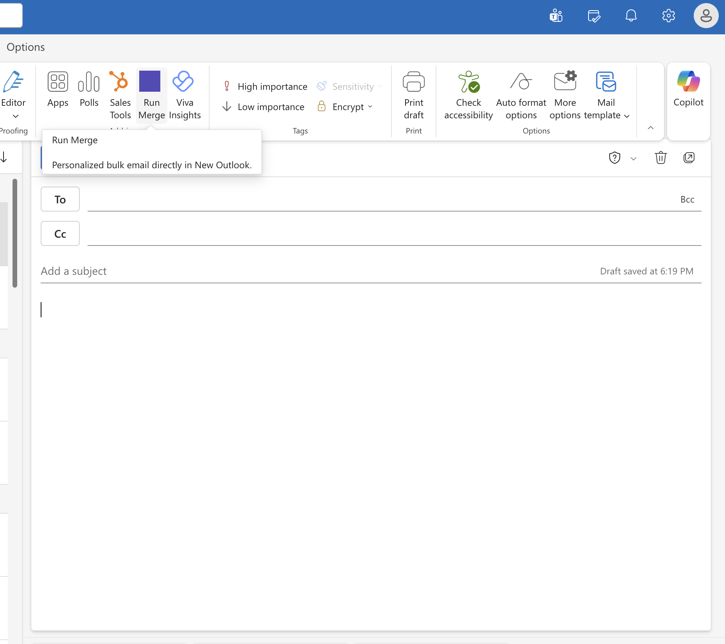
The Run Merge button appears in the compose ribbon under Options → Add-ins
The Mail Merge task pane will open on the right side of your compose window, showing the Recipients tab.

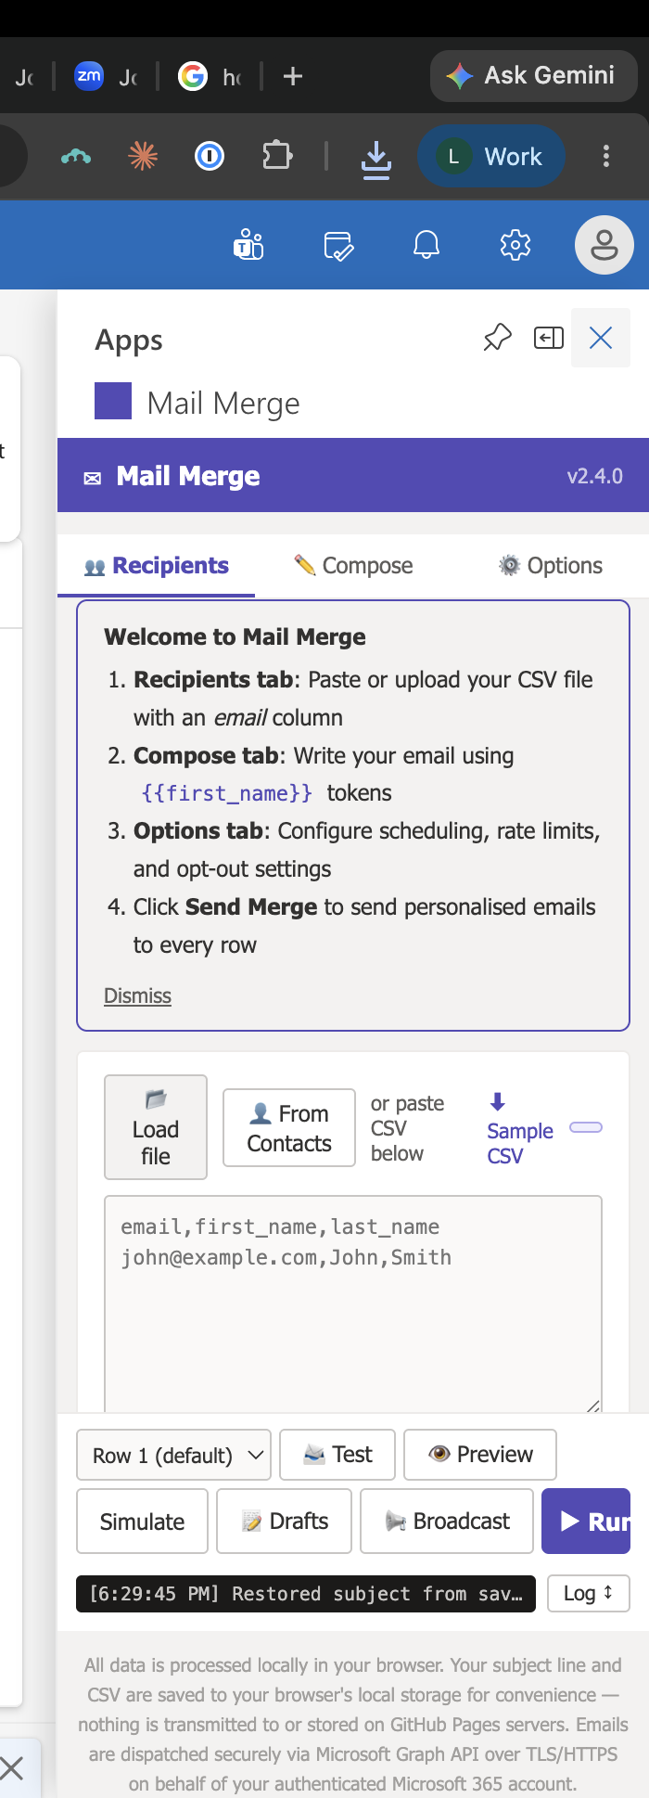
The Mail Merge task pane opens with the Recipients tab active

Step 3 — Prepare Your Data File
Your data file must be a CSV (.csv) or Excel (.xlsx) file with at least one column named email. Column headers become your merge field names.

Required column
email
Every row must have a valid email address in the email column. Rows without one are skipped.

Recommended columns
Column name | Used for
first_name | Recipient's first name — {{first_name}}
last_name | Recipient's last name — {{last_name}}
company | Company name — {{company}}
title | Job title — {{title}}

Example CSV format
email,first_name,last_name,company,title
jane@example.com,Jane,Smith,Acme Corp,CEO
john@example.com,John,Doe,Globex,Director

You can add any additional columns you need — they all become available as merge fields automatically.

Exporting from Microsoft 365 Admin Center
- Go to admin.microsoft.com
- Click Users → Active users
- Click Export users in the top toolbar
- Open the downloaded CSV in Excel and rename columns to match the field names you want to use (e.g. rename "Display Name" to "first_name")

Step 4 — Load Your Recipients
In the Recipients tab, load your data in one of three ways:

- Load file: Load file — click to browse and select your CSV or XLSX file
- From Contacts: From Contacts — search and select from your Outlook contacts
- Paste CSV: Paste CSV — type or paste CSV text directly into the text area

Once loaded, a preview table shows all recipients with checkboxes. Uncheck any rows you want to exclude from this send.

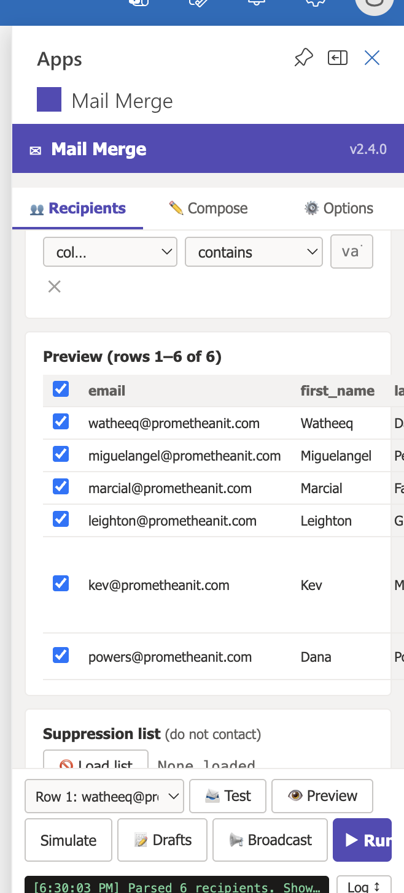
Recipients preview table — all 6 rows loaded and selected
The status bar at the bottom confirms how many recipients were parsed (e.g. "Parsed 6 recipients").

Filtering recipients
Use the filter controls at the top of the preview table to narrow down recipients by column value — useful for large lists where you only want to send to a subset.

Suppression list
Scroll down in the Recipients tab to find the Suppression list section. Load a separate CSV of email addresses you never want to contact. Matching recipients are automatically excluded from the send.

Step 5 — Compose Your Email
Click the Compose tab. Here you write the subject line and the email body in the main Outlook compose window using merge field tags.

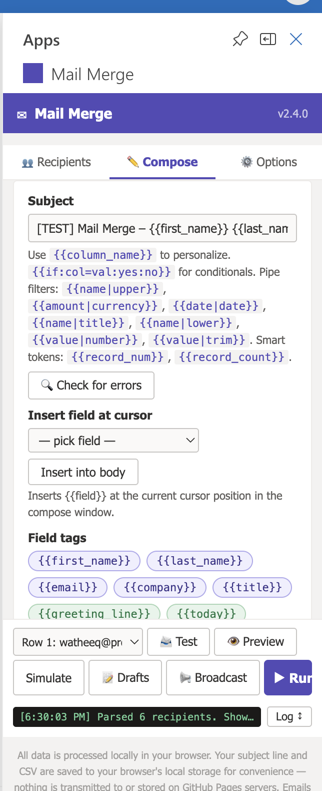
The Compose tab shows the subject field, available merge field tags, and action buttons

Subject line
Type your subject in the Subject field at the top of the Compose tab. You can include merge fields here too:
Invoice ready — {{first_name}} {{last_name}}

Email body
Write your email body in the main Outlook compose window (left side). Click Insert into body to insert a merge field tag at your cursor position, or type tags directly:

Available merge field syntax:
{{column_name}} | Inserts the column value for each recipient
{{first_name|upper}} | Converts to UPPERCASE
{{first_name|lower}} | Converts to lowercase
{{first_name|title}} | Converts to Title Case
{{amount|currency}} | Formats as currency ($1,234.56)
{{date|date}} | Formats as a date
{{value|number}} | Formats as a number
{{value|trim}} | Removes leading/trailing spaces
{{if:col=val:yes:no}} | Conditional — shows "yes" if col equals val, else "no"
{{record_num}} | Current record number (1, 2, 3…)
{{record_count}} | Total number of recipients
{{today}} | Today's date
{{greeting_line}} | Auto-generates "Dear First Last,"

Example email body
Hi {{first_name}},

This message is for {{first_name}} {{last_name}} at {{company}}.
Your role: {{title}}
Sent: {{today}}

Regards,
Leighton

Step 6 — Preview Your Emails
Click the Preview button at the bottom of the task pane to see exactly how your email will appear for each recipient before sending. A preview card shows the rendered subject and body with all merge fields substituted.

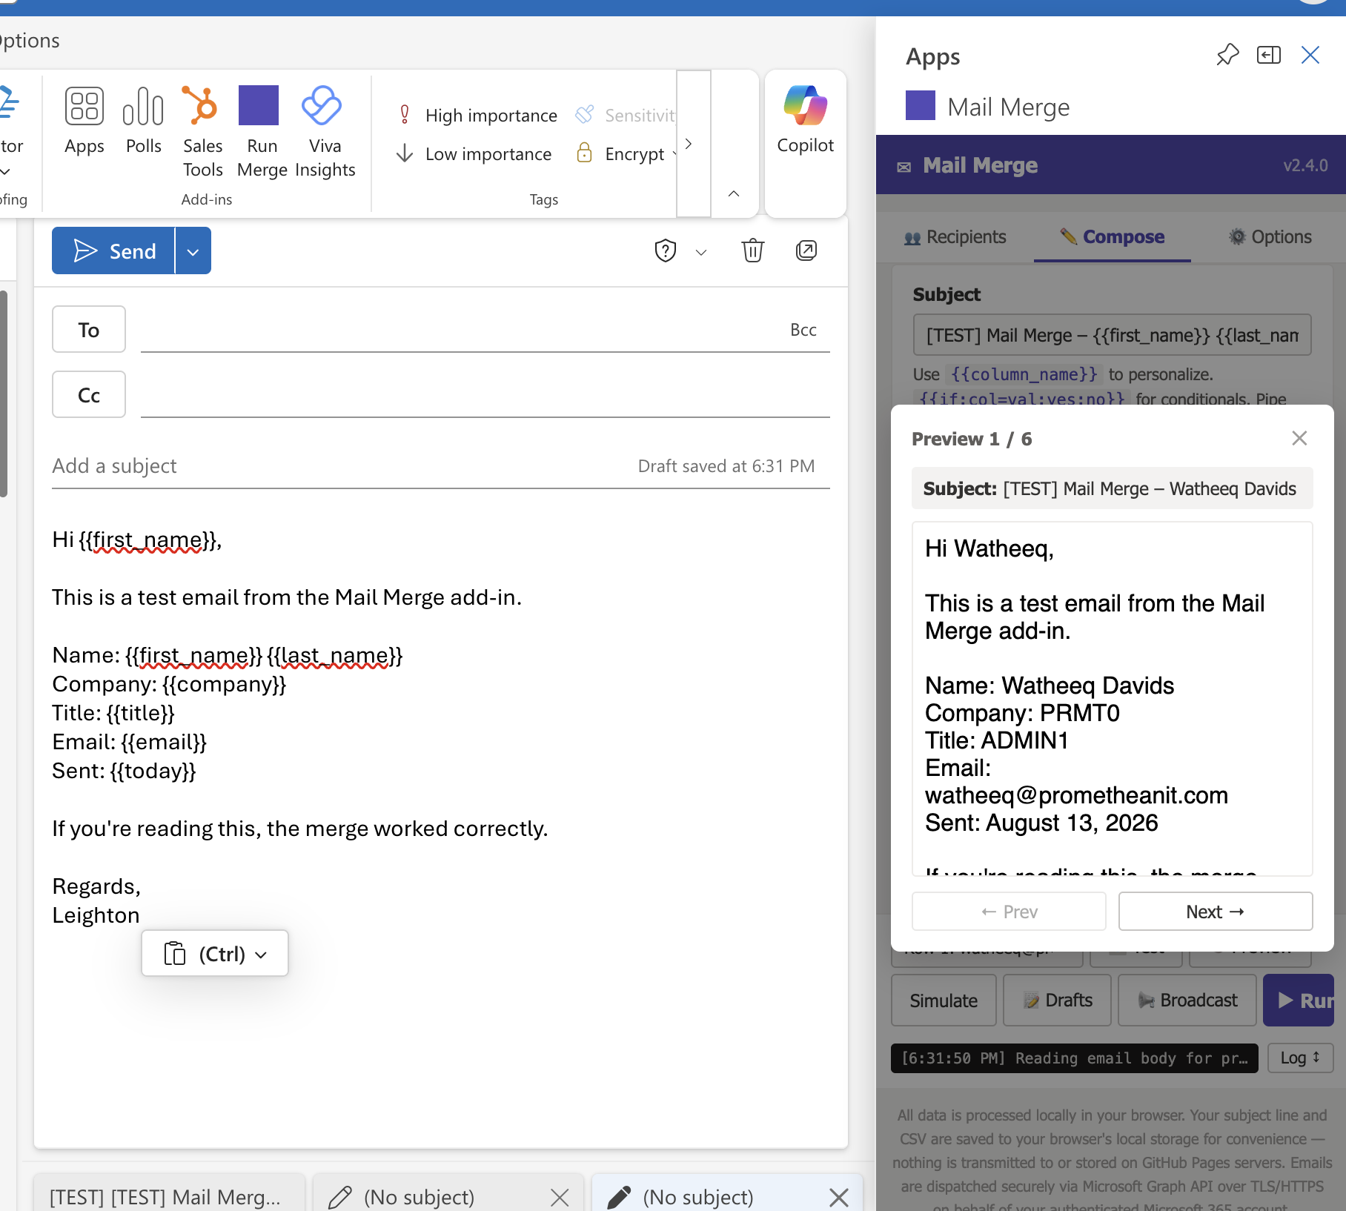
Preview card showing "Preview 1 / 6" with all merge fields resolved for the first recipient
Use the Prev and Next arrows to step through all recipients. If anything looks wrong, close the preview and fix your template or data file before sending.

Step 7 — Send Your Merge
Four send options are available at the bottom of the task pane:

Test | Sends the email only to yourself (using Row 1 data) so you can check how it looks in your inbox before the full send.
Simulate | Runs through the entire merge and logs what would have been sent — no emails are actually delivered. Use this to catch errors safely.
Broadcast | Saves every merged email as a draft in your Drafts folder so you can review each one individually before sending manually.
Run | Sends the merged emails to all selected recipients. A confirmation prompt shows the recipient count before proceeding.

Always use Test or Simulate first when sending to a new list or using a new template.

After a successful Run, each recipient receives their personalised email. You will see a confirmation in the status bar at the bottom of the task pane.

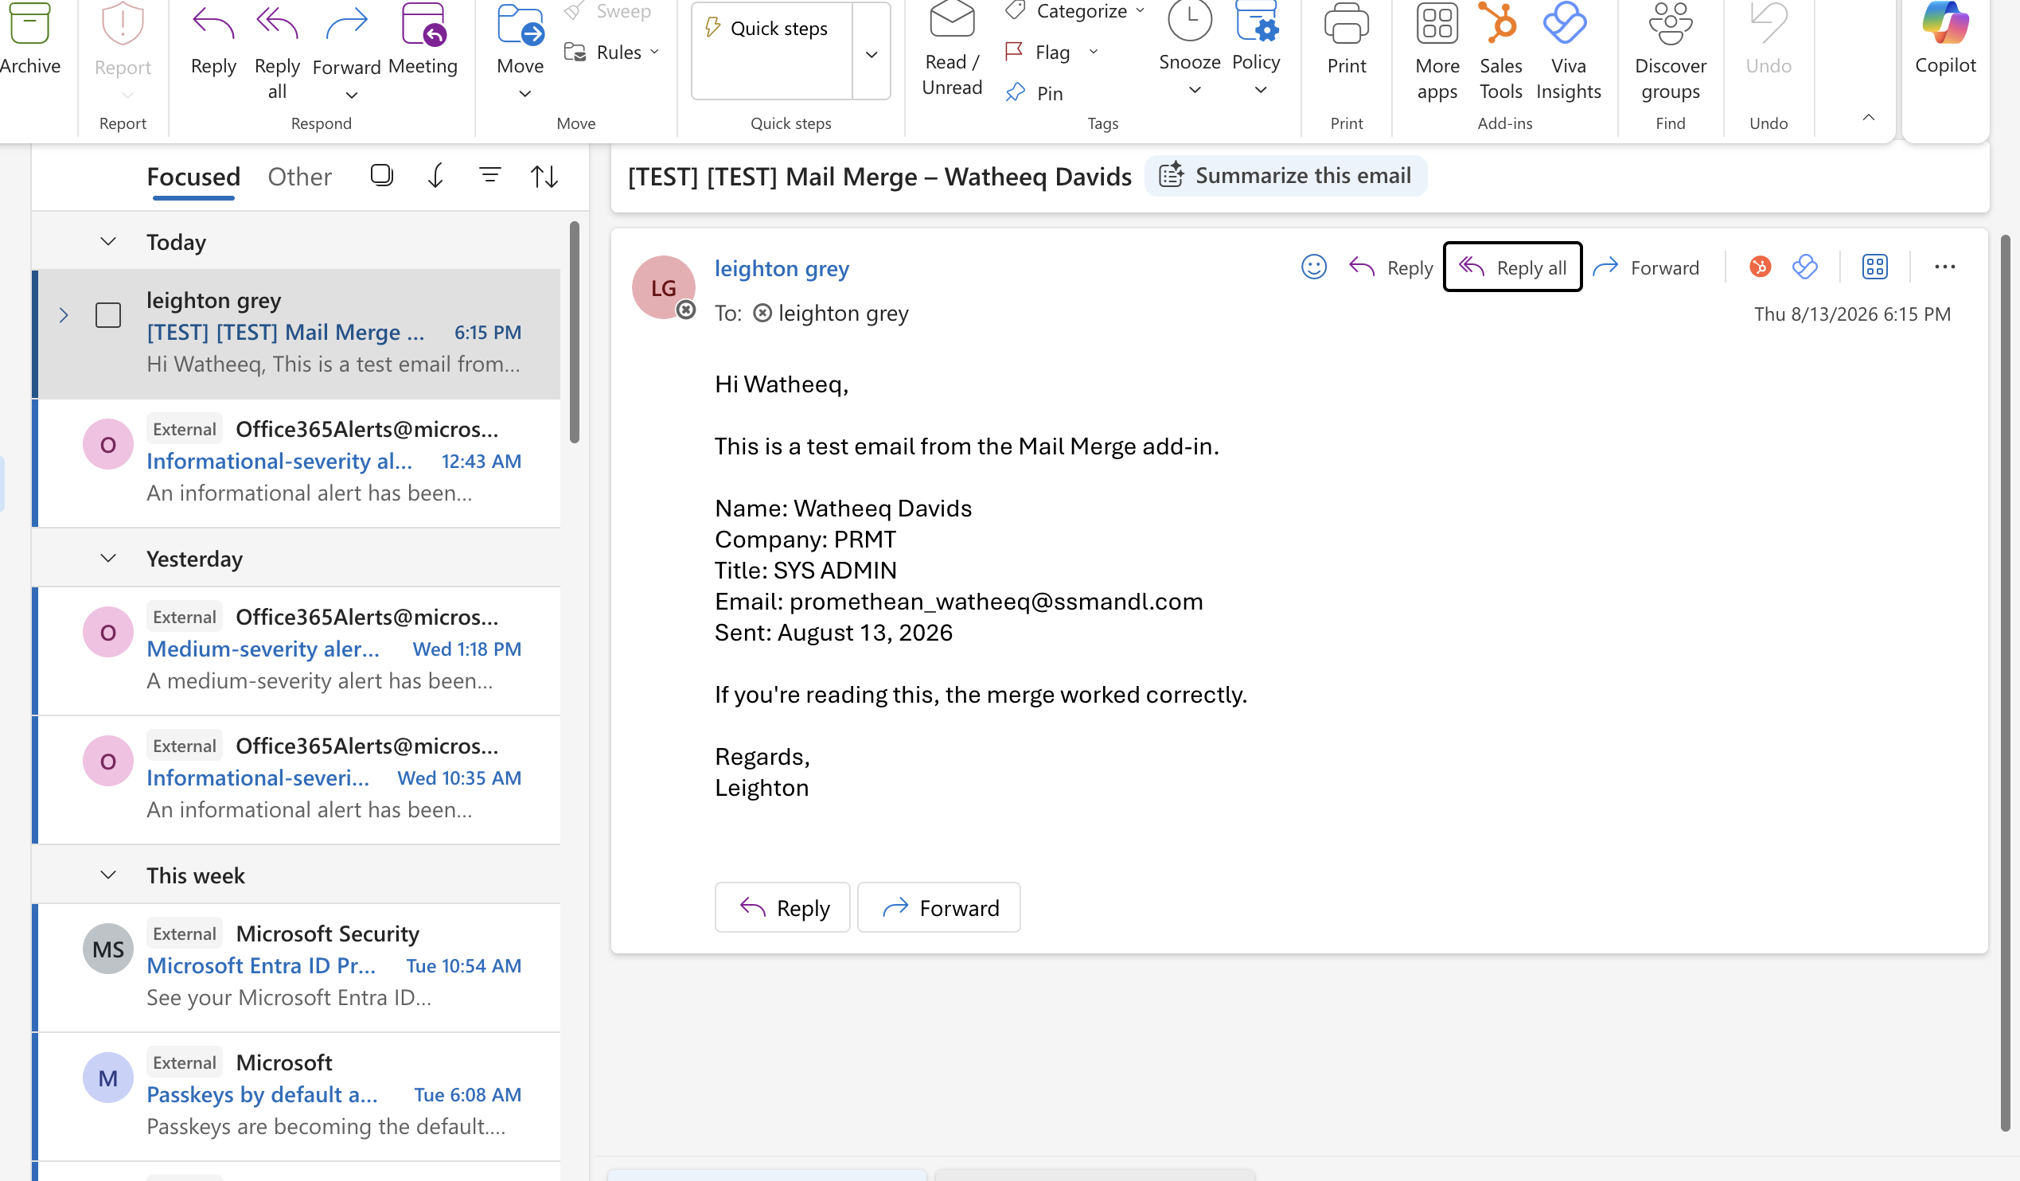
A successfully sent merge email — merge fields resolved correctly in the recipient's inbox

Options Tab
The Options tab (gear icon) lets you configure advanced settings for the send:

Rate limit | Sets a delay between emails to avoid triggering spam filters (e.g. 1 email per 2 seconds). Recommended for large sends.
Schedule | Schedule the merge to send at a specific date and time.
Opt-out / unsubscribe | Automatically adds an unsubscribe link and tracks who opts out.
Suppression list | Upload a list of addresses to exclude from all future sends.

Tips & Best Practices
- Always run a Test send first to verify formatting and merge fields.
- Keep your email list clean — remove bounced or invalid addresses before uploading.
- For large sends (500+ recipients), enable rate limiting in the Options tab.
- Use the Suppression list to honour opt-outs from previous campaigns.
- Column names in your CSV are case-sensitive — {{First_Name}} and {{first_name}} are different.
- Columns with spaces in the name should still work — use {{column name}} with the exact header.
- The {{greeting_line}} smart token automatically handles "Dear First Last," for you.

Troubleshooting
Problem | Solution
"Auth error" on sign-in | Close and reopen the add-in and try again. If it persists, contact your IT administrator.
Merge fields not substituting | Check that your column header names exactly match the tags in your template (case-sensitive). Confirm the file was parsed correctly in the Recipients tab preview.
"No email column found" | Ensure your CSV/XLSX has a column named exactly email (lowercase).
Emails landing in spam | Enable rate limiting in the Options tab. Avoid spam trigger words in your subject line.
Add-in not visible in ribbon | The add-in is only available in compose mode. Open a new compose window, then look under the Options tab in the ribbon.
File upload fails | Ensure the file is a standard .csv or .xlsx format. If the file was edited online (e.g. Google Sheets), re-download as CSV or XLSX before uploading.

Support
For technical issues with the add-in, contact your IT administrator or Promethean IT support.

Mail Merge Add-in v2.4.0 · SUNSHINE SACHS · August 2026

