Grey Dental
Technical Documentation

A standards-compliant technical reference for the Grey Dental platform

Prepared following the Intellema Technical Documentation Standard
Version 1.1 · October 2026 · Internal
Table of Contents
Grey Dental — Technical Documentation 4
1. Project Overview 4
2. System Architecture 4
2.1 Architecture Diagrams 4
3. Technology Stack 7
4. Repository Structure 7
5. Configuration 7
6. Shared Infrastructure 8
Core types (src/lib/supabase/types.ts) 8
Shared utilities (src/lib/) 9
7. Core Component 9
8. Components 9
Component: Middleware / session guard 9
Component: Auth pages 10
Component: Checkout 10
Component: Stripe webhook 10
Component: Student dashboard 11
Component: Lecture video 11
Component: Take assessment 12
Component: Admin dashboard 12
Component: Data access layer 12
Component: Database schema 13
Component: Verification scripts 13
Component: E2E tests 13
9. Data Layer 13
Entity relationships 14
10. Frontend / Entry Points 14
11. Logging & Artifacts 14
12. Data Flow 15
13. Remaining Work 15
14. Known Limitations 16
15. Getting Started 16

Grey Dental — Technical Documentation

1. Project Overview
Grey Dental is a continuing-education and community platform for dental professionals. It is a marketing site plus two role-based dashboards: students enroll in courses, register for workshops, take assessments, and download resources; admins manage learners, courses, workshops, resources, certificates, and analytics.
What it is:
• A Next.js App Router web application served on Vercel (production: https://grey-coral.vercel.app).
• A Supabase-hosted backend (Postgres + Auth + Row Level Security).
• A Stripe-integrated checkout that currently runs in a demo mode until real keys are supplied.
What it is not:
• A native mobile app.
• A live payments system (Stripe keys are placeholders today).
• A complete LMS: no video hosting, grading workflow, or progress tracking beyond an integer percentage.

2. System Architecture
The system is a single Next.js 16 application. Browsers talk to:
1. Next.js pages/components (React 19, server + client components).
2. Supabase directly from the browser for auth (sign-up, login, OAuth).
3. Next.js API routes (/api/*) for all data mutations/reads that need server-side secrets; these call Supabase with the user's session cookies.
4. Stripe via /api/checkout and /api/webhooks/stripe when real keys are configured.
Main workflows:
• Sign up / log in: email+password or Google OAuth via Supabase Auth → middleware refreshes the session cookie → redirect to /student-dashboard.
• Purchase: /checkout?course=<slug> → POST /api/checkout → in demo mode, orders.ts creates the order and enrollment directly; with live keys, Stripe Checkout Session → webhook checkout.session.completed → enrollment.
• Content access: student dashboard pages call /api/courses, /api/workshops, /api/resources and render seeded data.
• Assessment: student opens /student-dashboard/assessments/[id] → MCQ questions loaded from Supabase → on submit, score stored; leaving the tab auto-scores 0 (anti-cheat).

2.1 Architecture Diagrams
The four diagrams below show the system at the context, request, purchase, and data-model levels. They are generated from scripts/build-docs.py, so rerun that script after a structural change instead of editing the PNG files.
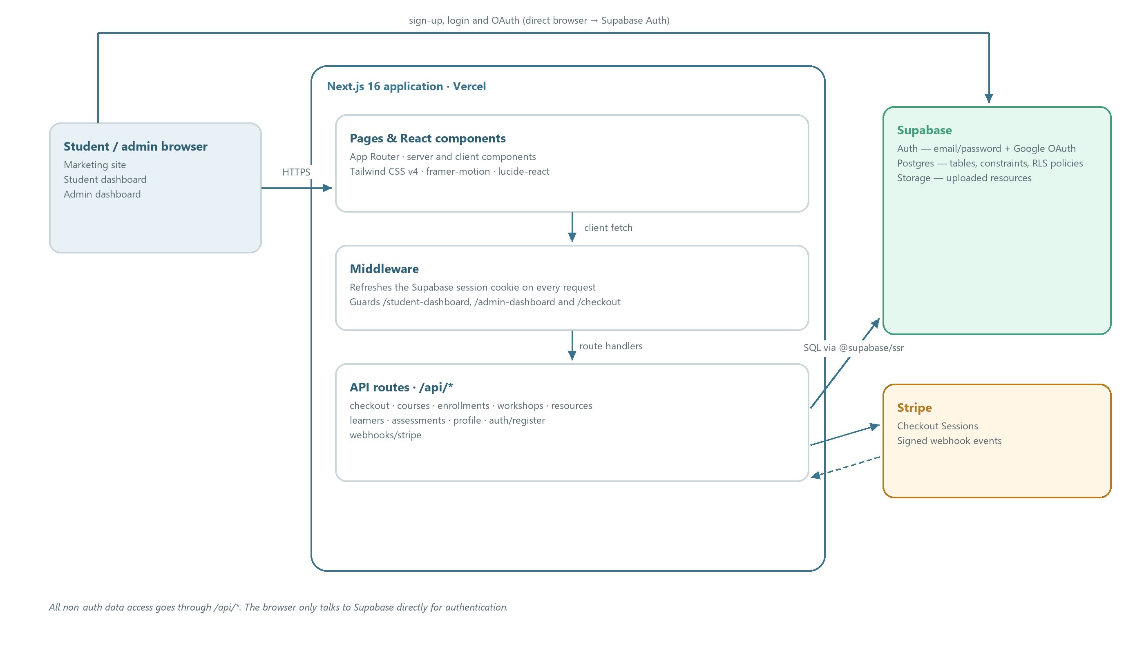
Figure 1 — System context: browser, Next.js, Supabase and Stripe
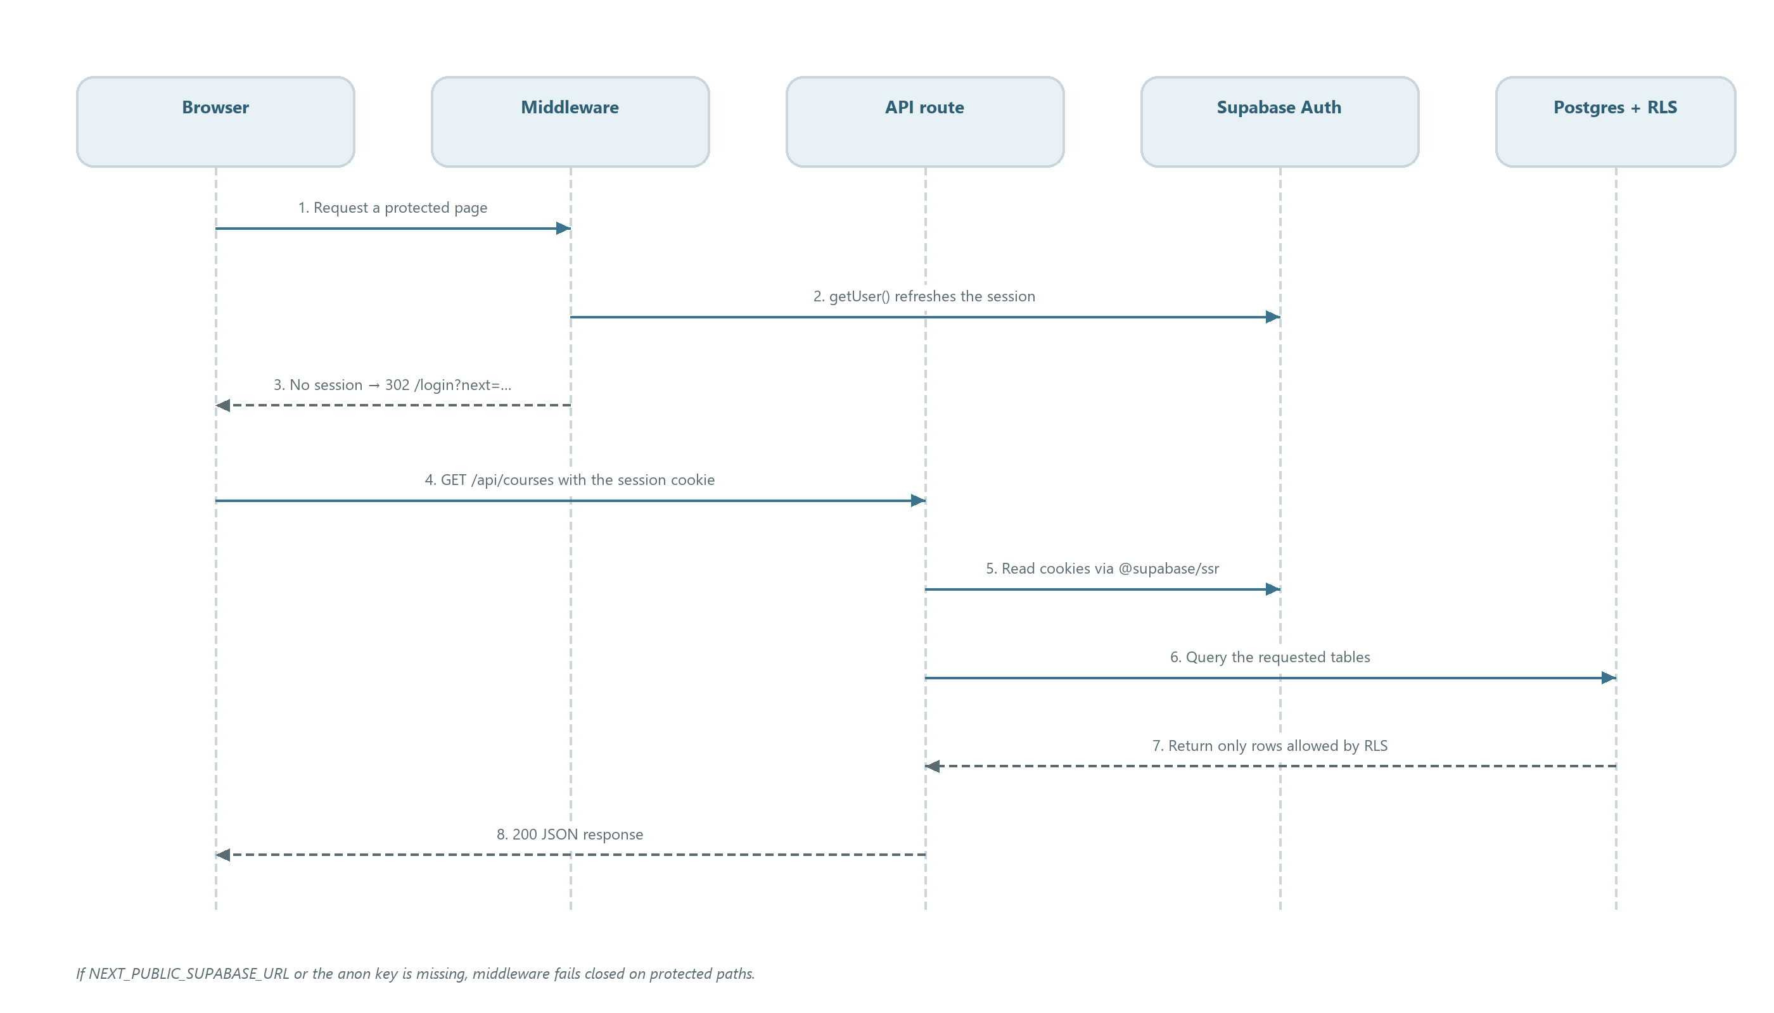
Figure 2 — Request and authentication lifecycle
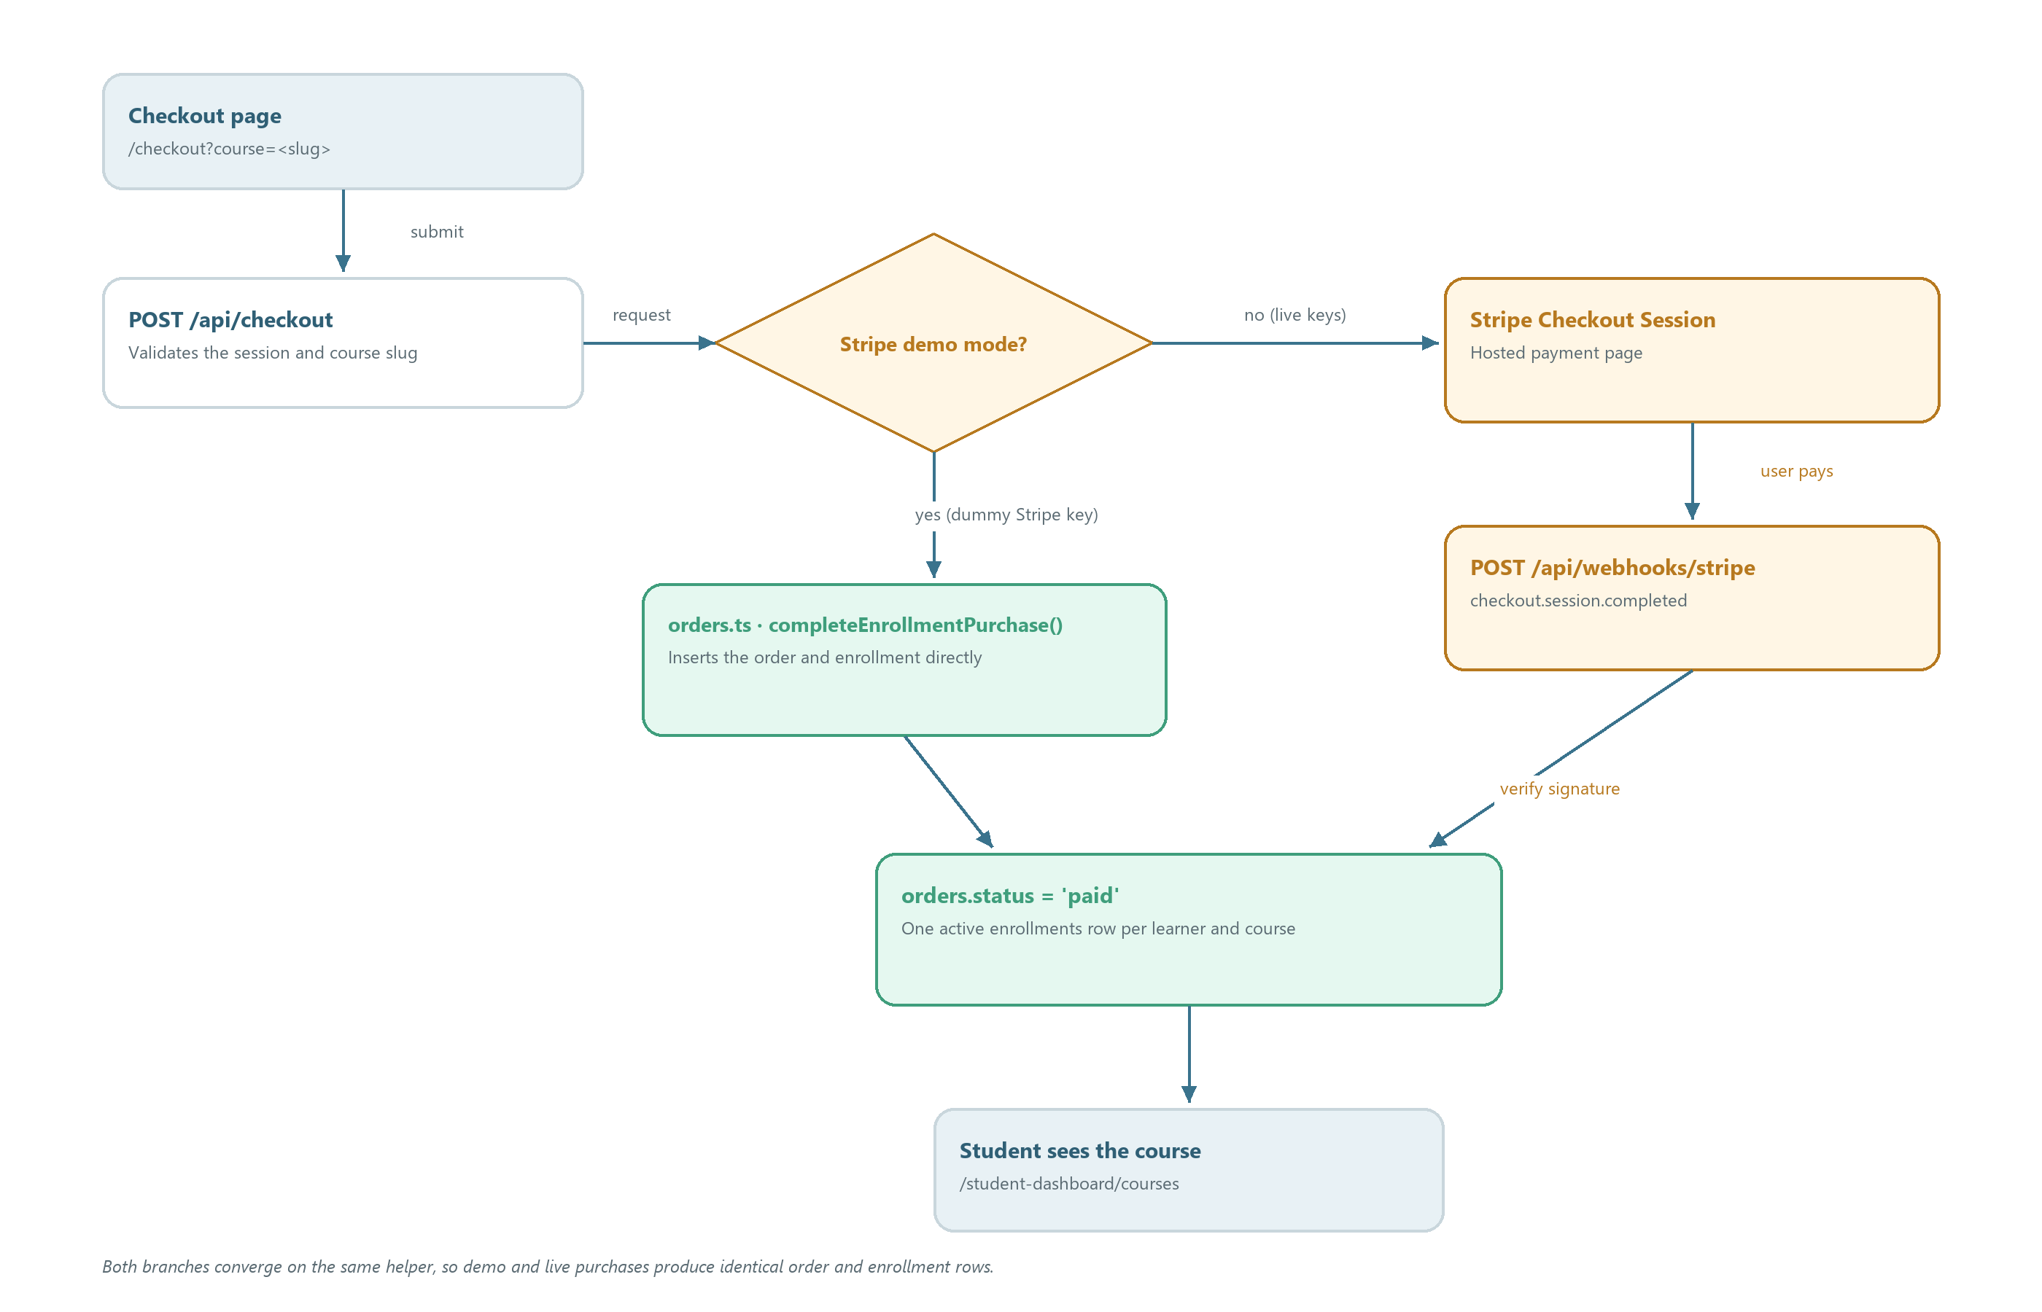
Figure 3 — Purchase and enrollment flow, demo and live Stripe
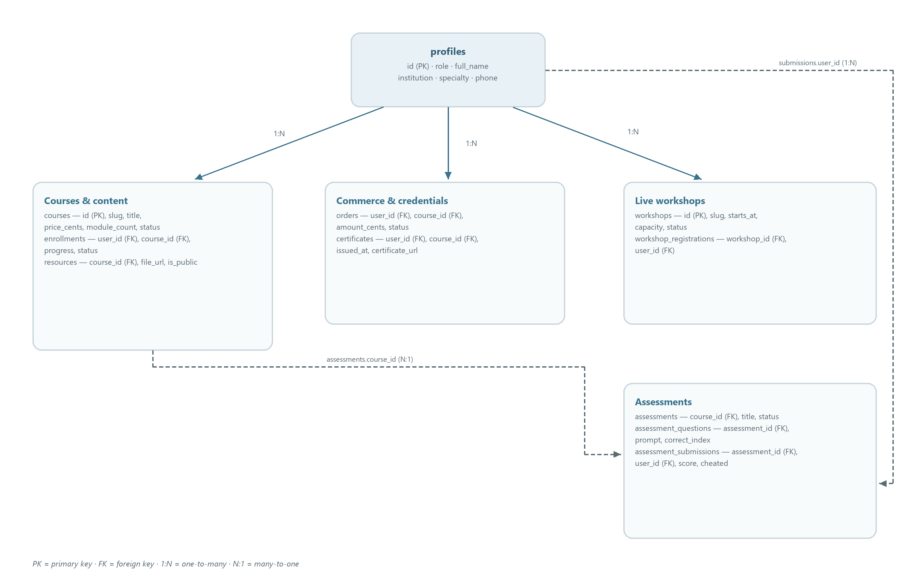
Figure 4 — Data model by domain

3. Technology Stack
Technology | Why it is used
Next.js 16 (App Router, Turbopack) | Routing, server/client rendering, API routes, deployment target on Vercel
React 19 | UI component model
TypeScript | Static typing across app, lib, and tests
Tailwind CSS v4 | Styling (via @tailwindcss/postcss)
Supabase (@supabase/ssr, @supabase/supabase-js) | Postgres database, auth, RLS, storage
Stripe (stripe SDK) | Checkout sessions and webhooks (demo mode until keys are real)
framer-motion | Animations on landing pages
lucide-react | Icons
Playwright | End-to-end browser tests
Vitest | Unit tests for pure logic in src/lib/
HTML5 <video> | Lecture playback from public/videos/; no third-party hosting or DRM
ESLint + eslint-config-next | Linting
pg | Direct Postgres access used by setup scripts
Python (python-docx, Pillow) | Generates the architecture diagrams and the Word document

4. Repository Structure
Greydental/
├── src/
│ ├── app/ # App Router pages and API routes
│ │ ├── api/ # Route handlers (checkout, courses, …)
│ │ ├── admin-dashboard/ # Admin pages
│ │ ├── student-dashboard/ # Student pages
│ │ ├── auth/callback/ # OAuth/email callback handler
│ │ └── … # Marketing pages (about, courses, …)
│ ├── components/ # All React UI components (one per file)
│ ├── hooks/ # useCurrentUser
│ ├── lib/ # Server/client utilities (see Section 6)
│ └── middleware.ts # Session refresh + route protection
├── supabase/ # SQL schemas and seed data
├── scripts/ # Node scripts + build-docs.py
├── e2e/ # Playwright specs and global setup
├── public/ # Static assets
│ └── videos/ # Lecture video (lecture.mp4)
├── docs/ # Documentation and generated diagrams
│ └── diagrams/ # PNG architecture diagrams
├── .env.example # Template for environment variables
├── USER_TODO.md # Manual Supabase/env steps (human-owned)
└── playwright.config.ts

5. Configuration
Environment variables (copy .env.example to .env.local):
Variable | Required | Description
NEXT_PUBLIC_SUPABASE_URL | Yes | Supabase project URL (no /rest/v1 suffix)
NEXT_PUBLIC_SUPABASE_ANON_KEY | Yes | Supabase anon public key
SUPABASE_SERVICE_ROLE_KEY | For webhooks/E2E | Service role key; enables confirmed-user registration, Stripe webhooks, E2E provisioning
STRIPE_SECRET_KEY | No (demo if dummy) | Stripe secret key; *_dummy triggers demo mode
NEXT_PUBLIC_STRIPE_PUBLISHABLE_KEY | No | Stripe publishable key
STRIPE_WEBHOOK_SECRET | For live webhooks | Signing secret for /api/webhooks/stripe
E2E_BASE_URL | No | Playwright target (defaults to production URL)
E2E_STUDENT_EMAIL / E2E_STUDENT_PASSWORD | For auth E2E | Student test account
E2E_ADMIN_EMAIL / E2E_ADMIN_PASSWORD | For auth E2E | Admin test account

next.config.ts only pins the Turbopack root to process.cwd(). tsconfig.json uses @/* → ./src/* path aliasing.

6. Shared Infrastructure

Core types (src/lib/supabase/types.ts)
Field | Type | Description
UserRole | `"student" \ | "instructor" \ | "admin"` | Role enum on profiles
Profile | object | id, full_name, role, institution, specialty, license_number, avatar_url, phone, timestamps
Course | object | slug, title, subtitle, instructor_name, image_url, module_count, price_cents, status
Enrollment | object | user_id, course_id, progress (0–100), status
Workshop | object | slug, title, location, starts_at, ends_at, capacity, plus WorkshopWithMeta adds registered_count, registered_by_me
Resource | object | title, file_url, resource_type, category, is_public
Order / Assessment / Certificate … | objects | See schema_lms_v2.sql

Shared utilities (src/lib/)
• supabase/client.ts — browser Supabase client; throws if env is missing.
• supabase/server.ts — server client bound to Next.js cookies.
• supabase/middleware.ts — session refresh + redirects unauthenticated users away from /student-dashboard, /admin-dashboard, /checkout.
• stripe.ts — isStripeDemoMode() / getStripe() guard.
• money.ts — formatUsd(cents).
• orders.ts — completeEnrollmentPurchase used by checkout and webhook.
• courses.ts, workshops.ts, resources.ts, learners.ts, assessments.ts — data access helpers for API routes.
• auth-errors.ts, auth-navigation.ts — shared auth helpers.

7. Core Component
The core of the system is the request path through middleware → Supabase session → API routes → RLS-protected tables. Middleware refreshes the auth cookie on every request, guards protected paths, and all mutations funnel through /api/* handlers that rely on Row Level Security policies defined in the SQL files under supabase/. If Supabase env vars are missing, middleware refuses access to protected paths (fail-closed).

8. Components

Component: Middleware / session guard
• Location: src/middleware.ts, src/lib/supabase/middleware.ts
• Role: Intercepts all non-static requests; refreshes Supabase auth cookies; redirects anonymous users from protected paths to /login?next=….
• Inputs:
Field | Type | Description
request | NextRequest | Incoming request with cookies
env | strings | NEXT_PUBLIC_SUPABASE_URL, NEXT_PUBLIC_SUPABASE_ANON_KEY

• Processing:
1. Read env vars; if missing, log an error and fail closed on protected paths.
2. Create a server Supabase client bound to request cookies.
3. Call getUser() to refresh the session.
4. If no user and path is protected, redirect to /login with next param.
5. Otherwise pass through with refreshed cookies.
• Outputs: NextResponse (redirect or passthrough with Set-Cookie).
• Artifacts: None.

Component: Auth pages
• Location: src/app/login/page.tsx, src/app/signup/page.tsx, src/app/forgot-password/page.tsx, src/components/LoginPage.tsx, src/components/SignupPage.tsx, src/components/ForgotPasswordPage.tsx
• Role: Email/password and Google OAuth sign-in; password reset.
• Inputs: user credentials; next query param.
• Processing: Supabase Auth signInWithPassword / signUp / signInWithOAuth / resetPasswordForEmail; on Google, redirect through Supabase callback /auth/callback.
• Outputs: redirect to /student-dashboard or OAuth consent.
• Artifacts: Supabase auth session cookies.

Component: Checkout
• Location: src/app/checkout/page.tsx, src/components/CheckoutPage.tsx, src/app/api/checkout/route.ts, src/app/api/checkout/session/route.ts, src/components/PaymentSuccess.tsx
• Role: Create an order for a course and grant enrollment.
• Inputs:
Field | Type | Description
course | string | Course slug from query string
user | session | Must be signed in

• Processing:
1. POST /api/checkout validates session and course.
2. If Stripe is in demo mode, completeEnrollmentPurchase inserts order + enrollment directly.
3. Otherwise create a Stripe Checkout Session and return its URL.
4. On success page or webhook, mark order paid and upsert enrollment.
• Outputs: { url } or purchase confirmation.
• Artifacts: orders and enrollments rows in Postgres.

Component: Stripe webhook
• Location: src/app/api/webhooks/stripe/route.ts
• Role: Finalize purchases when Stripe reports checkout.session.completed.
• Inputs: raw body, stripe-signature header, STRIPE_WEBHOOK_SECRET.
• Processing:
1. If demo mode, return { demo: true }.
2. Verify signature; reject on failure.
3. On checkout.session.completed, read userId/courseId metadata.
4. Call completeEnrollmentPurchase with the service role key.
• Outputs: JSON acknowledgement.
• Artifacts: orders.status = 'paid', enrollment row.

Component: Student dashboard
• Location: src/app/student-dashboard/**, src/components/Student*.tsx, src/components/StudentDashboardShell.tsx
• Role: Course list, progress, assessments, assignments, certificates, workshops, resources, profile, settings, community, help.
• Inputs: session user; API responses.
• Processing: fetch via /api/courses, /api/enrollments, /api/workshops, /api/resources; render tables/cards; useCurrentUser hook supplies the signed-in profile.
• Outputs: UI pages.
• Artifacts: React Query-style fetch state only; all persistence via Supabase.

Component: Lecture video
• Location: src/components/LectureVideo.tsx, src/lib/video.ts, public/videos/lecture.mp4
• Role: Plays the lecture recording inline on the course detail page and gives the student and admin dashboards a link to the same recording. It exists so every lecture surface has one source of truth instead of hard-coded URLs.
• Inputs:
Field | Type | Description
src | string (optional) | Video URL; defaults to LECTURE_VIDEO_SRC (/videos/lecture.mp4)
poster | string (optional) | Preview image shown before playback; defaults to the course hero image
title | string (optional) | Accessible name used in the play button label and the <video> element
className | string (optional) | Tailwind sizing classes supplied by the parent layout
priority | boolean (optional) | Preloads the poster image on the course page

• Processing:
1. Resolve the source with lectureVideoUrl(src), which trims whitespace and falls back to /videos/lecture.mp4.
2. Render the poster image and an accessible play button.
3. On click, replace the poster with a native <video controls autoplay playsinline> element.
4. The browser streams the MP4 from the Next.js public/ directory; no server route or signed URL is involved.
• Outputs: A <video> element on the course page; href="/videos/lecture.mp4" links from the student dashboard and admin on-demand cards.
• Artifacts: None. public/videos/lecture.mp4 is a static input that must be supplied manually (see public/videos/README.md).

Component: Take assessment
• Location: src/components/TakeAssessmentPage.tsx, src/app/student-dashboard/assessments/[id]/page.tsx, src/app/api/assessments/route.ts, src/app/api/assessments/[id]/route.ts
• Role: Run MCQ assessments with anti-cheat.
• Inputs: assessment id; question bank from Supabase.
• Processing: load questions → render one at a time → on submit upsert assessment_submissions → leaving/hiding the tab records score 0 and sets the cheat flag.
• Outputs: score page / submission row.
• Artifacts: assessment_submissions row, cheat flag column.

Component: Admin dashboard
• Location: src/app/admin-dashboard/**, src/components/Admin*.tsx
• Role: Manage learners, courses, workshops (edit), resources (upload/edit), certificates, assessments, analytics.
• Inputs: requests authenticated as role = 'admin' (enforced by RLS and UI shell).
• Processing: tables/forms hitting /api/learners, /api/courses, /api/workshops, /api/resources, /api/assessments.
• Outputs: CRUD updates in Supabase.
• Artifacts: Audio/video/files referenced from resources.file_url (storage links).

Component: Data access layer
• Location: src/lib/courses.ts, workshops.ts, resources.ts, learners.ts, assessments.ts, orders.ts
• Role: Single place where API routes read/write Supabase.
• Inputs: Supabase client + validated params.
• Processing: typed queries against tables defined in supabase/*.sql.
• Outputs: typed rows/inserts.
• Artifacts: None directly.

Component: Database schema
• Location: supabase/schema.sql, schema_lms.sql, schema_lms_v2.sql, schema_checkout.sql, schema_rls_fixes.sql, schema_assessments_mcq.sql, seed_content.sql
• Role: Define tables, policies, and seed content.
• Inputs: run manually in Supabase SQL Editor in the order listed in USER_TODO.md.
• Processing: creates tables: profiles, courses, enrollments, workshops, workshop_registrations, resources, orders, assessments, assessment_questions, assessment_submissions, certificate_templates, certificates.
• Outputs: schema + RLS policies + seed rows.
• Artifacts: Database objects in the Supabase project.

Component: Verification scripts
• Location: scripts/verify-backend.mjs, check-keys.mjs, apply-supabase-setup.mjs, provision-e2e-user.mjs
• Role: Backend health checks, env key validation, schema application, E2E user provisioning.
• Inputs: .env.local values (service role key for some).
• Processing: hit Supabase REST endpoints and report pass/fail.
• Outputs: console report; exit codes.
• Artifacts: none.

Component: E2E tests
• Location: e2e/smoke.spec.ts, e2e/global-setup.ts, playwright.config.ts
• Role: Browser-level smoke tests against a deployed or local instance.
• Inputs: E2E_BASE_URL, optional E2E_* credentials.
• Processing: launch Chromium, visit public pages, optionally log in as student/admin.
• Outputs: Playwright report in test-results/.
• Artifacts: test-results/ output directory.

9. Data Layer
• Source of truth: Supabase Postgres, project referenced by NEXT_PUBLIC_SUPABASE_URL.
• Format: Postgres rows typed in src/lib/supabase/types.ts.
• Access: browser (auth only), Next.js server via @supabase/ssr with RLS; scripts via pg / service role.
• Tables: see Section 6 type list; relationships: enrollments.user_id → profiles.id, enrollments.course_id → courses.id, orders.user_id → profiles.id, workshop_registrations join table, assessments → courses, certificates → enrollments/profiles.
• RLS: students read their own rows; admins can list learners (added in schema_rls_fixes.sql).

Entity relationships
Figure 4 in Section 2.1 groups the tables by domain. The foreign keys are:
Parent | Child | Foreign key | Cardinality
profiles | enrollments | user_id | 1:N
courses | enrollments | course_id | 1:N
profiles | orders | user_id | 1:N
courses | orders | course_id | 1:N
courses | resources | course_id | 1:N (nullable)
profiles | workshop_registrations | user_id | 1:N
workshops | workshop_registrations | workshop_id | 1:N
courses | assessments | course_id | 1:N
assessments | assessment_questions | assessment_id | 1:N
assessments | assessment_submissions | assessment_id | 1:N
profiles | assessment_submissions | user_id | 1:N
profiles | certificates | user_id | 1:N
courses | certificates | course_id | 1:N

10. Frontend / Entry Points
How to run the system, in order:
1. npm install
2. Copy .env.example to .env.local and fill in Supabase values.
3. Run the SQL files in supabase/ in order (see USER_TODO.md).
4. npm run dev and open http://localhost:3000.
5. npm run build / npm start for a production build.
6. npm run lint for linting.
7. npm run test:backend to verify Supabase connectivity.
8. npm run test:unit for Vitest unit tests.
9. npm run test:e2e for Playwright browser tests (E2E_BASE_URL controls the target).
10. npm run setup:supabase and npm run test:e2e:provision are helper scripts for schema setup and test-user provisioning.
Key entry files:
• src/app/layout.tsx — root layout, fonts (Inter), metadata.
• src/app/page.tsx — landing page.
• src/middleware.ts — request interception.

11. Logging & Artifacts
Artifact | Location | Retention
Playwright traces/screenshots | test-results/ | Until next run overwrites or manual cleanup
Build output | .next/ | Regenerated per build
tsconfig.tsbuildinfo | repo root | Incremental compiler cache
Server logs | Vercel function logs / local stdout | Per platform retention
Uploaded files | External storage (resources.file_url) | Managed in Supabase storage
Architecture diagrams | docs/diagrams/*.png | Committed; regenerated by scripts/build-docs.py
Word documentation | docs/Grey_Dental_Technical_Documentation.docx | Committed; regenerated from the Markdown
Lecture video | public/videos/lecture.mp4 | Supplied manually and served as a static asset

Nothing is written to disk by API routes themselves.

12. Data Flow
1. Auth flow: browser → Supabase Auth → session cookie → middleware refreshes → useCurrentUser reads profile from profiles.
2. Catalog read: student dashboard page → GET /api/courses → courses.ts queries courses table → React renders cards (CoursesListing, CourseDetailLanding).
3. Purchase flow: /checkout → POST /api/checkout → (demo) completeEnrollmentPurchase inserts orders + enrollments → student sees enrollment at /student-dashboard/courses; (live) Stripe session → webhook → same function.
4. Assessment flow: /student-dashboard/assessments/[id] → GET assessment + questions → submit → POST result → assessment_submissions row; tab-hide event sets score 0 + cheat flag.
5. Admin flow: admin pages → /api/learners, /api/resources POST, etc. → RLS checks role='admin' → table updates.
6. Lecture playback: course detail page or dashboard link → Next.js static file handler → public/videos/lecture.mp4 → native HTML5 player. No API route is involved.

13. Remaining Work
• Real Stripe keys are not configured; checkout runs in demo mode and the webhook ignores events until STRIPE_SECRET_KEY and STRIPE_WEBHOOK_SECRET are real.
• "Confirm email" in Supabase is recommended off during development; must be re-enabled for production.
• Google OAuth client must be created in Google Cloud Console and added to Supabase before the Google button works.
• E2E credentials (E2E_*) are blank; authenticated dashboard tests only run once accounts exist or SUPABASE_SERVICE_ROLE_KEY provisioning is run.
• Certificate generation templates exist (certificate_templates) but the issuance UI is minimal.
• No video upload pipeline. Every lecture surface points at one manually supplied file, public/videos/lecture.mp4; there is no per-module mapping, transcoding, or streaming service.
• The Word document and diagrams are generated by scripts/build-docs.py. Rerun it after structural changes, then run npm run docs:toc (Windows with Word installed) or update the table-of-contents field manually in Word.

14. Known Limitations
• Stripe webhook cannot be exercised until real keys + deployed webhook URL (/api/webhooks/stripe) are configured.
• If Supabase env vars are missing in production, MIDDLEWARE_INVOCATION_FAILED-class errors can occur; middleware is designed to fail closed on protected paths but public pages degrade.
• Assessment anti-cheat (tab-hide = score 0) is client-enforced and can be bypassed.
• Courses are currently a single catalog (endodontics-remote demo data); multi-course purchasing is untested.
• The app is deployed at a hardcoded Vercel URL (grey-coral.vercel.app) in defaults and USER_TODO.md; changing the domain requires updating Site URL/redirects in Supabase.
• .env.local is present in the working tree; ensure it is never committed (covered by .gitignore — verify before publishing).
• All lecture links share the single file /videos/lecture.mp4. Courses and modules cannot select different recordings yet.
• The generated Word file contains a Word field for the table of contents; run npm run docs:toc (Windows + Word) after regenerating, or update the field manually, to populate the page numbers.

15. Getting Started
Goal: a new developer installs and runs the system on their own.
1. Prerequisites: Node.js 20+, npm, a Supabase project, (optional) a Stripe account.
2. git clone the repo; cd Greydental; npm install.
3. cp .env.example .env.local; fill in NEXT_PUBLIC_SUPABASE_URL and NEXT_PUBLIC_SUPABASE_ANON_KEY.
4. In the Supabase SQL Editor, run the files from supabase/ in the order given in USER_TODO.md.
5. In Supabase Auth, disable "Confirm email" for local development.
6. Set your account's profiles.role = 'admin' if you need admin access.
7. npm run dev → open http://localhost:3000 → create an account → visit /student-dashboard.
8. Put the lecture recording at public/videos/lecture.mp4 (see public/videos/README.md).
9. Verify: npm run test:backend, npm run lint, npm run test:unit, npm run test:e2e.
10. Optional: python scripts/build-docs.py regenerates docs/diagrams/*.png and the Word document.
Unit tests (Vitest) cover the pure helpers in src/lib/: currency formatting, auth error mapping, assessment scoring, and lecture video URL resolution.
Read the source in this order to learn the system:
1. src/middleware.ts and src/lib/supabase/middleware.ts — how requests are guarded.
2. src/lib/supabase/types.ts — the data model.
3. supabase/schema_lms_v2.sql — tables and policies.
4. src/app/api/checkout/route.ts + src/lib/orders.ts — purchase/enrollment path.
5. src/app/api/courses/route.ts + src/lib/courses.ts — a representative read endpoint.
6. src/components/CheckoutPage.tsx and src/app/checkout/page.tsx — page wiring.
7. src/app/admin-dashboard/page.tsx + src/components/AdminDashboard.tsx — admin surface.
8. src/components/TakeAssessmentPage.tsx — assessment + anti-cheat logic.
9. src/components/LectureVideo.tsx + src/lib/video.ts — lecture playback wiring.
10. e2e/smoke.spec.ts — what is considered working.
11. USER_TODO.md — operational checklist.

