1、数据实体关系图

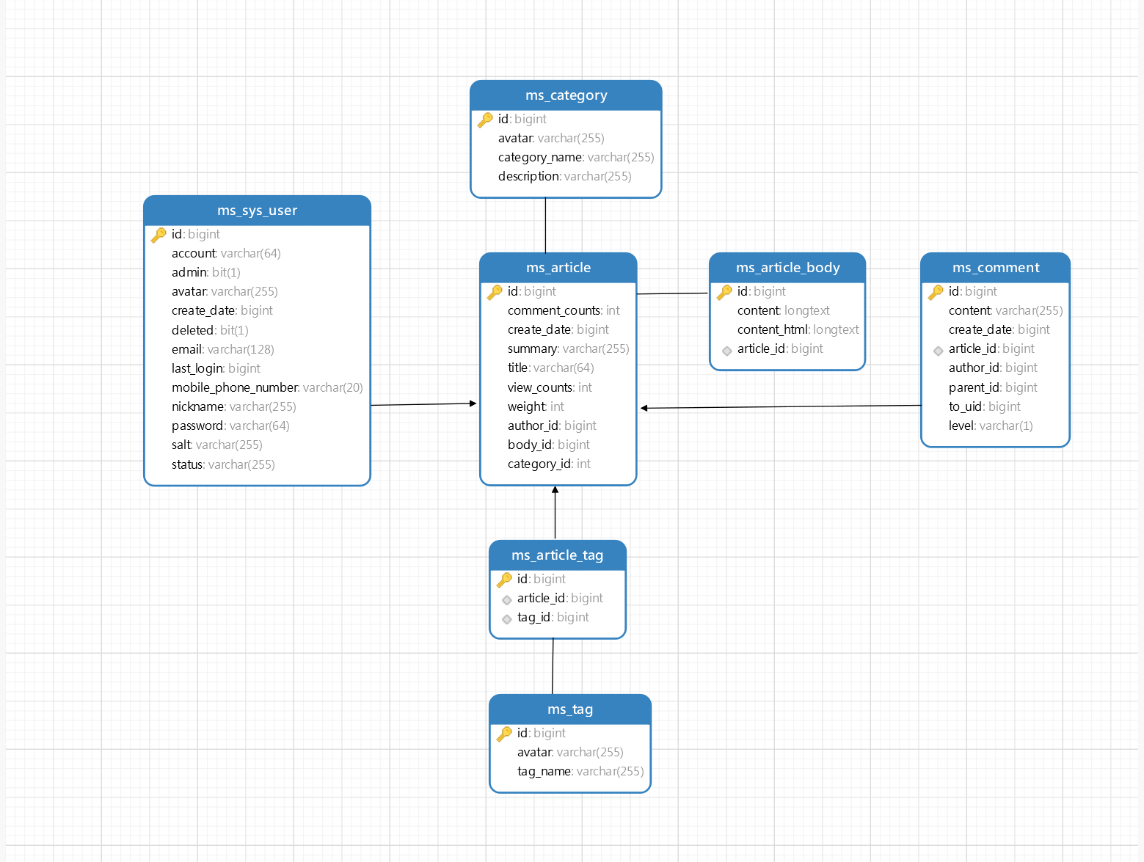

1. 数据库表结构设计

|  |  |  |  |  |  |  |
| --- | --- | --- | --- | --- | --- | --- |
| 用户表(ms_sys_user) | | | | | | |
| 字段名 | | 类型 | 字段解释 | | 主键、索引 | |
| id | | bigint | Id | | 主键 | |
| account | | varchar(64) | 账号 | |  | |
| admin | | bit(1) | 是否管理员 | |  | |
| avater | | varchar(255) | 头像 | |  | |
| create_date | | bigint | 注册时间 | |  | |
| deleted | | bit(1) | 是否删除 | |  | |
| email | varchar(128) | | 邮箱 |  | |
| last_login | bigint | | 最后登录时间 |  | |
| mobile_phone_number | varchar(20) | | 手机号 |  | |
| nickname | varchar(255) | | 昵称 |  | |
| password | varchar(64) | | 密码 |  | |
| salt | varchar(255) | | 加密盐 |  | |
| status | varchar(255) | | 状态 |  | |

|  |  |  |  |
| --- | --- | --- | --- |
| 文章表(ms_article) | | | |
| 字段名 | 类型 | 字段解释 | 主键、索引 |
| id | bigint | Id | 主键 |
| Comment_counts | int | 评论数量 |  |
| create_date | bigint | 创建时间 |  |
| summary | Varchar(255) | 简介 |  |
| title | Varchar(64) | 标题 |  |
| view_counts | int | 浏览数量 |  |
| weight | int | 是否置顶 |  |
| author_id | bigint | 作者id |  |
| body_id | bigint | 内容id |  |
| Category_id | int | 类别id |  |

|  |  |  |  |
| --- | --- | --- | --- |
| 类别表(ms_category) | | | |
| 字段名 | 类型 | 字段解释 | 主键、索引 |
| id | bigint | Id | 主键 |
| avatar | varchar(255) | 头像 |  |
| category_name | varchar(255) | 类别名 |  |
| description | Varchar(255) | 类别描述 |  |

|  |  |  |  |
| --- | --- | --- | --- |
| 标签表(ms_tag) | | | |
| 字段名 | 类型 | 字段解释 | 主键、索引 |
| id | bigint | Id | 主键 |
| avatar | varchar(255) | 头像 |  |
| tag_name | varchar(255) | 标签名 |  |

|  |  |  |  |  |  |  |
| --- | --- | --- | --- | --- | --- | --- |
| 评论表(ms_comment) | | | | | | |
| 字段名 | | 类型 | 字段解释 | | 主键、索引 | |
| id | | bigint | Id | | 主键 | |
| content | | Varchar(255) | 评论内容 | |  | |
| create_date | | bigint | 评论时间 | |  | |
| article_id | | bigint | 文章id | | 索引 | |
| author_id | | bigint | 作者id | |  | |
| parent_id | | bigint | 父评论id | |  | |
| to_uid | bigint | | 回复对象id |  | |
| level | varchar(1) | | 评论楼数 |  | |

|  |  |  |  |
| --- | --- | --- | --- |
| 文章内容表(ms_article_body) | | | |
| 字段名 | 类型 | 字段解释 | 主键、索引 |
| id | bigint | Id | 主键 |
| content | longtext | 文章内容 |  |
| Content_html | longtext | html内容 |  |
| article_id | bigint | 文章id | 索引 |

|  |  |  |  |
| --- | --- | --- | --- |
| 文章标签表(ms_article_tag) | | | |
| 字段名 | 类型 | 字段解释 | 主键、索引 |
| id | bigint | Id | 主键 |
| article_id | bigint | 文章id | 索引 |
| tag_id | bigint | 标签id | 索引 |