首先加载数据集并且进行一些数据处理，把数值型变量转换成因子型

house_price<-read.csv(file.choose())

#概览数据集，并且进行变量类型转换

summary(house_price)

class(house_price[,7])

house_price[,7]<-as.factor(house_price[,7])

class(house_price[,9])

house_price[,9]<-as.factor(house_price[,9])

class(house_price[,10])

house_price[,10]<-as.factor(house_price[,10])

class(house_price[,12])

house_price[,12]<-as.factor(house_price[,12])

class(house_price[,13])

house_price[,13]<-as.factor(house_price[,13])

class(house_price[,14])

house_price[,14]<-as.factor(house_price[,14])

house_price2<-house_price[,-17]

summary(house_price2)

house_price3<-house_price2[,1:14]

#设置随机种子

set.seed(5032)

#绘制拐点图

a<-(nrow(house_price3)-1)*sum(apply(house_price3,2,var))

for(i in 2:15) a[i]<-sum(kmeans(house_price3,centers=i)$withinss)

plot(1:15,a,type="b",xlab="clusters",ylab="距离平方和")

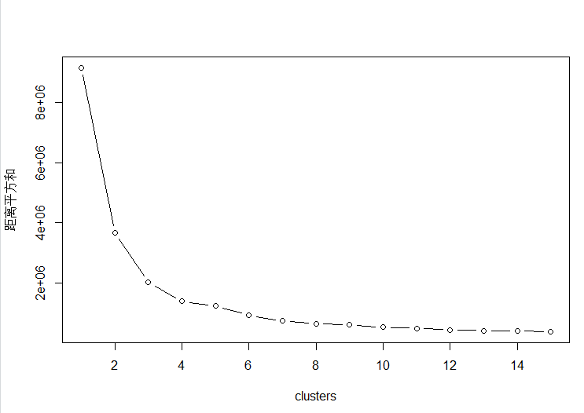

由拐点图可知，聚类时簇应选择为3，此时效果最好

#用k-means方法聚类

house_price_kmeans<-kmeans(house_price3,3)

house_price_kmeans

table(house_price$priceType,house_price_kmeans$cluster)

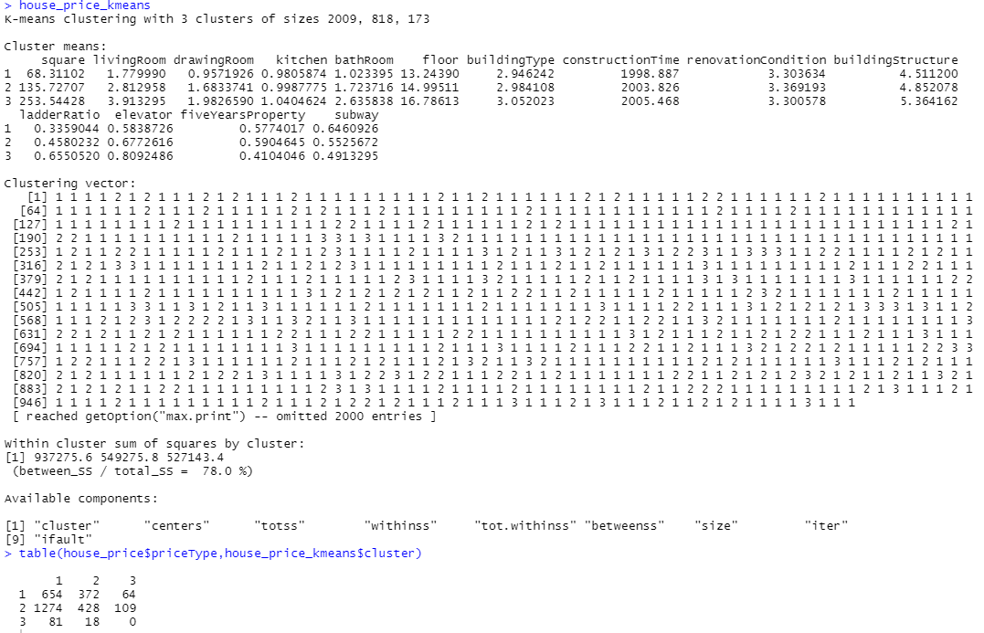

#下边我们将分类以及中心点打印出来

plot(house_price3$floor,house_price3$livingRoom,col=house_price_kmeans$cluster,pch="*")

points(house_price_kmeans$centers,pch="X",cex=1.5,col=4)

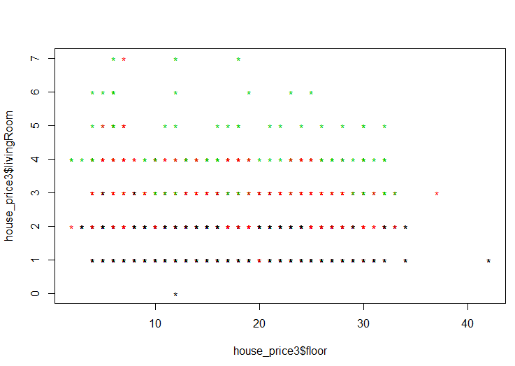

plot(house_price3$floor,house_price3$square,col=house_price_kmeans$cluster,pch="*")

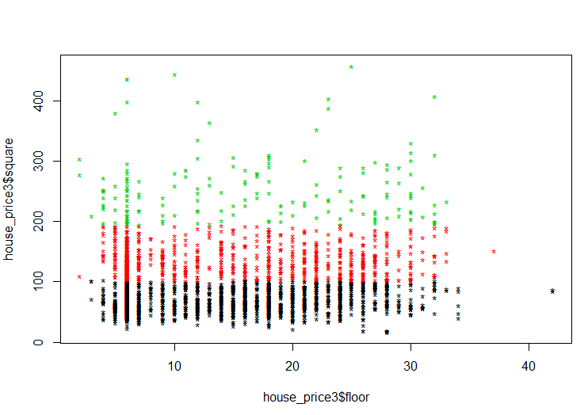

library(cluster)

set.seed(6598)

house_price.pam<-pam(house_price3,3)

house_price.pam

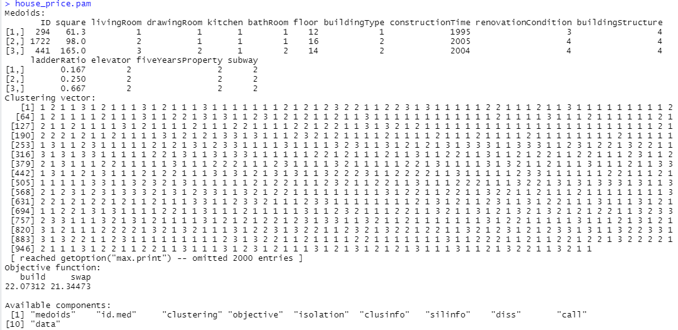

table(house_price$priceType,house_price.pam$clustering)

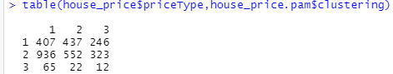

layout(matrix(c(1,2),1,2)) #每页显示两个图

plot(house_price.pam)

layout(matrix(1))

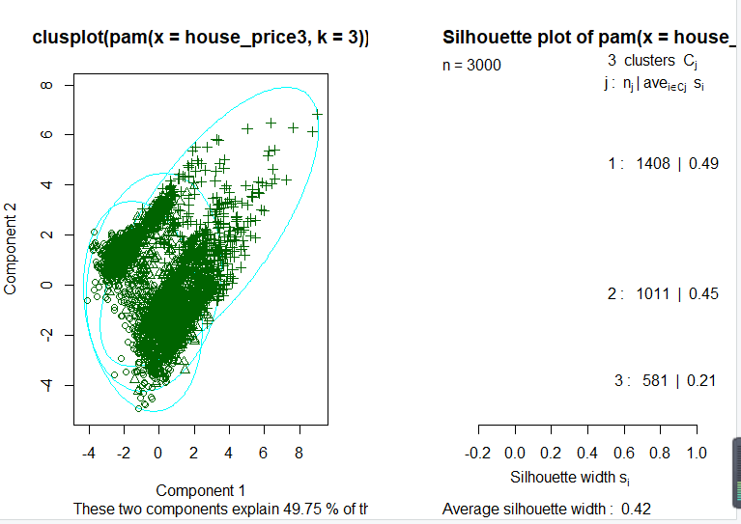

house_price.clara<-clara(house_price3,3)

house_price.clara

table(house_price$priceType,house_price.clara$clustering)

layout(matrix(c(1,2),1,2)) #每页显示两个图

plot(house_price.clara)

