Filebeat
首先filebeat是Beats中的一员。Beats在是一个轻量级日志采集器，其实Beats家族有6个成员，早期的ELK架构中使用Logstash收集、解析日志，但是Logstash对内存、cpu、io等资源消耗比较高。相比Logstash，Beats所占系统的CPU和内存几乎可以忽略不计。

Filebeat是用于转发和集中日志数据的轻量级传送工具。Filebeat监视您指定的日志文件或位置，收集日志事件，并将它们转发到Elasticsearch或 Logstash进行索引。
Filebeat的工作方式如下：启动Filebeat时，它将启动一个或多个输入，这些输入将在为日志数据指定的位置中查找。对于Filebeat所找到的每个日志，Filebeat都会启动收集器。每个收集器都读取单个日志以获取新内容，并将新日志数据发送到libbeat，libbeat将聚集事件，并将聚集的数据发送到为Filebeat配置的输出。

Kafka
数据缓冲队列。Kafka是一种高吞吐量的分布式发布订阅消息系统，它可以处理消费者在网站中的所有动作流数据。作为消息队列解耦了处理过程，提高了可扩展性。具有峰值处理能力，使用消息队列能使关键组件顶住突发的访问压力 不会超负荷而崩溃。
通过O(1)的磁盘数据结构提供消息的持久化，这种结构对于即使数以TB的消息存储也能够保持长时间的稳定性能。
高吞吐量 [2] ：即使是非常普通的硬件Kafka也可以支持每秒数百万 [2] 的消息。
支持通过Kafka服务器和消费机集群来分区消息。

Logstash
是一个用来搜集、分析、过滤日志的工具。它支持几乎任何类型的日志，包括系统日志、错误日志和自定义应用程序日志。它可以从许多来源接收日志，这些来源包括 syslog、消息传递（例如 RabbitMQ）和JMX，它能够以多种方式输出数据，包括电子邮件、websockets和Elasticsearch。

Elasticsearch
是实时全文搜索和分析引擎，提供搜集、分析、存储数据三大功能；是一套开放REST和JAVA API等结构提供高效搜索功能，可扩展的分布式系统。它构建于Apache Lucene搜索引擎库之上。

Kibana
是一个基于Web的图形界面，用于搜索、分析和可视化存储在 Elasticsearch指标中的日志数据。它利用Elasticsearch的REST接口来检索数据，不仅允许用户创建他们自己的数据的定制仪表板视图，还允许他们以特殊的方式查询和过滤数据

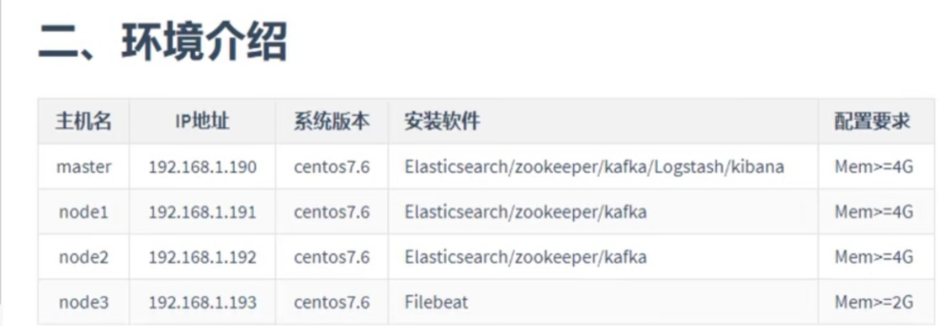
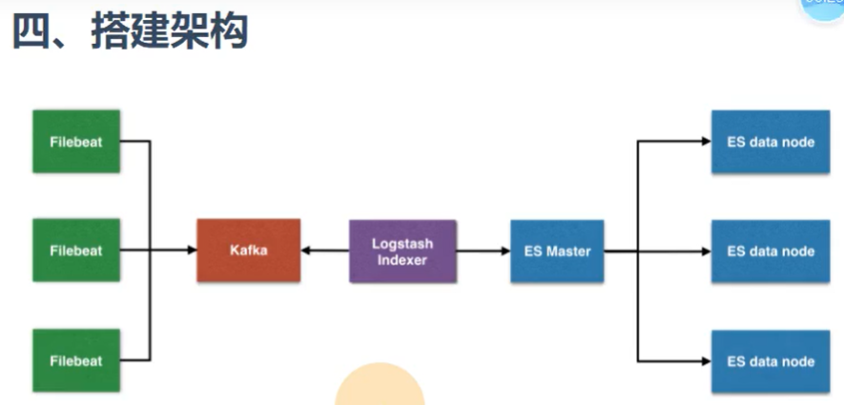

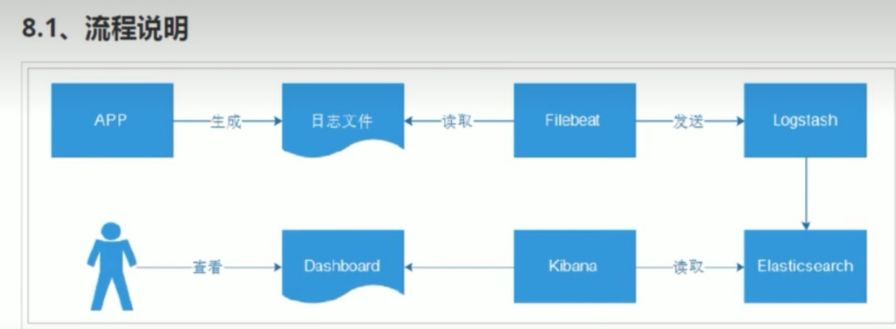
更新JAVA版本
which java
java -version
vim /etc/profile
rm -rf /app/ctgmq/jdk1.8.0_101
rm /usr/bin/java
ln -s $JAVA_HOME/bin/java /usr/bin/java
source /etc/profile
which java
java -version

ES安装
tar -xzvf /home/paasadmin/elasticsearch-7.1.1-linux-x86_64.tar.gz -C /usr/local/

cd /usr/local/elasticsearch-7.1.1/config

cp elasticsearch.yml{,.bak}

（修改master的 elasticsearch.yml）vim /usr/local/elasticsearch-7.1.1/config/elasticsearch.yml
cluster.name: paas-elk
node.name: master
node.master: true
node.data: true
path.data: /data/elasticsearch/data
path.logs: /data/elasticsearch/logs
bootstrap.memory_lock: false
bootstrap.system_call_filter: false
network.host: 0.0.0.0
http.port: 9200
discovery.zen.ping.unicast.hosts: ["10.145.210.178", "10.145.210.179"]
discovery.zen.minimum_master_nodes: 2
discovery.zen.ping_timeout: 150s
discovery.zen.fd.ping_retries: 10
client.transport.ping_timout: 60s
http.cors.enabled: true
# if master not discovered
discovery.seed_hosts: ["10.145.210.177"]
cluster.initial_master_nodes: ["10.145.210.177:9300"]
network.publish_host: 10.145.210.177

（修改slave的 elasticsearch.yml）vim /usr/local/elasticsearch-7.1.1/config/elasticsearch.yml
cluster.name: paas-elk
node.name: slave1
node.master: true
node.data: true
path.data: /data/elasticsearch/data
path.logs: /data/elasticsearch/logs
bootstrap.memory_lock: false
bootstrap.system_call_filter: false
network.host: 0.0.0.0
http.port: 9200
discovery.zen.ping.unicast.hosts: ["10.145.210.177", "10.145.210.179"]
discovery.zen.minimum_master_nodes: 2
discovery.zen.ping_timeout: 150s
discovery.zen.fd.ping_retries: 10
client.transport.ping_timeout: 60s
http.cors.enabled: true
# if master not discovered
discovery.seed_hosts: ["10.145.210.177"]
cluster.initial_master_nodes: ["10.145.210.177:9300"]
network.publish_host: 10.145.210.178

vim /usr/local/elasticsearch-7.1.1/config/jvm.options
-Xms10g
-Xmx10g

mkdir -pv /data/elasticsearch/data && mkdir -pv /data/elasticsearch/logs

chown -R logcenter:logcenter /data && chown -R logcenter:logcenter /usr/local/elasticsearch-7.1.1

ES所需的系统优化
（增加最大文件打开数、最大进程数）
vim /etc/security/limits.conf
* soft nofile 65536
* hard nofile 131072
* soft nproc 4096
* hard nproc 4096
（增加最大内存映射数）
echo vm.max_map_count=262144 >> /etc/sysctl.conf && sysctl -p
echo vm.swappiness=0 >> /etc/sysctl.conf && sysctl -p

启动ES
su - logcenter

cd /usr/local/elasticsearch-7.1.1
nohup bin/elasticsearch &

tailf nohup.out
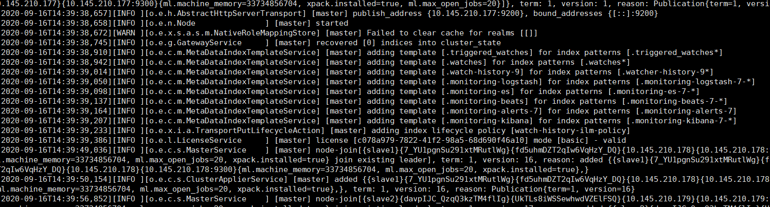
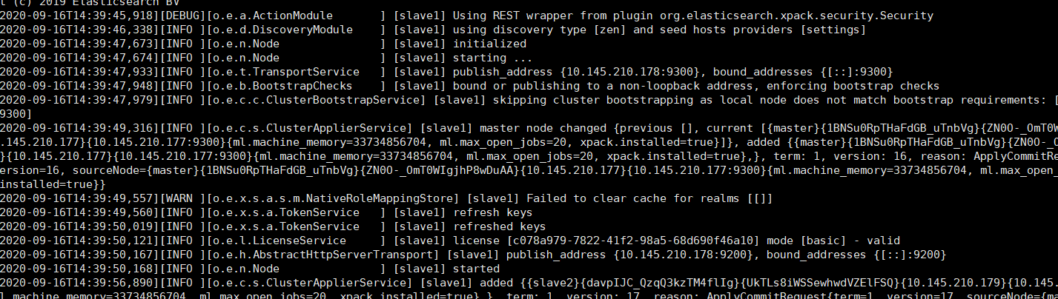
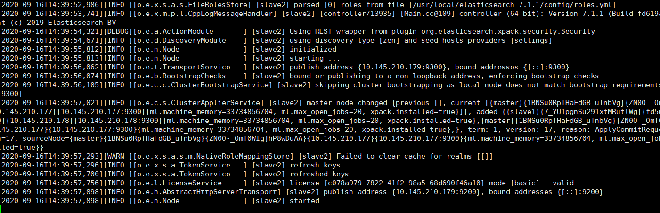
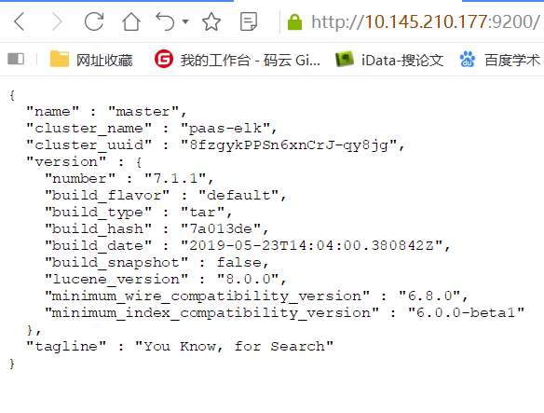

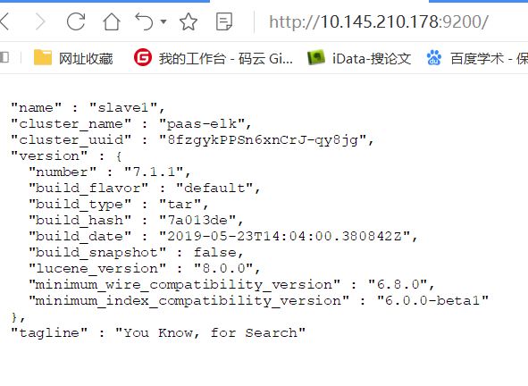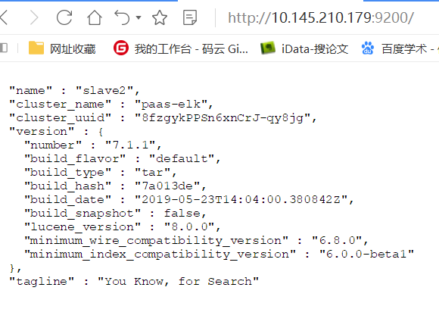

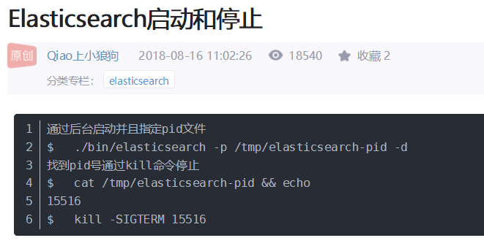

ES监控插件 head
只在master机子上安装就够了

node
tar xvf node-v14.8.0-linux-x64.tar -C /usr/local

export NODE_HOME=/usr/local/node-v14.8.0-linux-x64
export PATH=$NODE_HOME/bin:$PATH

离线安装grunt
cd /home/paasadmin/grunt-cli
cp bin/grunt /usr/local/bin
cp lib/cli.js /usr/local/lib && cp lib/completion.js /usr/local/lib && cp lib/info.js /usr/local/lib

cp -r completion/ /usr/local/completion
cp Gruntfile.js /usr/local/Gruntfile.js
cp .npmignore /usr/local/.npmignore
cp package.json /usr/local/package.json
cp .travis.yml /usr/local/travis.yml

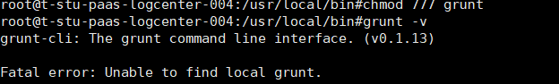

安装配置elasticsearch-head-master
cd /usr/local/elasticsearch-head-master
vim Gruntfile.js (约95行)
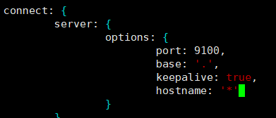

vim _site/app.js (约4374行)
localhost 改为本机IP

安装head需要的phantomjs插件
mkdir /tmp/phantomjs
cd /home/paasadmin/
cp phantomjs-2.1.1-linux-x86_64.tar.bz2 /tmp/phantomjs/

运行head
nohup grunt server &

Kibana

tar -zxvf /home/paasadmin/kibana-7.1.1-linux-x86_64.tar.gz -C /usr/local/

vim /usr/local/kibana-7.1.1-linux-x86_64/config/kibana.yml
server.port: 5601
server.host: "10.145.210.177"
kibana.index: ".kibana"
elasticsearch.hosts: ["http://10.145.210.177:9200","http://10.145.210.178:9200","http://10.145.210.179:9200"]

(启动)
cd /usr/local/kibana-7.1.1-linux-x86_64/
nohup ./bin/kibana &
tailf nohup.out
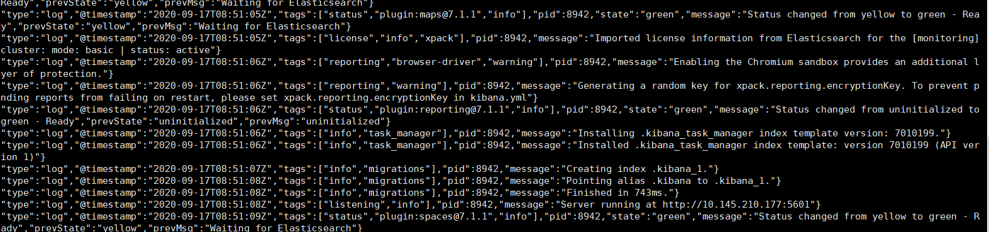

查看进程

http://10.145.210.177:5601/

( Nginx 反向代理
cd /home/paasadmin
tar -zxvf nginx-1.18.0.tar.gz -C /usr/local/
cd /usr/local/nginx-1.18.0/
./configure 提示说要装PCRE
)

Kafka
Kafka压缩包中集成了zookeeper
tar -xzvf /home/paasadmin/kafka_2.12-2.2.0.tgz -C /usr/local

cd /usr/local/kafka_2.12-2.2.0/config
vim zookeeper.properties

dataDir=/opt/data/zookeeper/data
dataLogDir=/opt/data/zookeeper/logs
clientPort=2166
tickTime=2000
initLimit=20
syncLimit=10
server.13 = 10.145.210.177:2666:3666
server.14 = 10.145.210.178:2666:3666
server.15 = 10.145.210.179:2666:3666

mkdir -p /opt/data/zookeeper/{data,logs}

echo 13 > /opt/data/zookeeper/data/myid

mv server.properties server.properties.bak && vim server.properties

broker.id = 1
listeners=PLAINTEXT://10.145.210.177:6230
num.network.threads = 18
num.io.threads = 30
socket.send.buffer.bytes = 102400
socket.receive.buffer.bytes = 102400
socket.request.max.bytes = 104857600
num.partitions = 30
num.recovery.threads.per.data.dir = 1
offsets.topic.replication.factor = 1
transaction.state.log.replication.factor = 1
transaction.state.log.min.isr = 1
log.dirs = /opt/data/kafka/logs
log.retention.hours = 72
log.segment.bytes = 1073741824
log.retention.check.interval.ms = 300000
log.flush.interval.messages = 20000
log.flush.interval.ms = 1000
zookeeper.connect = 10.145.210.177:2166,10.145.210.178:2166,10.145.210.179:2166
zookeeper.connection.timeout.ms = 6000
unclean.leader.election.enable = true
auto.create.topics.enable = true
default.replication.factor = 1

mkdir -p /opt/data/kafka/logs

（验证集群）
cd /usr/local/kafka_2.12-2.2.0
nohup bin/kafka-server-start.sh config/server.properties &
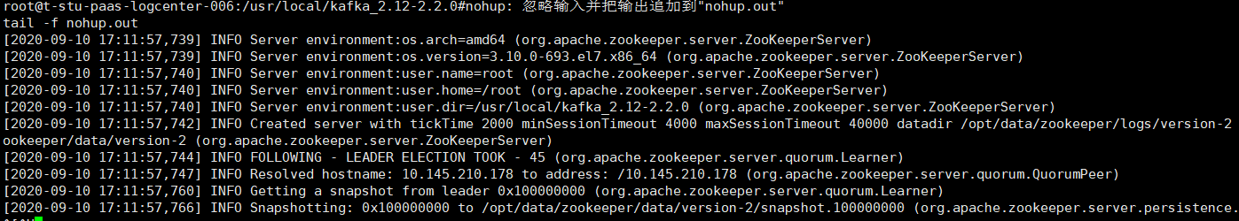
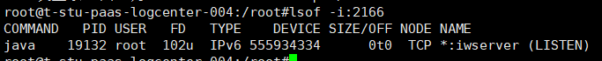

在一台服务器(10.145.210.177)上创建topic
bin/kafka-topics.sh --create --zookeeper localhost:2166 --replication-factor 1 --partitions 1 --topic testtopic
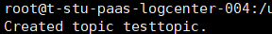

查询10.145.210.177上的topic
bin/kafka-topics.sh --zookeeper 10.145.210.177:2166 --list
查询10.145.210.178上的topic
bin/kafka-topics.sh --zookeeper 10.145.210.178:2166 --list
查询10.145.210.179上的topic
bin/kafka-topics.sh --zookeeper 10.145.210.179:2166 --list
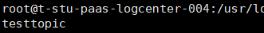

模拟生产和消费
发消息到10.145.210.177
bin/kafka-console-producer.sh --broker-list 10.145.210.177:6230 --topic testtopic
>hello world
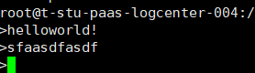
从10.145.210.178上接收消息
bin/kafka-console-consumer.sh --bootstrap-server 10.145.210.178:6230 --topic testtopic --from-beginning
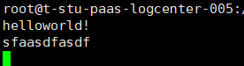

Kafka-manager配置
cd /home/paasadmin && unzip kafka-manager-2.0.0.2.zip && mv kafka-manager-2.0.0.2 /usr/local

cd /usr/local/kafka-manager-2.0.0.2 && vim conf/application.conf
修改kafka-manager.zkhosts为
kafka-manager.zkhosts="10.145.210.177:2166,10.145.210.178:2166,10.145.210.179:2166"

启动测试
cd /usr/local/kafka_2.12-2.2.0 && nohup bin/kafka-server-start.sh config/server.properties &
cd /usr/local/kafka-manager-2.0.0.2 && nohup ./bin/kafka-manager &

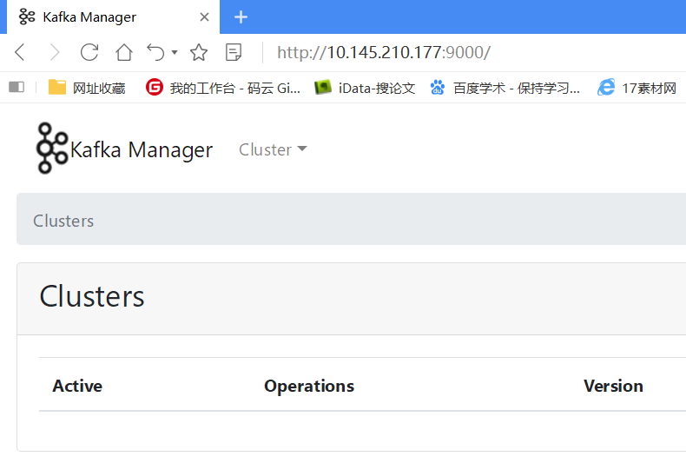
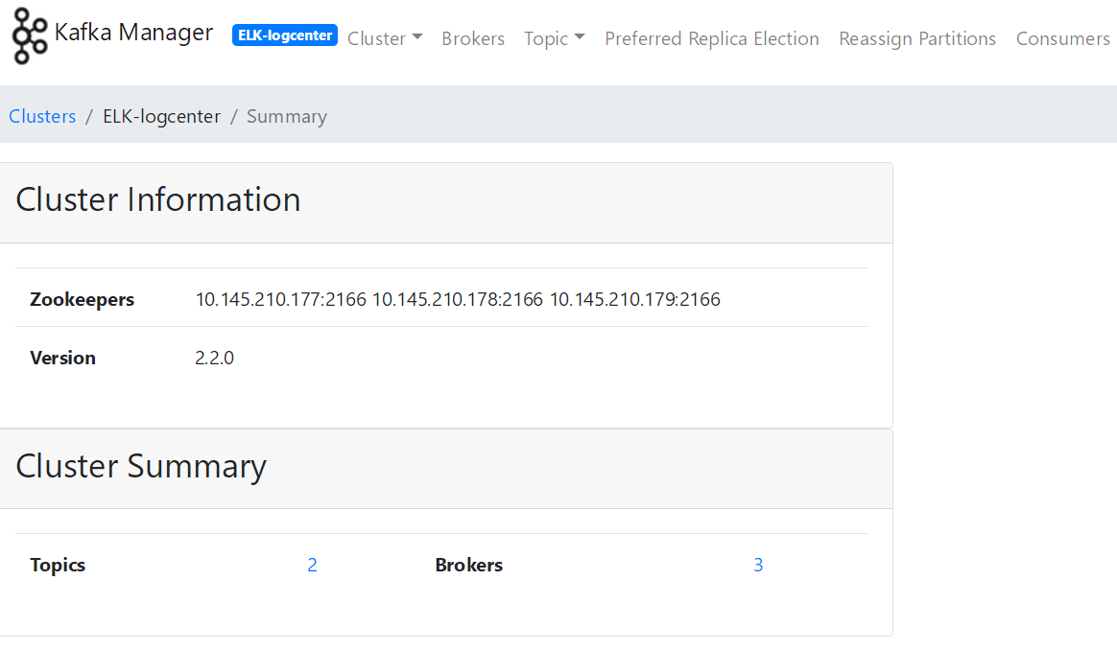

logstash
（只装在 10.145.210.177上）
cd /home/paasadmin && tar -xzvf logstash-7.1.1.tar.gz -C /usr/local/
mkdir /usr/local/logstash_data

cd /usr/local/logstash-7.1.1
vim config/logstash.yml

pipeline.batch.size: 10000
pipeline.batch.delay: 5
path.data: /usr/local/logstash_data #目录创建并赋予权限
pipeline.workers: 16
pipeline.batch.delay: 100
config.reload.automatic: true
config.reload.interval: 10s

jvm设置
在config目录下设置jvm.options 的值，根据自己的需求进行设置 (10g)
vim /usr/local/logstash-7.1.1/config/jvm.options

mkdir -p /usr/local/logstash-7.1.1/etc/conf.d
vim /usr/local/logstash-7.1.1/etc/conf.d/input.conf

input {
kafka {
type => "nginx_kafka"
codec => "json"
topics => "nginx"
decorate_events => true
bootstrap_servers => "10.145.210.177:6230, 10.145.210.178:6230, 10.145.210.179:6230"
}
}

vim /usr/local/logstash-7.1.1/etc/conf.d/output.conf
output {
if [type] == "nginx_kafka" {
elasticsearch {
hosts => ["http://10.145.210.177:9200", "http://10.145.210.178:9200", "http://10.145.210.179:9200"]
index => 'logstash-nginx-%{+YYYY-MM-dd}'
}
}
}

测试启动
nohup /usr/local/kafka_2.12-2.2.0/bin/kafka-server-start.sh /usr/local/kafka_2.12-2.2.0/config/server.properties &

nohup /usr/local/logstash-7.1.1/bin/logstash -f /usr/local/logstash-7.1.1/etc/conf.d/ --config.reload.automatic &

(177)
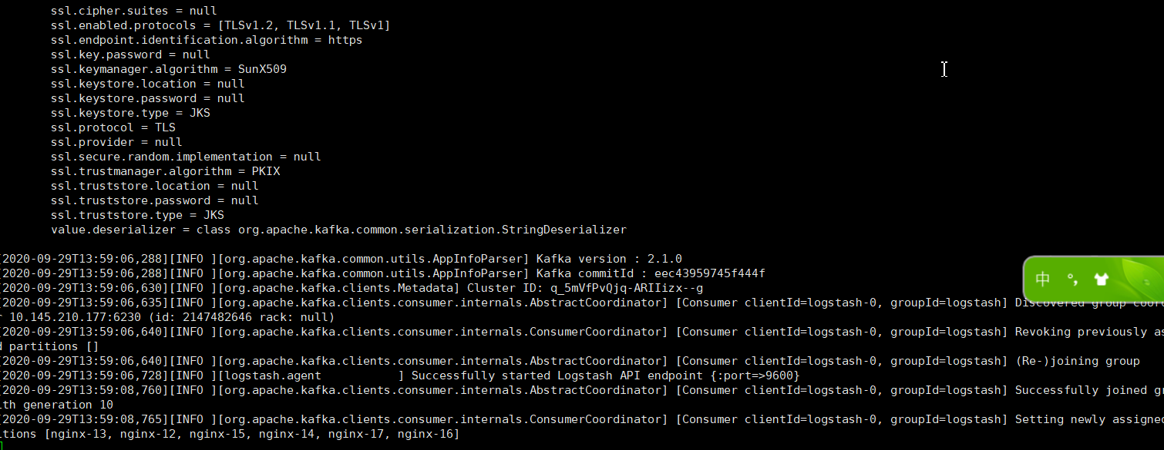
(178\179)
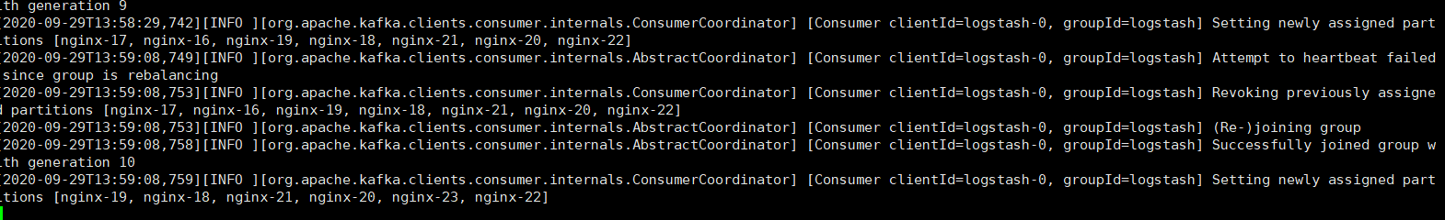

查询10.145.210.178上的topic
/usr/local/kafka_2.12-2.2.0/bin/kafka-topics.sh --zookeeper 10.145.210.178:2166 --list

Filebeat
在第四台机器上配置 作为生产者
tar -xzvf /home/paasadmin/filebeat-7.1.1-linux-x86_64.tar.gz -C /usr/local
cd /usr/local
mv filebeat-7.1.1-linux-x86_64 filebeat
cd filebeat/

vim filebeat.yml

output.kafka:
enabled: true
hosts: ["10.145.210.177:6230", "10.145.210.178:6230", "10.145.210.179:6230"]
topic: '%{[fields.topic]}'

filebeat.inputs:
- input_type: log
paths: #采集日志的路径
- /app/ctglb/tomcat-lvs-10120/logs/catalina.out
document_type: teledblvs
fields:
topic: teledb_lvs

启动
nohup ./filebeat -e -c filebeat.yml &

filebeat.inputs:
- input_type: log
paths:
- /var/log/nginx/access.log
fields:
log_topic: nginx

processors:
- drop_fields:
fields: ["beat", "input_type", "source", "offset",]
name: "10.145.210.177"
output.kafka:
enabled: true
hosts: ["10.145.210.177:6230", "10.145.210.178:6230", "10.145.210.179:6230"]
version: "0.10"
topic: '%{[fields][log_topic]}'
partition.round_robin:
reachable_only: true
worker: 2
required_acks: 1
compression: gzip
max_message_bytes: 10000000
logging.level: debug

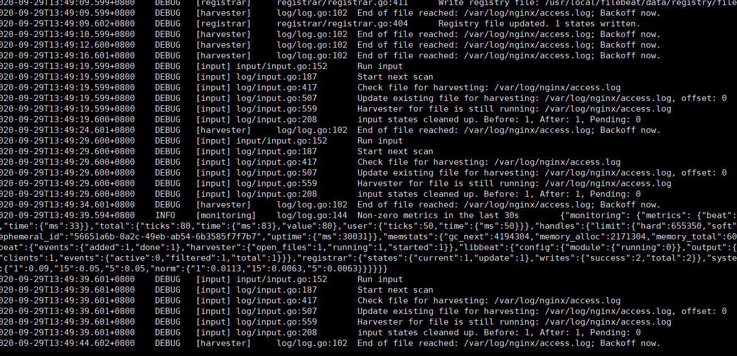

启动
nohup ./filebeat -e -c filebeat.yml &

cd /usr/local/filebeat
vim itcast-log.yml
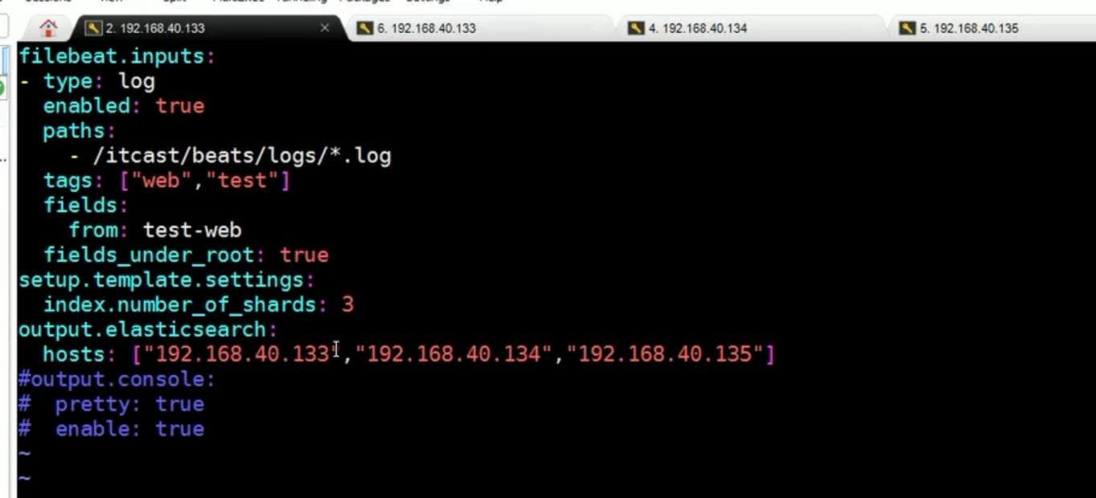

filebeat.inputs:
- input_type: log
enable: true
paths:
- /var/log/nginx/access.log
tags: [“web”,”test”]
fields:
from: test-web
fields_under_root: true
setup.template.settings:
index.number_of_shards: 3
output.elasticsearch:
hosts: ["10.145.210.177", "10.145.210.178", "10.145.210.179"]
#output.console:
# pretty: true
# enable: true

nohup ./filebeat -e -c itcast-log.yml &

更新JAVA地址
vim /etc/profile
export JAVA_HOME=/opt/java/
export PATH=$JAVA_HOME/bin:$PATH
export CLASSPATH=.:$JAVA_HOME/lib/dt.jar:$JAVA_HOME/lib/tools.jar

source /etc/profile
之后修改每个用户目录下的.bash_profile

rm /usr/bin/java
rm /usr/bin/javac
ln -s $JAVA_HOME/bin/java /usr/bin/java
ln -s $JAVA_HOME/bin/javac /usr/bin/javac
source /etc/profile
启动与调试
（启动ES）
sudo su -
su - logcenter
cd /usr/local/elasticsearch-7.1.1
nohup bin/elasticsearch &
（查看输出）tailf nohup.out

chrome浏览器插件: elasticsearch-head

验证master与node节点的畅通
curl http://10.145.210.177:9200/_cat/health?v
curl http://10.145.210.177:9200/_cat/master
curl http://10.145.210.179:9200/_cat/nodes

（Kibana启动）
sudo su -
cd /usr/local/kibana-7.1.1-linux-x86_64/
nohup ./bin/kibana &
tailf nohup.out

查看kibana进程号：netstat -tunlp|grep 5551
http://10.145.210.177:5601/

（Kafka验证集群）
cd /usr/local/kafka_2.12-2.2.0
nohup bin/kafka-server-start.sh config/server.properties &
（kafka-manager启动测试）
cd /usr/local/kafka_2.12-2.2.0 && nohup bin/kafka-server-start.sh config/server.properties &
cd /usr/local/kafka-manager-2.0.0.2 && nohup ./bin/kafka-manager &


（logstash启动）
cd /usr/local/logstash-7.1.1
nohup /usr/local/logstash-7.1.1/bin/logstash -f /usr/local/logstash-7.1.1/etc/conf.d/ --config.reload.automatic &

#tailf nohup.out
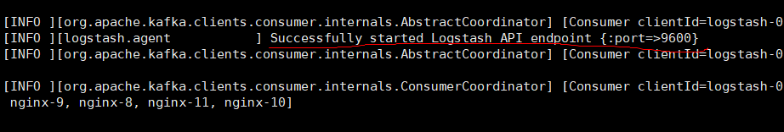
（filebeat在第四台机器上启动，作为日志生产者）
sudo su -
cd /usr/local/filebeat
#netstat -tunlp|grep 5601查询是否已有filebeat进程占用了端口
#nohup ./filebeat -e -c filebeat.yml &
nohup ./filebeat -e -c itcast-log.yml &

#tailf nohup.out

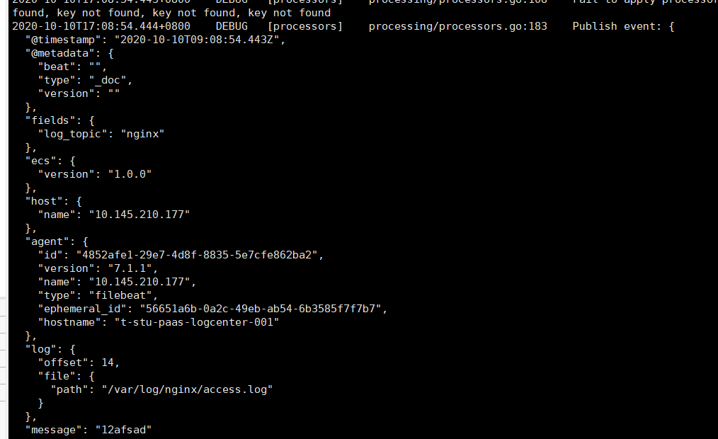
向日志文件中输入数据
另开窗口:
sudo su -
cd /var/log/nginx
echo “xxx” >> access.log
