**Stock-To-Flow Model**

The Stock to flow model (SF) is in simplicity, a way to measure how abundant a particular resource is. It is the ratio between the resources held in reserve and the amount produced annually, that is the ratio between current and new supply of a commodity. Where current supply is the size of the existing stockpiles or reserves and new supply is the yearly production.

This model generally applies to natural resources like the precious minerals and it shows how much of a resource enters the market relative to its entire supply each year. This leads to the conclusion that the higher a resource’s stock to flow ratio, the more it becomes scare relative to its entire supply in the market. That is, scarcity drives value, and the value is related to the rate of new supply for the resource. Following this theory, it can be concluded that a resource with a high stock to flow ratio would retain its value well over a long period of time.

An example of these type of natural resources is gold, on whose supposed market behaviour, this whole model is hinged.

The way Bitcoin works, it is not difficult to assume that this model would make sense because the model treats Bitcoin as equally scarce as gold or silver. The scarcity of Bitcoin is by design, as there is a halving event every 4 years. Because of this halving event, the total amount of Bitcoin is finite. BTC’s claim to fame is that only 21 million coins can ever exist. Right now, approximately 18.5 million BTC exists, and at a rate of 900 new coins produced every day, this gives us an SF of 25. And in four years, this Sf becomes 52, which is very similar to the current SF of gold - 62. The stock to flow model of Bitcoin can be seen in the diagram below:

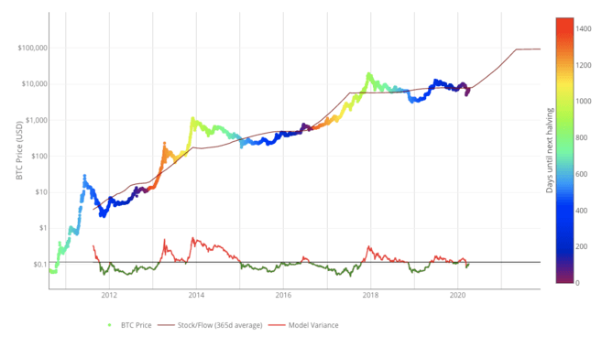

Stock-to-Flow Model for Bitcoin. Source: [LookIntoBitcoin.com](https://www.lookintobitcoin.com/charts/stock-to-flow-model/)

Plan B’s paper “Modeling Bitcoin Value with Scarcity” says the model predicts a stunning Bitcoin market capitalization of $ 1 trillion in about two years. A market price of $ 1 trillion puts the price of one bitcoin at $ 55, 000.

This model has been debunked a lot of time for various reasons, one being an over reliance on market forces. There is no evidence or research to support the idea that the USD market capitalization of a monetary is derived directly from their rate of new supply. And according to critics of the model, it fails if there are no other qualities attached to bitcoin apart from supply scarcity.

Also, the model defies physical laws and predicts exponential growth till infinity with no decline in value makes the model not too feasible.

Finally, the volatility of Bitcoin should decrease over time according to the model and an asset’s valuation needs to take its volatility into account. If, to an extent, the volatility is predictable, the valuation model may be more reliable. However, Bitcoin is characterized by its large price moves.