CA2
Applying Data Mining Techniques for Real-World Problem Solving
Mini Project: Credit Card Default Prediction using Python (Banking and Finance)
Student Name | Aryaman Sinha
Roll No. / Reg. No. | 28
Course | Data Mining and Business Integration
Submitted To | Archana Kshirsagar
Domain | Banking and Finance

1. Problem Definition

1.1 Real-World Problem
Banks earn a large part of their income from credit cards, but they also carry the risk that a customer will not repay the due amount. When a customer fails to pay, the account is called a default and the bank suffers a financial loss. Banks give thousands of cards every month and cannot manually judge each customer's repayment behaviour. The real-world problem is therefore: how can a bank identify, in advance, the customers who are likely to default in the next month?

1.2 Objective of the Project
- To build a classification model that predicts whether a credit-card customer will default next month (Yes / No).
- To compare the performance of Logistic Regression, Decision Tree and Random Forest algorithms.
- To find which factors (repayment history, credit limit, bill and payment amounts, demographics) influence default the most.
- To develop a small working system in which a bank officer enters customer details and gets the default risk.

1.3 How Data Mining Can Help
The bank already holds past records of customers along with the information whether they defaulted. Data mining techniques can learn the hidden pattern between customer behaviour and default from this historical data. The learned model can then score new customers instantly, so that the bank can reduce credit limits, send early reminders, or reject risky applications, thereby reducing losses.
Real-World Problem | Dataset | Preprocessing | Data Analysis | Data Mining Technique
Algorithm | Results | Evaluation | Insights | Conclusion

2. Dataset Collection

2.1 Source
The dataset used is "Default of Credit Card Clients" from the UCI Machine Learning Repository (https://archive.ics.uci.edu/dataset/350/default+of+credit+card+clients), also available on Kaggle as UCI_Credit_Card.csv. It was created by I-Cheng Yeh and Che-hui Lien and contains data of customers of a bank in Taiwan from April to September 2005. It is a reliable and widely used public benchmark dataset for credit-risk research.

2.2 Number of Records and Attributes
Property | Value
Number of records | 30,000 customers (about 29,965 after removing duplicates)
Number of attributes | 23 input features + 1 target variable = 24 columns
Target variable | DEFAULT (1 = customer defaulted next month, 0 = did not default)
Class distribution | About 22% defaulters and 78% non-defaulters (imbalanced)
Data type | Structured, tabular; numerical and categorical

2.3 Important Attributes
Attribute | Description | Why it is important
LIMIT_BAL | Credit limit of the customer | Reflects the bank's own trust in the customer and the customer's income level
SEX, EDUCATION, MARRIAGE, AGE | Demographic details | Shows whether certain groups have higher default tendencies
PAY_1 … PAY_6 | Repayment status for last 6 months (-2/-1/0 = on time, 1+ = months of delay) | Past payment behaviour is the best indicator of future behaviour
BILL_AMT1 … BILL_AMT6 | Bill statement amount for each month | Shows how much the customer owes and how heavily the card is used
PAY_AMT1 … PAY_AMT6 | Amount paid each month | Compared with the bill, it shows repayment capacity
DEFAULT | Target: default payment next month | The outcome the model must predict

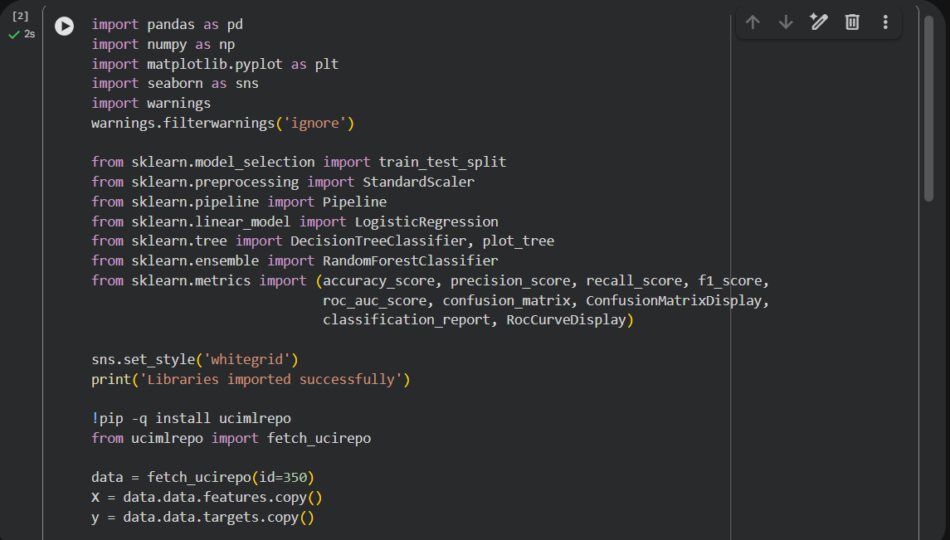
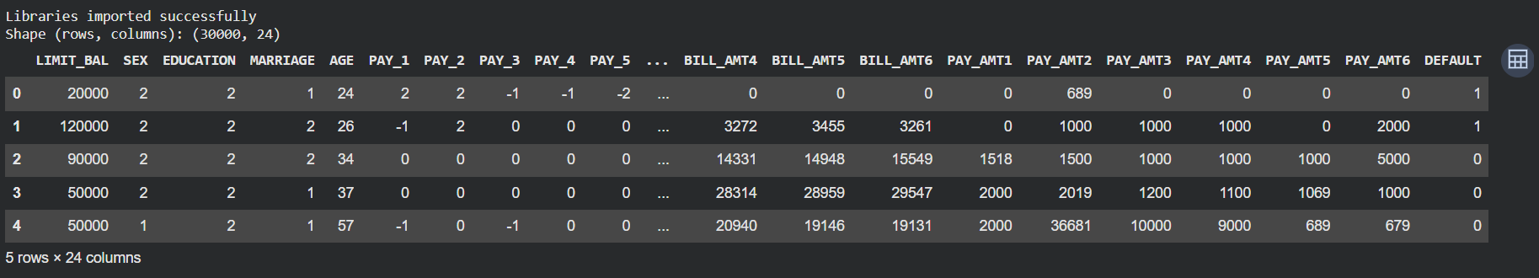
Figure 1: Dataset loaded in Google Colab – shape and first five records
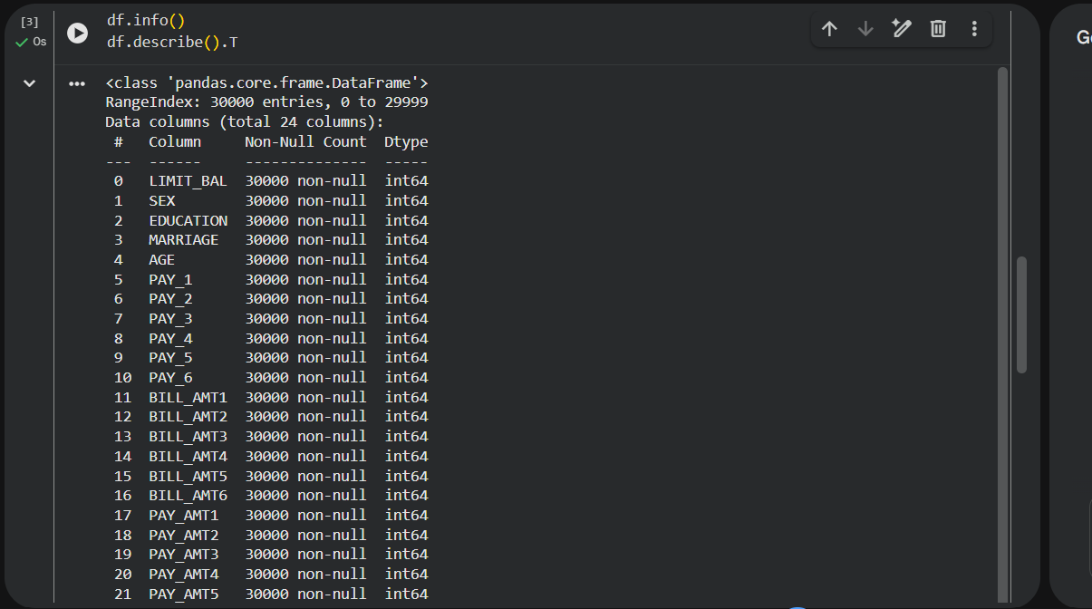
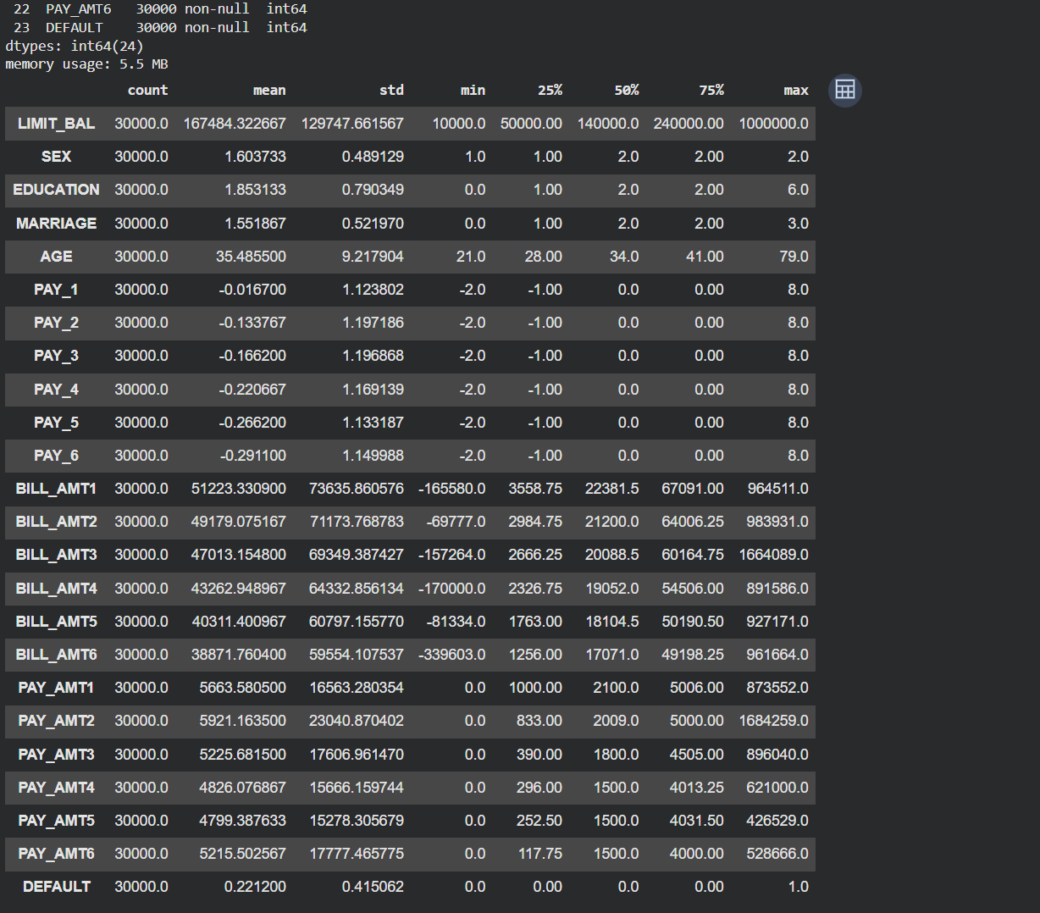
Figure 2: Data types and statistical summary of the attributes

3. Data Preprocessing
Preprocessing is done to convert raw data into a clean and consistent form so the algorithms learn real patterns rather than noise. Each step with its reason is given below.

3.1 Handling Missing Values
What was done: The number of null values in every column was checked using df.isnull().sum(). Why: Algorithms in scikit-learn cannot work with missing values. In this dataset the total missing values are zero, so no imputation was needed. 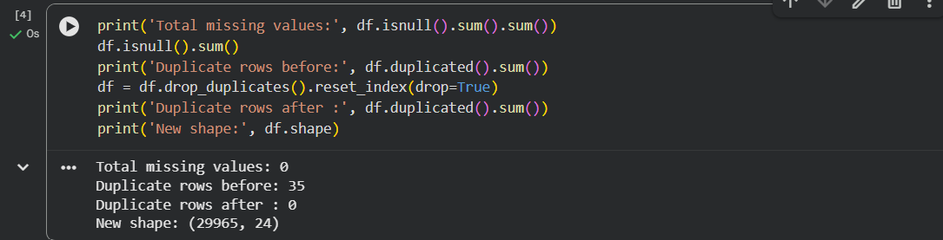
Figure 3: Missing values and duplicate records check

3.2 Removing Duplicates
What was done: Duplicate rows were detected using df.duplicated() and removed with drop_duplicates(). Why: Duplicate customers give extra weight to the same pattern and may appear in both training and test sets, making the model look better than it actually is.

3.3 Cleaning Invalid Category Codes
What was done: In EDUCATION the undocumented codes 0, 5 and 6 were merged into "Others" (4), and in MARRIAGE the code 0 was merged into "Others" (3). Why: These values are not defined in the data dictionary and are treated as data-entry errors; keeping them would create meaningless categories.
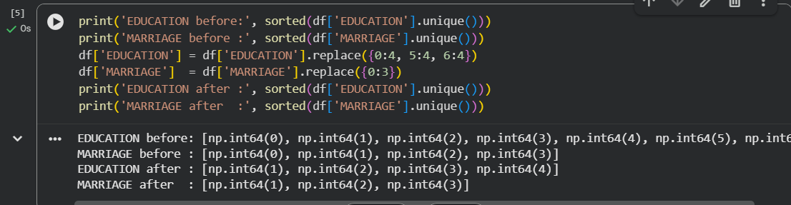
Figure 4: Cleaning of invalid category codes

3.4 Handling Outliers
What was done: Box plots showed very large values in LIMIT_BAL, BILL_AMT and PAY_AMT columns. These were capped at the 1st and 99th percentile (winsorization) in Step 6.1. Why: Extreme values are rare but real customers, so deleting them would lose information about high-spending and high-risk customers; capping reduces their distorting effect on models such as Logistic Regression.
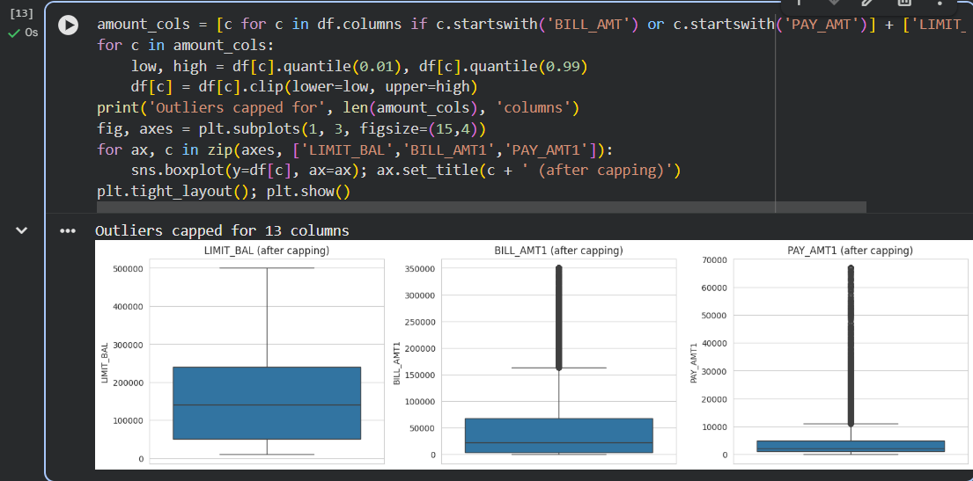
Figure 5: Box plots after outlier capping

3.5 Encoding Categorical Data
What was done: SEX, EDUCATION and MARRIAGE were converted into dummy (one-hot) columns using pd.get_dummies(drop_first=True). Why: These attributes are nominal – the number 3 does not mean "more" than 1. One-hot encoding prevents the algorithm from assuming a false order.

3.6 Feature Selection
What was done: Features having correlation above 0.90 with another feature (mainly the BILL_AMT columns) were dropped. Why: Highly correlated features carry the same information, so removing them reduces redundancy, noise, overfitting and training time.
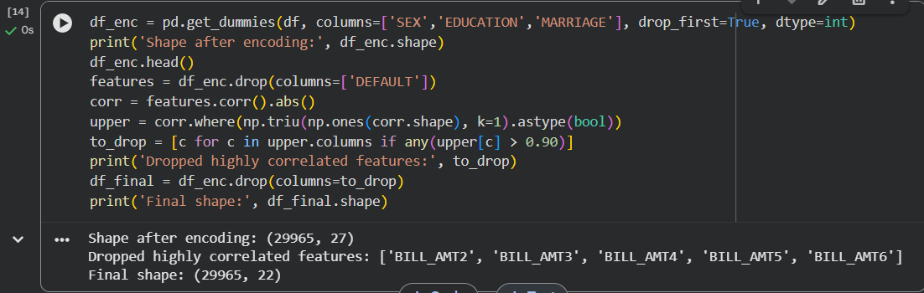
Figure 6: Encoding and feature selection output

3.7 Data Transformation / Normalization and Splitting
What was done: StandardScaler was applied inside a pipeline for Logistic Regression, and the data was split 80% training / 20% testing using a stratified split. Why: Features have very different ranges (AGE about 20–70, LIMIT_BAL up to lakhs); scaling avoids large-valued features dominating. Stratification keeps the same default ratio (about 22%) in both the training and test sets. The scaler is fitted only on the training data to avoid data leakage.
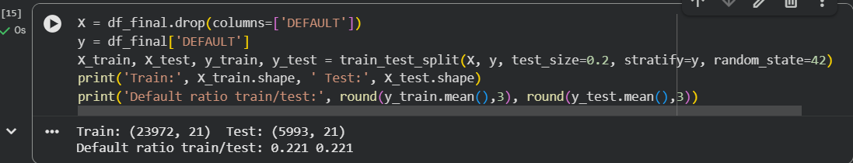
Figure 7: Train-test split

4. Exploratory Data Analysis and Visualization
Exploratory Data Analysis (EDA) was performed with Python libraries Pandas, Matplotlib and Seaborn to understand patterns in the data before applying algorithms.

4.1 Bar Chart – Class Distribution
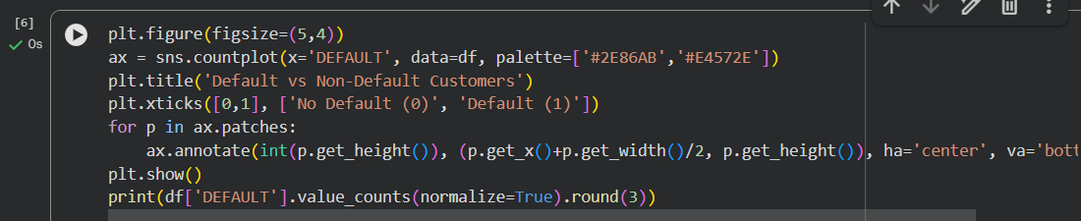
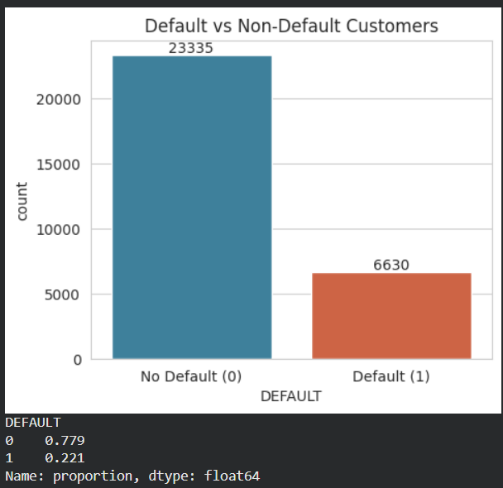

Figure 8: Distribution of the target variable
Observation: The data is imbalanced – only about 22% customers default. Therefore accuracy alone is not a reliable measure, and recall, F1-score and class weighting are used.

4.2 Histogram – Age and Credit Limit
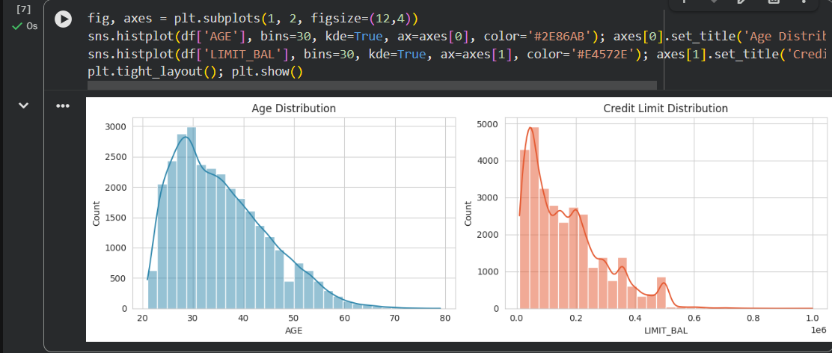
Figure 9: Distribution of age and credit limit
Observation: Most customers are between 25 and 40 years old, and the credit-limit distribution is right-skewed – most customers have small to medium limits and a few have very large limits.

4.3 Box Plot – Outliers
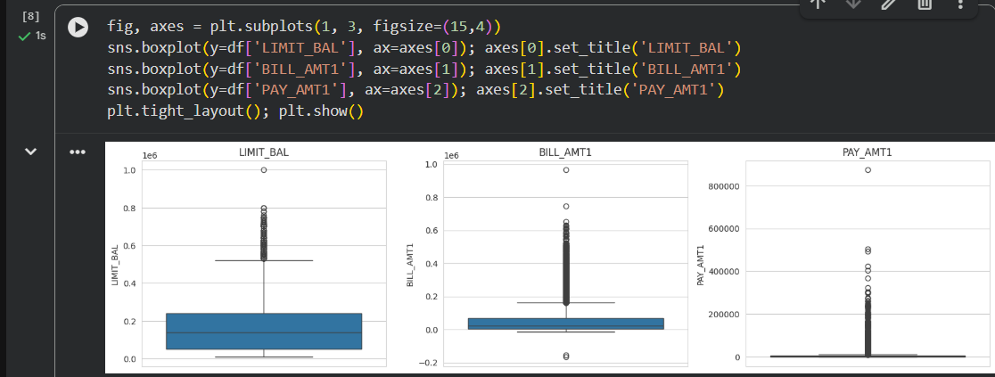
Figure 10: Box plots showing outliers
Observation: All three amount attributes have many high-value outliers, which justifies the outlier-capping step.

4.4 Default Rate by Demographic Groups
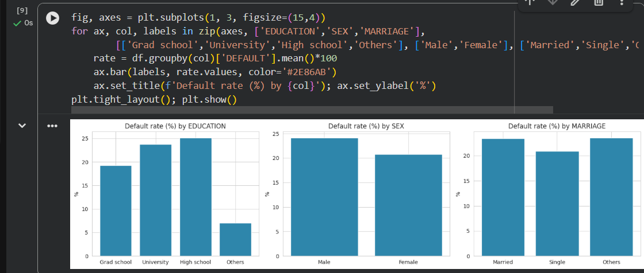
Figure 11: Default rate by education, gender and marital status
Observation: Default rates differ only slightly between groups (all roughly in the 19%–25% range). Demographic attributes therefore do not separate defaulters strongly.

4.5 Repayment Status vs Default
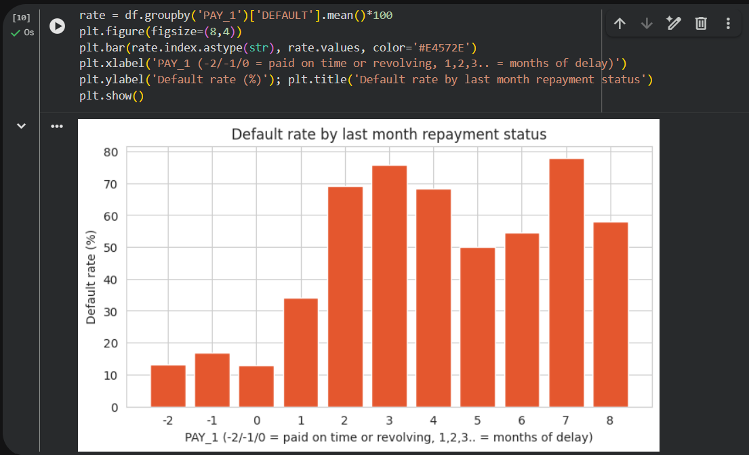
Figure 12: Default rate by last-month repayment status
Observation: Default rate rises sharply as the number of months of payment delay increases. Customers who are already 2 or more months late have a far higher chance of default than customers who pay on time. This is the clearest pattern in the dataset.

4.6 Scatter Plot – Age vs Credit Limit
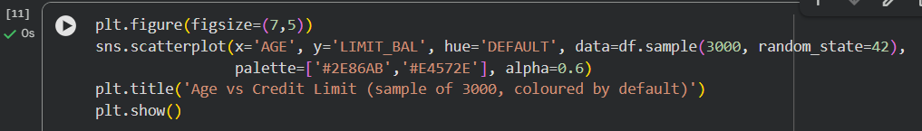
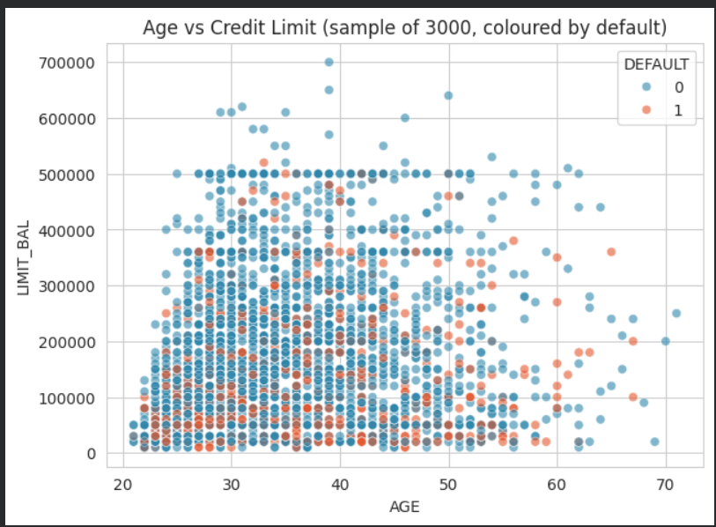
Figure 13: Scatter plot of age and credit limit
Observation: Defaulters (red) are found across all ages but are more concentrated at lower credit limits, and no clear linear separation exists – so a non-linear model such as Random Forest is useful.

4.7 Correlation Heatmap
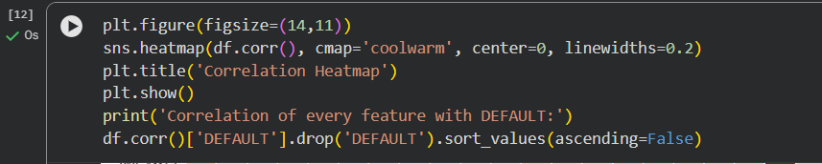
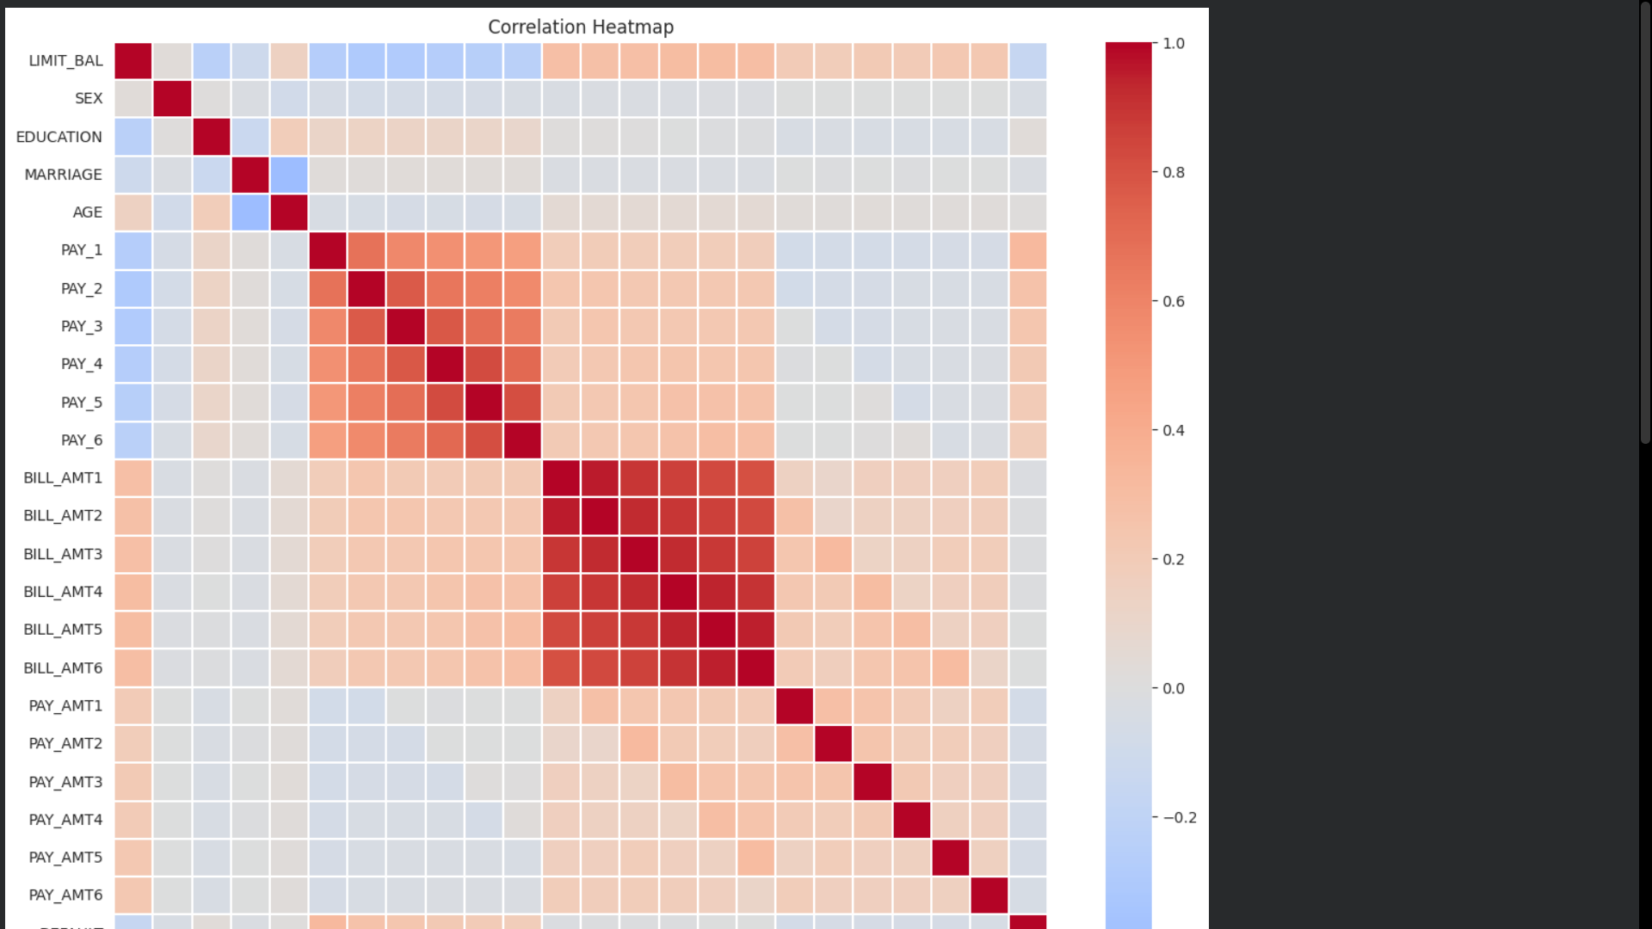
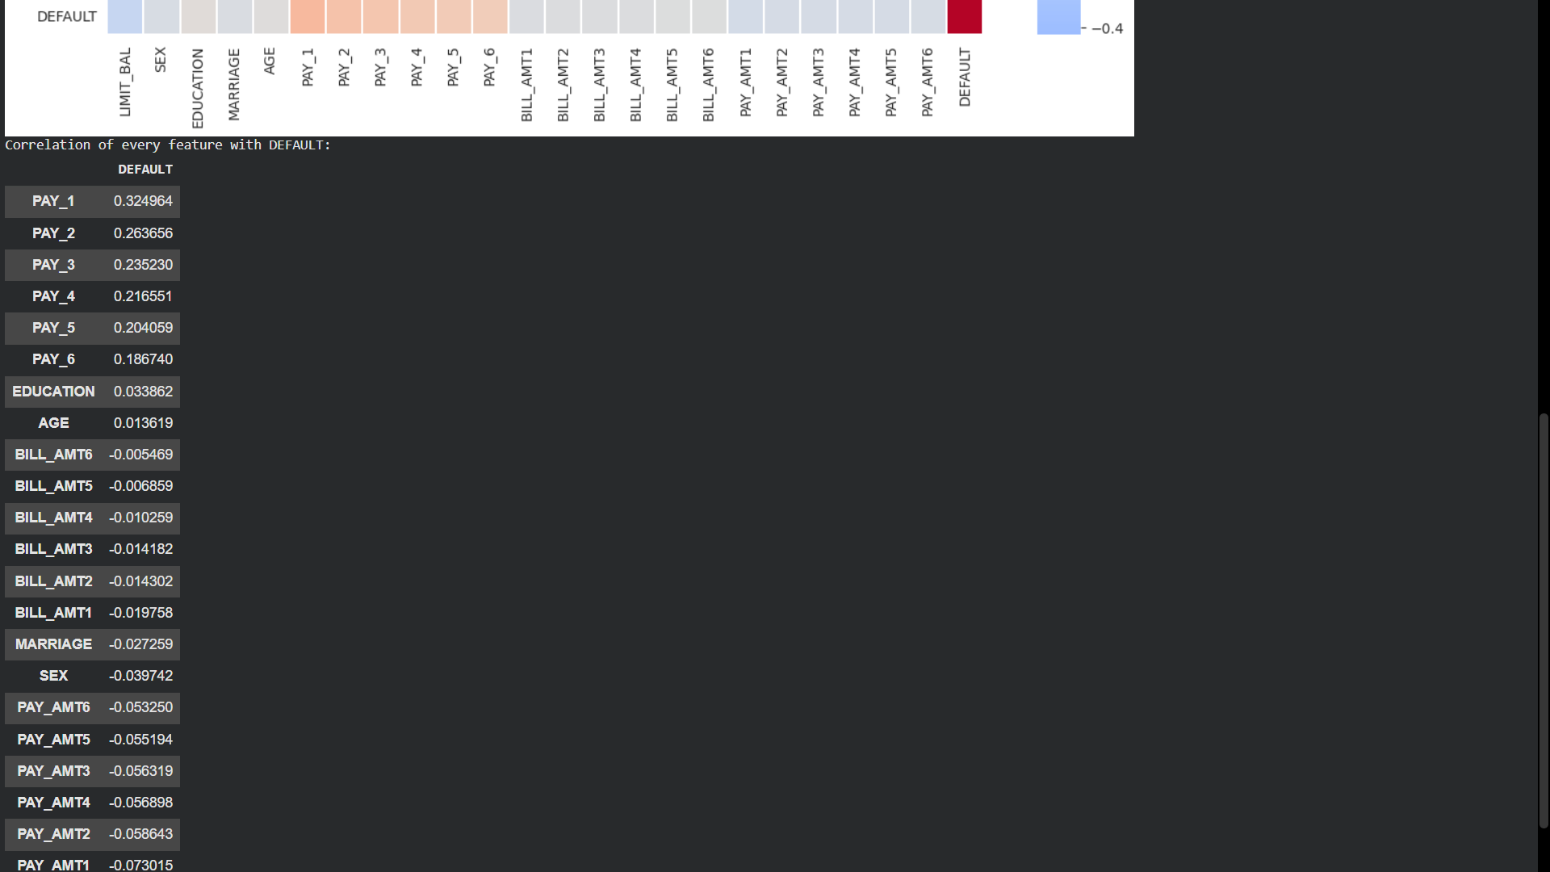
dtype: float64
Figure 14: Correlation heatmap
Observation: The six BILL_AMT columns are strongly correlated with each other (multicollinearity), and the PAY_1 to PAY_6 columns are also positively correlated. PAY_1 has the highest positive correlation with DEFAULT, while LIMIT_BAL has a negative correlation (higher limit → lower default).

5. Data Mining Technique and Algorithm

5.1 Data Mining Task: Classification
The target (DEFAULT) is a Yes/No category and the historical data has known outcomes. Hence this is a supervised classification problem. Regression is not suitable because a number is not predicted, and clustering/association rules are unsupervised and cannot directly predict a labelled outcome.

5.2 Selected Algorithms and Reasons
Algorithm | Why it was selected
Logistic Regression | Baseline model, the traditional method of credit scoring, simple and interpretable. Gives default probability.
Decision Tree | Produces clear if–else rules that bank managers can understand and explain; no scaling needed.
Random Forest | Combines many trees to give higher accuracy, handles non-linear relations and correlated features, and gives feature importance. Expected to be the best model.

Parameters used: Logistic Regression (max_iter = 1000, class_weight = balanced); Decision Tree (max_depth = 5, class_weight = balanced); Random Forest (n_estimators = 200, max_depth = 10, class_weight = balanced); random_state = 42 for all models so the results are reproducible. class_weight = balanced is used because of the 22%/78% class imbalance.

6. Implementation
The project was implemented in Python on Google Colab. The libraries used are:
Library | Purpose
Pandas | Loading the dataset, cleaning, grouping and encoding
NumPy | Numerical operations and correlation filtering
Matplotlib / Seaborn | Charts and visualizations (bar, histogram, box, scatter, heatmap)
Scikit-learn | Train-test split, scaling, the three classifiers and evaluation metrics
ipywidgets | Interactive input form for the mini system

Implementation steps: (1) import libraries, (2) load dataset, (3) understand data, (4) preprocess, (5) EDA, (6) split and scale, (7) train three models, (8) evaluate and compare, (9) interpret feature importance, (10) build the prediction system.
Google Colab notebook link: Paste your Colab share link here (Share → Anyone with the link → Viewer)
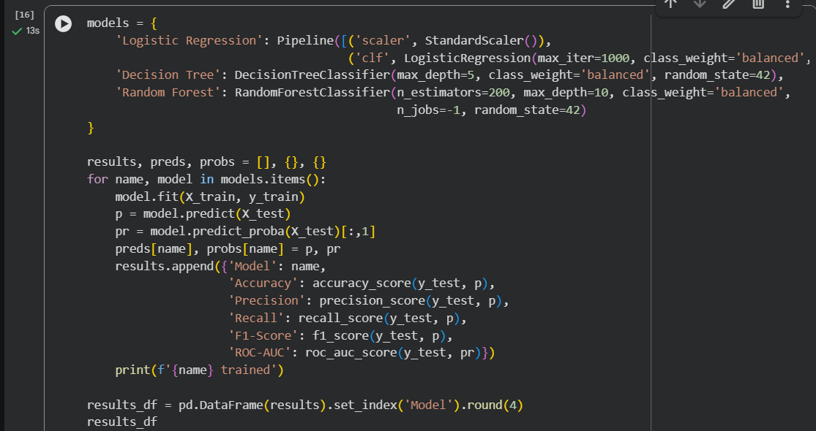
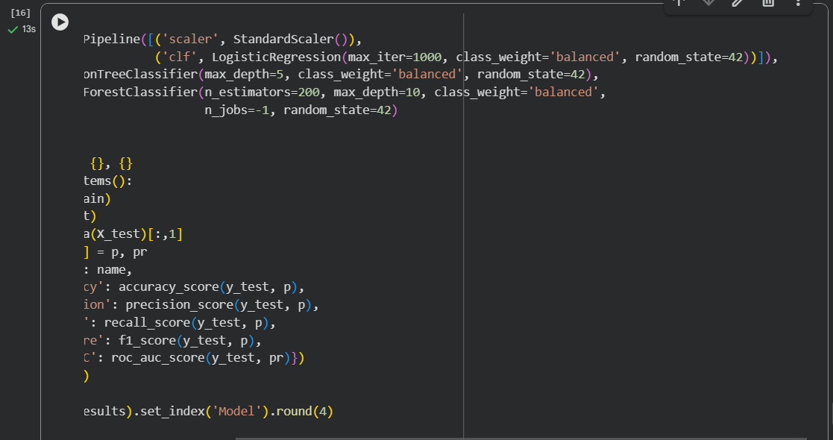
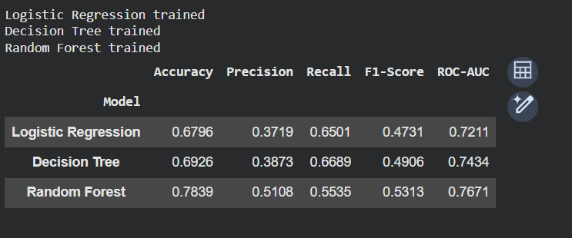
Figure 15: Model training and results table

7. Model Evaluation
The models were tested on the 20% test data which they had not seen. Measures used: Accuracy, Precision, Recall, F1-score, Confusion Matrix and ROC-AUC.

7.1 Performance Comparison
Model | Accuracy | Precision | Recall | F1-Score | ROC-AUC
Logistic Regression
Decision Tree
Random Forest
(Fill the table from the results_df output in Colab, then remove the yellow highlight.)
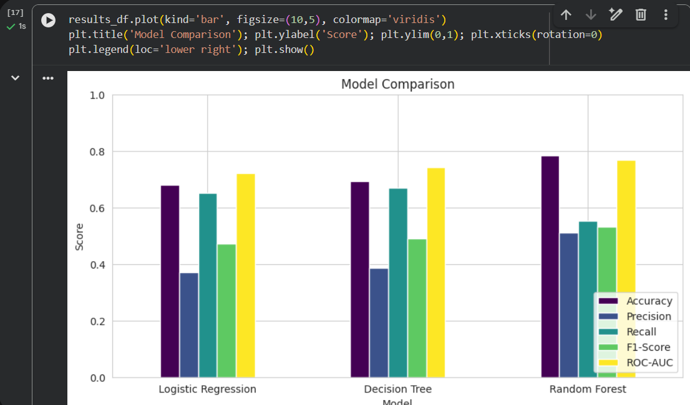
Figure 16: Comparison of model performance

7.2 Confusion Matrix
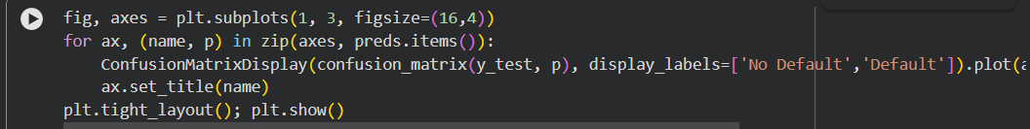
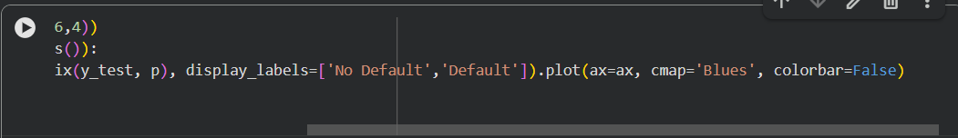
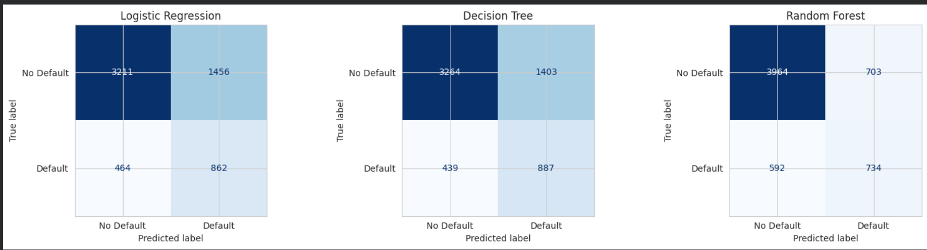
Figure 17: Confusion matrices of the three models
The confusion matrix shows the four outcomes – True Positive (defaulter caught), False Negative (defaulter missed), False Positive (good customer wrongly flagged) and True Negative (good customer correctly identified). For a bank the False Negatives are the costliest, so Recall of the "Default" class is carefully observed.

7.3 Classification Report and ROC Curve
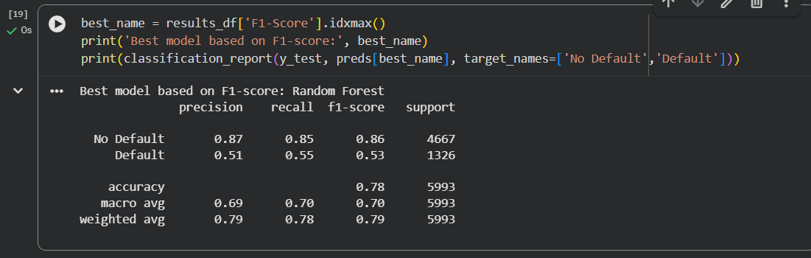
Figure 18: Classification report of the best model
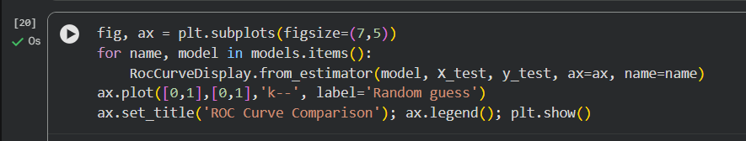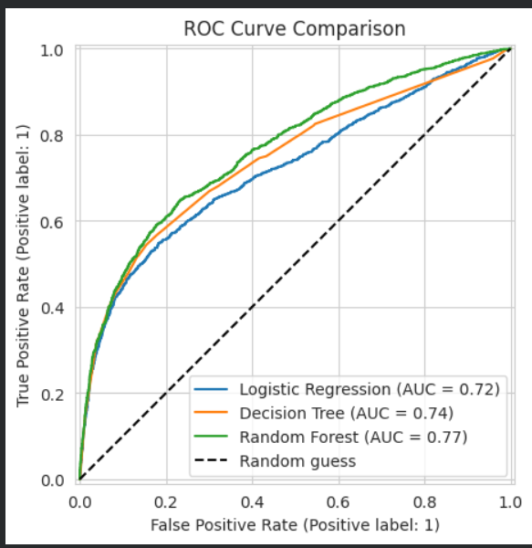
Figure 19: ROC curves

8. Results and Interpretation

8.1 What did the model reveal?
Among the three algorithms, Random Forest gave the best balance of results with an F1-score of 0.5313 and ROC-AUC of 0.7671. Random Forest generally outperforms the single Decision Tree and Logistic Regression because it captures non-linear patterns and reduces overfitting. All models show only moderate precision for defaulters, which is normal for this dataset because customer behaviour is naturally uncertain.

8.2 Important Factors
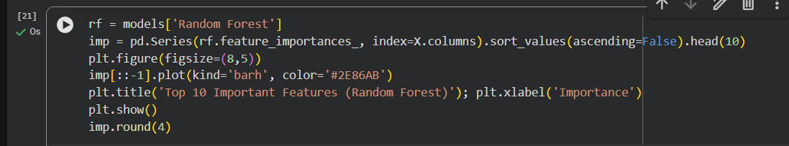
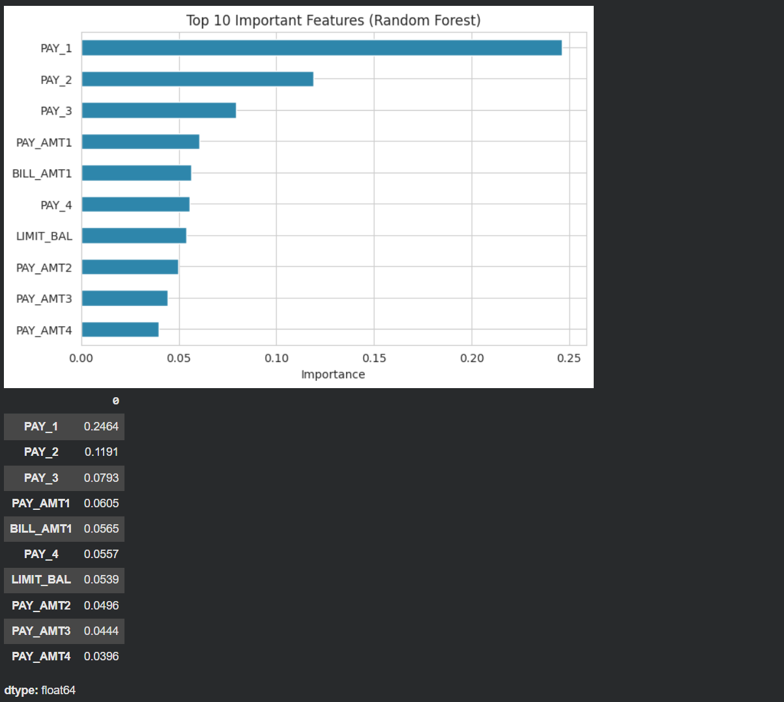
Figure 20: Top 10 important features
The feature-importance chart shows that PAY_1 (last month repayment status) and the other recent repayment-status attributes (PAY_2, PAY_3 …) are the most influential factors. Credit limit (LIMIT_BAL), bill amounts and payment amounts follow, while demographic attributes such as SEX, EDUCATION and MARRIAGE have very low importance. The top five features are PAY_1 (0.246), PAY_2 (0.119), PAY_3 (0.079), PAY_AMT1 (0.061) and BILL_AMT1 (0.057).

8.3 Patterns Identified
- Customers who delay payment by even 1–2 months are much more likely to default next month.
- Customers with lower credit limits and low payment amounts relative to their bills show higher risk.
- Demographic attributes alone do not decide default; behaviour matters more than who the customer is.
- The decision tree shows simple rules such as "if PAY_1 is greater than 1.5 then the risk is high".
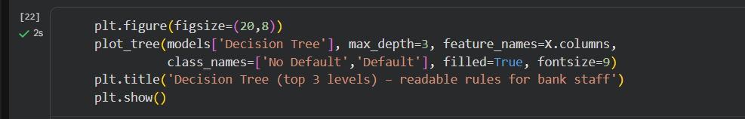
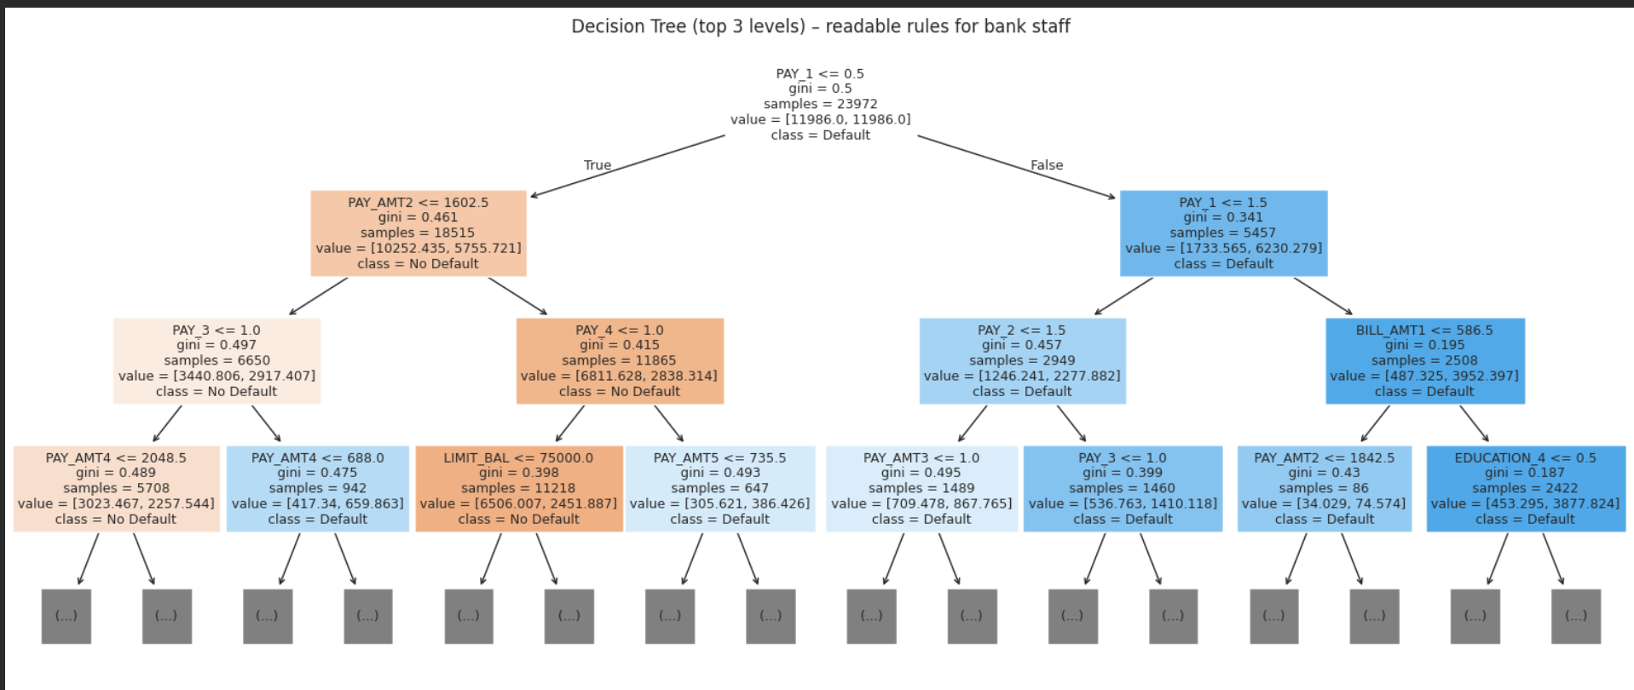
Figure 21: Decision tree rules

8.4 Usefulness in the Real World
- Early warning: Customers with 1–2 months of delay can be contacted before they default.
- Credit-limit management: Limits of high-risk customers can be frozen/reduced; low-risk customers can be offered increases.
- Card approval: New applications can be scored automatically and consistently.
- Financial planning: Bank can estimate expected losses and keep appropriate provisions.
- Choosing the threshold: Banks that want to avoid missing defaulters can choose a lower probability threshold to increase recall.

9. Mini System Demonstration
A small prediction system was built in Google Colab using ipywidgets. The bank officer enters the credit limit, age, months of payment delay, last bill amount and last payment amount. The trained Random Forest returns the default probability and a risk category (Low / Medium / High). Remaining features are filled with the median values of the training data.
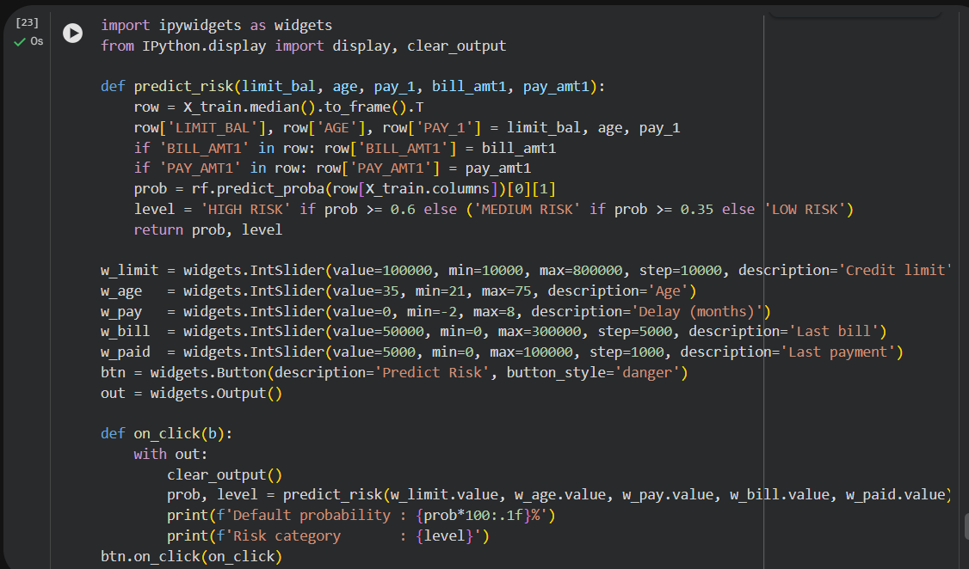
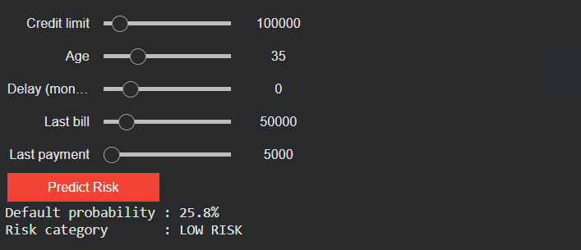
Figure 22: Mini system – low-risk customer
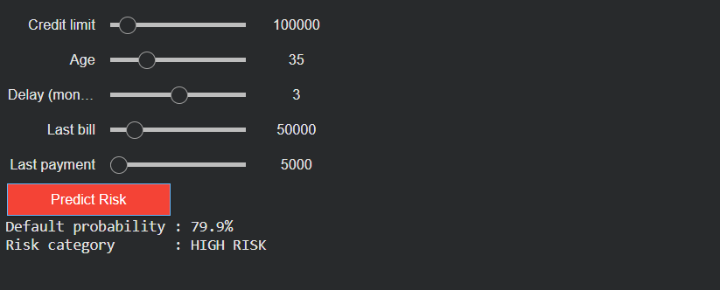
Figure 23: Mini system – high-risk customer

10. Conclusion
Point | Summary
Problem addressed | Predicting whether a credit-card customer will default next month so that the bank can reduce credit risk.
Technique and algorithms | Supervised classification using Logistic Regression, Decision Tree and Random Forest on the UCI Credit Card Default dataset (30,000 records).
Major findings | Recent repayment behaviour (PAY_1, PAY_2 …) is the strongest predictor of default; credit limit and payment amounts come next; demographics have little effect. Random Forest was the best model (F1-score 0.5313, ROC-AUC 0.7671).
Practical significance | Helps banks identify risky customers early, manage credit limits, approve cards faster and reduce financial losses.
Future improvements | Hyper-parameter tuning (GridSearchCV), cross-validation, handling imbalance with SMOTE, trying XGBoost/Gradient Boosting, explainability with SHAP, and deploying the system as a web app (Streamlit/Flask).

References
- Yeh, I. C., & Lien, C. H. (2009). The comparisons of data mining techniques for the predictive accuracy of probability of default of credit card clients. Expert Systems with Applications, 36(2), 2473–2480.
- UCI Machine Learning Repository – Default of Credit Card Clients. https://archive.ics.uci.edu/dataset/350/default+of+credit+card+clients
- Pedregosa et al. (2011). Scikit-learn: Machine Learning in Python. Journal of Machine Learning Research, 12, 2825–2830.
- Pandas, NumPy, Matplotlib and Seaborn official documentation.

