

SQL Server 2005 Security Overview for Database Administrators
SQL Server Technical Article

Writers: Don Kiely
Technical Reviewer: Rob Walters, Niraj Nagrani

Published: January 2007
Applies To: SQL Server 2005 RTM and SP1

Summary: SQL Server 2005 is the first version of this server software released since Microsoft developed and implemented its Trustworthy Computing initiative. The software is now secure by design, default, and deployment. Microsoft is committed to communicating information about threats, countermeasures, and security enhancements as necessary to keep your data as secure as possible. This paper covers some of the most important new security features in SQL Server 2005. It tells you how, as an administrator, you can install SQL Server securely and keep it that way even as applications and users make use of the data stored within.

Copyright
The information contained in this document represents the current view of Microsoft Corporation on the issues discussed as of the date of publication. Because Microsoft must respond to changing market conditions, it should not be interpreted to be a commitment on the part of Microsoft, and Microsoft cannot guarantee the accuracy of any information presented after the date of publication.

This White Paper is for informational purposes only. MICROSOFT MAKES NO WARRANTIES, EXPRESS, IMPLIED OR STATUTORY, AS TO THE INFORMATION IN THIS DOCUMENT.

Complying with all applicable copyright laws is the responsibility of the user. Without limiting the rights under copyright, no part of this document may be reproduced, stored in or introduced into a retrieval system, or transmitted in any form or by any means (electronic, mechanical, photocopying, recording, or otherwise), or for any purpose, without the express written permission of Microsoft Corporation.

Microsoft may have patents, patent applications, trademarks, copyrights, or other intellectual property rights covering subject matter in this document. Except as expressly provided in any written license agreement from Microsoft, the furnishing of this document does not give you any license to these patents, trademarks, copyrights, or other intellectual property.

© 2007 Microsoft Corporation. All rights reserved.

Microsoft, Windows, Windows NT, and Windows Server are either registered trademarks or trademarks of Microsoft Corporation in the United States and/or other countries.

The names of actual companies and products mentioned herein may be the trademarks of their respective owners.

Table of Contents
Introduction 1
Secure Installation and Configuration 1
Configuration tools 5
SQL Server Surface Area Configuration Tool 5
Authentication 9
Password policy enforcement 10
Endpoint authentication 11
Authorization 13
Granular permissions 13
Principals and securables 13
Roles and permissions 15
Metadata security 16
SQL Agent proxies 17
Execution context 20
User/schema separation 22
Database Security 24
Data encryption 24
Code module signing 26
DDL triggers 28
Conclusion 29

Introduction
Security is becoming increasingly important as more networks are connected together. Your organization’s assets must be protected, particularly its databases, which contain your company’s valuable information. Security is one of the critical features of a database engine, protecting the enterprise against myriad threats. The new security features of Microsoft® SQL Server™ 2005 are designed to make it more secure and to make security more approachable and understandable to those who are responsible for data protection.
During the past few years, the world has developed a far more mature understanding of what a secure, computer-based system must be. Microsoft has been in the forefront of this development, and SQL Server is one of the first server products that fully implements that understanding. It enables the important principle of least privilege so you do not have to grant users more permissions than are necessary for them to do their jobs. It provides in-depth tools for defense so that you can implement measures to frustrate even the most skillful attackers.
Much has been written and discussed about Microsoft's Trustworthy Computing initiative that guides all software development at the company. For more information, see the Trustworthy Computing Web site (http://www.microsoft.com/mscorp/twc/default.mspx).
The four essential components of this initiative are:
- Secure by design. Software requires a secure design as a foundation for repelling attackers and protecting data.
- Secure by default. System administrators should not have to work to make a fresh installation secure; it should be that way by default.
- Secure in deployment. Software should help to keep itself updated with the latest security patches and assist in maintenance.
- Communications. Communicate best practices and evolving threat information so that administrators can proactively protect their systems.
These guiding principles are evident throughout SQL Server 2005, which provides all the tools you need to secure your databases.
This paper explores the most important new security features for system and database administrators. It starts with a look at how SQL Server 2005 is much easier to install and configure securely. It explores new authentication and authorization features that control access to the server and determine what a user can do once authenticated. It finishes with a look at the database security features an administrator needs to understand in order to provide a secure environment for databases and the applications that access those databases.

Secure Installation and Configuration
The first requirement of a secure SQL Server installation is a secure environment. Nothing much has changed in the external security requirements of a server running SQL Server 2005. You need to physically secure the server and back up data regularly, put it behind one or more firewalls if it's connected to a network, avoid installing SQL Server on a computer with other server applications, and enable only the minimum network protocols required. Install SQL Server on a Microsoft Windows Server® 2003 computer so that it has full advantage of operating system-level security protections. Further, the most secure installation will be on one or more NTFS partitions.
Once the environment is secure, it is critical to install SQL Server 2005 securely. The installation program does all the usual installation tasks, and has a nice new System Configuration Checker that notifies you of any deficiencies that might cause problems. Installing SQL Server 2005 does not enable all features by default. Instead, it installs the core essentials and widely used features. Other features that might not be needed in a production environment are turned off by default.
You can use the supported tools to turn on just the features you need.
This is all part of Trustworthy Computing's secure by default mandate. It means that SQL Server 2005 is secure out of the box when you install it, with default settings set safely. Features that are not required by a basic database server are left uninstalled, aiming for a reduced surface area. Since by default not all features are enabled across all systems, a heterogeneity is introduced in terms of the install image of a system. Because this limits the number of systems that have features that are vulnerable to a potential attack, it helps defend against large-scale attacks or worms.
Table 1 lists the various SQL Server services, the Microsoft Windows® service startup type, and the default state upon installation. For certain services, you can elect during installation to auto-start the service when Windows restarts, which affects the initial Windows service startup state.

Table 1: State of various SQL Server 2005 features after initial installation
Service | Startup  [AutoStart State] | Default State
Analysis Services | Automatic | Started
Full-Text Search | Automatic | Stopped
Integration Services | Automatic | Started
Notification Services | Unconfigured | Unconfigured
Reporting Services | Automatic | Started
SQL Browser | Disabled  [Automatic] | Stopped
SQL Server | Automatic | Started
SQL Server Active Directory Helper | Disabled | Stopped
SQL Server Agent | Manual  [Automatic] | Stopped
SQL Writer | Disabled | Stopped

One decision you have to make when installing SQL Server is which Windows account each service will run under. You can have all services run under a single Windows account, but that is rarely the best option under the principle of least privilege since each service needs access to different resources. You could opt to have one or more services run under the Local System, Network Service, or Local Service accounts. These accounts are convenient because you don't have to take the time to grant the correct privileges and permissions for the service to run. But this potentially opens a huge security hole. For example, the Local System account has complete access to a server so if your SQL Server system is compromised by an attacker, there is no limit to the potential damage that can occur.

Table 2 Minimum permissions required for user accounts for SQL Server services
Service | User Group | Minimum Permissions Required
SQL Server  (MSSQLSERVER) | SQLServer2005MSSQLUser | Log on as a service (SeServiceLogonRight)  Act as part of the operating system (SeTcbPrivilege) (only on Windows 2000)  Log on as a batch job (SeBatchLogonRight)  Replace a process-level token (SeAssignPrimaryTokenPrivilege)  Bypass traverse checking (SeChangeNotifyPrivilege)
SQL Server Agent | SQLServer2005SQLAgentUser | Log on as a service (SeServiceLogonRight)  Act as part of the operating system (SeTcbPrivilege) (only on Windows 2000)  Log on as a batch job (SeBatchLogonRight)  Replace a process-level token (SeAssignPrimaryTokenPrivilege)  Bypass traverse checking (SeChangeNotifyPrivilege)  Adjust memory quotas for a process (SeIncreaseQuotaPrivilege)
Analysis Services | SQLServer2005MSOLAPUser | Log on as a service (SeServiceLogonRight)
Reporting Services | SQLServer2005ReportServerUser | Log on as a service (SeServiceLogonRight)
Notification Services | SQLServer2005NotificationServicesUser | None
Integration Services | SQLServer2005DTSUser | Log on as a service (SeServiceLogonRight)  Bypass traverse checking (SeChangeNotifyPrivilege)  Create global objects (SeCreateGlobalPrivilege)  Impersonate a client after authentication (SeImpersonatePrivilege)
Full-Text Search | SQLServer2005MSSQLUser2 | Log on as a service (SeServiceLogonRight)
SQL Browser | SQLServer2005SQLBrowserUser | Log on as a service (SeServiceLogonRight)  Deny log on as a batch job (SeDenyBatchLogonRight)  Deny log on through Terminal Services (SeDenyRemoteInteractiveLogonRight)  Deny access to this computer from a network (SeDenyNetworkLogonRight)  Deny log on locally (SeDenyInteractiveLogonRight)  Deny log on as a batch job (SeDenyBatchLogonRight)
SQL Server Active Directory Helper | Runs only as built-in accounts | None
SQL Writer | Runs only as built-in accounts | None

There may be additional permissions required in Windows for each of these services, depending on any additional functionality you require and on the operating system platform. For example, the SQL Server service is likely to require network write privileges to send e-mail using xp_sendmail. The xp_cmdshell extended stored procedure, a dangerous procedure to enable, requires the act as part of operating system on operating systems prior to Windows Server 2003. You should, of course, only grant these privileges if that feature is required on your server.
Services that use network resources may require a domain user account. Features such as remote procedure calls, replication, backing up to network drives, heterogeneous joins across machine boundaries, and some mail features commonly require network access. You can use SQL Server Management Studio to change user accounts for services as well as to update an account's password.

Configuration tools
SQL Server has long had a rich user interface for administering the server and its databases. SQL Server 2005 continues that tradition with new tools you can use to keep the server secure. One tool you'll use often is the SQL Server Configuration Manager, which replaces Client Network Utility, Network Utility, and Service Manager from SQL Server 2000. Its various sections, shown in Figure 1, let you start and stop services, enable and disable network protocols, and define aliases. (An alias is an alternate name that can be used to make a connection to the server. It encapsulates the elements of a connection string and exposes them with a user-defined name.)

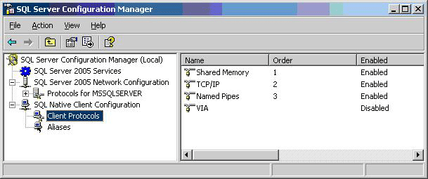
Figure 1 SQL Server Configuration Manager
SQLCMD is the latest incarnation of the isql and osql command-line tools of previous versions of SQL Server. Probably the most interesting feature from an administrator's point of view is the SQLCMD Dedicated Administrator Connection. This connection lets an administrator access an instance of SQL Server even when the instance is not otherwise responding to standard connections. There can be only one such connection to any instance at one time and you must be a member of the sysadmins group to make the connection.
Note The Dedicated Administrator Connection is also available through SQL Server Management Studio. Simply add "ADMIN:" to the beginning of the server name when connecting. The connection is off by default in SQL Server Express Edition, but you can enable it by enabling trace flag 7806.
Because the purpose of the Dedicated Administrator Connection is troubleshooting, there are a number of restrictions on the connection. For example, it supports only TCP/IP, the login's default database is available, and it requires CONTROL_SERVER permission. But SQL Server now has a secure access of last resort that administrators can use to solve database problems when all else fails. For more information, see Using a Dedicated Administrator Connection in SQL Server Books Online.

SQL Server Surface Area Configuration Tool
SQL Server 2005 comes packed with numerous features, many of which are installed in a disabled state. For example, CLR integration, database mirroring, debugging, Service Broker, and mail functions are installed but are not running and not available until you explicitly turn them on or configure them. This design is consistent with the reduction in surface area paradigm of the secure by default philosophy of SQL server, and leads to a reduced attack surface. If a feature is not available or enabled, an attacker cannot make use of it.
The tradeoff is that it can be time consuming to hunt down all of the Transact-SQL statements for turning on features. Even when you discover that the sp_configure system stored procedure does much of what you need, you still have to write non-intuitive code like this:
sp_configure 'show advanced options', 1
reconfigure with override
sp_configure 'clr enabled', 1
There are far too many configuration options to take the time to write this kind of code. So SQL Server includes the SQL Server Surface Area Configuration Tool, which provides a handy GUI for configuring the server. Running it should be the first thing you do after installing SQL Server. To start it, open the Windows Start menu and select All Programs, and then Microsoft SQL Server 2005. Select Configuration Tools, and then SQL Server Surface Area Configuration. The tool opens with a brief explanation of the purpose of the tool, a link to its documentation, and one link to configure services and protocols and another to configure other features.
The configuration tool for services and protocols, shown in Figure 2, displays all of the installed services for all local instances of SQL Server. This is a convenient alternative to using Computer Browser to start, stop, and modify SQL Server services. Some options let you control other server settings, such as Remote Connections, which lets you turn on and turn off remote connections to the server as well as specify whether to use TCP/IP or named pipes or both for communications.
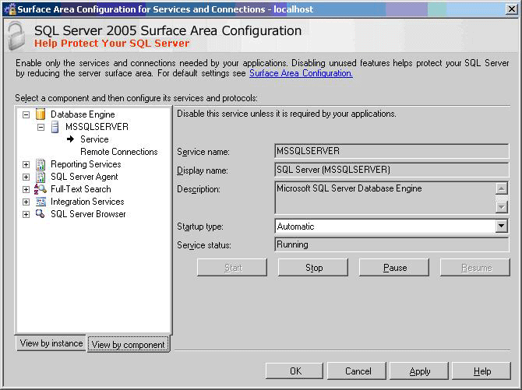
Figure 2 Services and protocols portion of the SQL Server Surface Area Configuration Tool
The configuration tool for features, shown in Figure 3, puts in one place all of the settings to enable various optional features for the server. Some features, such as Native Web Services and Service Broker, display a list of all existing endpoints to the server so that you can selectively turn them on and off. While Microsoft has worked hard to make these features as secure as possible, you should leave any that you don't use disabled. Enabling unused features can open potential attack paths to your server. For example, if you aren't going to write any .NET Common Language Runtime (CLR) extended stored procedures, don't enable it.
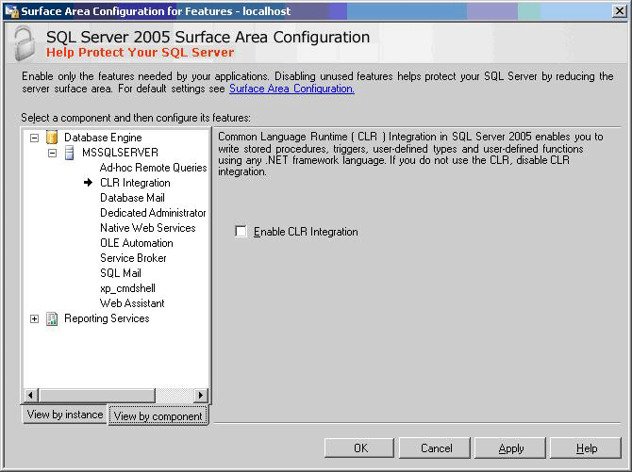
Figure 3 Features portion of the sql Server Surface Area Configuration Tool
This part of the configuration tool provides a list of features for the database engine, Reporting Services, and Analysis Services, as long as the service is currently running.
Following are the features available for each service in the SQL Server Surface Area Configuration Tool.
SQL Server Database Engine Features
- Ad hoc Remote Queries provides support for OPENROWSET and OPENDATASOURCE.
- CLR Integration allows code written using the .NET Common Language Runtime to run.
- Database Mail supports the new Database Mail system to send e-mail messages.
- Remote Dedicated Administrator Connections allows an administrator to connect to a SQL Server over the admin port remotely.
- Native Web Services enables HTTP endpoints to allow HTTP-SOAP connections.
- OLE Automation enables the sp_OA extended stored procedures.
- Service Broker provides queuing and reliable messaging endpoints.
- SQL Mail enables the legacy SQL Mail for sending e-mail messages from the database.
- Web Assistant enables the Web Assistant to generate HTML files from SQL Server.
- xp_cmdshell turns on the xp_cmdshell extended stored procedure to run operating system commands.
Analysis Services Features
- Ad hoc Data Mining Queries allow ad hoc queries through external providers.
- Anonymous Connections allow unauthenticated users to connect to a data store
- Linked Objects enables linking dimensions and measures between instances of Analysis Services.
- User-Defined Functions allows loading user-defined functions from .NET assemblies or COM objects.
Reporting Services Features
- HTTP and Web Service Requests allows report delivery via HTTP.
- Scheduled Events and Report Delivery enables delivery of reports at regular times.
Note There are interdependencies between services and features, so turning one on may cause others to start or become enabled.

Authentication
SQL Server 2000 was developed at a time when data and servers required protection but did not have to withstand the relentless onslaught of attacks seen on the Internet today. The basic authentication question remains the same—who are you and how can you prove it?—but SQL Server 2005 provides much more robust authentication features that provide better support at the security outskirts of the server for letting the good guys in and keeping the bad guys out.
SQL Server Authentication provides authentication for non-Windows-based clients or for applications using a simple connection string containing user ids and passwords. While this logon is easy to use and popular with application developers, it is not as secure as Windows authentication and is not the recommended authentication mechanism
SQL Server 2005 improves on the SQL Server Authentication option. First, it supports encryption of the channel by default through the use of SQL-generated certificates. Administrators do not have to acquire and install a valid SSL certificate to make sure that the channel over which the SQL credentials flow is secure. With SQL Server 2005 automatically generating these certificates, the channel is encrypted by default when transmitting login packets, and only if the client is at the SQL Server 2005 level as well.
Note The native certificate generated by SQL Server protects against passive man-in-the-middle attacks where the attacker is sniffing the network. To further secure your systems against active man-in-the-middle attacks, it is recommended that you deploy and use certificates that are trusted by the clients as well.
SQL Server Authentication is further enhanced by default in SQL Server 2005 because the database engine now supports Windows Group Policy with regards to password complexity, password expiration, and account lockout on SQL logins when used in combination with a Windows 2003 server. This means that you can enforce the same password policy as your Windows accounts.

Password policy enforcement
With SQL Server 2005, password policy enforcement is built into the server. Using the NetValidatePasswordPolicy() API, which is part of the NetAPI32 library on Windows Server 2003, SQL Server validates a password during authentication and during password set and reset in accordance with Windows policies for password strength, expiration, and account lockout. Table 3 lists the settings that comprise the policy.
Table 3 Windows Server 2003 password policy components
Category | Name | Notes
Password Policy | Enforce password history | Prevents users from reusing old passwords, such as alternating between two passwords.
 | Minimum password length
 | Password must meet complexity requirements | See text below.
 | Store passwords using reversible encryption | Allows retrieving the password from Windows. Should never be enabled, unless application requirements outweigh the need for secure passwords. (This policy doesn’t apply to SQL Server.)
Password Expiration | Maximum password age
 | Minimum password age
Account Lockout Policy | Account lockout duration | Time in minutes the account is locked out. Enabled when lockout threshold is > 0.
 | Account lockout threshold | Maximum number of unsuccessful login attempts.
 | Reset account lockout counter after | Time in minutes after which the counter of unsuccessful attempts is reset. Enabled when lockout threshold is > 0.

If you are not running Windows Server 2003, SQL Server still enforces password strength by using simple checks, preventing passwords that are:
- Null or empty
- The same as the name of computer or login
- Any of "password", "admin", "administrator", "sa", "sysadmin"
The same complexity standard is applied to all passwords you create and use in SQL Server, including passwords for the sa login, application roles, database master keys for encryption, and symmetric encryption keys.
The password policy is always checked by default, but you can suspend enforcement for individual logins with either the CREATE LOGIN or ALTER LOGIN statements as in the following code:
CREATE LOGIN bob WITH PASSWORD = 'S%V7Vlv3c9Es8',
CHECK_EXPIRATION = OFF, CHECK_POLICY = OFF
CHECK_EXPIRATION uses the minimum and maximum password age part of the Windows Server 2003 policy, and CHECK_POLICY uses the other policy settings.
Administrative settings also allow turning on and off password policy checks, turning on and off password expiration checks, and forcing a password change the first time a user logs on. The MUST_CHANGE option in CREATE LOGIN forces the user to change the password the next time they log on. On the client side, it allows a password change at logon. All of the new client-side data access technologies will support this, including OLE DB and ADO.NET, as well as client tools such as Management Studio.
If the user unsuccessfully attempts to log on too many times and exceeds the attempts allowed in the password policy, the account may be locked out, based on the settings in the Windows policy. An administrator can unlock the account with the ALTER LOGIN statement:
ALTER LOGIN alice WITH PASSWORD = '3x1Tq#PO^YIAz' UNLOCK

Endpoint authentication
SQL Server 2005 supports both the traditional, binary Tabulate Data Stream for client access to data as well as native XML Web service access using HTTP. The primary benefit of allowing access via HTTP is that any client software and development tools that understand Web service protocols can access data stored in SQL Server. This means SQL Server 2005 can provide standalone Web service methods as well as be a complete endpoint in a Service Oriented Architecture (SOA).
Using SQL Server 2005 as a Web service host requires two general steps, each with plenty of possible variations: defining stored procedures and user-defined functions that provide the Web service methods, and defining an HTTP endpoint that receives method calls via HTTP and routes them to the appropriate procedure. This paper focuses on the security issues involved. For details on configuring and using HTTP endpoints, see SQL Server 2005 Books Online (http://msdn2.microsoft.com/en-us/library/ms130214.aspx).
Because XML Web services in SQL Server uses HTTP and, by default, port 80, most firewalls are configured to allow the traffic to pass. But an unprotected endpoint is a potential vector for attacks and must be secured, so SQL Server is designed with strong authentication and authorization. No endpoints are installed by default with SQL Server and you have to have a high level of permissions to create, alter, and enable HTTP endpoints.
SQL Server 2005 provides five different authentication types, similar to those used by IIS for Web site authentication.
- Basic authentication
Basic authentication is defined as part of the HTTP 1.1 protocol, which transmits the login credentials in clear text that is base-64 encoded. The credential must map to a Windows login, which is then used to authorize access to database resources. If you use Basic authentication, you cannot set the PORTS argument to CLEAR but must instead set it to SSL and use a digital certificate with SSL to encrypt the communication with the client software.
- Digest authentication
Digest authentication is also specified as part of the HTTP 1.1 protocol. It hashes the credentials with MD5 before sending to the server so that they are not sent across the wire, even in encrypted form. The credentials must map to a valid Windows domain account; you cannot use local user accounts.
- NTLM authentication
NTLM uses the challenge-response protocol originally introduced in Microsoft Windows NT® and supported in all client and server versions of Windows since. It provides secure authentication when both client and server are Windows systems, and requires a valid domain account.
- Kerberos authentication
Kerberos authentication is available with Windows 2000 and later, based on an industry-standard protocol available on many operation systems. It allows for mutual authentication in which both the client and server are reasonably assured of the other’s identity and provides a highly secure form of authentication. To use Kerberos on Windows Server 2003, you must register the Kerberos Service Principal Name (SPN) with Http.sys by using the SetSPN.exe utility that is part of the Windows Support Tools.
- Integrated authentication
Integrated authentication provides the best of NTLM and Kerberos authentication. The server uses whichever of the two authentication types the client requests, allowing the most secure authentication the client supports while making the service available to older versions of Windows. You can configure Http.sys in Windows 2003 to negotiate with the client which protocol to use.
The authentication method used for an endpoint is set with the AUTHENTICATION attribute of the CREATE or ALTER ENDPOINT statement. For example, the following code creates an endpoint that uses Kerberos for authentication:
CREATE ENDPOINT myEndpoint
STATE=STARTED
AS HTTP (PATH = '/MyHttpEndpoint',
AUTHENTICATION = (KERBEROS),
PORTS = (CLEAR),
SITE = 'MySqlServer')
FOR SOAP (WSDL = DEFAULT,
DATABASE = 'myDB',
NAMESPACE = 'http://example.com/MySqlServer/myDB/WebService')
SQL Server 2005 supports endpoints that listen both to HTTP as well as a user-defined port on TCP. You can also format requests using a variety of formats: SOAP, Transact-SQL, a format specific to Service Broker, and another used for database mirroring. When using SOAP you can take advantage of WS-Security headers to authenticate SQL Server logins.
Microsoft has implemented Web service endpoint authentication to support a wide variety of protocols and specifications, of which this paper has touched on just a few. You’ll need to explicitly enable your authentication option and ensure that clients are able to provide the type of credentials required. Once the client is authenticated, you can authorize the resources that the login is authorized to access, described in the next section.

Authorization
After authentication, it's time to think about what an authenticated login can do. In this area, SQL Server 2005 is more flexible than earlier versions. Permissions are now far more granular so that you can grant the specific permissions required rather than grant membership in a fixed role that probably carries with it more permissions than are necessary. You now have far more entities—securables—to which you can assign more granular permissions.
In addition to the enhanced protection for user data, structural information and metadata about a particular securable is now available only to principals that have permission to access the securable.
Furthermore, it is possible to create custom permission sets using a mechanism that allows one to define the security context under which stored procedures can run.
In addition, SQL Agent uses a flexible proxy scheme to allow job steps to run and access required resources. All these features make SQL Server more complex but far more secure.

Granular permissions
One of the many ways that SQL Server 2005 is far more secure than earlier versions is the improved granularity of permissions. Previously, an administrator had to grant a user membership in a fixed server role or fixed database role to perform specific operations, but more often than not, those roles had permissions far too broad for simple tasks. The principle of least privilege requires that a user have only the minimum permissions to do a job, so assigning users to a broad role for narrow purposes violates this principle.
The set of fixed server and database roles is largely unchanged from SQL Server 2000, so you can still take advantage of those predefined bundles of permissions when users or applications require all or most of the defined permissions. Probably the biggest change is the addition of a public server role. But the principle of least privilege mandates that you not use a role that isn't a perfect fit for what the principal needs to do a job. Although it requires more work to discover and assign the permissions required for a principal, it can result in a far more secure database environment.

Principals and securables
In SQL Server 2005 a principal is any individual, group, or process that can request access to a protected resource and be granted permission to access it. As in previous versions of SQL Server, a principal can be defined in Windows or can be based on a SQL Server login with no corresponding Windows principal. The following list shows the hierarchy of SQL Server 2005 principals—excluding the fixed server and database roles—and how logins and database users can be mapped to security objects. The scope of the influence of the principal depends on the scope of its definition, so that a Windows-level principal is more encompassing than a SQL Server-level principal, which is more encompassing than a database-level principal. Every database user automatically belongs to the fixed public role.
Windows-level principals
- Windows Domain login
- Windows Local login
- Windows group
SQL Server-level principals
- SQL Server login
- SQL Server login mapped to a Windows login
- SQL Server login mapped to a certificate
- SQL Server login mapped to an asymmetric key
Database-level principals
- Database user
- Database user mapped to SQL Server login
- Database user mapped to a Windows login
- Database user mapped to a certificate
- Database user mapped to an asymmetric key
- Database role
- Application role
- Public role

The other part of authorization is the objects that can be secured through the granting or denying of permissions. Figure 4 lists the hierarchy of securable objects in SQL Server 2005. At the server level, you can secure network endpoints to control the communication channels into and out of the server, as well as databases, bindings, and roles and logins. At the database and schema level, virtually every object you can create is securable, including those that reside within a schema.

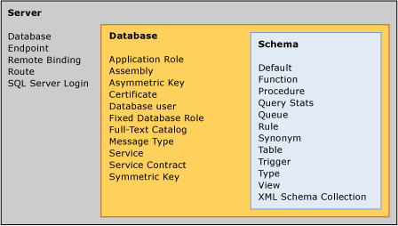
Figure 4 Securable objects hierarchy in SQL Server 2005

Roles and permissions
For a sense of the number of permissions available in SQL Server you can invoke the fn_builtin_permissions system function:
SELECT * FROM sys.fn_builtin_permissions(default)
Here are the new permission types in SQL Server 2005:
- CONTROL. Confers owner-like permissions that effectively grant all defined permissions to the object and all objects in its scope, including the ability to grant other grantees any permissions. CONTROL SERVER grants the equivalent of sysadmin privileges.
- ALTER. Confers permission to alter any of the properties of the securable objects except to change ownership. Inherently confers permissions to ALTER, CREATE, or DROP securable objects within the same scope. For example, granting ALTER permissions on a database includes permission to change its tables.
- ALTER ANY <securable object>. Confers permission to change any securable object of the type specified. For example, granting ALTER ANY ASSEMBLY allows changing any .NET assembly in the database, while at the server level granting ALTER ANY LOGIN lets the user change any login on that server.
- IMPERSONATE ON <login or user>. Confers permission to impersonate the specified user or login. As you'll see later in this article, this permission is necessary to switch execution contexts for stored procedures. You also need this permission when doing impersonating in a batch.
- TAKE OWNERSHIP. Confers the permission to the grantee to take ownership of the securable, using the ALTER AUTHORIZATION statement.
SQL Server 2005 still uses the familiar GRANT, DENY, and REVOKE scheme for assigning or refusing permissions on a securable object to a principal. The GRANT statement is expanded to cover all of the new permission options, such as the scope of the grant and whether the principal is able to grant the permission to other principals. Cross-database permissions are not allowed. To grant such permissions, you create a duplicate user in each database and separately assign each database's user the permission.
Like earlier versions of SQL Server, activating an application role suspends other permissions for the duration that the role is active. However, new in SQL Server 2005, is the ability to unset an application role. Another difference between SQL Server 2000 and 2005 is that when activating an application role, the role also suspends any server privilege, including public. For example, if VIEW ANY DEFINITION is granted to public, the application role won’t honor it. This is most noticeable when accessing server-level metadata under an application role context.
Note The new, preferred alternative to application roles is to use execution context in code modules. For more information, see Execution Context in this paper.
Granting a particular permission can convey the rights of other permissions by implication. The ALTER permission on a schema, for example, "covers" more granular and lower-level permissions that are "implied." Figure 5 displays the implied permissions for ALTER SCHEMA. SQL Server Books Online (http://msdn2.microsoft.com/en-us/library/ms130214.aspx) contains the Transact-SQL code for an ImplyingPermissions user-defined function that assembles the hierarchy list from the sys.fn_builtin_permissions catalog view and identifies the depth of each permission in the hierarchy. After adding ImplyingPermissions to the master database I executed this statement to produce Figure 5, passing in the object and permission type:
SELECT * FROM master.dbo.ImplyingPermissions('schema', 'alter')
ORDER BY height, rank
This is a great way to explore the permissions hierarchy in SQL Server 2005.

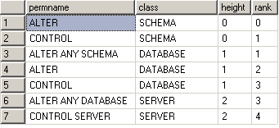
Figure 5 Hierarchy of implied permissions of ALTER SCHEMA
When you consider the number and types of principals available, the number of securable objects in the server and a typical database, and the sheer number of available permissions and the covered and implied permissions, it quickly becomes clear just how granular permissions can be in SQL Server 2005. Creating a database now requires a much more detailed analysis of its security needs and careful control of permissions on all objects. But this analysis is well worth it and using the new capabilities in SQL Server 2005 results in more secure databases.

Metadata security
One benefit of the newly granular permission scheme is that metadata as well as data is now protected. In earlier versions of SQL Server, a user with any access to a database could see the metadata of all objects within the database, whether or not the user could access the data within it or execute a stored procedure.
SQL Server 2005 examines the permissions a principal has within the database and reveals the metadata of an object only if the principal is the owner or has some permission on the object. There is also a VIEW DEFINITION permission that can grant permission to view metadata information even without other permissions in the object.
This protection extends to the error messages returned from operations to access or update an object that the user has no access to. Rather than acknowledging that there is indeed a table named Address and give an attacker confirmation that she is on track, SQL Server returns an error message with alternate possibilities. For example, if a user with no permissions on any object in the database attempts to drop the Address table, the following error message is displayed:
Msg 3701, Level 14, State 20, Line 1
Cannot drop the table 'Address', because it does not exist or you do not have permission.
This way, an attacker gets no confirmation that an Address table actually exists. But someone debugging this problem still only has a limited number of possibilities to explore.

SQL Agent proxies
One of the best examples of the new and improved authorization model in SQL Server 2005 is SQL Agent. You can define various credentials often associated with Windows logins—linked to users with the necessary permissions to perform one or more SQL Agent steps. An SQL Agent proxy then links a credential with a job step to provide the necessary permissions.
This provides a granular means of following the principle of least privilege: granting a job step the permissions it needs and no more. You can create as many proxies as you wish, associating each of them with one or more SQL Agent subsystems. This is in stark contrast to the all-powerful proxy account in SQL Server 2000 which let the user create job steps in any of the SQL Agent subsystems.
Note When you upgrade a server from SQL Server 2000, a single proxy account is created and all subsystems are assigned to that single proxy account so that existing jobs will continue to run. After upgrading, to create credentials and proxy accounts to implement a more secure, granular set of proxies to protect server resources.
Figure 6 shows the Object Explorer in Management Studio with a list of subsystems available in SQL Agent. Each subsystem can have one or more proxies associated with it that grant the appropriate permissions for a job step. The one exception to this scheme is that Transact-SQL subsystems execute with the permissions of the module owner as they did in SQL Server 2000.

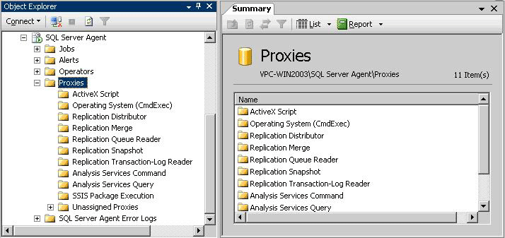
Figure 6 SQL Agent subsystems you can associate with proxies
Upon a fresh installation of SQL Server, only the System Administrator role has permissions to maintain SQL Agent jobs, and the management pane in the Management Studio Object Explorer is only available to sysadmins. SQL Server 2005 makes available a few other roles you can use to grant various levels of permissions. You can assign users to the SQLAgentUser, SQLAgentReaderRole, or SQLAgentOperator roles, each of which grants increasing levels of permission to create, manage, and run jobs, or the MaintenanceUser role, which has all the permissions of SQLAgentUser plus the ability to create maintenance plans.
Members of the sysadmin role, of course, can do anything they want in any of the subsystems. To grant any other user rights to use subsystems requires the creation of at least one proxy account, which can grant rights to one or more subsystems. Figure 7 shows how a proxy account, MyProxy, is assigned to multiple principals, here a user and a role. The proxy account uses a credential, which links it to an account, usually a domain account, with permissions in the operating system necessary to perform whatever tasks are required by the subsystem. Each proxy can have one or more subsystems associated with it that grant the principal the ability to run those subsystems.

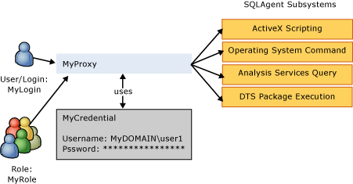
Figure 7 SQL Agent proxy account for various subsystems
The following code shows the Transact-SQL code necessary to implement the scheme shown in Figure 7. It starts by creating a credential, a database object that provides the link to the operating system account with rights to perform the desired actions in the subsystems. Then it adds a proxy account, MyProxy, that is really just a friendly name for the credential. Next, it assigns the proxy to two principals, here a SQL Server login and a custom role. Finally it associates the proxy with each of the four SQL Agent subsystems.
CREATE CREDENTIAL MyCredential WITH IDENTITY = 'MyDOMAIN\user1'
GO
msdb..sp_add_proxy @proxy_name = 'MyProxy',
@credential_name = 'MyCredential'
GO
msdb..sp_grant_login_to_proxy @login_name = 'MyLogin',
@proxy_name = 'MyProxy'
GO
msdb..sp_grant_login_to_proxy @login_name = 'MyRole',
@proxy_name = 'MyProxy'
GO

sp_grant_proxy_to_subsystem @proxy_name = 'MyProxy',
@subsystem_name = 'ActiveScripting'
GO
sp_grant_proxy_to_subsystem @proxy_name = 'MyProxy',
@subsystem_name = 'CmdExec'
GO
sp_grant_proxy_to_subsystem @proxy_name = 'MyProxy',
@subsystem_name = 'ANALYSISQUERY'
GO
sp_grant_proxy_to_subsystem @proxy_name = 'MyProxy',
@subsystem_name = 'DTS'
GO
Management Studio provides full support for creating credentials and proxies as shown in Figure 8. This creates the same proxy as the previous code.

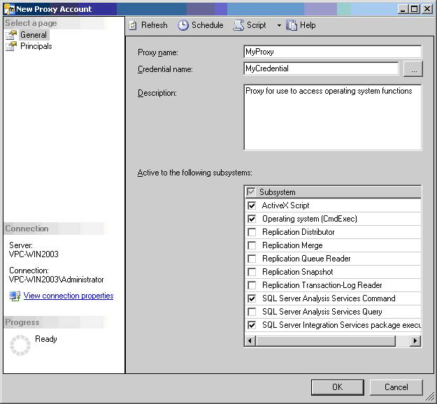
Figure 8 A new SQL Agent proxy in SQL Server Management Studio
A proxy is not a way to circumvent security in the operating system. If the credential used with a proxy doesn't have the permission in Windows, such as to write to a directory across the network, the proxy won't have it either. You can also use a proxy to grant limited execution rights to xp_cmdshell, since it is a favorite tool used by attackers to extend their reach into the network once they compromise a SQL Server computer. The proxy provides this protection because even if the principal has unlimited rights on the network—a domain administrator—any commands executed through the proxy have only the limited rights of the credential account.

Execution context
SQL Server has long supported the concept of ownership chaining as a way of ensuring that administrators and application developers have a way to check permissions upfront on the entry points to the database rather than being required to provision permissions on all objects accessed. As long as the user calling the module (stored procedure, function) or view had execute permissions on the module (or select permissions on the view) and the owner of the module (or view) was the owner of the objects accessed (an ownership chain), no permissions were checked on the underlying objects, and the caller received the data requested.
If the ownership chain was broken because the owner of the code didn't own the referenced object, permissions were checked against the caller's security context. If the caller had permission to access the object, the data was returned. If she didn't, an error would be raised.
Ownership chaining has some limitations—it applies only to data manipulation operations and not to dynamic SQL. Plus, if access were made to objects across ownership boundaries, ownership chaining would not be possible. Hence this upfront permissions checking behavior only worked for certain cases.
SQL Server 2005 introduces the ability to mark modules with an execution context, such that the statements within the module can execute as a particular user as apposed to the calling user. This way, while the calling user still needs permissions to execute the module, the permissions for statements within the module are checked against the execution context that the module was marked with. This behavior can be used to overcome some of the shortcomings of ownership chaining because it applies to all statements within the module. Administrators wanting to perform upfront permission checking can use the execution context to do that.
Now when you define user-defined functions (except inline table-valued), stored procedures, and triggers you can use the EXECUTE AS clause to specify which user's permissions SQL Server uses to validate access to objects and data referenced by the procedure:
CREATE PROCEDURE GetData(@Table varchar(40))
WITH EXECUTE AS 'User1'
SQL Server 2005 provides four EXECUTE AS options.
- EXECUTE AS CALLER specifies that the code is executed in the security context of the caller of the module; no impersonation occurs. The caller must have access permissions on all of the objects referenced. But SQL Server only checks permissions for broken ownership chains, so if the owner of the code also owns the underlying objects, only the module's execute permission is checked. This is the default execution context for backward compatibility.
- EXECUTE AS 'user_name' specifies that the code executes in the security context of the specified user. This is a great option if you don't want to rely on ownership chaining. Instead, you create a user with the necessary permissions to run the code and create custom permission sets.
- EXECUTE AS SELF is a shortcut notation for specifying the security context of the user who is creating or altering the module. SQL Server internally saves the actual user name associated with the module rather than "SELF."
- EXECUTE AS OWNER specifies that the security context is that of the current owner of the module at the time of module execution. If no owner is specified, the context of the containing schema's owner is used. This is a great option when you want to be able to change the module's owner without changing the module itself.
Any time the user context changes using the EXECUTE AS option, the creator or alterer of the module must have IMPERSONATE permissions for the specified user. You cannot drop the specified user from the database until the execution context of all modules has been changed to other users.

User/schema separation
SQL Server 2000 had no concept of a schema, which the ANSI SQL-99 specification defines as a collection of database objects owned by a single principal that forms a single namespace of objects. A schema is a container for database objects such as tables, views, stored procedures, functions, types, and triggers. It functions much as a namespace functions in the .NET Framework and XML, a way to group objects so that a database can reuse object names—such as allowing both dbo.Customer and Fred.Customer to exist in a single database—and to group objects under different owners.
Note You’ll need to switch to new catalog views like sys.database_sys.principals, sys.schemas, sys.objects, etc. The reason is that the old sysobjects system table did not “know” about schemas, and so was incapable of supporting U/S separation. Besides, the old catalog views are deprecated, so they’ll be dropped in a future version of SQL Server.
How schemas worked in SQL Server 2000 is shown in the top portion of Figure 9. When an administrator created a user Alice in a database, SQL Server would automatically create a schema Alice that hid behind Alice the user. If Alice logged on to a server running SQL Server without database ownership and created Table1, the actual name of the table was Alice.Table1. The same held for other objects Alice created, such as Alice.StoredProcedure1 and Alice.View1. If Alice were a database owner or a sysadmin, the objects she created would be part of the dbo schema instead. Although we used to say that dbo owned the objects, it amounts to the same thing.

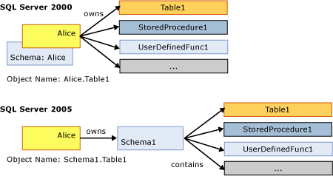
Figure 9 User/schema/objects in SQL Server 2000 and 2005
The problem with the unification of users and schemas in SQL Server 2000 arises when you need to change the ownership of objects, such as when Alice leaves the company and Lucinda takes over Alice's job. A system administrator would have to change ownership of all of the objects owned by Alice to Lucinda. More of a problem is that any Transact-SQL or client application code that referred to Alice.Table1 would have to be changed to Lucinda.Table1 after Lucinda took ownership of the table. Depending on the number of objects Alice owns and how many applications had the name embedded in them, this could be a major undertaking. Microsoft has long recommended that all database objects be owned by the built-in dbo to get around these problems. It was far easier to change a database's ownership than to change many objects and client applications.
Note Don't be confused by the SQL Server 2000 CREATE SCHEMA statement. This was just an easy way to create tables and views owned by a particular user and to grant permissions. You could use the statement to name a schema's owner but not name the schema. The owner was still irrevocably linked to the schema with all the problems of changing ownership.
SQL Server 2005 cleans this up and implements the SQL-99 schema by separating the user from the schema as shown in the bottom part of Figure 9. When you create a new user Alice using the new CREATE USER DDL, SQL Server no longer automatically creates a schema with the same name. Instead you must explicitly create a schema and assign ownership of it to a user. Because all of the database objects shown are now contained in the Schema1 schema, which Alice initially owns, it becomes simple to change ownership of all the schema's objects by simply changing the ownership of the schema to Lucinda. Each user can also have a default schema assigned to it, so that any objects referenced by name without the schema reference are assumed to be in the default schema. In the bottom part of Figure 9, if Alice has Schema1 as her default schema, she can refer to the table as either Schema1.Table1 or simply as Table1. User Carol, who perhaps does not have a default schema associated with her user name, would have to refer to the table as Schema1.Table1. Any user without a default schema defined has dbo as the default.
Fully qualified object names in SQL Server 2005 have a four-part structure, similar to those in earlier versions of SQL Server:
server.database.schema.object
As in earlier versions, you can omit the server name if the object is on the same server as that where the code is running. You can omit the database name if the connection has the same database open, and you can omit the schema name if it is either the default schema for the current user or is owned by dbo, since that is the schema of last resort as SQL Server tries to disambiguate an object name.
Use the CREATE USER statement, instead of sp_adduser, to create new users. This system stored procedure is still around for backward compatibility and has been changed a bit to conform to the new separation of users from schemas. sp_adduser creates a schema with the same name as the new user name or the application role and assigns the schema as the default schema for the user, mimicking SQL Server 2000 behavior but providing a separate schema.
Note When using the ALTER AUTHORIZATION statement, it is possible to arrive in a state where YOU own a table in MY schema (or vice versa). This has some serious implications. For example, who owns the trigger on that table: me or you? The bottom line is that it can now be very tricky to discover the true owner of a schema-scoped object or type. There are two ways to get around this:
- Use OBJECTPROPERTY(id, 'OwnerId') to discover the true owner of an object.
- Use TYPEPROPERTY(type,'OwnerId') to discover the true owner of a type.
SQL Server 2005 can help save keystrokes with synonyms. You can create a synonym for any object using the two-, three-, or four-part full object name. SQL Server uses the synonym to access the defined object. In the following code, the History synonym represents the specified schema.table in the AdventureWorks database. The SELECT statement returns the contents of the EmployeeDepartmentHistory table.
USE AdventureWorks
GO

CREATE SYNONYM History FOR HumanResources.EmployeeDepartmentHistory

SELECT * FROM History
Note The administrator or owner must grant permission on the synonym if someone else is to use it. GRANT SELECT on a synonym to a view or table or table-valued function. GRANT EXECUTE on a synonym to a procedure or scalar function, etc.
The History synonym could also have been defined for the complete, four-part name as in the following code:
CREATE SYNONYM History
FOR MyServer.AdventureWorks.HumanResources.EmployeeDepartmentHistory
Using the full, four-part name like this allows the use of the synonym from another database context, assuming the current user has permissions to use the synonym and read the table:
USE pubs
SELECT * FROM AdventureWorks..History
Note too that if you don’t provide a schema name as part of the new synonym name, it will be part of the default schema.

Database Security
Security at the server level is probably the greatest concern for system administrators, but the database is where all the action is in a production environment. For the most part, a database administrator can let the database developer worry about the details in the database, as long as the developer works within the constraints of the environment. SQL Server 2005 provides plenty of new features for securing the database.

Data encryption
SQL Server 2000 and earlier versions did not have built-in support for encrypting the data stored in a database. Why would you need to encrypt data that is stored in a well-secured database on a secure server nestled safely behind state-of-the-art firewalls? Because of an important, age-old security principal called defense in depth. Defense in depth means layering defenses so that even if attackers successfully pierce your outermost defenses they still have to get through layer after layer of defense to get to the prize. In a database, it means that if an attacker gets through the firewall and through Windows security on the server to the database, she still has to do some nasty brute force hacking to decrypt your data. And in these days of legislated data and privacy protection, data needs to have strong protection.
SQL Server 2005 has rich support for various types of data encryption using symmetric and asymmetric keys, and digital certificates. Best of all, it takes care of managing the keys for you, since key management is by far the hardest part of encryption. Keeping secrets secret is never easy.
Data encryption is largely an application development topic, so this paper does not go into detail in this area. But as an administrator, you'll probably need to manage at least the upper level of keys in the hierarchy shown in Figure 10. Database administrators need to understand the service master key at the server level and the database master key at the database level. Each key lower in the hierarchy is protected by its immediate parent, which is in turn protected by its parent, on up the tree. The one exception is where a password is used to protect a symmetric key or certificate, which is how SQL Server lets users manage their own keys and take responsibility for keeping the key secret.

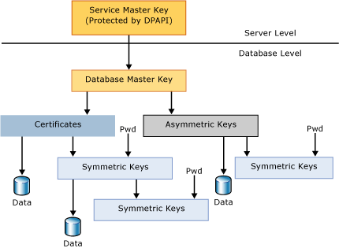
Figure 10 Encryption key hierarchy in SQL Server 2005
Note Microsoft recommends against using certificates or asymmetric keys for encrypting data directly. Asymmetric key encryption is orders of times slower and the amount of data that can be protected by this mechanism is limited, depending on the key modulus. Certificates and asymmetric keys can be protected by a password instead of by the database master key.
The service master key is the one key that rules them all—all the keys and certificates in SQL Server. It is a symmetric key that is created automatically when you install SQL Server. It is obviously a critical secret because if it is compromised an attacker can eventually decipher every key in the server that is managed by SQL Server. It is protected by the Data Protection API (DPAPI) in Windows.
SQL Server manages the service master key for you, although you can perform maintenance tasks on it to dump it to a file, regenerate it, and restore it from a file. But most of the time you won't need or want to make any of these changes to the key. It is strongly recommended that administrators back up their service master keys in case of key corruption.
Within the scope of a database, the database master key is the root encryption object for all keys, certificates, and data in the database. Each database can have a single master key; you'll get an error if you try to create a second key. You must create a database master key before using it by using the CREATE MASTER KEY Transact-SQL statement with a user-supplied password:
CREATE MASTER KEY ENCRYPTION BY PASSWORD = 'EOhnDGS6!7JKv'
The key is encrypted with a triple DES key derived from the password as well as the service master key. The first copy is stored in the database while the second is stored in the master database. Having the database master key protected by the service master key makes it possible for SQL Server to automatically decrypt the database master key when required. The end application or user does not need to open the master key explicitly using the password and is a major benefit of having the keys protected in the hierarchy.
Detaching a database with an existing master key and moving it to another server can be an issue. The problem is that the new server's service master key is different from that of the old server. As a result, the server cannot automatically decrypt the database master key. This can be circumvented by opening the database master key with the password with which it is encrypted and using the ALTER MASTER KEY statement to encrypt it by the new service master key. Otherwise, the database master key will always have to be explicitly opened before use.
Once the database master key exists, developers can use it to create any of three types of keys, depending on the type of encryption required:
- Asymmetric keys, used for public key cryptography with a public and private key pair
- Symmetric keys, used for shared secrets where the same key both encrypts and decrypts data
- Certificates, essentially wrappers for a public key
With all the encryption options and its deep integration into the server and database, encryption is now a viable way to add a final layer of defense to your data. But use the tool judiciously because encryption adds a lot of processing overhead to your server.

Code module signing
One of the nice benefits of having encryption within SQL Server is that it provides the ability to digitally sign code modules (stored procedures, functions, triggers, and event notifications) with certificates. This provides much more granular control over access to database tables and other objects. Like encrypting data, you sign the code with the private key contained within the certificate. The result is that the tables used in the signed code module are accessible only through the code and not allowed outside of the code module. In other words, access to the tables are only provisioned to the certificates that have been used to sign the module.
The effect can be the same with a stored procedure. For example, if it has an unbroken ownership chain, you carefully control which users get EXECUTE permission on the procedure, and you deny direct access to the underlying tables. But this doesn’t help in situations such as when the procedure has a broken ownership chain or executes dynamic SQL, requiring that the user executing the procedure have permissions to the underlying tables. Another way to achieve the same effect is to use EXECUTE AS, but this changes the security context under which the procedure executes. This may not be desirable, for example, if you need to record in the table the user who actually caused the procedure to run (short of requiring a user name as a parameter to the procedure).
Signing code modules has the additional benefit of protecting against unauthorized changes to the code module. Like other documents that are digitally signed, the certificate is invalidated when the code changes. The code doesn’t execute under the context of the certificate, so any objects that have their access provisioned to the certificate will not be accessible.
To do this, you create a certificate, associate it with a new user, and sign the procedure with the certificate. Grant this user whatever permissions are necessary to execute the stored procedure. In essence, this user is added to the security context of the stored procedure as a secondary identity. Then grant execute permissions to whatever users or roles need to execute the procedure. The following code shows these steps. Assume that you want to sign the mySchema.GetSecretStuff procedure, and that all of the referenced objects already exist in the database:
CREATE CERTIFICATE certCodeSigning
ENCRYPTION BY PASSWORD = 'cJI%V4!axnJXfLC'
WITH SUBJECT = 'Code signing certificate'
GO

-- Sign the stored procedure
ADD SIGNATURE TO mySchema.GetSecretStuff BY CERTIFICATE certCodeSigning
WITH PASSWORD = 'cJI%V4!axnJXfLC'
GO

-- Map a user to the certificate
CREATE USER certUser FOR CERTIFICATE certCodeSigning
GO

--Assign SELECT permissions to new certUser
GRANT SELECT ON SocialSecurity TO certUser
GO

-- Grant execute permission to the user who will run the code
GRANT EXECUTE ON mySchema.GetSecretStuff TO ProcedureUser
GO
Now only users explicitly granted EXECUTE permission on the stored procedure are able to access the table’s data.

DDL triggers
DDL triggers are an interesting addition to database security. Unlike DML triggers that execute Transact-SQL code when data in a table changes, a DDL trigger fires when the structure of the table changes. This is a great way to track and audit structural changes to a database schema.
The syntax for these triggers is similar to that of DML triggers. DDL triggers are AFTER triggers that fire in response to DDL language events; they do not fire in response to system-stored procedures that perform DDL-like operations. They are fully transactional, and so you can ROLLBACK a DDL change. You can run either Transact-SQL or CLR code in a DDL trigger. DDL triggers also support the EXECUTE AS clause similar to other modules.
The information about the trigger event is materialized as untyped XML. It is available though a new, XML-emitting built-in function called EVENTDATA(). You can use XQuery expressions to parse the EVENTDATA() XML in order to discover event attributes like schema name, target object name, user name, as well as the entire Transact-SQL DDL statement that caused the trigger to fire in the first place. You will find examples in SQL Server Books Online (http://msdn2.microsoft.com/en-us/library/ms130214.aspx).
Database-level DDL triggers fire on DDL language events at the database level and below. Examples are CREATE_TABLE, ALTER_USER, and so on. Server-level DDL triggers fire on DDL language events at the server level, for example CREATE_DATABASE, ALTER_LOGIN, etc. As an administrative convenience, you can use event groups like DDL_TABLE_EVENTS as a shorthand to refer to all CREATE_TABLE, ALTER_TABLE, and DROP_TABLE events. The various DDL event groups and event types, and their associated XML EVENTDATA(), are documented in SQL Server Books Online.
Unlike DML trigger names, which are schema-scoped, DDL trigger names are database scoped or server-scoped.
Use this new catalog view to discover trigger metadata for DML triggers and database-level DDL triggers:
SELECT * FROM sys.triggers ;
GO
If the parent_class_desc column has a value of 'DATABASE' then it is a DDL trigger and the name is scoped by the database itself. The body of a Transact-SQL trigger is found in the sys.sql_modules catalog view, and you can JOIN it to sys.triggers on the object_id column. The metadata about a CLR trigger is found in the sys.assembly_modules catalog view, and again, you can JOIN to sys.triggers on the object_id column.
Use this catalog view to discover metadata for server-scoped DDL triggers:
SELECT * FROM sys.server_triggers ;
GO
The body of a Transact-SQL server-level trigger is found in the sys.server_sql_modules catalog view, and you can JOIN it to sys.server_triggers on the object_id column. The metadata about a CLR server-level trigger is found in the sys.server_assembly_modules catalog view, and again, you can JOIN to sys.server_triggers on the object_id column.
You can use DDL triggers to capture and audit DDL activity in a database. Create an audit table with an untyped XML column. Create an EXECUTE AS SELF DDL trigger for the DDL events or event groups you are interested in. The body of the DDL trigger can simply INSERT the EVENTDATA() XML into the audit table.
Another interesting use of DDL triggers is to fire on the CREATE_USER event and then add code to automate permissions management. For example, suppose you want all database users to get a GRANT EXECUTE on procedures P1, P2, and P3. The DDL trigger can extract the user name from the EVENTDATA() XML, dynamically formulate a statement like 'GRANT EXECUTE ON P1 TO someuser', and then EXEC() it.

Conclusion
SQL Server 2005 provides rich security features to protect data and network resources. It is much easier to install securely, since all but the most essential features are either not installed by default or disabled if they are installed. SQL Server provides plenty of tools to configure the server, particularly the SQL Server Surface Area Configuration Tool. Its authentication features are stronger because they is more closely integrated with Windows authentication and protect against weak or ancient passwords. Granting and controlling what a user can do when authenticated is far more flexible with granular permissions, SQL Agent proxies, and execution context. Even metadata is more secure, since the system metadata views return information only about objects that the user has permission to use in some way. At the database level, encryption provides a final layer of defense while the separation of users and schemas makes managing users easier.

For more information:
http://www.microsoft.com/technet/prodtechnol/sql/2005/library/security.mspx

Did this paper help you? Please give us your feedback. On a scale of 1 (poor) to 5 (excellent), how would you rate this paper?!href(mailto: sqlfback@microsoft.com?subject=Feedback: SQL Server 2005 Security: Strong Security That’s Easy to Configure and Manage)

