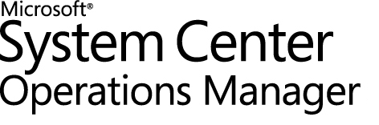

SQL Server Management Pack Guide for System Center Operations Manager
Microsoft Corporation
Published: October 2013
Send suggestions and comments about this document to mpgfeed@microsoft.com. Please include the management pack guide name with your feedback.
Information in this document, including URL and other Internet Web site references, is subject to change without notice. Unless otherwise noted, the companies, organizations, products, domain names, e-mail addresses, logos, people, places, and events depicted in examples herein are fictitious. No association with any real company, organization, product, domain name, e-mail address, logo, person, place, or event is intended or should be inferred. Complying with all applicable copyright laws is the responsibility of the user. Without limiting the rights under copyright, no part of this document may be reproduced, stored in or introduced into a retrieval system, or transmitted in any form or by any means (electronic, mechanical, photocopying, recording, or otherwise), or for any purpose, without the express written permission of Microsoft Corporation.
Microsoft may have patents, patent applications, trademarks, copyrights, or other intellectual property rights covering subject matter in this document. Except as expressly provided in any written license agreement from Microsoft, the furnishing of this document does not give you any license to these patents, trademarks, copyrights, or other intellectual property.
© 2012 Microsoft Corporation. All rights reserved.
Microsoft, MS-DOS, Windows, Windows Server, and Active Directory are trademarks of the Microsoft group of companies. All other trademarks are property of their respective owners.
Revision History

Release Date | Changes
March, 2007 | Original release of this guide
June 25, 2007 | New or changed topic sections in this release:  - New section "Create a New Management Pack for Customizations" in the "Getting Started" topic  - Changed section "Key Scenarios" in the "Understanding the SQL Server Management Pack" topic
October 21, 2007 | New topic in this release:  - Monitors and Overrides for Management Packs
February 1, 2008 | Added "Changes in This Update" section to list the changes in the December 2007 update to the management pack.
March 24, 2008 | New or changed topic sections in this release:  - Added "Changes in This Update" section to list the changes in the March 2008 update to the management pack.  - New content was added to the “Key Monitoring Scenarios” section to discuss exclusions and long-running agent jobs.
October 2008 | - Added "Changes in This Update" section to list the changes in the October 2008 update to the management pack.  - Added a “Supported Configurations” section to this guide.  - Various updates were made to the guide to account for the introduction of the SQL Server 2008 Management Pack.  - Add “Known Issues” section.
November 2008 | Updated the “Changes in This Update” section.
March 2009 | Updated the following sections in the Guide: “Changes in This Update,” “Low-Privilege Environments,” “Known Issues.”
July 2009 | - Updated the “Changes in This Update” section.  - Updated “Configuring for Monitoring Clustered Resources” in the “Other Requirements” section.  - Updated “Rules and monitors that are based on events from the event log do not work reliably on clustered installations of SQL” in Appendix: Known Issues.  - Updated “SQL Database Space Report” in Appendix: Reports.
November 2009 | - Added note to “Supported Configurations” that monitoring of Microsoft SQL Server 2000 Desktop Engine (MSDE) is not supported.  - Removed duplicate monitor names from list in “Before You Import the Management Pack” section.  - Reworded note in “Configuration for Monitoring Clustered Resources” to clarify software requirements.
July 2010 | Extensive updates were made to the guide to account for the introduction of the SQL Server 2008 R2 Management Pack. New sections include “Import the Management Pack” and “Appendix: Monitors”.
March 2011 | - Updated the “Run As Profiles” section with detailed information about Run As accounts mapping targets.  - Updated the “Changes in This Update” section.  - Updated “Configuration for Monitoring Clustered Resources” in the “Other Requirements” section.
February 2012 | - Updated the “Run As Profiles” section with detailed information about Run As accounts mapping targets.  - Added information about support SQL Server 2012 and SCOM 2012.  - Added support for AlwaysOn Monitoring  - Added support for Policy based management monitoring information  - Added support for Mirroring monitoring information  - Added support for Replication Monitoring information  - DB Space monitoring update with information about mount points support  - Updated the “Changes in This Update” section  - Updated “Configuration for Monitoring Clustered Resources” in the “Other Requirements” section.  - Other small changes
August 2012 | - Fixed DB File Group Free Space bug
September 2013 | - Added new monitors and performance collection rules  - Added DB Dashboard  - A number of bug fixes
October 2013 | - Fixed CPU Utilization Monitor  - Fixed SQL Server seed discovery for WoW64 environments  - Alert severity of Average Wait Time Monitor was changed to Warning, added consecutive sampling to reduce noise, threshold was changed to 250  - Alert severity of SQL Re-Compilation monitor was changed to Warning, threshold was changed to 25. The monitor was disabled by default.  - Minor fixes

Contents
Introduction to the SQL Server Management Pack Guide 9
Getting Started 19
Security Considerations 28
Understanding the SQL Server 2008 and SQL Server 2008 R2 Mirroring Management Pack 36
Understanding the SQL Server 2012 AlwaysOn Management Pack 43
Understanding the SQL Server Management Pack 49
Appendix: Known Issues and Troubleshooting 66
Appendix: Monitors 70
Appendix: Reports 84
Appendix: Mirroring Management Pack Contents 89
Appendix: AlwaysOn Management Pack Contents 92

Introduction to the SQL Server Management Pack Guide
The SQL Server Management Pack provides both proactive and reactive monitoring of Microsoft SQL Server 2005, SQL Server 2008, SQL Server 2008 R2 and SQL Server 2012. It monitors SQL Server components such as database engine instances, databases, and SQL Server agents.
The monitoring provided by this management pack includes availability and configuration monitoring, performance data collection, and default thresholds. You can integrate the monitoring of SQL Server components into your service-oriented monitoring scenarios.
In addition to health monitoring capabilities, this management pack includes dashboard views, extensive knowledge with embedded inline tasks, and views that enable near real-time diagnosis and resolution of detected issues.
Document Version
This guide was written based on the 6.4.1.0 Management Pack.
Getting the Latest Management Pack and Management Pack Documentation
You can find the SQL Server Management Pack at the System Center Operations Manager catalog (http://go.microsoft.com/fwlink/?LinkId=82105). The latest version of this document is available on Microsoft TechNet http://go.microsoft.com/fwlink/?LinkId=85414.
Changes in October 2013 Update
SQL Server Management Pack version 6.4.1.0 includes the following changes:
- Fixed CPU Utilization Monitor
- Fixed SQL Server seed discovery for WoW64 environments
- Alert severity of Average Wait Time Monitor was changed to Warning, added consecutive sampling to reduce noise, threshold was changed to 250
- Alert severity of SQL Re-Compilation monitor was changed to Warning, threshold was changed to 25. The monitor was disabled by default.
- Minor fixes
Changes in September 2013 Update
SQL Server Management Pack version 6.4.0.0 includes the following changes:
- New Dashboard for SQL Server 2012 DB
- New Monitors and Rules – only for SQL 2008 and SQL 2012
  - Collect DB Active Connections count
  - Collect DB Active Requests count
  - Collect DB Active Sessions count
  - Collect DB Active Transactions count
  - Collect DB Engine Thread count
  - Thread Count monitor
  - Transaction Log Free Space (%) monitor
  - Transaction Log Free Space (%) collection
  - Collect DB Engine CPU Utilization (%)
  - CPU Utilization (%) monitor for DB engine
  - Buffer Cache Hit Ratio monitor
  - Collect DB Engine Page Life Expectancy (s)
  - Page Life Expectancy monitor
  - Collect DB Disk Read Latency (ms)
  - Collect DB Disk Write Latency (ms)
  - Disk Read Latency monitor
  - Disk Write Latency monitor
  - Collect DB Transactions per second count
  - Collect DB Engine Average Wait Time (ms)
  - Average Wait Time monitor
  - Collect DB Engine Stolen Server Memory (MB)
  - Stolen Server Memory monitor
  - Collect DB Allocated Free Space (MB)
  - Collect DB Used Space (MB)
  - Collect DB Disk Free Space (MB)
  - SQL Re-Compilation monitor
- SPN monitor improved
- Support for special symbols in DB names.
- Improved AlwaysOn seed discovery
- Run As configuration changes to support Low privilege for SQL Server 2012 Cluster
- Improved performance of AlwaysOn discovery
- Custom User Policy Discovery and Monitoring performance optimization
- Hided AG health object from Diagram view
- Minor changes
Changes in August 2012 Update
SQL Server Management Pack version 6.3.173.1 includes the following changes:
- Fixed DB File Group Free Space bug
Changes in February 2012 Update
SQL Server Management Pack version 6.3.173.0 includes the following changes:
- Added support of SQL Server 2012
- Added support of SQL Server 2012 AlwaysOn Monitoring
  - Automatically discover and monitor availability groups, availability replicas, and database replicas for hundreds of computers.
  - Health roll-up from database replicas to availability replicas.
  - Detailed knowledge with every critical health state to enable faster resolution to a problem.
- Seamless integration with Policy Based Management (PBM)
  - Auto-discover custom PBM polices targeting AlwaysOn and database components.
  - Rollup of health of policy execution within the SQL monitoring pack under extended health.
  - SQL DB PBM monitoring is supported
- Added support of SQL Server 2008 Mirroring monitoring (only applicable to SQL Server 2008 and 2008 R2 version of management pack)
  - Discover mirroring databases, witness, and mirroring group.
  - Monitor database mirror state, database mirror witness state, and mirroring partners’ state.
  - Custom diagram view to visually represent the primary and the mirrored databases.
- Added support of SQL Server 2008 Replication monitoring
  - Approximately twenty rules to detect replication events.
- Freespace monitoring was improved with mount point support.
- Support for SCOM 2012.
- Fixed the following issues:
  - Update display strings for SQL 2005, SQL 2008 MPs to match same style
  - SEED discovery introduces for SQL 2005, SQL 2008 and SQL 2012 MPs
  - Fixed DB Free space monitoring problems reports by customers
  - Fixed issue related to false alert when Full text search component is not installed
  - Blocking sessions monitor has been fixed, now it shows head blocker in case of long queries
  - Optimized the SQL MP SQL queries to run more efficiently
  - Monitoring of Service Principal Name
  - Created a dedicated Group for all SQL components
  - Introduced Database Backup Status monitoring
  - Master DB location script now scans for parameters from registry
  - Minor fixes in Knowledge Bases and display strings
Changes in May 2011 Update
SQL Server Management Pack version 6.1.400.00 includes the following changes:
• Documented association of Run As profiles and targets for account mapping.
• Made minor fixes in string resources.
• Made security improvements.
Changes in the July 2010 Update
SQL Server Management Pack version 6.1.314.35 includes the following changes:
• Removed DMO installation requirement.
• Added support for SQL Server 2008 R2 and removed support for SQL Server 2000.
• Made security improvements.
• Documented settings for low-privilege environments.
• Introduced new rules and monitors, updated existing rules and monitors, and improved Knowledge Base information.
• Populated empty alert descriptions.
• Improved database consistency check monitoring and introduced detailed configuration monitoring for the ‘SQL Database’ object.
• Reconfigured space monitoring takes into account autogrow settings and all levels of storage hierarchy in SQL Server (DB File, DB Log File, DB File Group and Database).
• Fixed the following issues:
• File Group discovery fails when Databases are excluded.
• SQL DB Engine version is incorrect
• “Last Run Status” monitor changes states inappropriately.
• SQL Agent Job Discovery fails when some job properties are NULL.
• Default interval for the rule “Logins per second” is not compliant with MPBA.
• Monitor “SQL Server Windows Service” turns to red state when service is restarting.
• “Script : Failed to login” alert is triggered if service is unavailable.
• DB files, DB file groups and DB Log files discoveries are not triggered consistently.
• Frequently changed properties of DB affect performance of the monitored system.
• Discovery intervals for “Discover Databases for a Database Engine”, “Discover Replication Components”, and “Agent job discovery” are not compliant with MPBPA.
• Full Text Search Service Start/Stop tasks do not work on SQL 2008 Cluster.
• Disabled the following monitors and rules to cut down noise:
Monitors:
• SQL Server Full Text Search Service
• Blocking Sessions
• Long Running Jobs
• Auto Close Configuration
• Auto Create Statistics Configuration
• Auto Shrink Configuration
• Auto Update Statistics Configuration
• DB Chaining Configuration
• DB Total Space
• DB Space Percentage Change
Rules:
• SQL Server Service Broker or Database Mirroring Transport stopped
• SQL Server Service Broker transmitter shut down due to an exception or a lack of memory
• SQL Server Service Broker or Database Mirroring is running in FIPS compliance mode
• The SQL Server Service Broker or Database Mirroring transport is disabled or not configured
• An SQL Server Service Broker procedure output results
• The Service Broker or Database Mirroring Transport has started
• Process Worker appears to be non-yielding on Scheduler
• IO Completion Listener Worker appears to be non-yielding on Node
• An SQL job failed to complete successfully
• IS Service has attempted to stop a running package
• Deprecated the following monitors and rules:
Monitors:
• DB Space Free (MB)
• DB Log File Space Free (%)
• DB Log File Space Free (MB)
• Disk Free Space
Rules:
• Collect Database Size (MB)
• Collect Transaction Log Free Space (MB)
• Collect Transaction Log Free Space (%)
• Collect Transaction Log Size (MB)
• An exception occurred while encrypting a message in the target queue
• Could not find column in syscolumns for object in database
• DBCC executed found and repaired errors
• Cannot retrieve row from page by RID because the slotid is not valid
• Could not retrieve row from page by RID because the requested RID has a higher number than the last RID on the page
• The nonclustered index indicated by the index ID is in error
• Table error: Page is allocated to different object found in page header
Changes in the October 2009 Update
SQL Server Management Pack version 6.0.6648.0 includes the following changes:
Fixed an issue with all versions of the SQL MP, where event based workflows were not working on clustered instances of SQL that were clustered on the Windows Server 2003 operating system. In order for this fix to work fully on Windows Server 2003 and Windows Server 2008 operating systems, all agents on clustered nodes need to be running either Operations Manager 2007 R2, or Operations Manager 2007 SP1 with the update installed from Knowledge Base article 959865, Issues that are resolved by the Operations Manager Module rollup update for System Center Operations Manager 2007 Service Pack 1. For more information, see “Rules and monitors that are based on events from the event log do not work reliably on clustered installations of SQL” in Appendix: Known Issues and Troubleshooting.
Changes in the March 2009 Update
SQL Server Management Pack version 6.0.6569.0 included the following changes:
• Fixed performance issues caused by excessive CPU utilization and script timeouts from Windows Management Instrumentation (WMI) queries in the following management pack discoveries: Discover SQL Server 2005 Database Engines (Windows Server), Discover SQL Server 2005 Reporting Services (Windows Server), Discover SQL Server 2005 Analysis Services (Windows Server), Discover SQL Server 2008 Database Engines (Windows Server), Discover SQL Server 2008 Reporting Services (Windows Server), Discover SQL Server 2008 Analysis Services (Windows Server).
• Fixed an issue where SQL Server 2005 and SQL Server 2008 Analysis Services and Reporting Services discoveries were not reliably discovering these objects on instances of SQL Server that did not have the Database Engine installed.
• Removed the hard-coded exception in rules and monitors that prevented the monitoring of the System, Temp, and Master databases.
• Improved the means by which database discoveries recognize autogrowth enabled settings. Database discoveries now recognize both “KB” and “%” growth settings; previously the database discoveries recognized only the “KB” growth setting.
• Corrected typographical errors in product knowledge and improved the quality of the text.
Changes in the November 2008 Update
SQL Server Management Pack version 6.0.6460.0 included the following changes:
• The DB discovery script casts the values that correspond to “Database Size (MB) (Numeric)” and “Log Size (MB) (Numeric)” as INT, to avoid overflows exceptions within the script itself.
• The DB discovery script checks for possible overflow on the “Database Size (MB) (Numeric)” and “Log Size (MB) (Numeric)” values and prevents those overflows from occurring.
• The numeric properties on the database class are limited to 2147483647 MB (~2047 terabytes). In the event that a database or log file exceeds that size, the value will be set to the maximum possible value of 2147483647 MB to prevent overflows. In these instances, the ”Database Size (MB) (String)” and “Log Size (MB) (String)” will support larger values.
Changes in the October 2008 Update
SQL Server Management Pack version 6.0.6441.0 included the following changes:

General Changes | • The management pack now includes the SQL Server 2008 discovery and monitoring management packs. SQL Server 2008 monitoring is identical to the SQL Server 2005 Management Pack, including the new functionality added in this release for SQL Server 2005 monitoring.  • Addressed issues with a few performance rules attempting to collect performance counters or instances by the wrong name  • Updated a number of discoveries, rules, and tasks to ensure they use the correct RunAs profiles for discovery and monitoring.  • Updated the criteria on a number of event-based rules to make their criteria more specific to reduce alert volumes.  • SQL DB Engine discovery will now work on systems that do not have the SQL tools installed.  • The SQL Server 2005 Management Pack and SQL Server 2008 Management Pack support discovery and partial monitoring of 32-bit instances of SQL components installed on 64-bit operating systems. This is discussed in more detail in the “Supported Configurations” section of this guide.  • All monitors are now set to public accessibility, allowing increased customization. Most notably, custom diagnostics and recoveries can now be added.  • The “Database Size” and “Log Size” properties of databases are now available as a numeric property, in addition to the string form of the property that already existed.  • Updated knowledge for various reports.  • Database snapshots are no longer discovered and monitored as if they were a full-fledged database.  • The possible states of the “Blocking SPIDs” monitor in all management packs have been changed to better align with the default override behaviors. Previously, the monitor could either be in a “Success” or “Warning” state. The “Warning” state has been replaced with “Error”.
Changes to the SQL Server 2000 Management Pack | • The default thresholds for the “Job Duration” have been revised. The numbers were previously an integer corresponding to minutes when it should have been in the format of HHMMSS. The knowledge for this monitor has been updated to more clearly explain the format of the threshold.  • Changed the frequency at which the SAPasswordMonitor.vbs script is run from 24 seconds to 24 hours.
Changes to SQL Server 2005 Management Pack | • Added monitoring for log shipping with the “Destination Log Shipping Monitor” and “Source Log Shipping Monitor” monitors.  • Fixed a few typos and formatting issues with product knowledge in various places.

Changes in the March 2008 Update
The March 2008 update to the SQL Server Management Pack included the following changes:

General changes | • The “Transaction Log Space Free (%)” monitor was made public for both SQL Server 2000 and SQL Server 2005 to allow for further customization.  • Some corrections were made and additional detail provided in the “Key Monitoring Scenarios” sections of this guide.  • Removed the hard-coded exception for jobs with a specific name from the “A SQL job failed to complete successfully” rules for both SQL Server 2000 and SQL Server 2005.  • Fixed an issue with the scripts used to calculate database free space which was preventing some databases from having their free space correctly monitored on SQL installations that did not have databases with contiguous IDs.  • Corrected typographical errors.
Changes to SQL Server 2000 Management Pack | • Fixed an issue where incorrect free space values were being calculated for some SQL Server 2000 databases.
Changes to SQL Server 2005 Management Pack | • A fix was made to address issues with collection of performance data from specific instances of Analysis Services.  • Significant changes were made to the “Database Status” monitor in the SQL Server 2005 Management Pack. The monitor now has three states reflecting good, bad, and neither. The possible database states have been realigned into these categories which will reduce “false-positive” alert volumes specifically when log-shipping and database backups are occurring.

Changes in the December 2007 Update
The December 2007 update to the SQL Server Management Pack included the following changes:

General changes | • Corrected typographical errors, missing display strings, and localization issues in all SQL Server Management Packs  • Fixed an issue where incorrect values were being populated for “Category” and “Owner” of discovered SQL jobs  • Updated the “SQL Server Configuration” report in both SQL Server Management Packs to take advantage of the respective version specific SQL DB Engine class  • Fixed issues in the SetSQL2005DBState.js, GetSQL2000DBSpace.js and SetSQL2000DBState.js scripts
Changes to SQL Server 2000 Management Pack | • Renamed the SQL Server 2000 instance of the “GetSQL2005AgentJobStatus.vbs” script to “GetSQL2000AgentJobStatus.vbs” and updated the script to work with SQL Server 2000  • Set the “SQL DB Engine Service Health Rollup” and “AD Helper Health Rollup” rollup monitors to be enabled by default  • Fixed an issue with the state of the “User Connections Baseline” and “AD Helper Service Busy” monitors  • Made the following monitors public to allow customization:  • “Auto Close Flag”  • “Auto Create Statistics Flag”  • “Auto Shrink Flag”  • “Auto Update Flag”  • “DB Chaining Flag”
Changes to SQL Server 2005 Management Pack | • Added optimized performance collection rules for “Lock Waits/sec” and “Lock Requests/sec”  • Fixed a number of issues with the SQL Server 2005 database free space scripts  • Fixed a number of issues with the SQL agent job discovery for SQL Server 2005  • Fixed a script that was resulting in invalid alerts being generated from the agent job’s “Job Duration” monitor  • Added missing SQL Server 2005 agent tasks on actions panel for SQL Agent Job State view  • Added Locks:LockWaits and Locks:LockRequests to the SQL Server Lock Analysis report  • Added support for discovery of push subscriptions

Supported Configurations
The SQL Server Management Pack for Operations Manager is designed for the following versions of System Center Operations Manager:
- System Center Operations Manager 2007 R2 (Except Dashboards)
- System Center Operations Manager 2012(Except Dashboards)
- System Center Operations Manager 2012 SP1

In general, the supported configurations are outlined in the following locations:
- Microsoft Support Lifecycle policy
- Operations Manager 2007 R2 Supported Configurations
- Operations Manager 2012 Supported Configurations

We recommend that you monitor no more than 50 databases and 150 database files per agent to avoid spikes in CPU usage that may affect the performance of monitored computers.
The SQL Server Management Pack for Operations Manager is designed to monitor the versions of SQL Server listed in the following table.

Version | 32-bit SQL Server on 32-bit OS | 32-bit SQL Server on 64-bit OS | 64-bit SQL Server on 64-bit OS
SQL Server 2005 | Supported | Supported* | Supported (for SQL Server 2005 SP2 or later only)
SQL Server 2008 | Supported | Supported* | Supported
SQL Server 2008 R2 | Supported | Supported* | Supported
SQL Server 2012 | Supported | Supported* | Supported

* For more information, see “10102 Events” in Appendix: Known Issues.
For each version of SQL Server, the following editions are supported (when they apply):
• Data Center
This edition is new for SQL Server 2008 R2.
• Enterprise
• Developer
• Standard
• Express
The SQL Server Management Packs also provide monitoring for clustered installations of SQL Server DB Engine. The following limitations apply to support for monitoring clustered installations:
• Installations of SQL Server on cluster quorum drives are not supported, and this configuration is not suggested, as documented in Knowledge Base article 280345.
• Having a SQL Server cluster resource group that contains more than one network name resource might mean that the clustered SQL Server resource is not monitored. For more information, see Knowledge Base article 919594.
As of the October 2009 release of the SQL Server Management Pack package, agentless monitoring is not supported. The monitoring for clustered resources is still supported.
For more information and detailed instructions on setup, configuration, and monitoring of clustered SQL Server resources, see Configuration for Monitoring Clustered Resources in the Other Requirements section of this guide.
Current version of Management Pack provides monitoring of Mirroring and Replication in SQL Server 2008 and SQL Server 2008 R2.

Getting Started
You can use the SQL Server Management Pack to monitor components of SQL Server 2005, SQL Server 2008, SQL Server 2008 R2 and SQL Server 2012. You can use the Authoring pane of the Operations Manager Operations console to enable discovery of these components. For more information about enabling object discovery, see the Object Discoveries in Operations Manager 2007 topic in Operations Manager Help.
Before You Import the Management Pack
As a best practice, you should import the Windows Server Management Pack for the operating system you are using. The Windows Server Management Packs monitor aspects of the operating system that influence the performance of computers running SQL Server, such as disk capacity, disk performance, memory utilization, network adapter utilization, and processor performance.
Files in This Management Pack
This release includes:
• Two SQL Server 2005 Management Packs
• Two SQL Server 2008 Management Packs
• Two SQL Server 2008 Mirroring Management Packs
- Two SQL Server 2012 Management Packs
- Two SQL Server 2012 AlwaysOn Management Packs
- SQL Server 2012 Presentation Management Pack
- The Visualization Component Extensions Library
• The SQL Server Library Management Pack
The Visualization Component Extensions Library extends standard System Visualization library and contains new widgets.
The SQL Server Library Management Pack provides the foundation components for the SQL Server 2005, SQL Server 2008, SQL Server 2008 R2 and SQL Server 2012 Management Packs. Use the Import Management Packs dialog box in the Administration pane of the Operations console to import this group of management packs.
The following table describes the files included in this management pack.

File | Display name | Description
Microsoft.SQLServer.Library.mp | SQL Server Core Library | Contains the object types and groups that are common to SQL Server 2005, SQL Server 2008, SQL Server 2008 R2 and SQL Server 2012.
Microsoft.SystemCenter.Visualization.Component.Extensions.Library.mpb | The Visualization Component Extensions Library | Visualization Component Extensions Library extends standard System Visualization library.
Microsoft.SQLServer.2005.Discovery.mp | SQL Server 2005 (Discovery) | Contains definitions for object types and groups that are specific to SQL Server 2005. It contains the discovery logic to detect all objects of the type defined on servers running SQL Server 2005.
Microsoft.SQLServer.2005.Monitoring.mp | SQL Server 2005 (Monitoring) | Provides all monitoring for SQL Server 2005.  Note  SQL Server 2005 will not be monitored until you import this management pack.
Microsoft.SQLServer.2008.Discovery.mp | SQL Server 2008 (Discovery) | Contains definitions for object types and groups that are specific to SQL Server 2008 and SQL Server 2008 R2. It contains the discovery logic to detect all objects of the type defined on servers running SQL Server 2008 and SQL Server 2008 R2.
Microsoft.SQLServer.2008.Monitoring.mp | SQL Server 2008 (Monitoring) | Provides all monitoring for SQL Server 2008 and SQL Server 2008 R2.  Note  SQL Server 2008 and SQL Server 2008 R2 will not be monitored until you import this management pack.
Microsoft.SQLServer.2008.Mirroring.Discovery.mp | SQL Server 2008 Mirroring (Discovery) | Contains definitions for object types and groups that are specific to SQL Server 2008. It contains the discovery logic to detect all objects of the type defined on servers running SQL Server 2008 and SQL Server 2008 R2 which use Mirroring.
Microsoft.SQLServer.2008.Mirroring.Monitoring.mp | SQL Server 2008 Mirroring (Monitoring) | Provides all monitoring for Mirroring in SQL Server 2008 and SQL Server 2008 R2.  Note  Mirroring for SQL Server 2008 and SQL Server 2008 R2 will not be monitored until you import this management pack.
Microsoft.SQLServer.2012.Discovery.mp | SQL Server 2012 (Discovery) | Contains definitions for object types and groups that are specific to SQL Server 2012. It contains the discovery logic to detect all objects of the type defined on servers running SQL Server 2012.
Microsoft.SQLServer.2012.Monitoring.mp | SQL Server 2012 (Monitoring) | Provides all monitoring for SQL Server 2012.  Note  SQL Server 2012 will not be monitored until you import this management pack.
Microsoft.SQLServer.2012.AlwaysOn.Discovery.mp | SQL Server 2012 AlwaysOn (Discovery) | Contains definitions for object types and groups that are specific to SQL Server 2012 AlwaysOn. It contains the discovery logic to detect all objects of the type defined on servers running SQL Server 2012 AlwaysOn.
Microsoft.SQLServer.2012.AlwaysOn.Monitoring.mp | SQL Server 2012 AlwaysOn (Monitoring) | Provides all monitoring for SQL Server 2012 AlwaysOn  Note  SQL Server 2012 AlwaysOn (Availability Groups, Availability Replicas and Database Replicas) will not be monitored until you import this management pack.
Microsoft.SQLServer.Presentation.mpb | SQL Server 2012 Presentation | SQL Server 2012 Presentation management pack. This management pack adds SQL Server 2012 Databases Summary Dashboard.

The management pack also includes the Microsoft Software License Terms (EULA.RTF) and the SQL Server Management Pack Guide (SQLServerMPGuide.doc).
Other Requirements
To run the SQL Management Studio task and the SQL Profiler task, you must have installed SQL Server Management Studio and SQL Server Profiler on all Operations Manager computers where these tasks will be used.
If you try to run one of these tasks without the appropriate features installed, you will receive the error message "The system cannot find the file specified."
You do not need SQL Server Management Studio or SQL Server Profiler for discovery and monitoring.
Configuration for Monitoring Clustered Resources
To monitor clustered resources, perform the following tasks:
1. Install the Operations Manager agent on each physical node of the cluster.
2. Enable the Agent Proxy setting on all agents that are installed on servers that are members of the cluster. For instructions, see the procedure that follows this list.
3. Associate the Windows Cluster Action Account Run As profile with an account that has administrator permissions for the cluster, such as the Cluster service account that is created when you configure the cluster. If the Default Action Account Run As profile for cluster nodes is associated with Local System or with another account that has administrator permissions for the cluster, then no additional associations are required. For instructions on associating an account with a profile, see How to Change the Run As Account Associated with a Run As Profile in Operations Manager 2007.
All agents on clustered nodes need to be running Operations Manager 2007 R2, or Operations Manager 2007 SP1 with the update installed from Knowledge Base article 959865, Issues that are resolved by the Operations Manager Module rollup update for System Center Operations Manager 2007 Service Pack 1. For more information, see “Rules and monitors that are based on events from the event log do not work reliably on clustered installations of SQL” in Appendix: Known Issues and Troubleshooting.
Important
To enable the Agent Proxy setting
1. Open the Operations console and click the Administration button.
2. In the Administrator pane, click Agent Managed.
3. Double-click an agent in the list.
4. On the Security tab, select Allow this agent to act as a proxy and discover managed objects on other computers.
5. Repeat steps 3 through 4 for each agent that is installed on a clustered server.
After discovery occurs, each physical node of the cluster is displayed in the Operations console in the Agent Managed pane; the cluster and each named application instance are displayed in the Agentless Managed pane.
Having a SQL Server cluster resource group that contains more than one network name resource might mean that the clustered SQL Server resource is not monitored. For more information, see Knowledge Base article 919594.
Notes
To ensure proper monitoring of cluster resources, when you add a resource to a cluster, do not change the name that is assigned to the resource in the Cluster Administrator user interface by default.
Import the Management Pack
For more information about importing a management pack, see How to Import a Management Pack in Operations Manager 2007.

To start monitoring, import management pack files for your version of SQL Server: library, discovery and monitoring.
SQL Server 2005
Library | Microsoft.SQLServer.Library.mp
Discovery | Microsoft.SQLServer.2005.Discovery.mp
Monitoring | Microsoft.SQLServer.2005.Monitoring.mp
SQL Server 2008 and SQL Server 2008 R2
Library | Microsoft.SQLServer.Library.mp
Discovery | Microsoft.SQLServer.2008.Discovery.mp
Monitoring | Microsoft.SQLServer.2008.Monitoring.mp
SQL Server 2008 and SQL Server 2008 R2 Mirroring
Library | Microsoft.SQLServer.Library.mp
Discovery | Microsoft.SQLServer.2008.Discovery.mp
Discovery | Microsoft.SQLServer.2008.Mirroring.Discovery.mp
Monitoring | Microsoft.SQLServer.2008.Mirroring.Monitoring.mp
SQL Server 2012
Library | Microsoft.SQLServer.Library.mp
Discovery | Microsoft.SQLServer.2012.Discovery.mp
Monitoring | Microsoft.SQLServer.2012.Monitoring.mp
Library | Microsoft.SystemCenter.Visualization.Component.Extensions.Library.mpb
Visualization | Microsoft.SQLServer.Presentation.mpb
SQL Server 2012 AlwaysOn
Library | Microsoft.SQLServer.Library.mp
Discovery | Microsoft.SQLServer.2012.Discovery.mp
Monitoring | Microsoft.SQLServer.2012.Monitoring.mp
AlwaysOn Discovery | Microsoft.SQLServer.2012.AlwaysOn.Discovery.mp
AlwaysOn Monitoring | Microsoft.SQLServer.2012.AlwaysOn.Monitoring.mp

To avoid monitoring noise
1. If you are upgrading from a previous version, export and save your current management pack with any customizations so that you can roll back the installation if needed.
2. Import the library file.
3. Define Run-As accounts.
4. Import the discovery file.
5. Make sure that the required objects are discovered. In case of security alerts, adjust Run As accounts. If the list of discovered objects is not as expected, enable or disable discovery for management groups.
6. Import the monitoring file.
7. Customize the management pack.

Create a New Management Pack for Customizations
The SQL Server Management Pack is sealed so that you cannot change any of the original settings in the management pack file. However, you can create customizations, such as overrides or new monitoring objects, and save them to a different management pack. By default, Operations Manager saves all customizations to the default management pack. As a best practice, you should instead create a separate management pack for each sealed management pack you want to customize.
Creating a new management pack for storing overrides has the following advantages:
• It simplifies the process of exporting customizations that were created in your test and pre-production environments to your production environment. For example, instead of exporting the default management pack that contains customizations from multiple management packs, you can export just the management pack that contains customizations of a single management pack.
• It allows you to delete the original management pack without first needing to delete the default management pack. A management pack that contains customizations is dependent on the original management pack. This dependency requires you to delete the management pack with customizations before you can delete the original management pack. If all of your customizations are saved to the default management pack, you must delete the default management pack before you can delete an original management pack.
• It is easier to track and update customizations to individual management packs.
For more information about sealed and unsealed management packs, see Management Pack Formats. For more information about management pack customizations and the default management pack, see About Management Packs.
To Create a New Management Pack for Customizations
1. Open the Operations console, and then click the Administration button.
2. Right-click Management Packs, and then click Create New Management Pack.
3. Enter a name (for example, ADMP Customizations), and then click Next.
4. Click Create.
Customize the SQL Server Management Pack
The following recommendations may help reduce unnecessary alerts.
• If you are monitoring instances of SQL Server 2005 that do not have the SQL Server Full Text Search service installed, disable the monitor SQL Server Full Text Search Service Monitor.
• If you are monitoring instances of SQL Server 2008 that do not have the SQL Server Full Text Filter Daemon Launcher service installed, disable the monitor SQL Server Full Text Search Service Monitor.
• Some monitors in this management pack check the state of services. These monitors have parameter “Alert only if service startup type is automatic” that is set to True by default, which means that it checks services that are set to start automatically. On servers in a cluster, the startup type for the services is set to manual. If you are monitoring a SQL Server cluster, change the parameter, “Alert only if service startup type is automatic”, to false for the following monitors:
• SQL Server Windows Service (for SQL DB Engine)
• SQL Server Reporting Services Windows Service
• SQL Server Analysis Services Windows Service
• SQL Server Integration Services Windows Service
• SQL Server Full Text Search Service Monitor
• SQL Server Agent Windows Service
Optional Configuration
After you import the SQL Server Management Pack, the navigation pane of the Monitoring pane displays the object types that are discovered automatically. For more information about object types, see Objects the Management Pack Discovers section. You can modify the default discovery configuration of objects discovered by the SQL Server Management Pack. You use the overrides feature of Operations Manager to change configuration settings.
For an object type that is not automatically discovered, you can enable the setting for automatic discovery in the Authoring pane in the Operations Console.
To use an override to change the setting for automatic discovery
1. In the Authoring pane, expand Management Pack Objects, and then click Object Discoveries.
2. On the Operations Manager toolbar, click Scope, and filter the objects that appear in the details pane to include only SQL Server objects.
3. In the details pane, click the object type for which you want to change the setting.
4. On the Operations Manager toolbar, click Overrides, click Override the Object Discovery, and then click either For all objects of type: <name of object type>, For a group, For a specific object of type: <name of object type>, or For all objects of another type.
5. In the Override Properties dialog box, click the Override box for the Enabled parameter you want to change.
6. Under Management Pack, click New to create an unsealed version of the Management Pack, and then click OK.
After you change the override setting, the object type is automatically discovered and appears in the Monitoring pane under Microsoft SQL Server.
For more information about setting overrides, see Overrides in Operations Manager 2007 (http://go.microsoft.com/fwlink/?LinkId=86870).
The following monitoring scenarios might require manual configuration. For more specific information about these requirements, see the Key Monitoring Scenarios section.
• Database configuration monitoring
• DB File monitoring
• DB File Group monitoring
• Excluding databases from monitoring
• Excluding DB engine instances from monitoring
• Publication component monitoring
• Service pack compliance
• Subscription component monitoring

Security Considerations
As of the October 2009 release of the SQL Server Management Pack package, agentless monitoring is no longer supported. This change was made to allow full support of monitoring for clustered resources.
You may need to customize your management pack. Certain accounts cannot be run in a low-privilege environment or must have minimum permissions.
The following topics are covered in this section:
• Low-Privilege Environments
• Run As Profiles
• Groups
Run As Profiles
When the SQL Server Core Library Management Pack is first imported, it creates three new Run As profiles:
- SQL Server Default Action Account
- SQL Server Discovery Account
This profile is associated with all discoveries.
- SQL Server Monitoring Account
This profile is associated with all monitors and tasks.
By default, all discoveries, monitors, and tasks defined in the SQL Server management packs default to using the accounts defined in the “Default Action Account” Run As profile. If the default action account for a given system does not have the necessary permissions to discover or monitor the instance of SQL Server, then those systems can be bound to more specific credentials in the SQL Server Run As profiles, which do have access.
The following steps help you configure Run As profiles for SQL Server:
To configure Run As profiles
1. Identify the names of the target computers where the default action account has insufficient rights to monitor SQL Server.
2. For each system, create or use an existing set of credentials that have at least the SQL Server privileges discussed in the Low-Privilege Environments section of this management pack guide.
3. For each set of credentials identified in step 2, make sure a corresponding Run As account exists in the management group. Create the Run As account if necessary.
4. Set up the mappings between the targets and the Run As accounts on the Run As Accounts tab of each of the Run As profiles. Use the following table to identify mappings.

Run As Profile | Targets
SQL Server Discovery Account | Classes:  - Windows Server  SQL Server 2005 DB Engine  - SQL Server 2008 DB Engine  - SQL Server 2012 DB Engine  - SQL Server 2005 Agent  - SQL Server 2008 Agent  - SQL Server 2012 Agent  - SQL Server 2008 Mirroring DB  - SQL Server 2008 Mirroring Witness  Groups:  - SQL 2005 Computers  - SQL 2008 Computers  - SQL 2012 Computers  - SQL Server 2008 Mirroring Group  - SQL 2005 DB Engine Group  - SQL 2008 DB Engine Group  - SQL 2008 R2 DB Engine Group  - SQL 2012 DB Engine Group
SQL Server Monitoring Account | Classes:  - SQL Server 2005 DB Engine  - SQL Server 2008 DB Engine  - SQL Server 2012 DB Engine  - SQL Server 2005 DB  - SQL Server 2008 DB  - SQL Server 2012 DB  - SQL Server 2005 DB File  - SQL Server 2008 DB File  - SQL Server 2012 DB File  - SQL Server 2005 DB Log File  - SQL Server 2008 DB Log File  - SQL Server 2012 DB Log File  - SQL Server 2005 Agent  - SQL Server 2008 Agent  - SQL Server 2012 Agent  - SQL Server 2005 Agent Job  - SQL Server 2008 Agent Job  - SQL Server 2012 Agent Job  - SQL Server 2005 DB File Group  - SQL Server 2008 DB File Group  - SQL Server 2012 DB File Group  - SQL Server 2005 Analysis Services  - SQL Server 2008 Analysis Services  - SQL Server 2012 Analysis Services  - SQL Server 2005 Integration Services  - SQL Server 2008 Integration Services  - SQL Server 2012 Integration Services  Groups:  - SQL 2005 DB Engine Group  - SQL 2008 DB Engine Group  - SQL 2008 R2 DB Engine Group  - SQL 2012 DB Engine Group
SQL Server Default Action Account | Classes:  - SQL Server 2005 DB Engine  - SQL Server 2008 DB Engine  - SQL Server 2012 DB Engine  - SQL Server 2005 Agent  - SQL Server 2008 Agent  - SQL Server 2012 Agent  - SQL Server 2005 Analysis Services  - SQL Server 2008 Analysis Services  - SQL Server 2012 Analysis Services  - SQL Server 2005 Integration Services  - SQL Server 2008 Integration Services  - SQL Server 2012 Integration Services  - SQL Server 2005 DB  - SQL Server 2008 DB  - SQL Server 2012 DB  - SQL Server 2005 Reporting Services  - SQL Server 2008 Reporting Services  - SQL Server 2012 Reporting Services  - SQL Server 2005 Agent Job  - SQL Server 2008 Agent Job  - SQL Server 2012 Agent Job  Groups:  - SQL 2005 DB Engine Group  - SQL 2008 DB Engine Group  - SQL 2008 R2 DB Engine Group  - SQL 2012 DB Engine Group

For more information, see Run As Profiles and Run As Accounts in Operations Manager 2007 and the Low-Privilege Environments section.
Low-Privilege Environments
This section describes how to configure the SQL Server management pack for low-privilege access (discovery, monitoring, and action) for both monitored SQL Server instances and the host operating system. When you follow the instructions in this section, the health service hosting the SQL Server management pack executes all the workflows with low-privilege access to the target SQL Server instances and to the operating system where those instances are running.
For more information, see the Run As Profiles section.
Low privilege for SQL Server Mirroring is not supported
Note
Setting up a Low-Privilege Environment
The following procedure describes the steps needed to configure low-privilege Discovery, Monitoring, and Action for version 6.4.1.0 of the SQL Server Management Pack. This low-privilege configuration is only supported for non-clustered SQL Server environments.
Note
Clustered SQL Server instance monitoring under the Low-Privilege is supported only for SQL Server 2012 monitored from System Center Operations Manager 2012. It is not guaranteed to work for previously-released management packs.
To configure the low-privilege environment in Active Directory
1. In Active Directory, create three domain users that will be commonly used for low-privilege access to all target SQL Server instances:
a. SQLDefaultAction
b. SQLDiscovery
c. SQLMonitor
2. Create a domain group named SQLMPLowPriv and add the following domain users:
a. SQLDiscovery
b. SQLMonitor
3. Grant special permission: Read-only Domain Controllers - “Read Permission” to the SQLMPLowPriv
To configure the low-privilege environment on the agent machine
1. On the agent machine, add the SQLDefaultAction and SQLMonitor domain users to the “Performance Monitor Users” local group.
2. If the operating system of the agent machine is Windows Server 2008 or above, add the SQLDefaultAction and SQLMonitor domain users to “EventLogReaders” local group.
• If the operating system of the agent machine is Windows Server 2003 or Windows Server 2003 R2, ensure that SQLDefaultAction and SQLMonitor have read access to the Application Event Log and System Event Log. For more information, see How to set event log security locally or by using Group Policy in Windows Server 2003.
3. Add the SQLDefaultAction domain user and SQLMPLowPriv domain group as members to the local Users group.
4. Configure the “Log On Locally” local security policy setting to allow the SQLDefaultAction domain user and SQLMPLowPriv domain group users to log on locally.
5. Grant Read permission on HKLM:\Software\Microsoft\Microsoft SQL Server registry path
for SQLDefaultAction and SQLMPLowPriv
6. Grant “Execute Methods”, “Enable Account”, “Remote Enable”, “Read Security” permissions
for root, root\cimv2, root\default, root\Microsoft\SqlServer\ComputerManagement11
WMI namespaces to SQLDefaultAction and SQLMPLowPriv
7. Grant Read permission on HKLM:\Software\Microsoft\Microsoft SQL Server\[InstanceID]\MSSQLServer\Parameters registry path for SQLMPLowPriv for each monitored instance

To configure the low-privilege environment on the agent machine in cluster

1. Grant “Remote Launch” and “Remote Activation” DCOM permissions to the SQLMPLowPriv, SQLDefaultAction
using DCOMCNFG
2. Allow Windows Remote Management through the Windows Firewall
3. Grant “Read” and “Full Control” access for the cluster to the SQLMPLowPriv using Failover
Cluster Manager
To configure the instances for monitoring in SQL Server Management Studio
1. In SQL Server Management Studio, create a login for “SQLMPLowPriv” on all SQL Server instances to be monitored on the agent machine, and grant the following permissions to each “SQLMPLowPriv” login:
a. VIEW ANY DEFINITION
b. VIEW SERVER STATE
c. VIEW ANY DATABASE
2. Create a SQLMPLowPriv user that maps to the SQLMPLowPriv login in each existing user database, master, msdb, and model. By putting user in the model database, it will automatically create a SQLMPLowPriv user in each future user-created database. See the code sample below. You will need to manually provision the user for attached and restored databases.
3. Add the SQLMPLowPriv user on msdb to the SQLAgentReaderRole database role.
4. Add the SQLMPLowPriv user on msdb to the PolicyAdministratorRole database role.
To configure the instances for default action in SQL Server Management Studio
1. In SQL Server Management Studio, create a login for SQLDefaultAction on all SQL Server instances to be monitored on the agent machine, and grant the following permissions to each SQLDefaultAction login:
a. VIEW ANY DEFINITION
b. VIEW SERVER STATE
c. VIEW ANY DATABASE
2. Create a SQLDefaultAction user that maps to the SQLDefaultAction login in each existing user database, master, msdb, and model. By putting the user in to the model database, you automatically create a SQLDefaultAction user in each future user-created database. See code sample below. You need to manually provision the user for attached and restored databases.
3. Add a SQLDefaultAction user on msdb to the SQLAgentReaderRole database role.
4. Add the SQLDefaultAction user on msdb to the PolicyAdministratorRole database role.
Some optional System Center Operations Manager tasks require a higher privilege on the agent machine and the databases where the tasks need to be executed. You should only execute the following provisioning steps on the agent machine or databases where you want the System Center Operations Manager console operator to take remedial actions.
To enable execution of System Center Operations Manager tasks for a database object
1. On the agent machine, grant the SQLDefaultAction user permission to start or stop a NT service if the task is about starting or stopping a NT service such as DB Engine Service, SQL Server Agent service, SQL FullText Search Service, Analysis Services, Integration Services, and Reporting Services. This involves setting a service’s security descriptor. For more information, see Sc sdset.
The basic process is to read the existing privileges for a given service (using sc sdshow) and then grant additional privileges to the SQLDefaultAction user for that server. For example, suppose the results of the SC sdshow command for SQL Server service are as follows:
D:(A;;CCLCSWRPWPDTLOCRRC;;;SY)(A;;CCDCLCSWRPWPDTLOCRSDRCWDWO;;;BA)(A;;CCLCSWLOCRRC;;;IU)(A;;CCLCSWLOCRRC;;;SU)S:(AU;FA;CCDCLCSWRPWPDTLOCRSDRCWDWO;;;WD)
In that case, the following command line confers sufficient access to SQLDefaultAction for starting and stopping the SQL Server service (with appropriate substitutions for italicized values and keeping everything on a single line of text):
sc sdset SQL Server service name D:(A;;GRRPWP;;;SID for SQLDefaultAction)(A;;CCLCSWRPWPDTLOCRRC;;;SY)(A;;CCDCLCSWRPWPDTLOCRSDRCWDWO;;;BA)(A;;CCLCSWLOCRRC;;;IU)(A;;CCLCSWLOCRRC;;;SU)S:(AU;FA;CCDCLCSWRPWPDTLOCRSDRCWDWO;;;WD)
2. In SQL Server Management Studio,add “SQLDefaultAction” to db_owner database role for each database to check:
a. “Check Catalog (DBCC)”
b. “Check Database (DBCC)”
c. “Check Disk (DBCC)” (invokes DBCC CHECKALLOC)
3. Grant the ALTER privilege to SQLDefaultAction for each database on which to set state:
a. “Set Database Offline”
b. “Set Database Emergency State”
4. Grant the ALTER ANY DATABASE privilege to SQLDefaultAction login to run the task of “Set Database Online”.
To configure System Center Operations Manager
1. Import the SQL Server Management Pack if it has not been imported.
2. Create a SQLDefaultAction, SQLDiscovery and SQLMonitor Run As accounts with “Windows” account type. For more information about how to create a Run As account, see How to Create a Run As Account in Operations Manager 2007 or How to Create Run As Account in Operations Manager 2012. For more information about various Run As Account types, see Run As Accounts and Run As Profiles in Operations Manager 2007 or Managing Run As Accounts and Profiles in Operations Manager 2012.
3. On the System Center Operations Manager console, configure the Run As profiles for the SQL Server Management Pack as following:
a. Set the “SQL Server Default Action Account” Run As profile to use the SQLDefaultAction Run As account.
Warning
Note: When you make SQLDefaultAction the “SQL Server Default Action Account” at the management server, except you need to grant access to the Operations Manager database.
i. Grant CONNECT to SQLDefaultAction for the Operations Manager database.
ii. Add “SQLDefaultAction” to the dbmodule_users database role.
b. Set the “SQL Server Discovery Account” Run As profile to use the SQLDiscovery Run As account.
c. Set the “SQL Server Monitoring Account” Run As profile to use the SQLMonitor Run As account.
The following code example shows provisioning the SQLMPLowPriv login on an instance.
use master
go

create login [yourdomain\SQLMPLowPriv] from windows
go

grant view server state to [yourdomain\SQLMPLowPriv]
grant view any definition to [yourdomain\SQLMPLowPriv]
grant view any database to [yourdomain\SQLMPLowPriv]
grant select on sys.database_mirroring_witnesses to [yourdomain\SQLMPLowPriv]
go

The following code example shows how to generate a Transact-SQL provisioning script. The generated script provisions the SQLMPLowPriv user in current user databases and also the model database (thereby automating the provisioning in future databases).
Note: You need to output the results of this query in text format.
Warning
SELECT 'use ' + name + ' ;'
+ char(13) + char(10)
+ 'create user [yourdomain\SQLMPLowPriv] FROM login [yourdomain\SQLMPLowPriv];'
+ char(13) + char(10) + 'go' + char(13) + char(10)
FROM sys.databases WHERE database_id = 1 OR database_id >= 3
UNION
SELECT 'use msdb; exec sp_addrolemember @rolename=''SQLAgentReaderRole'', @membername=''yourdomain\SQLMPLowPriv'''
+ char(13) + char(10) + 'go' + char(13) + char(10)
UNION
SELECT 'use msdb; exec sp_addrolemember @rolename=''PolicyAdministratorRole'', @membername=''yourdomain\SQLMPLowPriv'''
+ char(13) + char(10) + 'go' + char(13) + char(10)

Groups
The following groups are added when you import the SQL Server Management Pack:
• SQL 2005 Computers
• SQL 2005 DB Engine Group
• SQL 2005 Replication Computers
• SQL 2008 Computers
• SQL 2008 DB Engine Group
• SQL 2008 Replication Computers
• SQL 2008 Mirroring Group
• SQL 2008 R2 Computers
• SQL 2008 R2 DB Engine Group
• SQL 2008 R2 Replication Computers
• SQL 2012 Computers
• SQL 2012 DB Engine Group
• SQL Computers
• SQL Instances

Understanding the SQL Server 2008 and SQL Server 2008 R2 Mirroring Management Pack
This section contains the following topics:
Objects the Management Pack Discovers
How Health Rolls Up
Key Monitoring Scenarios
Viewing Information in the Operations Manager Console
Inheritance Class Diagram
SQL Server 2008 Mirroring - Inheritance Class Diagram
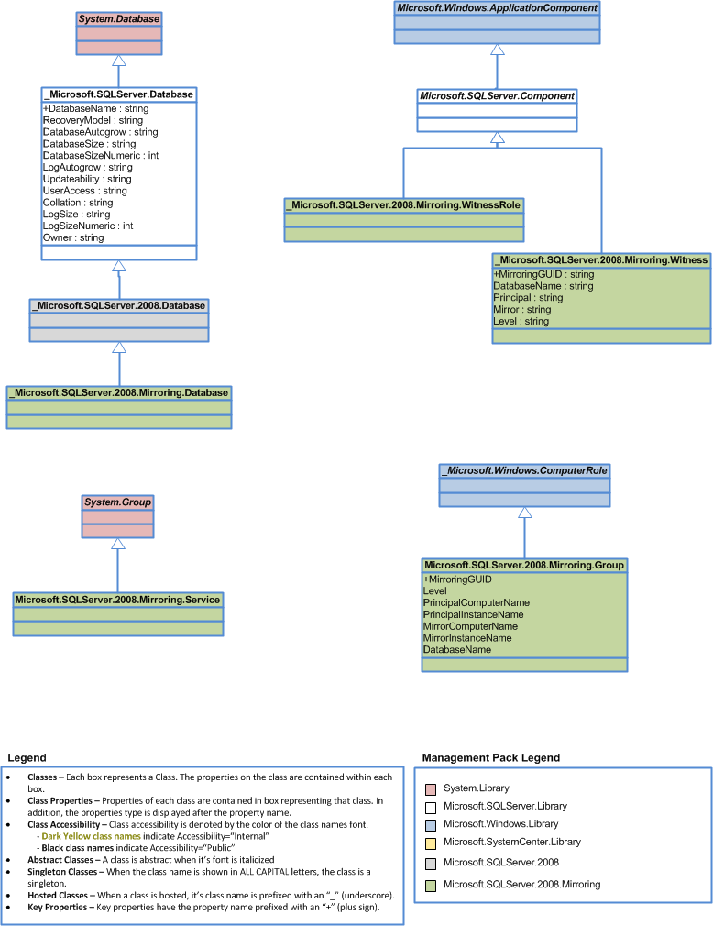

Relationship Class Diagram
SQL Server 2008 Mirroring - Relationship Class Diagram
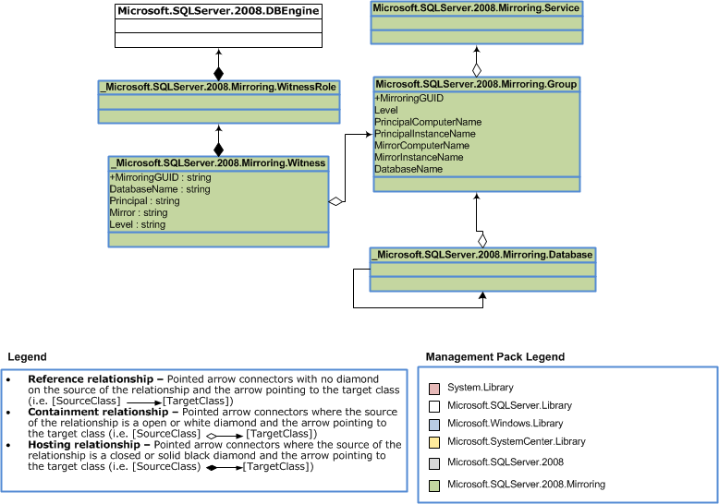
Objects the Management Pack Discovers
You can use the SQL Server 2008 Mirroring Management Pack to monitor components SQL Server 2008 and SQL Server 2008 R2 Database Mirroring. You can use the Authoring pane of the Operations console to enable discovery of components that are not automatically discovered. For more information about enabling object discovery, see Object Discoveries in Operations Manager 2007 in Operations Manager Help.
You can use the same procedure to override the settings for discovery of any object.
Note
The SQL Server 2008 Mirroring Management Pack discovers the object types described in the following table. Not all of the objects are automatically discovered. Use overrides to discover those that are not discovered automatically.

Category | Object type | Discovered Automatically
SQL Server Mirroring Component | SQL Server 2008 Mirroring Database | Yes
SQL Server Mirroring Component | SQL Server 2008 Mirroring Witness | Yes
SQL Server Mirroring Component | SQL Server 2008 Witness Role | Yes
SQL Server Mirroring Component | SQL Server 2008 Mirroring Service | Yes
SQL Server Mirroring Component | SQL Server 2008 Mirroring Group | Yes

How Health Rolls Up
The SQL Server 2008 Mirroring Management Pack health roll up are based on layered structure of health roll up in SQL Server Management Pack.
Health Roll Up Diagram
You can create dependency monitors to customize health rollup. To view a health rollup diagram for your configuration, select an object and click Health Explorer in the Actions pane.
Note
The following illustration shows the objects that are enabled and disabled.
Illustration of enabled objects
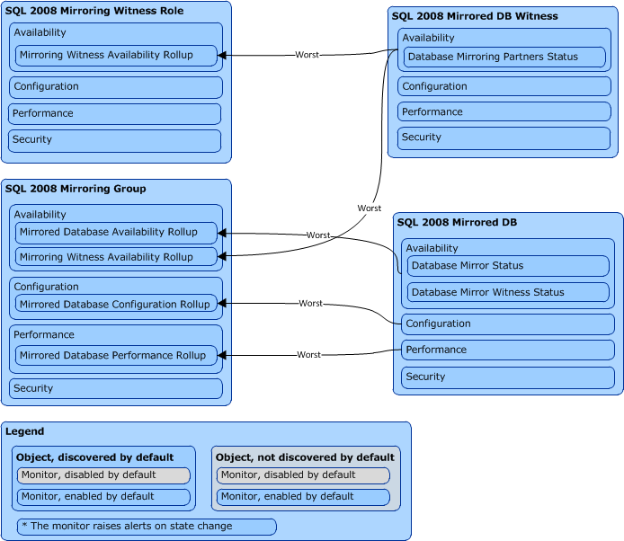

Key Monitoring Scenarios
The SQL Server 2008 Mirroring Management Pack for Operations Manager includes a number of key monitoring scenarios that can be configured as follows.
The list is not intended to be a complete manifest of the management pack functionality.
Note

Discovery of Mirroring components
The following objects are discovered for each of SQL Server instance:
- Databases enabled for Mirroring with all their properties (required for mirroring monitoring)
- Mirroring group contains the collection of databases enabled for mirroring and properties required to identify principal and mirror roles
- Witness Role and Witness
- Mirroring Session direction required to show mirroring dataflow on the diagram view
You can apply overrides to the following discoveries to specify an “Exclude List” (in comma-delimited format) of the database names that the discovery should overlook:
- SQL 2008 Mirrored DB Discovery Provider
The almost all requirements to prevent performance degradation should be kept as well as for objects in SQL Server Management Pack.

Database Mirror Synchronization state monitoring
The monitor checks the status of the database mirror reported by SQL Server. It checks availability of mirror database as well as it’s SYNCHRONIZED state. This monitor also checks the following warning states:
SYNCHRONIZING - The contents of the mirror database are lagging behind the contents of the principal database. The principal server is sending log records to the mirror server, which is applying the changes to the mirror database to roll it forward. At the start of a database mirroring session, the database is in the SYNCHRONIZING state. The principal server is serving the database, and the mirror is trying to catch up.
SUSPENDED - The mirror copy of the database is not available. The principal database is running without sending any logs to the mirror server, a condition known as running exposed. This is the state after a failover. A session can also become SUSPENDED as a result of redo errors or if the administrator pauses the session. SUSPENDED is a persistent state that survives partner shutdowns and startups.
PENDING_FAILOVER - This state is found only on the principal server after a failover has begun, but the server has not transitioned into the mirror role. When the failover is initiated, the principal database goes into the PENDING_FAILOVER state, quickly terminates any user connections, and takes over the mirror role soon thereafter.

Mirroring Witness state monitoring

This monitor checks the status of the database mirroring witness reported by SQL Server. Monitor checks that connection between Mirroring Partner and Witness server is available in case if Mirroring witness is presented in Mirroring configuration.

Mirroring Partner state monitoring

This monitor checks the status of the database mirroring session reported by SQL Server. An unhealthy state indicates that the SQL Server database mirroring session is not in operational state.

Viewing Information in the Operations Manager Console
You can see a high-level view of object types in your SQL Server deployment.
A view can contain a lengthy list of objects. To find a specific object or group of objects, you can use the Scope, Search, and Find buttons on the Operations Manager toolbar. For more information, see the How to Manage Monitoring Data Using Scope, Search, and Find topic in Operations Manager Help.
These views are listed under Mirroring folder of the Microsoft SQL Server node in the Monitoring pane of the Operations Console. Details for most views are listed in the following table.
• Active Alerts, which displays an aggregation of all alerts that are not closed.
• Mirroring Diagram, which shows diagram of mirroring components and their relationships.

Mirroring State Views

View Name | Description
Mirroring Groups | Displays all discovered Mirroring Groups with links to Mirrored Databases and Witness objects.

Mirroring Diagram

Mirroring diagram show the main object which are participated in mirroring session: Mirroring database, Mirroring Group, Mirroring Service, Witness Role and Witness. Also beside general relationship between components like Hosting and Containment the mirroring diagram shows additional reference type relationship which indicates the direction of mirroring data flow. When failover happens that reference will be changed considering new direction, but it can take some time. To reduce refresh time it’s possible to configure override for discovery of that type of relationship.

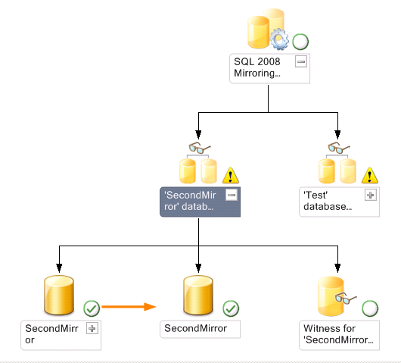

Understanding the SQL Server 2012 AlwaysOn Management Pack
This section describes SQL Server 2012 AlwaysOn Management Pack
The scope of this management pack includes:
- Discovery of AlwaysOn objects (availability groups, availability replicas, and database replicas) on the SQL Server 2012 instances with enabled AlwaysOn.
- Monitoring of AlwaysOn objects’ health by collecting PBM (Policy Based Management) policies’ state via SQL Server PowerShell provider (part of the SQLPS module).
- Collecting of performance data for availability replicas and database replicas.
- Tasks for execution in SQL Server Management Studio and SQLPS console.

Prerequisites
The following Management Packs should be imported into System Center Operation Manager (SCOM) before SQL Server 2012 AlwaysOn Management Pack:
- SQL Server 2012 MP 6.4.1.0

SQL Server 2012 Management Studio should be installed on the machine where Operations Console is installed to provide the capability to invoke SQL PowerShell tasks from Operations Console.

Mandatory Configuration
• Import prerequisite Management Packs.
- Enable the Agent Proxy setting on all agents that are installed on servers participating in an AlwaysOn session. For instructions, see the procedure that follows this list.
To enable the Agent Proxy setting
1. Open the Operations Console and click the Administration button.
2. In the Administrator pane, click Agent Managed.
3. Double-click an agent in the list.
4. On the Security tab, select Allow this agent to act as a proxy and discover managed objects on other computers.

Low-privilege
The low privilege configuration for AlwaysOn monitoring is a subset of required configuration for SQL Server monitoring. So it’s not required to explicitly configure low privilege for AlwaysOn.
- Map Microsoft.SQLServer.2012.AlwaysOn.DiscoveryAccount profile with SQLDiscovery Run As account
- Map Microsoft.SQLServer.2012.AlwaysOn.MonitoringAccount profile with SQLMonitor Run As account
For details see Setting up a Low-Privilege Environment section.

Understanding SQL Server 2012 AlwaysOn Management Pack
The goal of the SQL Server 2012 Management Pack is to provide discovery and monitoring for SQL Server 2012 AlwaysOn objects (availability groups, availability replicas, and database replicas) by reflecting the state of PBM policies. Also this management pack provides the capability to collect performance data for AlwaysOn objects and to invoke the SQL Server Management Studio and SQL PowerShell by calling console tasks
In this section:
- Monitoring Scenarios
- How Health Rolls Up
For details on the discoveries, rules, monitors, views, and reports contained in this management pack, see Appendix: AlwaysOn Management Pack Contents

Key Monitoring Scenarios

Discovery of availability groups, availability replicas and database replicas
The following objects are automatically discovered:

- Availability Group – which represents SMO Availability Group object and contains all required for identification and monitoring properties

- Availability Replica – which represents SMO Availability Replica object and contains all required for identification and monitoring properties

- Database Replica – which represents database level object of AlwaysOn and contains properties from SMO objects: Availability Database and Database Replica State

- Availability Group Health – which is hidden object used for rollup health from agents to availability group level

Availability groups, availability replicas and database replicas health monitoring
This scenario collects health for all available AlwaysOn objects on the target SQL Server instance by using SQL Server PowerShell provider which reads PBM policies state for each of the objects.

Availability groups, availability replicas and database replicas performance monitoring
This scenario checks performance counters for availability replicas and database replicas on target machine and target SQL instance

Monitoring of Custom User Policies
All AlwaysOn monitors reflect their state by reader state of system policies using API provided by PBM (policy based management). Beside system policies AlwaysOn management pack provides ability to monitor Custom User Policies defined by user.
AlwaysOn management pack also extends capabilities of CUP (custom user policy) monitoring from SQL Server Management Pack where only policies with Database as Facet are monitored. AlwaysOn MP supports monitoring of policies where the following objects are facets:
- Availability Group
- Availability Replica
- Database Replica

For each of possible facet there are two types of CUP monitors:
- Two state monitor with 'Warning' critical state used particularly for reflecting state of Custom User Policies which have <object> as Facet and one of the predefined warning categories as Policy Category.
- Two state monitor with 'Error' critical state used particularly for reflecting state of Custom User Policies which have <object> as Facet and one of the predefined error categories as Policy Category.

How Health Rolls Up
The following diagram shows how the health states of objects roll up in this management pack.

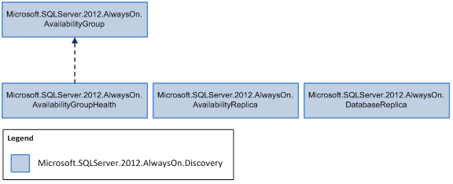

Security Configuration

Run As Profile Name | Associated Rules and Monitors | Notes
Microsoft.SQLServer.2012.AlwaysOn.DiscoveryAccount | - Microsoft.SQLServer.2012.AlwaysOn.GeneralAlwaysOnDiscovery  - Microsoft.SQLServer.2012.AlwaysOn.GeneralUserPolicyDiscovery
Microsoft.SQLServer.2012.AlwaysOn.MonitoringAccount | - Microsoft.SQLServer.2012.AlwaysOn.ClusterStateMonitor  - Microsoft.SQLServer.2012.AlwaysOn.AvailabilityGroupOnline  - Microsoft.SQLServer.2012.AlwaysOn.AutomaticFailoverReadiness  - Microsoft.SQLServer.2012.AlwaysOn.AvailabilityReplicasSynchronizing  - Microsoft.SQLServer.2012.AlwaysOn.AvailabilityReplicasSynchronizationState  - Microsoft.SQLServer.2012.AlwaysOn.AvailabilityReplicaRoleState  - Microsoft.SQLServer.2012.AlwaysOn.AllAvailabilityReplicasAreConnected  - Microsoft.SQLServer.2012.AlwaysOn.RoleOfAvailabilityReplicaIsHealthy  - Microsoft.SQLServer.2012.AlwaysOn.AvailabilityReplicaIsConnected  - Microsoft.SQLServer.2012.AlwaysOn.AvailabilityReplicaDataSynchronizationHealth  - Microsoft.SQLServer.2012.AlwaysOn.AvailabilityReplicaIsJoined  - Microsoft.SQLServer.2012.AlwaysOn.DbrDataSynchronizationState  - Microsoft.SQLServer.2012.AlwaysOn.DbrJoinState  - Microsoft.SQLServer.2012.AlwaysOn.DbrSuspendState  - Microsoft.SQLServer.2012.AlwaysOn.AvailabilityGroupErrorPolicyStateMonitor  - Microsoft.SQLServer.2012.AlwaysOn.AvailabilityGroupWarningPolicyStateMonitor  - Microsoft.SQLServer.2012.AlwaysOn.AvailabilityReplicaErrorPolicyStateMonitor  - Microsoft.SQLServer.2012.AlwaysOn.AvailabilityReplicaWarningPolicyStateMonitor  - Microsoft.SQLServer.2012.AlwaysOn.DatabaseReplicaErrorPolicyStateMonitor  - Microsoft.SQLServer.2012.AlwaysOn.DatabaseReplicaWarningPolicyStateMonitor
;

Understanding the SQL Server Management Pack
This section contains the following topics:
Objects the Management Pack Discovers
How Health Rolls Up
Key Monitoring Scenarios
Viewing Information in the Operations Manager Console
Inheritance Class Diagram
Inheritance Class Diagram
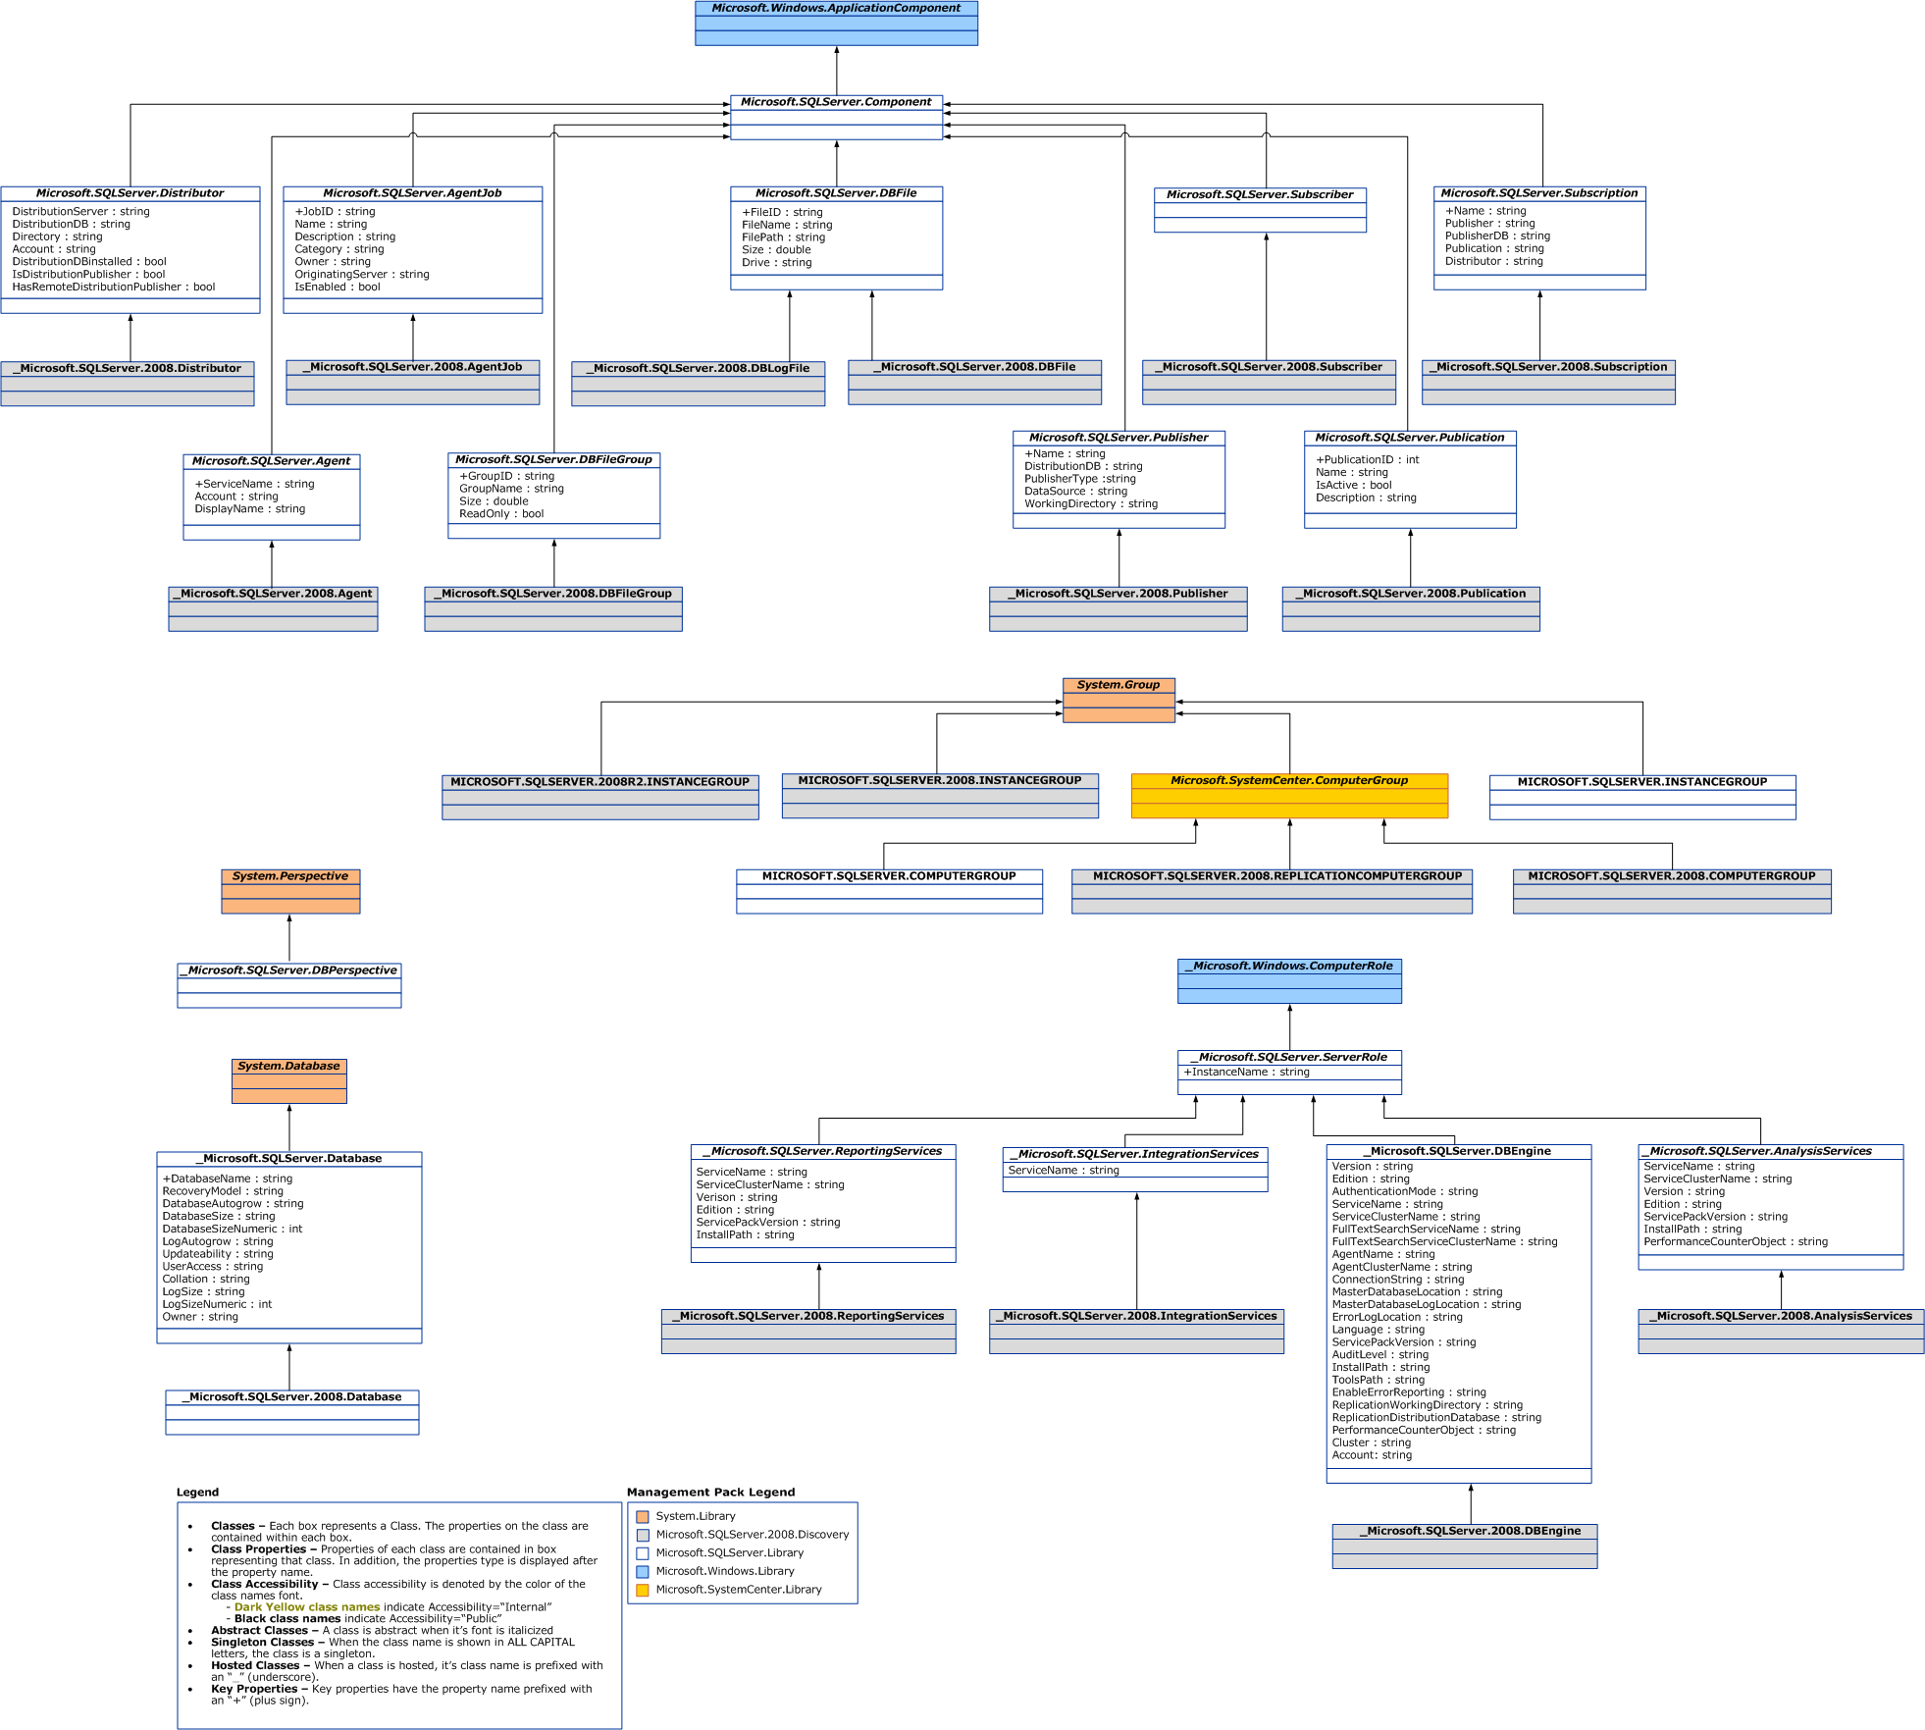

Relationship Class Diagram
Relationship Class Diagram
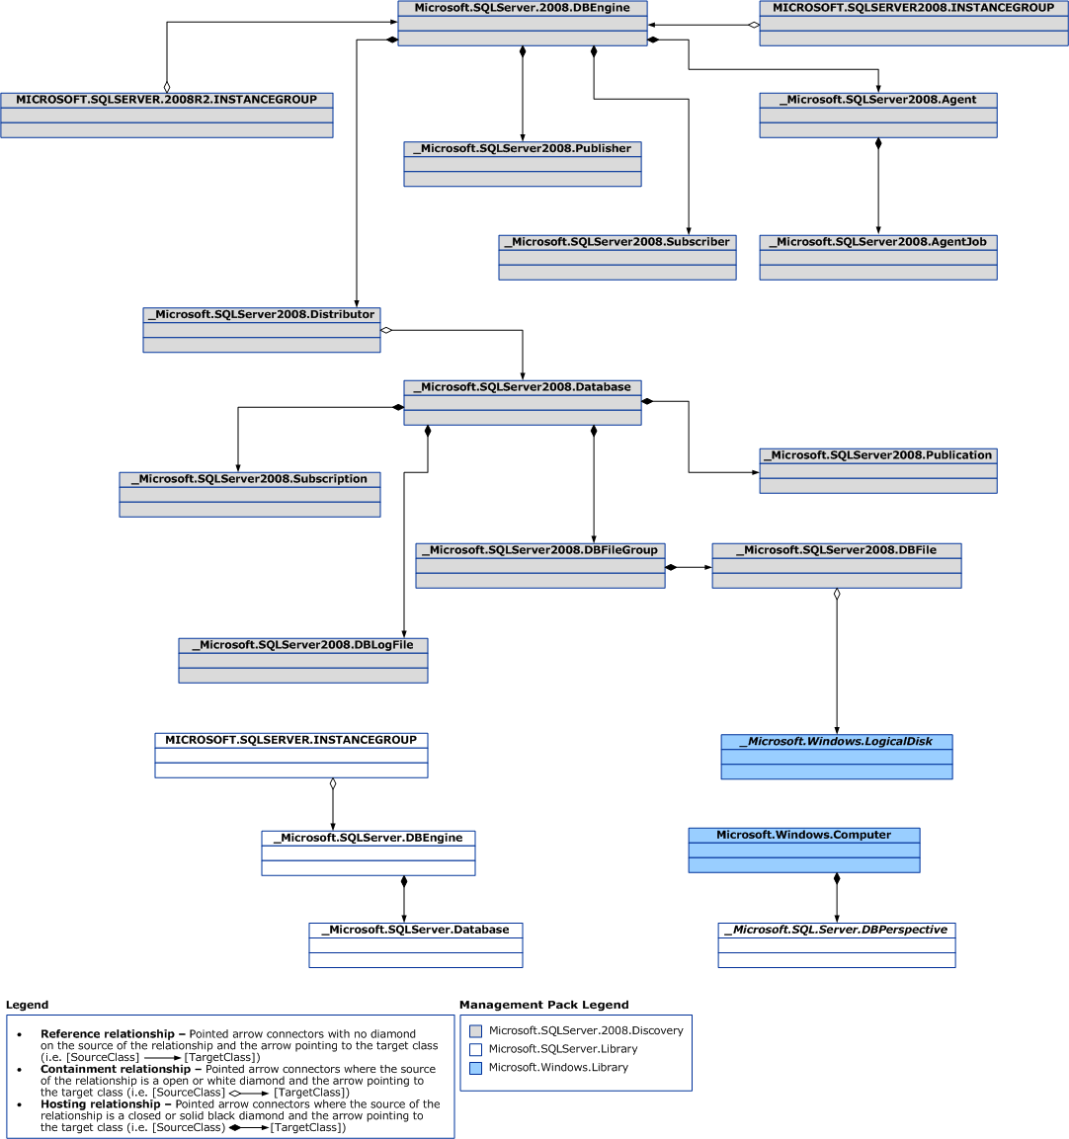

Objects the Management Pack Discovers
You can use the SQL Server Management Pack to monitor components of SQL Server 2005, SQL Server 2008, SQL Server 2008 R2 and SQL Server 2012. You can use the Authoring pane of the Operations console to enable discovery of components that are not automatically discovered. For more information about enabling object discovery, see Object Discoveries in Operations Manager 2007 in Operations Manager Help.
You can use the same procedure to override the settings for discovery of any object.
Note
The SQL Server Management Pack discovers the object types described in the following table. Not all of the objects are automatically discovered. Use overrides to discover those that are not discovered automatically.

Category | Object type | Discovered Automatically
SQL Server Roles | SQL Server 2008 R2 DB Engine | Yes
SQL Server Roles | SQL Server 2008 DB Engine | Yes
SQL Server Roles | SQL Server 2005 DB Engine | Yes
SQL Server Roles | SQL Server 2012 DB Engine | Yes
SQL Server Roles | SQL Server 2008 R2 Analysis Services | Yes
SQL Server Roles | SQL Server 2008 Analysis Services | Yes
SQL Server Roles | SQL Server 2005 Analysis Services | Yes
SQL Server Roles | SQL Server 2012 Analysis Services | Yes
SQL Server Roles | SQL Server 2008 R2 Reporting Services | Yes
SQL Server Roles | SQL Server 2008 Reporting Services | Yes
SQL Server Roles | SQL Server 2005 Reporting Services | Yes
SQL Server Roles | SQL Server 2012 Reporting Services | Yes
SQL Server Roles | SQL Server 2008 R2 Integration Services | Yes
SQL Server Roles | SQL Server 2008 Integration Services | Yes
SQL Server Roles | SQL Server 2005 Integration Services | Yes
SQL Server Roles | SQL Server 2012 Integration Services | Yes
Replication Components | SQL Server 2008 R2 Distributor | No
Replication Components | SQL Server 2008 Distributor | No
Replication Components | SQL Server 2005 Distributor | No
Replication Components | SQL Server 2012 Distributor | No
Replication Components | SQL Server 2008 R2 Publisher | No
Replication Components | SQL Server 2008 Publisher | No
Replication Components | SQL Server 2005 Publisher | No
Replication Components | SQL Server 2012 Publisher | No
Replication Components | SQL Server 2008 R2 Subscriber | No
Replication Components | SQL Server 2008 Subscriber | No
Replication Components | SQL Server 2005 Subscriber | No
Replication Components | SQL Server 2012 Subscriber | No
Replication Components | SQL Server 2008 R2 Subscription | No
Replication Components | SQL Server 2008 Subscription | No
Replication Components | SQL Server 2005 Subscription | No
Replication Components | SQL Server 2012 Subscription | No
Other Object Types | SQL Server 2008 R2 DB | Yes
Other Object Types | SQL Server 2008 DB | Yes
Other Object Types | SQL Server 2005 DB | Yes
Other Object Types | SQL Server 2012 DB | Yes
Other Object Types | SQL Server 2008 Mirroring DB | Yes
Other Object Types | SQL Server 2008 Mirroring Witness | Yes
Other Object Types | SQL Server 2008 R2 Agent | Yes
Other Object Types | SQL Server 2008 Agent | Yes
Other Object Types | SQL Server 2005 Agent | Yes
Other Object Types | SQL Server 2012 Agent | Yes
Other Object Types | SQL Server 2008 R2 Agent Job | No
Other Object Types | SQL Server 2008 Agent Job | No
Other Object Types | SQL Server 2005 Agent Job | No
Other Object Types | SQL Server 2012 Agent Job | No
Other Object Types | SQL Server 2008 R2 DB File Group | Yes
Other Object Types | SQL Server 2008 DB File Group | Yes
Other Object Types | SQL Server 2005 DB File Group | Yes
Other Object Types | SQL Server 2012 DB File Group | Yes
Other Object Types | SQL Server 2008 R2 DB File | Yes
Other Object Types | SQL Server 2008 DB File | Yes
Other Object Types | SQL Server 2012 DB File | Yes
Other Object Types | SQL Server 2005 DB File | Yes
Other Object Types | SQL Server 2012 DB Policy | No

Objects Discovered
Use the following procedures as an example of enabling automatic discovery for SQL Server 2005 Agent Job.
To use an override to change the setting for automatic discovery
1. In the Authoring pane, expand Management Pack Objects, and then click Object Discoveries.
2. On the Operations Manager toolbar, click Scope, and then filter the objects that appear in the details pane to include only SQL Server objects.
3. In the Operations Manager toolbar, use the Scope button to filter the list of objects, and then click SQL Server Agent Job.
4. On the Operations Manager toolbar, click Overrides, click Override the Object Discovery, and then click For all objects of type: SQL 2005 Agent, For a group.
5. In the Override Properties dialog box, click the Override box for the Enabled parameter.
6. Under Management Pack, click New to create an unsealed version of the management pack, and then click OK, or select an unsealed management pack that you previously created in which to save this override. As a best practice, you should not save overrides to the Default Management Pack.
After you change the override setting, the object type is automatically discovered and appears in the Monitoring pane under SQL Server.
How Health Rolls Up
The SQL Server Management Pack categorizes the SQL Server components into a layered structure, where the health of one layer can depend on the health of the lower level.
Top Level
The top level of this model contains Windows Server. If the SQL Server application is not healthy, Windows Server is not healthy.
Second Level

The second level contains these components: | • Database Engine  • Reporting Services (contains no lower-level components)  • Analysis Services (contains no lower-level components)  • Integration Services (contains no lower-level components)  Note  The health of each of these components directly affects the health of Windows Server.

Database Engine

The Database Engine contains these lower-level components: | • Database (only the database has lower-level components)  • Distributor  • Publisher  • Subscriber

Database
The Database contains the following lower-level components.

Database File | Affects the health of the file-group component, which in turn affects the health of the database.
SQL Server Agent | Contains one lower-level component, the SQL Server Agent Job. If the SQL Server Agent Job is not healthy, the SQL Server Agent will not be healthy, and therefore the Database Engine will not be healthy.
Publication | Rolls up to the database but has no lower-level components
Subscription | Rolls up to the database but has no lower-level components
Database Policy | Rolls up the state of Custom User Policies mapped to Database.

Health Roll Up Diagram
You can create dependency monitors to customize health rollup. To view a health rollup diagram for your configuration, select an object and click Health Explorer in the Actions pane.
Note
The following illustration shows the objects that are enabled and disabled.
Illustration of enabled objects
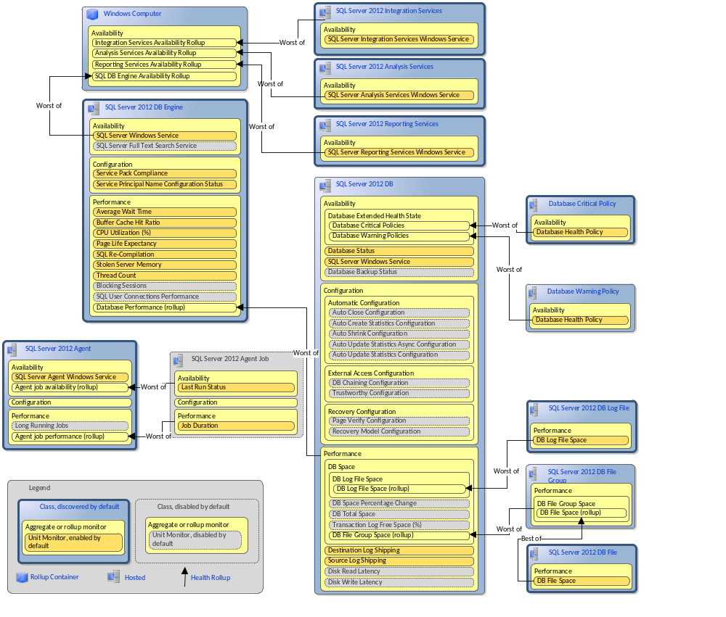

Key Monitoring Scenarios
The SQL Server Management Pack for Operations Manager includes a number of key monitoring scenarios that can be configured as follows.
The list is not intended to be a complete manifest of the management pack functionality.
Note
Monitoring of Custom User Policies (CUP - PBM policies defined by user)
The new monitoring feature was added for SQL Server 2012 based on Policy Based Management capabilities. The state of user defined policies can be monitored if the database is used as facet.

If database is in Restoring state the CUP targeted to that database won’t be monitored.
Note
There are two monitors which reflects state of CUP:
- Two state monitor with 'Error' critical state used particularly for reflecting state of Custom User Policies which have Database as Facet and one of the predefined error categories as Policy Category.
- Two state monitor with 'Warning' critical state used particularly for reflecting state of Custom User Policies which have Database as Facet and any category except predefined error categories as Policy Category.
Separated configuration for SQL Server 2008 and SQL Server 2008 R2
To configure different monitoring or discovery settings for SQL Server 2008 and SQL Server 2008 R2, apply overrides to predefined computer groups:
• SQL Server 2008 DB Engine Group – includes instances of SQL Server 2008 and SQL Server 2008 SP1
• SQL Server 2008 R2 DB Engine Group – includes instances of SQL Server 2008 R2
Data file and log file space monitoring
Management pack rules collect total data log and log file free space. You can use reports for reviewing this information across multiple databases and over extended periods of time for such functions as problem management and capacity planning. Management pack monitors provide space monitoring on three levels: data files, file groups and databases.
For more information, see the hierarchy of space monitors and overridable parameters in “Unit Monitors” and “Health Rolls Up Diagram” sections. The following performance counters are provided to support space monitoring:
1. Database Level
a. Collect Database Total Free Space (in MB and in %)
The amount of space left in database for all files in all file groups for this database in megabytes or in percent. Also includes space left on media hosting files with auto grow enabled.
2. DB File Group Level
a. Collect DB File Group Free Space (in MB and in %)
The amount of space left in all files for this file group in megabytes or in percent. Also includes space left on media hosting files with auto grow enabled.
b. Collect DB File Group Allocated Space Left (in MB and in %)
The amount of space left in all files for this file group in megabytes or in percent. Does not include space left on media hosting files with auto grow enabled.
3. SQL DB File Level
a. Collect DB File Free Space (in MB and in %)
The amount of space left in a file in megabytes or in percent. Also includes space left on media hosting files with auto grow enabled.
b. Collect DB File Allocated Space Left (in MB and in %)
The amount of space left in a file in megabytes or in percent. Does not include space left on media hosting files with auto grow enabled.
4. SQL DB Log File Level
a. Collect DB Log File Free Space (in MB and in %)
The amount of space left in all log files for this database in megabytes or in percent. Also includes space left on media hosting files with auto grow enabled.
b. Collect DB Log File Allocated Space Left (in MB and in %)
The amount of space left in all log files for this database in megabytes or in percent. Does not include space left on media hosting files with auto grow enabled.
By default, space monitoring is enabled for the following levels:
• Database
• File Group
• File
If your environment is sensitive for any extra load, you may consider disabling monitoring on File Group and File level. To disable File Group level monitoring, you should disable the following rules:
• Collect DB File Group Allocated Space Left (%)
• Collect DB File Group Allocated Space Left (MB)
• Collect DB File Group Free Space (%)
• Collect DB File Group Free Space (MB)
To disable File level monitoring, you should disable the following rules and monitors:
Rules
• Collect DB File Allocated Space Left (%)
• Collect DB File Allocated Space Left (MB)
• Collect DB File Free Space (%)
• Collect DB File Free Space (MB)
• Collect DB Log File Allocated Space Left (%)
• Collect DB Log File Allocated Space Left (MB)
• Collect DB Log File Free Space (%)
• Collect DB Log File Free Space (MB)
Monitors
• DB File Space Monitor
• DB Log File Space Monitor
Many databases on the same drive
Default space monitoring settings are noisy in environments where data or log files for many databases are located on the same drive and have autogrow “On”. In such environments, an alert for each database is generated when the amount of free space on the hard drive reaches the threshold. To avoid noise, turn off the space monitors for data and log files, and use Base OS Management Pack to monitor space on the hard drive.
Long-running SQL Server Agent jobs
By default, this scenario is fully enabled in the management packs on a per-SQL Server Agent basis. This means that for each monitoring SQL Server Agent, maximum job duration is what is compared against the thresholds, and alerts are raised if any single job runs too long.
In addition, more detailed monitoring, which is on a per-job basis is provided in the management packs but the discoveries for SQL Server Agent jobs are disabled by default. Enable the following object discoveries:
- SQL Server 2012: Discover SQL Server 2012 Agent Jobs
- SQL Server 2008: Discover SQL Server 2008 Agent Jobs
- SQL Server 2005: Discover SQL Server 2005 Agent Jobs

Job failure
To get alerts for failed jobs, enable the rule “A SQL job failed to complete successfully” and make sure that the option "Write to the Windows Application Event Log” “when the job fails” is selected for all jobs you want to monitor.
For more information, see Job Properties / New Job (Notifications Page) in the MSDN Library
Blocking sessions
A monitor periodically queries each database engine instance for a list of active sessions (SPIDs) and checks to see if any long-running blocking is occurring. If blocking is detected and it exceeds the given threshold, then the state is changed and an alert is raised.
You can apply an override to change the time-duration value that is used to determine whether blocking is long-running. The default time-duration value is one minute.
Discovery of SQL Server Database Engine instances
The discovery of stand-alone and clustered instances of the SQL Server Database Engine role across all managed systems can be configured to exclude particular instances of the database engine.
You can apply overrides to the following discoveries to specify an “Exclude List” (in comma-delimited format) of the names of SQL Server Database Engine instances that the discovery should overlook:
- SQL Server 2012: Discover SQL Server 2012 Database Engines (Windows Server)
- SQL Server 2008: Discover SQL Server 2008 Database Engines (Windows Server)
- SQL Server 2005: Discover SQL Server 2005 Database Engines (Windows Server)
Database discovery and state monitoring
For each managed database engine, the databases on it are discovered and monitored using a number of rules and monitors. Information about monitor-based functionality is provided in other areas of this table.
You can apply overrides to the following discoveries to specify an “Exclude List” (in comma-delimited format) of database names that the discovery should overlook.
• SQL Server 2012: Discover Databases for a Database Engine
• SQL Server 2008: Discover Databases for a Database Engine
• SQL Server 2005: Discover Databases for a Database Engine
Some rules and monitors in this management pack use the script GetSQL2005DBSpace.js. When all rules and monitors that use that script have matching parameters, only one instance of the script runs for the entire group of rules and monitors. When any of the rules or monitors that use that script have different parameter values, a separate instance of the script and scripting host will run at the same time for each rule or monitor that has parameter values that differ from the rest. Because GetSQL2005DBSpace.js scans all SQL databases, performance problems can result when it runs frequently.
To prevent performance problems, ensure that the rules and monitors in the following list use the same parameter values. If you override a parameter for any of these rules or monitors, you should apply the same override to the others.
Rules and monitors for SQL Server 2005 are in the following list:
• Rules:
• Microsoft.SQLServer.2005.Database.DBSpaceFree.Collection DISABLED
• Microsoft.SQLServer.2005.Database.DBSpaceFreePercent.Collection DISABLED
• Microsoft.SQLServer.2005.Database.DBSize.Collection ENABLED
• Microsoft.SQLServer.2005.Database.TransactionLogSpaceFree.Collection DISABLED
• Microsoft.SQLServer.2005.Database.TransactionLogSpaceFreePercent.Collection DISABLED
• Microsoft.SQLServer.2005.Database.TransactionLogSize.Collection DISABLED
• Monitors:
• Microsoft.SQLServer.2005.Database.DBSizePercentMonitor DISABLED
• Microsoft.SQLServer.2005.Database.DBSizeMegabytesMonitor DISABLED
• Microsoft.SQLServer.2005.Database.TransactionLogSizePercentMonitor DISABLED
If you observe performance problems related to any of these rules or monitors, consider changing the Timeout Seconds parameter for all of these rules and monitors to a less frequent interval.
Restart of DB Engine
The availability of DBEngine is monitored by monitor “SQL Server Windows Service” for the object “SQL DB Engine”. This monitor does not reflect the service restart.
To be notified about each restart of DBEngine, you can enable the rule “SQL Server <version> DB Engine is restarted”. (<version> can be 2012, 2008 or 2005)

SQL DB Engine CPU monitoring
CPU utilization is monitored by the monitor which provides a measure of how much processors actually working on SQL Server’s process threads and raises an alert if all allocated CPUs are busy processing SQL Server tasks. This monitoring scenario takes into account current affinity mask of SQL DB Engine.

DB Storage latency monitoring
DB Storage performance is monitored by two monitors “Disk Read Latency” and “Disk Write Latency”. In case in significant storage performance degradation alert will be raised. These monitors disabled by default. Enable these monitors only for specific DBs where it is required monitor storage performance. In addition latency can be viewed on Database Dashboard.
Disabled Rules
Some rules in the management pack are disabled by default to avoid noise. Consider enabling rules that can be valuable in your environment. The following rules are disabled by default:
• An SQL job failed to complete successfully
• An SQL Server Service Broker procedure output results
• An SNI call failed during a Service Broker/Database Mirroring transport operation
• SQL Server restarted
• SQL Server Service Broker Manager has shutdown
• SQL Server Service Broker or Database Mirroring is running in FIPS compliance mode
• SQL Server Service Broker or Database Mirroring Transport stopped
• SQL Server Service Broker transmitter shut down due to an exception or a lack of memory
• SQL Server terminating because of system shutdown
• Table: Creating statistics for the following columns
• The Service Broker or Database Mirroring Transport has started
• The SQL Server Service Broker or Database Mirroring transport is disabled or not configured
Viewing Information in the Operations Manager Console
You can see a high-level view of object types in your SQL Server deployment.
A view can contain a lengthy list of objects. To find a specific object or group of objects, you can use the Scope, Search, and Find buttons on the Operations Manager toolbar. For more information, see the How to Manage Monitoring Data Using Scope, Search, and Find topic in Operations Manager Help.
These views are listed directly under the Microsoft SQL Server node in the Monitoring pane of the Operations Console. Details for most views are listed in the following table.
• Active Alerts, which displays an aggregation of all alerts that are not closed.
• Computers, which displays a state view of all the computers running SQL Server.
• Task Status, which displays a status view of all available tasks.
• Databases
• Health Monitoring
• Performance
• Replication
• Server Roles
• SQL 2005
• SQL 2008
• SQL 2008 R2
• SQL 2012
• SQL Agent
Databases Views

View Name | Description
Database Free Space | The Legend pane displays a list of counters for every monitored database.  A chart illustrates the information in the Legend pane.
Database State | Displays a list of monitored databases and their current states.  The Detail View pane displays the properties of the database selected above.
Transaction Log Free Space | The Legend pane displays a list of Transaction Log files.
SQL Server 2012 Databases Summary Dashboard | Displays list of SQL Server 2012 databases and their state. Provides detailed information about selected database.  Use Databases widget to select a database. DB Alerts widget displays alerts and warnings that target the database.  Free Space widget displays three series of data that represent Used, Allocated and Disk Free space, if auto grow is disabled only two series of data will be displayed (Used and Allocated). The widget has 2 scale types: Linear and Logarithmic. Hover over Y-Axis to switch between them. Red and Yellow lines represent Upper and Lower thresholds that are set for DB Total Space monitor.  Performance section contains eight performance collection rules, four of them can be linked with monitors. If linked monitors are disabled widgets display performance collection data without heath state indication. Since there are no monitors for DB Active Sessions, DB Active Requests, DB Active Connections and DB Transactions/sec they do not have health state indication. Next monitors are linked with top four performance widgets: Transaction Log Free Space (%), DB Total Space, Disk Read Latency and Disk Write Latency monitors.  Personalization option allows selecting Time Range for Free Space and Performance widgets by default the value is set to 2 days.

Health Monitoring Views

View Name | Description
Agent Health | This is a dashboard view that displays the health of SQL Agents and, for each agent, the alerts that have not been closed.  If you have discovered agent jobs, they are also included in this view.  The Detail View pane provides the properties of the agent selected in the SQL Agent State pane.
Database Engine Health | This is a dashboard view that displays the health of each database engine instance, including a list of the alerts that have not been closed for that database engine instance and for any objects that instance contains.  The Detail View pane displays the properties of the selected database engine instance.

Performance Views

View Name | Description
All Performance Data | The Legend pane contains a list of objects for which data is collected.
Database Free Space | The Legend pane displays a list of databases.
User Connections | The Legend pane displays a list of objects governed by the SQL User Connections rule.
Transaction Log Free Space | The Legend pane displays a list of Transaction Log files.

Replication Views

View Name | Description
Distributor State | Displays the state of the replication distributor.
Publication State | Displays the state of the replication publication.
Publisher State | Displays the state of the replication publisher.
Subscription State | Displays the state of the replication subscription.

Server Roles Views

View Name | Description
Analysis Services | Displays a list of instances with SQL Server Analysis Services installed.
Database Engines | Displays a list of instances with SQL Server Database Engine installed.
Integration Services | Displays a list of instances with SQL Server Integration Services installed.
Reporting Services | Displays a list of instances with SQL Server Reporting Services installed.

SQL Server Agent Views

View Name | Description
SQL Agent Job State | The SQL Server Agent Job State pane displays a list of agent jobs.  The Detail View pane contains the properties of the SQL Server Agent Job.
SQL State | Displays a list of SQL Server Agents. If agent jobs have been discovered, it also contains columns for each agent job and their respective health states.  The Detail View displays the properties of the SQL Server Agent.

Appendix: Known Issues and Troubleshooting
Free Space widget incorrectly displays data
Issue: Free Space widget displays data provided by 3 performance collection rules:
1. SQL 2012 DBs Used Space (MB) performance collection rule
2. MSSQL 2012: Collect DB Allocated Free Space (MB)
3. MSSQL 2012: Collect DB Used Space (MB)
If intervals for this rules are not synchronized, the widget cannot correctly display the chart and user sees shifted data series or overlaps in the chart.
Resolution: Make sure intervals for the rules are the same. When intervals are synchronized the widget will start displaying chart correctly. Previously collected data will be incorrectly displayed anyway.
SQL Server 2012 Databases Summary Dashboard displays all active alerts if nothing is selected
Issue: Currently the dashboard displays all active alerts if nothing is selected. It’s a standard querying mechanism of the default Alerts widget.
Resolution: Make sure that at least one DB suites the filtering options.
Widgets cannot display performance data if DB name has special symbols like bracers
Issue: Default performance widgets and SQL Server 2012 Databases Summary Dashboard will not display performance data for Databases that have name with bracers. This is a known SCOM issue.
Resolution: There is no known workaround at the moment.
SQL Server 2012 Databases Summary Dashboard may stop refreshing if left open for a long period of time
Issue: SCOM console has a memory leak that becomes noticeable if you have a dashboard with considerable amount of widgets. Because of the memory leak Authoring Console may consume all available memory and cause a situation when widgets stop refreshing.
Resolution:
Restart the Authoring Console.
Functions fail if instance name contains Asian characters
Problem: Functions fail to work on SQL Server 2008 if the instance name contains Asian characters. This situation is caused by the System Center Operations Manager 2007 and System Center Operations Manager 2007 SP1 known issue of the SCOM.ScriptAPI object which is used to pass data from discovery script to Health Service at target machine. This object incorrectly converts Variant to BSTR data type. For more information, see the Microsoft TechNet System Center Operations Manager Authoring forum.
Resolution: This issue is resolved in System Center Operations Manager 2007 R2. Users who need to monitor SQL Server with a localized instance name should update to Operations Manager 2007 R2.
10102 events from “Health Service Modules” are being generated on systems with 32-bit instances of SQL Server running on a 64-bit operating system, indicating that “PerfDataSource” could not resolve counters
Problem: On agent-managed systems that have a 32-bit instance of SQL Server installed on a 64-bit operating system, many 10102 error events will be reported into the Operations Manager log, indicating that PerfDataSource could not resolve a number of counters and that the module will be unloaded. These events are immediately followed by an 1103 event from HealthService indicating that one or more rules or one or more monitors failed and that the failed rules or monitors were unloaded.
Resolution: No resolution. Only a subset of monitoring will work for 32-bit installations of SQL Server that are monitored on a 64-bit operating system. This is because the SQL Server processes are 32-bit, the Operations Manager agent processes are 64-bit, and there are limitations in collecting performance data across architectures. These limitations are documented in Knowledge Base article 891238.
11771 events from “Health Service Modules” are reported on systems with SQL Server 2005 or SQL Server 2008 Management Pack running the SQL Server Full Text Search Service Monitor
Problem: Agent-managed systems are running the SQL Server Management Pack, and many 11771 events are reported. For example, see the following 11771 event.

Log | Operations Manager
Source | Health Service Modules
Event ID | 11771
Level | Warning
Description | Error getting state of service  Error: 0x8007007b  Details: The filename, directory name, or volume label syntax is incorrect.

Resolution: The SQL Server Full Text Search Service Monitor expects to monitor the running SQL Server Full Text Search Service. If the SQL Server Full Text Search Service is not running, the management pack generates the 1171 events. To stop receiving the 11771 events, you can disable the SQL Server Full Text Search Service Monitor.
On clustered SQL Server, Management Pack discovery scripts time out for SQL Server Database Engines, SQL Server Analysis Services, and SQL Server Reporting Services
Problem: On a cluster, when there are multiple clustered SQL Server instances, management pack discovery scripts may time out for Database Engines, Analysis Services, and Reporting Services. You might see events similar to the following example.

Log Name: | Operations Manager
Source: | Health Service Modules
Date: | 1/8/2009 5:33:23 PM
Event ID: | 21402
Task Category: | None
Level: | Warning
Keywords: | Classic
User: | N/A
Computer: | SQL-Ex88S22.MPLAB.com
Description: | Forced to terminate the following process started at 5:28:24 PM because it ran past the configured timeout 300 seconds.
Command executed: | "C:\Windows\system32\cscript.exe" /nologo "DiscoverSQL2008DBEngineDiscovery.vbs" {32FBB1E4-C6D1-0517-2F47-3DDA67D46A3B} {D1C9D03B-AAAE-D1FF-5ECA-6AF1981FE271} SQL-Ex88S22.MPLAB.com SQL-Ex88S22.MPLAB.com SQL-Ex88S22 "Exclude:"
Working Directory: | C:\Program Files\System Center Operations Manager 2007\Health Service State\Monitoring Host Temporary Files 3\796\
Description: | One or more workflows were affected by this.  Workflow name: Microsoft.SQLServer.2008.DBEngineDiscoveryRule.Server  Instance name: SQL-Ex88S22.MPLAB.com  Instance ID: {D1C9D03B-AAAE-D1FF-5ECA-6AF1981FE271}  Management group: MOMGroup1

Resolution: Use overrides to increase the timeout value. To identify a new timeout value, use the following guidelines: (number of Database Engine instances on the physical node multiplied by 25 seconds*) plus (number of Analysis Services instances on the physical node multiplied by 25 seconds*) plus (number of Reporting Services instances on the physical node multiplied by 25 seconds*).
*This number approximates the time it takes for a script to run. The time it takes for a script to run on your system may vary.
For example, for a clustered SQL Server environment where there are 12 instances of Database Engine on each physical node, 10 instance of Analysis Services on each physical node, and 8 instances of Reporting Services on each physical node, the new timeout estimate is based on the calculation (12*25 sec)+(10*25 sec)+(8*25 sec). The default timeout value is 300 seconds. In this case, the new timeout value should be 750 seconds.
To use an override to enter a new timeout value for discovery scripts
1. Open the Operations console, and then click Authoring.
2. In the Authoring pane, in the left navigation area, click Management Pack Objects, and then click Object Discoveries. The Object Discoveries pane displays a list of objects that the management pack discovers.
3. Right-click the discovery that you want to change, click Overrides, click Override the Object Discovery, and then click For all objects of type: Windows Server. The Override Properties dialog box is displayed.
4. Under Override-controlled parameters, select the Override box next to the Timeout Seconds parameter, and then increase the default number of seconds in Override Value by typing in a new number.
5. Under Management Pack, in Select a destination management pack, click the arrow to select a management pack from the list, or click New and follow the instructions in the wizard to create a new management pack for storing overrides and other customizations. For more information about creating a new management pack for customizations, see the Create a New Management Pack for Customizations section.
Data file and log file free space and free space percent collection rules and monitors might return inaccurate size values
Problem: On some agent-managed systems with databases that are two terabytes or larger, or with databases that were upgraded from SQL Server 2000, free space and free space percent collection rules and monitors might return inaccurate values for data file and log file sizes. The following rules and monitors are reported to have been affected for SQL Server 2005, SQL Server 2008 and SQL Server 2012:
Database Size Provider (Optimized)
• Collect Database Free Space (MB)
• Collect Database Free Space (%)
• Collect Database Size (MB)
• Collect Transaction Log Free Space (MB)
• Collect Transaction Log Free Space (%)
• Collect Transaction Log Size (MB)
Database / Log Free Space
• Database Space Free (%)
• Database Space Free (MB)
• Transaction Log Space Free (%)
• Transaction Log Space Free (MB)
Database Percentage Change
• Percentage Change in Database % Used Space
Resolution: If you encounter this problem, run the DBCC Update usage (Transact-SQL) command against the affected databases as described in SQL Server 2008 Books Online (February 2009).
Running this command might affect the overall performance of the database. We recommend that you schedule the command to run when it will not negatively affect the production workload.
Note
No other workarounds exist. If the problem persists, contact customer support services or disable the affected rules or monitors.
Rules and monitors that are based on events from the event log do not work reliably on clustered installations of SQL Server
Problem: On clustered installations of SQL Server, rules and monitors that are based on events from the event log do not work reliably. The problem occurs because events for clustered installations of SQL Server are generated to event logs differently based on the version of the operating system.
Resolution: To resolve this issue, the following prerequisites must be met:
1. Ensure that the version of the SQL Server Management pack that is imported is version 6.0.6648.0 or greater.
2. Check the version of the management group:
• If the management group is running Operations Manager 2007, upgrade to Operations Manager 2007 SP1 and install the update from Knowledge Base article 959865, Issues that are resolved by the Operations Manager Module rollup update for System Center Operations Manager 2007 Service Pack 1.
• If the management group is running Operations Manager 2007 SP1, install the update from Knowledge Base article 959865, Issues that are resolved by the Operations Manager Module rollup update for System Center Operations Manager 2007 Service Pack 1.
• If the management group is running Operations Manager 2007 R2, no additional update is required.

Appendix: Monitors
The following monitors are part of this management pack.
DB Engine Unit Monitors
The following DB Engine unit monitors are included in this management pack.
SQL SPN Configuration Status
This monitor type checks the state of a Microsoft SQL Server 2012 Database Engine SPN configuration.
A Service Principal Name (SPN) for the SQL Server Database Engine may either be missing, misplaced, or is a duplicate to other SPNs configured in the Active Directory of the domain.

Parameter | Default value
Alert On State | Warning
Alert Priority | Normal
Alert Severity | Warning
Auto-Resolve Alert | True
Generates Alert | True
Enabled | True
Interval (sec) | 900
Unavailable Time (seconds) | 300
SQL Server Windows Service
If the parameter “Alert only if service startup type is automatic” is True and SQL Server windows service startup mode is not automatic, the monitor is always in Green state.
Otherwise, the (Interval) monitor checks the state of the SQL Server windows service every 60 seconds. If the service is not in the “Running” state for 900 seconds (Unavailable Time), the monitor changes state to Critical. If the service is in the “Running” state, the monitor displays the state as Healthy.
The following parameters are overridable.

Parameter | Default value
Alert On State | Critical
Alert Priority | Medium
Alert Severity | Critical
Auto-Resolve Alert | True
Generates Alert | True
Enabled | True
Interval (sec) | 60
Unavailable Time (seconds) | 900
Alert only if service startup type is automatic | True

SQL Server Full Text Search Service
Standard Windows Service monitor for SQL Server Full Text Search windows service.
Service Pack Compliance
This monitor has a parameter named Good Value, which represents the service pack number under which a SQL Server installation is considered out of compliance. The parameter can be overridden to specify the service pack version for which to check.
The following parameters are overridable.

Parameter | Default value
Alert On State | Warning
Alert Priority | Medium
Alert Severity | Critical
Auto-Resolve Alert | True
Generates Alert | True
Enabled | True
Interval (sec) | 43200
Minimal Service Pack level for SQL Server 2005 | 1
Minimal Service Pack level for SQL Server 2008 | 1
Minimal Service Pack level for SQL Server 2008 R2 | 0
Minimal Service Pack level for SQL Server 2012 | 0

Blocking Sessions
This monitor checks blocking sessions every 300 seconds (Interval). If there is a blocking session that is blocked more than 1 minute (wait time) and the amount of such blocking sessions is more or equal to 1 (Number of blocked session), then the monitor changes state to Critical.
The following parameters are overridable.

Parameter | Default value
Alert On State | Critical
Alert Priority | High
Alert Severity | Critical
Auto-Resolve Alert | True
Generates Alert | True
Enabled | False
Interval (sec) | 300
Number of blocked sessions | 1
Wait Time (min) | 1
Synchronization Time
Timeout (sec) | 300

SQL User Connections Performance
This monitor analyses the user connections to the SQL Server Database Engine over time and calculates a baseline over the initial learning period. A warning or error alert is raised if the user connections number moves outside the baseline that has been captured.
The following parameters are overridable.

Parameter | Default value
Alert On State | Warning
Alert Priority | Medium
Alert Severity | Critical
Auto-Resolve Alert | True
Generates Alert | True
Enabled | False
Inner Sensitivity | 2.81
Outer Sensitivity | 3.31

Average Wait Time
The monitor is designed to check average amount of wait time (in milliseconds) for each lock request that resulted in a wait. If wait time exceeds the given threshold the monitor changes its state and raises an alert.
The following parameters are overridable.
Parameter | Default value
Alert On State | Warning
Alert Priority | Normal
Alert Severity | Warning
Auto-Resolve Alert | True
Enabled | True
Generates Alert | True
Interval (seconds) | 300
Samples | 6
Threshold | 250
Timeout Seconds (seconds) | 300
Buffer Cache Hit Ratio
The monitor checks percentage of pages that were found in the buffer pool without having to incur a read from desk. Zero value indicates memory bottleneck and if it is detected the monitor generates an alert.
The following parameters are overridable.
Parameter | Default value
Alert On State | Critical
Alert Priority | Medium
Alert Severity | Critical
Auto-Resolve Alert | True
Enabled | True
Generates Alert | True
Interval (seconds) | 900
Threshold | 0
Page Life Expectancy engine level monitoring
Page Life Expectancy is number of seconds a page will stay in the buffer pool without references. High page life expectancy means that required data can be found in cache instead of going to hard drive. If the value is extremely low and alert will be raised to notify about the problem.
The following parameters are overridable.
Parameter | Default value
Alert On State | Critical
Alert Priority | Medium
Alert Severity | Critical
Auto-Resolve Alert | True
Enabled | True
Generates Alert | True
Interval (seconds) | 900
Threshold | 300
CPU Utilization
The monitor provides a measure of how much processors actually working on SQL Server’s process threads and raises an alert if all allocated CPUs are busy processing SQL Server tasks.
The following parameters are overridable.
Parameter | Default value
Alert On State | Critical
Alert Priority | Medium
Alert Severity | Critical
Auto-Resolve Alert | True
Enabled | True
Generates Alert | True
Interval (seconds) | 300
Number of samples | 6
Threshold | 95
Timeout Seconds (seconds) | 200
SQL Re-Compilations
Certain changes in a database can cause an execution plan to be either inefficient or invalid, based on the new state of the database. SQL Server detects the changes that invalidate an execution plan and marks the plan as not valid. A new plan must then be recompiled for the next connection that executes the query. If number of recompilations it too high an alert is raised.
The following parameters are overridable.
Parameter | Default value
Alert On State | Warning
Alert Priority | Normal
Alert Severity | Warning
Auto-Resolve Alert | True
Enabled | False
Generates Alert | True
Interval (seconds) | 300
Number of samples | 6
Threshold | 25
Timeout Seconds (seconds) | 200
Stolen Server Memory
Monitors amount of memory the server is currently using for the purposes other than the database pages and raises an alert if the amount exceeds the threshold.
The following parameters are overridable.
Parameter | Default value
Alert On State | Critical
Alert Priority | Medium
Alert Severity | Critical
Auto-Resolve Alert | True
Enabled | True
Generates Alert | True
Interval (seconds) | 300
Number of samples | 6
Threshold | 70
Timeout Seconds (seconds) | 200
Thread Count
Usually SQL Server opens system thread for each query request, but if amount of threads exceeds specified max worker threads value, SQL Server pools the worker threads. When all worker threads are active with long running queries, SQL Server may appear unresponsive until a worker thread completes and becomes available. Though not a defect, this can sometimes be undesirable. The monitor analyzes amount of free threads and notifies if the amount is low.
The following parameters are overridable.
Parameter | Default value
Alert On State | Critical
Alert Priority | Medium
Alert Severity | Critical
Auto-Resolve Alert | True
Enabled | True
Generates Alert | True
Interval (seconds) | 300
Number of samples | 6
Minimum Free Threads Count | 70
Timeout Seconds (seconds) | 200

Database Unit Monitors

Database Backup Status
This monitor checks the existence and age of database backup as reported by Microsoft® SQL Server™. This is done by running a query against the master database of the SQL instance and returning the age of the database backup.
Parameter | Default value
Alert On State | Error
Alert Priority | Normal
Alert Severity | Error
Auto-Resolve Alert | True
Generates Alert | True
Enabled | False
Interval (sec) | 86400
Timeout (seconds) | 300
Database Status
Periodically the monitor checks the status of the database as reported by SQL Server. This is done by running a query against the master database of the SQL Server instance and returning the state of the database. If you receive an alert from this monitor, an action is required in order to bring the database back to an operational state.

SQL Server database state | Monitor health state
ONLINE | GREEN
OFFLINE | RED
RECOVERY PENDING | RED
SUSPECT | RED
EMERGENCY | RED
RESTORING | YELLOW
RECOVERING | YELLOW

The following parameters are overridable.

Parameter | Default value
Alert On State | Critical
Alert Priority | Medium
Alert Severity | Critical
Auto-Resolve Alert | True
Generates Alert | True
Enabled | True
Interval (sec) | 3600
Synchronization Time
Timeout (seconds) | 300

SQL Server Windows Service
This monitor translates the state of the "SQL Server Windows Service" monitor of DB Engine to Database. For more information, see the "SQL Server Windows Service" monitor Knowledge Base article.
The following parameters are overridable.

Parameter | Default value
Enabled | True
Generates Alert | False
Auto-Resolve Alert | False
Alert Priority | Low
Alert on State | Critical
Alert Severity | Critical
Interval (sec) | 60

Configuration Monitors
Configuration monitors check a configuration value for the database and compare it with the expected value. If they do not match, the monitor turns to warning state; otherwise, the monitor turns to red state.
The following parameters are overridable.

Parameter | Default value
Alert on State | Warning
Alert Priority | Medium
Alert Severity | Warning
Auto-Resolve Alert | True
Generates Alert | True
Enabled | False
Expected Value | Depends on monitor
Disable Check for SQL Express | True
Interval (sec) | 43200
Timeout (sec) | 300

Aggregate Monitor | Monitor | Expected value | Databases
Automatic Configuration | Auto Close Configuration | OFF | User and System
Automatic Configuration | Auto Create Statistics Configuration | ON | User and System
Automatic Configuration | Auto Shrink Configuration | OFF | User and System
Automatic Configuration | Auto Update Statistics Configuration | ON | User and System
Automatic Configuration | Auto Update Statistics Async Configuration | OFF | User and System
External Access Configuration | DB Chaining Configuration | OFF | User
External Access Configuration | Trustworthy | OFF | User
Recovery | Page Verify Configuration | CHECKSUM | User and System
Recovery | Recovery Model Configuration | FULL | User and System

Destination Log Shipping
This monitor detects if a log shipping destination did not have a log restored to it within the threshold defined as a part of the log shipping configuration. When this condition occurs the monitor will change to an error (red) state. Once the log restores resume and are within the defined thresholds then the monitor will return to a success (green) state. By default, this monitor generates alerts when it is in an error state.
The following parameters are overridable.

Parameter | Default value
Alert on State | Critical/Warning
Alert Priority | Medium
Alert Severity | Critical/Warning
Auto-Resolve Alert | True
Generates Alert | True
Enabled | True

Source Log Shipping
This monitor detects if a log shipping source has not had its logs backed up within the threshold defined as a part of the log shipping configuration. When this condition occurs the monitor will change to an error state. Once the log backups resume and are within the defined thresholds then the monitor will return to a success (green) state. By default, this monitor generates alerts when it is in an error state.
The following parameters are overridable.

Parameter | Default value
Alert on State | Critical/Warning
Alert Priority | Medium
Alert Severity | Critical/Warning
Auto-Resolve Alert | True
Generates Alert | True
Enabled | True

DB Total Space
Monitors the space available on the database and on the media hosting the database. The space available on the media hosting the database is only included as part of the space available if auto grow is enabled for at least one of the files.
Every 900 (Interval) seconds monitor calculates space available on the log files in percentage. If value of less than Lower Threshold (%) monitor changes state to Critical. If value of less than Lower Threshold (%) and greater than Upper Threshold (%) monitor changes state to Warning. Otherwise, monitor saves Healthy state.
The following parameters are overridable.

Parameter | Default value
Alert on State | Critical/Warning
Alert Priority | High
Alert Severity | Matches monitor’s health
Auto-Resolve Alert | True
Generates Alert | True
Enabled | False
Interval (sec) | 900
Timeout (sec) | 300
Synchronization Time
Lower Threshold | 20
Upper Threshold | 10

DB Total Space Percentage Change
Monitors for a large change in value of database available space over a set number of sample periods.
Every 900 (Interval) seconds the monitor calculates the database available space as a percentage. After 5 (Number of Samples) samples, the monitor compares the value from the first sample and sixth sample. If there is a difference between values greater than 45 % (Upper Threshold), the monitor changes state to Critical. If there is a difference between values less than 45 % (Upper Threshold) and greater 25 % (Lower Threshold), the monitor changes state to Warning. Otherwise, the monitor saves the Healthy state.
The following parameters are overridable.

Parameter | Default value
Alert on State | Critical/Warning
Alert Priority | Medium
Alert Severity | Matches monitor’s health
Auto-Resolve Alert | True
Generates Alert | True
Enabled | True
Interval (sec) | 900
Timeout (sec) | 300
Synchronization Time
Lower Threshold (%) | 25
Upper Threshold (%) | 45
Number of Samples | 5

Disk Read Latency
This monitor checks latency for the disk read operations and throws an alert if the latency exceeds threshold. To avoid noise the monitoring is disabled by default.
The following parameters are overridable.
Parameter | Default value
Alert On State | Critical
Alert Priority | Medium
Alert Severity | Critical
Auto-Resolve Alert | True
Enabled | False
Generates Alert | True
Interval (seconds) | 300
Number of samples | 6
Threshold | 40
Timeout Seconds (seconds) | 200

Disk Write Latency
This monitor checks latency for the disk write operations and throws an alert if the latency exceeds threshold. To avoid noise the monitoring is disabled by default.
The following parameters are overridable.
Parameter | Default value
Alert On State | Critical
Alert Priority | Medium
Alert Severity | Critical
Auto-Resolve Alert | True
Enabled | False
Generates Alert | True
Interval (seconds) | 300
Number of samples | 6
Threshold | 25
Timeout Seconds (seconds) | 200

DB File Unit Monitors

DB File Space
Monitors the space available in a file and on the media hosting the file. The space available on the media hosting the files is only included as part of the space available if auto grow is enabled for this file.
Every 900 (Interval) seconds, the monitor calculates the space available on the log files in percentages. If the value is less than the Lower Threshold (%), the monitor changes state to Critical. If value is less than the Lower Threshold (%) and greater than the Upper Threshold (%), the monitor changes state to Warning. Otherwise, the monitor saves the Healthy state.
The following parameters are overridable.

Parameter | Default value
Alert on State | Critical/Warning
Alert Priority | Low
Alert Severity | Matches monitor’s health
Auto-Resolve Alert | False
Generates Alert | False
Enabled | True
Interval (sec) | 900
Timeout (sec) | 300
Synchronization Time
Lower Threshold (%) | 20
Upper Threshold (%) | 10
DB Log File Unit Monitors

DB Log File Space
Monitors the space available on the log files and on the media hosting the log files. The space available on the media hosting the log files are only included as part of the space available if auto grow is enabled for at least one of the files.
Every 900 (Interval) seconds, the monitor calculates the space available on the log files in percentages. If the value is less than the Lower Threshold (%), the monitor changes state to Critical. If the value is less than the Lower Threshold (%) and greater than the Upper Threshold (%), the monitor changes state to Warning. Otherwise, the monitor saves a Healthy state.
The following parameters are overridable.

Parameter | Default value
Alert on State | Critical
Alert Priority | Low
Alert Severity | Critical
Auto-Resolve Alert | False
Generates Alert | False
Enabled | True
Interval (sec) | 900
Timeout (sec) | 300
Synchronization Time
Lower Threshold (%) | 20
Upper Threshold (%) | 10

Agent Unit Monitors

SQL Server Agent Windows Service
Every minute, this monitor checks the state of the SQL Server Agent windows service. If the service is not in “Running” state, the monitor changes state to Critical. If the service is in “Running” state, the monitor changes state to Healthy.
The following parameters are overridable.

Parameter | Default value
Alert on State | Critical
Alert Priority | Medium
Alert Severity | Critical
Auto-Resolve Alert | True
Generates Alert | True
Enabled | True
Alert only if service startup type is automatic | True

Long Running Jobs
Every 600 (Interval) seconds, the monitor verifies all currently executed jobs. If for at least one job its execution time exceeds the lower or upper threshold, the monitor changes state to warning or critical accordingly. If all execution times are lower than thresholds, the monitor changes state to healthy.
The following parameters are overridable.

Parameter | Default value
Alert on State | Critical/Warning
Alert Priority | Medium
Alert Severity | Matches monitor’s health
Auto-Resolve Alert | True
Generates Alert | True
Enabled | False
Interval (sec) | 600
Timeout (sec) | 300
Synchronization Time
Lower Threshold (minutes) | 60
Upper Threshold (minutes) | 120

Agent Job Unit Monitors

Last Run Status
Every 600 (Interval) seconds, the monitor verifies the last run status of the job. If the last run status equals failed, the monitor changes state to Critical. If the job hasn’t finished yet and does not have a last run status, the monitor does not change state.
The following parameters are overridable.

Parameter | Default value
Generates Alert | False
Enabled | True
Interval (sec) | 600
Timeout (sec) | 300
Synchronization Time

Job Duration
Every 600 Interval) seconds, the monitor verifies the execution time of the job. If the execution time exceeds the lower or upper threshold, the monitor changes state to warning or critical accordingly. If execution times are lower than thresholds, the monitor changes state to healthy.
The following parameters are overridable.

Parameter | Default value
Generates Alert | False
Enabled | True
Interval (sec) | 600
Timeout (sec) | 300
Synchronization Time
Lower Threshold (minutes) | 60
Upper Threshold (minutes) | 120

Analysis Services Unit Monitors

SQL Server Analysis Services Windows Service
Standard Windows Service monitor for SQL Server Analysis Services windows service.
Integration Services Unit Monitors

SQL Server Integration Services Windows Service
Standard Windows Service monitor for SQL Server Integration Services windows service.
Reporting Services Unit Monitors

SQL Server Reporting Services Windows Service
Standard Windows Service monitor for SQL Server Reporting Services windows service.

Appendix: Reports
You can use the reports of the SQL Server Management Pack to track trends or changes across days, weeks, or months. The following tables describe the available SQL Server reports.
Capacity Information Reports

Report | Class | Description
SQL Broker Performance | Microsoft.SQLServer.2005.DBEngine  Microsoft.SQLServer.2008.DBEngine  Microsoft.SQLServer.2012.DBEngine | Displays a chart with the following performance items:  • Activation stored procedures invoked per second statistics  • Activation task limit reached  • Activation task limit reached per second statistics  • Activation tasks aborted  • Messages per second placed in the queue  • Transport messages per second placed in the queue  • SQL RECEIVEs per second  • SQL SENDs per second  • Tasks started per second  • Total transaction rollbacks  • Transport message fragment RECEIVEs per second  • Transport message fragments  • Transport open connection count statistics  • Transport receive I/Os per second  • Transport Send I/Os per second
SQL Server Database Counters | Microsoft.SQLServer.2005.DBEngine  Microsoft.SQLServer.2008.DBEngine  Microsoft.SQLServer.2012.DBEngine | Displays a chart with the following performance items.  • Buffer cache hit ratio  • Lock timeouts per second  • Number of deadlocks per second  • SQL recompiles per second  • Transactions per second

Operations Information Reports

Report | Class | Description
SQL Server Configuration | Microsoft.SQLServer.2005.DBEngine  Microsoft.SQLServer.2008.DBEngine  Microsoft.SQLServer.2012.DBEngine | When the objects supplied are of the type SQL DB Engine, displays the following discovered properties.  • Audit level  • Authentication mode  • Cluster  • Enable error reporting  • Error log location  • Language  • Master database location  • Master database log location  • Service pack version  • Replication distribution database  • Replication working directory  • Version
SQL Server Lock Analysis | Microsoft.SQLServer.2005.DBEngine  Microsoft.SQLServer.2008.DBEngine  Microsoft.SQLServer.2012.DBEngine | When the objects supplied are of the type SQL DB Engine, displays a chart with the performance item, Number of deadlocks per second.
SQL Server Service pack | Microsoft.SQLServer.2005.DBEngine  Microsoft.SQLServer.2008.DBEngine  Microsoft.SQLServer.2012.DBEngine | When the objects supplied are of type SQL DB Engine or ServicePackVersion, displays the following discovered properties:  • Service Pack Version  • Version
SQL User Activity | Microsoft.SQLServer.2005.DBEngine  Microsoft.SQLServer.2008.DBEngine  Microsoft.SQLServer.2012.DBEngine | For each selected object, displays a chart with the performance item, Logins per second. Data is aggregated to days of a month.
Top 5 Deadlocked Databases | Microsoft.SQLServer.2005.DBEngine  Microsoft.SQLServer.2008.DBEngine  Microsoft.SQLServer.2012.DBEngine | Displays a chart with the top five deadlocked databases and a table detailing the databases and their counter values.
User Connections by Day | Microsoft.SQLServer.2005.DBEngine  Microsoft.SQLServer.2008.DBEngine  Microsoft.SQLServer.2012.DBEngine | When the objects supplied are of type SQL DB Engine, displays a chart for each selected object with the performance item, SQL user connections.
User Connections by Peak Hours | Microsoft.SQLServer.2005.DBEngine  Microsoft.SQLServer.2008.DBEngine  Microsoft.SQLServer.2012.DBEngine | When the objects supplied are of the type SQL DB Engine, displays a chart for each selected object with the performance item, SQL user connections. Data is aggregated to days of a month.

Trend Information Reports

Report | Class | Description
SQL Database Space Report | Microsoft.SQLServer.2005.DBEngine  Microsoft.SQLServer.2008.DBEngine  Microsoft.SQLServer.2012.DBEngine | When the objects supplied are of the type SQL Database or a type derived from SQL Database, displays a chart for each selected object with the following performance items:  • Database free space in MB  • Database free space in percentage  • Database space in MB  • Transaction log free space in MB  • Transaction log free space in percentage  • Transaction log space in MB  Data is aggregated to days of a month.

Appendix: Mirroring Management Pack Contents

The SQL Server 2008 Mirroring Management Pack discovers the object types described in the following sections:

Mirroring Database
Description
Microsoft SQL Server 2008 Mirrored Database
Discovery Information
Interval | Enabled | When to Enable
14400 | True | Not applicable
Related Monitors
Microsoft.SQLServer.2008.Mirroring.DatabaseStateMonitor
Data Source: | Microsoft.SQLServer.2008.Mirroring.ScriptedStateProvider
Interval: | 900
Alert: | Yes
Reset Behavior: | Automatic
Corresponding Rule: | No
Enabled: | True
When to Enable: | Not Applicable

Microsoft.SQLServer.2008.Mirroring.WitnessStateMonitor
Data Source: | Microsoft.SQLServer.2008.Mirroring.ScriptedStateProvider
Interval: | 900
Alert: | Yes
Reset Behavior: | Automatic
Corresponding Rule: | No
Enabled: | True
When to Enable: | Not Applicable

Mirroring Witness
Description
Microsoft SQL Server 2008 Mirrored Database Witness
Discovery Information
Interval | Enabled | When to Enable
14400 | True | Not applicable
Related Monitors
Microsoft.SQLServer.2008.Mirroring.PartnersStateMonitor
Data Source: | Microsoft.SQLServer.2008.Mirroring.ScriptedStateProvider
Interval: | 900
Alert: | Yes
Reset Behavior: | Automatic
Corresponding Rule: | No
Enabled: | True
When to Enable: | Not Applicable

Witness Role
Description
Microsoft SQL Server 2008 Database Mirroring Witness Role.
Discovery Information
Interval | Enabled | When to Enable
14400 | True | Not applicable

Mirroring Service
Description
Microsoft SQL Server 2008 Mirroring Service
Discovery Information
Interval | Enabled | When to Enable
14400 | True | Not applicable

Mirroring Group
Description
Microsoft SQL Server 2008 Mirroring Group
Discovery Information
Interval | Enabled | When to Enable
14400 | True | Not applicable

Appendix: AlwaysOn Management Pack Contents
The SQL Server 2012 AlwaysOn Monitoring Management Pack discovers the object types described in the following sections.

AlwaysOn Seed
Description
The discovery scenario creates a seed object for SQL Server 2012 with AlwaysOn enabled. The main AlwaysOn discovery is targeted on the seed object.
Discovery Information
Interval | Enabled | When to Enable
14400 | True | Not applicable

Availability Group
Discovery Information
Interval | Enabled | When to Enable
14400 | True | Not applicable
Related Monitors
Microsoft.SQLServer.2012.AlwaysOn.AlwaysOnGeneralDS
Data Source: | Microsoft.SQLServer.2012.AlwaysOn.AlwaysOnGeneralDS
Interval: | 900
Alert: | No
Reset Behavior: | Automatic
Corresponding Rule: | No
Enabled: | True
When to Enable: | Not Applicable

Microsoft.SQLServer.2012.AlwaysOn.AvailabilityGroupOnline
Data Source: | Microsoft.SQLServer.2012.AlwaysOn.AlwaysOnGeneralDS
Interval: | 900
Alert: | No
Reset Behavior: | Automatic
Corresponding Rule: | No
Enabled: | True
When to Enable: | Not Applicable

Microsoft.SQLServer.2012.AlwaysOn.AutomaticFailoverReadiness
Data Source: | Microsoft.SQLServer.2012.AlwaysOn.AlwaysOnGeneralDS
Interval: | 900
Alert: | No
Reset Behavior: | Automatic
Corresponding Rule: | No
Enabled: | True
When to Enable: | Not Applicable

Microsoft.SQLServer.2012.AlwaysOn.AvailabilityReplicasSynchronizing
Data Source: | Microsoft.SQLServer.2012.AlwaysOn.AlwaysOnGeneralDS
Interval: | 900
Alert: | No
Reset Behavior: | Automatic
Corresponding Rule: | No
Enabled: | True
When to Enable: | Not Applicable

Microsoft.SQLServer.2012.AlwaysOn.AvailabilityReplicasSynchronizationState
Data Source: | Microsoft.SQLServer.2012.AlwaysOn.AlwaysOnGeneralDS
Interval: | 900
Alert: | No
Reset Behavior: | Automatic
Corresponding Rule: | No
Enabled: | True
When to Enable: | Not Applicable

