**Chapter 3**

**System analysis and design**

Introduction

This section elaborates on the lab and assessment management system analysis and design.

Models and diagrams in this chapter simply show the operational context of our system and architectural model of how the system interacts with actors or the sequence of activities in the lab and assessment management system

**System modeling**

Modeling this system is the process of developing abstract models of a lab and assessment management system, with each model presenting a different view or perspective of that system.

System modeling has now come to mean representing a system using some kind of graphical notation, which is now almost always based on notations in the Unified Modeling Language (UML).

System modelling helps the analyst to understand the functionality of the system and models are used to communicate with end users.

**Lab and assessment management system Use case model**

This diagrams, which show the interactions between a system and its actor or how a person who actually uses that process or system will accomplish a goal.

The four basic elements used to design use case model are

Actors

System

Use Cases

Relationships between actors and use cases

**Actors:** The users that interact with a system. An actor can be a person, an organization, or an outside system that interacts with our application or system. They must be external objects that interact or use data.

**System:** A specific sequence of actions and interactions between actors and the system. A system may also be referred to as a scenario.

**Relationship: A** line between actors and use cases.

**Use cases:** Horizontally shaped ovals that represent the different uses that a user might have in our system.

Following are actor in this system

1. Admin
2. Student
3. Teacher
4. Lab assistant

The following use case are identified in our system

* UC_01 Login
* UC_02 Upload Assignment
* UC_03 add user
* UC_04 issue device
* UC_05 view lab equipment
* UC_06 See device status
* UC_07 borrow device
* UC_08 submit Assignment
* UC_9 add new device
* UC_10 Update account

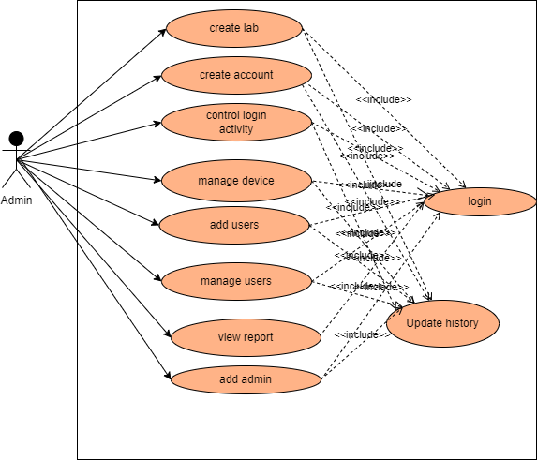

Figure3-1 Use Case model for Admin

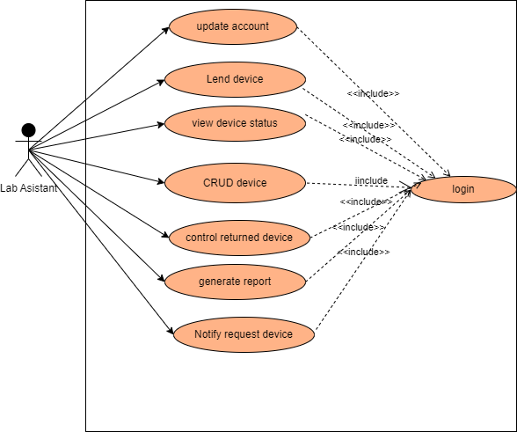

Figure3-2 Use Case model for Lab assistant

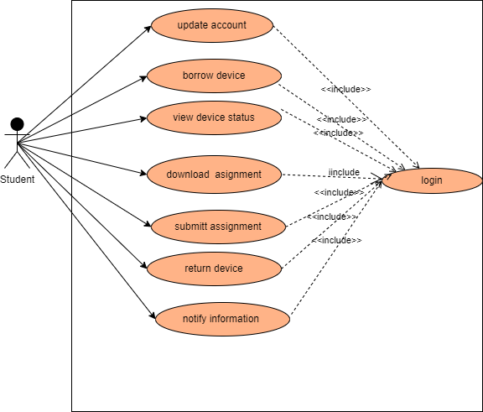

Figure3-3 Use Case model for Student

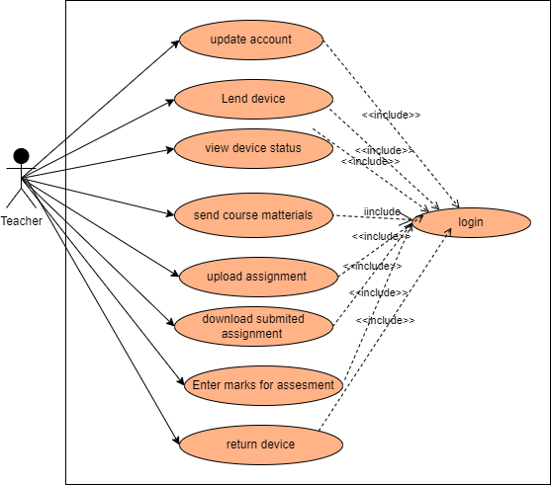

Figure3-4 Use Case model for Teacher

|  |  |
| --- | --- |
| Use case name | Login |
| Number | UC_01 |
| Description | This use case is used by Admin, Techer, Lab assistant and Student to log in to the system according to their privilege. |
| Participating actor | Admin, Teacher, Lab assistant, student |
| Precondition | * Admin must have an internet access. * The admin must have create User Name, email and password for each user then initially all other user use this account to access the system and they can change their user name and password after logged in to the system. |
| Flow events | 1. Admin create account for each user. 2. Each actor take their email and password from admin. 3. Actors browse the system using any browser. 4. System displays login form 5. Each actor enter their email and password to the login form. 6. Send in to the database by pressing login button. 7. The system authenticates the User Name and password. 8. The system redirects to the authorized page according to the privilege specified in the database and displays Dashboard based on their privilege. 9. End-use case |
| Post condition | The system should display to Admin, student, lab assistant or Teacher page |
| Alternative flow of events | If any incorrect user Name or password displays an error message.  Go back to login form |

|  |  |
| --- | --- |
| Use case name | Upload Assignment |
| Number | UC_02 |
| Description | Teacher Upload Assignment |
| Participating actor | Teacher |
| Precondition | * Admin must have an internet access * The Teacher must enter User Name and password to access the system. |
| Normal flow of events | 1. Teacher selects dashboard link.  2. Selects the Upload Assignment link.  3. Teacher select Assignment  4. Then teacher choose a file to be uploaded  5. Click upload button.  6. The system displays user assignment is uploaded successfully message.  End of use case. |
| Post condition | The Assignment is uploaded and Student can download the Assignment  And teacher can visit the uploaded assignment |
| Alternative flow of events | If any kind of error occurs while uploading the system redirects to the upload form |

|  |  |
| --- | --- |
| Use case name | Add user |
| Use case number | Uc_03 |
| Use case description | Admin create account for each user according to their privilege |
| Participating actor | Admin |
| Pre-conditions | * Admin must have an account that created by developer or another admin * Admin must have an internet access |
| Flow of events | 1. Admin browses to the system. 2. Admin click add user link. 3. Add new user page displayed 4. Admin fill the form 5. Admin save the form to the database 6. System check validation 7. Data stored in to database |
| Post condition | User data fetched from database and visited by admin |
| Alternate flow of events | * If the validation is error while entering data error message displayed * System stayed on current page. |

|  |  |
| --- | --- |
| Use case name | issue device |
| Use case number | Uc_04 |
| Use case description | The laboratory assistant issue device if the device is available by referring device status in the device table |
| Participating actor | Laboratory Assistant. |
| Pre-conditions | * Laboratory assistant must have an account created by the admin * Laboratory assistant must have an internet access |
| Flow of events | 1. Laboratory Assistant browses the system. 2. Laboratory Assistant view issue request 3. If the device status in the device table is available and the user is authenticated click approve button 4. Laboratory assistant fills out the approved form. 5. Laboratory assistant approves the form for the database 6. Data stored in the database |
| Postcondition | Student view the request page issue date and return date |
| The alternate flow of events | * If the approval is not approved by the laboratory assistant the page stays on the previous status meaning the issue date and the return date is not fill. * System stayed on current page. |

|  |  |
| --- | --- |
| Use case name | view lab equipment |
| Use case number | Uc_05 |
| Use case description | * All actors view lab equipment status, quantity, and other detailed information about the device * But Laboratory assistants can register, update, delete and borrow the device if necessary. |
| Participating actor | All actors |
| Pre-conditions | * All actors must have an account to view lab equipment. * All actors must have an internet access |
| Flow of events | 1. All actors browse the system. 2. All actors view all lab equipment 3. All users can send issue requests to the lab assistant to borrow the device. 4. Laboratory Assistant adds, updates, deletes and borrows a device for the authenticated user. 5. Data stored in the database |
| Postcondition | Users view the request page issue date and return date if they send an issue request |
| The alternate flow of events | * If the approval is not approved by the laboratory assistant the page stays on the previous status meaning the issue date and the return date is not fill. * System stayed on current page. |

|  |  |
| --- | --- |
| Use case name | See device status |
| Use case number | Uc_06 |
| Use case description | * All actors view lab equipment status detailed information about the device |
| Participating actor | All actors |
| Pre-conditions | * All actors must have an account to view device status. * All actors must have an internet access |
| Flow of events | 1. All actors browse the system 2. Users can ask request if the status is available in device status 3. But Laboratory assistants can borrow if the status is available 4. Data stored in the database |
| Postcondition | If the device status is available in device information user can send request to the laboratory assistant and if users cannot see the status of the device and the status is not available laboratory assistant also check the status if not available |
| The alternate flow of events | * If the status is not available the request is not approved since the status is available |

|  |  |
| --- | --- |
| Use case name | borrow device |
| Use case number | Uc_07 |
| Use case description | * Teachers and students can send requests and then borrow the device if the device is available |
| Participating actor | All actors |
| Pre-conditions | * All actors must have an account to borrow devices in the department. * All actors must have an internet access |
| Flow of events | 1. All actors browse the system 2. Users can ask request if the status is available in the device status 3. But Laboratory assistants can borrow if the status is available 4. Data stored in the database |
| Postcondition | * Borrow the device and return the device between the return date. unless expired. |
| The alternate flow of events | * If the user is not authorized the request is not approve. |

|  |  |
| --- | --- |
| Use case name | Submit Assignment |
| Use case number | Uc_08 |
| Use case description | * Teachers can send Assessment for the students and then student download the assignment send by the teacher if the assignment is available |
| Participating actor | Student and teachers |
| Pre-conditions | * Both actors must have an account to send assessment and to submit assignment. * both actors must have an internet access |
| Flow of events | 1. both actors browse the system to send assessment and te view assignment. 2. Teachers must send assessment for the specific group of students. 3. Students check the new assignment page if there is new assignment 4. If student get new assignment from teachers the student submit assignment on assignment submission data unless submit button is disabled. |
| Postcondition | * If assignment is submitted on be for submission last date the assignment is submitted. Else assignment is not submitted. |
| The alternate flow of events | * Report the reason why the assignment is not submitted for the teacher. |

|  |  |
| --- | --- |
| Use case name | Add new or unregistered device |
| Use case number | Uc_09 |
| Use case description | The laboratory assistant add device if the device is new or unregistered |
| Participating actor | Laboratory Assistant. |
| Pre-conditions | * Laboratory assistant must have an account created by the admin * Laboratory assistant must have an internet access |
| Flow of events | 1. Laboratory Assistant browses the system. 2. Laboratory Assistant add now device or unregistered device. 3. Laboratory assistant fills out the add device form. 4. Laboratory assistant insert the form for the database 5. Data stored in the database |
| Postcondition | After all forms are fill to register device, the registered device fetch to the device table automatically |
| The alternate flow of events | * If not, device register form fills correctly stayed on device registered page |

|  |  |
| --- | --- |
| Use case name | Update account |
| Use case number | Uc_10 |
| Use case description | All actors update their account like password, specialization, year and so on  But some attributes not updated like first name, last name, student group, session so on |
| Participating actor | All actors |
| Pre-conditions | * All actors must have an account created by the admin * All actors must have an internet access |
| Flow of events | 1. All actors browse the system. 2. All actors update their account. Like password and specialization. When updating their password, the old password must be entered first after this the new password and coniform new password must be the same to update the old password. 3. The updated Data stored in the database |
| Post-condition | After data is updated, the previous data is removed and the updated data is stored |
| The alternate flow of events | * If not updated stayed on the previous data. |