**PHILIPPINE SPORTS COMMISSION**

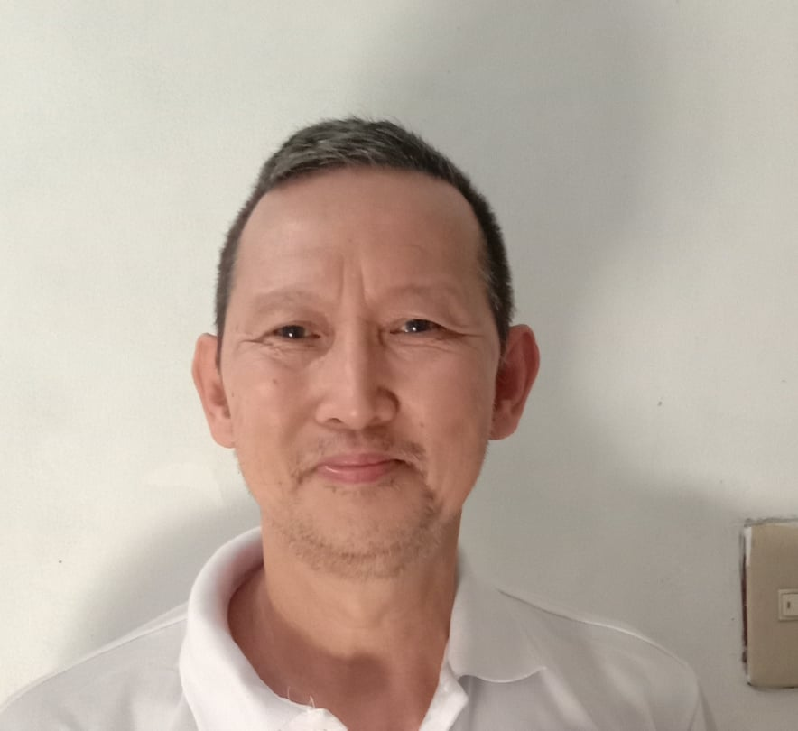

**ATHLETES’ PROFILE**

**SPORT: Chess**

|  |  |  |  |  |  |  |  |  |
| --- | --- | --- | --- | --- | --- | --- | --- | --- |
| **PERSONAL INFORMATION** | | | | | | | | |
| **SURNAME** | | De Guzman | | | | | | |
| **FIRST NAME** | | Ricardo | | | | | | |
| **MIDDLE NAME** | | Estraza | | | | | | |
| **DATE OF BIRTH:** | |  | | **GENDER** | | | Male | |
| **PROVINCIAL ADDRESS** | | Antipolo City, Rizal Province | | | | | | |
| **RESIDENTIAL ADDRESS** | | Blk 4 lot 16 Rhea St. Crestview subdivision | | | | | | |
| **EMAIL ADDRESS** | | Ricardodeguzman777@yahoo.com | | **CONTACT NUMBER** | | | 09277335668 | |
| **CIVIL STATUS** | | Married | | **RELIGION** | | | Born again Christian | |
| **HIGHEST EDUCATIONAL ATTAINMENT** | | | | | | | | |
| **YEAR GRADUATED** | | | **LEVEL/COURSE** | | | **NAME OF SCHOOL/ UNIVERSITY** | | |
| 1988-89 | | | 2 BS PSYCHOLOGY | | | Lyceum University | | |
|  | | |  | | |  | | |
|  | | |  | | |  | | |
| **SPORTS CAREER RECORDS** | | | | | | | | |
| **DATE** | **COMPETITION EVENT** | | | | **COUNTRY/VENUE** | | | **MEDAL/ RANK** |
| 1978 | Chess Olympiad Member | | | | Buenos Aires, Argentina | | |  |
| 1981 | Asian Junior Champion | | | | Dhaka, Bangladesh | | | First Place |
| 1983 | Asian Team Champion | | | | New Delhi, India | | |  |
| 1984 | Chess Olympiad Member | | | | Greece | | |  |
| 1985 | Asian Masters Champion | | | | Singapore | | | First Place |
| 1992 | Chess Olympiad Member | | | | Manila | | | First Place |
| 2002 | Calchess State Champion | | | | California, USA | | | First Place |
| 2002 | Bay Area Master’s Grand Pix | | | | San Francisco, USA | | | First Place |
| 2002 | Central CA chess congress | | | | Fresno California | | | First Place |
| 2003 | Vallejo Chess championship | | | | USA | | | First Place |
| 2003 | North Amercan International Open | | | | Las Vegas | | | Fifth Place |
| 2003 | Western States Open (Reno) | | | | Nevada, USA | | | Second Place |
| 2003 | Los Angeles Open | | | | Los Angeles | | | Second Place |
| 2004 | Pacific Coast Open | | | | USA | | | Second Place |
| 2004 | People’s Open(Berkeley | | | | USA | | | First Place |
| 2006 | Cal Classic Championship | | | | California | | | First Place |
| 2010 | Dolan Memorial International Chess | | | | San Francisco | | | First Place |
| 2010 | Pafnutieff Open Chess Championships | | | | San Francisco | | | First Place |
| 2011 | Sacramento Chess Championship | | | | Sacramento | | | First Place |
| 2013 | Calchess State Champion | | | | California | | | First Place |
| 2014 | Fresno International Chess Tournament | | | | California | | | First Place |
| 2019 | PECA National Executive Open | | | | Manila | | | First Place |
| 2019 | National Executive Championships | | | | Boracay, Aklan | | | Fifth Place |
| 2020 | PSC-NCFP Chess Championship | | | | Quezon City | | | Second Place |
| 2020 | Asian Senior Chess Qualifier 3.3 zone | | | | Online, Manila | | | First Place |
| 2020 | Asian Chess Championship 50+ | | | | Online, UAE Host | | | Fourth Place |
|  |  | | | |  | | |  |
|  |  | | | |  | | |  |
|  |  | | | |  | | |  |
|  |  | | | |  | | |  |
|  |  | | | |  | | |  |
|  |  | | | |  | | |  |
| ***(Continue on separate sheet if necessary)*** | | | | | | | | |
|  | | | | **October 4, 2020** | | | | |
| **SIGNATURE OF ATHLETE** | | | | **DATE ACCOMPLISHED** | | | | |