**Voice of Customer**

**Batch 2020**



Student 1: Aminah Rashid Roll#193-20-0003

Student 2: Ahsan Ali Shah Roll#023-20-0049

Student 3: Aneesh Lalwani Roll#023-20-0130

Supervisor: Dr. Raheel Ahmed Memon  
Associate Professor, Computer Science

**Sukkur IBA University**

**Department of Computer Science**

Table of Contents

1. INTRODUCTION 3

2. BACKGROUND 4

3. PROBLEM IDENTIFICATION 4

4. OBJECTIVES 5

5. CONTRIBUTIONS 6

6. SCOPE 6

7. LIMITATIONS 7

8. LITERATURE REVIEW 8

9. Modules 9

9.1 User Modules 9

9.2 Business Modules 9

9.3 Admin Modules 9

10. PROJECT TECHNICAL APPROACH, TECHNOLOGY STACK AND METHODOLOGY 9

Layers 10

Technology Stack 10

11. WORKFLOW DIAGRAMS 11

**User Module** 11

**Business Module**  12

**Admin Module**  13

12. PROJECT TIMELINE 14

13. Work Division 14

**ABSTRACT**

The rise of online businesses has transformed customer engagement and purchasing decisions. However, traditional methods of managing feedback and resolving complaints have proven inefficient. Businesses rely on scattered channels, hindering comprehensive analysis of customer sentiments. Customers struggle to find reliable information and resolve complaints across multiple platforms, leading to frustration and a lack of trust. To address these challenges, we propose a robust web-based voice of customer platform. It will provide a centralized portal for customers to leave holistic feedback and for businesses to access and manage reviews. The platform will streamline complaint resolution, ensuring customer concerns are not overlooked and providing regular updates. A fake review detection algorithm will enhance review authenticity, and businesses can gather direct feedback through surveys. Customers can flag suspicious companies and view reported businesses to protect themselves. Detailed ratings and feedback on specific experience factors will help businesses prioritize improvements. A user-friendly dashboard will allow customers to track business progress over time. The platform will curate a list of trending companies to assist customers in making informed purchasing decisions. This system aims to enhance the customer experience, foster trust, and drive the success of online businesses in Pakistan by providing valuable insights and improving complaint handling processes.

1. INTRODUCTIONThe rise of online businesses has transformed the way customers interact with brands and make purchasing decisions. In this digital era, customers have access to a vast array of products and services at their fingertips, leading to a significant shift in consumer behavior. Before making a purchase, customers now rely heavily on the opinions and experiences of others, seeking reassurance and validation through online reviews and ratings.

As a result, customer feedback has gained paramount importance in shaping the success and reputation of businesses. Positive reviews can significantly influence potential customers, driving sales and fostering brand loyalty. Conversely, negative reviews can deter potential customers, leading to lost opportunities and a tarnished brand image.

Businesses, on the other hand, face the challenge of managing and leveraging customer feedback and resolving complaints effectively. The sheer volume of customer reviews and the need to address customer concerns in a timely manner can be overwhelming. Also, oftentimes, the complaints are lost in the huge amount of data, making it difficult for businesses to identify and address them promptly. Without a systematic approach to capturing, analyzing, and responding to customer feedback and complaints, businesses risk losing valuable insights, tarnishing their brand image and losing customer trust.

Similarly, customers face their own set of challenges. With numerous options available, they often struggle to find reliable and trustworthy information about products and services. The lack of a centralized platform to access comprehensive and authentic customer reviews across different industries further compounds this problem. And from the customer's perspective, resolving an issue can be a frustrating and time-consuming process. Customers often face difficulties in finding the right channels to voice their complaints and may experience delays or lack of response from businesses. This can lead to dissatisfaction, negative word-of-mouth, and ultimately, loss of trust in the brand.

Therefore, there is a pressing need for a robust voice of customer platform that bridges the gap between businesses and customers. Such a platform would enable businesses to proactively track and resolve customer complaints, gain insights into customer preferences, and manage their online reputation effectively. Simultaneously, customers would benefit from a centralized platform where they can write reviews, access reliable information about companies, and make informed purchasing decisions and get their issue resolved.

By observing the challenges faced by both businesses and customers, it motivates us in providing a solution that caters to the evolving needs of both businesses and customers, our voice of customer platform aims to enhance the customer experience, foster trust, and drive the success of online businesses in this digital age.

# BACKGROUND The rise of online businesses has reshaped consumer behavior, with customers relying heavily on online reviews and ratings before making purchases. Positive reviews can boost sales, while negative ones can harm a brand's image. Managing and leveraging customer feedback is a challenge for businesses due to the sheer volume and lack of a systematic approach. Customers also struggle to find reliable information and face difficulties in voicing complaints. This has created a need for a comprehensive voice of customer platform. Our proposal aims to bridge this gap by empowering businesses to proactively address complaints, gain insights, and manage their online reputation. Simultaneously, customers will benefit from a centralized platform for reviews, trusted information, and issue resolution, thereby enhancing the customer experience and fostering trust in the digital age.

# PROBLEM IDENTIFICATION

To address the lack of a standardized rating system across different platforms that businesses use to collect customer feedback, which currently makes it difficult for businesses to consolidate rating metrics from various sources like individual websites and Facebook pages. A standardized rating system will allow businesses to identify key areas of improvement based on customer sentiment by consolidating metrics from various sources Some of the main limitations of existing approaches include:

* Lack of a single integrated platform: Existing platforms like Facebook pages and groups generate a vast amount of data daily, making it challenging for businesses to extract meaningful insights and manage customer feedback effectively.
* Difficulty in reputation management: Scattered reviews across various platforms make it difficult for businesses to monitor and manage their reputation consistently.
* Inefficient complaint tracking and resolution: Without a centralized system, businesses struggle to track and resolve customer complaints promptly, leading to customer dissatisfaction.
* Lack of improvement based on customer feedback: Customers often provide feedback and suggestions in their reviews, but businesses fail to implement necessary improvements, resulting in customer frustration. And without analyzing trends, businesses miss opportunities to enhance products/services as per customer needs.
* Missed business opportunities: Lack of actionable insights deprives businesses from understanding customer pain points and identifying new opportunities.
* Ineffective communication: Scattered platforms make it challenging for businesses to proactively communicate with and engage customers.

# OBJECTIVES

# To address the lack of standardized rating system cross different platforms that businesses use to collect customer feedback, which currently makes it difficult for businesses to consolidate rating metrics from various sources like individual websites and Facebook pages. A standardized rating system will allow businesses to identify key areas of improvement based on customer sentiment by consolidating metrics from various sources.

# To provide a centralized public platform for customers to directly submit complaints to individual businesses. This will ensure complaints are efficiently handled through a coordinated approach as businesses can properly track and address complaints in a timely manner.

# To provide businesses with performance reports analyzing metrics like complaint resolution rates and average customer ratings over time gathered from a centralized platform. This will enable businesses to make data-driven decisions and targeted improvements by gaining insights into trends and where they may be lacking as perceived by customers on specific experience attributes to meet shifting customer demands and expectations.

# CONTRIBUTIONS

* The platform will provide a standardized and centralized rating system where customers can leave granular ratings and feedback on individual experience factors for each business. This includes attributes like service quality, product quality, price, delivery speed, packaging, customer service, return/exchange process etc. Businesses will be able to access consolidated rating metrics in one place and identify key areas for improvement according to customer sentiment.
* The platform will enable a streamlined complaint submission and resolution process. Customers can submit complaints directly to the relevant businesses through the public platform. As it is publicly visible, issues will be addressed promptly to avoid negative perception. This ensures complaints do not get lost and are handled efficiently.
* The platform will generate regular performance reports to help businesses improve. Monthly reports will show average attribute ratings to track monthly changes, while annual reports analyze year-over-year trends across attributes like quality and service through graphs. Insights from annual reports highlight attributes needing most improvement based on customer feedback. This allows businesses to monitor short and long-term performance on specific experience factors through regular reports, helping them identify priority areas for targeted improvements that meet shifting customer demands over time.

# SCOPE

* The platform will target specific industries such as food, clothing, cosmetics, and electronics.
* The Voice of Customer (VOC) will be implemented as a web-based platform, excluding a mobile application.
* Analysis will be conducted using the OpenAI API.
* The Customer Module will facilitate feedback and complaint submission and history, display trending companies, provide a company progress dashboard, and send survey notifications.
* The Business Module will oversee review and complaint management, offer a monthly and yearly analysis dashboard, conduct competitor analysis, and generate surveys.
* The Admin Management Module will focus on managing users, companies, reviews, and review moderation.
* Technology used for development will be the MERN stack.
* For customer verification, the platform will allow two types of users: general customers and verified customers. A QR code generated by the company on our platform will be used to verify customers when they come to submit reviews.

# LIMITATIONS

* The platform will not include personal opinions and will rely solely on customer reviews, excluding third-party reviews.
* There will be no integration of a Customer Relationship Management (CRM) system into our platform and no integration with external systems due to time constraints.
* While complete authenticity of users cannot be guaranteed, a weighting of 30% for general reviews and 70% for verified reviews will be used to calculate the overall company rating.
* Due to time limitations, there will be no implementation of a defamation and scammer management module.
* Businesses will have the capability to distribute surveys only to registered customers of our platform.

# LITERATURE REVIEW

In the traditional approach, customer feedback is often collected passively through methods like suggest boxes, email, and occasional surveys. This feedback collection usually lacks real-time insights. The traditional approach may provide limited insight to customer sentiments, Businesses may not have a comprehensive understanding of customers need, pain points, and preferences. Feedback collected through traditional methods may take time to process and analyze. This delay can result in address urgent issues or make timely improvements. Without the robust feedback collection approach and analysis process, business may struggle to personalize products and services according to individual customer preferences. In traditional approach, businesses often react to issues only after they become significant problems. This reactive approach can harm customer satisfaction and brand reputation. Customers who actively submit feedback might not be an accurate sample if passive feedback collection techniques are used. This could potentially exclude the opinions of a significant portion of the customer base. Traditional feedback approaches may not provide enough data for businesses to make informed decisions. The lack of actionable insights can limit the strategic planning and innovation. To effectively address the need for a VOC platform, we conducted an extensive review of existing solutions in the market. We identified several notable platforms with features aligned with our objectives. Some key finds are summarized below:

|  |  |  |
| --- | --- | --- |
| Existing Solutions | Features | Redundant Features |
| Voice of Customer (Facebook Page)[1] | * Customer feedback collection * Engagement and interaction * Product/Services updates | * Negative feedback * Volume of data * Troll or Fake accounts * Difficulty in filtering relative feedback |
| Get Feedback[2] | * Customizable Surveys * Multi-channel distribution | * Survey Fatigue * Learning Curve * Cost Consideration * Limited Analytics |
| Survey Monkey[3] | * Survey creation and design * Survey analysis * Collaboration | * Limited customization option * Lack of real-time analytics |

# While these solutions provide valuable insights, our platform aims to offer a unique combination of features that addresses specific challenges faced by businesses in collecting and utilizing VOC.

# Modules

## 9.1 User Modules

* Search
* Categories
* Personal Review History
* Personal Complain History
* Survey Notification

## 9.2 Business Modules

* Manage Reviews
* Get Complains
* Get Reviews
* Analytics
* Generate Surveys

## 9.3 Admin Modules

* User Management
* Business Management
* Reviews Management
* Reviews Moderations

# PROJECT TECHNICAL APPROACH, TECHNOLOGY STACK AND METHODOLOGY

In our technical approach, we are embracing a robust architectural design to ensure a well-structured and scalable Brand Complaint Management and Rating App. This architecture consists of interconnected layers and modular components that facilitate efficient functionality and user interaction. At the forefront is the presentation layer, responsible for delivering an engaging and user-friendly interface through React. Beneath this lies the application logic layer, powered by Node.js and Express.js, which handles critical tasks such as complaint processing, user authentication, and sentiment analysis. To enhance sentiment analysis, we're integrating the powerful GPT-3.5 Turbo API, provided by OpenAI, which enables a deeper understanding of user comments and reviews. Anchoring the architecture is our data storage layer, entrusted to MongoDB, a versatile NoSQL database. By adhering to this architectural approach and incorporating modular design principles, we aim to provide a seamless and user-centric solution for efficient complaint management and user ratings.

OPENAI-GPT: OpenAI's GPT (generative pre-trained transformer) models have been trained to understand natural language and code. GPTs provide text outputs in response to their inputs. The inputs to GPTs are also referred to as "prompts". Designing a prompt is essentially how you “program” a GPT model, usually by providing instructions or some examples of how to successfully complete a task.[4]

Sentiment Analysis Code Example[5]

def get_sentiment(text):  
messages = [  
{"role": "system", "content": """You are trained to analyze and detect the sentiment of given text.   
If you're unsure of an answer, you can say "not sure" and recommend users to review manually."""},  
{"role": "user", "content": f"""Analyze the following product review and determine if the sentiment is: positive or negative.   
Return answer in single word as either positive or negative: {text}"""}  
]  
  
response = openai.ChatCompletion.create(model="gpt-3.5-turbo",messages=messages, max_tokens=100, temperature=0)  
response_text = response.choices[0].message.content.strip().lower()

return response_text

|  |  |
| --- | --- |
| Layers | Technology Stack |
| Frontend | HTML, CSS, JavaScript, React.js, Next.js, Bootstrap |
| Backend | Node.js, Express.js |
| Database | MongoDB |
| Data Analysis | Flask, GPT-3.5 Turbo |
| IDE and Project Management Tools | VSCode, Intellij Idea, Github, Git, Figma, Miro board |

# WORKFLOW DIAGRAMS

## **User Module**

## **Business Module**

## **Admin Module**

# PROJECT TIMELINE

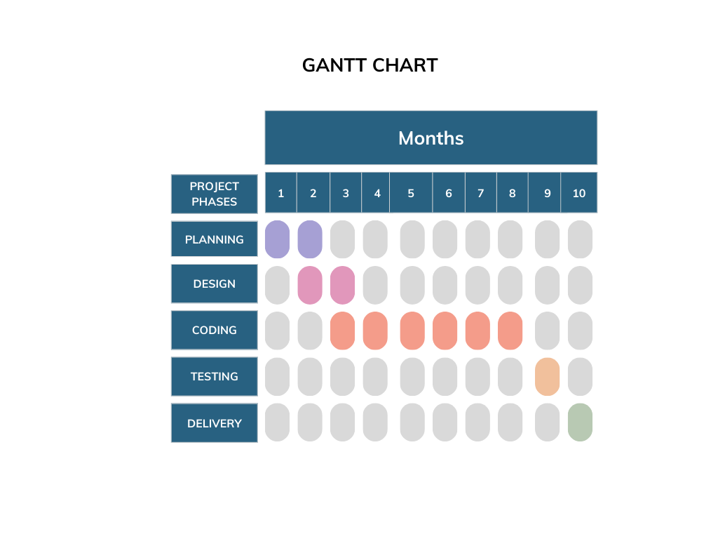

# Work Division

|  |  |  |  |
| --- | --- | --- | --- |
| **Topic** | **Aminah** | **Aneesh** | **Ahsan** |
| **Requirement** | ✔ | ✔ | ❌ |
| **System Analysis** | ✔ | ✔ | ✔ |
| **Front end** | ✔ | ❌ | ❌ |
| **Back end** | ❌ | ✔ | ✔ |
| **Testing** | ✔ | ✔ | ✔ |

1. [voiceofcustomer.com.pk](https://voiceofcustomer.com.pk/)
2. [getfeedback.com](https://www.getfeedback.com/en/)
3. [surveymonkey.com](https://www.surveymonkey.com/)
4. <https://platform.openai.com/docs/introduction/key-concepts>
5. <https://blog.gopenai.com/sentiment-analysis-web-app-with-flask-and-openai-api-8d0c1f01d55f>