A Minor Project-I Proposal on

**Movie Ticket Booking System**

Submitted in partial fulfilment of the requirements for the degree of Bachelor of Engineering in Software Engineering at Pokhara University.

**By**

**Anurag Gurung**

**Jwalanta Gurung**

**Sumin Gurung**



**Department of Research and Development**

**GANDAKI COLLEGE OF ENGINEERING AND SCIENCE**

Lamachaur, Kaski, Nepal

June, 2022

A Minor Project-I Proposal on

**Movie Ticket Booking System**

Submitted in partial fulfilments of the requirements for the degree of Bachelor of Engineering in Software Engineering at Pokhara University.

**By**

**Anurag Gurung**

**Jwalanta Gurung**

**Sumin Gurung**



**Supervisor**

**Er. Pratikshya Shrestha**

**Department of Research and Development**

**GANDAKI COLLEGE OF ENGINEERING AND SCIENCE**

Lamachaur, Kaski, Nepal

**APPROVAL CERTIFICATE**

This project entitled " **Movie Ticket Booking System** " prepared and submitted by "**Anurag Gurung, Jwalanta Gurung, Sumin Gurung**" under the supervision of " **Pratikshya Shrestha**" in partial fulfillment of the requirements for the Degree of Bachelor of Engineering in Software Engineering has been examined and is recommended for approval and acceptance.

**Date of Evaluation:** June 16, 2022

**……………………………………**

**Er. Pratikshya Shrestha**

(Project Supervisor)

**…………………………………**

**Er. Rajendra Bahadur Thapa**

(Acting Coordinator)

**Research Management Committee**

**Gandaki College of Engineering and Science**

**Abstract**

The project objective of "Movie Ticket Booking System" is to book cinema tickets through internet. Customers may view the contents of any movie show at any time and may book any movie ticket as needed. This online ticket reservation system provides a website for a cinema hall where any user of internet can access it. User is required to login to the system for booking the tickets. Tickets can be collected at the counter and watching movies with family and friends in theatre is one of the best medium of entertainment after having a hectic schedule. But all this excitement vanishes after standing in hours in long queues to get tickets booked. Our online tickets reservation system is one of the best opportunities for those who cannot afford enough time to get their tickets reserved standing in long queues. Our reservation system also provides option to cancel the tickets which are reserved previously.

Contents

Chapter 1 3

INTRODUCTION 3

1.1. Background 3

1.2. Problem Statement 3

1.3. Objectives 3

1.4. Project Specifications 3

1.5. Implications 4

Chapter-2 5

Literature Review 5

Chapter 3 6

Methodology 6

3.1 System Analysis 6

3.2 Use-case Diagram 6

3.3 Entity Relational Diagram (ERD) 7

Fig 3.2: Entity Relational Diagram of Movie Ticket Booking System 7

3.4 System Sequential Diagram (SSD) 8

Fig 3.3: System Sequential Diagram of Movie Ticket Booking System. 8

3.5 Required Tools 9

Chapter 4 10

Time Line Chart 10

4.1 Timeline Chart of Movie Ticket Booking System 10

Fig 4.1: Gantt chart of Movie Ticket Booking System 10

Chapter 5 11

Software Testing 11

5.1 Software testing 11

5.2 Test Objectives 11

5.3 Test Results 12

Fig 5.3: Test Cases 12

Chapter 6 13

Results and Discussion 13

6.1 Limitations 13

6.1 Future Improvements 13

Chapter 7 14

Conclusion 14

Chapter 8 15

Wireframe 15

5.1 Login Page 15

Fig 5.1: Wireframe of Login Page 15

5.2 Home Page 16

Fig 5.2: Wireframe of Home Page. 16

Bibliography 17

# Chapter 1

# INTRODUCTION

## 1.1. Background

Movie Ticket Booking System is a web-based system which is made or build that helps to book ticket easily without wasting any time and can be done in few clicks. Customer can book their ticket without having to stand in a queue at the cinema hall. They can book ticket 24 hours a day from anywhere in the Country. As mentioned, they do not have to travel to hall to buy the ticket like traditional way. Simply people can just choose their favorite movies with preferable time as well as seats. The main purpose of this project is to provide a reliable as well as secure and efficient and user friendly environment to the customers or users and management. It is also benefit to the customer because of efficient and faster service.

## 1.2. Problem Statement

* Had to wait for hours outside cinema to book tickets.
* Lack of proper management regarding booking of seats
* Unmanaged way of distributing tickets outside cinema

## 1.3. Objectives

* To develop website for booking tickets of movies.

## 1.4. Project Specifications

* Customer can select a movie/price
* Customer can select/deselect seats
* Customer can’t select occupied seats

## 1.5. Implications

Booking system helps to solve the traditional way of booking tickets which is time consuming as well has poor management system. In some clicks you can easily book your movie tickets and can enjoy your movie without standing in line for long period of time. You can book your tickets in advance so you don’t have to fight for your seat or have a problem of not getting seats. You can enjoy your favorite movie with your families and friends.

# Chapter-2

# Literature Review

There are already few similar websites such as Midtown Galleria, Qfx Cinemas etc. that serves similar purposes as ours due to which we have tried to add some different and easy to use features in our product which makes little bit different from other products.

* **QFX CINEMAS**

QFX Cinemas was founded by Rajesh Siddhi, Bhaskar Dhungana and Nakim Uddin. It features Nepali movies as well as Bollywood and Hollywood movies.

It was established in July, 2002 and online ticket system in QFX was established in March 2010.

* **MIDTOWN GALLERIA**

Midtown Galleria was founded by Jit Prasad Dwa on January, 2015. This idea has been the guiding principle for us in designing our spaces, planning our operations, choosing our clients and deciding what facilities that we should provide our clients and customers.

# Chapter 3

# Methodology

## 3.1 System Analysis

Project proposal from our group is Movie Ticket Booking System. This program will help customers to book ticket and reserve seat according to their desire in the available date and seat in the cinema hall. They can also cancel the ticket in certain period of time. Simply people can just choose their favorite movies with preferable time as well as seats.

## 3.2 Use-case Diagram

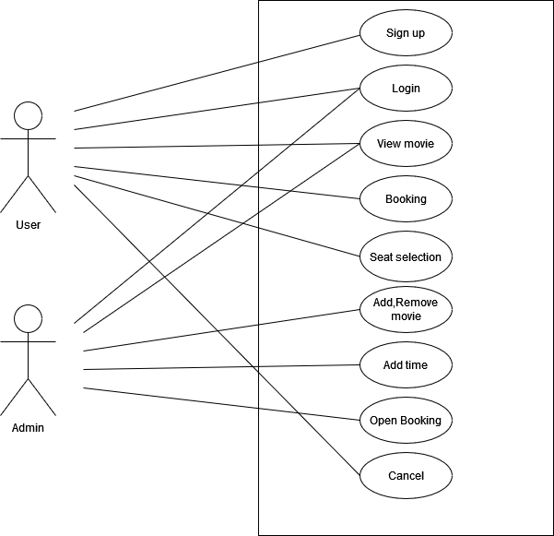

Fig 3.1: Use-case diagram of Movie Ticket Booking System

### 3.3 Entity Relational Diagram (ERD)

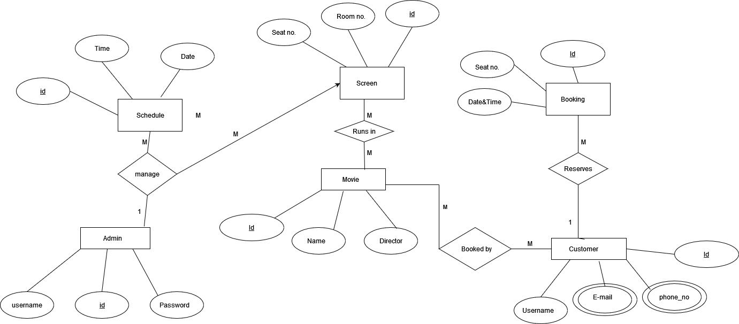

Fig 3.2: Entity Relational Diagram of Movie Ticket Booking System.

## 3.4 System Sequential Diagram (SSD)

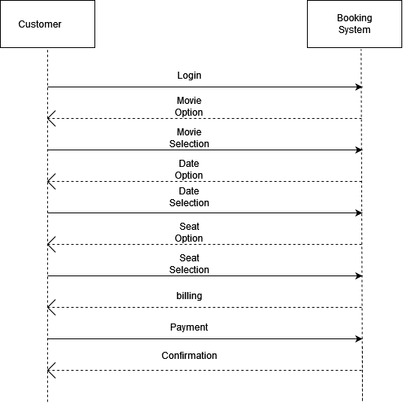

### Fig 3.3: System Sequential Diagram of Movie Ticket Booking System.

## 3.5 Required Tools

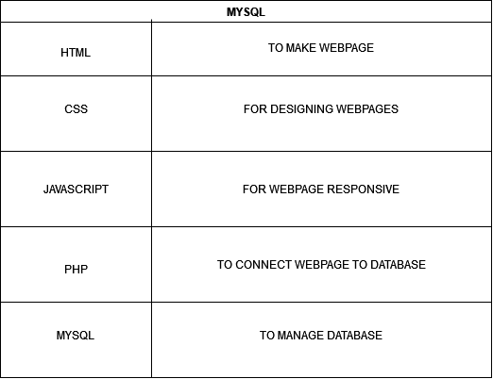

# Chapter 4

# Time Line Chart

## 4.1 Timeline Chart of Movie Ticket Booking System

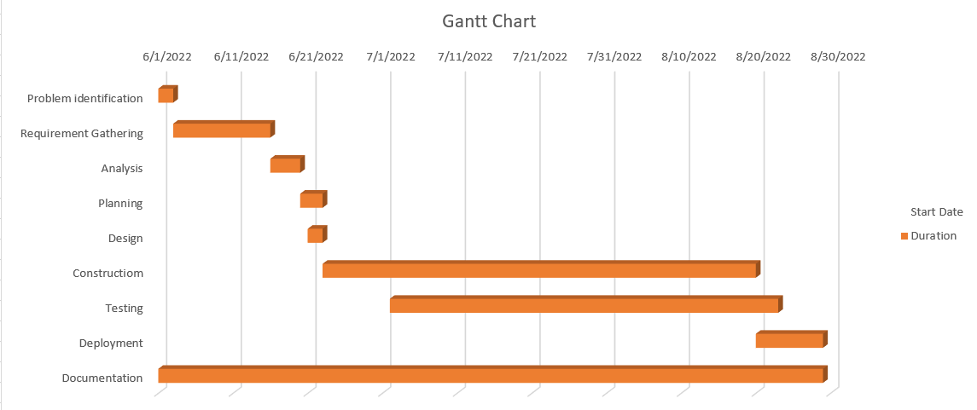

### Fig 4.1: Gantt chart of Movie Ticket Booking System

# Chapter 5

# Software Testing

# 5.1 Software testing

Software testing is a phenomenon to evaluate the functionality of a software application with an intent to find whether the developed software met its condition or not. It also identifies the defects to ensure that the product is defect-free in order to produce a quality product.

# 5.2 Test Objectives

The main objectives of testing our project i.e. Gurung Cinema were to:

* Check whether the website is as condition or not.
* Ensure that all the bugs are fixed by developer before presenting.

# 5.3 Test Results

|  |  |  |  |  |
| --- | --- | --- | --- | --- |
| S.N. | Test Cases | Expected | Observed | Results |
| 1 | Authentication for admin | A specific emails with its respective password is used | Only specific emails can be logged in | OK |
| 2 | About the site | -Stay updated about movies, seats and bookings  -user can see their bookings and cancel it | Movies, seats and bookings were checked  -Cancellation was successful and user were able to see their bookings | Ok |
| 3 | Adding Data | -Admin can add movies and its details | -The data were sent only when all the required data are provided | Ok |
|  |  |  |  |  |

### Fig 5.3: Test Cases

# Chapter 6

# Results and Discussion

Our project Gurung Cinema has helps us to learn various important things about development of websites. It provided us the opportunity to get knowledge about various web development language like html, css, java script and php. Our project can also be used in real world for Cinema halls. Our project was completed within the estimated time and with the help of our supervisor and team members.

# 6.1 Limitations

Our project was designed for booking seats in Cinema halls as only handful of cinema halls has online movie ticket booking system. But there are some limitations. They are as follows:

* Internet is required for accessing the project.
* Admin is needed, therefore technical person is requires for managing it.
* Digital devices are required for accessing the system.

# 6.1 Future Improvements

We can do following improvements in future:

* Addition of new features like payment.
* Optimization of the system.

# 

# Chapter 7

# Conclusion

Our website i.e. Gurung Cinema is for booking movie tickets, the main motive of our project is to provide customers reliable and easy way to book their desired movie. This website provides a platform for customers reliable as well as secure and efficient and user friendly environment to book their ticket 24 hours a day from anywhere in the country as mentioned they don’t have to travel to hall to buy the ticket like old traditional way

# 

# Chapter 8

# Wireframe

## 5.1 Login Page

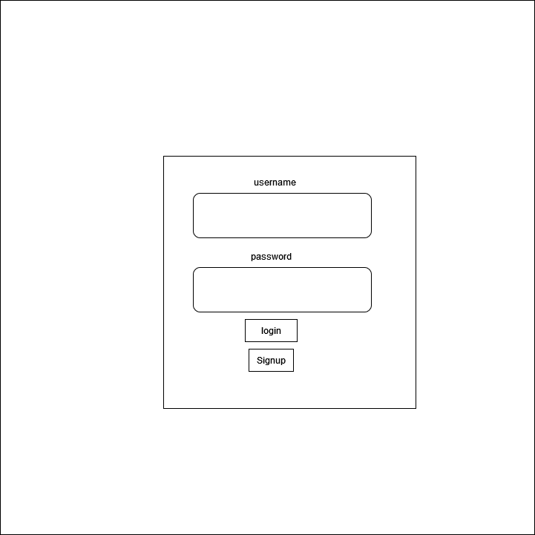

### Fig 5.1: Wireframe of Login Page

## 5.2 Home Page

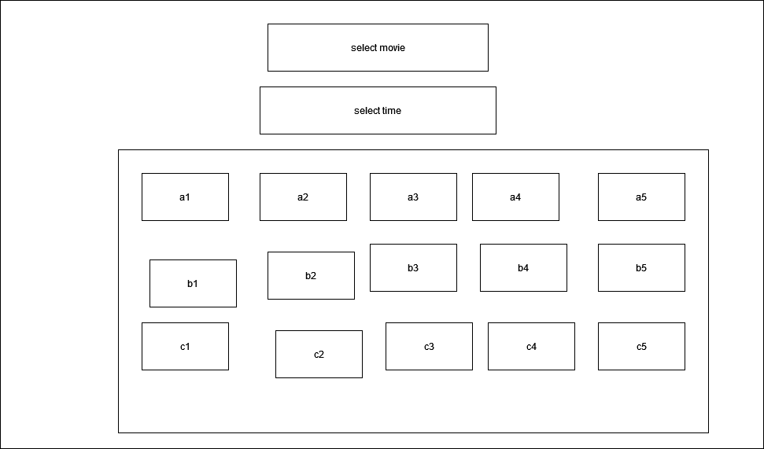

### Fig 5.2: Wireframe of Home Page.

# Bibliography

*Diagram.net*. (n.d.). Retrieved from https://draw.io/ .

*Midtown Galleria*. (n.d.). Retrieved from https://www.midtown.com.np/aboutus.

*QFX Cinema*. (n.d.). Retrieved from https://www.qfxcinemas.com/our-story.

*Slidshare*. (n.d.). Retrieved from https://www.slideshare.net.