AE3524 Assignment

Orbit Simulator for Formation Flying

Grgur Dujmović

# Introduction

To start the assignment, the given values are determined. There are two satellites a simulation has to be created for. The following are the given/calculated specifications for each:

**Satellite 1:**

* Size:
  + x – 300mm – 0.3m
  + y – 300mm – 0.3m
  + z – 300mm – 0.3m
* Mass – 30kg
* Orbit height – 500km
* Orbit circular and sun-synchronous, hence inclination ≈ 98o and orbit eccentricity = 0
* **Velocity** ≈ 7.61268km/s
* **Orbital radius (**semi-major axis**)** ≈ 6878km
* **Orbital period** ≈ 1h34m37s

**Satellite 2:**

* Size:
  + x – 300mm – 0.3m
  + y – 300mm – 0.3m
  + z – 300mm – 0.3m
* Mass – 30kg
* **Velocity ≈** 7.61368km/s
* **Orbit height ≈** 498.19km
* Orbit circular and sun-synchronous, hence inclination≈ 98o and orbit eccentricity = 0
* **Orbital radius (**semi-major axis**)** ≈ 6876km
* **Orbital period** ≈ 1h34m35s

# Task 1. Two satellite decaying orbit simulation

To perform this task, a python script was developed to simulate the decaying orbits of the satellites. To calculate the rate of change of orbital altitude, a simplified decay model is used:

r – distance of satellite to Earth centre

α0(r) – sum of accelerations acting on the satellite as a function of r (in this model we only consider atmospheric drag)

T(r) – period of the satellite as a function of r.

To calculate α0, the following equation is used:[1]

ρ(r) – atmosphere density at r distance from origin

v – orbital velocity

cd – drag coefficient

The atmospheric density model was adapted from Braeunig[2].

Values that remain constant during the orbit are:

* **i** -the inclination of the orbit – since the only force except gravity acting on the satellites is drag, the shape of the orbital plane is constant, therefore so is the inclination of it
* **Ω** – the longitude of the ascending node – the orbital plane is constant, so is Ω
* **ω –** the argument of periapsis – the orientation of the orbital plane is constant and the orbit is circular, hence it does not have a periapsis

Theorbit is circular, hence the **eccentricity** of it is 0, and as it decays it turns spiral, not having an eccentricity.

Values that are tracked during the orbit are:

* **a** – semimajor axis – this is expected to decrease as the orbit progresses and will be tracked using the altitude of the satellite
* **M** – mean anomaly – this is expected to increase linearly as the orbit progresses with a limit from -π to π radians
* **v** – velocity of the satellite – this is expected to increase as **a** decreases
* **D** – distance between satellites – the distance between satellites is expected to increase and then decrease because the satellite with the lower altitude will always be faster

The decaying orbit was simulated for 1 week with a drag coefficient for a cube (cd = 0.8 [3]). The altitude changes, shown in Figure 1 and 2, are minimal, with a change of 1.15m for satellite 1 and 1.20m for satellite 2. However, as the satellites decay, the atmosphere will become denser, resulting in higher drag hence more altitude loss. Estimated time for re-entry (the satellite dropping below 120km [4]) for satellite 1 is approximately 425 years and for satellite 2 it is 400 years.

Figure

To calculate the mean anomaly of the satellites, first the mean angular motion is calculated:

where T is the orbital period. Then, for each time step, the change in mean anomaly is calculated:

where ts is the timestep of the simulation.

Figures 3 and 4 don’t convey much information because a span of a week is a long time compared to the orbital period of around 1.5h but reducing the time frame on Figures 5 and 6 the orbital period can be read out. It is quite similar for both satellites and will only start to deviate later in the orbit.

Figure

Figure

Figure

Figure

Figure

In addition to calculating mean anomaly and altitude changes, the change in distance between the satellites and velocities is also calculated. Velocity was calculated using the altitude of the satellite:

where µ is the Earth’s gravitational parameter, equal to G × Mearth. The distance between satellites was calculated using a combination of the distance formula and the formula for the length of a circle chord:

where θ is the difference in mean anomaly of the satellites to effectively calculate the angle between the satellites. Figure 7 shows how the formula for the distance was derived. To find the distance between the satellites, the distance formula is used:

where ad is the difference between the semi-major axes.

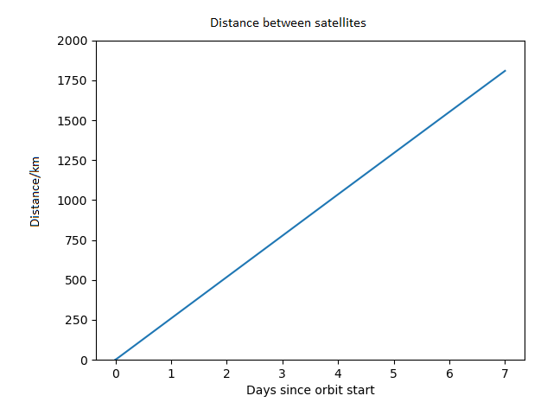Figure 8 shows the change in distance over a period of a week, and figure 9 shows the change in distance over a year. Figure 9 displays how satellite 2, which is faster (check figure 10 and 11) oscillates the distance between it and satellite 1, effectively lapping it because of the minimal difference in velocity. The maximum distance is just under 1400km, which is in line with the diameter of Earth + altitudes of both satellites.

Figure

Figure

Figure

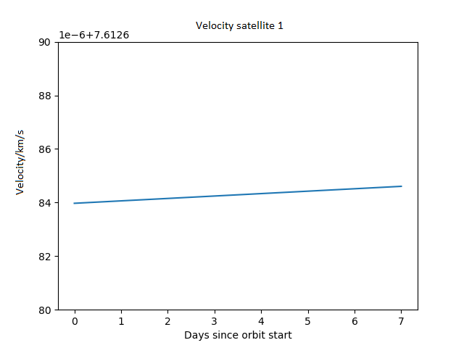Lastly, the velocities of the satellites are shown in figures 10 and 11.

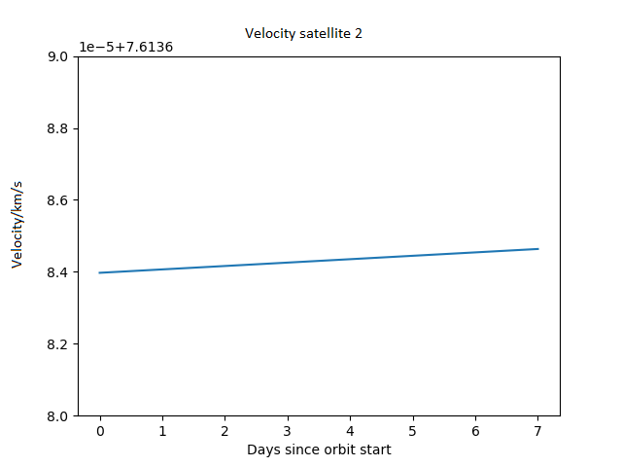The initial velocity of satellite 1 is ≈ 7.6127km/s. It increased by 6.331×10-7km/s. The initial velocity of satellite 2 is ≈ 7.6137. It increased by 6.627×10-7km/s. It is evident that the increases of velocity per week are negligible, amounting to less than centimetres per second difference on velocities that are measured in kilometres per second. However, over a longer time period, the changes will be larger.

Figure

Figure

# Task 2. Delta-v manoeuvres for along-track formation

1. Low, Samuel Y. W. (August 2018). "Assessment of Orbit Maintenance Strategies for Small Satellites". AIAA/USU Conference on Small Satellites.
2. "Properties Of Standard Atmosphere". Braeunig.us, 2022, http://www.braeunig.us/space/atmos.htm.
3. "Drag Coefficient". Engineeringtoolbox.Com, 2004, https://www.engineeringtoolbox.com/drag-coefficient-d_627.html.
4. Reentry And Collision Avoidance. 2022, https://www.esa.int/Space_Safety/Space_Debris/Reentry_and_collision_avoidance.