- Combinations to generate natural language planning problem variants in combination_variants.xlsx

Natural language problems available in problem_def

- Instructions for LLM to generate JSON files (see llm_instructions):
- Attach problem_def problem file (agricultural or construction)
- Attach JSON output example
- Attach natural language variant (agricultural or construction)
Example:
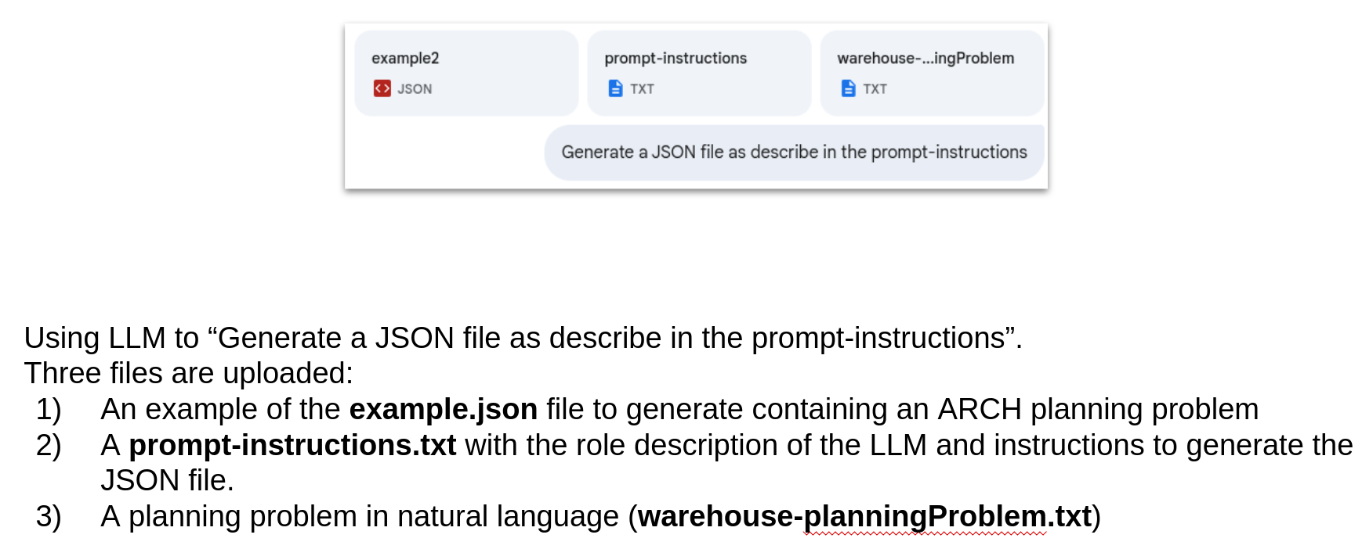

JSONs’ generated by DeepSeek and ChatGpt, as well as Gemini, available in separate subfolder.

