1. Combinations to generate natural language planning problem variants in combination_variants.xlsx

Natural language problems available in problem_def

1. Instructions for LLM to generate JSON files (see llm_instructions):

* Attach problem_def problem file (agricultural or construction)
* Attach JSON output example
* Attach natural language variant (agricultural or construction)

Example for Gemini:

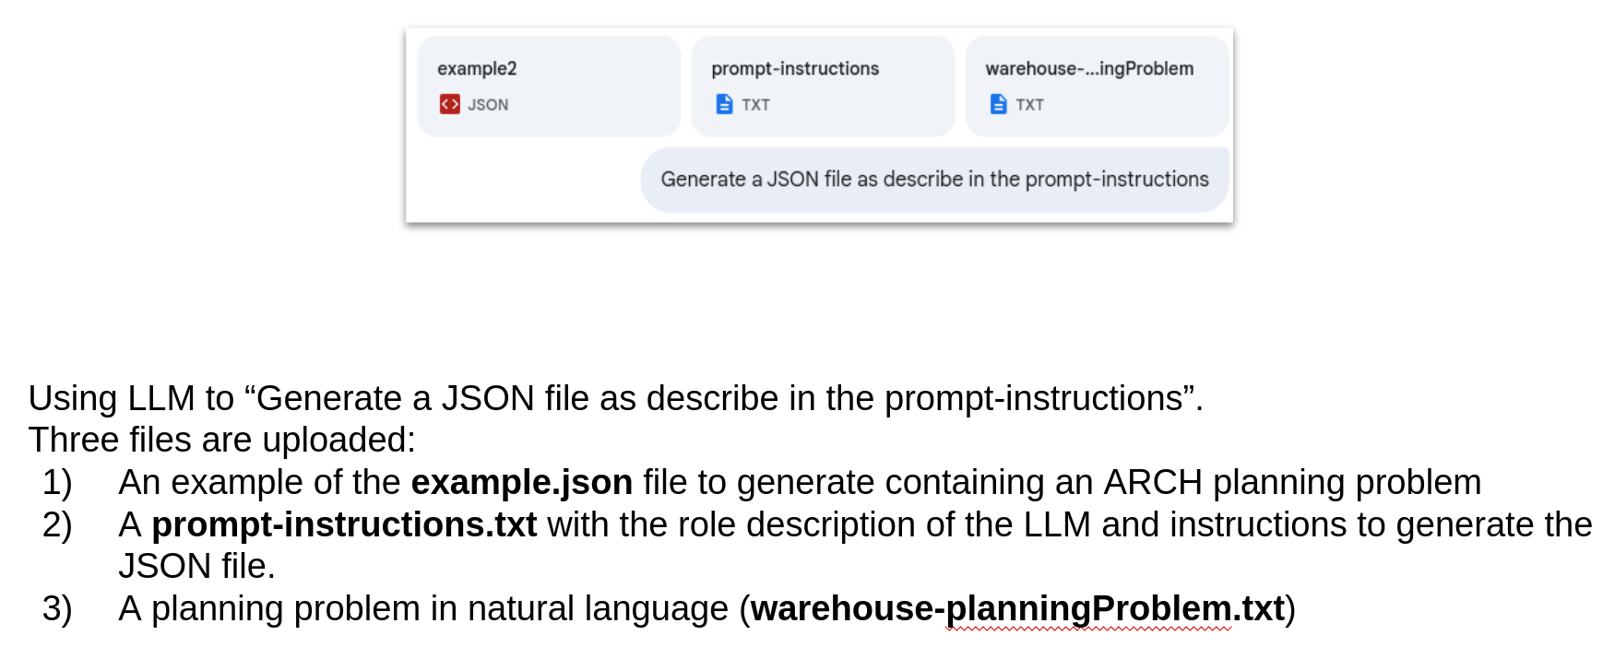

JSONs’ generated for Gemini. DeepSeek and ChatGpt available in each folder.