# openPDC v1.4.110 SP1 Upgrade Notes

**As a significant overall performance improvement**, SP1 of the openPDC v1.4.110 includes an optional (but enabled by default) non-broadcast method of directly routing measurements within the openPDC (based on suggestions by Tim Yardley and Erich Heine of the University of Illinois at Urbana-Champaign) which will provide at least a 50% reduction in CPU utilization in most configurations. Performance improvements will be greater with increased internal routing (time-series framework change set [**66077**](http://timeseriesframework.codeplex.com/SourceControl/changeset/changes/66077)).  
  
Other improvements include:

* Added *ProcessByReceivedTimestamp* property to *ConcentratorBase* so applications using class can sort and publish measurements by received time which is useful in scenarios where very large volumes of data need concentration, but not necessarily in real-time, such as, reading data from a file where you want it sorted and processed as fast as possible as per suggestion by Chuanlin Zhao of Washington State University - this includes a new connection string setting "*processByReceivedTimestamp*" to set enable processing option; defaults to False (time-series framework change set [**65777**](http://timeseriesframework.codeplex.com/SourceControl/changeset/changes/65777)).
* Implemented an "update configuration" per device connection, accessible via link on browse device screen, to simplify use case of updating a connection's modeled configuration (openPDC work item [**8249**](http://openpdc.codeplex.com/workitem/8249)).
* Added a secure offline user data cache to allow caching of key user information (e.g., user's group list) when user is disconnected from domain such that when role based rights are based on active directory group associations (i.e., where openPDC group name matches AD group name), rights upon login will still be active when logged in with cached Windows credentials without domain access (code library change set [**65150**](http://tvacodelibrary.codeplex.com/SourceControl/changeset/changes/65150)).
* Added historical time tracking to the time-series framework's *IFrame* and *IMeasurement* interfaces for both received and published timestamps (used by *ProcessByReceivedTimestamp*).
* Made audit log database triggers optional so that openPDC Manager can run faster when auditing is not needed (openPDC work item [**8544**](http://openpdc.codeplex.com/workitem/8544)).

Service Pack 1 also corrects issues reported by some users with openPDC v1.4.90, including the following:

* [**8571**](http://openpdc.codeplex.com/workitem/8571) Local in-process historian requires manual initialize for newly added device.
* [**8572**](http://openpdc.codeplex.com/workitem/8572) ID not displayed on manage measurements screen.
* [**8570**](http://openpdc.codeplex.com/workitem/8570) CPU spike on startup until frames per second assignment.
* [**8309**](http://openpdc.codeplex.com/workitem/8309) Historian Playback Utility Program doesn't work in non-English culture.
* [**8440**](http://openpdc.codeplex.com/workitem/8440) Exiting login dialog without successful login causes openPDCManager to spin.
* [**8260**](http://openpdc.codeplex.com/workitem/8260) openPDC.sql patch and User creation by configuration setup utility.
* [**8327**](http://openpdc.codeplex.com/workitem/8327) Use Local Clock as Real-time setting not honored in system view.
* [**8308**](http://openpdc.codeplex.com/workitem/8308) Web based historian: The request timed out before the page could be retrieved..
* [**8236**](http://openpdc.codeplex.com/workitem/8236) openPDC Manager :: Access Denied - Error loading security provider.
* [**8287**](http://openpdc.codeplex.com/workitem/8287) Device to Data in 5 Easy Steps - FrameParser raises MissingMethodException.
* [**8531**](http://openpdc.codeplex.com/workitem/8531) Setup utility does not automatically allow use of integrated security for openPDC service.
* [**8244**](http://openpdc.codeplex.com/workitem/8244) Optionally enable full timestamp history per measurement.
* [**8161**](http://openpdc.codeplex.com/workitem/8161) Enable of real-time data stream fails after the stream has been disabled once.
* [**8532**](http://openpdc.codeplex.com/workitem/8532) Cannot add default admin user when database created remotely.
* [**8196**](http://openpdc.codeplex.com/workitem/8196) Added new output stream latency statistics.
* [**7682**](http://openpdc.codeplex.com/workitem/7682) Calculated measurements show appear with a DeletedFromProcessing status.
* [**8537**](http://openpdc.codeplex.com/workitem/8537) Pre-populate existing information on step 3 of input wizard for existing devices.
* [**8538**](http://openpdc.codeplex.com/workitem/8538) Display historian update warning only if type was LocalOutputAdapter or IsLocal=true.

This service pack also corrects the following known issues with openPDC v1.4.90:

* Enabling the optional encryption on the connection strings on Windows 7 / 2008 requires that openPDC Manager be run as administrator or be installed into a non-protected folder such that it can have read/write access to the crypto-key cache. Otherwise an error will be displayed on startup of the openPDC Manager similar to: "Access Denied - Error loading security provider: Failed to decrypt connection string" (code library change set [**64226**](http://tvacodelibrary.codeplex.com/SourceControl/changeset/changes/64226)).
* Addition of duplicate settings in the connection strings (e.g., manually adding Integrated Security string along with checking the checkbox for this feature) will cause an error to be displayed on startup of openPDC Manager as "Access Denied - Error loading security provider" (code library change set [**64277**](http://tvacodelibrary.codeplex.com/SourceControl/changeset/changes/64277)).

When upgrading from the openPDC v1.4.90 released in March (or older versions) it is recommended that you upgrade your schema to the latest version since there were corrections made to some of the system views and you can also now choose to optionally enable the audit log triggers. Unless required for compliance, you can choose to not enable audit logging in your database schema which will represent a performance optimization for the openPDC Manager. Use the configuration setup utility to handle your data migration:

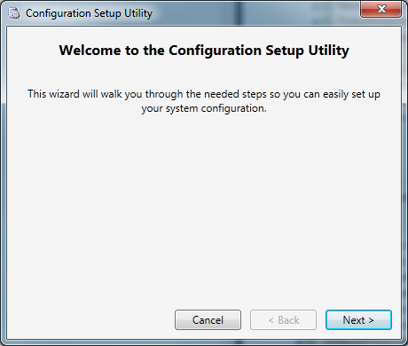

Follow these steps to upgrade your schema:

1. Choose to use an existing configuration:

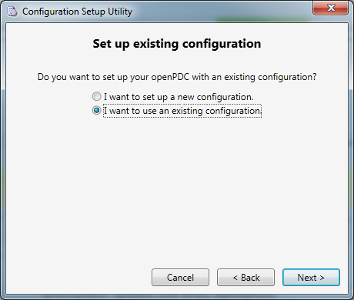

1. Select "Database" as the configuration type:

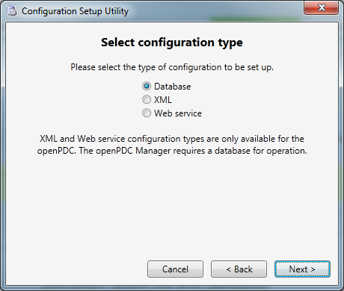

1. Choose to upgrade your existing database to the latest schema:

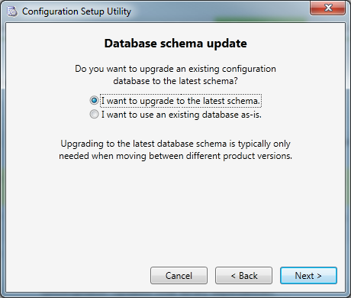

1. Follow the remaining setup steps and when the configuration setup utility completes, the data migration utility will run. Remove "AuditLog" from the excluded tables list if this history is important for compliance. Make sure the connections are correct (*from* is old schema, *to* is new schema), click "Test" links for both data sources, then click "Migrate":

