GridSenpAI
Data Model Design (DMD)
Version 1.0
Date: March 05, 2026
Architecture: Microservices on IBM Cloud (Watson-enabled)

1. Purpose
This Data Model Design (DMD) defines the logical and physical data models used by GridSenpAI. It specifies the entities, relationships, identifiers, persistence strategies, and constraints required to support the system behaviors defined in the SRS and the service boundaries defined in the SAD/DSD.

2. Data Domains and Storage Layers

2.1 Data Domains
- Project and Access Domain: projects, principals, role assignments, and access scopes.
- Artifact Domain: raw uploaded documents and extracted text/index records.
- Run Domain: run lifecycle, pinned configuration, lineage, and state transitions.
- Extraction/Normalization Domain: extracted entities, normalized inputs, validation reports, follow-up questions.
- Retrieval Domain: evidence bundles, snippet identifiers, and retrieval configuration.
- Outputs Domain: generated parameters, provenance, confidence tags, and scenario sets.
- Export Domain: export manifests, produced files, and changelogs/diffs.
- Audit/Compliance Domain: audit events, retention policies, and deletion/hold records.

2.2 Storage Layers
Object Storage (IBM Cloud Object Storage): Raw artifacts and generated export files (JSON + Word/PDF).
Relational Database (Db2 on IBM Cloud or PostgreSQL): Authoritative structured records for projects, runs, inputs/outputs, provenance, and audit events.
Vector Index / Search (Watson Discovery or Watsonx Vector Index): Embeddings and searchable corpora for vendor specs and modeling references; stores stable snippet identifiers and metadata pointers.

3. Canonical Schemas and Contract Strategy
GridSenpAI is schema-first. Canonical JSON schemas define the boundary contracts between services. At minimum, the platform maintains: GridSenpAI_inputs_schema.json (canonical inputs) and GridSenpAI_outputs_schema.json (canonical outputs).
Schema version identifiers are persisted with every NormalizedInput, ModelOutput, ScenarioSet, and Export to ensure reproducibility and compatibility over time.

4. Logical Data Model
The logical model defines entities and relationships independent of any specific database vendor. A high-level ERD is included below.
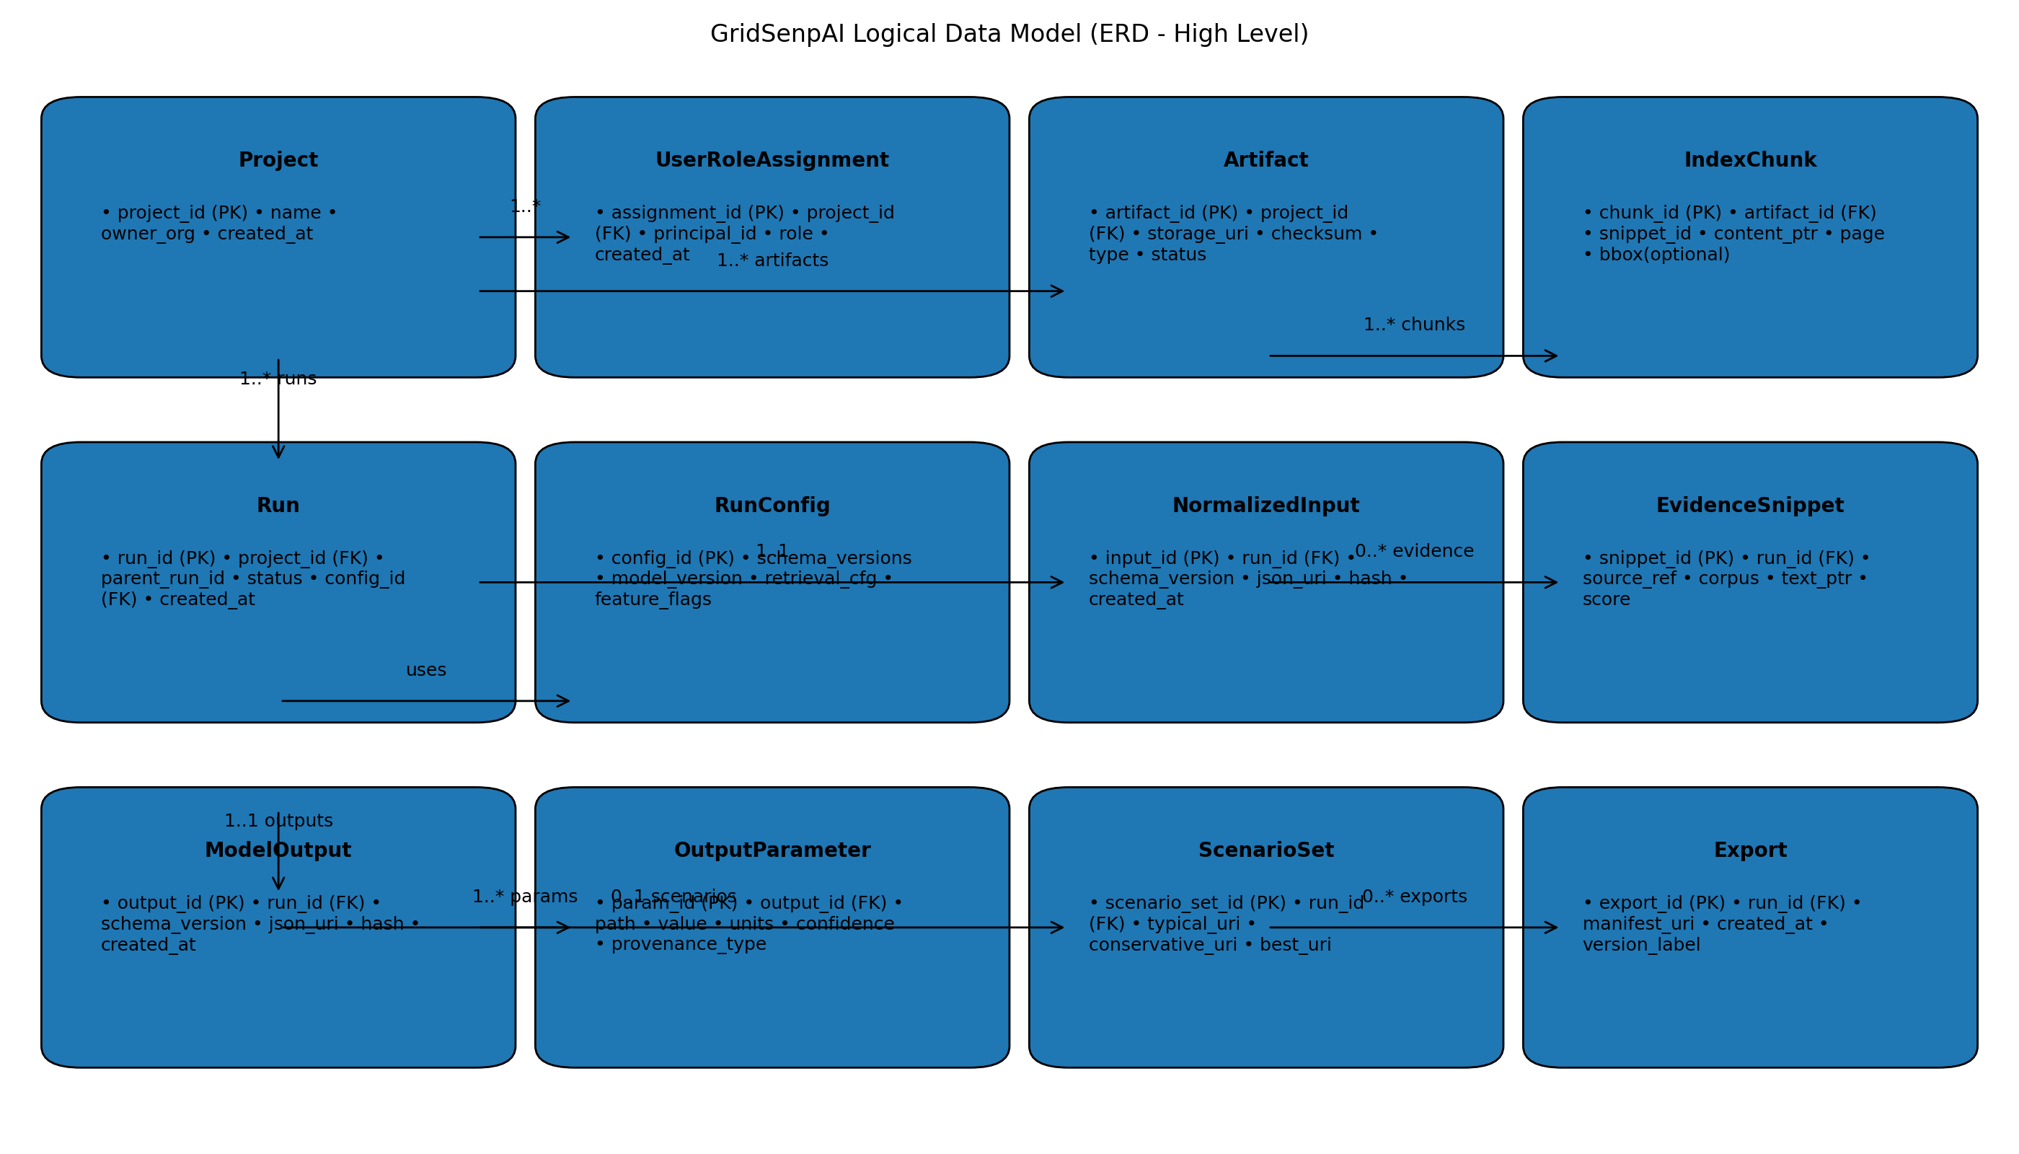

4.1 Entity Definitions (Logical)
Project: Top-level workspace and access boundary. Owns artifacts, corpora, and runs.
Principal: A user or service identity (mapped from IAM).
UserRoleAssignment: Project-scoped role assignment binding a principal to a role (Engineer/Planner/Admin/Auditor).
Artifact: Uploaded file metadata and storage pointer; includes type tags, checksum, and ingestion status.
ArtifactText: Extracted text pointer and extraction metadata for an artifact.
IndexChunk: Index record representing a chunk/snippet derived from an artifact; includes optional anchor metadata.
Run: A single execution instance; includes lineage (parent_run_id), run state, and references pinned configuration.
RunConfig: Pinned configuration for reproducibility (schema versions, model version, retrieval config, feature flags).
ExtractionResult: Structured entities and topology cues derived from artifacts, with source anchors.
SourceAnchor: Stable reference into an artifact (page + optional bbox + content pointer).
NormalizedInput: Schema-valid canonical input object, persisted as JSON + hash.
ValidationReport: Normalization validation output: errors, warnings, conflicts, missing fields.
FollowUpQuestion: Structured missing-data questions tied to schema field paths and reasons.
EvidenceBundle: Run-scoped set of retrieved evidence snippets with retrieval configuration metadata.
EvidenceSnippet: Single retrieved passage with snippet_id, source_ref, and text pointer.
ModelOutput: Schema-valid canonical output object, persisted as JSON + hash.
OutputParameter: Individual parameter records for queryability (path/value/units/confidence/provenance pointer).
Assumption: Explicitly declared assumption used when evidence is missing; bound to parameter paths.
ScenarioSet: Scenario variants (Typical/Conservative/Best-Case) persisted as JSON pointers and metadata.
Export: Published export manifest for a run; links to JSON and report artifacts stored in object storage.
ExportArtifact: Individual artifact entries within an export manifest (type, uri, checksum).
RunDiff: Parameter-level diffs between a run and its parent_run_id (or chosen baseline).
AuditEvent: Immutable security and operational events (access, run execution, export download).
RetentionPolicy: Project-scoped retention rules and deletion schedules for artifacts and exports.

4.2 Relationship Summary
- Project 1..* Artifacts
- Project 1..* Runs
- Project 1..* UserRoleAssignments (role bindings)
- Artifact 0..1 ArtifactText
- Artifact 0..* IndexChunks
- Run 1..1 RunConfig
- Run 0..1 ExtractionResult; ExtractionResult 0..* SourceAnchors
- Run 0..1 NormalizedInput; NormalizedInput 0..1 ValidationReport; ValidationReport 0..* FollowUpQuestions
- Run 0..1 EvidenceBundle; EvidenceBundle 0..* EvidenceSnippets
- Run 0..1 ModelOutput; ModelOutput 0..* OutputParameters; ModelOutput 0..* Assumptions
- Run 0..1 ScenarioSet
- Run 0..* Exports; Export 1..* ExportArtifacts
- Run 0..* RunDiffs (vs parent or baseline)
- Project 0..* RetentionPolicies
- Project/Run/Artifact 0..* AuditEvents (scoped by object_type + object_id)

5. Physical Data Model (Relational)
This section provides a production-ready physical model suitable for Db2 on IBM Cloud or PostgreSQL. The design uses stable UUID identifiers, explicit foreign keys, and indexes for common access patterns.

5.1 Identifier Strategy
Primary keys: UUID (v4) for all top-level entities (project_id, artifact_id, run_id, etc.).
Natural keys: checksums and artifact storage URIs are treated as unique constraints per project.
Snippet IDs: stable string identifiers provided by indexing/retrieval layer; treated as primary key within evidence scope.

5.2 Core Tables

Table: projects
Columns:
- project_id PK (uuid)
- name
- owner_org
- created_at
- created_by_principal_id
- status
Constraints / Indexes:
- UNIQUE(name, owner_org)

Table: principals
Columns:
- principal_id PK (string)
- principal_type (user|service)
- display_name
- email(optional)
- created_at
Constraints / Indexes:
- UNIQUE(email) WHERE email IS NOT NULL

Table: project_role_assignments
Columns:
- assignment_id PK (uuid)
- project_id FK -> projects
- principal_id FK -> principals
- role
- created_at
- created_by_principal_id
Constraints / Indexes:
- UNIQUE(project_id, principal_id, role)

Table: artifacts
Columns:
- artifact_id PK (uuid)
- project_id FK -> projects
- filename
- mime_type
- storage_uri
- checksum
- artifact_type
- tags(json)
- ingestion_status
- created_at
- created_by_principal_id
Constraints / Indexes:
- UNIQUE(project_id, checksum)
- UNIQUE(project_id, storage_uri)

Table: artifact_text
Columns:
- artifact_id PK/FK -> artifacts
- extraction_method
- extracted_text_uri
- page_count
- extracted_at
- status

Table: index_chunks
Columns:
- chunk_id PK (uuid)
- artifact_id FK -> artifacts
- project_id FK -> projects
- snippet_id (string)
- content_ptr_uri
- page_num
- bbox_json(optional)
- created_at
Constraints / Indexes:
- INDEX(project_id, snippet_id)
- INDEX(artifact_id)

Table: run_configs
Columns:
- config_id PK (uuid)
- inputs_schema_version
- outputs_schema_version
- model_version
- retrieval_config_json
- feature_flags_json
- created_at

Table: runs
Columns:
- run_id PK (uuid)
- project_id FK -> projects
- parent_run_id FK -> runs (nullable)
- config_id FK -> run_configs
- status
- status_reason(optional)
- created_at
- created_by_principal_id
- started_at(optional)
- completed_at(optional)
Constraints / Indexes:
- INDEX(project_id, created_at)
- INDEX(parent_run_id)

Table: run_state_transitions
Columns:
- transition_id PK (uuid)
- run_id FK -> runs
- from_state
- to_state
- timestamp
- actor_principal_id
- details_json(optional)
Constraints / Indexes:
- INDEX(run_id, timestamp)

Table: extraction_results
Columns:
- extraction_id PK (uuid)
- run_id FK -> runs UNIQUE
- result_json_uri
- result_hash
- created_at
- status
Constraints / Indexes:
- INDEX(run_id)

Table: source_anchors
Columns:
- anchor_id PK (uuid)
- run_id FK -> runs
- artifact_id FK -> artifacts
- page_num
- bbox_json(optional)
- text_snippet_ptr_uri
- created_at
Constraints / Indexes:
- INDEX(run_id)
- INDEX(artifact_id)

Table: normalized_inputs
Columns:
- input_id PK (uuid)
- run_id FK -> runs UNIQUE
- schema_version
- input_json_uri
- input_hash
- created_at
Constraints / Indexes:
- INDEX(run_id)

Table: validation_reports
Columns:
- report_id PK (uuid)
- run_id FK -> runs UNIQUE
- report_json_uri
- created_at
- has_blockers(boolean)
Constraints / Indexes:
- INDEX(run_id)

Table: followup_questions
Columns:
- question_id PK (uuid)
- run_id FK -> runs
- field_path
- reason
- severity
- suggested_sources_json(optional)
- status(open|answered|dismissed)
- created_at
- answered_at(optional)
- answered_by_principal_id(optional)
Constraints / Indexes:
- INDEX(run_id, status)

Table: evidence_bundles
Columns:
- bundle_id PK (uuid)
- run_id FK -> runs UNIQUE
- retrieval_config_json
- created_at
Constraints / Indexes:
- INDEX(run_id)

Table: evidence_snippets
Columns:
- snippet_id PK (string)
- run_id FK -> runs
- bundle_id FK -> evidence_bundles
- corpus
- source_ref
- text_ptr_uri
- score(optional)
- metadata_json(optional)
- created_at
Constraints / Indexes:
- INDEX(run_id)
- INDEX(bundle_id)

Table: model_outputs
Columns:
- output_id PK (uuid)
- run_id FK -> runs UNIQUE
- schema_version
- output_json_uri
- output_hash
- created_at
Constraints / Indexes:
- INDEX(run_id)

Table: assumptions
Columns:
- assumption_id PK (uuid)
- output_id FK -> model_outputs
- parameter_path
- bounds_json
- rationale
- created_at
Constraints / Indexes:
- INDEX(output_id)

Table: output_parameters
Columns:
- param_id PK (uuid)
- output_id FK -> model_outputs
- parameter_path
- value_json
- units
- confidence_tag
- provenance_type (evidence|rule|assumption)
- provenance_ref (snippet_id|rule_id|assumption_id)
- created_at
Constraints / Indexes:
- INDEX(output_id)
- INDEX(parameter_path)

Table: scenario_sets
Columns:
- scenario_set_id PK (uuid)
- run_id FK -> runs UNIQUE
- typical_json_uri
- conservative_json_uri
- bestcase_json_uri
- created_at
Constraints / Indexes:
- INDEX(run_id)

Table: exports
Columns:
- export_id PK (uuid)
- run_id FK -> runs
- manifest_uri
- version_label
- created_at
- created_by_principal_id
Constraints / Indexes:
- INDEX(run_id, created_at)

Table: export_artifacts
Columns:
- export_artifact_id PK (uuid)
- export_id FK -> exports
- artifact_kind (json|report|changelog|other)
- storage_uri
- checksum
- created_at
Constraints / Indexes:
- INDEX(export_id)

Table: run_diffs
Columns:
- diff_id PK (uuid)
- run_id FK -> runs
- baseline_run_id FK -> runs
- diff_json_uri
- created_at
Constraints / Indexes:
- INDEX(run_id)
- INDEX(baseline_run_id)

Table: audit_events
Columns:
- event_id PK (uuid)
- timestamp
- principal_id FK -> principals
- project_id FK -> projects (nullable)
- object_type (project|artifact|run|export|admin)
- object_id
- action
- result (success|failure)
- details_json(optional)
Constraints / Indexes:
- INDEX(project_id, timestamp)
- INDEX(object_type, object_id)

Table: retention_policies
Columns:
- policy_id PK (uuid)
- project_id FK -> projects
- policy_name
- applies_to (artifacts|exports|all)
- retain_days
- legal_hold(boolean)
- created_at
- created_by_principal_id
Constraints / Indexes:
- INDEX(project_id)

5.3 Common Access Patterns and Supporting Indexes
List runs for a project (most recent first): INDEX(runs.project_id, runs.created_at)
Fetch all artifacts for a project: INDEX(artifacts.project_id); UNIQUE(project_id, checksum)
Fetch a run with pinned config and lineage: INDEX(runs.parent_run_id); FK runs.config_id
Fetch evidence for a run: INDEX(evidence_snippets.run_id)
Query parameters by path across outputs (debug/analysis): INDEX(output_parameters.parameter_path)
Audit queries by project over time: INDEX(audit_events.project_id, audit_events.timestamp)

6. Object Storage Layout
Object storage holds raw artifacts and generated export files. The relational database stores pointers (storage_uri) and checksums for integrity.
Recommended bucket/prefix layout (per environment):
- cos://gridsenpai-{env}/projects/{project_id}/artifacts/{artifact_id}/raw/{filename}
- cos://gridsenpai-{env}/projects/{project_id}/artifacts/{artifact_id}/derived/text/extracted.txt
- cos://gridsenpai-{env}/projects/{project_id}/runs/{run_id}/inputs/normalized_input.json
- cos://gridsenpai-{env}/projects/{project_id}/runs/{run_id}/evidence/evidence_bundle.json
- cos://gridsenpai-{env}/projects/{project_id}/runs/{run_id}/outputs/model_outputs.json
- cos://gridsenpai-{env}/projects/{project_id}/runs/{run_id}/scenarios/scenario_set.json
- cos://gridsenpai-{env}/projects/{project_id}/runs/{run_id}/exports/{export_id}/manifest.json
- cos://gridsenpai-{env}/projects/{project_id}/runs/{run_id}/exports/{export_id}/report.docx
- cos://gridsenpai-{env}/projects/{project_id}/runs/{run_id}/exports/{export_id}/report.pdf
- cos://gridsenpai-{env}/projects/{project_id}/runs/{run_id}/exports/{export_id}/outputs.json
- cos://gridsenpai-{env}/projects/{project_id}/runs/{run_id}/exports/{export_id}/changelog.json

7. Provenance Model
Provenance is mandatory for all exported parameters. Each OutputParameter stores a provenance_type and a provenance_ref that points to either evidence (snippet_id), a deterministic rule identifier, or an explicit assumption identifier.
- provenance_type = evidence → provenance_ref = evidence_snippets.snippet_id
- provenance_type = rule → provenance_ref = rule_id (string identifier defined by the translation ruleset)
- provenance_type = assumption → provenance_ref = assumptions.assumption_id
If a parameter cannot be linked to evidence, rule, or assumption, the export must be blocked for that parameter and the system must emit remediation guidance.

8. Versioning, Lineage, and Diff Storage
Runs are versioned through parent_run_id lineage. Each run pins a RunConfig and references immutable input/output artifacts via hashes and checksums. Parameter-level diffs between a run and its baseline are stored as run_diffs.diff_json_uri for auditability.
- runs.parent_run_id links versions within a project.
- model_outputs.output_hash and normalized_inputs.input_hash support reproducibility claims.
- run_diffs stores the computed diffs to avoid re-computation and to ensure audit consistency.

9. Security and Access Control in the Data Model
Access is project-scoped. Every primary entity is either directly owned by a project (artifact, run, export) or is only accessible via a project-owned reference. Role assignments are stored in project_role_assignments and should be enforced at the API boundary and optionally at the database layer (row-level security where supported).

10. Data Retention and Compliance
Retention policies are project-scoped and stored in retention_policies. Storage cleanup jobs should use these policies to schedule deletion of object storage content and to prune structured records where allowed. Legal hold flags prevent deletion while active.

11. Implementation Notes for IBM Watson Integration
When using Watson Discovery or Watsonx Vector Index, snippet identifiers should be treated as stable external IDs. The relational model stores snippet_id and source_ref plus a text pointer (text_ptr_uri) rather than duplicating large passages. This keeps the database lean while preserving auditability.

12. Out of Scope for This Version
- Full vendor-specific schema adapters beyond canonical input/output schemas.
- Advanced graph representation of topology beyond stored topology cues (can be added as a separate graph store if required).
- Full analytics warehouse model for aggregated cross-project reporting.

