Software Design Document

An Accreditation Software for UTB

Alberto Hernandez

Matthew Garcia

11/11/14

Revision 0

Revision History

Revision 11/11/14

Revision History

Revision 0 11/8/14

**Table of Contents**

1 Introduction ..............................................................................................................2

1.1 Purpose..................................................................................................................2

1.2 Scope ....................................................................................................................2

1.3 Definitions, Acronyms, and Abbreviation.. .............................................................2

1.3.1 Customer …….....................................................................................................3

2 Design Overview........................................................................................................3

2.1 Description of Problem ….......................................................................................3

2.2 Class Structure ……...............................................................................................4

2.3 System Operation …..............................................................................................5

4 Project Timeline ………..............................................................................................6

1. **Introduction**

1.1 **Purpose**

The purpose of this document is to present a detailed description of the new UTRGV accreditation software.  It will explain the purpose, features, and the interface of the software through a desktop GUI based application.  It will implement a form of network connectivity and will be organized using Databases/HTML/XML.  At the end of this project it will automate the software that will work for every department in the University.

1.2 **Scope**

The QsARC software will be intended to be used by the University’s individual departments, and their end users’ curiosity to learn more of UTRGV.  It will give the university’s information and background, as in mission’s statements and visions.  This software will allow each department to edit the pages with detailed program information, degree plans, and student’s statistics.  Students will be allowed to find information on curriculums as well as the accompanied information regarding their selection.

The goal of this document is to specify its developmental requirements in order to properly implement what is stated in its scope.

1.3 **Definitions, Acronyms, and Abbreviations**

|  |  |
| --- | --- |
| **Terms** | **Definition** |
| QsARC | Refers to software name |
| Stakeholder | The people with an interest or concern with the project |
| end user | People using the software |
| DB | DB is an acronym for database |
| Agile Process | A group of software development methods based on  iterative and incremental development, where  requirements and solutions evolve through  collaboration between self organizing, cross functional  teams |
| SRS | Software Requirement Specifications |
| Hardware | The machines, wiring, and other physical components of a computer or other electronic system. |
| JVM | Java Virtual Machine |
| UTRGV | University of Rio Grande Valley |

1.3.1 **Customer**

**Any school which is willing to create forms for its own enterprise.**

The end user of the software developed for this project.

2 **Design Overview**

2.1 **Description of Problem**

The customer has requested the development of software that is capable of storing data from an enterprise and be able to generate that input into a document.

2.2 **Class Structure**

This system is designed to be as simple as possible. Initial designs call for three main classes:

2.2.1.1 UTRGV – a base class that holds data from the root member of a tree which includes: name, mission, etc.

2.2.1.2 Department – in this class all the information is distributed between multiple classes which include the faculty members, the name of the department, programs and student information.

2.2.1.3 Faculty – in this class we will store the faculty members and their position.

2.2.1.4 Programs – in this class we have the list of the degrees of the university.

2.2.1.5 Student Info – in this class we will store the number of students, rank, gender, ethnicity, and age.

2.2.1.6 Class Diagram

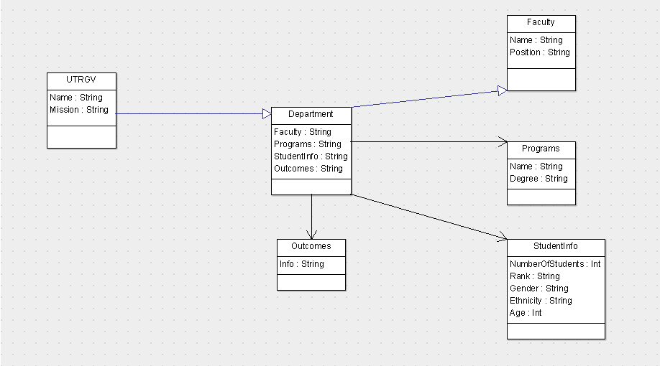

2.3 **System Operation**

2.3.1 **Store Data**

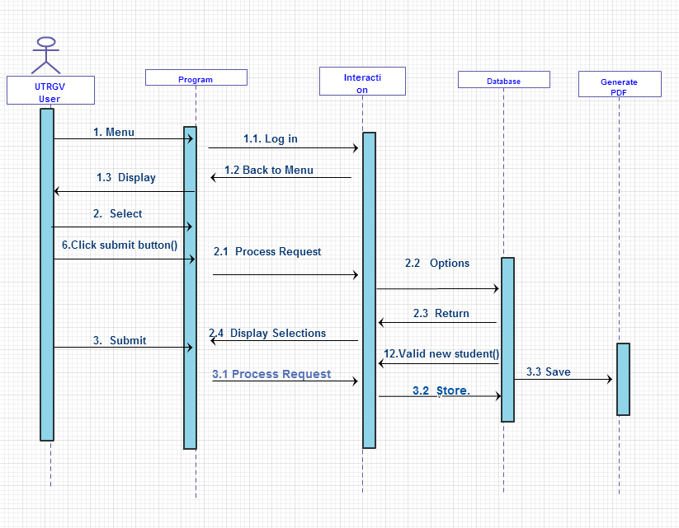

2.3.2 Generate PDF

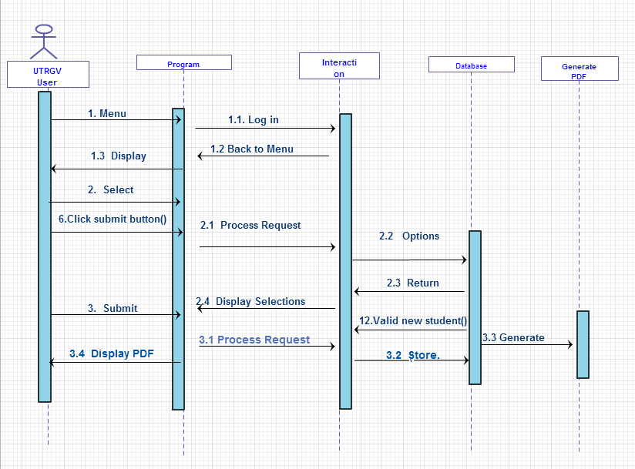

Sequence Diagram for software interaction

4 **Project Timeline**

Throughout the process, this document and the specifications document will be updated as implementation introduces additional features or further details concerning ways and means become available. The client will be consulted before any major change to either document.

|  |  |
| --- | --- |
| Deliverable | Deadline |
| * GUI outline complete, capable of inputting. * Capability of generating new branches on tree. | 11/15/14 |
| • Software can connect to the database and store data. | 11/24/14 |
| • Software can handle errors from user such as inputting numbers where text should be in etc. | 11/27/14 |
| • Confirmation email functionality and retrieving information from database. | 12/05/14 |
| •Generate forms up and running. Testing complete. Ensure all final product deliverables complete:  ◦ Compile testing data into report  ◦ Ensure documentation complete  ◦ Create final update for specifications, software design diagram, and readme file | 12/05/14-12/09/14 |
| • Deliver final product with all associated documentation | 12/11/14 |