Lab at OPM  
Website Copy Deck

Notes on IA

It’s a small site; subsections for each primary page are sectioned by Headings as described below.

Top Navigation Includes: **What We Do**, **Take a Class**, **About Us**, **Contact Us**

**[Home]**

[Tagline for Branding]

The Lab helps government organizations transform their programs, processes, and people through human-centered design.

[Some fantastic graphic/hero image]

Driven by a spirit of collaboration across the federal workforce, we nurture the creative potential it takes for people to solve difficult and complex problems.

Idea below needs design exploration, business card continuation

Let’s

**Ponder**

1. Learn more about what we do
2. [“It was so helpful to have all day to work on this. I worked on it through all the things they walked us through, and it’s a lot better now.” – VA Employee]

**Explore**

1. Attend Design School to explore a complex problem that you want to solve
2. [“The studio day was such a great opportunity to do the group work, move through the process, and present insights that could potentially have a real impact. Thank you so much for this experience, and for the ideas you’ve planted in my own head about how to help VA employees design solutions for the real challenges our Veterans face in receiving health care.”] -VA Employee

**Design**

1. Ever heard of a Journey Map? We’ll teach you how to design one in Mapping Systems and Processes
2. [“The journey map and storybook were invaluable in developing a deeper understanding of the specific aspects of the VA experience that have presented particular challenges for women and - crucially - communicating those to senior leaders in a compelling way.”} -VA Leader

**Build**

1. Design-led work at the Lab has resulted in programs and tools that improve hiring outcomes.
2. [“USAJOBS release 7.2 went out this morning…a significant step forward as it will allow job seekers to share more about themselves which has long been a goal of the project.” -USAJOBS Design Lead

**Solve**

1. Sign up for our class, Problem-Framing for Solution Finding
2. “Just wanted to shoot a quick note to thank you both for making the Summer Design School available as an opportunity for PMF training. This was one of the most memorable and impactful professional development experiences I have ever participated in.”] – Presidential Management Fellow

**Together**

1. Partner with Us
2. [or] [“Quote about doing something together…”]

# About the Lab at OPM

### Our Mission

Enable and engage public sector employees to transform their programs, processes, and people through human-centered design.

### Our Vision

To create the conditions that enable a dynamic public sector to deliver effective programs, services, and products.

### How We Work

Design methods can reveal new perspectives and help individuals better understand the challenges they face in their work. The Lab helps build the capacity for civil servants and Federal programs to leverage the discipline of Design to help uncover opportunities to improve programs and services that they are entrusted to deliver. Through collaboration, we build partnerships focused on creating cultural, intellectual and organizational shifts that will improve the way government works to support a more capable democracy.

### About Human-centered Design (HCD)

Human-centered design (HCD) is a creative and strategic approach to solving challenging problems. The method puts people at the center of the process. It takes into account behaviors, ways of thinking, and peoples’ needs and aspirations. HCD integrates academic disciplines including anthropology, psychology, economics, and other practical and theoretical design disciplines. It is a qualitative, participatory and iterative approach. This technique for creative problem-solving rapidly generates new ideas and innovative approaches to better understand and address people’s real needs.

As designers, we have no hidden agenda. We simply want to help our partners solve their problems and improve the way things work. Design methods help us better understand what is going on in the world. The human-centered design approach can provide a sense of why people are struggling with a specific challenge or process and offer insights about how to innovate or intervene to bring about positive change.

## Our History

In 2011, OPM leadership was encouraged to identify actionable ways to foster greater creativity and innovation within the federal workforce and improve the products of our work and the services we provide the United States and its people. Founded in 2013, we were first known as the OPM Innovation Lab. Renamed the Lab at OPM in 2015, we have expanded our professional and administrative staff and extended our reach across public and private sectors. Today, we collaborate with a broad network of partners, including a wide array of federal programs, as well as state and local government agencies, academic institutions, non-profits and international partners.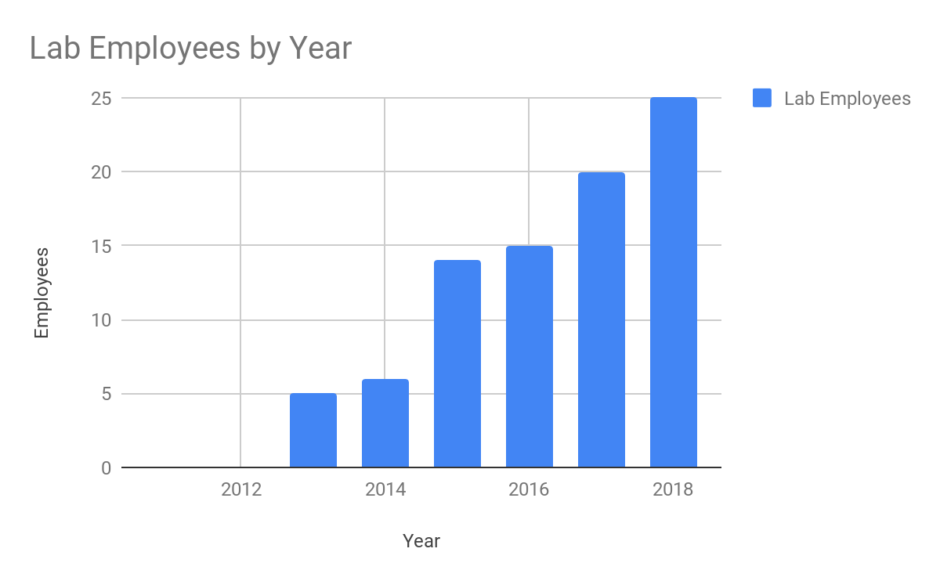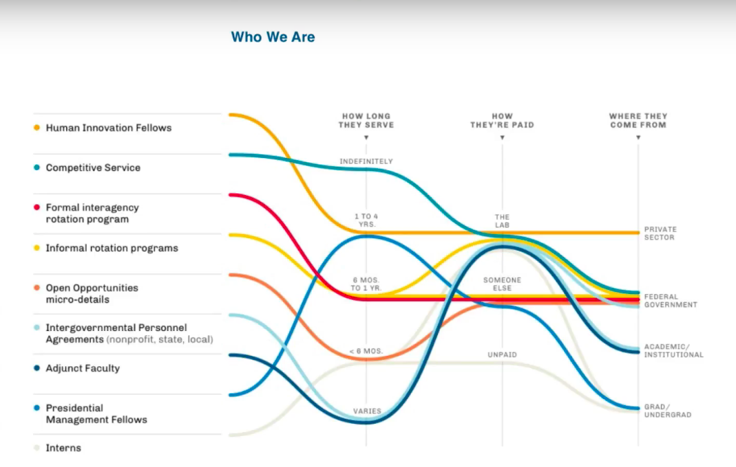

Over the past several years, The Lab’s team and portfolio of projects have grown in size and scope. More than 4,000 government employees have attended our classes and our network of alumni continues to expand.

### What Makes the Lab at OPM Different?

We not only help find solutions, we teach people the skills needed to sustain changes. We do this through an integrated blend of classroom-based learning and project-based, hands-on experiences. Individuals can simply attend classes to learn specific skills and the application of design concepts. We also develop long-term partnerships that include a diverse portfolio of projects to advance specific objectives while also developing the capacity at the individual, team, program and organizational levels.

A broad array of opportunities exists for government organizations to work with the Lab. We focus on building problem solving approaches that are effective, scalable and sustainable over the long term. Our partners become advocates, teachers and practitioners of human-centered design. Our return on investment is not only quantified by the measurable positive effects of our work, but by how our partners value and sustain it.

## Meet the Lab at OPM

The Lab Team is comprised of a group of design professionals with expertise across many disciplines including design, digital design and development, creative and art direction, business, education, architecture, journalism, content strategy, community organizing, urban design and public policy. Our team brings formidable skills, deep curiosity and a commitment to service to our work.

## Who We Are

### Sean Baker Director of Design Strategy and Operations (Lab DC)

Sean Baker is a designer with 12 years of experience in a range of design disciplines including exhibition design, service design, communications design, design strategy and operations.  
His work is currently focused on improving the cultural and operational conditions for Design as applied to policy, program and service development within the Federal government.  
Sean began as a designer working in fine art and architecture. His work focused on exhibition concepts, sales and communication for a contemporary art firm and interior design and build work for residential and commercial spaces.  
For the last 7 years, Sean has worked to address pressing public challenges by working with non-profits, NGOs and government agencies to improve the policies, programs, and services that civil servants and the public rely on. Programs and organizations are his design medium.  
While at the Lab, he has developed multiple internal design capabilities at federal agencies including the Department for Veterans Affairs, US Citizen and Immigration Services and General Services Administration. As co-manager of the Lab, Sean has enabled the organization's adaptability, impact and sustainable growth.  
Sean holds a master’s degree in Transdisciplinary Design from Parsons School of Design.

### Elaine Daniel Learning Experience Designer (Lab DC)

Elaine is an avid learner and emerging practitioner of innovation and design both inside and outside government. She received her undergraduate degree in American studies and her master’s in teaching and instructional design from the University of Maryland, Baltimore County. Elaine currently manages a range of duties including communications, instruction, and human resources. Elaine’s first exposure to the Lab was as an intern. She is now a permanent staff member.

### Matthew Dingee Human Innovation Fellow (Lab DC)

As lead designer on USAJOBS.gov, Matthew is responsible for delivering the next generation of USAJOBS. Matthew has worked in Silicon Valley with 19 years of varied experience in the tech industry, coming most recently from the design firm EightShapes. He has designed and prototyped solutions for Cisco, Marriott, Microsoft, and others.

### James Gasapo Management & Program Analyst (Lab DC)

Jim contributes to the Lab’s operational administration and management. In addition, he develops quantitative and qualitative analytical products, to inform leadership. Jim also supports design-based tasks as needed. Before arriving at the Lab, Jim served as a Presidential Management Fellow and performed data analytics and internal consulting at the Department of Homeland Security Federal Emergency Management Administration (DHS/FEMA). He also served as an officer in the US Army, deploying twice to Iraq. Despite his collegiate training in the liberal arts, he’s always had an interest, even a knack, for the visual arts and design.

### Sarah Hughes Communications Designer (Lab DC)

As a communications designer, Sarah gathers and shares stories about innovations at the US Department of Veterans Affairs that are improving how Veterans experience services and support. Sarah has worked as a professional writer for 15 years. As a local reporter, she covered community affairs for public radio stations in Colorado, Washington, DC, and Alaska. Sarah earned a master’s degree in journalism from the University of California at Berkeley.

### Mina Jafarpoor Service Designer (Lab DC)

As a designer and a social innovator, Mina applies her interdisciplinary knowledge of design, research and analysis to resolve, form and transform. A consultant and educator, Mina has worked with innovation labs, non-profits, schools and state governments. Mina has designed several initiatives for educators and small businesses. Her work has been featured in the Dubai Global Grad Show, an international exposition of inventions from the world’s largest design and technology schools. Mina has a master’s in industrial design from Rhode Island School of Design and holds a BS in physics.

### Jen Kaczor Design Project Manager (Lab SF)

Jen is a senior project manager with many years of experience in digital product development and management, organizational and technology systems development, and team management. Her work has been focused in the news and media industries with an emphasis on audience development and engagement, and additionally in recent years on strategy and execution for internal service-oriented business operations.

### Eulani Labay Experience Designer (Lab NY)

Eulani is a service designer whose approach to interactive storytelling draws from a background in theater and game design, along with a lifetime of writing. Eulani has taught at Made in NY Media Center and Parsons School of Design. Helping people tell their own stories is her key to social change. Eulani has tapped the imagination of teens to reverse the food-desert status of the South Bronx, channeled children’s gameplay to manage disease in developing countries, empowered teachers to reform their urban high schools, and sparked generosity amongst a fleeting community of NYC subway riders.

### Arianne Miller Managing Director (Lab DC)

Arianne is builds capacity for innovation among federal employees by teaching human-centered design through both workshops and mentoring in addition to managing a variety of design projects that address the high-priority needs of OPM and other federal agencies. Arianne came into the federal government as a Presidential Management Fellow at the Consumer Financial Protection Bureau after earning an MBA from the University of Michigan. Prior to that, Arianne worked to build and improve access to high quality public schools through a variety of organizations, including Chicago Public Schools, the U.S. Department of Education, and DonorsChoose.org.

### Ana Monroe Designer (Lab NY)

Ana is a service designer who began her design education as a production designer for the still photography and motion picture industries. Following the design and release of D_Coder, a mobile application dealing with language and communication, Ana joined the Media Design Practices Department at Art Center College of Design and earned an MFA in 2016. She is excited to bring her love of design, systems thinking, and humanities to the team. Ana holds a BA in history from Columbia University.

**Jane Newman  
Content Strategist (Lab Boston)**

Jane is a digital content strategist. Her content strategy work has been primarily focused in healthcare and biomedical sciences. She built the medical taxonomy that underpins massgeneral.org and led content development within the Department of Medicine’s 30 Divisions. While at Mass General she also edited two editions of the Cecil Textbook of Medicine and used Cecil as the pilot to develop the system that now runs manuscript submissions for all of Elsevier’s medical titles. At MedStar Health, she was involved in digital strategy and built websites and applications for both patients and physicians. She has also consulted for IDEO, Kaiser Permanente, Scripps Health, UCSF, OHSU, Healthline and a number of digital health startups. She holds a master’s degree in science journalism from New York University.

### Sara Romanoski Presidential Management Fellow (Lab DC)

With a background in community planning, Sara specializes in addressing urban challenges including preservation, housing, economic development, and public health. In this work, she has consistently forwarded the interests of independent small business through the conscious application of technology, community, and responsible land use.

### Roseann Stempinski Service Designer (Lab SF)

Roseann is a service designer inspired by human behavior, Roseann integrates a systems thinking and doing approach to innovation and problem solving. With over 15 years' experience, she has worked in various facets of brand and design strategy in graphic, industrial, and interactive design. As a multi-dimensional experience designer and strategist, she honed her craft while working with innovation and design agencies including IDEO, Adaptive Path, and Hot Studio as well as technology companies including eBay and Adobe. She co-founded the event series, Design Means Business, focused on bringing human-centered design to the forefront of business strategy. Roseann has mentored and advised tomorrow’s creators at schools including California College of Arts, Tradecraft and University of California at Berkeley. She thrives in the early to mid-stages of product development, enjoying product and service design challenges focused on creating elegant, impactful solutions to challenging, complex problems.

### Aaron Stienstra Designer (Lab SF)

Aaron is a visual designer with over 15 years of professional design experience and his own independent studio based in the San Francisco Bay Area. His recent work includes projects with Stanford Law School, Airbus Group, Orrick LLP, Code for America, and Yerba Buena Center for the Arts. Previously, Aaron was design director at the Focal Point LLC, a firm that provides design and trial strategy for the legal community. He also worked with The Brady Center to Prevent Gun Violence and The Law Center to Prevent Gun Violence. Throughout his career, Aaron has been steadfast in his commitment to human-centered design focused on public good -- he brings to this work a passion for creating beautiful, accessible, and functional visual communication.

### Tim Vienckowski Designer (Lab NY)

Tim is a visual designer who specializes in distilling complex ideas into clear, engaging infographics. With 10 years of experience as an editorial designer and art director at various magazines, he has brought a playful visual dimension to a multitude of subjects for publications such as Hemispheres, Bloomberg Markets, Billboard, Popular Mechanics and Dwell.

### Corinne Vizzacchero Visual Designer (Lab NY)

Corinne is a visual designer with 20 years’ experience. Corinne studied art history and visual arts at Fordham University. She holds a master’s in fine arts in graphic design from Yale University. Corinne has worked as an independent consultant and in-house designer for both large corporations such as Morgan Stanley and small studios like O.R.G. She also taught Introduction to Graphic Design at Fordham University. Corinne believes in the power of human-centered design tools and frameworks to create positive social impact, and her process is guided by curiosity, empathy, and optimism.

### Han Wang Design Strategist (Lab SF)

Han a is a user experience strategist with over 15 years of experience, and works on the Veterans Experience team, based in San Francisco. His work has focused on applying human-centered design with corporate, not-for-profit, government, and startup clients to generate creative solutions to a wide variety of business, technology, and design challenges. Some of his previous projects include providing user experience design for the Bay Area Rapid Transit's award-winning website, and helping to create and launch a next-generation smart TV platform for a global electronics company.

### Ben Winter Service Designer (Lab NY)

Ben is a designer, strategist, and educator working at the intersection of service design and social innovation. Drawing on diverse experience in the public, private, and nonprofit sectors, Ben helps to develop and lead design projects, trainings, and programs with federal agency partners. He also works with local organizations and civic institutions to build a community of practice in NYC and the greater Northeast. Before joining the Lab, Ben taught in the School of Design Strategies at Parsons School of Design. He has collaborated with NYC government agencies and other partners such as Black Girls CODE, Food Bank for New York City, Microsoft, Skanska, and the Rockefeller Foundation to create breakthroughs in user experience, organizational change, and social justice.

### Ariel Yardeni Presidential Management Fellow (Lab DC)

Ariel received her MPhil in Education, Globalisation and International development from the University of Cambridge, with a focus on qualitative education research. Before joining the Lab, Ariel worked on various research projects focusing on practitioner and patient communications at public hospitals, behavioral nudging interventions, and curriculum design and inclusion.

## Locations

We currently have team members based in Washington, DC; San Francisco; New York; and Boston, but that geography does not limit our work . We engage with and support partners based across the United States and beyond. Our flexible and adaptable team is positioned to meet current and future partners wherever they might be.

### Lab DC HQ

<Google Map>

Theodore Roosevelt Building  
1900 E Street NW  
Washington, DC 20415-1000

**Lab NY**

<Google Map>

One World Trade Center  
285 Fulton Street  
New York, NY 10007

### Lab SF

<Google Map>

50 UN Plaza   
San Francisco, CA 94102

### Lab Boston

Tip O’Neill Federal Building  
Boston, MA 02114

### We Go Places

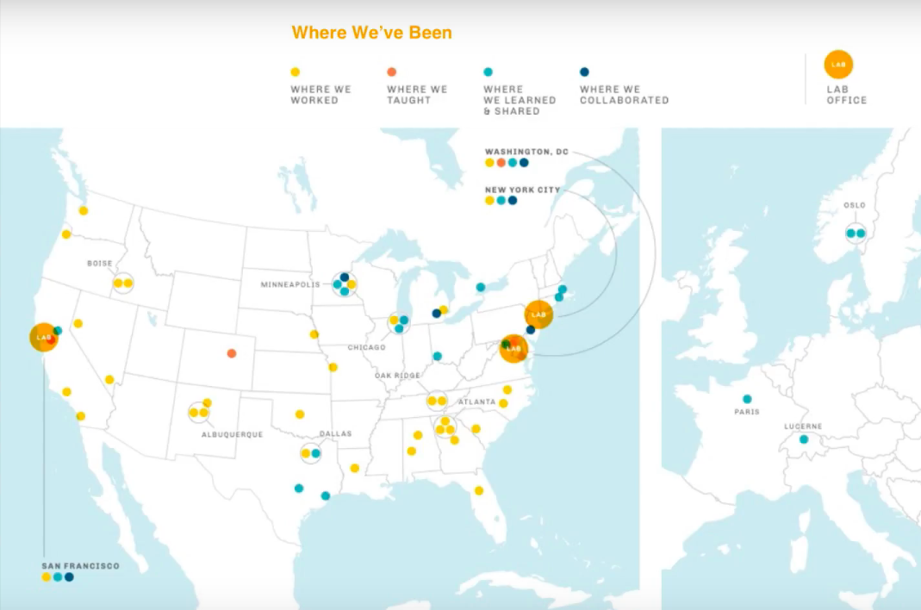

We connect with federal partners across the country and we have office locations that provide us with proximity to our partners and programs across the globe. The above map highlights where we have traveled for project-based work, educational programs and outreach.

## Careers – THIS PAGE NEEDS REWORKING

Are you looking to make a positive impact on some of the biggest challenges in government? The Lab is always looking for creative thinkers to work with us as employees or on short term engagements as detailees.

### Open Positions

At the current time the Lab has no open positions. Follow us on Twitter ([@labopm](http://twitter.com/labopm)) or join our listserv to hear of job openings or opportunities for design careers in government.

### Details for Government Employees

We offer immersive experiences in managing human-centered design projects and educational programming aligned with a focused project through details for government employees. A detail is a temporary assignment of an employee to another position within the federal government for a specified time period. Federal employees who complete our 3-day Fundamentals of Human Centered Design workshop or commensurate coursework can join the Lab through temporary detail assignments. The expectation is that the employee will return to their official position after their detail term ends and bring what they have learned through their work at The Lab back to their home agency.  
  
At the Lab, we offer flexibility around the length of detail assignments. A typical detail ranges from three to six months. The Lab participates in several established programs offering details for current federal employees – including Presidential Management Fellows, Executive Potential Program and the President's Management Council Interagency Rotation Program - the as well as hosting details that we scope directly with individual federal employees. For those employees not in a position to leave their permanent role for an extended period of time, we also offer part-time and short term details (sometimes listed on the Open Opportunities website) some require only few hours or days and provide exposure to our projects and programming. If you are interested in joining us, complete this [[interest form](https://airtable.com/shrClp00LFsPQOUm9)] to get started.  
  
[Side Bar]

First Name

What agency did they come from?

What was their background before joining?

What did they work on with us?

How they applied their experience once their detail was done?

### Open Opportunities

If you’re a federal employee who has preferably completed at least one class with the Lab and you’re interested about becoming more engaged with us, a “microdetail” can provide you with greater exposure to our practices for a short period of time. Upcoming [Open Opportunities](https://openopps.usajobs.gov/) may offer the experience you need. Learn by doing and help us facilitate some of the trainings that we run. Upcoming opportunities include:

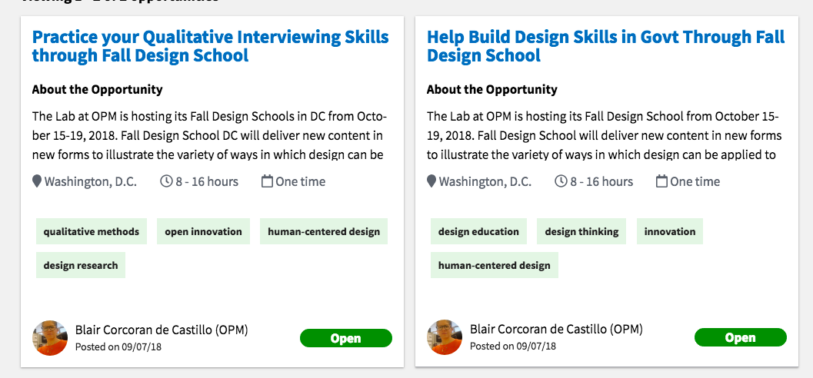

Practice your Qualitative Interviewing Skills through Fall Design School

<https://openopps.usajobs.gov/tasks/839>

Help Build Design Skills in Govt Through Fall Design School  
https://openopps.usajobs.gov/tasks/840

# What We Do

The Lab is a group of designers helping the federal government solve complex challenges. Across all of our services, we strive to build human-centered design capacity across the federal government. We:

* Develop and offer design education classes informed by our experience practicing human-centered design in the federal space to help federal employees respond to and manage the complex challenges they face. To learn more about our educational offerings, visit the Take a Class page.
* Partner with federal agencies and other organizations to take on complex public sector challenges. Working with us can unleash new perspectives and fresh approaches to help solve pressing challenges. Learn more under Partner with Us page.
* Host and participate in events across the country dedicated to bringing innovators together to build and support human-centered design as an effective approach for solving complex challenges. Visit Events to learn more about upcoming opportunities.
* Create teaching tools and other resources to help others use design. Download these materials for free under Resources.

## Partner with the Lab

Are you a government agency or organization facing complex challenges? A partnership with the Lab to address your issue through the lens of human-centered design can help you to surface rich insights and consider new alternatives. Our team can help guide deep investigations of human perspectives to improve the experiences of people that engage with the government across programs, services, and experiences. Over the years, we’ve worked with numerous partners across the public and private sector.

### Our Partners

Active projects and collaborations at the Lab include individuals and teams from the following government agencies and organizations:

### Non-profits/NGOs

AARP

Policy Design Lab

Public Policy Lab

### Government/Agency Partners

Department of Agriculture

Department of Commerce

Department of Defense

Department of Education

Department of Energy

Department of Health and Human Services

Department of Homeland Security

Department of Labor

Department of the Interior

Department of Veterans Affairs

General Services Administration

Millennium Challenge Corporation

National Aeronautics and Space Administration

National Geospatial-Intelligence Agency

Office of Personnel Management

U.S. Patent and Trademark Office

### Academic Collaborations

Duke University

IIT Institute of Design

Parsons / The New School

University of Michigan

University of Virginia

## How We Work

With a government-wide mission and as a revolving fund in the federal government, the Lab works with other agencies on a fee-for-service basis. We work with a wide variety of agencies that approach us, seeking to have a conversation about our work and how it might align with their current needs. Some engagements are very small and short-term, others are substantial and partnerships last for extended periods of time.

We employ a flexible approach to helping you find new avenues for solving problems. Most of our partnerships start with an initial discussion of your concerns and expectations surrounding a potential project. Please complete the contact us form or email us for more information.

### Our Ideal Partner

* Is faced with a complex public sector challenge in need of new solutions;
* Is interested in developing internal design-focused capabilities within their team or organization;
* Has leadership committed to actively supporting a project;
* Dedicates staff to work side-by-side with the Lab team during the design process;
* Is invested in responding to the needs of their stakeholders and working through the implementation stages of the design process.

### Featured Work/Case Studies

At the Lab we are focused on helping the federal government use design to solve complex issues. Much of our work is based in human-centered design, which is a creative and strategic approach to solving challenging problems. Our method puts people at the center of our process, taking into account their complex behaviors, mental models, and needs. This allows us to quickly generate ideas and test new prototypes that meet the true needs of our design partners.

## 

# Take a Class

At the Lab, we teach new skills through dynamic learning experiences. Our curriculum adapts to the needs of the federal government and the latest developments in public sector innovation. This allows us to produce design knowledge for government and adapt it to specific problems.

Our classes are small and interactive. They cover both theory and practice to give participants a foundation on the given topic and awareness of how to apply aspects of class to daily challenges. Many alumni return for additional coursework and further develop skills around human-centered design.

Visit Our Classes to learn more and register for classes.

We also provide coaching services for those needing specific, hands-on support.   
Visit Coaching to learn more.

## Our Classes

### The Lab’s educational offerings in human-centered design provide individuals, teams, and agencies several options for growth and development. You can choose from a range of formats from a week-long total immersion Design School to shorter-form options. Classes typically occur at the Lab but we can customize them to meet the needs of your organization. Custom Classes Our classes are attended by a diverse group of students from across the government. If you have a group that is interested in one of our classes and you are interested using your work as a vehicle for learning design, a custom class may be right for you. Custom programming can simply be a class in our catalogue delivered at your organization or it can draw from the material in our existing classes, newly developed content and external contributors and disciplines. We use your challenges to contextualize the learning experience which can result in project output for your team. If you are interested in a custom offering, contact us directly.

Fulfilling our mission to bring human-centered design to government at scale, our curriculum expanded in 2018 with eight new single-day topic-specific classes. These new classes bring key aspects of design practice, process, methods and theory to broad audiences. They cover a range of topics associated with problem-solving, creative thinking, and communication.

**[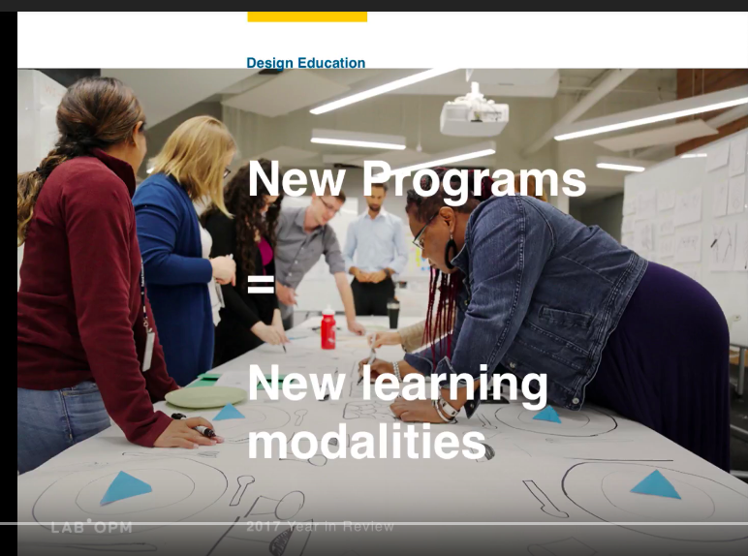](https://www.youtube.com/watch?v=DGDCd2ELpok&feature=youtu.be)**

Caption: *New programs at the Lab at OPM*

### Class Details and Schedule

### Multi-Day Sessions

#### <Title>Design School</Title>

##### Format

Workshop that includes classroom and field activities

##### Description

Design School is a week-long immersion for government employees eager to experience new ways to understand and apply human-centered design methods in government. To help foster and scale new approaches to solving problems, Design School will help you navigate challenges through the use of structured and unstructured learning formats. Activities provide ample opportunities for customized explorations and discoveries.

To get the most out of Design School, come prepared and bring your own challenge. What’s a good challenge to bring?

An opportunity that is:

* Action and goal-oriented;
* Has open-ended potential;
* Invites collaboration.

##### Learning Outcomes

This class will equip you with the following skills and tools:

* Practical experience applying human-centered design to a complex challenge;
* Exposure to the broader spectrum of design and how it can be applied to the public sector;
* Techniques and approaches for analyzing and addressing challenges through design and collaboration that you can apply to your daily work.

##### Length

One week

##### Location

Washington DC, San Francisco/Oakland CA

##### Offered

Quarterly

##### Upcoming Dates, Locations

March 25-29, 2019 | Washington, DC

#### <Title>Fundamentals of Human-centered Design</Title>

##### Format

Workshop that includes classroom and field activities

##### Description

Experience the value of design first hand in our interactive 3-day Fundamentals of Human-centered Design. You’ll get a high-level overview of design theory and how it can lead to better efficiency within your organization. This immersive, hands-on workshop includes applying human-centered design to a real-world challenge. Working in small teams, you’ll practice critical thinking, problem solving, and data analysis. You will also be exposed to new ways of breaking down complex problems and identifying root causes. Overall, the workshop will provide you with a better understanding of how to apply design within your organization.

##### Learning Outcomes

* A critical understanding of human-centered design, as well as why, when, and how to apply it to your daily work;
* Knowledge of human-centered design theory and ways to apply it to solve complex challenges;
* Experience in rapid prototyping to learn about and develop potential solutions;
* Enthusiasm to learn more and apply your knowledge. (Many alumni take in-depth design coaching that focuses on a particular area of interest or initiate their own human-centered design project at their agency.

##### Length

Three days

##### Location

Washington, DC

##### Offered

Monthly

##### Upcoming Dates, Locations

January TK | Washington, DC

#### <Title>Immersive Design Studio</Title>

##### Format

Classroom-based workshop

Description

This multi-month series provides you with the opportunity to practice Human-centered Design (HCD) with professionals from areas such as state, local and federal government; community organizations; advocacy groups; philanthropic organizations, and academic institutions. Together, you’ll apply HCD principles while exploring a complex, real-world challenge.

This session will address [TK real-world issue]. We’ll focus on the societal, legislative, economic, and technological trends affecting [topic TK] and learn how the fundamentals of HCD can help delve deeper into the root causes and generate new insights on the topic.

##### Learning Outcomes

##### This class will equip you with the following skills and tools:

##### ● Practice applying HCD to a complex, real-world issue;

##### ● Strategies for collaborating and partnering with others on HCD projects;

##### ● Access to potential partners from various fields and practices;

##### ● Insight on how to see problems or challenges as an opportunity;

##### ● Practice visualizing or mapping relevant systems

##### Location

Washington, DC.

##### Upcoming Dates, Locations

TBD

### Single Day Sessions

#### <Title>Mapping Systems and Processes</Title>

##### Format

Classroom-based workshop

##### Description

##### Often the best ways to explore a complex process or system is to sketch or map it. On the most fundamental level, maps can help find where you’re going and where you’ve been. They can also help depict both real-life and conceptual challenges. To help provide clarity into where problems exist and how to solve them, this class will explore approaches and techniques for mapping to demonstrate the value in using them to solve problems.

##### Learning Outcomes

This class will equip you with the following skills and tools:

##### Knowledge of mapping formats that are widely used in human-centered design and public sector innovation;

##### Exposure to different mapping strategies and techniques required to create a valuable tool to explore and solve complex problems;

##### Knowledge of mapping vocabularies and methods that support high-level discovery, communication, and critical thinking towards problem-solving.

##### Location

Washington, DC.

##### Upcoming Dates, Locations

TBD

#### <Title>Problem Framing for Solution Finding</Title>

##### Format

Classroom-based workshop

##### Description

Design is often characterized as a process of creative problem solving. Beyond simply finding solutions, design methods and mindsets can lead us to unexplored possibilities, untapped potential, and entirely new ways of approaching a problem. Framing a problem is as much a design opportunity as finding its solution. Re-framing old problems in new ways is often the key to discovering truly innovative solutions. In this one-day class, we will explore problem framing in various fields including the arts, sciences, industry, diplomacy, and others. We also will experiment with various applications and approaches with this powerful practice in design.

##### Learning Outcomes

This class will equip you with the following skills and tools:

##### Knowledge of mapping formats that are widely used in human-centered design and public sector innovation;

##### Exposure to different mapping strategies and techniques required to create a valuable tool to explore and solve complex problems;

##### Knowledge of mapping vocabularies and methods that support high-level discovery, communication, and critical thinking towards problem-solving.

##### Location

Washington, DC.

##### Upcoming Dates, Locations

TK

#### <Title>Constructive Critique</Title>

##### Format

Classroom-based workshop

##### Description

##### All too often, feedback - if we have time to give it at all - is delivered impulsively, identifying weaknesses over strengths and advocating for our own view. This class will introduce you to the principles of constructive critique. You'll practice techniques for discussing and evaluating ideas, plans, pitches, stories, and presentations to identify future action and designs. You will also use insight gained from facilitated conversations to reflect on your personal approach to providing feedback.

##### Learning Outcomes

This class will equip you with the following skills and tools:

##### Exposure to the elements of constructive critique and its value giving and receiving feedback in the decision making and design process;

##### Practice providing thoughtful reflection to refine whatever you are designing;

##### Critical techniques to improve collaboration through constructive dialogue,

##### Location

Washington, DC.

##### Upcoming Dates, Locations

TBD

#### <Title>Participatory Design</Title>

##### Format

Classroom-based workshop

##### Description

Creating products, services, and experiences for your intended audience can be even more successful when you invite that audience to participate in the design process. Participatory design is designing with the people most affected by the end result, and not just for them. Following this method provides a rich understanding of what people think, feel and believe. It is vital to creating something to meet the needs of those who will use what you design. In this interactive course, we explore the theory and methods of participatory design, as well as strategies for how and when to use them.

##### Learning Outcomes

* Knowledge of participatory design concepts and methods for inviting user feedback;
* Strategies for deploying participatory design in your own project work;
* Exposure to researching, planning, and designing activities using participatory methods;
* Understanding of how to use insights from users to inform the development of a project.

##### Location

Washington, DC.

##### Upcoming Dates, Locations

TBD

#### <Title>Visualizing Systems</Title>

##### Format

Classroom-based workshop

##### Description

Translating written or spoken information into a visual medium is a tool to help us understand it in a different way. In this course, we’ll focus on using visual language – diagrams, maps, drawings – to understand systems. We’ll first examine different types of systems, from natural to technological, and how they are represented. Then we’ll break down everyday systems into their basic parts and practice drawing their flows and behaviors. From there, you'll create a map of your own system and be able to use it as a diagnostic tool for identifying problems, possibilities, and potential impacts. You’ll also explore various levels of intervention in order to identify the best opportunities for change in your systems. Visualizing Systems helps you propose sustainable improvements to a system and communicate your insights to others. With practice, you'll be seeing systems everywhere you go.

##### Learning Outcomes

* Ability to visualize your challenges to help identify, communicate, and address problems;
* Exposure to applying systems thinking to complex government challenges;
* Ability to identify systems for their basic parts, flows and behaviors and organize these elements visually into maps of your own design;
* Understanding of different types of intervention and how to use it to frame decision-making.

##### Location

Washington, DC.

##### Upcoming Dates, Locations

TBD

#### <Title>Visual Eloquence </Title>

##### Format

Classroom-based workshop

##### Description

As the saying, “A picture is worth a thousand words” implies, visual eloquence is a major element of design. It helps explain, communicate, and clarify to others -- and ourselves -- what would be much harder to explain with written or spoken words. Whether you are drawing, diagramming, doodling, or rendering, your visualization can quickly explain complex problems. It can also help us to understand the depth of insights we generate to address challenges and how we present our design process to others. Come prepared to put pen to paper and marker to whiteboard, as we learn about the principles of visual eloquence for thinking and action in human-centered design.

##### Learning Outcomes

* Techniques and practices to help communicate ideas effectively through sketching, drawing and diagramming;
* Exposure to combining words and visual elements in expressing complex challenges, processes, and systems;
* Experience testing ways to clarify problems visually and find solutions using signs, symbols, and hand-generated notations;
* The ability to create personal vocabularies of visual elements that enable high-level discovery, communication, and critical thinking.

##### Location

Washington, DC.

##### Upcoming Dates, Locations

TBD

#### <Title>Design for Government</Title>

##### Format

Classroom-based workshop

##### Description

To some, government is synonymous with red tape, inefficiency, and complexity. But bureaucracy isn’t all bad. Is it? Join us for an energized discussion on how the historical design of the United State’s government informs today’s democracy and federal bureaucracy. This interactive class gives you a chance to analyze your current role in democracy and how government’s design constrains or enables you. Working in teams, you’ll share insights on how to reframe bureaucratic obstacles as opportunities through the lens of human-centered design.

##### Learning Outcomes

* Awareness of how the founding father’s design has influenced government today;
* Insight into how your current role is influenced by bureaucracy;
* Ideas for reframing bureaucratic obstacles into opportunities.

##### Location

Washington, DC.

##### Upcoming Dates, Locations

TBD

#### <Title>Visual Communication for Everyone</Title>

##### Format

Classroom-based workshop

##### Description

Whether consciously or not, we all communicate visually and make value judgments based on visual design every day. Through exercises and examples, we will explore the design principles that guide effective visual communication. With hands-on activities using the most accessible tools at hand, participants will learn to apply these principles in their own work.

##### Learning Outcomes

* Ability to recognize basic visual design principles and apply them to create work that visually aligns with your intentions;
* Shared language and insights to improve collaboration with designers;
* Practice in using principles of visual design effectively.

##### Location

Washington, DC.

##### Upcoming Dates, Locations

TBD

### Coaching

Creators and change-makers often need support and expertise beyond their team. The Lab works one-on-one with individuals and teams who want guidance, coaching, and feedback. Ideal candidates for coaching include those who are:

* Trained in human-centered design through the Lab’s Fundamentals of Human-Centered Design workshop or similar coursework;
* Currently using design as a tool for problem solving but want help during a specific part of the design process;
* In need of an external ally to help move an innovation project forward and think through strategies for overcoming potential roadblocks;
* Building an innovation practice.

If you are interested in coaching, please complete our contact form and include any relevant details that might help us prepare in advance of a conversation with you.

# In the News

## Posts

[The Lab Year in Review 2017](https://www.youtube.com/watch?v=YcZXPs-y3mo), YouTube, July 16, 2018.  
[Making the Case for Ambiguity in Government Innovation](https://www.govloop.com/making-case-ambiguity-government-innovation/), Enrique Martinez, GovLoop, April 18, 2018

[How We are Enabling Government Innovation With You](https://www.google.com/search?q=How+We+are+Enabling+Government+Innovation+With+You&oq=How+We+are+Enabling+Government+Innovation+With+You&aqs=chrome..69i57.508j0j4&sourceid=chrome&ie=UTF-8), Blair Corcoran DeCastillo, GovLoop, February 24, 2018.

## Press

### Government Partners

[Spring Design School: A Breath of Fresh Air](https://www.opm.gov/blogs/Director/author/erin-siminerio/), OPM Director’s Blog, June 12, 2018.

[VA Launches Welcome Kit to Guide Veterans to the Services and Benefits They Have Earned](https://www.blogs.va.gov/VAntage/44852/va-announces-new-welcome-kit-guide-veterans-benefits-services-theyve-earned/), Vantage Point Blog, February 1, 2018.

[NSWC Carderock Embraces Human Centered Design to Strengthen its Innovative Culture – Department of Navy](http://www.secnav.navy.mil/innovation/Pages/2017/11/CarderockHCD.aspx), Navy Blog, November 2017.

[CX Day in Government: How GSA Uses Data to Improve Customer Experience](https://gsablogs.gsa.gov/gsablog/2017/10/03/cx-day-in-government-how-gsa-uses-data-to-improve-customer-experience/), GSA Blog, October 3, 2017.

[Designs on the V.A](https://www.nytimes.com/2017/02/24/opinion/designs-on-the-va.html). | New York Times, February 24, 2017.

[(New) Public Goods – The Journal of Design Strategies, Parsons School of Design](https://issuu.com/journalofdesignstrategies/docs/the_journal_of_design_strategies_vo?e=5521259/39002243), Fall, 2016.

[Redesigning Healthcare for Women Veterans: A VA employee’s introduction to human-centered design](https://medium.com/vainnovation/redesigning-healthcare-for-women-veterans-b425f7508c1e), Medium, November 20, 2015

[Using Human-Centered Design to Make Government Work Better and Cost Less](https://www.whitehouse.gov/blog/2015/09/04/using-human-centered-design-make-government-work-better-and-cost-less), White House Blog, September 14, 2015

[USDA Announces Progress in Reducing Improper Payments in School Meals](http://www.fns.usda.gov/pressrelease/2015/fns-0005-15), Press Release, USDA, May 4, 2015

### USAJOBS

[Federal Online Job Site Gets Update](https://www.washingtonpost.com/news/powerpost/wp/2016/02/24/federal-online-job-site-gets-update/?utm_term=.5716928d1936), Washington Post, February 24, 2016  
[OPM Updates the Application Process on USAJOBS.gov](http://www.federaltimes.com/story/government/management/hr/2016/02/24/opm-updates-usajobsgov-application-process/80860708/), Federal Times, February 24, 2016

[Expect more incremental changes to USAJobs.gov next year, OPM says](http://federalnewsradio.com/opm/2015/12/expect-incremental-changes-usajobs-gov-next-year-opm-says/). Federal News Radio, December 2, 2015

[OPM Innovation Lab Leads USAJobs Rebuild With Agile](http://fedscoop.com/opm-innovation-lab-leads-usajobs-rebuild-with-agile), FedScoop, May 28, 2015  
[Inside the USAJobs Revamp and Other Digital Summit Highlights](http://www.nextgov.com/emerging-tech/emerging-tech-blog/2015/05/inside-usajobs-revamp-and-other-highlights-digital-summit/113509/), Nextgov, May 21, 2015  
[OPM Starts Rolling Out USAJOBS ‘Total Redesign’](http://wjla.com/news/local/opm-starts-rolling-out-usajobs-total-redesign), WJLA, ABC 7, February 26, 2015.

### OPM/Innovation

[OPM’s Breach Response? Cyber Experts ‘Camping in Our Basement’](http://www.federaltimes.com/story/government/management/agency/2015/09/11/opms-new-initiatives-target-employee-engagement/72066832/), Federal Times, September 11, 2015  
[The Lab at OPM: Reflections on My Detail so Far](https://www.govloop.com/community/blog/lab-opm-reflections-detail-far/), GovLoop, August 5, 2015

[OPM Touts Its Innovation Lab](http://www.fedweek.com/federal-managers-daily-report/opm-touts-its-innovation-lab/), FEDweek, June 2, 2015

[Office of Personnel Management’s Innovation Lab: A Portal to Silicon Valley](https://www.washingtonpost.com/national/on-innovations/office-of-personnel-managements-innovation-lab-a-portal-to-silicon-valley/2012/08/02/gJQA3iyDSX_story.html?noredirect=on&utm_term=.210c7c7ceb59), Washington Post, August 2, 2012

#### **Awards** [Graphic]

Design Management Institute (DMI) Design Value Awards - First Place, 2015.   
For work with the US Department of Agriculture’s (USDA) Food and Nutrition Services (FNS) to eliminate obstacles in children’s access to healthy meals at school for free and reduced prices.

# Contact Us

We’d love to talk about working together.

Be the first to know what’s happening next.

To learn more about our events and activities, follow @labopm on Twitter or email us at lab@opm.gov.

# [[Contact Form](https://airtable.com/shrLkEit93WUPxzZv)]

## Hello, it’s Great to Meet You.

The Lab Team at OPM leads human-centered design projects and education that result in innovative outcomes. We’re dedicated to helping potential partners like you, use design to solve complex challenges whether your area of focus is policy design, program management, or service delivery. We are looking forward to learning more about your project.

Please fill out the form below and we'll get back to you shortly. This can help guide us in responding to your request. If the form won’t suit your needs, you can also contact us by email directly at [lab@opm.gov](mailto:lab@opm.gov).

### Contact Information

Full Name:

Email address:

Phone:

Website (if any):

Agency/Organization/Department:

### We are planning (check all that apply)

* We need to organize a custom education program
* We need to review our service
* We need to rethink a service
* We need to develop a strategy for measurement
* We need to build a product/service
* We need strategic help
* We need mentoring or coaching
* We want to develop internal design-focused capabilities within my team or organization
* "We don't know what we need, let's talk"

### This project involves (check all that apply)

* Service design
* Product design
* Program design
* Policy design
* Design strategy
* Design research
* Visual design
* UX design
* Other (Explain)

### Some Considerations

Estimated Deadline: mm/dd/yyyy

Budget:

### Project Details

(Please provide any other information about your proposed project):

### Confirmation Message

Thank you for this information. We will respond shortly and look forward to learning more about your interest in the Lab at OPM.

# [Global Footer]

**The Lab at OPM (HQ)**  
Theodore Roosevelt Building  
1900 E Street NW  
Washington, DC 20415-1000

**Lab SF**  
50 UN Plaza   
  
San Francisco, CA 94102

**Lab NY**  
One World Trade Center  
285 Fulton Street  
New York, NY 10007

[lab.opm.gov](https://lab.opm.gov/) | [@LabOPM](http://twitter.com/labopm) | [lab@opm.gov](mailto:lab@opm.gov)

Latest Tweets: <embed feed>

### Connect with Us

|  |  |
| --- | --- |
|  |  |
| [Twitter](https://twitter.com/LABopm/status/1004411117261635585) | [Subscribe to Lab Newsletter](mailto:%20LabNetworks-subscribe-request@listserv.gsa.gov) |

Contact Us | [Privacy Policy](https://www.opm.gov/information-management/privacy-policy/) | [FOIA](https://www.opm.gov/information-management/freedom-of-information-act/) | [Accessibility](https://www.opm.gov/information-management/accessibility/)