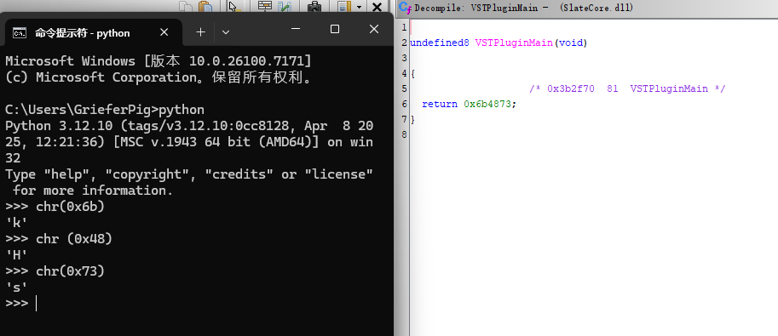
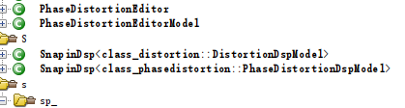

00007FFB3D91AB70-00007FFB3C850000 + 180000000
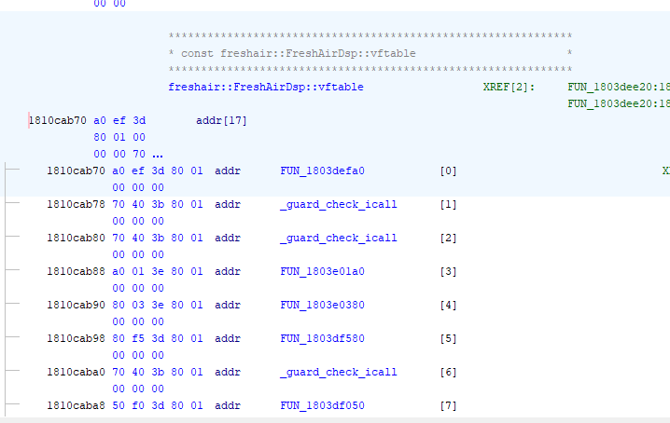
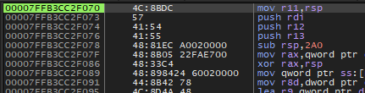

00007FFB3D3BF050
00007FFB3CFC5220
00007FFB3D34E090
00007FFB3CFC5220
00007FFB3D34E090
00007FFB3D34E090
00007FFB3CC2FC10
00007FFB3D4701D0
00007FFB3D044920
00007FFB3D3BF050
00007FFB3CFC5220

00007FFB3D3BF050
00007FFB3CFC5220
00007FFB3D34E090
00007FFB3CFC5220

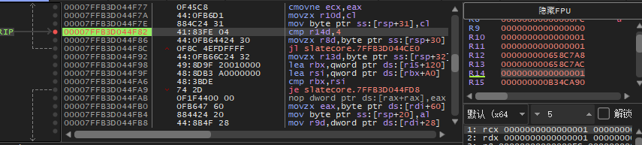
Bandsplitter has 4 lane but only 2 of them called processing (0 and 1)

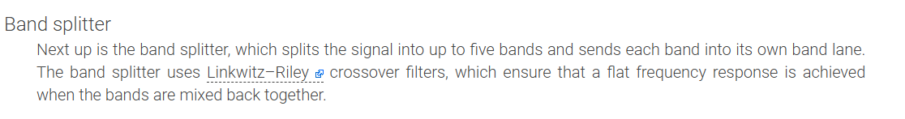

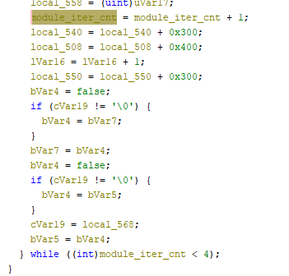
Increment cnt at end
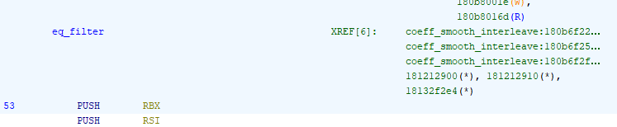
Coeff call eq_filter

