Basic Controls and User Interfaces of NeXTA

Working Document Version 1.0

**Prepared by:**

**Jeffrey Taylor (**[**jeffrey.taylor.d@gmail.com**](mailto:jeffrey.taylor.d@gmail.com)**)**

**Last Revised: June 10, 2013**

Please feel free to send any questions, feedback, and corrections to Jeffrey Taylor (jeffrey.taylor.d@gmail.com) or Dr. Xuesong Zhou (zhou@eng.utah.edu) by adding comments in this document.

**Copyright © 2012 Jeffrey Taylor**

Permission is granted to copy, distribute and/or modify this document under the terms of the GNU Free Documentation License, Version 1.3 or any later version published by the Free Software Foundation; with no Invariant Sections, no Front-Cover Texts, and no Back-Cover Texts. A copy of the license is included in [www.gnu.org/licenses/fdl.html](http://www.gnu.org/licenses/fdl.html).

Table of Contents

## GIS Interface

The latest version of NeXTA uses a GIS-like user interface to add functionality/flexibility while providing an interface which is similar to software applications commonly used in transportation modeling. In general, the GIS interface in NeXTA is described by its layer and visualization controls, allowing the user to modify which object types are shown on the screen and how those objects are displayed.

### Layer Control Panel

NeXTA’s new user interface uses layer controls which are similar to those used in common GIS software applications to manage which network object types are displayed/selected.

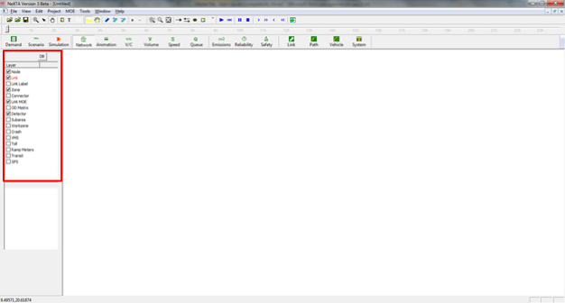

**Figure 1:** The layer control panel in NeXTA.

The list of layers at the left side of the screen, highlighted in Figure 1, is used to control what is visible in the display. The panel display controls the Node, Link, Link Label, Zone, Connector, Link MOE, OD Matrix, Detector, Subarea, Workzone, Crash, VMS, Toll, Ramp Meters, Transit, and GPS layers. Each layer refers to a different type of network data, which is stored in the network input/output files in the project folder.

The box alongside each layer’s text label is used to control the layer’s visibility. An empty box indicates that the layer is not visible, and a check mark in the box indicates that the layer is visible (if data is available for display). In some cases, after turning a layer on or off, the user may need to click the layer’s text label to refresh the display for that specific layer.

The layer text label is used to control which objects can be selected in the network. In particular, the selectable layers are limited to the Node, Link, and Link MOE layers. With the layer turned on (enabled), left-clicking on the layer text label enables selection using the Select Object tool. The text label is highlighted in red text after selection, indicating which network object type can be selected using the Select Object tool. Please see the Select Object tool[JDT1] documentation for examples for using this functionality.

### Attribute Data Display Panel

The lower half of the panel at the left side of the screen shows attribute data for a selected object, as shown in Figure 2. The information displayed in this section of the panel is dependent upon the selected network object type.

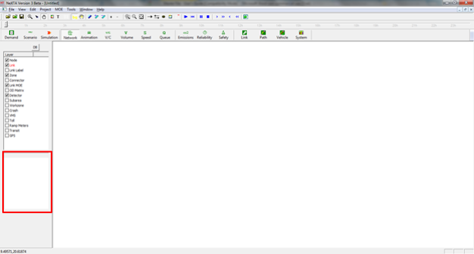

**Figure 2:** The attribute data display panel in NeXTA.

Node attribute data displayed in the panel includes the node ID number, control type, geographic coordinates, and activity location flag (indicates if a node is an activity location) for the selected node. Link attribute data displayed in the panel includes the link ID number, starting and ending node ID numbers, link type, speed limit, length, free-flow travel time, number of lanes, and lane capacity for the selected link. An example is shown below in Figure 3 with link attribute data.

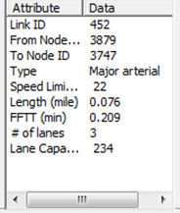

**Figure 3:** The object attribute display panel in NeXTA.

### Visualization Options

(colors, object size, bandwidths, etc.)

Show/Hide Legend

Show/Hide Text Label

Show/Hide Grid

Show/Hide Background Image

Enable Background Image Modification

Switch Link Bar/Line Display Mode

Increase Link Bandwidth

Decrease Link Bandwidth

## Network Control Toolbar

Introductory paragraph



### Basic Functions

|  |  |  |
| --- | --- | --- |
| **Icon** | **Name** | **Function/Description** |
|  | Search Node/ Link/Path/Vehicle | Opens a dialog box which enables search functionality in NeXTA. Search by node number to find nodes, links (from node and to node notation), paths (from node and to node notation, using shortest path), and vehicle number (when simulations results are available). |
|  | Select Objects |  |
|  | Move Network (Pan) |  |
|  | Zoom In |  |
|  | Zoom Out |  |
|  | Zoom Extents |  |

#### Search Node/Link/Path/Vehicle

#### Select Objects

#### Move Network (Pan)

#### Zoom In

#### Zoom Out

#### Zoom Extents

### Network Editing Tools

|  |  |  |
| --- | --- | --- |
| **Icon** | **Name** | **Function/Description** |
|  | Add New One-Way Link | Create a new one-way, directional link between two nodes. |
|  | Add New Two-Way Links | Create two one-way, directional links between two nodes. |
|  | Add New Node | Create a new node to which links can be attached. |
|  | Set Default Link Type | Opens a dialog box displaying the default link properties for different link types. The user may select and edit the default link properties so that all new links created afterward are assigned those changes. |
|  | Create Subarea | Create a subarea boundary which is used to perform a subarea cut (see Subarea Analysis for more details). |

#### Add New One-Way Link

#### Add New Two-Way Links

#### Add New Node

#### Set Default Link Type

#### Create Subarea

### Controlling Time with the Clock Bar

The Clock Bar is a toolbar feature located at the top of the screen which allows the user to view time-dependent MOEs by controlling the position of the slider on the toolbar. As shown below, the toolbar is divided into hours so that the position of the slider refers to the time within a 24-hour modeling time horizon.



The buttons highlighted at the right in the figure above are used for controlling the progression of time. This can also be accomplished by using the mouse to move the slider, clicking and dragging the slider to the desired location (time) on the bar. The current time position in the simulation can be found at the top left corner of the window, as shown below. The time on the left is the current time, and the time on the right is the modeling horizon time over which the simulation was run.



The  buttons are used to automatically progress through time. The buttons in this section of the toolbar are the Play, Reset, Pause, and Stop buttons, in order from left to right. Each button is described in the table below.

|  |  |  |
| --- | --- | --- |
| **Icon** | **Name** | **Function/Description** |
|  | Play | Progresses forward automatically through time in 1 minute steps |
|  | Reset | Resets the time back to 00:00 |
|  | Pause | Temporarily stops the automatic progression of time until the play button is pressed again |
|  | Stop | Stops the automatic progression of time and reset the time back to 00:00 |

The  buttons are used to move through time in short steps. The buttons in this section of the toolbar are the Forward, Fast Forward, Rewind, and Fast Rewind buttons, in order from left to right. Each button is described in the table below.

|  |  |  |
| --- | --- | --- |
| **Icon** | **Name** | **Function/Description** |
|  | Forward | Moves forward in time by 1 minute |
|  | Fast Forward | Moves forward in time by 5 minutes from the current time |
|  | Rewind | Moves backward in time by 1 minute |
|  | Fast Rewind | Moves backward in time by 5 minutes from the current time |

## Network/Simulation Management Tools



### Demand

The Demand button opens the OD Demand Table window, as shown in Figure 4, which allows users to view demand table data in a matrix format, demand attributes for different demand types (Value of Time, vehicle types, information types, etc.), and the time-dependent demand profile, as shown in Figure 5.

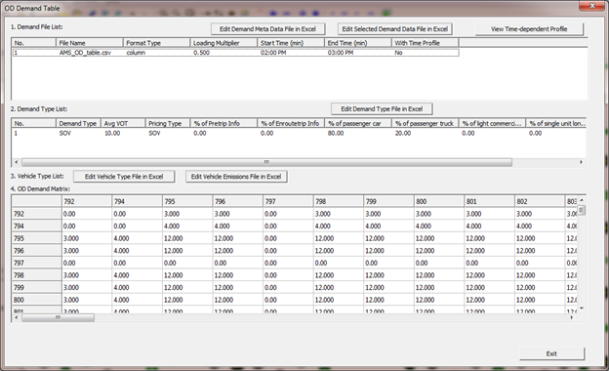

**Figure 4:** Viewing the OD Demand Table in NeXTA.

More advanced networks may use a time-dependent profile with which to distribute demand over time. The time-dependent profile can be viewed clicking the **View Time-dependent Profile** **button** at the top-right corner of the window. The network data is visualized in a new window, as shown in Figure 5 below.

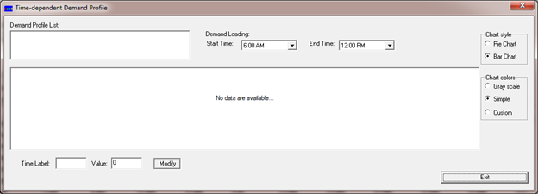

**Figure 5:** Viewing the time-dependent demand profile

### Scenario

The Scenario button opens the View/Edit Scenario Configuration window, as shown in Figure 6, which allows users to add work zones, dynamic message signs (VMS), incidents, and link-based tolls to the network.

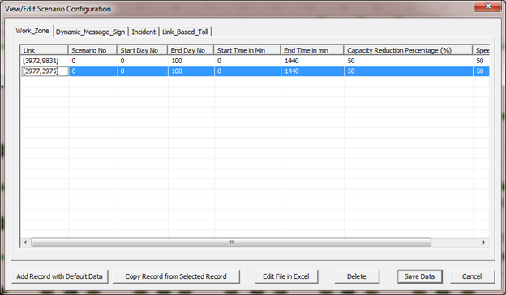

**Figure 6:** Editing scenario configurations in NeXTA.

### Simulation

## Viewing Modes

Two different viewing modes are available in NeXTA – Network View mode and Animation View mode. The default Network View mode is used to display Measures of Effectiveness (MOEs) and the network geometry, while the Animation View is used to show individual vehicles moving in the network during simulation. The user can use the  and  buttons on the MOE Toolbar to control which view is used.



### Network View

In the default visualization state, each link is shown with a line width to represent the number of lanes. Additionally, many MOE visualization features use the link width to visually show how MOEs change over time or differ from one link to another. The  button on the MOE Toolbar changes this visualization state so that no links in the network will be shown with a link width. A comparison between the two states is shown below for a portion of the Fort Worth network for the Volume MOE (left is with the  button depressed, right is with button not depressed).

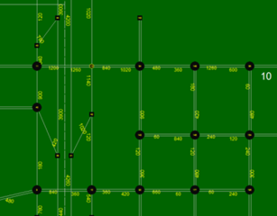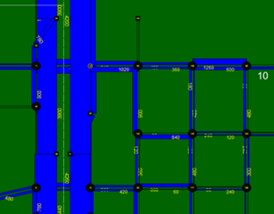

### Animation View

The Animation View changes the visualization state to show vehicles moving in the simulation over time, where the time step is controlled by the Clock Bar. This feature is engaged by pressing the  button. Vehicles in the simulation are represented as green circles moving along the links in the network. An example is provided below, showing a portion of the Fort Worth sample network.

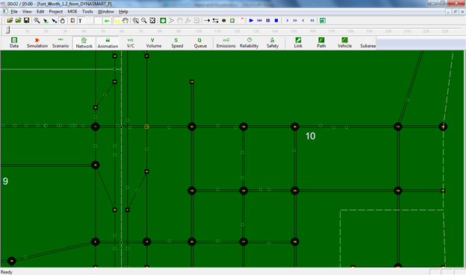

## MOE Toolbar

The majority of the visualization tools provided in NeXTA are available through the MOE Toolbar features highlighted below. Traditional MOE (Measure of Effectiveness) visualizations are provided for the Volume/Capacity Ratio, Volume, Speed, and Queue. In general, multiple visualization modes cannot be enabled at the same time, except in the case of using the Synchronized Display Mode. In addition to these traditional visualization options, three new analysis features are currently available: Emissions, Path Travel Time Reliability, and Safety analysis tools. Each visualization feature is explained in the relevant sections below.



### Volume/Capacity (V/C) Ratio Visualization

The V/C Visualization View is enabled using  the button, showing the time-dependent Volume-to-Capacity Ratio for each link in the network. An example is shown below for a portion of the Fort Worth network, where the link width is based on the time-dependent link volume. The visualization may be modified to show links without widths by using the  button.

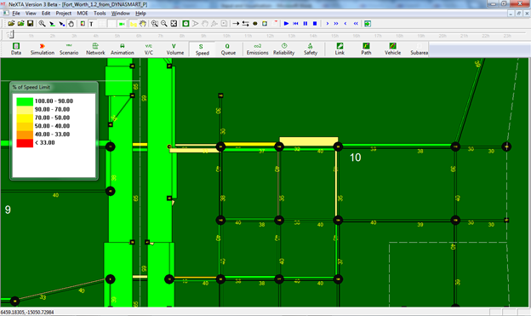

Each link is color-coded based on the MOE value at the time specified by using the Clock Bar, and a legend is provided (shown at left in the above figure) to relate MOE values to color codes. Legend visibility can be toggled using the  button on the toolbar. Additionally, the numerical values show the specific time-dependent V/C MOE value next to each link, and their visibility can be toggled using the  button on the toolbar.

### Volume Visualization

The Volume Visualization View is enabled using the  button, showing the time-dependent volume for each link in the network. An example is shown below for a portion of the Fort Worth network, where the link width is based on the time-dependent link volume. The visualization may be modified to show links without widths by using the  button.

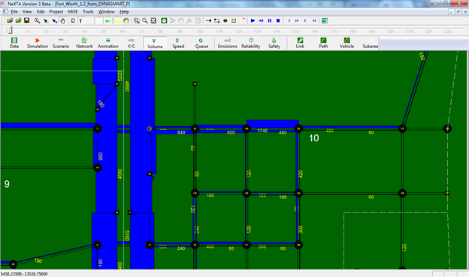

The numerical values next to each link show the specific time-dependent Volume MOE at the time specified by using the Clock Bar, and their visibility can be toggled using the  button on the toolbar.

### Speed Visualization

The Speed Visualization View is enabled using the  button, showing the time-dependent speed for each link in the network. An example is shown below for a portion of the Fort Worth network, where the link width is based on the time-dependent link volume. The visualization may be modified to show links without widths by using the  button.

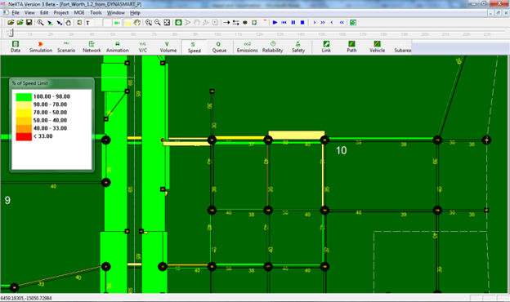

Each link is color-coded based on the MOE value at the time specified by using the Clock Bar, and a legend is provided (shown at left in the above figure) to relate MOE values to color codes. As shown in the legend, the color coding is based on the ratio of the average speed vs. the specified speed limit for each specific link. Legend visibility can be toggled using the  button on the toolbar. Additionally, the numerical values show the specific time-dependent Speed MOE value next to each link, and their visibility can be toggled using the  button on the toolbar.

### Queue Visualization

The Queue Visualization View is enabled using the  button, showing the time-dependent queue length for each link in the network. An example is shown on the next page for a portion of the Fort Worth network. This visualization mode works in both Network View Mode and with link widths corresponding to the number of lanes (not volume), and these viewing modes can be toggled using the  button.

The queue is visually represented as the portion of the link which is colored red, and the distance over which the red color is applied on each link represents the percentage of the link which is occupied with queued vehicles. The length of the red portion on the link changes dynamically over time, corresponding to the time-dependent queue length. The numerical values next to each link show the specific time-dependent Queue MOE at the time specified by using the Clock Bar, and their visibility can be toggled using the  button on the toolbar. The values are shown in terms of the percentage of the link occupied with queued vehicles.

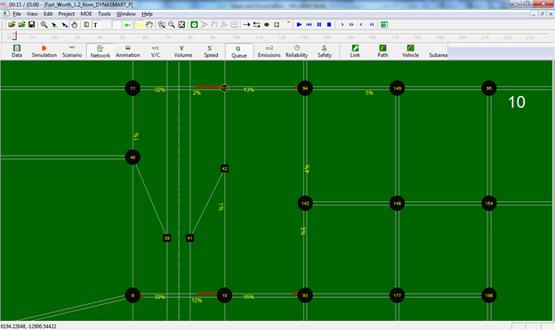

## Detailed Analytical Tools

In addition to the previously-described visualization tools, the Link, Path, Vehicle, and System analytical tools are available for more detailed analyses. These features may be accessed through the highlighted buttons shown below on the MOE Toolbar. Each visualization feature is explained in different sections below.



### Link Analysis Tool

Selecting the  button in the MOE Toolbar, or going to MOE > Link List, opens the Link Information window, shown below, which is used to view link attributes and MOEs. Selecting a row with the mouse also selects the link in the network, allowing the user to quickly find specific links. The Link Zoom toggle button at the bottom left side of the window centers the network view window at the selected row after a row is selected. Each column of data can be used to sort the list, allowing the user to more quickly find links with specific attributes or which meet certain criteria. Additionally, the Link Selection menu at the top left side of the window offers options for filtering the rows by link type. Filtering options are available for displaying only Highway, Ramp, Arterial, and Non-Connector links.

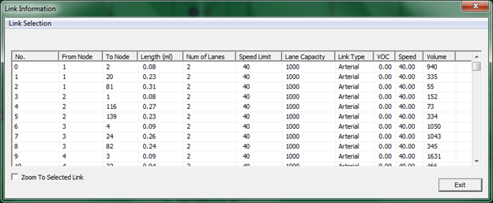

### Path Analysis Tool

The Path Analysis Tool is enabled using the  button in the MOE Toolbar or going to MOE > Path List. This tool is similar to the Link Analysis Tool in that it is used to view link attributes and path travel time statistics. To use the tool, a path must first be selecting by using the Find Directions feature from the Right-Click context menu. As a recap, this is accomplished by right-clicking the mouse at the origin node for the path, selecting “Direction from Here”, and then right-clicking again at the destination, selecting “Direction to Here”. The path is chosen automatically based on the shortest path between the two points.

Selecting the  button opens the Path Information window, as shown in the example below with the Fort Worth network. Similar to the Link Information window, this tool shows link attributes for the links in the path, but no MOEs. However, path statistics – distance and travel time – are shown in the box below the table. The Link Zoom toggle button at the bottom left side of the window centers the network view window at the selected row after a row is selected. Each column of data can be used to sort the list, allowing the user to more quickly find links with specific attributes or which meet certain criteria.

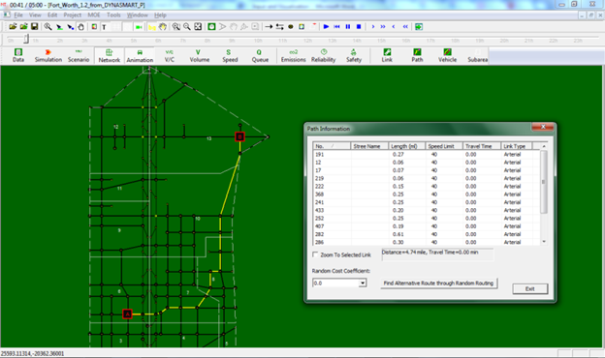

To offer some variability in path selection, a tool is provided at the bottom of the window for Random Routing. The user may select a Random Cost Coefficient from the drop-down list (values from 0.0 to 2.0), and select the Alternative Route button to choose a randomized alternative route between origin and destination nodes. Higher random cost coefficients should result in more variable alternative route selections.

### Vehicle Analysis Tool

The Vehicle Analysis Tool, enabled using the  button or going to MOE > Vehicle Path Analysis, is a powerful analysis feature used to examine travel statistics for individual vehicles or groups of vehicles. Selecting the Vehicle Analysis button opens the Find/Filter Vehicle window (shown on the next page for the Fort Worth network), which is divided into four sections: the OD Pair Filter, OD List, Path List, and Vehicle List.

The **OD Pair Filter**, located at the top of the window, offers several filtering options for limiting an analysis based on specific criteria. The top row of drop-down lists primarily provides filterable criteria related to the vehicle, including the Origin and Destination Zone ID, Demand Type and Vehicle Type, a vehicle’s Information Class and Departure Time, and whether the vehicle was traveling within a certain Time Interval. Also relevant to vehicle characteristics, a filter based on a range for the Value of Time is offered at the far right side of the window. The drop-down lists immediately to the right of the OD List are filterable criteria related to path attributes, including the Number of Vehicles using a path, the Total Travel Distance (in miles) and Travel Time Index on the path.

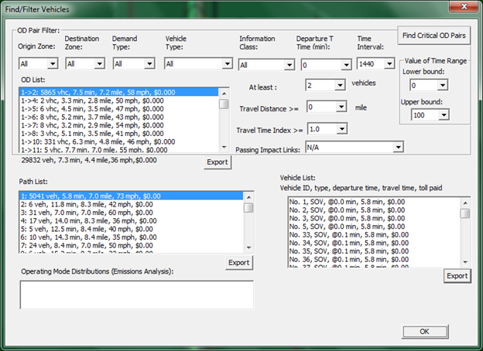

The Find Critical OD Pairs button, found at the top right corner of the window, uses some default filter criteria (path with more than 500 vehicles and at least 2 miles in length) to find the most important OD Pairs.

The **OD List** shows any Origin-Destination pairs which meet the criteria used in the OD Pair Filter. Each pair is listed with the number of vehicles, along with its average travel time, distance, speed, and travel cost. By double-clicking on a specific OD Pair in the OD List, the **Path List** and **Vehicle List** is populated with paths and vehicles associated with that specific OD Pair. Selecting different paths in the Path List highlights those paths in the network, as shown below, and further limits the vehicles shown in the vehicle list to only those vehicles using the selected path. Export buttons are located near the bottom of each list so that the user may export the items in the separate lists and save them as CSV files.

Where emissions analysis was performed, the OD, Path, and Vehicle lists will include Total Energy (in Joules) and CO2 emissions estimates in each list. The Operating Mode Distribution list for Emissions Analysis, located at the bottom of the window, is currently for demonstration purposes only.

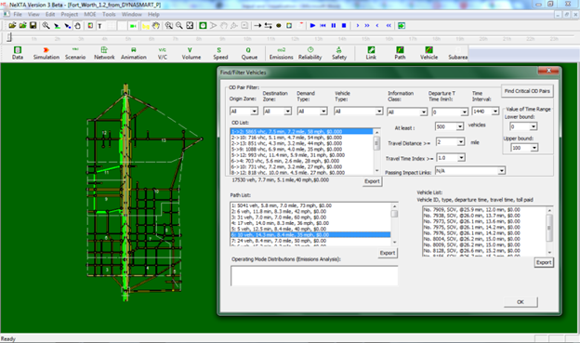

### System Analysis Tool

The System Analysis Tool is used to examine travel statistics for groups of vehicles. By going to MOE > Vehicle Statistics, the Vehicle Statistics Analysis window opens, as shown below. It has similar capabilities compared to the Travel Time Reliability Analysis Tool, but is slightly more flexible.

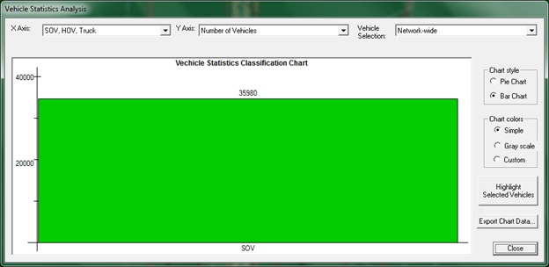

The drop-down lists at the top of the window are inputs which allow the user to modify the chart shown in the window. As described in the figure, the first drop-down list controls the X Axis, and the second controls the Y Axis. The X Axis options will divide groups based on their Value of Time (VOT), vehicle type, traveler information class, and by time intervals over the modeling horizon. The Y Axis options allow plotting the number of vehicles, total and average travel times, total and average travel distance, total toll revenue, average toll cost, total and average generalized travel cost (in minutes and dollars), and total and average emissions.

The third drop-down list controls the area or features over which statistics are collected in the chart. The default is for network-wide statistics, but the user may also choose a set of OD Pairs, a Path (using the method described for using the Path Selection Tool), a link or set of links.

Using the Subarea Selection Tool, the user can also choose from a set of subarea-related options, including analyzing vehicles leaving the selected subarea, vehicles traversing the subarea, and subarea trips disaggregated by internal-external, external-internal, and internal-internal trips. The user can create a subarea by selecting the  button on the upper Toolbar, or by going to Edit > Create Subarea. After initiating the tool, the user can create a subarea in the larger network by selecting points in a polygon which defines the subarea. The subarea is completed by clicking very close to the location of the first point which defines the subarea. After the subarea is defined, the subarea is represented with a dotted white line, and the links contained within the subarea are selected (highlighted in green), as shown in the figure below. For more information about defining a subarea, see the Subarea Analysis section.

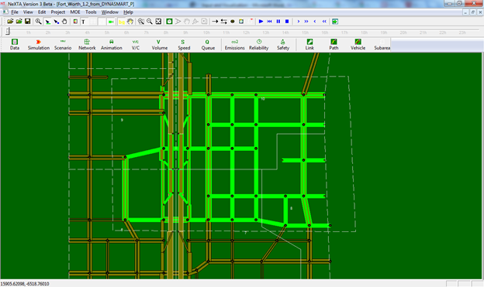

Visualization options are available at the right side of the System Analysis Tool window, with Chart style (Pie or Bar Charts) and Chart colors available for modification. The Simple color option uses a default color selection, and the Gray scale color option performs a simple conversion for black and white diagrams. The Custom color option uses different cross-hatching patterns for visualization.

Two buttons are available at the bottom right side of the window – one to Highlight Selected Vehicles, and another to Export Chart Data. The Highlight Selected Vehicles button will make relevant link colors green to indicate where the selected vehicles travel in the network. After pressing the button, pressing the button again will hide the highlighted vehicles (remove green link highlighting). An example is shown below for the Fort Worth network. Clicking the Export Chart Data button will export the data used to create the chart currently displayed in the right panel.

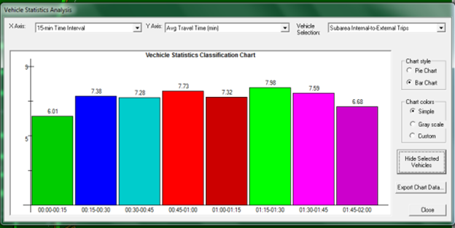

# Scenario Testing

## Scenario Settings/Configuration

NeXTA allows testing of different real-world scenarios that have impacts on traffic operations, performance, and route choice. The most common scenarios that can impact drivers’ route choice are work zones, incidents, en-route information (VMS), and toll facilities. The scenarios are defined through NeXTA’s scenario manager.

To define scenarios, first open the network in NeXTA, and then define scenarios through the Menu>Project>4. Single/Multi-Scenario Settings, as shown in the figure below:

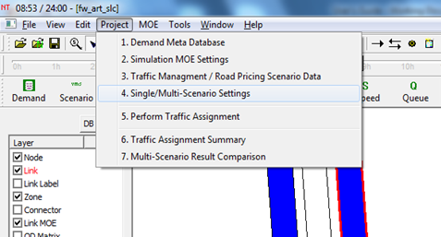

This action will open input_scenario_settings.csv files, where the number of scenarios, names and main parameters are defined, as given in the following figure:

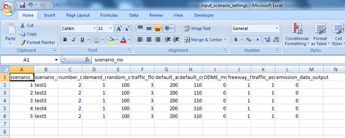

Once the number of scenarios and main settings are saved, the user can proceed to scenario testing.

## Work Zones

Work zones are defined on links, and they are configured through scenario number, start day, end day, start time, end time, capacity reduction (%) and work zone speed limit. The user needs to be in the Select Object>Link mode to define a work zone through the GUI. The link work zone is defined by right-clicking the position on the link where the work zone is located, and then selecting the Add Work Zone option from the menu, as given in the figure below.

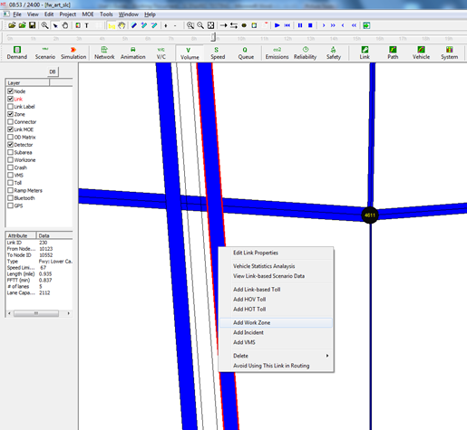

A dialog box will open, where the user provides the work zone inputs. The work zone link will automatically be generated from the previous step. Within the Scenario No, the user defines the scenario to which the work zone will apply (see Scenario Configuration, with the number of scenarios). If this input is 0 (zero), than the work zone will be applied to all scenarios. Otherwise, the user can select the exact scenario to apply work zone. The Start Day No, End Day No, Start Time and End time define the duration of the work zone. Capacity reduction (in %) can represent the number of lanes closed within the work zone. The Speed Limit provides the limit within the work zone, and it will generally be applied to the given link. The software allows for a definition of multiple work zones within the same network. The dialog box is shown in the following figure.

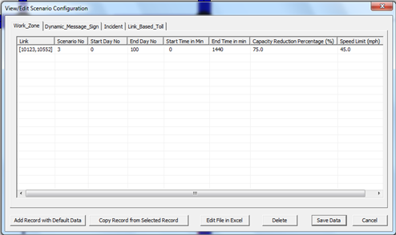

In this example, the work zone will be applied to scenario 3, both assignment days (see Scenario Configuration), 24 hours a day, with a 75% capacity reduction (for example, 3 out of 4 freeway lanes are closed), and the speed limit is set to 45 mph.

The work zone configuration can be assessed again by clicking on the Scenario button from in the tool menu. Through this dialog box the configuration can be changed, work zones added or deleted:

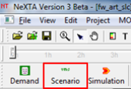

The user also needs to define the MOE settings for the particular scenario. The MOE settings are assessed through Menu>Project>2. Simulation MOE Settings:

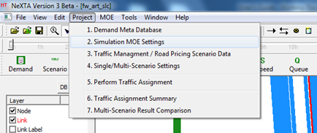

The settings are defined on a network, OD, link and path level. The network, OD and path settings can be kept as default, while the user needs to make sure to define the correct links that will be impacted by the implementation of the work zone. The critical links, paths and OD pairs will be automatically recognized during the simulation. In the example given here, the impacted freeway link and a parallel arterial link are defined:

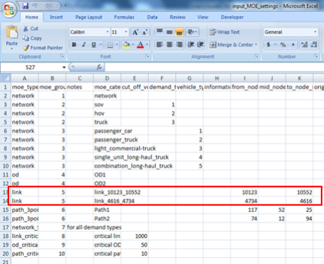

After saving the data, the work zone configuration is defined and the scenarios can be tested. The user now needs to run the simulation, and the DTA will be applied to the new settings. The new simulation outputs need to be written in the output files.

The scenario results can be accessed through Menu>Project>7. Multi-Scenario Result Comparison, as shown in the figure below:

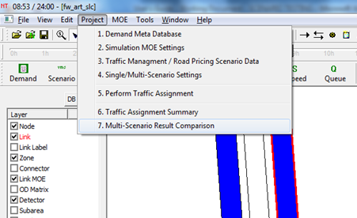

The simulation outputs are written in a spreadsheet where they can be analyzed. The output has the following format:

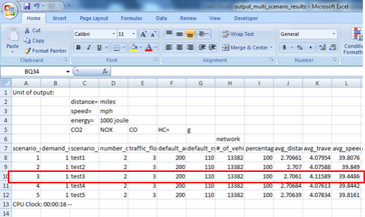

It can be seen that for Scenario 3 (where the work zone is defined), the average network speed is lower than in other scenarios, while the average network travel time is higher. By scrolling to the right of the spreadsheet, the user can see the link parameters for the defined links. It can be seen that a number of vehicles was redirected from the freeway link, which now has a higher travel time and a lower speed due to the work zone.

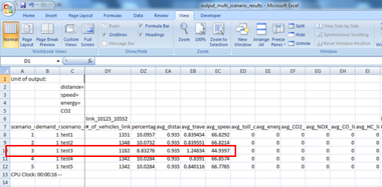

The alternate arterial link experiences an increase in traffic volumes, also with increased link travel times and lower speeds. It can be seen that only a number of vehicles was using this alternate link, since there were more available options:

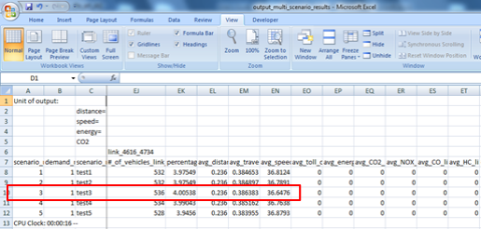

## Incidents

The procedure for creating incidents is similar to adding work zones. Incidents can be defined for one assignment day, any number of hours. They are defined on links, so the user needs to be in the Select Object>Link mode. Right click on the selected link provides a dialog box for creating the incident:

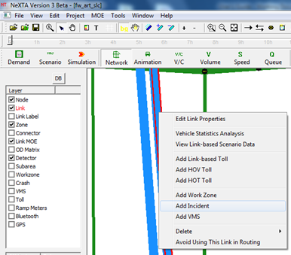

The dialog box will prompt the user to configure the incident. The needed inputs are the scenario number to which the incident will apply (0 meaning to apply the incident to all scenarios), the assignment day when the incident occurs (see Single/Multi Scenario Settings, the incident day must be within this input range), start time and end time (must be within the limits defined by the Demand Meta Database), capacity reduction caused by the incident, and speed within the incident impact zone (which is the speed on the given link). This dialog box is given in the following figure:

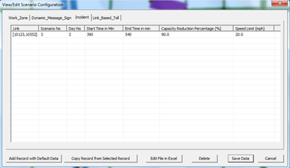

After saving the data, the incident scenario is prepared. The incident configuration can be accessed again by clicking on the Scenario button from the tool menu, and selecting the Incident tab in the top portion of the dialog box. In this dialog box the configuration can be changed, incidents added or removed.

In this example, the incident is defined for scenario 3 on link [10123,10552] (freeway link), for assignment day 2, starting 30 min after the simulation period start and lasting the entire simulation period (the simulation period is 6:00 am to 9:00 am, or 360 to 540 min), the incident is severe (90% reduction in link capacity), and the link speed in the incident zone is 20 mph. before running the simulation, the user needs to define the MOE settings for this scenario (same approach as for the work zones). The simulation is then performed for the given inputs, and the results can be accessed through Menu>Project>7. Multi-Scenario Result Comparison.

The Network wide MOEs for this incident scenario are as follows:

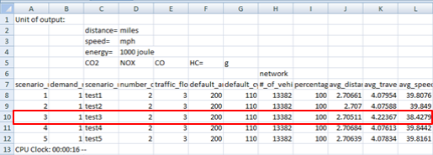

The results for incident scenario 3 give higher travel times and lower speeds on the network level. The MOEs for the impacted link are given in the following table. The number of vehicles using the impacted link is much lower, since they were diverted to other alternate routes. The link travel times are higher, with lower speeds.

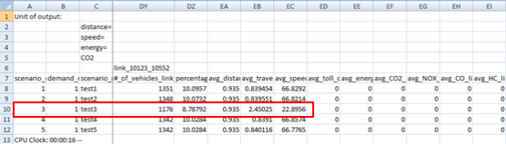

## Pricing/Tolling

The software allows adding tolls on selected links, and for selected vehicle categories (therefore simulating HOV vs. HOT lanes). The initial steps for creating tolls are the same as for work zones and incidents. Once the network is loaded and the single/multi scenarios are set, the user can define tolls on selected links. The user needs to be in the Select Object>Link mode, and defines the toll through right click>Add Link-based Toll, as shown below:

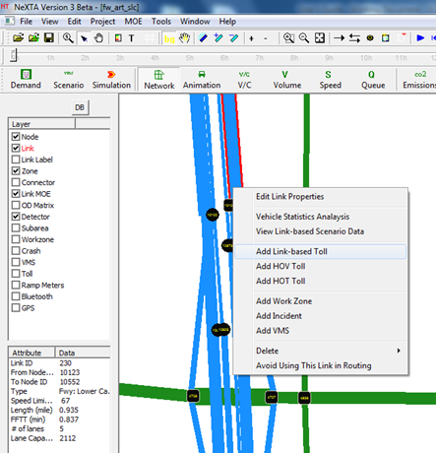

The dialog box will open where the user configures link tolls. The first six columns are the same as for work zone definition, where the link, scenario to which the toll is applied, start day, end day, start time, and end time are defined. The next four columns provide inputs for link-based tolls, for different vehicle types (low occupancy – LOV, high occupancy – HOV, trucks and intermodal transportation). This is the charge that will be applied to the defined link only, so the process has to be repeated multiple times to define a toll section consisting of several links.

In this example, the toll is set for the same link as in previous examples, for the entire analysis period, and a $0.50 link toll is charged to LOVs and trucks, as shown in the following figure:

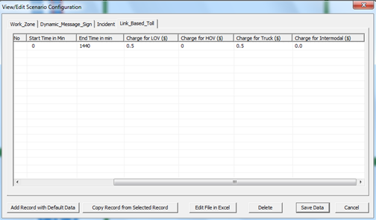

After running the simulation, the following results are obtained on the network and link level:

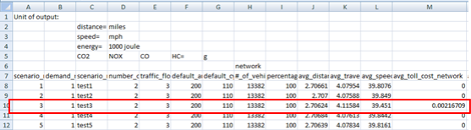

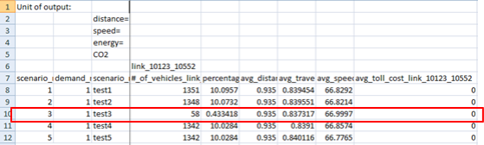

The network MOEs show some impacts on travel times and speeds (travel times are higher, while speeds are lower), and they also give the total cost of the given toll on the network level, including the lost time for vehicles switched to alternate routes to avoid paying the toll. The link MOEs are interesting in this case, since more than 95% of vehicles switched to alternate routes. The toll cost on the given link is $0, meaning that only the HOVs and intermodal vehicles stayed on this link, while all LOVs switched to alternate routes. Of course, these results will be impacted by the toll level, as well as the overall network congestion/travel times, so the results would be different for other combination of inputs.

## Variable Message Signs (VMS)

The most common way in which the traffic operators respond to incident situations is providing en-route information through Variable Message Signs (VMS). Depending on the incident severity, location and expected impacts, the VMS message will have different levels of information provided to drivers, and in return the driver response will be different. NeXTA allows testing the impacts of different levels of VMS/driver responses on operations and route switching. The procedure is similar as for the previous steps. First the user loads the network and defines single/multi scenario settings, and then creates a VMS scenario. A VMS is added to a link through right click on the link, and selecting the Add VMS option (again, the user needs to be in the Select Object>Link mode):

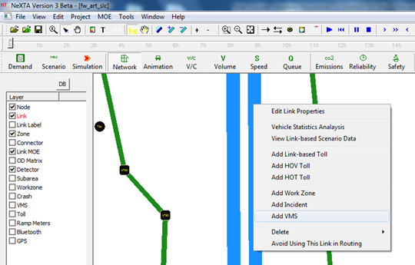

The dialog box for creating VMS is similar to the previous cases. It consist of the link number, scenario to which the VMS is to be applied, start day, end day, start time, end time, and a percentage of drivers that respond to VMS and divert to alternate routes. The dialog box is given in the figure below:

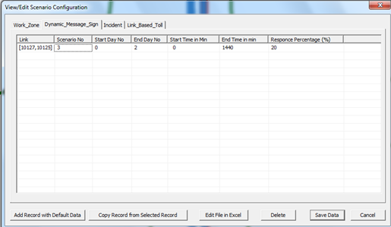

In this example, the VMS is also applied to scenario 3, for both assignment days, and 20% of the drivers respond to the VMS and divert to alternate routes.