1. 添加引用log4net.dll
2. 添加log4net.config，并将属性设置为“始终复制”

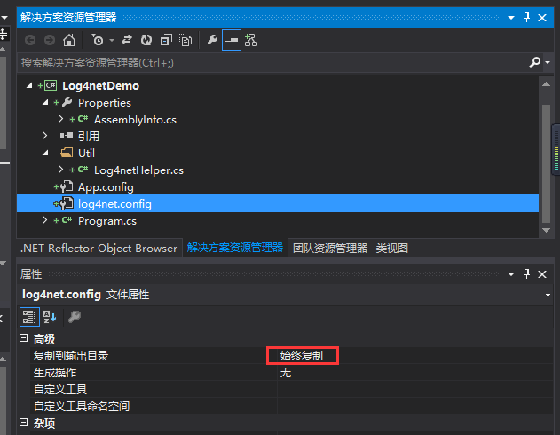

1. 在项目里的Properties/AssemblyInfo.cs添加：

[assembly: log4net.Config.XmlConfigurator(ConfigFile

= "log4net.config", Watch = true)]

1. 添加Log4netHelper.cs