**INVOICE** **MINATO ENTERPRISES**

Invoice Number: G/67, DR MN GHOSH ROAD

Date: 2024-04-22 RANIGANJ, WEST-BENGAL

713347

**BILL TO:**



**ITEM** **DESCRIPTION** **PRICE** **AMOUNT**

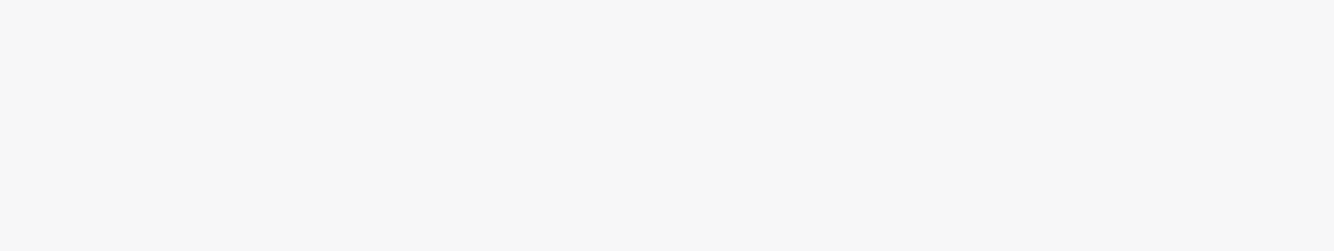

1. R2384786, Nissan, BHU983, Yellow 119047.62 119047.62

|  |  |  |
| --- | --- | --- |
| Sub Total: | | $119047.62 |
| C.G.S.T @ | 2.5% | 2,976.19 |
| S.G.S.T @ | 2.5% | 2,976.19 |
| L.G.S.T @ 5% | | 0.00 |
| ROUND OFF | | 0.00 |

**one lakh, twenty-five thousand only**

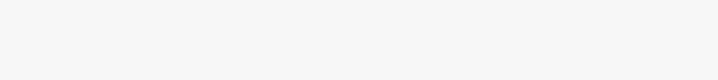

**TOTAL:**

**WELCOME TO THE MINATO FAMILY**

Thanks for shopping with us :)

