**INVOICE** **MINATO ENTERPRISES**

Invoice Number: {{invoice_number}} G/67, DR MN GHOSH ROAD

Date: {{date_input}} RANIGANJ, WEST-BENGAL

713347

**BILL TO:**

{{customer_name}}

{{customer_address}}

{{customer_mobile}}



**ITEM** **DESCRIPTION** **PRICE** **AMOUNT**

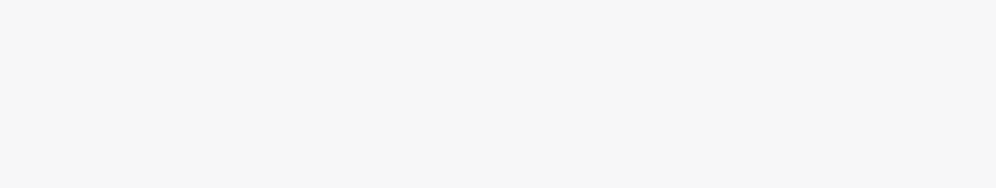

1. {{description}} {{price}} {{total}}

|  |  |  |
| --- | --- | --- |
| Sub Total: | | ${{sub_total}} |
| C.G.S.T @ | 2.5% | {{cgst}} |
| S.G.S.T @ | 2.5% | {{sgst}} |
| L.G.S.T @ 5% | | {{lgst}} |
| ROUND OFF | | {{round_off}} |

**{{in_words}}**

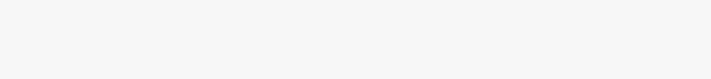

**TOTAL: {{FINAL_TOTAL}}**

**WELCOME TO THE MINATO FAMILY**

Thanks for shopping with us :)

