Status report 1: Programmatic braided-wire shields in Discovery

Electro Magnetic Applications, Inc.

Prepared by Griffin Kowash

26 May 2023

**Objective:** To develop a tool to programmatically generate braided-wire shield models using the Discovery scripting API and evaluate transfer impedance properties.

**Status summary:** The tool can programmatically construct helical braids using Discovery sketching curves. Several physical variables can be manipulated to generate arbitrary braid patterns.

**Samples:**

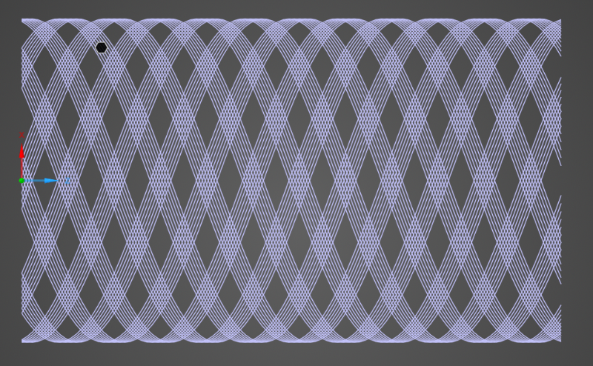 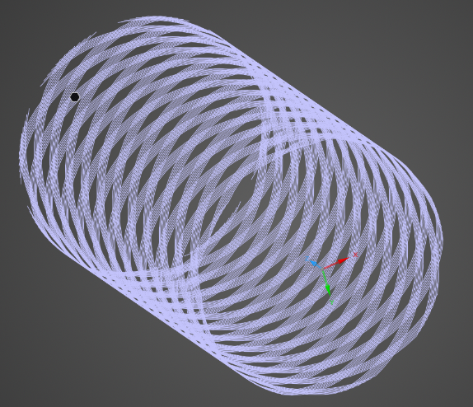

**Figure**: Side view (left) and oblique view (right) of a programmatically generated braid in Discovery.

**Description:**

The braids modeled by this tool consist of several wire groups, called carriers, arranged in clockwise and counterclockwise helices around a common axis. The carriers are ribbon-like structures consisting of a fixed number of wires arranged side-by-side without gaps along the surface of the cable cylinder.

Each braid geometry is uniquely determined by the following parameters:

|  |  |  |
| --- | --- | --- |
| **Parameter name** | **Units** | **Comments** |
| Shield radius | mm | Distance between center and edge of helix |
| Number of carriers | (count) | Total number of wire groups (divided equally between clockwise and counterclockwise directions) |
| Wires per carrier (“ends”) | (count) | Number of wires composing each carrier |
| Wire diameter | mm | Width of wire cross-section |
| Pitch angle  **OR**  crossing frequency (“picks”) | degrees  **OR** mm-1 | Pitch angle: angle between wire and xy-plane  Picks: number of carrier crossings per unit length along shield axis |
| Cable length | mm | Total length of shield along z-axis |
| Resolution (points per wire) | (count) | Number of discrete points used to model each wire |

The ability of the script to accurately reproduce the desired braid has been assessed for the following parameters using an example geometry:

|  |  |  |
| --- | --- | --- |
| **Parameter** | **Expected** | **Measured** |
| Shield radius | 3.00 mm | 3.00 mm |
| Carriers | 8 | 8 |
| Wires per carrier | 9 | 9 |
| Wire diameter | 0.150 mm | 0.150 mm |
| Pitch angle | 15.00° | 15.03° |
| Pitch height | 5.051 mm | 5.050 mm |
| Cable length | 20.00 mm | 20.00 mm |
| Resolution | 300 | 300 |

There is a small discrepancy observed between the expected and measured pitch angles and pitch heights. The error increases with lower wire resolution; for this geometry, lowering the resolution from 300 to 100 points per wire resulted in a pitch angle error of about 1°.

**Limitations:**

* Braids are restricted to straight lines extending from the origin along the positive z-axis.
* Clockwise and counterclockwise strands are assigned the same physical parameters; variables like pitch angle cannot be modified independently for each direction.
* Geometry data is generated by a separate Python script rather than directly via the Discovery API due to lack of NumPy support in IronPython.
* Loading geometries with high resolution and/or large numbers of wires is somewhat time-consuming. (8 carriers, 9 wires per carrier, 300 points per wire = ~10 minutes loading time.)

**Next steps:**

* Identify any necessary changes to existing functionality.
* Characterize error in pitch angle and height.
* Clarify steps required to simulate shield braid and evaluate transfer impedance.
* Establish procedure for validation of simulation results.
* Investigate strategies to improve model loading efficiency.
* Consider defining wire resolution using per-winding length rather than total length.

**References:**

Vance, E.F. (1974.) *Shielding effectiveness of braided wire shields*. Stanford Research Institute, Interaction Note 172.