Status report 2: Programmatic braided-wire shields in Discovery

Electro Magnetic Applications, Inc.

Prepared by Griffin Kowash

2 June 2023

**Objective:** To develop a tool to programmatically generate braided-wire shield models using the Discovery scripting API and evaluate transfer impedance properties.

**Status summary:** The tool can programmatically construct helical braids using Discovery sketching curves and can now be executed entirely from within the Discovery GUI. Verification of simulation results against the reference model will be available soon.

**Updates since previous report:**

* The user can now generate a braid with a single execution from within the Discovery GUI. (Previous version required manual execution of separate Python and IronPython scripts.)
* Code has been refactored to an object-oriented structure to enable further development.
* Preliminary validation of simulation results shows different magnitudes but similar minima and maxima in relevant parameters between the generated and reference braids.

**Preliminary validation:** To evaluate the ability of the tool to accurately reproduce the physical behavior of shield braids, a geometry was generated with the same specifications as the hand-made reference model. The parameters utilized are:

|  |  |
| --- | --- |
| **Parameter** | **Value (as measured from reference)** |
| Shield radius | 0.89 mm |
| Carriers | 16 (8 per winding direction) |
| Wires per carrier | 4 |
| Wire diameter | 0.131 mm |
| Pitch angle | 72.0° (relative to normal plane) |
| Cable length | 145 mm |

The generated model has a resolution of 400 points per curve (400*16*4 = 25600 points total).

Additional components, including cable ends, material assignments, domain settings, current sources, and measurement probes, were also copied from the reference model.

Preliminary verification results are shown below.Note that **simulations were not run to completion**; the difference in final time step value make comparisons of absolute magnitude unreliable. However, the locations of local minima and maxima for each model roughly correspond to each other, suggesting similar physical behavior. Full simulations are underway and will provide more useful verification results.

**Figure 1:** Model used for validation, showing procedurally generated braid with additional components copied from reference model.

**Figure 2:** Preliminary validation — Electric field strength by frequency

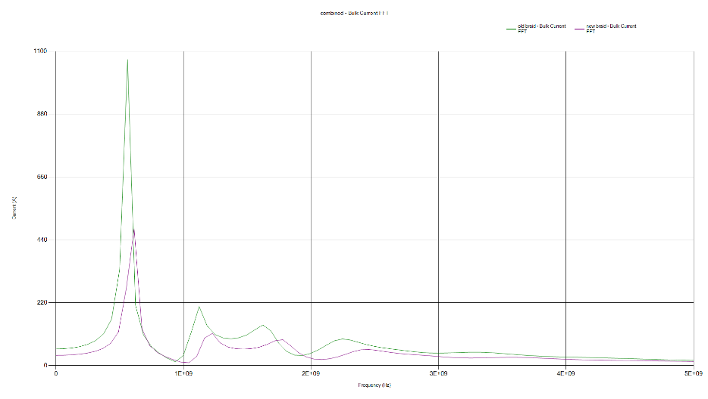

**Figure 3:** Preliminary validation — Bulk current by frequency

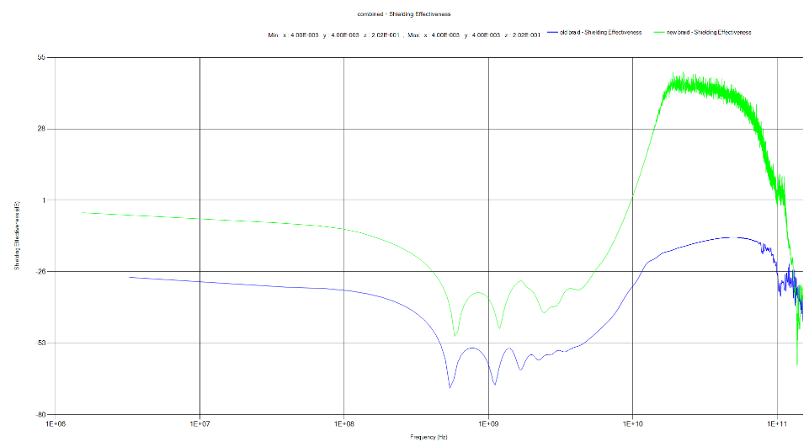

**Figure 4:** Preliminary validation — Shielding effectiveness by frequency

**Next steps:**

* Obtain full simulation results and validate against reference model.
* Establish procedure for calculating transfer impedance.
* Investigate efficiency of IronPython I/O operations.

**References:**

Vance, E.F. (1974.) *Shielding effectiveness of braided wire shields*. Stanford Research Institute, Interaction Note 172.