Spheres vs. Cubes

Griffin Schneider
Northeastern University

gcs@ccs.neu.edu

TJ Higgins
Northeastern University
thomashiggins10@gmail.com

ABSTRACT
In this paper, we describe the implementation of our 3D Computer Graphics final project, Spheres vs. Cubes. Spheres vs. Cubes is a 3D third-person 'platformer' video game with physically-accurate physics simulation.
Categories and Subject Descriptors
I.3.7 [Computer Graphics]: Three-Dimensional Graphics and Realism – animation, color, shading, shadowing, and texture, virtual reality.
General Terms
Algorithms, Performance, Design, Experimentation.
Keywords
Keywords are your own designated keywords.

INTRODUCTION
For our 2D project, this group created Circles vs. Squares a 2D physics-based platformer. We found this to be an excellent learning experience and an enjoyable project, so we decided to extend the idea into three dimensions for our 3D project, and Spheres vs. Cubes was born.
While creating Spheres vs. Cubes, our goal was to gain some appreciation of the work that goes into creating 3D games, an area in which our group did not have experience prior to this project. Although Spheres vs. Cubes is obviously a much smaller project than even the simplest commercial 3D games, many of the general concepts and architecture decisions in our project are also applicable to the majority of 3D games.
We will discuss previous related works which we drew inspiration from to create Spheres vs. Cubes, as well as various technical aspects of the game and the techniques that we used to implement those features.

RELATED WORK
Related work.

Permission to make digital or hard copies of all or part of this work for personal or classroom use is granted without fee provided that copies are not made or distributed for profit or commercial advantage and that copies bear this notice and the full citation on the first page. To copy otherwise, or republish, to post on servers or to redistribute to lists, requires prior specific permission and/or a fee.
Conference’13, Month 1–2, 2013, City, State, Country.
Copyright 2010 ACM 1-58113-000-0/00/0010 …$15.00.

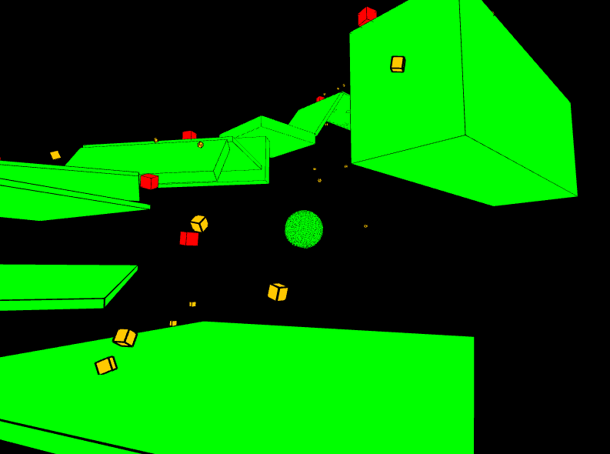Figure 1. Example Spheres vs. Cubes gameplay screenshot

METHOD

Physics Integration and Control System
Spheres vs. Cubes uses the Bullet physics engine – specifically JBullet, a port of the C-based Bullet to the Java programming language. Since we were already planning to use Processing, which is Java-based, to create the graphics for Spheres vs. Cubes, it was easier to use JBullet rather than deal with JNI to interface between Java and C code. We considered that using the Java port rather than the C-based version could lead to performance issues; however, preliminary testing showed that using JBullet was unlikely to detract from our ability to obtain 60 frames per second for the relatively simple physical situations that we planned on simulating.
Bullet is a professional-level physics engine containing a vast array of advanced features, including large numbers of optional optimizations that were generally out of scope for this project. Due to relatively tight time constraints for the project and our group's lack of experience with Bullet and 3D physics simulation in general, we decided to use only a small subset of Bullet's features for Spheres vs. Cubes. The main use of Bullet in our game is for simple rigid-body simulation of spheres and rectangular prisms, plus some basic collision detection for determining when the player can jump and when the player has been hit by an enemy bullet.
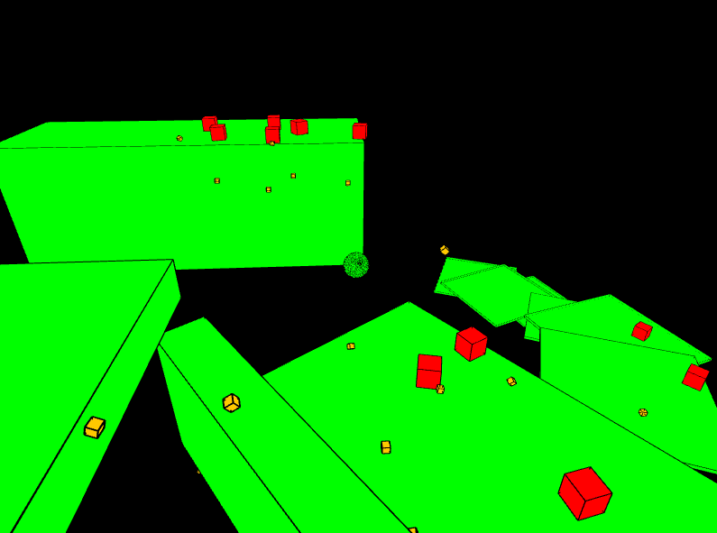Figure 2. Another example screenshot. The player is now smaller due to loss of health.
Since the sphere controlled by the player is an object in a physics simulation, we had to take care not to disrupt the simulation when the sphere is moved by the player's controls. The naïve implementation of movement controls, which is often sufficient in games without complex physics simulation, is to simply translate the player's body when a directional key is held. When the player's body is an object in our Bullet simulation, however, translating the player's body can often have adverse effects on the physics simulation. Since actual physical bodies do not move in discrete increments, abruptly shifting the player by a fixed amount every frame can lead to inaccuracies when the player collides with other objects, or when an external force is applied to the player by the physics simulation. So instead of translating the player's body, we apply a small impulse to the body for every frame during which the directional key is held down. Impulse is the integral of a force over time, so our application of a given impulse each frame is equivalent to applying a small force to the player's body for the entire time period represented by the frame during which the movement key was held down.
This repeated application of impulse still does not produce an acceptable control system – the player can accelerate without limit, and when the movement key is released at high speeds, the player continues to move since there are no forces slowing it down, except perhaps a small amount of friction from the ground. Fixing the first problem is quite easy – we simply do not apply the movement impulse if applying that impulse would cause the player to move over some pre-set maximum velocity. Solving the second problem, however, presents more possibilities. We first tried using Bullet's built-in linear damping – bodies in Bullet have a linear damping attribute, and setting this attribute to a positive non-0 value will cause the linear velocity of the body to be scaled downwards each frame. Unfortunately, applying a linear damping to the player body affects velocity in all directions, when we really only want to decrease the player's velocity in the horizontal plane. Applying a linear damping to the player body causes jumps to feel too 'floaty' – the damping causes the player to spend an unnaturally large time at the peak of the jump. To fix this problem, we implemented our own variation on linear damping. For each frame during which the player is not holding a movement key, we find the player's velocity, project it onto the horizontal plane, normalize that projection, reverse its direction, multiply it by a small constant damping factor, and apply the resulting vector as an impulse to the player's body. This has the effect of counteracting any motion in the horizontal plane whenever the player has released all movement keys.
Implementing the player's jump presented a different set of problems than the implementation of horizontal movement. It is easy to implement the jump itself – just apply an upward impulse to the player – but the difficulty lies in determining when the player is capable of jumping. If we simply apply an impulse whenever the jump button is pressed, the player can essentially fly by jumping repeatedly in midair. To figure out when the player should actually be able to jump, we implemented a collision handler that listens to collision events from Bullet involving the player and uses this information to keep track of all the bodies that the player body is currently touching. Then, when the jump button is pressed, we apply the jump impulse only if the player is currently touching some other body.
This jump implementation is still not perfect, although our group decided that it was sufficiently robust for our project. For more accurate jump ability determination, we could check if any bodies are intersecting a sphere slightly smaller than the player sphere and slightly below it. This would do a better job of only enabling the player to jump if it is standing on something – our current method allows the player to jump even if the body it is touching is just the side of a vertical wall, which allows the player to climb walls of any height.

Camera Control
Spheres vs. Cubes uses a third-person camera that is always directly controlled by the player. Many third-person games have a camera that attempts to move automatically to give the player the best possible view of the game, but we anticipated that such a system would be too difficult to implement for this project. Instead, we attempted to give the player enough manual control to attain a satisfactory camera view in a variety of situations.
It seems unlikely that the player would ever want to look away from their own body, so we decided to always have the camera centered on the player. We also decided that the camera should always have a vertical up-vector, so that it is always clear which direction gravity is pointing in. These two restrictions are the only restrictions on the player camera, however – the camera can be positioned at any point in space, as long as it is pointing at the player and oriented with the same up vector. Given these restrictions, we decided that spherical coordinates were the natural choice to represent the position of the camera.

Spherical Coordinates
Spherical coordinates are a method of addressing any point in a 3D space. Each point is defined uniquely by a radius r and two angles, θ and φ. Spherical coordinates essentially extend the 2D polar coordinate system by adding an additional angle. The meaning of each of these angles can be seen in figure 2 below.
We chose spherical coordinates to represent our camera position because of the convenient correspondence between the parameters of spherical coordinates (r, θ, and φ) and the control inputs used to move the camera. The radius r corresponds to the zoom level of the camera, and is controlled by moving the mouse wheel up or down, or by pressing the “+” and “-” keys to zoom in and out respectively. φ represents the horizontal rotation of the camera, and is incremented or decremented by moving the mouse left or right. Note that when moving the mouse to the left, the camera actually moves to the right so that it will be angled more to the left. Finally, θ represents the vertical angle of the camera and is controlled by moving the mouse up or down. Again, the camera moves in the opposite direction of the mouse, so that its orientation will change as the player expects.
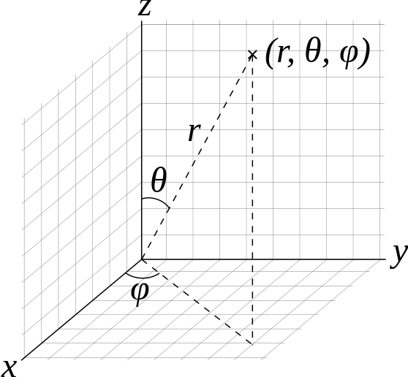Figure 3. Spherical coordinates

Game Logic
Most professional games have extremely complex game logic to maximize performance. While this is crucial for production games it is time consuming to implement. Since the game is fairly simple it was not necessary to add further multi-threading. All of the logic is handled in one main thread in the game scene.
Since Spheres vs. Cubes utilizes Processing it takes advantage of its draw method. This in turn is the main loop of the game. It simulates the physics of the world. Then it updates and draws all of the objects that existed prior to the start of that loop tick.
The only other threads are Processing's key and mouse callbacks. There is a input manager that handles these callbacks, and allows the information to be used in the main loop without having to worry about thread safety.

Level Editor
Level design is often a crucial factor in the enjoyability of platformer-style games. If Spheres vs. Cubes were being produced commercially, it would likely have a full stand-alone level editing suite that could create arbitrary solid polygons to be used as the walls and floors of our levels. Since Spheres vs. Cubes is actually a game being produced by two people in a few weeks, we decided to hack our level editor into the game as quickly as possible. To decrease the amount of work required to implement our level editor, we decided that the editor need only enable the editor to place arbitrarily-sized, not necessarily axis-aligned rectangular prisms at arbitrary points in 3D space. In short, our goal for the editor was to be able to create any possible arrangement of boxes. To enable this, there are a few parameters that our editor must use to place each rectangle – the rectangle's three-dimensional size along each of its sides, the 3-dimensional position of the rectangle's center, and some way of representing the rotation of the rectangle. To represent rotation, we chose to use a system similar to our representation of the camera's rotation with spherical coordinates. We use two angles, θ and φ, to determine the direction of the normal vector of one of the faces of the box being placed.
Our choice of parameters for box placement was based on the correspondence between these parameters and the parameters used to represent the player's position and camera's rotation. When the player places a box in the level editor, we derive its position by finding a point slightly in front of the player's position. We take the θ and φ angles for the box's normal directly from the θ and φ angles of the camera's spherical coordinates. Thus, when the player places a box, the box will show up slightly in front of the camera, with one side of the box parallel to the view plane of the camera.
Once the box has been placed, the level editor provides keybindings to increase or decrease the size of the last placed box along each of its 3 axis. Thus, the editor provides a way to set each of the previously mentioned parameters for each placed box. Also, for convenience, the editor has keybindings to move the last placed box in the positive or negative direction along each axis, and to increment or decrement θ or φ.
Once we created our level editor with these specifications, we realized that there was no easy way to place perfectly axis-aligned boxes. The continuous nature of the mouse-controlled camera makes it difficult to place multiple rectangles so that the walls form right angles with the ground. To overcome this defect, we added additional hotkeys to the level editor that set θ or φ to various pre-definied settings. The editor has keybindings to set φ so that the camera is facing along either of the horizontal axis in either direction, and to set θ so that the camera is looking straight ahead, directly up, or directly down. This allows the player to easily create axis-aligned boxes that intersect with one another at right angles.

Scene Manager
Spheres vs. Cubes like most video games has a scene manager. With the time constraints it is a simple implementation that can only cycle scenes in and out. It does not handle transitions although that could be a possible future improvement. All stages of the game are scenes. The main menu is a scene that transitions to the game that then proceeds to the game over scene. At initialization of the game the menu scene is set to be the current scene. To change scenes a new scene is created, and set to be the next scene. Then in the main update loop it checks to see if there is a next scene and swaps out the current scene.
A problem that had to be overcome was the initialization of the important elements on the transition as apposed to the creation of the scene itself. Since the scenes are swapped during the update loop it caused issues if the scene was initialized before it got swapped in.

Subsequent Pages
For pages other than the first page, start at the top of the page, and continue in double-column format. The two columns on the last page should be as close to equal length as possible.

Table 1. Table captions should be placed above the table
Graphics | Top | In-between | Bottom
Tables | End | Last | First
Figures | Good | Similar | Very well

References and Citations
Use the “ACM Reference format” for references – that is, a numbered list at the end of the article, ordered alphabetically and formatted accordingly. See examples of some typical reference types, in the new “ACM Reference format”, at the end of this document. Within this template, use the style named references for the text. Acceptable abbreviations, for journal names, can be found here: http://library.caltech.edu/reference/abbreviations/. Word may try to automatically ‘underline’ hotlinks in your references, the correct style is NO underlining.
The references are also in 9 pt., but that section (see Section 7) is ragged right. References should be published materials accessible to the public. Internal technical reports may be cited only if they are easily accessible (i.e. you can give the address to obtain the report within your citation) and may be obtained by any reader. Proprietary information may not be cited. Private communications should be acknowledged, not referenced (e.g., “[Robertson, personal communication]”).

Page Numbering, Headers and Footers
Do not include headers, footers or page numbers in your submission. These will be added when the publications are assembled.

RESULTS AND DISCUSSION
Place Tables/Figures/Images in text as close to the reference as possible (see Figure 1). It may extend across both columns to a maximum width of 17.78 cm (7”).
Captions should be Times New Roman 9-point bold. They should be numbered (e.g., “Table 1” or “Figure 2”), please note that the word for Table and Figure are spelled out. Figure’s captions should be centered beneath the image or picture, and Table captions should be centered above the table body.

CONCLUSION
The heading of a section should be in Times New Roman 12-point bold in all-capitals flush left with an additional 6-points of white space above the section head. Sections and subsequent sub- sections should be numbered and flush left. For a section head and a subsection head together (such as Section 3 and subsection 3.1), use no additional space above the subsection head.

Subsections
The heading of subsections should be in Times New Roman 12-point bold with only the initial letters capitalized. (Note: For subsections and subsubsections, a word like the or a is not capitalized unless it is the first word of the header.)

Subsubsections
The heading for subsubsections should be in Times New Roman 11-point italic with initial letters capitalized and 6-points of white space above the subsubsection head.

Subsubsections
The heading for subsubsections should be in Times New Roman 11-point italic with initial letters capitalized.

Subsubsections
The heading for subsubsections should be in Times New Roman 11-point italic with initial letters capitalized.

ACKNOWLEDGMENTS
Our thanks to ACM SIGCHI for allowing us to modify templates they had developed.

REFERENCES
- Bowman, M., Debray, S. K., and Peterson, L. L. 1993. Reasoning about naming systems. ACM Trans. Program. Lang. Syst. 15, 5 (Nov. 1993), 795-825. DOI= http://doi.acm.org/10.1145/161468.16147.
- Ding, W. and Marchionini, G. 1997. A Study on Video Browsing Strategies. Technical Report. University of Maryland at College Park.
- Fröhlich, B. and Plate, J. 2000. The cubic mouse: a new device for three-dimensional input. In Proceedings of the SIGCHI Conference on Human Factors in Computing Systems (The Hague, The Netherlands, April 01 - 06, 2000). CHI '00. ACM, New York, NY, 526-531. DOI= http://doi.acm.org/10.1145/332040.332491.
- Tavel, P. 2007. Modeling and Simulation Design. AK Peters Ltd., Natick, MA.
- Sannella, M. J. 1994. Constraint Satisfaction and Debugging for Interactive User Interfaces. Doctoral Thesis. UMI Order Number: UMI Order No. GAX95-09398., University of Washington.
- Forman, G. 2003. An extensive empirical study of feature selection metrics for text classification. J. Mach. Learn. Res. 3 (Mar. 2003), 1289-1305.
- Brown, L. D., Hua, H., and Gao, C. 2003. A widget framework for augmented interaction in SCAPE. In Proceedings of the 16th Annual ACM Symposium on User Interface Software and Technology (Vancouver, Canada, November 02 - 05, 2003). UIST '03. ACM, New York, NY, 1-10. DOI= http://doi.acm.org/10.1145/964696.964697.
- Yu, Y. T. and Lau, M. F. 2006. A comparison of MC/DC, MUMCUT and several other coverage criteria for logical decisions. J. Syst. Softw. 79, 5 (May. 2006), 577-590. DOI= http://dx.doi.org/10.1016/j.jss.2005.05.030.
- Spector, A. Z. 1989. Achieving application requirements. In Distributed Systems, S. Mullender, Ed. ACM Press Frontier Series. ACM, New York, NY, 19-33. DOI= http://doi.acm.org/10.1145/90417.90738.

Columns on Last Page Should Be Made As Close As Possible to Equal Length

