< $30,000 income, Single filing status

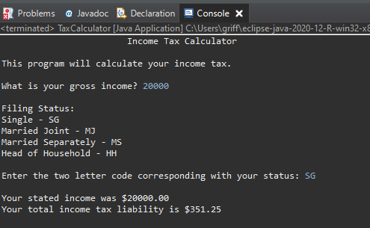

< $60,000, Married-Joint filing status

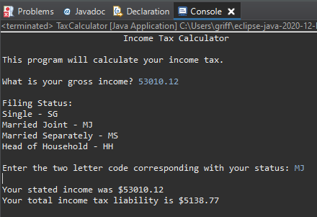

< 100,000, Married-Separate filing status

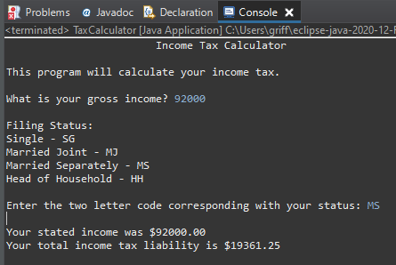

< $250,000, Head of Household filing status

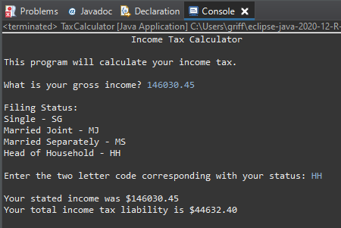

> $250,000, no filing status or incorrect filing status

