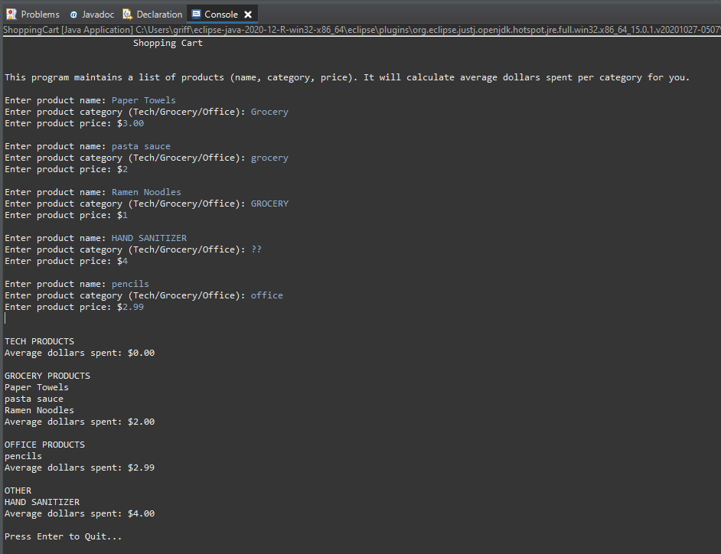Inputs: varied capitalization, varied decimals, varied names  
Outputs: correct $0.00 average, correct category processing, all categories printed, “Enter to Quit” displayed

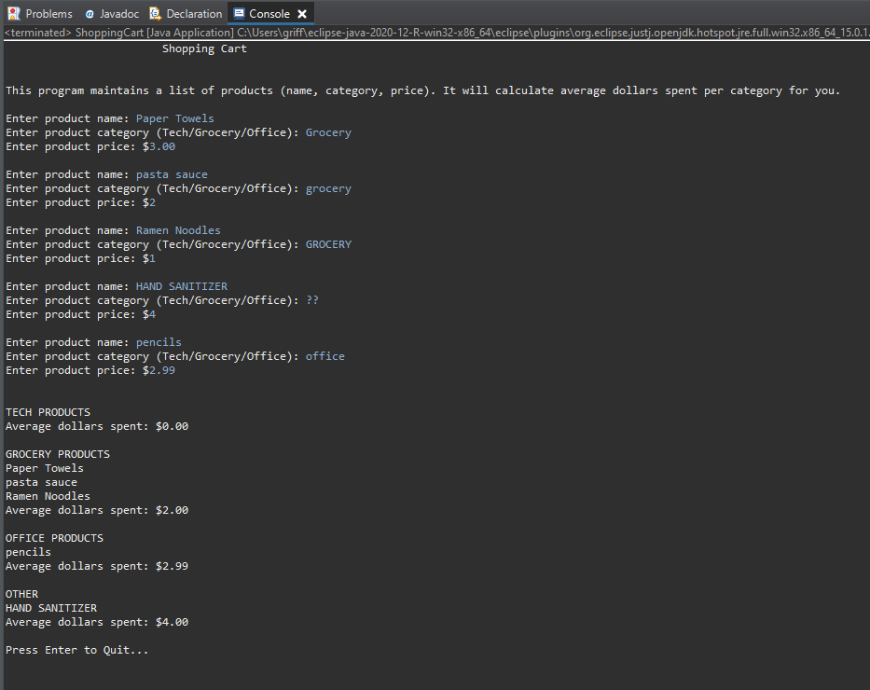Program terminates properly upon pressing ENTER