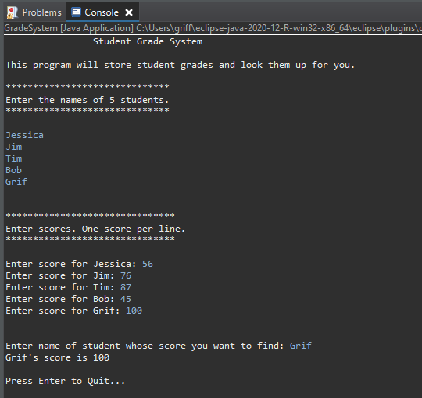

Prior to hitting ENTER (code is still running)

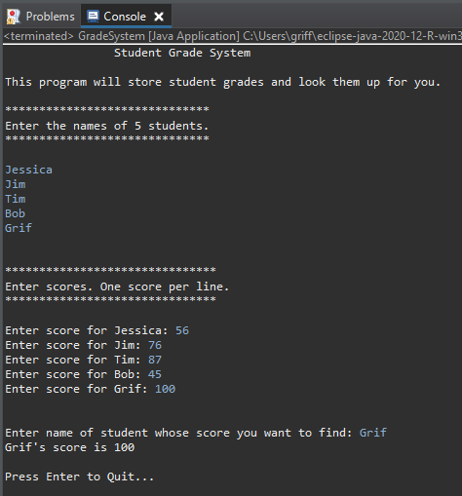

After hitting ENTER (code is <terminated>)

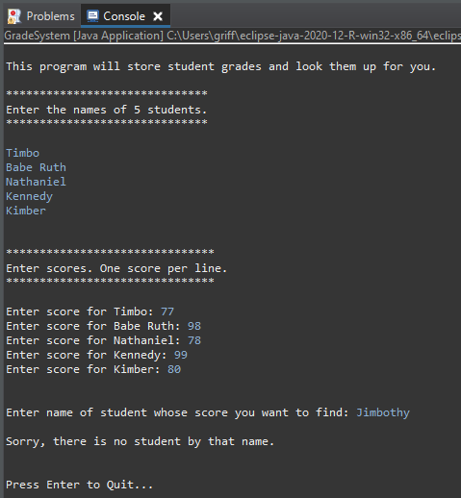

Fail state (student was not found in nameArray)