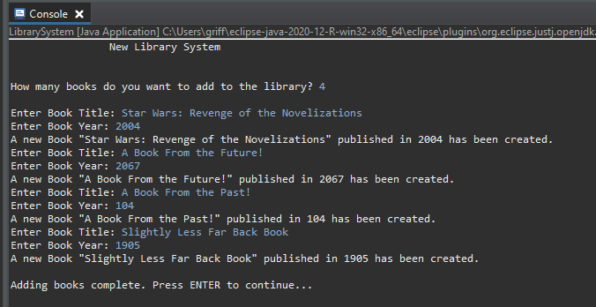

4 Books input. Titles and Years are read correctly (including years out of the range; shows program reads input properly).

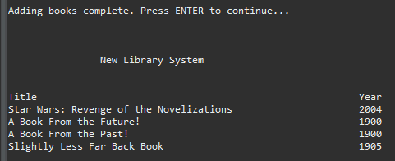

Header displayed again, book titles and dates listed properly and in columns. Dates from before 1100 and after 2021 are corrected to 1900.