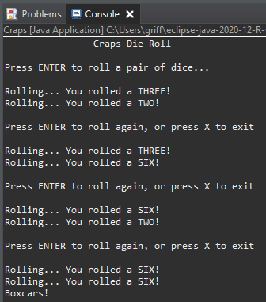

Code in motion: Boxcars!

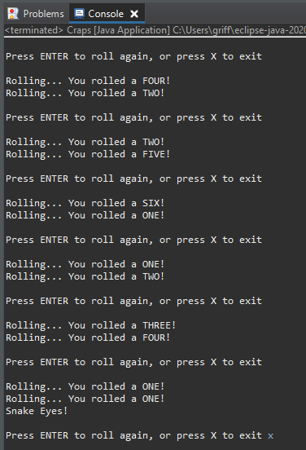

Code terminated (also a Snake Eyes!)