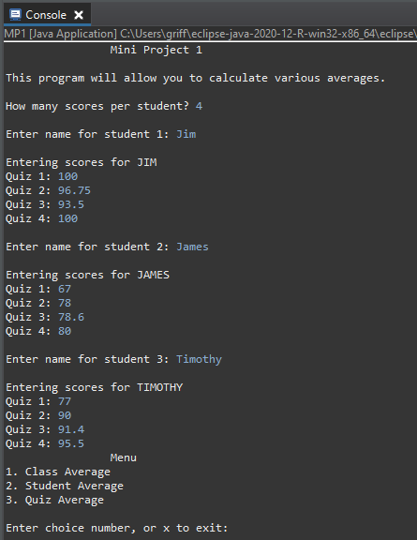

Data entry and first menu display

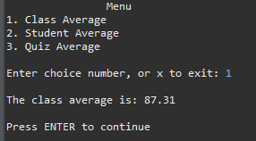

Output of choice 1: class average

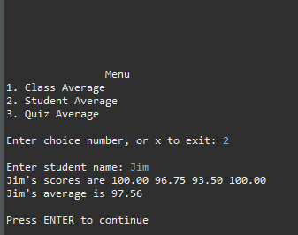

5-line gap and result of choice 2: student average (correct input)

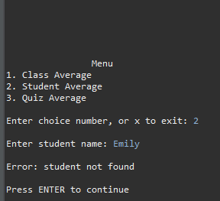

5-line gap and result of choice 2: student average (incorrect input)

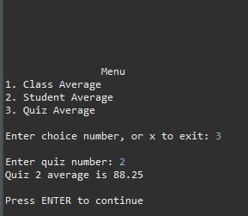

5-line gap and result of choice 3: quiz average

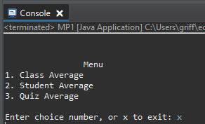

Program properly terminated after user inputs “x”