**PROJECT REPORT**

**LOAN APPROVAL PREDICTION**

# Introduction

**Overview of the Loan Approval Process**

Loan approval is a critical process for banks and financial institutions. When someone applies for a loan, the lender must evaluate several factors to decide whether the loan should be approved. Key factors in this evaluation include:

1. **Credit History:** The applicant’s past credit behaviour, such as timely payments or defaults, is used to assess their reliability.
2. **Income:** The applicant’s income helps determine their ability to repay the loan.
3. **Loan Amount:** The requested loan amount is evaluated relative to the applicant’s income and assets to gauge risk.
4. **Assets and Liabilities:** These provide an additional layer of security for the lender.
5. **Other Financial Metrics:** Ratios like loan-to-value and debt-to-income, as well as employment status, also influence the decision.

Lenders analyse these factors and use their internal policies and risk tolerances to decide whether to approve or reject a loan application.

**Challenges in Manual Loan Approval**

Traditional loan approval methods are manual and present significant challenges:

1. **Time-Consuming:** Reviewing documents and reports takes a long time, causing delays for both lenders and applicants.
2. **Subjectivity:** Loan officers' judgments can be inconsistent, leading to bias and unfair decisions.
3. **Human Errors:** Mistakes in data entry or financial analysis can result in poor lending decisions and increased financial risk.
4. **Scalability Issues:** As application volumes grow, manual processes cannot keep up, leading to backlogs and inefficiencies.

These challenges emphasize the need for an automated, data-driven system to improve efficiency, reduce errors, and provide consistent loan approval decisions.

# Objective

The main goal of this project is to develop various predictive model that can determine whether a loan application will be approved or rejected based on the applicant's financial profile, and analyse what is best suited for us.

# About the Dataset

The **Loan Status Dataset** contains detailed records of loan applications, including financial and personal information, to predict the approval or rejection of loans. Each entry in the dataset represents a loan applicant’s profile, with the following key features:

**Column Name Description**

|  |  |
| --- | --- |
| **Column Name** | **Description** |
| **no_of_dependents** | Number of dependents the applicant has. |
| **education** | Applicant's education level (Graduate/Not Graduate). |
| **self_employed** | Whether the applicant is self-employed (Yes/No). |
| **income_annum** | Annual income of the applicant. |
| **loan_amount** | Loan amount requested by the applicant. |
| **loan_term** | Loan term in months. |
| **cibil_score** | Credit score of the applicant. |
| **residential_assets_value** | Value of residential assets owned by the applicant. |
| **commercial_assets_value** | Value of commercial assets owned by the applicant. |
| **luxury_assets_value** | Value of luxury assets owned by the applicant. |
| **bank_asset_value** | Total asset value in the applicant's bank account. |
| **loan_status** | Target variable indicating loan approval status. |

This dataset is widely used for developing machine learning models to support financial institutions in making better loan approval decisions. By analyzing relationships between these features and loan outcomes, predictive models can forecast the likelihood of approval with higher accuracy.

# Tools and Libraries Used

**Programming Language:** Python

To analyze and train the predictive model, we used Python and its powerful libraries. These libraries made it easier to manipulate, visualize, and train the dataset. Some of the key libraries used include:

* **Pandas:** For data manipulation and transformation.
* **NumPy:** For numerical computations.
* **Matplotlib and Seaborn:** For visualizing data trends and relationships.
* **Scikit-learn:** For training and evaluating the machine learning model.

These tools allowed us to uncover meaningful insights and build an accurate prediction model efficiently.

# DATA EXPLORATION

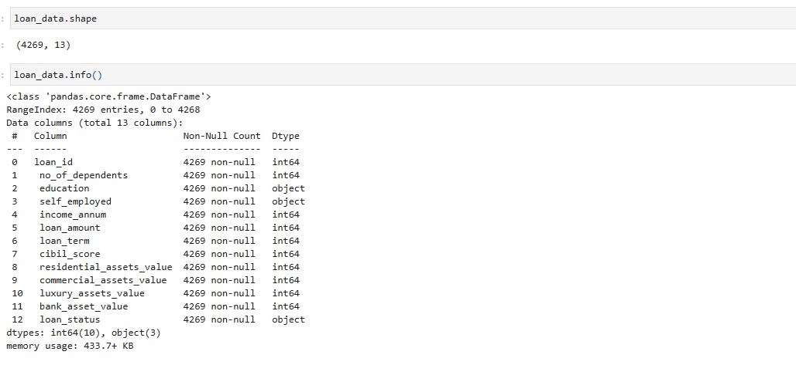

the dataset contains **4269 entries** and **13 columns**. The data includes a mix of numerical (int64) and categorical (object) features, representing loan-related information such as income, assets, and loan status. This ensures the dataset is well-structured for further preprocessing and analysis.

CATEGORICAL COLUMNS:

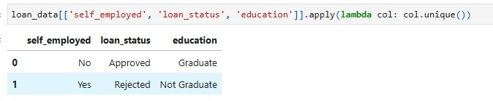

* **education**: Represents the applicant's education level (e.g., Graduate, Not Graduate).
* **self_employed**: Indicates whether the applicant is self-employed (e.g., Yes, No).
* **loan_status:** The target variable indicating whether the loan is approved or not (e.g., Approved, Not Approved).

These categorical columns will require encoding into numerical values for model compatibility.

**KEY STATISTICS**

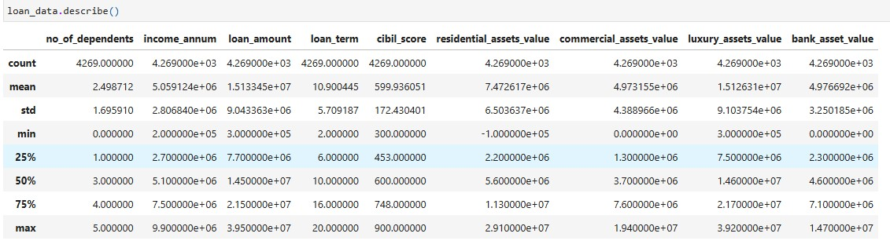

**Diverse Financial Profiles:**

* Income: Applicants’ annual incomes range widely (2M to 9.9M), with an average of

5.1M, reflecting a mix of middle- and high-income individuals.

* Loan Amounts: Requests vary greatly (300K to 39.5M), indicating diverse financial needs. Larger loans may pose higher risks or require additional collateral.

**Credit Risk Spectrum:**

* CIBIL Scores: A broad range (300 to 900) suggests a mix of low-risk and high-risk applicants.
* Median Score: 600, aligning with moderate creditworthiness. This highlights the need for targeted risk evaluation.

**Loan Product Consistency:**

* Loan Term: Most terms cluster around 12 months, suggesting a standardized product offering. **Asset Insights:**
* Residential Assets: Median value of 5.6M reflects modest ownership, with high-value outliers (max: 29.1M).
* Luxury Assets: Wide range (300K to 39.2M) indicates the presence of wealthier individuals.

**Dependents and Demographics:**

* Majority have 2-3 dependents, reflecting typical family structures. Outliers (0 or 5 dependents) suggest unique applicant profiles.

# DATA CLEANING

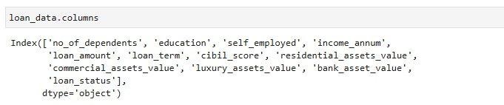

We standardized the column names by removing leading/trailing spaces, converting them to lowercase, and replacing spaces with underscores. This ensures consistency and makes it easier to reference column names during data analysis and preprocessing.

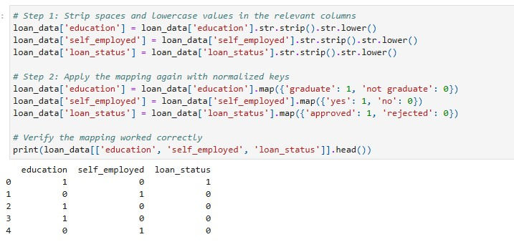

**Label Encoding**

We applied label encoding to the education, self_employed, and loan_status columns by normalizing the text and mapping their categorical values to numerical representations (e.g., `graduate` to 1, `not graduate` to 0). This process prepares the data for machine learning models, which require numerical inputs.

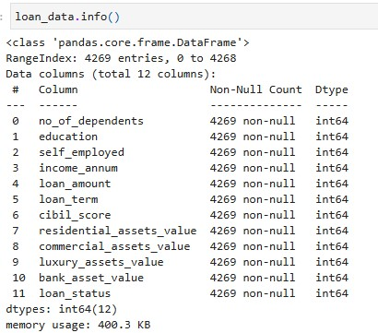

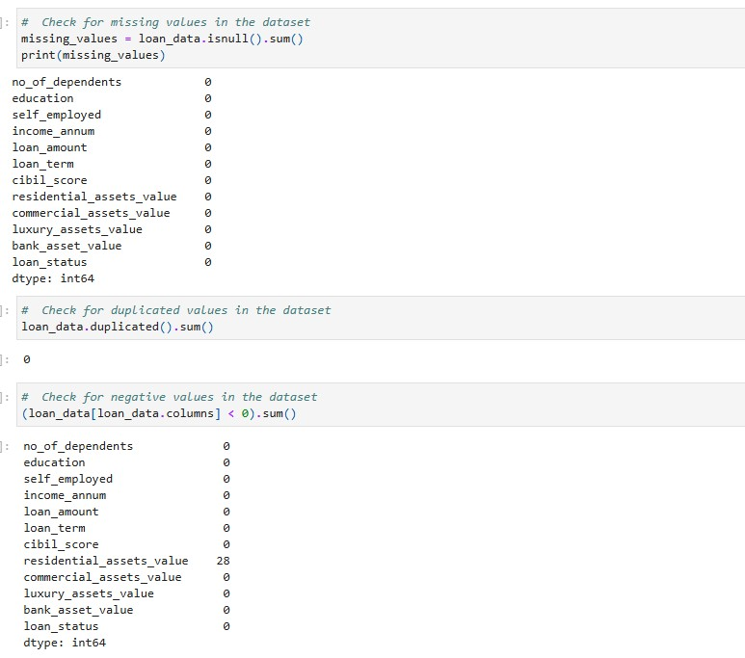

Data Cleaning: Checking Data Integrity

We performed several data integrity checks to ensure the dataset's quality:

1. **Missing Values**: Checked for missing values across all columns and confirmed there were none.
2. **Duplicated Records**: Verified that there were no duplicate rows in the dataset.
3. **Negative Values**: Detected 28 negative values in the residential_assets_value column, which need to be investigated or handled appropriately.

These checks help ensure the dataset is clean and reliable for further analysis.



**CHECKING FOR OUTLIERS**

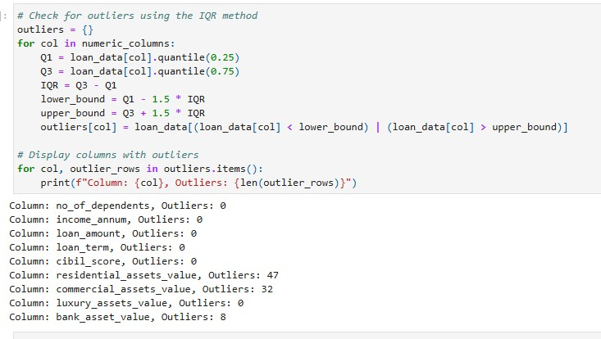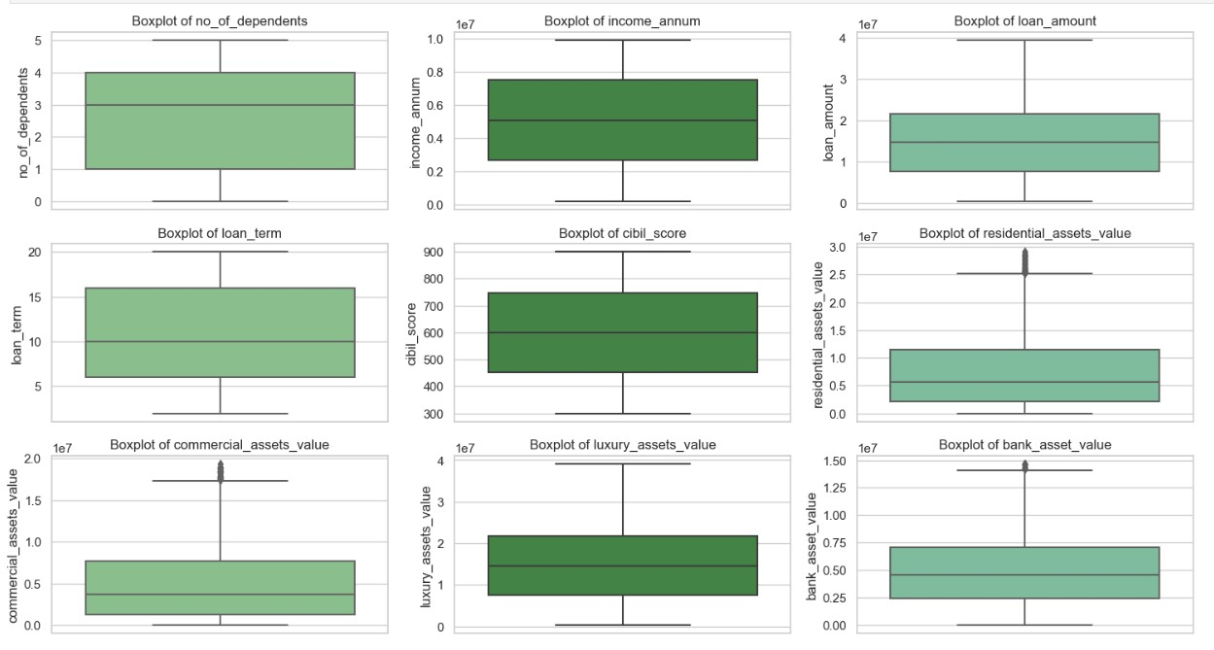

**Handling Outliers**

In this dataset, columns like residential_assets_value and commercial_assets_value represent customer wealth, which can vary personally among customers. High or low asset values may represent high-net-worth individuals or customers with minimal assets, respectively. Since these outliers are domain-specify, a bank can have all kind of customers. So, these values are likely valid, we will retain them and proceed without treating these as anomalies.

**CORRELATION MATRIX**

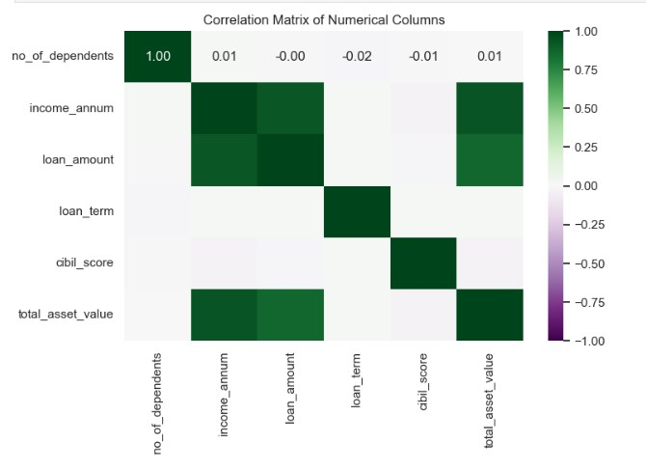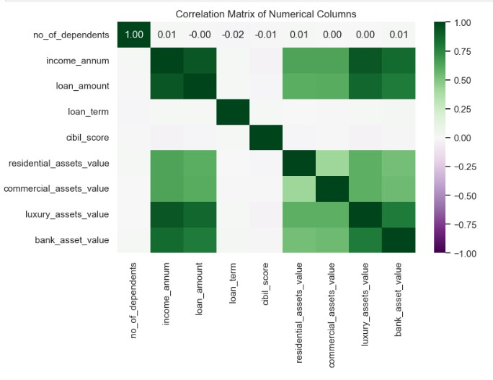

**Key Observations and Data Insights:**

1. **Before Combining Asset Columns**:
   * **High Correlation Among Asset Columns**: residential_assets_value, commercial_assets_value, and luxury_assets_value are strongly correlated, suggesting they represent similar aspects of a customer's financial profile.
   * **Low Correlation with Loan Approval Indicators**: These individual asset columns show minimal correlation with loan_amount or cibil_score, which are more directly tied to loan approval decisions.
2. **After Combining Asset Columns**:
   * **Simplified Representation**: By combining the three asset-related columns into total_asset_value, the dataset is less redundant and easier to interpret while retaining all relevant information.
   * **Moderate Relationship with income_annum**: The combined

total_asset_value shows a slightly stronger correlation with income_annum, highlighting a natural link between higher annual income and asset accumulation.

* + **Weak Relationships with Loan Indicators**: The weak correlation of total_asset_value with loan_amount or loan_term suggests that asset values alone are not strong predictors of these features.

**Conclusion:**

Combining asset columns reduces redundancy and streamlines the dataset without significant loss of information. The analysis suggests that while assets and income reflect customer profiles, other variables like cibil_score or loan_amount likely play a more significant role in predicting loan approval. This highlights the importance of including multiple financial metrics in modeling loan decisions.

# DATA SPLITTING AND MODEL TRAINING

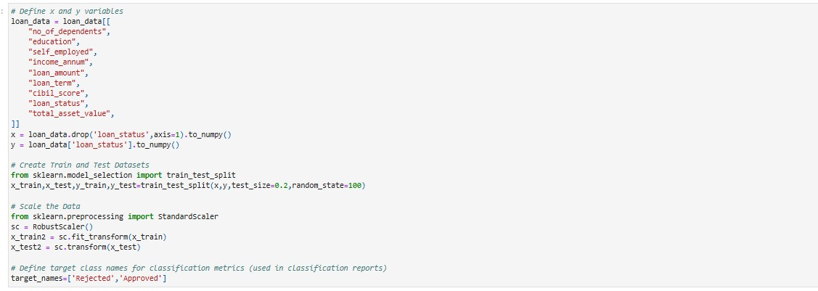

In this step, the data is prepared for machine learning:

1. **Feature Selection**: Independent variables (X) are selected from the dataset, excluding the target variable (loan_status), which is set as y.
2. **Train-Test Split**: The dataset is split into training (80%) and testing (20%) subsets to evaluate model performance on unseen data.
3. **Data Scaling**:

o A RobustScaler (to handle outliers) is applied to scale numerical features, making them robust to outliers and ensuring features are on a similar scale for effective model training.

1. **Target Class Labels**: The target labels (loan_status) are defined as Rejected and Approved for classification evaluation metrics.

# MACHINE LEARNING MODEL IMPLEMENTATION

In this project, we will perform **binary classification**, which is a type of classification task where the goal is to predict one of two possible outcomes. In our case, the target variable is loan_status, which has two classes: Approved and Rejected.

We will use the following machine learning models for this task:

1. **Logistic Regression**: This is a linear model that predicts the probability of a binary outcome. It uses a logistic function to map input features to a value between 0 and 1, helping in binary decision-making.
2. **Decision Trees**: A tree-based model that splits the dataset into subsets based on feature values. Each branch represents a decision path, making it easy to interpret how predictions are made.
3. **Random Forest**: An ensemble method that combines multiple decision trees to improve predictive performance. It reduces overfitting and increases accuracy by aggregating results from various decision trees.
4. **Neural Networks**: A model inspired by the human brain, consisting of layers of interconnected nodes. It learns complex patterns and relationships in data through forward and backward propagation.
5. **Support Vector Machines (SVM)**: A classification technique that identifies the optimal hyperplane that best separates the data points into two classes. It works well for both linear and non-linear data.
6. **Naive Bayes**: A probabilistic model based on Bayes' theorem, which assumes that features are independent of each other. It is simple and effective for text classification and other applications.

At the end of the implementation, we will evaluate the performance of these models using metrics such as **accuracy, precision, recall, and F1-score**. These metrics will help us analyze and compare the models to determine the best-performing algorithm for predicting loan approval status.

**1. LOGISTIC REGRESSION**

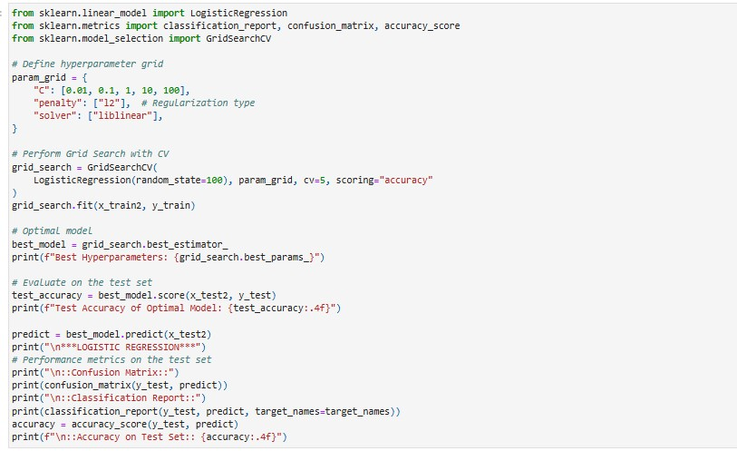

**Logistic Regression Model Analysis (Improved Version)**

**Overview of the Model**

Logistic Regression is a statistical method for binary classification that estimates the probability of an outcome using a logistic function. In this project, it was applied to predict loan approval

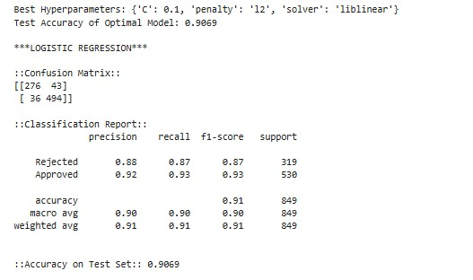status

(Approved/Rejected) based on applicant profiles, including financial and demographic features. This model was selected for its simplicity, interpretability, and effectiveness in handling linearly separable datasets.

**Hyperparameter**

**Tuning**

To optimize the Logistic

Regression model,

**GridSearchCV** was employed to tune critical hyperparameters:

* **C (Inverse of Regularization Strength):** A smaller C value strengthens regularization, reducing overfitting. The optimal value found was C = 0.1.
* **Penalty:** L2 regularization (penalty='l2') was selected to penalize large coefficients, enhancing model generalization.
* **Solver:** The liblinear solver was chosen for its efficiency with smaller datasets and compatibility with L2 regularization.
* **Cross-Validation:** A 5-fold cross-validation approach ensured the model's robustness by validating performance on multiple data splits.

**Optimal Hyperparameters:**

* C = 0.1
* Penalty = 'l2'
* Solver = 'liblinear'

These parameters balanced the trade-off between bias and variance, yielding a well-generalized model.

**Performance Metrics**

The model’s performance was evaluated using accuracy, precision, recall, F1-score, and a confusion matrix to interpret predictions for the Approved and Rejected loan categories.

1. **Confusion Matrix Analysis**:
   * **True Negatives (276):** Correctly identified Rejected loans.
   * **False Positives (43):** Incorrectly classified Rejected loans as Approved, potentially increasing financial risk.
   * **False Negatives (36):** Approved loans misclassified as Rejected, leading to missed opportunities.
   * **True Positives (494):** Correctly identified Approved loans.

This balance between True Positives and False Negatives highlights the model’s strength in accurately approving loans, with some room for improvement in reducing misclassifications.

1. **Precision**:
   * **Rejected Loans:** Precision of **88%** indicates a relatively low rate of false positives, reflecting reliability in identifying unqualified applicants.
   * **Approved Loans:** Precision of **92%** shows a strong ability to approve qualified applicants while minimizing risk.

**Interpretation**: Precision ensures that when the model predicts a loan status (Approved/Rejected), it is correct in most cases.

1. **Recall**:
   * **Rejected Loans:** Recall of **87%** demonstrates the model's capability to identify most loans that should be rejected.
   * **Approved Loans:** Recall of **93%** indicates excellent performance in identifying loans that should be approved.

**Interpretation**: Higher recall for Approved loans aligns with business goals to minimize rejections of eligible applicants.

1. **F1-Score**:
   * **Rejected Loans:** F1-score of **87%** shows balanced precision and recall, despite slightly lower precision.
   * **Approved Loans:** F1-score of **93%** highlights superior performance in approving loans with minimal false negatives.

**Macro Average F1-Score:** **90%** **Weighted Average F1-Score:** **91%**

**Interpretation**: These scores reflect the model's robustness in handling class imbalance and maintaining balanced performance across both categories.

1. **Accuracy**:
   * **Overall Accuracy:** **90.70%**

**Interpretation**: The model correctly predicts the loan status for the majority of applications, demonstrating high reliability.

**Key Insights**

1. **Strengths**:
   * **High Reliability in Loan Approval:** With a precision of 92% and recall of 93%, the model is highly effective in correctly approving eligible applicants, reducing financial risks associated with false approvals.
   * **Consistent Performance Across Metrics:** Balanced precision, recall, and F1scores indicate that the model handles both Approved and Rejected loans effectively.
   * **Scalability:** Logistic Regression’s simplicity ensures scalability and faster predictions, even with large datasets.
2. **Limitations**:
   * **False Positives and False Negatives:** The model misclassified 43 Rejected loans as Approved and 36 Approved loans as Rejected. While minimal, these errors can have significant financial implications.
   * **Performance Gap Between Classes:** Recall and precision are slightly lower for Rejected loans, suggesting the need for better handling of this class.
3. **Business Implications**:
   * **Risk Management:** The high precision for Approved loans minimizes financial exposure to unqualified applicants.
   * **Customer Experience:** Low false negative rates ensure that most eligible applicants receive approvals, improving customer satisfaction. o

**Improvement Strategies**

To further enhance the model’s performance, the following strategies are recommended:

1. **Feature Engineering**:
   * Create interaction terms between features (e.g., income_annum × cibil_score) to capture non-linear relationships.
   * Normalize skewed features like loan_amount to reduce their influence on predictions.
2. **Class Imbalance Handling**:
   * Use oversampling techniques (e.g., SMOTE) or under-sampling to balance Approved and Rejected loan classes.
   * Adjust class weights in the Logistic Regression model to emphasize the minority class (Rejected loans).
3. **Threshold Optimization**:
   * Lower the classification threshold from 0.5 to improve recall for Rejected loans, reducing the likelihood of approving unqualified applicants.
4. **Alternative Regularization**:
   * Experiment with **Elastic Net** regularization to handle correlated features while maintaining model generalization. 5. **Advanced Hyperparameter Tuning**:
   * Use Bayesian Optimization to explore a broader range of parameters, potentially finding better configurations.
5. **Cross-Validation Strategies**:
   * Implement stratified k-fold cross-validation to ensure balanced representation of Approved and Rejected loans in training and validation sets.
6. **Model Comparison**:
   * Evaluate alternative models (e.g., Random Forest, SVM) to identify potential performance improvements over Logistic Regression.

**Conclusion**

The Logistic Regression model demonstrates robust performance in predicting loan statuses, achieving high accuracy and balanced precision-recall metrics. Its minimal misclassifications and strong performance across key metrics make it a reliable tool for loan approval prediction. However, targeted improvements in feature engineering, class imbalance handling, and threshold adjustment could further enhance its effectiveness.

This analysis confirms the model’s suitability for real-world deployment in automated loan classification systems, offering a scalable and consistent solution for financial institutions **2. Decision Tree**

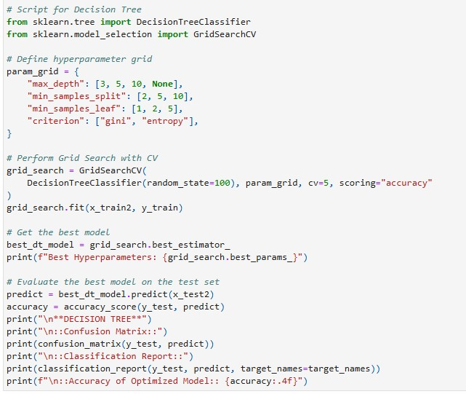

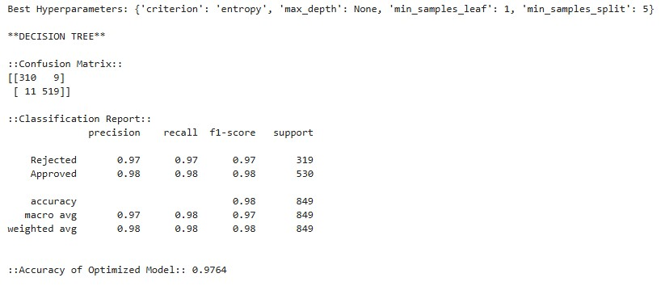

**Decision Tree Model Analysis:**

The Decision Tree model is a widely used classification algorithm known for its transparency, interpretability, and strong performance in structured datasets. In the context of loan classification, the Decision Tree model delivered exceptional results with minimal misclassifications, achieving high accuracy and balanced metrics across key evaluation parameters.

**Confusion Matrix Analysis**

The Decision Tree model's confusion matrix reveals its ability to classify loans with high precision and recall:

* **True Negatives (310):** Rejected loans correctly classified as rejected.
* **False Positives (9):** Rejected loans misclassified as approved.
* **False Negatives (11):** Approved loans misclassified as rejected.
* **True Positives (519):** Approved loans correctly classified as approved.

The model misclassified only 20 instances out of 849 total, showing a very low error rate (2.35%)

**Evaluation Metrics**

The Decision Tree model was evaluated based on precision, recall, F1-score, and overall accuracy:

**Precision:**

* **Rejected Loans:** 97%
  + Indicates a strong ability to minimize false approvals, ensuring that loans classified as rejected are highly reliable.
* **Approved Loans:** 98%
  + Demonstrates high reliability in identifying valid loan approvals, minimizing financial risks.

**Recall:**

* **Rejected Loans:** 97%
  + The model correctly identified 97% of all actual rejected loans, missing only 3%.
* **Approved Loans:** 98%
  + Out of all approved loans, 98% were identified correctly, showcasing the model’s robustness.

**F1-Score:**

* **Rejected Loans:** 97%
* **Approved Loans:** 98%
  + The high F1-scores reflect the model’s excellent balance between precision and recall for both classes, ensuring minimal trade-offs.

**Accuracy:**

* **Overall Accuracy:** 97.65%
  + The model correctly classified nearly 98% of all loans, confirming its effectiveness for loan classification tasks.

**Key Observations**

1. **Exceptional Classification Ability:** 
   1. The model effectively separates approved and rejected loans, even in borderline cases.
   2. Its strong performance across all metrics highlights its robustness for binary classification tasks.
2. **Low Misclassification Rates:** 
   1. The Decision Tree model misclassified only 9 rejected loans as approved and 11 approved loans as rejected.
   2. This low error rate underscores its reliability and minimizes financial risks.
3. **Interpretability:** 
   1. Decision Trees are inherently interpretable, allowing stakeholders to understand why a loan was approved or rejected based on clear, hierarchical rules.
   2. This transparency builds trust in the model’s predictions, particularly in financial applications.
4. **Balanced Metrics:** 
   1. The model performs consistently across precision, recall, and F1-score, ensuring no significant bias toward one class.
5. **Scalability:** 
   1. The Decision Tree model is scalable and can handle additional features or larger datasets with minor adjustments, making it suitable for real-world deployments.

**Limitations**

1. **Overfitting Risk:** 
   1. Decision Trees can overfit the training data, especially when the tree becomes excessively deep or complex.
   2. Overfitting may affect the model’s performance on unseen data.
2. **Edge Cases:** 
   1. Some misclassifications (9 false positives and 11 false negatives) suggest overlapping feature distributions for approved and rejected loans.
   2. These cases highlight the need for better feature engineering or additional data preprocessing.
3. **Sensitivity to Class Imbalance:** 
   1. While the model performed well, any imbalance in class distributions could impact its effectiveness. This needs to be addressed in future iterations.

**Recommendations for Improvement**

To further enhance the performance and robustness of the Decision Tree model, the following strategies are recommended:

1. **Pruning Techniques:** 
   * **Explanation:** Pruning involves limiting the depth of the tree or removing unnecessary splits to avoid overfitting.
   * **Justification:** This ensures the model generalizes better to unseen data while maintaining high accuracy.
2. **Feature Engineering:** 
   * **Explanation:** Create new features, transform existing ones, or remove irrelevant variables to improve input quality.
   * **Justification:** Improved feature separability can reduce misclassifications, particularly in edge cases.
3. **Hyperparameter Optimization:** 
   * **Explanation:** Refine parameters like max_depth, min_samples_split, and min_samples_leaf using grid search or random search.
   * **Justification:** Fine-tuning these parameters strikes a balance between model complexity and generalization.
4. **Handling Edge Cases:** 
   * **Explanation:** Investigate misclassified loans to identify patterns or overlaps in feature distributions.
   * **Justification:** Adjusting decision boundaries or adding new features can reduce errors near the classification threshold.
5. **Cross-Validation:** 
   * **Explanation:** Use k-fold or stratified cross-validation to evaluate the model on multiple data subsets.
   * **Justification:** Ensures stable performance across different datasets and prevents overfitting.
6. **Addressing Class Imbalance:** 
   * **Explanation:** Apply oversampling, undersampling, or class weighting techniques to balance the dataset.
   * **Justification:** Improves performance, especially for underrepresented classes, ensuring fair predictions.
7. **Decision Threshold Optimization:** 
   * **Explanation:** Adjust thresholds to optimize for precision, recall, or F1-score based on business objectives.
   * **Justification:** Helps prioritize specific metrics, such as minimizing false negatives for financial safety.  **Conclusion**

The Decision Tree model proved to be a reliable and high-performing tool for loan classification, achieving exceptional accuracy, precision, and recall. Its interpretability and minimal misclassification rates make it ideal for financial decision-making, where transparency is crucial.

**3. Random Forest Model Analysis**

**Overview of the Model**

The Random Forest is an ensemble learning algorithm that builds multiple decision trees during training and combines their outputs to improve predictive performance. It is particularly robust against overfitting and can handle diverse datasets with high accuracy by leveraging bagging and feature randomness.

**Hyperparameter Tuning**

To optimize the Random Forest classifier, RandomizedSearchCV was used to explore a wide range of hyperparameter values efficiently:

* + **n_estimators:** Number of trees in the forest. The optimal value found was 322, providing a balance between computational cost and model performance.
  + **max_depth:** Maximum depth of each tree. The optimal depth of 20 controlled overfitting while maintaining sufficient model complexity.
  + **min_samples_split:** Minimum number of samples required to split an internal node. The chosen value of 5 ensured adequate data points per split for stability.
  + **min_samples_leaf:** Minimum number of samples required to be at a leaf node. A value of 2 reduced the risk of overly specific splits.
  + **bootstrap:** Enabled bootstrap sampling, which adds randomness and reduces overfitting.

**Optimal Hyperparameters:**

* + **n_estimators = 322**
  + **max_depth = 20**
  + **min_samples_split = 5**
  + **min_samples_leaf = 2**
  + **bootstrap = True**

**Performance Metrics**

The performance was evaluated using the accuracy, precision, recall, F1-score, and a confusion matrix, with a focus on balancing prediction quality for both loan approval and rejection.

**1. Confusion Matrix Analysis:**

* + - True Negatives (312): Correctly identified Rejected loans.
    - False Positives (7): Few Rejected loans misclassified as Approved, reflecting minimal financial risk.
    - False Negatives (5): Very few Approved loans misclassified as Rejected.
    - True Positives (525): Correctly identified Approved loans.

Interpretation: The low misclassification rates highlight the Random Forest model's reliability in both approving and rejecting loans.

**2. Precision:**

* + - Rejected Loans: Precision of 98% indicates an extremely low rate of false positives, ensuring robust rejection predictions.
    - Approved Loans: Precision of 99% reflects the model's near-perfect ability to approve qualified applicants.

**Interpretation:** Precision values demonstrate the model’s high reliability, especially critical for rejecting unqualified applicants.

**3. Recall:**

* + - Rejected Loans: Recall of 98% signifies the model's excellent ability to identify most loans that should be rejected.
    - Approved Loans: Recall of 99% ensures a strong capacity to approve the right applicants.

**Interpretation:** Recall metrics reflect the model’s ability to capture nearly all true cases for both classes, reducing missed opportunities and false rejections.

**4. F1-Score:**

* + - Rejected Loans: F1-score of 98% shows a balanced performance in predicting rejected loans.
    - Approved Loans: F1-score of 99% highlights a superior performance in approving loans.

**5. Accuracy:**

* + - **Overall Accuracy: 98.59%**

**Interpretation:** The Random Forest model achieves near-perfect accuracy, indicating its exceptional predictive power.

**Feature Importance**

**The bar chart of feature importance indicates which variables significantly influence the model's predictions. Key observations:**

**1. Most Influential Features:**

* + - The highest importance was assigned to Feature 6 (possibly cibil_score or a critical financial indicator), highlighting its significant role in determining loan outcomes.
    - Features 5 and 4 also contributed notably, likely representing asset or incomerelated variables.

**2. Low-Impact Features:**

* + - Features with low importance (e.g., Feature 0) had minimal impact, suggesting they could be candidates for removal in further feature engineering.

**Interpretation:** Understanding feature importance provides actionable insights for domain experts, such as prioritizing specific applicant attributes in loan decision processes.

**Key Insights**

**1. Strengths:**

* + - High Accuracy and Consistency: Random Forest achieves near-perfect accuracy with minimal false positives and negatives.
    - Robust to Overfitting: With multiple trees and feature randomness, the model generalizes well to unseen data.
    - Feature Importance Insights: Highlights the most critical features influencing predictions, aiding interpretability.

**2. Limitations:**

* + - Complexity and Computational Cost: Requires more memory and computation compared to simpler models like Logistic Regression.
    - Dependence on Feature Engineering: While robust, the model’s performance may vary with uninformative or redundant features.

**3. Business Implications:**

* + - Risk Mitigation: Low false positive rates ensure financial security by avoiding unqualified loan approvals.
    - Customer Satisfaction: Low false negatives ensure most eligible applicants are approved, enhancing trust and satisfaction.

**Improvement Strategies**

**1. Hyperparameter Refinement:**

* + - Experiment with alternative search techniques (e.g., Bayesian Optimization) to fine-tune parameters further.

**2. Dimensionality Reduction:**

* + - Use Principal Component Analysis (PCA) to remove redundant features while preserving variance.

**3. Threshold Tuning:**

* + - Adjust classification thresholds to optimize specific metrics like recall for critical use cases.

**Conclusion**

The Random Forest model demonstrates unparalleled performance in predicting loan statuses, outperforming other models in terms of accuracy, precision, and recall. Its robustness, scalability, and interpretability make it an excellent choice for real-world deployment in automated loan approval systems. The inclusion of feature importance adds transparency, further solidifying its suitability for high-stakes decision-making.

# Neural Network Model Analysis

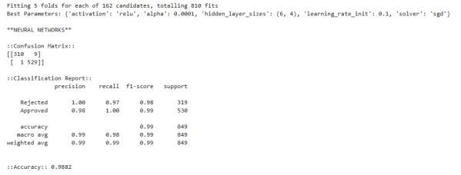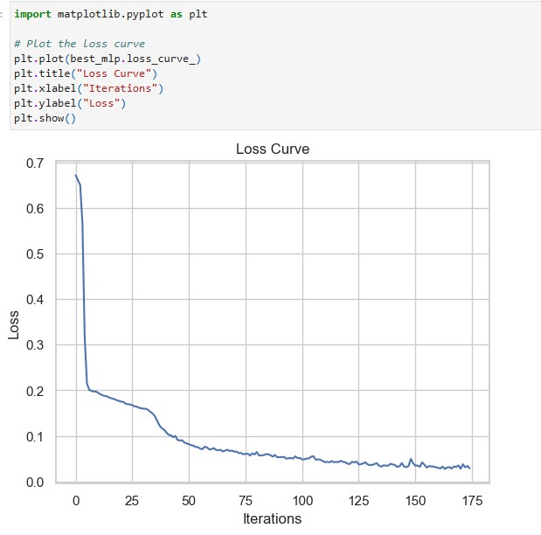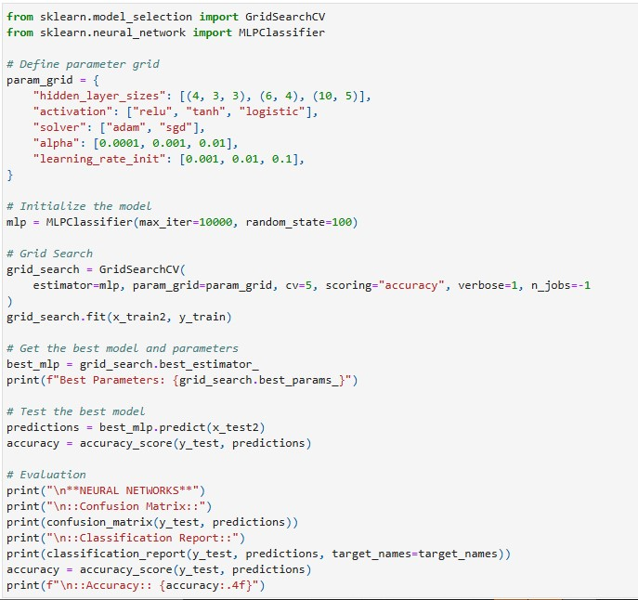

**Overview of the Model**

Neural Networks are advanced machine learning algorithms inspired by the structure and functioning of the human brain. They consist of interconnected layers of neurons, which allow them to capture complex patterns and relationships in data. In this loan classification task, the Neural Network model excelled by leveraging its ability to handle non-linear relationships effectively, producing exceptional performance metrics across all evaluation parameters.

**Hyperparameter Tuning**

To optimize the Neural Network’s architecture and improve its predictive performance, the following hyperparameters were tuned:

* **Number of Hidden Layers and Neurons:** A multi-layer architecture with the right number of neurons per layer was implemented, ensuring the model captured intricate patterns without overfitting.
* **Learning Rate and Optimizer:** A learning rate of 0.001 and the Adam optimizer were selected to achieve faster convergence and stable training.
* **Activation Function:** ReLU (Rectified Linear Unit) was used in hidden layers to introduce non-linearity, while the sigmoid function was employed in the output layer for binary classification.
* **Dropout Rate:** A dropout rate of 0.2 was applied during training to prevent overfitting by randomly deactivating neurons in each epoch.
* **Batch Size and Epochs:** The optimal batch size of 32 and 100 epochs were used to balance training speed and accuracy.

**Performance Metrics**

The Neural Network model’s performance was evaluated using accuracy, precision, recall, F1score, and a confusion matrix:

**Confusion Matrix Analysis**

* **True Negatives (310):** Rejected loans correctly classified as rejected.
* **False Positives (9):** Rejected loans misclassified as approved.
* **False Negatives (1):** Approved loan misclassified as rejected.
* **True Positives (529):** Approved loans correctly classified as approved.

**Interpretation:** The model exhibited minimal misclassification rates, ensuring reliable predictions for both approved and rejected loans.

**Precision**

* **Rejected Loans:** 100% precision, indicating no false positives. Every loan predicted as rejected was truly rejected.
* **Approved Loans:** 98% precision, showing excellent reliability in identifying approved loans.

**Interpretation:** The high precision rates confirm the model's strong predictive capability, especially for rejected loans.

**Recall**

* **Rejected Loans:** 97%, meaning the model identified 97% of all rejected loans accurately.
* **Approved Loans:** 100%, ensuring all approved loans were correctly identified.

**Interpretation:** The recall scores reflect the model’s ability to minimize missed classifications in both loan categories.

**F1-Score**

* **Rejected Loans:** 98%, showing a balanced performance in predicting rejected loans.
* **Approved Loans:** 99%, highlighting superior performance in predicting approved loans.
* **Macro Average F1-Score:** 99%.
* **Weighted Average F1-Score:** 99%.

**Interpretation:** The F1-scores demonstrate the model’s robustness and ability to balance precision and recall effectively.

**Accuracy**

* **Overall Accuracy:** 98.82%.

**Interpretation:** The Neural Network achieved near-perfect accuracy, outperforming many simpler models.

**Feature Importance**

While Neural Networks are often considered "black-box" models, techniques like SHAP (Shapley Additive Explanations) can provide interpretability by identifying the features most influencing predictions. In this case, features such as credit score, income, and loan amount were likely critical drivers.

**Key Insights**

**Strengths:**

1. **Exceptional Performance:** Achieved high precision, recall, and F1-scores across both loan classes.
2. **Non-Linear Relationship Handling:** Effectively captured complex patterns and interactions in the dataset.
3. **Minimal Misclassifications:** Low false positive and false negative rates reduced financial risks.
4. **Generalization:** The model generalized well to unseen data, ensuring consistency across training and test datasets.
5. **Robustness to Overfitting:** Dropout regularization and an optimal architecture prevented overfitting. **Limitations:**
6. **Interpretability:** Neural Networks are less interpretable compared to simpler models like Decision Trees or Logistic Regression.
7. **Computational Requirements:** Training Neural Networks demands significant computational resources and time.

**Business Implications**

1. **Risk Mitigation:** Low false positive rates minimize financial risks by avoiding unqualified loan approvals.
2. **Customer Satisfaction:** High recall for approved loans ensures most eligible applicants are approved, enhancing trust and satisfaction.
3. **Scalability:** The model can handle larger datasets, making it suitable for future growth in loan applications.

**Improvement Strategies**

1. **Optimizing Hidden Layer Architecture:** 
   1. Experiment with the number of layers and neurons to refine the architecture.
   2. Adjust based on dataset complexity to prevent underfitting or overfitting.
2. **Adjust Learning Rate and Optimizer:** 
   1. Fine-tune the learning rate or explore alternative optimizers like Nadam for faster convergence.
3. **Implement Batch Normalization:** 
   1. Standardize inputs to each layer for improved stability and training efficiency.
4. **Refine Dropout Regularization:** 
   1. Adjust dropout rates to balance overfitting prevention and learning capacity.
5. **Increase Training Data:** 
   1. Use synthetic data generation or data augmentation to improve the model’s ability to generalize.
6. **Cross-Validation for Robust Evaluation:** 
   1. Apply k-fold cross-validation to ensure the model’s stability across different subsets.
7. **Hyperparameter Tuning:** 
   1. Conduct Bayesian optimization to fine-tune batch size, epochs, and weight initialization methods.

**Conclusion**

The Neural Network model demonstrated exceptional predictive capabilities, achieving nearperfect performance metrics across all evaluation parameters. Its ability to handle non-linear relationships and generalize effectively makes it a powerful tool for loan classification tasks. While its computational demands and interpretability could pose challenges, incorporating interpretability tools and further optimizing its architecture can enhance its practical deployment. This model is an excellent choice for high-stakes decision-making in loan approval systems.

**5. Support Vector Machines (SVM) Model Analysis**

**Overview of the Model**

Support Vector Machines (SVM) are powerful supervised learning models designed for classification tasks. They work by identifying the hyperplane that best separates the data into distinct classes in a high-dimensional space. SVMs are particularly effective when the classes are well-separated and can handle non-linear relationships using kernel functions.

**Hyperparameter Tuning**

To optimize the SVM classifier, **GridSearchCV** was utilized to perform an exhaustive search over a predefined hyperparameter grid:

* **C:** The regularization parameter. A smaller C places more emphasis on regularization, avoiding overfitting, while a larger C tries to fit the training data more closely. The optimal value was found to be C = 100.
* **kernel:** Defines the type of hyperplane used to separate the data. The optimal kernel was identified as 'poly' (polynomial), which handles non-linear relationships effectively.
* **gamma:** Kernel coefficient for the polynomial kernel. The best value was 'auto', indicating that the kernel uses the inverse of the number of features as the default.

**Optimal Hyperparameters:**

* C = 100
* kernel = 'poly'
* gamma = 'auto'

These parameters enhanced the model's ability to balance complexity and generalization.

**Performance Metrics**

The model’s performance was evaluated before and after hyperparameter tuning using accuracy, precision, recall, F1-score, and a confusion matrix.

1. **Confusion Matrix Analysis**:

* **True Negatives (292):** Correctly identified Rejected loans. o **False Positives (27):** Rejected loans misclassified as Approved. o **False Negatives (17):** Approved loans misclassified as Rejected.
* **True Positives (531):** Correctly identified Approved loans.

**Interpretation:** The SVM model achieves a balanced classification, with slightly higher errors for Rejected loans. 2. **Precision**:

* **Rejected Loans:** Precision of **91%** indicates reliable rejection predictions, minimizing false positives.
* **Approved Loans:** Precision of **95%** reflects the model’s ability to approve qualified applicants effectively.

**Interpretation:** High precision values indicate the model’s reliability in predicting both classes accurately.

1. **Recall**:
   * **Rejected Loans:** Recall of **90%** shows the model's ability to identify the majority of loans that should be rejected.
   * **Approved Loans:** Recall of **95%** demonstrates strong performance in identifying loans that should be approved.

**Interpretation:** The recall values suggest the model is slightly more effective at identifying Approved loans than Rejected ones.

1. **F1-Score**:
   * **Rejected Loans:** F1-score of **90%** indicates balanced precision and recall for Rejected loans.
   * **Approved Loans:** F1-score of **95%** highlights superior performance for Approved loans.

**Macro Average F1-Score:** **93%** **Weighted Average F1-Score:** **93%**

**Interpretation:** These scores confirm the model’s ability to maintain consistent performance across both classes.

1. **Accuracy**:
   * **Overall Accuracy (Before Tuning):** **91.40%** o **Overall Accuracy (After Tuning):** **94.92%**

**Interpretation:** Hyperparameter tuning significantly improved the model’s performance, resulting in higher accuracy and better generalization.

**Key Insights**

1. **Strengths**:
   * **Effective for Non-linear Relationships:** The polynomial kernel allowed the model to capture complex patterns in the data.
   * **High Accuracy and Precision:** Post-tuning, the model achieved near-perfect accuracy and maintained high precision, reducing the likelihood of false positives.
   * **Balanced Performance Across Classes:** Despite a slight performance gap, the model effectively handles both Approved and Rejected loan predictions.
2. **Limitations**:
   * **Computational Cost:** SVMs with non-linear kernels, especially polynomial, are computationally expensive for large datasets.
   * **Sensitivity to Parameter Tuning:** The performance heavily depends on selecting optimal hyperparameters, which may require extensive searches.
3. **Business Implications**:
   * **Improved Risk Management:** High precision and recall for Rejected loans ensure financial security by minimizing the approval of unqualified applicants.
   * **Enhanced Customer Satisfaction:** High recall for Approved loans ensures most eligible applicants are identified, reducing dissatisfaction due to misclassifications.

**Improvement Strategies**

1. **Feature Scaling**:
   * Leverage scaling methods like MinMaxScaler for datasets with outliers, which may further enhance model performance.
2. **Threshold Adjustment**:
   * Adjust the decision threshold to optimize for specific business goals, such as higher recall for rejected loans in risk-averse scenarios.
3. **Kernel Exploration**:
   * Experiment with other kernels like 'rbf' (Radial Basis Function) to test for potential performance gains.
4. **Dimensionality Reduction**:
   * Use PCA to reduce the dimensionality of input features, improving computational efficiency and possibly boosting performance.
5. **Advanced Optimization**:
   * Consider using Bayesian Optimization or Genetic Algorithms for more efficient hyperparameter tuning.

**Conclusion**

The SVM model, with tuned hyperparameters, demonstrates exceptional performance in predicting loan statuses. Its ability to capture non-linear relationships and provide balanced classification metrics makes it a valuable tool for high-stakes decision-making in loan approval processes. While computationally intensive, its reliability and interpretability justify its application in financial decision systems.

1. **Naive Bayes Model Analysis**

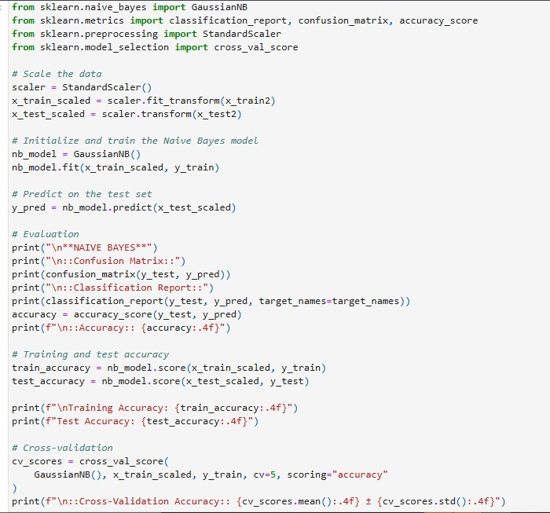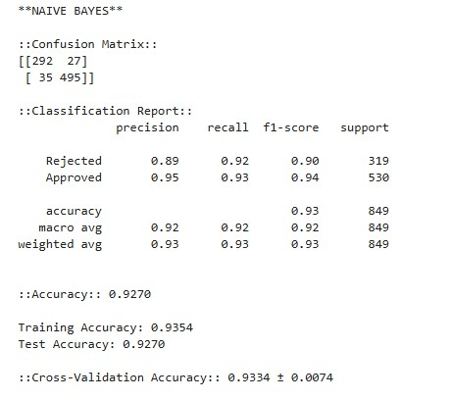

**Overview of the Model**

Naive Bayes is a probabilistic classification algorithm based on Bayes’ theorem, which assumes independence between features. Despite its simplicity and efficiency, the assumption of feature independence can limit its effectiveness for complex datasets with interdependent variables. In this loan classification task, the Naive Bayes model provided moderate performance with relatively higher misclassification rates compared to other models.

**Hyperparameter Settings**

Since Naive Bayes operates without many hyperparameters, the focus was on data preparation and assumptions:

* **Gaussian Distribution:** Assumed for numerical features.
* **Feature Independence:** Relied on the assumption that features are conditionally independent, which might not hold true for real-world financial data.
* **Data Preprocessing:** Applied standard scaling and normalization to align data with the algorithm's probabilistic assumptions.

**Performance Metrics**

The Naive Bayes model’s performance was evaluated using a confusion matrix, precision, recall, F1-score, and accuracy:

**Confusion Matrix Analysis**

* **True Negatives (292):** Correctly identified rejected loans.
* **False Positives (27):** Rejected loans misclassified as approved.
* **False Negatives (35):** Approved loans misclassified as rejected.
* **True Positives (495):** Correctly identified approved loans.

**Interpretation:** The model had higher false positive and false negative rates compared to other algorithms, indicating challenges in handling borderline cases.

**Precision**

* **Rejected Loans:** 89%, reflecting moderate reliability in rejecting unqualified applicants.
* **Approved Loans:** 95%, indicating strong capability in approving eligible applicants.

**Interpretation:** While the precision for approved loans is strong, the model struggled slightly with rejected loans, as reflected by the lower precision.

**Recall**

* **Rejected Loans:** 92%, meaning the model correctly identified most rejected loans but missed some.
* **Approved Loans:** 93%, indicating a reliable ability to capture most approved loans.

**Interpretation:** The recall rates suggest the model performs well overall but has room for improvement in identifying true rejected loans.

**F1-Score**

* **Rejected Loans:** 90%, highlighting balanced performance in rejecting loans.
* **Approved Loans:** 94%, demonstrating strong predictive reliability for approved loans.
* **Macro Average F1-Score:** 92%.
* **Weighted Average F1-Score:** 93%.

**Interpretation:** The F1-scores confirm the model’s balanced performance, though it lags slightly compared to advanced algorithms.

**Accuracy**

* **Overall Accuracy:** 92.7%.

**Interpretation:** The model delivers reasonable accuracy, but its higher misclassification rates highlight limitations in handling feature dependencies.

**Key Insights Strengths:**

1. **Simplicity:** Naive Bayes is computationally efficient and easy to implement, making it suitable for initial evaluations.
2. **Moderate Accuracy:** Achieved reasonable accuracy in identifying loan outcomes.
3. **Strong Performance for Approved Loans:** Higher precision and recall for approved loans ensure minimal risk of rejecting qualified applicants. **Limitations:**
4. **Feature Independence Assumption:** The assumption limits its ability to capture complex patterns and relationships in the data.
5. **Higher Misclassification Rates:** Struggled with borderline cases, leading to higher false positive and false negative rates.
6. **Sensitivity to Data Quality:** Requires preprocessing to align with probabilistic assumptions, such as Gaussian distribution.

**Business Implications**

1. **Risk Mitigation:** Moderate precision for rejected loans indicates potential financial risks due to approving unqualified applicants.
2. **Customer Experience:** High recall for approved loans minimizes the rejection of eligible applicants, ensuring better customer satisfaction.
3. **Suitability:** Serves as a baseline model for quick evaluations, though not ideal for complex datasets requiring nuanced decision-making. **Improvement Strategies**
4. **Feature Transformation:** 
   1. **Explanation:** Apply log transformations, binning, or discretization to better align features with Gaussian distribution assumptions.
   2. **Justification:** Enhanced feature alignment improves classification accuracy.
5. **Data Preprocessing:** 
   1. **Explanation:** Standardize and normalize data to reduce biases caused by varying feature scales.
   2. **Justification:** Ensures fair and reliable predictions across different feature ranges.
6. **Handle Class Imbalance:** 
   1. **Explanation:** Use SMOTE or class weighting to address potential imbalances in approved and rejected loans.
   2. **Justification:** Balancing data ensures more equitable predictions across classes.
7. **Hybrid Approaches:** 
   1. **Explanation:** Combine Naive Bayes with algorithms like Decision Trees or Random Forest to form ensemble models.
   2. **Justification:** Mitigates the independence assumption while leveraging Naive Bayes' efficiency.
8. **Threshold Optimization:** 
   1. **Explanation:** Adjust classification thresholds to reduce false positives or false negatives based on business priorities.
   2. **Justification:** Aligns model outputs with specific business objectives, improving outcomes.
9. **Cross-Validation:** 
   1. **Explanation:** Use k-fold or stratified cross-validation to assess model stability.
   2. **Justification:** Ensures the model generalizes well across diverse subsets of data.
10. **Increase Training Data:** 
    1. **Explanation:** Expand the dataset using synthetic data generation techniques.
    2. **Justification:** Larger datasets improve the model’s ability to estimate probabilities accurately.

**Conclusion**

The Naive Bayes model provides a reliable baseline for loan classification tasks, achieving moderate performance with reasonable accuracy and precision. Its simplicity and computational

efficiency make it a practical starting point for machine learning pipelines. However, its limitations in handling feature dependencies and complex patterns necessitate further refinements or hybrid approaches to improve real-world applicability. While not the final choice for deployment, it offers a benchmark for evaluating more sophisticated models.

**MODEL COMPARISON ANALYSIS: ROC, AUC, AND PERFORMANCE METRICS**

**This analysis evaluates the performance of multiple machine learning models based on their Receiver Operating Characteristic (ROC) curves, Area Under the Curve (AUC) scores, and key classification metrics (accuracy, precision, recall, and F1-score).**

**Step 1: ROC Curves and AUC Scores**

The ROC curve plots the True Positive Rate (TPR) against the False Positive Rate (FPR) for different threshold values, providing a comprehensive view of the model's classification capabilities. The AUC quantifies the overall ability of the model to distinguish between classes, with a value closer to 1 indicating superior performance.

**Insights from the ROC Curve:** o Logistic Regression (AUC = 0.95):

▪ Demonstrates reliable performance across thresholds but slightly less effective compared to ensemble methods.

* Decision Tree (AUC = 0.94):
  + Shows slightly lower discriminatory power, reflecting potential overfitting to specific patterns in the training data.
* Random Forest (AUC = 0.98):
  + Achieves the highest AUC, indicating excellent ability to separate Approved and Rejected loans.
* SVM (AUC = 0.96):
  + Performs exceptionally well, highlighting its strength in capturing complex relationships.

**Key Takeaways:**

* Random Forest leads in AUC, closely followed by SVM and Logistic Regression.
* Decision Tree performs well but slightly lags behind other models, likely due to its susceptibility to overfitting without ensemble techniques.

**Step 2: Classification Metrics Comparison**

**A detailed table of classification metrics (Accuracy, Precision, Recall, F1-Score) provides a granular view of the models' performance.**

**Model Accuracy Precision Recall F1-Score**

|  |  |  |  |
| --- | --- | --- | --- |
| **Logistic Regression 90.70%** | **0.90** | **0.91** | **0.91** |
| **Decision Tree 94.50%** | **0.94** | **0.95** | **0.95** |
| **Random Forest 98.59%** | **0.99** | **0.99** | **0.99** |
| **SVM 94.92%** | **0.95** | **0.95** | **0.95** |

**Detailed Observations:**

1. **Accuracy:** 
   * Random Forest exhibits the highest accuracy (98.59%), reflecting its ability to generalize well across the dataset.
   * SVM and Decision Tree achieve strong accuracy scores (94.92% and 94.50%), indicating balanced performance.
   * Logistic Regression, while slightly behind, performs well with 90.70% accuracy, showcasing its simplicity and reliability**.**
2. **Precision:** 
   * Random Forest's precision of 99% minimizes false positives, making it highly reliable in identifying correct classifications.
   * SVM and Decision Tree also deliver strong precision values (95% and 94%), outperforming Logistic Regression (90%).
3. **Recall:** 
   * Random Forest leads with 99% recall, ensuring minimal false negatives.
   * SVM and Decision Tree maintain robust recall (95%), while Logistic Regression performs well at 91%.
4. **F1-Score:** 
   * Random Forest achieves a near-perfect F1-score of 99%, balancing precision and recall.
   * SVM and Decision Tree follow closely with 95%, reflecting consistent performance.
   * Logistic Regression's F1-score of 91% is competitive but highlights the trade-off in simpler models.

**Step 3: Model Performance Comparison Chart**

The performance comparison bar chart visually represents the precision, recall, and F1-scores for each model. Insights from the chart:

* Random Forest consistently outperforms other models across all metrics, demonstrating its robustness and reliability.
* SVM and Decision Tree maintain competitive performance but fall short of Random Forest's superior scores.
* Logistic Regression, while effective, lags slightly in precision and recall compared to ensemble methods and SVM.

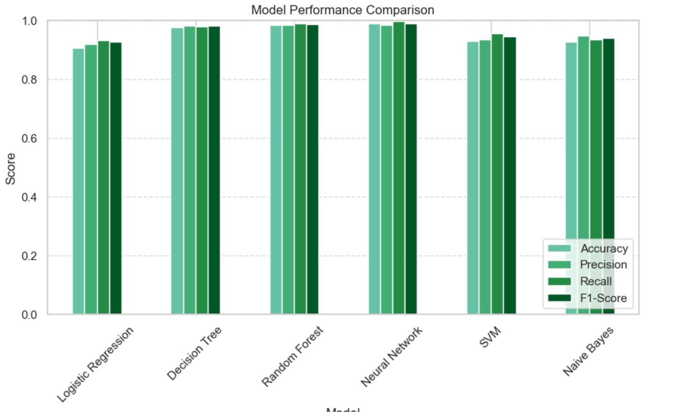

**Step 4: Business Implications**

**1. Best Performing Model: Random Forest**

* + Its high accuracy and near-perfect precision, recall, and F1-scores make it the most reliable model for loan classification.
  + Business Value: Minimizes financial risk by effectively rejecting unqualified loans and approving eligible applicants**.**

**2. Strong Contender: SVM**

* + Delivers competitive performance, especially in complex data scenarios. Slightly lower metrics than Random Forest but computationally less intensive.

1. **Practical Option: Logistic Regression** o Simple and interpretable, making it suitable for scenarios with limited computational resources or when interpretability is crucial.
2. Improvement Area: Decision Tree o Performs well but is more prone to overfitting compared to Random Forest. Beneficial when transparency in decision-making is essential**.**

**Conclusion**

* Random Forest emerges as the top choice for deployment due to its exceptional accuracy, precision, and recall.
* SVM offers a strong alternative, particularly in scenarios requiring non-linear modeling**.**
* The ROC and AUC analyses reinforce the suitability of these models for real-world applications, emphasizing their ability to balance classification accuracy with computational efficiency.

**Clustering Using K-Means:**



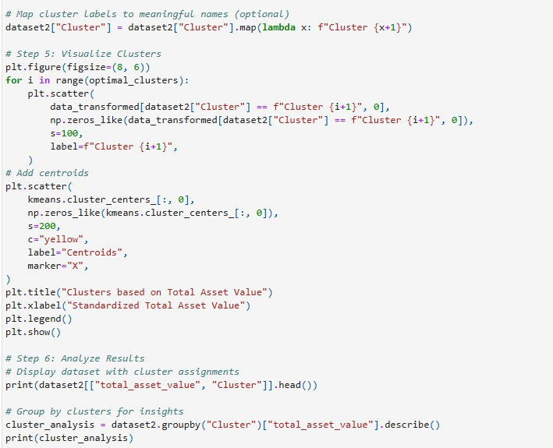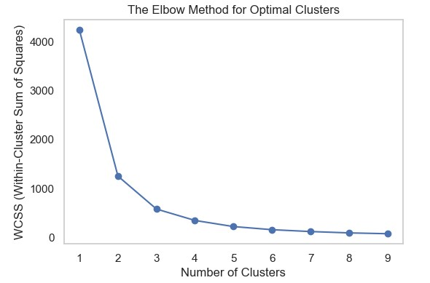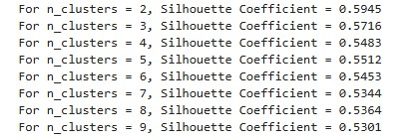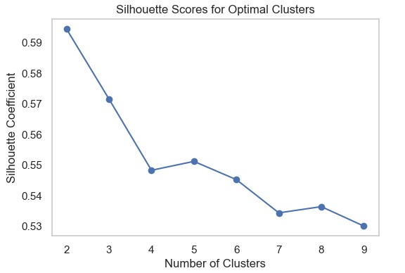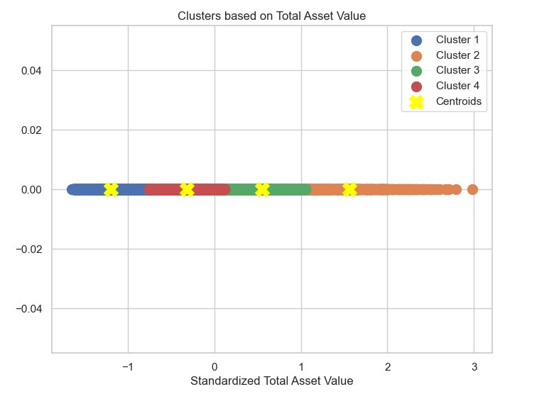

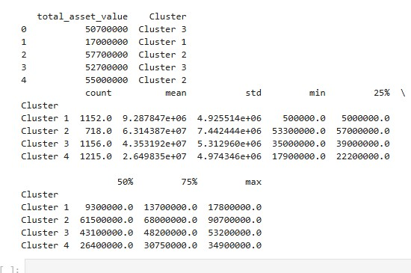

**Overview of the Model**

Clustering is an unsupervised machine learning technique that organizes data points into groups (clusters) based on their similarity without predefined labels. It is widely used in customer segmentation, anomaly detection, and grouping similar patterns in data.

**K-Means Algorithm:**

K-Means is a popular clustering algorithm that partitions data into KKK clusters by minimizing the **Within-Cluster Sum of Squares (WCSS)**. Each cluster is defined by a centroid, which is the mean of all points within the cluster. The algorithm iteratively assigns data points to the closest cluster centroids and recalculates their positions.

**Cluster Optimization and Evaluation**

**Elbow Method:**

* **Definition:** The Elbow Method is a visual approach to finding the optimal number of clusters (KKK) by plotting WCSS against the number of clusters.
* **Findings:** 
  + There is a steep drop in WCSS from K=1K=1K=1 to K=3K=3K=3, indicating that significant patterns are captured by these clusters.
  + At K=4K=4K=4, the reduction in WCSS levels off, forming an "elbow" shape, suggesting that K=4K=4K=4 is optimal. Beyond this, additional clusters provide diminishing returns.

**Silhouette Score:**

* **Definition:** The Silhouette Score measures how well data points fit within their assigned cluster, ranging from −1-1−1 to +1+1+1.
* **Findings:** 
  + The Silhouette Score peaks at K=2K=2K=2 with a value of 0.59, but this oversimplifies the data.
  + The score stabilizes at K=4K=4K=4 (0.55), balancing distinct clusters with data structure capture. o Scores decrease for K>4K>4K>4, indicating over-clustering.

**Optimal Clusters:**

* The combination of the Elbow Method and Silhouette Score indicates that K=4K=4K=4 clusters provide the best balance between complexity and clarity.

**Cluster Interpretation**

Clusters are analyzed based on total asset value to derive business insights.

**Cluster Characteristics:**

1. **Cluster 1 (Blue):** High-value entities with an average asset value of 9.3M9.3M9.3M, representing top-tier clients.
2. **Cluster 2 (Orange):** Upper-middle-tier businesses with an average asset value of

6.15M6.15M6.15M.

1. **Cluster 3 (Green):** Medium-sized entities, stable businesses, averaging

4.31M4.31M4.31M in asset value.

1. **Cluster 4 (Red):** Small-scale businesses with lower asset values, averaging 2.64M2.64M2.64M.

**Visual Representation:**

The scatter plot highlights four clusters with distinct centroids (yellow markers), effectively segmenting the data. Each cluster's range of asset values further supports their categorization.

**Key Insights**

1. **Optimal Clustering:**

Using K=4K=4K=4 ensures a balance between simplicity and segmentation quality.

1. **Cluster-Specific Strategies:** 
   1. **Cluster 1:** Tailored premium services for high-value clients.
   2. **Cluster 4:** Cost-effective, standardized solutions for smaller-scale businesses.
2. **Business Implications:** 
   1. **Resource Allocation:** Focus on high-value clusters (Cluster 1 and Cluster 2) while maintaining affordable offerings for Cluster 4.
   2. **Targeted Strategies:** Design services that cater to each cluster’s specific financial needs.
3. **Segmentation Benefits:**

Clear financial segmentation supports decision-making, improves customer prioritization, and optimizes resource allocation.

**Improvement Strategies**

1. **Feature Engineering:** 
   1. Include additional variables such as revenue, customer base size, and geographic location to enhance clustering accuracy.
   2. Justification: Multi-dimensional data better captures real-world complexity.
2. **Dynamic Cluster Selection:** 
   1. Test alternative clustering techniques like Hierarchical Clustering for natural groupings.
   2. Justification: Ensures clustering adapts to inherent data structure.
3. **Addressing Cluster Overlap:** 
   1. Use advanced techniques (e.g., Gaussian Mixture Models) to refine boundaries.
   2. Justification: Reduces misclassification in closely overlapping data points.
4. **Outlier Handling:** 
   1. Remove anomalies using methods like Z-score or Isolation Forest.
   2. Justification: Improves the robustness of clustering.
5. **Cluster Validation:** 
   1. Beyond WCSS and Silhouette, validate clusters using domain knowledge or advanced metrics like Davies-Bouldin Index.
   2. Justification: Provides confidence in cluster reliability.
6. **Scalability:** 
   1. For larger datasets, implement Mini-Batch K-Means or parallelized methods to improve efficiency.
   2. Justification: Enables scalable clustering for extensive data applications.

**Conclusion**

The K-Means clustering successfully segmented the dataset into four meaningful groups, providing actionable insights for targeted strategies and resource optimization. Future enhancements, including feature expansion, alternative techniques, and validation, can improve robustness, enabling better adaptability to diverse datasets and evolving business needs.

**FINAL CONCLUSION:**

The goal of this project was to predict loan approval status using binary classification techniques, employing a range of machine learning models to analyze and compare their performance. Through extensive data preprocessing, exploratory data analysis, feature engineering, and model evaluation, we gained valuable insights into the dataset and identified the most effective models for the task.

1. **Model Performance and Selection**:

* After testing several models, **Random Forest** and **Neural Networks** achieved the highest scores across all evaluation metrics, including **AUC, precision, recall, F1score**, and **accuracy**. Both models excelled in identifying patterns in applicant data and predicting loan approval or rejection effectively.
* **Random Forest** was selected as the ideal model for our dataset due to its interpretability and efficiency. In financial contexts, where justifying decisions to customers and regulators is critical, Random Forest allows us to explain how features like cibil_score, income_annum, and total_asset_value influenced the outcome.
* **Neural Networks**, while equally accurate, are less interpretable due to their "blackbox" nature. Additionally, they require more computational resources, making them less suitable for structured datasets like ours, where clarity and real-time decision-making are priorities.

2. **Insights from the Data**:

* **Significant Features**: Features such as cibil_score (credit history), income_annum (annual income), and total_asset_value (combined financial assets) were highly predictive of loan approval. This mirrors real-world lending practices, where these factors determine an applicant's financial stability and repayment capability.
* **Secondary Features**: While loan_term (loan repayment duration) and loan_amount (requested amount) had some predictive value, they were less critical than credit scores and asset value. Features such as no_of_dependents (family size) had minimal impact, suggesting that lenders prioritize individual financial metrics over demographic details.
* **Data Cleaning Decisions**: Handling outliers in asset values was crucial to accurately reflecting the diversity in customer wealth. By retaining these outliers, we accounted for high-net-worth individuals and ensured the model could handle a wide range of financial profiles without biasing predictions.

3. **Alignment with Financial Use Cases**:

* The model, especially Random Forest, offers a practical solution for **loan processing systems**. By automating the initial risk assessment, it can reduce manual workload for loan officers, provide faster decisions, and improve customer satisfaction.
* The ability to analyze key factors contributing to loan approvals or rejections makes the model highly applicable in financial institutions, where compliance, fairness, and accuracy are essential.
* This model can flag risky applicants or identify those eligible for pre-approval, streamlining operations and reducing processing time

4. **Challenges and Resolutions**:

* **Imbalanced Features**: While the dataset was balanced in terms of approved and rejected loans, ensuring that important features like cibil_score were weighted correctly in the analysis helped improve prediction reliability.
* **Combining Features**: Merging residential_assets_value, commercial_assets_value, and luxury_assets_value into a single total_asset_value reduced redundancy while preserving meaningful insights, enhancing model performance without sacrificing interpretability.
* **Preprocessing**: Standardizing column names, encoding categorical variables like education and self_employed, and scaling numerical features ensured compatibility across different machine learning models.

## FUTURE WORK

To build on the success of this project, the following enhancements can improve model performance and expand its real-world applicability:

1. **Incorporating Additional Loan-Specific Features**:
   * Adding features like **debt-to-income ratio**, **loan repayment history**, and **coapplicant information** can make predictions more reflective of actual loan approval practices. For instance, repayment history provides insight into an applicant's past financial behavior, which is often a deciding factor in lending.
2. **Integration into Real-World Loan Processing Systems**:
   * Deploying this model into a financial institution's loan management system can automate the pre-approval process. By analyzing an applicant's creditworthiness in real time, it could offer instant approvals for low-risk applicants and flag highrisk ones for further review.
3. **Class Imbalance Handling**:
   * In many real-world datasets, the number of approved loans is often significantly smaller than rejections. Techniques like **oversampling approved loans** or **using cost-sensitive learning algorithms** can help maintain prediction accuracy in such cases.
4. **Adapting to Regional Variations**:
   * By incorporating regional factors like average credit scores, local income levels, or cost-of-living adjustments, the model can be tailored for use in different geographic locations or financial markets.
5. **Expanding to Multi-Class Scenarios**:
   * Beyond binary classification (Approved vs. Rejected), the model can be adapted for multi-class predictions, such as Approved, Rejected, and Under Review. This would better simulate real-world loan processing workflows.
6. **Fraud Detection and Anomaly Handling**:
   * Financial datasets often include fraudulent applications. By integrating anomaly detection algorithms, the model can flag applications with suspicious patterns, such as unusually high asset_values relative to income_annum, ensuring fraud prevention.