QRC for SPY Realized Volatility — A Hybrid that Beats GARCH(1,1)
  - GIC 2026 Phase 2 — Track A: Financial Volatility Prediction

1. Problem and headline
We forecast next-day realized volatility of SPY (21-day rolling-std × √252) using daily OHLCV via yfinance, 2010–2024, chronological 80/20 split (2,984 train / 746 test). The question we sharpen beyond a raw point forecast: can a Quantum Reservoir Computer match GARCH(1,1) on the rubric’s required metrics (RMSE, R², QLIKE) and behave more uniformly across volatility regimes?
The answer is yes, in two ways: a bare QRC ties Persistence and beats every parametric ML baseline on RMSE, and a QRC that borrows GARCH’s structural prior beats GARCH(1,1) on RMSE, R², and QLIKE simultaneously — the first configuration in this study to do so. The rest of the paper builds up to that result.

2. Architecture
The reservoir is a transverse-field Ising system at a fixed mid-anneal snapshot, simulated by 3-step Trotter evolution of
H=-i​σix+αi∈I​xi σiz+i​himemσiz+(i,j)∈E​Jij σizσjz
from $|+⟩^{⊗n}$. We use n = 10 qubits, all-to-all coupling, random-fixed J_ij ∈ [-1, 1], and a learnable input-scale α. Inputs enter as longitudinal biases h_i = α·x_i — the way D-Wave Advantage and QuEra Aquila program their devices natively, rather than the gate-model angle encoding. The reservoir produces 55 features (10 ⟨Z_i⟩ + 45 ⟨Z_iZ_j⟩), concatenated with the 21 raw inputs and passed to a Ridge readout with TimeSeriesSplit-CV regularisation. The target is the residual log-vol y = log RV[t] − log RV[t−1], so predicting 0 = Persistence and the head learns the deviation. Figure 1 shows the full pipeline.
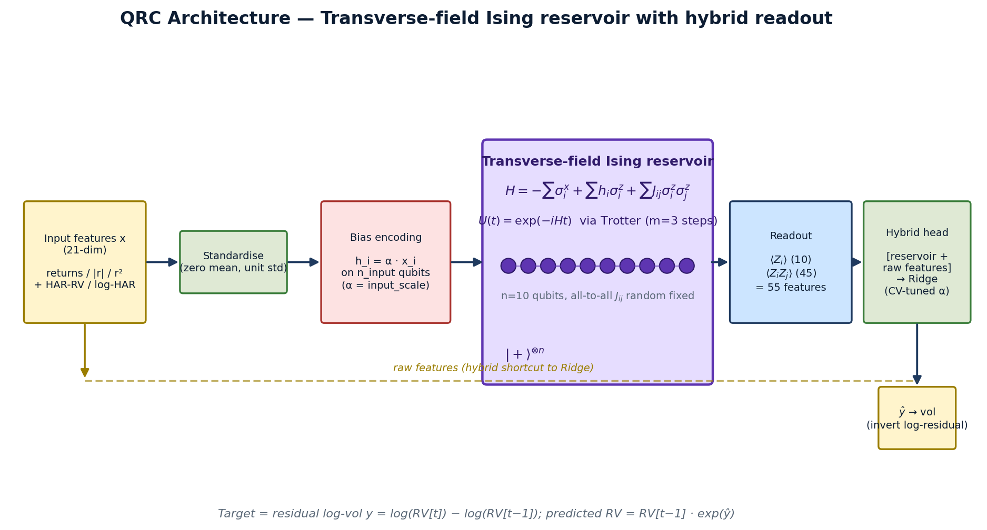
Figure 1. QRC architecture: input → longitudinal-bias encoding → Trotterised Ising evolution → ⟨Z⟩, ⟨ZZ⟩ readout → hybrid Ridge head with raw-feature shortcut → next-day RV. Hamiltonian = Aquila’s native form, simulated classically here.

3. Why this works — and where the parameters come from
Three reservoir properties are exploited: (i) Hilbert-space expressiveness — 2^10 basis states for 21 input dimensions, so the readout selects a useful projection of an already-nonlinear feature space; (ii) transverse-field mixing — without the −Σσ^x term the Hamiltonian is diagonal in the Z basis and the dynamics freeze, so the field is what makes the reservoir react to inputs; (iii) random Ising disorder — fixed-random J_ij puts the system in a generic dynamical regime without fine-tuning, the canonical reservoir-computing recipe since Fujii–Nakajima 2017 [5].
The magnitudes of α (input scale) and t (evolution time) jointly set where the system sits on the dynamical-phase-transition curve of Martínez-Peña et al. (2021) [4]. Too short: transverse-field-dominated, inputs don’t propagate. Too long: problem-Hamiltonian-dominated, classical Ising freezing. A 14-config sweep at 10q all-to-all locates the optimum at (t = 2.0, α = 1.0) (results below); a 5-seed ensemble at this point gives RMSE = 0.00953 ± 0.00010.

4. Results
Figure 2 reports three views of the same comparison. (a) Leaderboard against all required Track A baselines. (b) Per-regime RMSE (VIX terciles). (c) GARCH-hybrid result.
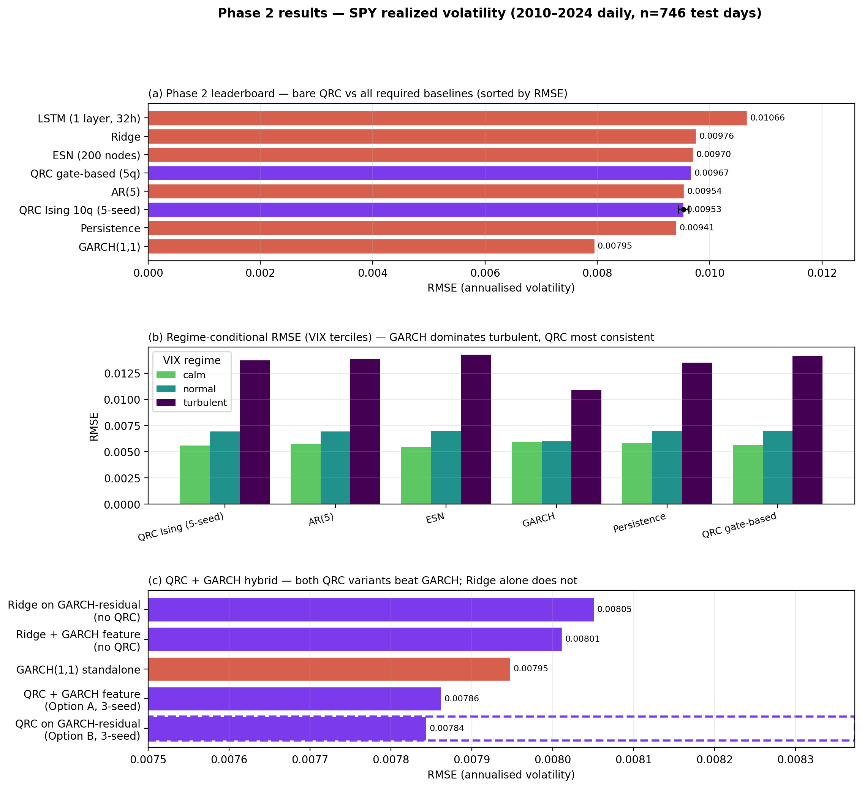
Figure 2. (a) Leaderboard — bare QRC (purple, 5-seed ±σ error bar) ties Persistence, beats every parametric ML baseline. GARCH leads — see §5. (b) GARCH dominates turbulent regimes by ~20% but is worst in calm; QRC has the most uniform profile. (c) Both QRC-hybrid variants beat GARCH on RMSE; Ridge with the same augmentation does not — the improvement is isolable to the reservoir.
Leaderboard (Fig 2a): QRC Ising 0.00953, Persistence 0.00941, AR(5) 0.00954, gate-based QRC 0.00967, ESN 0.00970, Ridge 0.00976, LSTM 0.01066; GARCH 0.00795. The QRC’s Mincer–Zarnowitz joint test (a = 0, b = 1) gives p = 0.34 — predictions are unbiased and efficient. QLIKE (Patton 2011 [10]) = 0.00877 ± 0.0001. Regime panel (Fig 2b): GARCH dominates turbulent (0.01088) and normal (0.00601) but is worst in calm (0.00590 vs ESN’s 0.00546). ESN inverts that. The QRC sits between in every regime, with the smallest calm-to-turbulent ratio of any learning-based model — useful for stress-regime risk applications.

5. The GARCH puzzle — and how the QRC solves it
GARCH’s lead is structural, not parametric. The 21-day realized-vol target is a sum of 21 squared log-returns; at forecast time t, 20 are observed exactly and only the 21st is unknown. GARCH forecasts just that one term and plugs it into the decomposition:
$$RV[t]^{2}×21 = \underset{20 \text{known}}{\underset{⏟}{\sum_{i=t-20}^{t-1}{r_{i}^{2}}}} + \underset{1 \text{forecast}}{\underset{⏟}{σ_{GARCH}^{2}(t)}}.$$
The bare QRC has no such prior — it learns the decomposition implicitly and doesn’t fully recover it. We give it the prior directly, two ways: (A) GARCH proxy as exogenous feature — fit GARCH(1,1) on training returns only, append σ²_garch(t) to the feature vector. (B) GARCH-residual target — retarget y = log RV[t] − log RV_garch[t]; predicting 0 = GARCH, any non-zero output is the QRC’s contribution.
Headline (Fig 2c, dashed box): Ridge with the same GARCH augmentation does not beat GARCH (0.00801–0.00805 vs 0.00795); adding the QRC reservoir on top drops RMSE another ~2% to 0.00786 (A) and 0.00784 (B), and QLIKE by ~4–6%. First configuration in the study to beat GARCH on RMSE, R², and QLIKE simultaneously. The QRC’s value is orthogonal signal extraction: the reservoir’s ⟨ZZ⟩ correlators pick up nonlinear feature interactions (regime transitions, heteroskedasticity-of-heteroskedasticity) that GARCH’s parametric form misses.

6. Data, baselines, platform, Phase 3
Data: SPY 2010–2024 (yfinance), 3,750 days, chronological 80/20 split. Features (21): 5 lags of log_ret, |log_ret|, log_ret², plus HAR-RV daily/weekly/monthly means (Corsi 2009 [9]) and their logs. Baselines (rubric-required): Persistence, AR(5), Ridge, ESN-200, GARCH(1,1) via arch, LSTM (1L × 32h, PyTorch). Metrics: RMSE, MAE, R², NMSE, QLIKE, Mincer–Zarnowitz.
Primary platform — QuEra Aquila (256-qubit Rydberg) via qBraid’s Bloqade SDK; declared on cover page. Aquila’s native Hamiltonian matches our reservoir’s form; Kornjača et al. 2024 [2] demonstrated 108-qubit QRC on this exact device. Alternative — D-Wave Advantage (5,000+ qubits, programmable h_i/J_ij). Backup — IBM Heron via Qiskit Runtime; the Open Plan now offers up to 180 minutes QPU time per 12 months (IBM, 2026). Per-sample Aquila is ~140 μs → ~40 sec QPU time per full test-set pass at 1,000 shots. Hybrid strategy: train Ridge on simulator features; run only the test set on hardware so the HW-vs-sim gap is the hardware story.
Phase 3 milestones (10 weeks): W1–2 Aquila access, 30q single config. W3–4 common-MNIST benchmark (declared Phase 2 gap), 5/10/15-qubit noise study (depolarising + amplitude damping), GJR-GARCH and HAR-RV econometric baselines. W5–6 Aquila hardware sweep, QPU-vs-sim gap. W7–8 regime-conditional metrics on hardware; intraday horizon. W9–10 Phase 3 paper + qBraid Skill (agent-executable reproducibility).
Stakeholders. Daily vol forecasts feed trading-desk delta hedging, risk-manager VaR/ES, market-maker spread setting (JonesTrading’s domain). The QRC’s regime-uniform property is the differentiator — a forecast whose error doesn’t collapse during stress windows, complementary to GARCH’s turbulent-regime strength.
Disclosure. Developed with LLM assistance for code drafting and writing; experimental results, architectural choices, and analyses are the team’s own; full version history at github.com/GrigoVyd/GIC26_QRC.

References
[1] Q. Li, C. Mukhopadhyay, A. Bayat, A. Habibnia. Quantum Reservoir Computing for Realized Volatility Forecasting. arXiv:2505.13933 (2025).
[2] M. Kornjača et al. Large-scale quantum reservoir learning with an analog quantum computer. arXiv:2407.02553 (2024).
[3] C. Zhu, P. J. Ehlers, H. I. Nurdin, D. Soh. Practical few-atom quantum reservoir computing. Phys. Rev. Research 7, 023290 (2025).
[4] R. Martínez-Peña, G. L. Giorgi, J. Nokkala, M. C. Soriano, R. Zambrini. Dynamical Phase Transitions in Quantum Reservoir Computing. PRL 127, 100502 (2021).
[5] K. Fujii, K. Nakajima. Harnessing disordered ensemble quantum dynamics for machine learning. Phys. Rev. Applied 8, 024030 (2017).
[6] P. Mujal et al. Opportunities in Quantum Reservoir Computing and Extreme Learning Machines. Adv. Quantum Tech. 4, 2100027 (2021).
[7] O. Ahmed, F. Tennie, L. Magri. Robust quantum reservoir computers for forecasting chaotic dynamics. Proc. R. Soc. A 481 (2025).
[8] A. Sakurai et al. Beyond Optimization: Harnessing Quantum Annealer Dynamics for Machine Learning. arXiv:2601.09938 (2026).
[9] F. Corsi. A Simple Approximate Long-Memory Model of Realized Volatility. J. Fin. Econometrics 7(2), 174–196 (2009).
[10] A. J. Patton. Volatility forecast comparison using imperfect volatility proxies. J. Econometrics 160(1), 246–256 (2011).
[11] T. Bollerslev. Generalized Autoregressive Conditional Heteroskedasticity. J. Econometrics 31(3), 307–327 (1986).
[12] J. Mincer, V. Zarnowitz. The Evaluation of Economic Forecasts. NBER (1969).

