Staying Connected

SPRING HIGHLIGHTS 2020

____________________________________________________________________________

**Twentieth Century Club of Park Ridge**

**President’s Message**

I hope that you are well and staying safe during this unprecedented time. Who could have predicted the suffering and lifestyle ramifications of COVID-19. Staying spiritually connected despite being socially distant is something none of us has endured during our lifetimes. However, we are able to adjust and work within the confines outlined by the government. All of us are strong women with purpose and dedication. So, while many of our club endeavors are cancelled or on hold, the 20th Century Club continues to support the community and each other. A special thanks to all my board members who are working so hard during this time.

In light of this epidemic, the Park Ridge Presbyterian Church decided to suspend all church and community activities until further notice. Therefore, the March and April meetings have been cancelled. After much deliberation, the Benefit Committee, the Board of Directors and the Park Ridge Country Club decided to cancel the April 18th Benefit until next spring. The Park Ridge Library will still be the recipient and the theme the same. The Promenade baskets that have been made will be stored until next year. Money collected for the Benefit meal or for the Angel Donations will either be refunded or used for the 20th Century Club 2020 Scholarship Awards depending on the decision of the donor/member.

And what about the Grand Raffle? It’s doing just great and could even do better. I will be calling for a special meeting after the stay at home order is lifted… hopefully in June or July. At that meeting, we will hold the Grand Raffle drawing, election of new officers and handle the revision changes to the bylaws. While we are not planning a program, we will have refreshments served on paper products, if allowed. Knowing how great and dedicated you all are, I was delighted to hear the Stitchery Committee is making masks for the Park Ridge Police Department and other groups in our community. Please also remember the Maine Township Food Pantry. Call Myrna Fogarty with your donations.

May God bless you, keep you healthy and safe. May He also bless our community and the United States of America.

– Sue James, President

**Early Spring Meetings: New Grove Exhibit and Senior Scams**

The 20th Century Club meetings are designed to meet the diverse interests of our members. Due to COVID-19, this year’s schedule was cut short.

Our **January 2020** meeting kicked off with a showing of a prototype for a new Grove exhibit plus a delightful and informative presentation of the “Life and Death of Robert Kennicott”, founder of The Grove, given by Ashley DeAngeles (left) Grove Operations Manager and Elizabeth Kopp, Grove Archivist.

In **February,** Park Ridge Det. William Jackson, son of Mary Ellen Jackson, gave an entertaining yet rather chilling portrayal of how “scammers” prey on seniors (and their neighbors) with ingenious scenarios. He showed how easy it is to be taken in with seemingly innocent conversations. Det. Jackson was amusing but, at the same time, very informative.

At the **January** meeting, (from left) president Sue James, and Membership Vice President, Liz Greenhill welcomed Pat Groziak, Maria Bronny Ciesla and returning member Mary Haaning (not shown). Membership is key to the growth of the 20th Century Club. Liz has been doing a great job and with the upcoming vote on changing the bylaws regarding residency, the club may be poised to extend its reach to the nearby communities. The need for outreach at this time is great and once the stay at home policy is lifted, we will be in a perfect position to respond to the needs of others.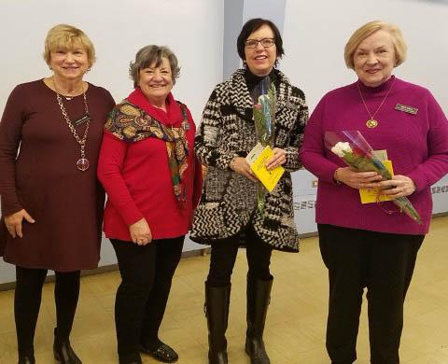

**Bus Trip Tours the Halim Glass and Block Museums & Lunch**

Leave it to Irene Horst to create an artistically stimulating outing coupled with a gourmet-style   
lunch at Evanston’s Trattoria D.O.C. Originally scheduled for November 14th, the bus trip   
actually took place on January 30th and was thoroughly enjoyed by all!

Halim Glass Museum

**20th Century Club Keeps Moving FORWARD**

**20th Century 2020 Scholarship Fund**

Every year, the 20th Century Club Foundation of Park Ridge awards scholarships to deserving Park Ridge high school seniors. This yearly event is one of the many ways the club supports the community and this year will be **no** different. The club is working hard to support this endeavor. We are pleased to announce that many of our members who became Angels for the Spring Benefit have decided to pay it forward to the scholarship fund. Some members contributed their luncheon money to the fund as well. We will also use the proceeds from the Benefit’s Grand Raffle to add to the fund. If you are interested, there is still time to buy tickets for the Grand Raffle.

Call Angie Bratek (847) 698-2175 to purchase more raffle tickets.

**20th Century Stitchery Club Creates Masks**

The talented ladies in the 20th Century Stitchery Club rallied to the cause and began making much needed masks for front line workers. Among the club members making masks were: Helen Roppel, Mary Schaefer and Margaret Teich. Other non-members of the club also volunteered. The masks were given to the University of Chicago Hospital, Park Ridge Police Department, Saint Paul Of the Cross Food Pantry and Avenues to Independence.

**20th Century “Till We Meet Again”**

Our next meeting will hopefully be held during June or July. At that time, we will have the election of new officers for 2020-2021 club year, voting on the Club’s new bylaws (please see 20th Century website for details) and the Grand Raffle drawing (winner need not be present). Stay healthy and safe.