

**BN002/013/104 Year 2 Software Engineering and Testing**

**Assessment 2: Requirements Document**

**Submitted by:**

**Andrew Leonard B00095125**

**Grigor Dimitrov B00099288**

**Putera Rameli B00095349**

**Submission date**

**Declaration**

I herby certify that this material, which I now submit for assessment on the programme of study leading to the award of Ordinary Degree in Computing in the Institute of Technology Blanchardstown, is entirely my own work except where otherwise stated.

Author: __________________________ Dated: _____________

Author: __________________________ Dated: _____________

**Table of Contents**

# Title: The till counter

# Client: Retailers

# Project Overview

The project is to develop an application for a generic till and counting system. This till application processes transactions. This till also includes the added feature of a till counter which makes calculating money easier. It also reduces the chance of errors while counting the till. The application then saves this information to a database for permanent storage and for future reference. An interface should be provided as the application will be used on touch screen monitors.

# Document Revision

Rev. 1.0 February 8, 2018– initial version

Rev. 2.0 February 15, 2018 – Added use case specification, use case diagram

# Scope

This software will be designed and developed to take transactions in a retail environment. It will be compatible with any basic monitor system with a touch screen. The user of the till will enter what the customer will like to buy. The total is summed up, the cash is entered and change is calculated. The till will have an option to accept sterling notes, which enables this till to be used all over the country and in airports.

This till contains an added counting feature for end of day **summarization**. It is a basic transaction based software that automates the counting process as much as possible. This will benefit employees, save time and lower risk of human errors. This till also accommodates permanent storage, by saving transactions and balances to the till.

1. **Walkthrough Scenarios**

*User:*

User should be able to select an item based on a button and an image located on the GUI. After all the items have been selected the user has the option to select subtotal or cancel the transaction. The user has the option of voiding an item in case there was a mistake or if the customer changes their mind. If the user clicks the cancel button, all the items will be voided. If the user clicks subtotal, the total cost of the transaction is displayed. The user can now enter the money given (to be converted if necessary) into the system, which then calculates the change. At the end of the Users shift, they can click the “End of Day” button, which begins the till counting process. The user will then be prompted to enter the money into the till that is in the drawer. After user enters the money, they click calculate and the balance will be saved to the database.

1. **Software Requirements Analysis:**

***Functional Requirements:***

# 5.1 User Requirements

* Enter items being purchased. The system should allow the user to enter items that are being purchased.
* Void item: The user has the choice to void items from the sale.
* Display total: The system should display the total cost of the items on the screen so the user can see.
* Enter Money: The system should allow the user to enter an amount given by the customer, calculate if more money is needed and the change.
* Cancel transaction: At any point the user should be able to cancel the transaction.
* **Till counting: At any point the system should allow the user to count the till with an end of day feature.**
* **The system should calculate the cash in drawer for the user.**
* **The cash is easily saved to permanent storage for the user.**
* **The system should aid the user in counting the till.**

# 5.2 System Requirements

* The system should calculate change based on money entered and the price.
* The system should save transactions to the database.
* The system should save the end of day total tender to the database.
* The system should save the tills balance to the database.

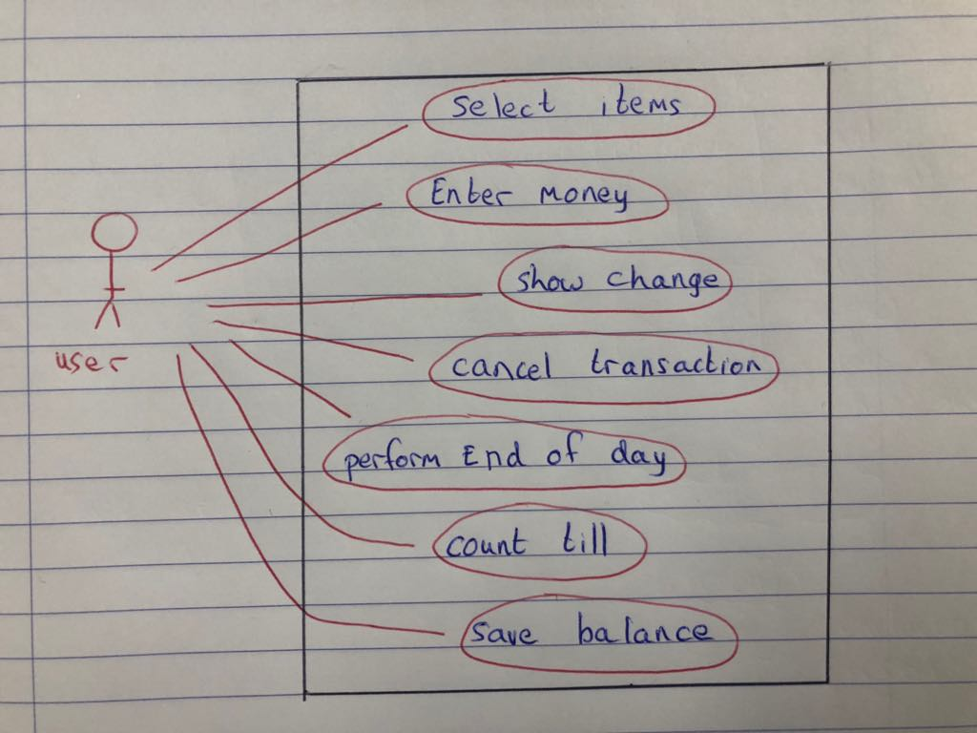Use Case Diagram -

Use Case Specification -

**Primary Path**

1. The user selects the items that will be purchased
2. The user selects subtotal
3. The user enters the money received by the customer
4. The system calculates change and saves the transaction
5. The user performs “End OF Day”
6. The system saves the balance into database

**Alternative scenario**

* 1. The user can also remove items
  2. The user need to remove an item
     1. The user goes back to the items menu
  3. The user cancels “End Of Day”

5.2.3 Activity Diagrams

# 5.3 Non-functional Requirements:

Total transaction time should be less than one minute during transactions.

# Graphical User Interface Design

# Technical Requirements and Feasibility:

System models –This will be developed using UML.

Development language – A high level language supported on all machines.

Persistent storage –A database to store information.

Interface & Software / Hardware APIs – a graphical user interface to assist user use.

## Conclusion

Based on this feasibility study the group has agreed that the project is feasible and it will go ahead. This project is subject to minor changes when more in depth analysis goes ahead. Through experience in retail, our team believes that the software justifies its means and resources. After the rigorous analysis, we will then deliver the final documentation on the 22nd of February 2018.