**The Effect of High Oxygen Level on Kidney Function in Trauma Patients: A Large Cohort retrospective Study Using Electronic Health Record Database**

**Abstract**

**Backgroun**d

The effect of liberal oxygen usage on outcomes in the intensive care setting is still debated. However, the impact of keeping supranormal arterial blood oxygen tensions during intensive care unit (ICU) stay on kidney function, where early aggressive supplemental oxygen is commonly provided, is unclear. The aim of this study is to investigate the association between hyperoxemia and the development of acute kidney injury (AKI).

**Methods**

For this single-center, retrospective cohort study the MIMIC-III (Medical Information Mart for Intensive Care III) database was used. Patients with major trauma admitted to intensive care units in a tertiary-care academic medical center between 2001 and 2012 were evaluated. Hyperoxemia was defined as … The primary outcome was acute kidney injury within 48 hours of ICU admission and the secondary outcome was 20-day mortality. Multivariate logistic regression, propensity score stratification, marginal structural model and standardization (g-formula) was used to evaluate the association of oxygen level with acute kidney injury within 48 hours. Kaplan Meier curve and Cox proportional hazards model were used to study the association of oxygen level with 20-day ICU mortality. Subgroup analyses was also conducted within a propensity score matched sub-cohort.

**Results**

There were 2,484 trauma patients identified in the primary cohort. Of those, 789 (31.8%) had conservative oxygen therapy during the first 24 hours of ICU stay and 1695 (68.2%) had liberal oxygen therapy during the first 24 hours of ICU stay. Most baseline characteristics were different between the groups. Among those who had complete follow up for the entire 48 hours, 1200 patients in liberal oxygen group (79.2%) and 501 patients in conservative group (80.4%) had developed AKI within 48 hours of their ICU stay. The crude, multivariate adjusted and propensity score adjusted odds ratio for developing AKI were 0.93 (95% CI, 0.73-1.17), 0.75 (95% CI, 0.58, 0.97) and 0.79 (95% CI, 0.61, 1.02) respectively comparing liberal oxygen group versus conservative oxygen group. Marginal structural model and standardization yielded an odds ratio of 0.54 (95%CI, 0.40-0.72) in the liberal and 0.840 (95% CI, 0.839-0.841) in conservative group. The cox proportional hazard models generated hazard ratios of 1.62 (95% CI, 1.09-2.40), 1.70 (95% CI, 1.13-2.53) and 1.42 (95% CI, 0.95-2.13) for crude, multivariate adjusted and propensity score adjusted analyses. There were no significant differences in risks/rates of AKI or mortality in propensity score matched sub-cohort.

**Conclusions**

Our findings suggest a protective effect of high oxygen level on kidney function in trauma patients and is unlikely to be caused by unmeasured confounding bias, selection bias or survivor bias. However, more research is needed to guide clinicians to develop the most appropriate oxygen therapy for trauma patients given their conditions.

**Introduction**

Oxygen (O2) is undoubtedly essential for human beings and the consequences associated with hypoxemia are devastating. While O2 has been most widely prescribed for therapy in medicine (1), there is an emerging concern that hyperoxia and hyperoxemia could also embrace potential detrimental systemic effects (2), involving numerous injurious pathways including the development of oxidative stress and cellular damage caused by excess reactive oxygen species (3). Recently, the potential harmful impact of oxygen has been studied in clinical trials and advocated in specific and non-specific population; cardiopulmonary resuscitation (4-6), stroke (7, 8), myocardial infarction (9), traumatic brain injury (10), mechanical ventilation (11) and medical-surgical intensive care (12).

Considering the suggested injurious mechanisms such as excessive reactive oxygen species production induced by excess oxygen exposure and the systemic effect of oxidative stress (13, 14), kidney could be one of the targeted organs (15, 16). Some animal studies have shown the detrimental effect of hyperoxia on renal tissue through protein expression associated with inflammation and imbalance of renal oxygen delivery and demand (17, 18). A human study showed that intraoperative oxidative damage, which could be induced by hyperoxia, independently predicts AKI following cardiac surgery (19). In addition, hyperoxia increases peripheral vascular resistance (20, 21), which could lead to renal hypoperfusion and cause kidney injury.

Since significant hypoxemia can be fatal and profound hemorrhage can lower the ability of oxygen carriage by hemoglobin, early aggressive supplemental oxygen is commonly provided either in response to or for prevention of hypoxemia for traumatic patients. However, the impact of keeping possible supranormal arterial blood oxygen tensions during ICU stay on kidney function is unclear.

We hypothesize that hyperoxemia increase renal dysfunction in traumatic patients. The aim of this study is to investigate the association between partial arterial oxygen (PaO2) and blood oxygen saturation (SpO2) and the development of acute kidney injury (AKI) and other outcomes.

**Materials and Methods**

**Study Population**

For this retrospective single-center study, we used MIMIC-III (Medical Information Mart for Intensive Care III) database, which comprises de-identified health-related data associated with over forty thousand patients. The caracterisitics of the database are covered extensively elsewhere.

The MIMIC III database was searched and patients with at least one trauma diagnosis were identified based on International Classification of Diseases 9th Revision codes (ICD-9: 800 – 956). We only included patients who: 1) were 18 years old and older, 2) admitted to the ICU directly from the emergency department or through the operation room, within 6 hours after hospital admission, 3) stayed in the ICU for at least 24 hours, and 4) had at least one PaO2 or SpO2 measured during the first 24 hours in ICU stay. Based on the PaO2 (mmHg) or SpO2 (%) measurements, we excluded patients with time-weighted mean SpO2 (SpO2ave) less than 94% or time-weighted mean PaO2 (PaO2ave) less than 70 mmHg for the first 24 hours in the ICU.

**Classifications**

Time-weighted SpO2 (SpO2ave) and PaO2(PaO2ave) were calculated assuming a linear trend between individual measurements and weighted by the time period between adjacent measurements. For example, 94% of SpO2 at 6:00 a.m. and 96% of SpO2 at 6:05 a.m. would be the same as 95% of SpO2 continuing for 5 minutes. The sum of such values was then divided by 24 hours and used as SpO2ave or PaO2ave.

We categorized patients into liberal oxygen or conservative oxygen groups based on their time-weighted PaO2/SpO2 level for the first 24 hours in the ICU. Patients with PaO2ave less than 100 mmHg or SpO2ave less than 98% were classified into the conservative oxygen group while those with PaO2ave greater than or equal to 100 mmHg or SpO2ave greater than or equal to 98% were classified into the liberal oxygen group.

**Outcome Measurements**

The primary outcome was the development of acute kidney injury (AKI) within 48 hours after the ICU admission, which is defined based on Kidney Disease Improving Global Outcomes (KDIGO) consensus criteria (Appendix Table 1) (23). The secondary outcome was 20-day ICU mortality. For patients with multiple ICU admissions, only the first admission was included in the analysis.

**Statistical Analyses**

Patient characteristics were compared between those received liberal and conservative oxygen therapy using 2-tailed t tests for continuous variables and chi-square tests for categorical variables. Univariable and multivariable logistic regression were conducted to assess the relationship between oxygen level and the development of acute kidney injury within 48 hours. Loss of follow-up were further adjusted using inverse probability weighting. Propensity score were generated for each group and used as a covariate in the logistic regression. Marginal structural modeling was also performed using inverse probability weighting. All weighted models were also adjusted for clustering in calculating 95% confidence intervals (CIs). Standardization (g-formula) were also conducted and the corresponding 95% confidence intervals were calculated using bootstrapping. Odds ratios are reported for the development of AKI within 48 hours. Time-to-event analyses using Kaplan Meier Curve and Cox proportional hazards models were conducted for ICU mortality, and crude and fully adjusted incidence rate ratios (IRR) and their corresponding 95% confidence intervals (CIs) were calculated.

Subgroup analyses were conducted in the propensity score matched sub-cohort. We used a greedy matching algorithm allowing for a p=0.01 caliper.

Candidate covariables, which were selected based on previous literature, expert knowledge and biologic plausibility included age, gender, insurance type, ethnicity, admission type, disease severity (APACHE IV), whether had surgery or not, amount of transfused blood products (blood loss) and pre-existing chronic clinical conditions based on ICD-9 codes (heart diseases, diabetes mellitus, and lung diseases) (Appendix Table 2). The significant level was defined as a P value of less than 0.05. All statistical analyses were performed using the programming language R and a statistical software RStudio (Version 1.0.136 (RStudio, Inc., Boston, MA)).

**Results**

**Cohort Selection and Characterization**

From the selection algorithm, we identified 2,484 trauma patients who were older than 18 years when admitted to the ICU. Of those, 789 (31.8%) had conservative oxygen therapy during the first 24 hours of ICU stay and 1695 (68.2%) had liberal oxygen therapy during the first 24 hours of ICU stay. Baseline characteristics of the two oxygen therapy groups were very different in demographics, with no significant differences in gender only. Patients in the conservative group had more surgery before ICU admission, as well as more chronic heart disease, hypertension, diabetes and lung diseases. However, patients in liberal oxygen group had much more severe trauma conditions compared to the conservative group and received more blood transfusion during the first 24 hours (Tabel 1). Figure 1(a) shows the distribution of propensity scores that were generated based on the baseline covariates for each oxygen group. It gives the same information that the patients in the two groups are very different from each other, indicating confounding by indication at baseline.

After propensity score matching, there were 578 patients in each group with similar baseline characteristics with difference existing in only blood transfusion during the first 24 hours. Given the similarity between two groups in the sub-cohort, confounding by indication is less of a concern. The results would mimic randomized control trials more and be less likely to be biased by confounding.

**Table 1. Baseline characteristics of study patients by oxygen level for primary cohort and propensity score matched sub-cohort**

|  |  |  |  |  |  |  |  |
| --- | --- | --- | --- | --- | --- | --- | --- |
|  | Primary Cohort | |  |  | PS Matched Cohort | |  |
|  | Conservative | Liberal | P |  | Conservative | Liberal | P |
|  | N=789 | N=1695 |  |  | N=578 | N=578 |  |
| age (%) |  |  | <0.001 | age (%) |  |  | 0.876 |
| 18-29 yr | 88 (11.2) | 337 (19.9) |  | 18-29 yr | 83 (14.3) | 72 (12.5) |  |
| 30-39 yr | 68 ( 8.6) | 170 (10.0) |  | 30-39 yr | 56 ( 9.6) | 50 ( 8.7) |  |
| 40-49 yr | 102 (12.9) | 236 (13.9) |  | 40-49 yr | 84 (14.5) | 74 (12.8) |  |
| 50-59 yr | 117 (14.8) | 204 (12.0) |  | 50-59 yr | 74 (12.7) | 85 (14.7) |  |
| 60-69 yr | 91 (11.5) | 186 (11.0) |  | 60-69 yr | 64 (11.0) | 65 (11.2) |  |
| 70-79 yr | 118 (15.0) | 232 (13.7) |  | 70-79 yr | 77 (13.3) | 86 (14.9) |  |
| 80-89 yr | 149 (18.9) | 250 (14.7) |  | 80-89 yr | 101 (17.4) | 105 (18.2) |  |
| >=90 yr | 56 ( 7.1) | 80 ( 4.7) |  | >=90 yr | 42 ( 7.2) | 41 ( 7.1) |  |
| Male (%) | 507 (64.3) | 1084 (64.0) | 0.918 | Male (%) | 369 (63.5) | 362 (62.6) | 0.803 |
| insurance (%) | |  | 0.001 | insurance (%) | |  | 0.699 |
| Government | 21 ( 2.7) | 72 ( 4.2) |  | Government | 18 ( 3.1) | 16 ( 2.8) |  |
| Medicaid | 69 ( 8.7) | 154 ( 9.1) |  | Medicaid | 57 ( 9.8) | 45 ( 7.8) |  |
| Medicare | 348 (44.1) | 605 (35.7) |  | Medicare | 239 (41.1) | 254 (43.9) |  |
| Private | 324 (41.1) | 794 (46.8) |  | Private | 245 (42.2) | 244 (42.2) |  |
| Self Pay | 27 ( 3.4) | 70 ( 4.1) |  | Self Pay | 22 ( 3.8) | 19 ( 3.3) |  |
| marital_status (%) | |  | <0.001 | marital_status (%) | |  | 0.58 |
| DIVORCED | 40 ( 5.1) | 76 ( 4.5) |  | DIVORCED | 31 ( 5.3) | 35 ( 6.1) |  |
| MARRIED | 313 (39.7) | 571 (33.7) |  | MARRIED | 208 (35.8) | 210 (36.3) |  |
| SEPARATED | 6 ( 0.8) | 18 ( 1.1) |  | SEPARATED | 4 ( 0.7) | 6 ( 1.0) |  |
| SINGLE | 225 (28.5) | 570 (33.6) |  | SINGLE | 182 (31.3) | 155 (26.8) |  |
| UNKNOWN (DEFAULT) | 91 (11.5) | 280 (16.5) |  | UNKNOWN (DEFAULT) | 75 (12.9) | 87 (15.1) |  |
| WIDOWED | 114 (14.4) | 180 (10.6) |  | WIDOWED | 81 (13.9) | 85 (14.7) |  |
| ethnicity (%) | |  | <0.001 | ethnicity (%) | |  | 0.253 |
| ASIAN | 7 ( 0.9) | 27 ( 1.6) |  | ASIAN | 7 ( 1.2) | 5 ( 0.9) |  |
| BLACK | 20 ( 2.5) | 98 ( 5.8) |  | BLACK | 19 ( 3.3) | 8 ( 1.4) |  |
| HISPANIC | 20 ( 2.5) | 74 ( 4.4) |  | HISPANIC | 18 ( 3.1) | 15 ( 2.6) |  |
| OTHER | 104 (13.2) | 292 (17.2) |  | OTHER | 84 (14.5) | 82 (14.2) |  |
| WHITE | 638 (80.9) | 1204 (71.0) |  | WHITE | 453 (78.0) | 468 (81.0) |  |
| religion (%) | |  | 0.067 | religion (%) | |  | 0.822 |
| CHRISTIAN | 311 (39.4) | 613 (36.2) |  | CHRISTIAN | 224 (38.6) | 213 (36.9) |  |
| OTHER | 115 (14.6) | 218 (12.9) |  | OTHER | 84 (14.5) | 88 (15.2) |  |
| UNKNOWN | 363 (46.0) | 864 (51.0) |  | UNKNOWN | 273 (47.0) | 277 (47.9) |  |
| admission_type (%) | |  | 0.003 | admission_type (%) | |  | 0.948 |
| ELECTIVE | 5 ( 0.6) | 43 ( 2.5) |  | ELECTIVE | 5 ( 0.9) | 4 ( 0.7) |  |
| EMERGENCY | 771 (97.7) | 1634 (96.4) |  | EMERGENCY | 568 (97.8) | 566 (97.9) |  |
| URGENT | 13 ( 1.6) | 18 ( 1.1) |  | URGENT | 8 ( 1.4) | 8 ( 1.4) |  |
| surg = 1 (%) | 208 (26.4) | 350 (20.6) | 0.002 | surg = 1 (%) | 137 (23.6) | 141 (24.4) | 0.798 |
| has_chronic_lung_conditions = 1 (%) | 122 (15.5) | 180 (10.6) | 0.001 | has_chronic_lung_conditions = 1 (%) | 81 (13.9) | 90 (15.6) | 0.484 |
| has_chronic_heart_problems = 1 (%) | 298 (37.8) | 528 (31.2) | 0.001 | has_chronic_heart_problems = 1 (%) | 203 (34.9) | 218 (37.7) | 0.357 |
| has_diabetes = 1 (%) | 128 (16.2) | 227 (13.4) | 0.07 | has_diabetes = 1 (%) | 85 (14.6) | 84 (14.5) | 1 |
| has_hypertension = 1 (%) | 308 (39.0) | 513 (30.3) | <0.001 | has_hypertension = 1 (%) | 197 (33.9) | 209 (36.2) | 0.458 |
| sofa (mean (sd)) | 3.33 (3.14) | 5.66 (3.22) | <0.001 | sofa (mean (sd)) | 3.96 (3.37) | 4.15 (2.84) | 0.317 |
| transfusion_first_24hr (mean (sd)) | 99.56 (339.67) | 315.69 (980.41) | <0.001 | transfusion_first_24hr (mean (sd)) | 126.63 (385.22) | 193.16 (576.87) | 0.021 |

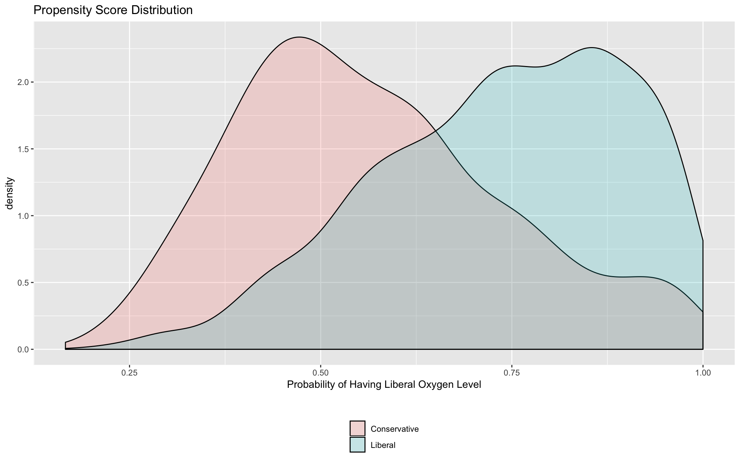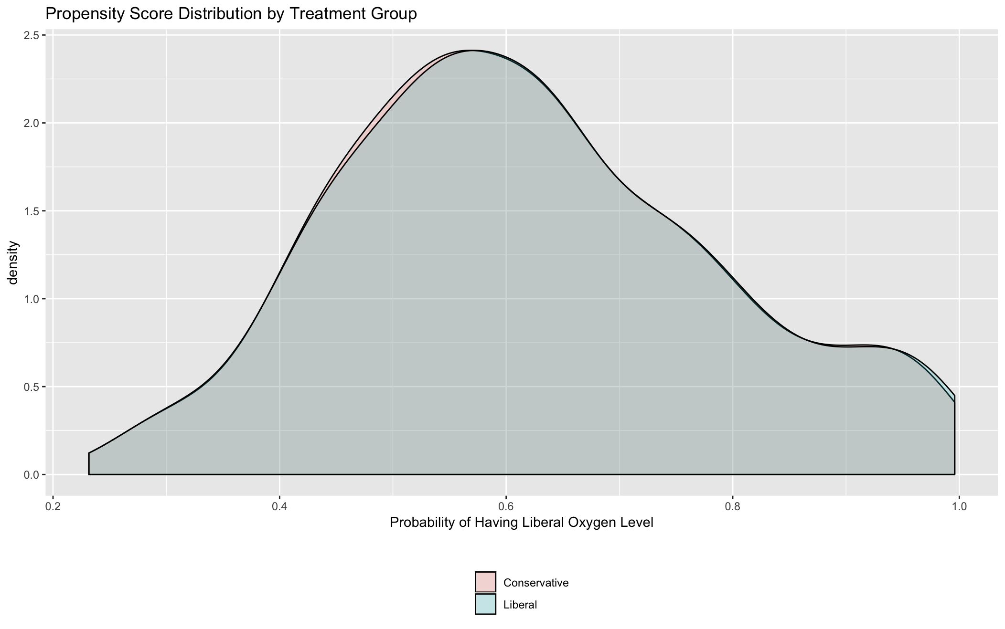

(a) (b)

**Figure 1. Propensity score distribution for conservative vs. liberal oxygen group in the primary cohort (a) and in the propensity score matched sub-cohort (b).**

**Studies of Acute Kidney Injury**

In our primary cohort, among those who had complete follow up for the entire 48 hours, 1200 patients in liberal oxygen group (79.2%) and 501 patients in conservative group (80.4%) had developed AKI within 48 hours of their ICU stay. The corresponding crude odds ratio for developing AKI was 0.93 (95% CI, 0.73-1.17) comparing liberal oxygen group versus conservative oxygen group (Table 2). Multivariate adjustment moved the point estimate further away from the null: the odds for developing AKI in the liberal group was 25% (95% CI, 3%-42%) less than that in the conservative group. The findings remained similar after adjusting for censoring in the analyses or stratified on propensity score in the model. However, marginal structural model yielded a more pronounced protective effect of high oxygen level on kidney function in trauma patients with an odds ratio of 0.54 (95%CI, 0.40-0.72). Propensity score matched subgroup analysis showed an attenuated result: patients in liberal group had 2% decreased odds of developing AKI compared to those in conservative group.

**Table 2. Association of liberal oxygen vs. conservative oxygen and acute kidney injury within 48 hours**

|  |  |
| --- | --- |
| Method | Odds Ratio (95% CI) |
| Unadjusted Logistic Regression | 0.93 (0.73-1.17) |
| Adjusted Logistic Regression | 0.75 (0.58-0.97) |
| Additional Adjusting for Censoring | 0.76 (0.58-0.98) |
| Marginal Structural Model | 0.54 (0.40-0.72) |
| Propensity Score Stratification | 0.79 (0.61-1.02) |
| Propensity Score Matching | 0.98 (0.77-1.26) |
| Standardization | 0.84 (0.84-0.84) |

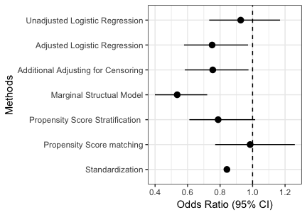

**Figure 2. Odds ratios of developing AKI within 48 hours of ICU stay comparing patients in liberal oxygen group vs. conservative oxygen group.**

**Studies of ICU Mortality**

Crude Kaplan Meier curve showed a higher mortality within 20 days in liberal oxygen group compared to conservative group while the Kaplan Meier curve in propensity score matched sub-cohort suggests a non-differential mortality rate in the two groups (Figure 3). Using Cox proportional hazard model, liberal oxygen was associated with 20-day ICU mortality both before and after adjusting for covariates. After controlling for confounders as stated earlier, the hazard ratio of death was pronounced from 1.62 (95% CI, 1.09-2.40) to 1.70 (95% CI, 1.13-2.53) comparing liberal oxygen group versus conservative oxygen group (Table 3). However, when comparing mortality rate within 48 hours, there is no significant difference between liberal and conservative groups after adjusting for covariates both in Kaplan Meier Curve (Figure 4) and Cox proportional hazard models (Table 4).

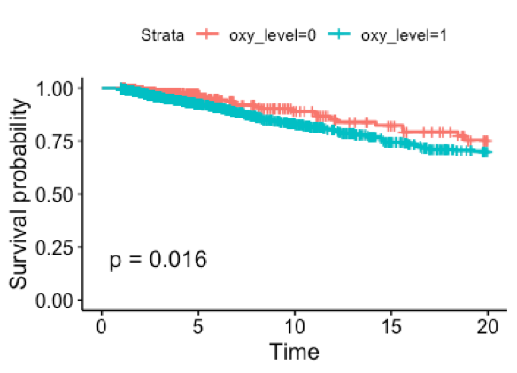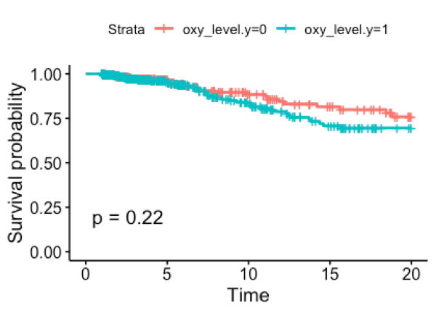

**Figure 3. Crude (a) and propensity score matched subgroup (b) Kaplan Meier survival curve in at 20 days of ICU stay.**

**Table 3. Association of liberal oxygen vs. conservative oxygen and 20-day ICU mortality**

|  |  |  |
| --- | --- | --- |
| **Cox Proportional Hazard Model** | **Unadjusted (95% CI)** | **Adjusted (95% CI)** |
| HR (95% CI) | 1.62 (1.09-2.40) | 1.70 (1.13-2.53) |

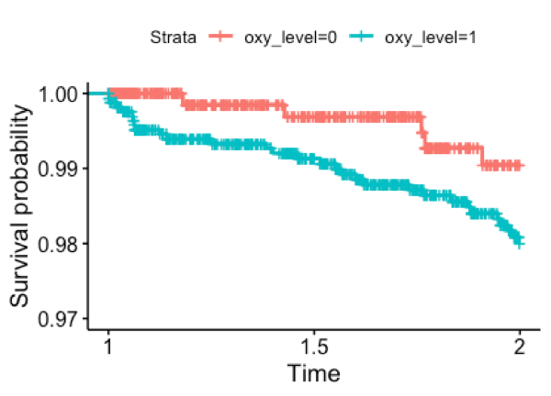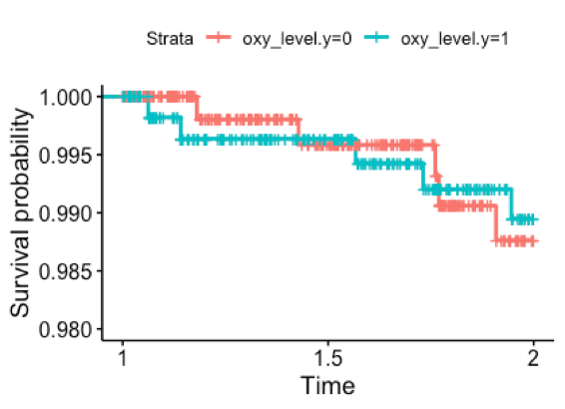

**Figure 4. Crude (a) (p = 0.077) and propensity score matched (b) subgroup (p = 0.86) Kaplan Meier survival curve in 48 hours.**

**Table 4. Association of liberal oxygen vs. conservative oxygen and 48-hour ICU mortality.**

|  |  |  |
| --- | --- | --- |
| **Cox Proportional Hazard Model** | **Unadjusted (95% CI)** | **Adjusted (95% CI)** |
| HR (95% CI) | 2.30 (0.89-5.95) | 1.74 (0.66-4.60) |

**Discussion**

In a large cohort of trauma patients with liberal and conservative oxygen level during their first 24 hours of stay in the ICU, we found that, being very different from trauma patients in conservative oxygen group at baseline, patients in liberal oxygen group experienced lower risks of acute kidney injury within 48 hours but higher rates of 20-day ICU mortality. These findings were robust across different modeling assumptions in the primary cohort. By contrast, our work did not demonstrate any differences in the risks of developing AKI within 48 hours or rates of 20-day ICU mortality between the two oxygen groups in the propensity score matched sub-cohort.

To our knowledge, this is the first study specifically aimed at detecting any differences in relative renal safety between different oxygen level in trauma patients.

These findings need to be considered in awareness of the limitation of the study. Patients were not randomized to receiving the 2 oxygen level but were administered by their caregivers. During the study years, there was no evidence of superiority of one oxygen level over the other in terms of kidney safety, while there were controversial results regarding other body organs. From observed baseline characteristics, we can also see that young patients and more severe patients are more likely to receive higher oxygen level, suggesting aggressive treatment strategies for young or severe patients. Therefore, confounding by indication is of concern in our study. Selection bias is another concern given differential loss of follow up (transferring out of the ICU) in two groups and lower risks of AKI after moving to general units. Since exposure assignment were based on the combination of both SpO2 and PaO2 criteria, exposure misclassification is likely to be present.

These limitations are balanced by the strengths of this study. We were able to utilize inpatient electronic healthcare record to generate a large cohort with trauma patients. By implementing different models, we tested the robustness of our findings. Though the magnitude of the protective effect of high oxygen level on kidney function varied across models, the same directionality suggested valid results. In addition, compared to crude results, all the models adjusting for confounders demonstrated larger effects. Given the assumption that unmeasured confounders bias the results in the same direction as the measured ones, the observed protective effect is unlikely to be caused by unmeasured confounding. Selection bias was also appropriately adjusted via inverse probability weighting. Although patients in high oxygen group seem to have a higher 20-day ICU mortality, there was no difference in 48-hour mortality between the two groups, suggesting that the observed protective effect is also unlikely to be caused by survivor bias.

There was no significant difference in risks/rates of either outcomes in our propensity score matched subcohort. By matching patients in the two groups based on their propensity score, the subcohort emulated more of a randomized control trial. However, since a large number of unmatched individuals were dropped in the sub-cohort, the generalizability of the results from the subgroup analyses could be of concern.

**Conclusion**

In a large cohort of trauma patients who admitted to ICU and received liberal or conservative oxygen therapy for the first 24 hours of their ICU stay, we found decreased risk of acute kidney injury within 48 hours in patients receiving liberal oxygen compared to conservative oxygen. The observed results were unlikely to be caused by unmeasured confounding bias, selection bias or survivor bias. However, patients in liberal oxygen group experienced a slightly higher mortality rate, which may due to baseline disease severity. This study suggests a protective effect of high oxygen therapy on kidney function in trauma patients. Although previous studies have indicated an increased risk of cardiovascular outcome with higher oxygen level, the present study suggests that high oxygen therapy may have conditional benefit and risk for certain types of patients in the ICU. Serious clinical consideration should be taken when making the decision for oxygen administration of oxygen for trauma patients.

**Appendix:**

**Table 1. Definition and staging of acute kidney injury based on Kidney Disease Improving Global Outcomes consensus criteria**

|  |  |  |
| --- | --- | --- |
| **Stage** | **Serum creatinine** | **Urine output** |
| **1** | 1.5–1.9 times baseline OR >=0.3 mg/dl increase | < 0.5 ml/kg/h for 6–12 hours |
| **2** | 2.0–2.9 times baseline | < 0.5 ml/kg/h for >=12 hours |
| **3** | 3.0 times baseline OR  Increase in serum creatinine to >=4.0 mg/dl OR  Initiation of renal replacement therapy | < 0.3 ml/kg/h for >=24 hours OR Anuria for >=12 hours |

**Table 2. ICD-9 codes for chronic conditions (heart diseases, diabetes mellitus, and lung diseases)**

|  |  |
| --- | --- |
| **Conditions** | **ICD-9 codes** |
| Chronic heart problem | 393-398, 412, 414, 416, 423.1, 423.2, 425, 426, 427, 428 (exceptfor 428.21, 428.31, 428.41) |
| Hypertension | 401-405 |
| Chronic lung conditions | 162.3, 162.4, 162.5, 277.02, 327.23, 416.0, 491, 492, 493, 494, 496, 501, 510 |
| Diabetes | 250 |

**References**

1. Bateman NT, Leach RM. ABC of oxygen. Acute oxygen therapy. BMJ. 1998;317(7161):798-801.

2. Hafner S, Beloncle F, Koch A, Radermacher P, Asfar P. Hyperoxia in intensive care, emergency, and peri-operative medicine: Dr. Jekyll or Mr. Hyde? A 2015 update. Ann Intensive Care. 2015;5(1):42.

3. Laffey JG, Boylan JF, Cheng DC. The systemic inflammatory response to cardiac surgery: implications for the anesthesiologist. Anesthesiology. 2002;97(1):215-52.

4. Kilgannon JH, Jones AE, Parrillo JE, Dellinger RP, Milcarek B, Hunter K, et al. Relationship between supranormal oxygen tension and outcome after resuscitation from cardiac arrest. Circulation. 2011;123(23):2717-22.

5. Kilgannon JH, Jones AE, Shapiro NI, Angelos MG, Milcarek B, Hunter K, et al. Association between arterial hyperoxia following resuscitation from cardiac arrest and in-hospital mortality. JAMA. 2010;303(21):2165-71.

6. Janz DR, Hollenbeck RD, Pollock JS, McPherson JA, Rice TW. Hyperoxia is associated with increased mortality in patients treated with mild therapeutic hypothermia after sudden cardiac arrest. Crit Care Med. 2012;40(12):3135-9.

7. Padma MV, Bhasin A, Bhatia R, Garg A, Singh MB, Tripathi M, et al. Normobaric oxygen therapy in acute ischemic stroke: A pilot study in Indian patients. Ann Indian Acad Neurol. 2010;13(4):284-8.

8. Rønning OM, Guldvog B. Should stroke victims routinely receive supplemental oxygen? A quasi-randomized controlled trial. Stroke. 1999;30(10):2033-7.

9. Stub D, Smith K, Bernard S, Nehme Z, Stephenson M, Bray JE, et al. Air Versus Oxygen in ST-Segment-Elevation Myocardial Infarction. Circulation. 2015;131(24):2143-50.

10. Rincon F, Kang J, Vibbert M, Urtecho J, Athar MK, Jallo J. Significance of arterial hyperoxia and relationship with case fatality in traumatic brain injury: a multicentre cohort study. J Neurol Neurosurg Psychiatry. 2014;85(7):799-805.

11. de Jonge E, Peelen L, Keijzers PJ, Joore H, de Lange D, van der Voort PH, et al. Association between administered oxygen, arterial partial oxygen pressure and mortality in mechanically ventilated intensive care unit patients. Crit Care. 2008;12(6):R156.

12. Girardis M, Busani S, Damiani E, Donati A, Rinaldi L, Marudi A, et al. Effect of Conservative vs Conventional Oxygen Therapy on Mortality Among Patients in an Intensive Care Unit: The Oxygen-ICU Randomized Clinical Trial. JAMA. 2016;316(15):1583-9.

13. Brueckl C, Kaestle S, Kerem A, Habazettl H, Krombach F, Kuppe H, et al. Hyperoxia-induced reactive oxygen species formation in pulmonary capillary endothelial cells in situ. Am J Respir Cell Mol Biol. 2006;34(4):453-63.

14. Fessel JP, Porter NA, Moore KP, Sheller JR, Roberts LJ. Discovery of lipid peroxidation products formed in vivo with a substituted tetrahydrofuran ring (isofurans) that are favored by increased oxygen tension. Proc Natl Acad Sci U S A. 2002;99(26):16713-8.

15. Francis A, Baynosa R. Ischaemia-reperfusion injury and hyperbaric oxygen pathways: a review of cellular mechanisms. Diving Hyperb Med. 2017;47(2):110-7.

16. Hsia CCW, Ravikumar P, Ye J. Acute lung injury complicating acute kidney injury: A model of endogenous αKlotho deficiency and distant organ dysfunction. Bone. 2017;100:100-9.

17. Hinkelbein J, Böhm L, Spelten O, Sander D, Soltész S, Braunecker S. Hyperoxia-Induced Protein Alterations in Renal Rat Tissue: A Quantitative Proteomic Approach to Identify Hyperoxia-Induced Effects in Cellular Signaling Pathways. Dis Markers. 2015;2015:964263.

18. Pohlmann A, Arakelyan K, Seeliger E, Niendorf T. Magnetic Resonance Imaging (MRI) Analysis of Ischemia/Reperfusion in Experimental Acute Renal Injury. Methods Mol Biol. 2016;1397:113-27.

19. Billings FT, Pretorius M, Schildcrout JS, Mercaldo ND, Byrne JG, Ikizler TA, et al. Obesity and oxidative stress predict AKI after cardiac surgery. J Am Soc Nephrol. 2012;23(7):1221-8.

20. Harten JM, Anderson KJ, Angerson WJ, Booth MG, Kinsella J. The effect of normobaric hyperoxia on cardiac index in healthy awake volunteers. Anaesthesia. 2003;58(9):885-8.

21. Harten JM, Anderson KJ, Kinsella J, Higgins MJ. Normobaric hyperoxia reduces cardiac index in patients after coronary artery bypass surgery. J Cardiothorac Vasc Anesth. 2005;19(2):173-5.

22. Johnson AE, Pollard TJ, Shen L, Lehman LW, Feng M, Ghassemi M, et al. MIMIC-III, a freely accessible critical care database. Sci Data. 2016;3:160035.

23. Kellum JA, Lameire N, Group KAGW. Diagnosis, evaluation, and management of acute kidney injury: a KDIGO summary (Part 1). Crit Care. 2013;17(1):204.