Harc – $table→rememberToken();

verjum avelacnel tex vori mijocov kverakangnem password@

create schema `cinema_star` default character set utf8mb4 collate utf8mb4_unicode_ci;
alias sail='bash vendor/bin/sail'

1)Stexcenq bazan
2)stexcenq migrations
3) env um popoxutyun mtcnenq
4)katarenq migrate
5)stexcenq stexcenq migreishon u modelner@

5.1) Sail artisan Make:model Cinema/films

5.2) stexcenq table-ner users,films,ratings,categories ev rejisor

6) katarenq migrate ;

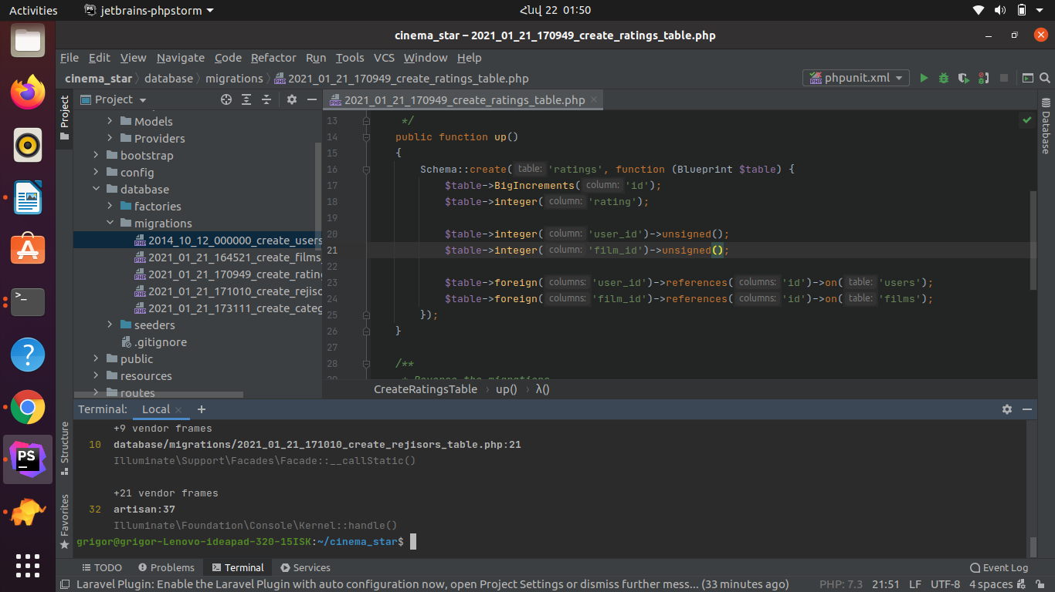
petq e unsigned dnel vorpisi chstananq error

stexcenq tex mer nor filmi hamar

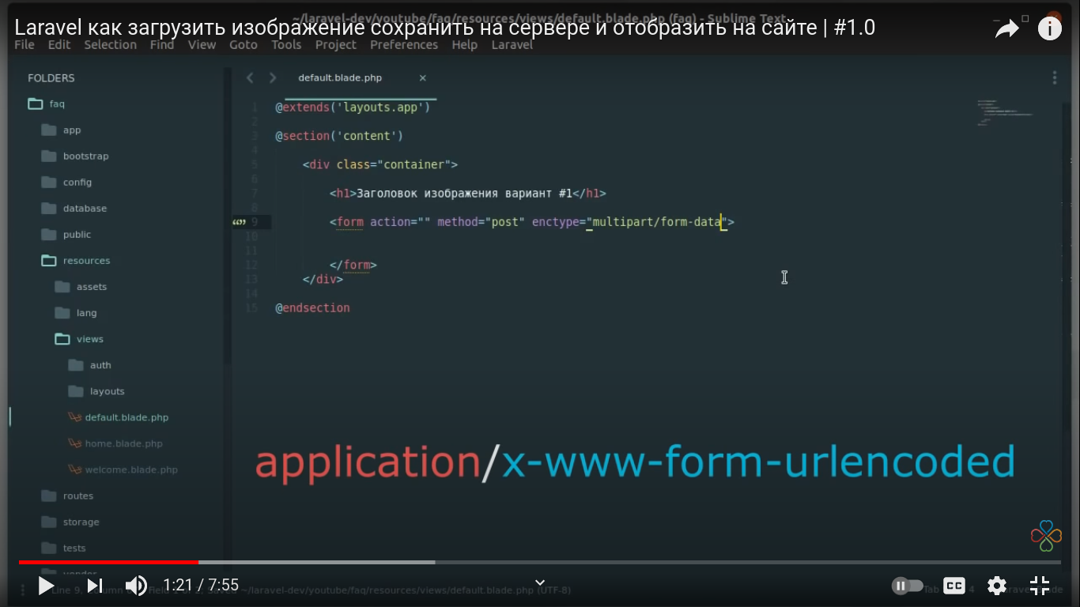

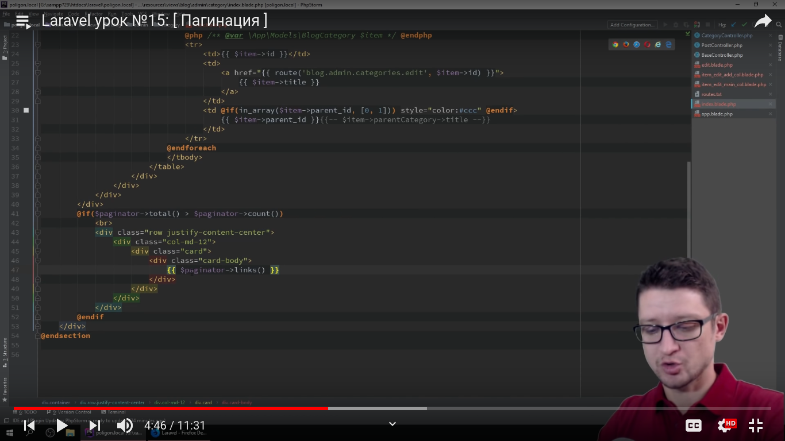

index, edit, update, create,store,show

