**NAME: RIYA CHOUDHURY**

**REGISTRATION NUMBER: 18BCM0108**

**COURSE NAME: UNIT PROCESSES IN ORGANIC SYNTHESIS**

**DATE: 27/01/20**

**DIGITAL ASSIGNMENT 1**

**QUESTION 1**

Discuss briefly following principle and process involved in fractional distillation, steam distillation, sublimation, zone refining solvent extraction, and Craig method with neat diagram**.**

**ANSWER**

1. The principle of **fractional distillation** is that different liquids boil at different temperature. The miscible liquids boil at different temperature and evaporate at different temperature. When the mixture is heated, the liquid with lower boiling point boils and turns into vapours. So, the mixture is heated to a temperature at which one or two components of the mixture will vaporise. Fractional distillation involves repeated distillations and condensations.

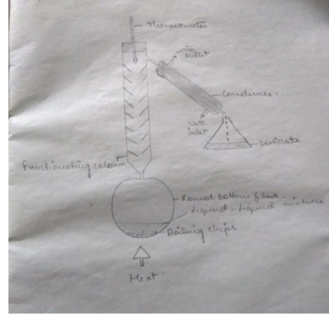

1. When a mixture of two immiscible liquids (e.g., water and organics) is heated and agitated, the surface of each liquid exerts its own vapor pressure as though the other component of the mixture was absent. Thus, the vapor pressure of the system increases as a function of temperature beyond what it would be if only one of the components was present. When the sum of the vapor pressures exceeds atmospheric pressure, boiling begins. Because the temperature of boiling is reduced, damage to heat-sensitive components is minimized. The process of **steam distillation** separates the substances of a mixture through evaporation, which then involves condensing the vapor back into liquid, taking advantage of the fact that different elements or compounds have different boiling points.

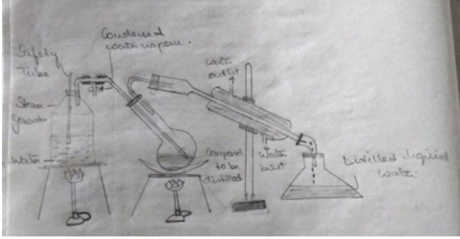

1. **Sublimation** is a process in which a solid turn directly into gas without passing into liquid state. It works on the principle that solids have a weak intermolecular force hence a higher vapour pressure which converts it into directly vapour state. It is the conversion between the solid and the gaseous phases of matter, with no intermediate liquid stage. In the water cycle, sublimation is most often used to describe the process of snow and ice changing into water vapor in the air without first melting into water. The opposite of sublimation is "deposition", where water vapor changes directly into ice—such a snowflakes and frost.

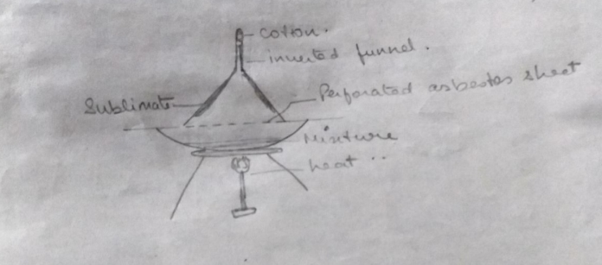

1. **Zone refining** is a group of similar methods of purifying crystals, in which a narrow region of a crystal is melted, and this molten zone is moved along the crystal. The molten region melts impure solid at its forward edge and leaves a wake of purer material solidified behind it as it moves through the ingot. The impurities concentrate in the melt, and are moved to one end of the ingot. The principle of zone refining is that the impurities in an ingot or ore of metal are more soluble in the melt state when compared to the corresponding solid state of the impurities.

In the zone refining process, the impurities are concentrated at one end of the block of metal so that the rest of the block is purified. It can be noted that the segregation coefficient (which is defined as the ratio of impurity in the solid state to the impurity in the liquid or melt state) is generally less than 1.

This implies that when the conditions are set at the solid-liquid boundary, the atoms of the impurity tend to diffuse into the liquid region.

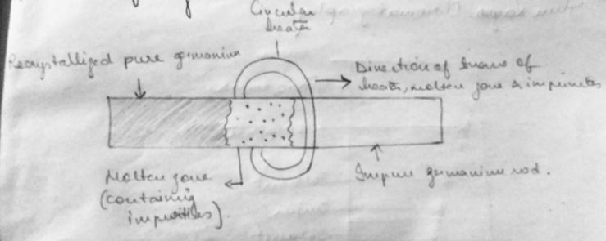

1. Counter current distribution is a separation process that is founded on the principles of [**liquid–liquid extraction**](https://en.wikipedia.org/wiki/Liquid%E2%80%93liquid_extraction) where a chemical compound is distributed (partitioned) between two immiscible liquid phases (oil and water for example) according to its relative solubility in the two phases. A method of multiple liquid-liquid extractions is counter current extraction, which permits the separation of substances with different distribution coefficients (ratios). A clever design known as Craig apparatus is used for this purpose.

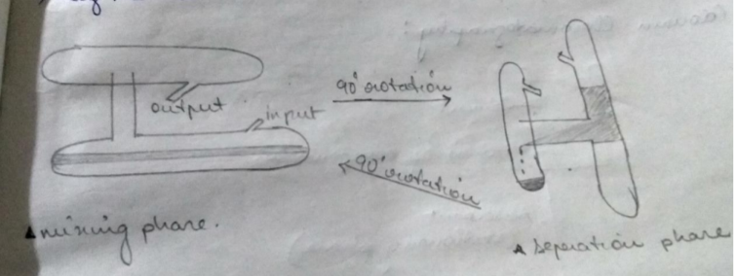

**QUESTION 2**

Discuss briefly principle and process involved in different types of chromatographic techniques TLC, Column, GC LC and HPLC with neat diagram.

**ANSWER**

1. **Thin layer chromatography** is also based on the principle of separation.

The separation depends on the relative affinity of compounds towards stationary and the mobile phase.

The compounds under the influence of the mobile phase (driven by capillary action) travel over the surface of the stationary phase. During this movement, the compounds with higher affinity to stationary phase travel slowly while the others travel faster. Thus, the separation of components in the mixture is achieved.

Once separation occurs, the individual components are visualized as spots at a different level of travel on the plate. Their nature or character are identified using suitable detection techniques.

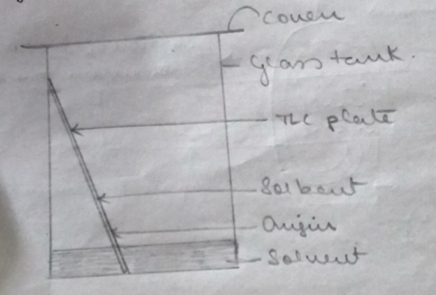

1. **Column chromatography** is a technique which is used to separate a single chemical compound from a mixture dissolved in a fluid. It separates substances based on differential adsorption of compounds to the adsorbent as the compounds move through the column at different rates which allow them to get separated in fractions.

When the mobile phase along with the mixture that needs to be separated is introduced from the top of the column, the movement of the individual components of the mixture is at different rates. The components with lower adsorption and affinity to stationary phase travel faster when compared to the greater adsorption and affinity with the stationary phase. The components that move fast are removed first whereas the components that move slow are eluted out last.

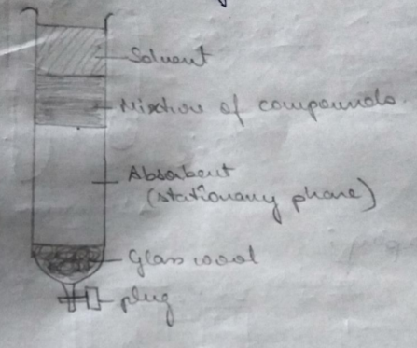

1. **Gas chromatography** is a novel technique for separating and quantitating vaporized compounds using an inert carrier gas.

A sample is dissolved in a mobile phase and passed through a porous stationary structure.

Non-reactive gases such as helium (He) or hydrogen (H) are used as a carrier for vaporized molecules of interest. This gaseous mixture is flowed through the column of a gas chromatograph, which comprises a microscopic fluidic membrane and an inert, solid substrate. This column partitions vapours based on their mechanical properties and their affinity with the stationary fluid.

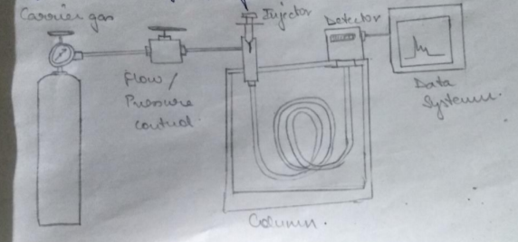

1. **Liquid chromatography (LC)** is a separation process used to isolate the individual components of a mixture. This process involves mass transfer of a sample through a polar mobile phase and non-polar stationary phase. The device is a column packed with the porous medium made of a granular solid material (i.e., stationary phase), such as polymers and silica, where the sample is injected and the solvent (i.e., mobile phase) passes to transport the sample.

When a sample is injected, it is adsorbed on the stationary phase, and the solvent passes through the column to separate the compounds one by one, based on their relative affinity to the packing materials and the solvent. The component with the most affinity to the stationary phase is the last to separate. This is because high affinity corresponds to more time to travel to the end of the column.

1. **High performance liquid chromatography (HPLC)** is basically a highly improved form of column liquid chromatography. Instead of a solvent being allowed to drip through a column under gravity, it is forced through under high pressures of up to 400 atmospheres. That makes it much faster. All chromatographic separations, including HPLC operate under the same basic principle; separation of a sample into its constituent parts because of the difference in the relative affinities of different molecules for the mobile phase and the stationary phase used in the separation.

