AT-ICE: A Multi-Platform ERP System for Bella Erin Tube Ice Inc. Ice Manufacturing Company with HRIS, IMS, SCM, CRM,

Business Intelligence Integration, GPS and Geofencing
A Capstone Project Proposal
Presented to the Faculty of the
Information and Communications Technology Program
STI College San Jose Del Monte

In Partial Fulfilment
of the Requirements for the Degree
Bachelor of Science in Information Technology
Kevin O. Abad
Carlo Jade W. Jayco
Czar Aldrin S. Justo
Rhalf Thristan L. Valencia

2026
ENDORSEMENT FORM FOR PROPOSAL DEFENSE

TITLE OF RESEARCH: AT-ICE: A Multi-Platform ERP System for Bella Erin Tube Ice Inc. Ice Manufacturing Company with HRIS, IMS, SCM, CRM, Business Intelligence Integration, GPS, and Geofencing
NAME OF PROPONENTS: Kevin O. Abad
Carlo Jade W. Jayco
Czar Aldrin S. Justo
Rhalf Thristan L. Valencia

In Partial Fulfilment of the Requirements
for the degree Bachelor of Science in Information Technology
has been examined and is recommended for Proposal Defense.

ENDORSED BY:

Joshua M. Pavia
Capstone Project Adviser

APPROVED FOR PROPOSAL DEFENSE:

Louis Matthew P. Sindao
Capstone Project Coordinator

NOTED BY:

Sheila Marie B. Llesol
Program Head

2026

APPROVAL SHEET
This capstone project proposal titled AT-ICE: A Multi-Platform ERP System for Bella Erin Tube Ice Inc. Ice Manufacturing Company with HRIS, IMS, SCM, CRM, Business Intelligence Integration, GPS, and Geofencing, prepared and submitted by Kevin O. Abad, Carlo Jade W. Jayco, Czar Aldrin S. Justo, and Rhalf Thristan L. Valencia, in partial fulfillment of the requirements for the degree of Bachelor of Science in Information Technology, has been examined and is recommended for acceptance and approval.
Joshua M. Pavia
Capstone Project Adviser
Accepted and approved by the Capstone Project Review Panel
in partial fulfillment of the requirements for the degree of
Bachelor of Science in Information Technology

<Panelist's Given Name MI. Family Name> | <Panelist's Given Name MI. Family Name>
Panel Member | Panel Member

<Panelist's Given Name MI. Family Name>
Lead Panelist

Noted:
Louis Matthew P. Sindao | Sheila Marie B. Llesol
Capstone Project Coordinator | Program Head

2026

TABLE OF CONTENTS
 |  | Page
Title Page |  | i
Endorsement form for Proposal Defense |  | ii
Approval Sheet |  | iii
Table of Contents |  | iv
Introduction |  | 1
 | Project Context | 1
 | Purpose and Description | 3
 | Objectives | 8
 | Scope and Limitations  Review of Related Literature/Studies/Systems  Synthesis | 10  16  27
Methodology |  | 28
 | Technical Background | 28
 | Resources | 33
 | Calendar of Activities  Requirements Analysis  Requirements Documentation | 35  36  37
 | Design of Software, System, Product, and/or Processes | 38
References |  | 51
Appendices |  | 55
 | Resource Persons | 56
 | Personal Technical Vitae | 57

Introduction

Project Context
Bella Erin Tube Ice Inc. is Ice Manufacturing Company located at Block 63, Lot 4 Anubing St, Amparo Subdivision, Barangay 179 Zone 16, Caloocan City North, 1425, Metro Manila, according to owner and shareholder Dr. Dave Tee Co. According to Mr. Co, the company was a startup sister company which from the preceding main company “Alexandra Tube Ice Inc.” The Bella Erin Tube Ice Inc. supplies tube ice to certain stores e.g., Pickup Coffee Shop, Alfamart, Waltermart, SM Malls, etc. The company is only at its nearly two years of running.
Based on the proponent’s assessment with the client Dr. Dave T. Co, emphasized that logistics is the backbone of Bella Erin Tube Ice Inc. Beyond producing ice, the company’s success depends on how efficiently products are delivered through its logistics. That is why according to Mr. Co fuel consumption and truck maintenance were highlighted as critical concerns, since they directly affect costs, and reliability. Each delivery truck requires an oil change every three months, but without a tracking system, missed maintenance schedules have led to unexpected breakdowns that disrupt deliveries. Also it is crucial to monitor fuel usage per truck weekly and monthly, as untracked consumption makes it hard to identify which trucks are inefficient. Moreover, to the attendance, as of now the company uses finger print biometrics and time card, but wanted to upgrade into something more accurate especially system that can determine if certain worker is wearing proper uniform to follow standard rules of the company. Also, one recurring problems of Dr. Dave on his company was the payroll management, there are a lot of time wasted computing the just and accurate calculation of the salary. According to the client, procurement of certain items varies, plastic bags, sacks, truck parts, and machine related items are included. Dr. Co also emphasized that inventory was very crucial to the company especially related to the inventory of truck parts, and it should notify them when certain items are having low quantity of stocks. Additionally, Dr. Co stated that some customers such as Pickup Coffee take up to 75 days to settle payments, which affects the company's cash flow. The client expressed the need for automatic alerts when a customer's payment becomes overdue beyond two weeks to allow immediate follow-up. Also, according to the client Mr. Dave T. Co, one of the most crucial fields of the company is determining the expenses, fuel consumption, and overall sales performance of the company, the client also stated that receipts of Meralco and Maynilad alone is not enough to distinguish if the sales from current month versus from the previous months, and years are competitive enough.
According to the client’s assessment, the main concern and focus was the logistics which the proponents are aiming to resolve to help the company’s logistics overall concerns. According to Globe Business (2023), GPS-enabled fleet management and geofencing technologies play a vital role in logistics and delivery monitoring in the Philippines. Fleet tracking systems allow companies to monitor vehicle locations in real time, optimize delivery routes, and generate alerts when vehicles enter or exit designated geographic zones. Geofencing also supports real-time visibility in supply chain operations. As discussed by OPSdesign (2024), geofencing enhances delivery monitoring and logistics management in modern enterprise systems.
Also, based on the client’s assessment, about tracking the company’s sales performance and logistic performance, a key innovation is the use of GPS-enabled fleet tracking combined with Business Intelligence (BI). GPS monitoring allows managers to track vehicle routes, fuel usage, and delivery efficiency in real time. BI then transforms this operational data into dashboards, analytics, and forecasting models. As Nguyen, Newby, and Macaulay (2021) explain, BI embedded in ERP systems provides meaningful insights by analyzing sales trends, monitoring inventory turnover, and predicting future demand. For Bella Erin Tube Ice Inc., this means admins, and higher officials of the company can identify, track fuel inefficiencies, and compare expenses against sales performance.

Purpose and Description
The proponents are making a transition where this system becomes the standard for performance tracking. With better training and leadership support, we ensure that the technology is backed by accountability that the old system clearly lacked. The purpose of the project AT-ICE: ERP System was for Bella Erin Tube Ice Inc. to unify the HRIS, IMS, SCM, CRM, Business Intelligence Integration, and GPS Geofencing module is to provide Bella Erin Tube Ice Inc. system that manages thoroughly its daily operations, functions and logistics. The project is designed to help the company manage its workforce, monitor inventory, track deliveries, and evaluate sales performance more efficiently. By combining different modules into one system, the project aims to simplify management tasks and give company leaders a clearer view of how the business is performing.
This project functions as integrated Enterprise Resource Planning system tailored to the needs of Bella Erin Tube Ice Inc., a growing ice manufacturing company. It brings together human resource management, inventory monitoring, supply chain coordination, customer relationship management, and business intelligence into a single platform. What makes the project unique is its integration of GPS geofencing with business intelligence tools. This allows admin, higher officials and managers to monitor delivery trucks in real time, track fuel consumption, and ensure that logistics are both cost-efficient and reliable. The system is innovative because it does more than record data—it transforms operational information into meaningful insights. Admin and higher officials can see patterns in sales, compare expenses with revenues, and anticipate future demand. This makes the project highly relevant to Bella Erin Tube Ice Inc., as it directly addresses the company’s challenges in logistics, inventory control, and financial monitoring. By providing accurate, timely, and easy-to-understand information, the project supports better decision-making and helps the company strengthen its operations as it continues to grow.

Objectives

To develop an integrated HRIS module with payroll system to manage employee records, attendance, and performance efficiently.
  - To improve employee management, the system will automate employee record keeping, utilize a two-step verification process consisting of face recognition to verify employee identity and proper uniform detection via TensorFlow.js that verifies three attributes, namely the collar style, logo, and color of the employee's uniform, to confirm dress code compliance during clock-in. The system will also include payroll processing by automatically computing the bi-weekly salary of each employee based on their recorded attendance and daily rate.

To implement inventory management features to monitor stock levels, track usage, and ensure timely replenishment.

To enhance inventory control, the system will provide real-time stock monitoring of materials such as plastic bags, sacks, and truck parts. Automated alerts will notify administrators when stock levels are low, helping prevent shortages and ensuring continuous operations.

To establish a supply chain management module to improve logistics coordination and delivery efficiency.

To streamline logistics operations, the system will manage procurement, delivery scheduling, and distribution processes. This will reduce delays, improve coordination, and ensure timely delivery of ice products to partner stores.
- To develop a customer relationship management (CRM) module to manage customer data, orders, and transactions effectively.
  - To improve customer service and sales tracking, the system will store customer information, monitor transactions, and generate sales records. This will help the company maintain strong customer relationships and track business performance.
- To integrate GPS geofencing and fleet tracking to monitor delivery operations in real time.
  - To address logistics challenges, the system will track vehicle locations, monitor routes, and detect deviations using geofencing technology. Alerts will be generated when vehicles leave designated zones, helping reduce delays, improve fuel efficiency, and ensure reliable deliveries.
- To incorporate business intelligence tools to analyze sales, expenses, and operational performance.
  - To support data-driven decision-making, the system will generate dashboards and analytical reports. Management will be able to compare fuel consumption, expenses, and sales performance, identify trends, and forecast future demand.
- To develop financial monitoring features to track expenses and evaluate company performance.
  - To improve financial transparency, the system will record operational expenses such as fuel and utilities and compare them with sales data. This will help management assess profitability and control costs effectively.
- To consolidate all modules into a single ERP web platform to enhance transparency, efficiency, and competitiveness.
  - To ensure seamless integration, all modules will be centralized into one web-based ERP system. This unified platform will promote data consistency, improve interdepartmental coordination, and strengthen the company’s overall operational performance.

Scope and Limitations
Scope:
Admin Module
- Login
The developers create and provide the admin account credentials. The System Administrator logs in using their email and password through a desktop browser to access the full system.
- Dashboard
Consists of summarized data and key performance indicators that can be easily monitored by the admin, including sales overview, inventory status, delivery updates, employee attendance summary, and truck mileage status that notifies the admin when a truck reaches the defined mileage threshold indicating that an oil change is due.
- Employee Management
Contains a detailed list of all registered employees in the system. The admin can add, edit, and manage employee records and their assigned roles.
- Attendance Management
Employees clock in at a dedicated attendance station by completing a two-step verification consisting of face recognition to confirm identity and uniform detection that verifies three attributes, namely the collar style, logo, and color, to confirm that the employee's uniform matches the standard assigned to their role. If both pass, the time in is recorded. If either fails, the clock-in is rejected and the admin is notified.

- Leave Management
Allows the admin to manage and approve employee leave requests. Leave records are tracked and reflected in the payroll computation.
- Payroll Management
The payroll module computes the bi-weekly salary of each employee based on their recorded attendance and daily rate. Statutory deductions including SSS, Phil-health, PAG-IBIG and withholding tax are
calculated based on current government-mandated contribution tables.
- Customer Management
Contains a detailed list of all registered customers. The admin can add, edit, and manage customer accounts and track their orders and payments.
- Order Management
Allows the admin to create, manage, and track customer orders from placement to delivery completion.
- Customer Payments
Supports Cash, GCash, Check, and Bank Transfer. Each transaction with customer is recorded to ensure transparency.

Inventory Module
- Inventory Management
Allows authorized employees to manually record and manage all inventory data including raw materials and ice products through phone or desktop, replacing the traditional logbook method.
- Stock In and Stock Out
Authorized employees record all incoming and outgoing stock movements in the system. A second employee is required to confirm each entry before it is saved to maintain accurate inventory levels at all times.
- Low Stock Alert
Automatically notifies the admin when inventory levels fall below the defined minimum threshold to prevent stock shortages.

Supply Chain Module
- Supplier Management
Contains a detailed list of all registered suppliers. The admin can add, edit, and manage supplier information and track supplier transactions.
- Delivery Management
Allows the admin to create and manage delivery orders assigned to drivers and monitor the status of each delivery in real time.
- Delivery Confirmation
Drivers submit a photo of the delivered items through the system as proof of completed delivery, which the admin can view on the dashboard.
- Sales Recording
The system automatically generates a sales record upon delivery confirmation based on the quantity delivered and the customer's unit price. The recorded sales data is reflected in the admin dashboard and Business Intelligence reports.

Driver Module
- Login
Driver accounts are created and managed by the System Administrator. The driver logs in using their credentials through a company-provided mobile phone browser to access the driver's dashboard.
- View Deliveries
Displays a list of all deliveries assigned to the driver including delivery details such as customer information, destination, and delivery status.
- GPS Tracking and Geofencing
Allows the admin to monitor the driver's location and delivery progress in real time through an interactive map showing labeled markers for each store assigned to the driver's route. The system automatically alerts the admin when the driver enters or exits a defined delivery zone.
- Delivery Photo Upload
Allows the driver to take and upload a photo of the delivered items as proof of delivery confirmation directly through the driver module.
Customer Portal
- Login
Customer accounts are created and managed by the admin. Customers can log in to the portal to access their account.
- Payment Overview
Customers can view their current balance, outstanding payments, and payment history.
- Track Orders and Delivery
Customers can view the status of their current and past orders and monitor the real-time delivery status through the customer portal.
- Overdue Payment Alert
The system automatically notifies the admin when a customer's payment becomes overdue beyond two weeks.
- Contact Support
Customers can reach out to Bella Erin Tube Ice Inc. for concerns, inquiries, and support through the customer portal.

Business Intelligence Module
- AI-Powered Reports and Dashboards
Utilizes artificial intelligence to analyze operational data and generate visual reports and dashboards including sales trends, inventory levels, delivery performance, and employee attendance to help management make informed business decisions.

- Expense Monitoring
The admin can record monthly operational expenses including fuel, water, and electricity costs. These are displayed alongside sales data in the BI dashboard to help management compare expenses against revenue and assess profitability.

Limitations:
- The system requires an active internet connection to operate and does not support offline functionality.
- The driver location tracking requires the driver's mobile browser to stay open and active during the entire delivery. If the driver closes the browser or locks their phone, location tracking will stop. Continuous background GPS tracking is not supported in browser-based environments.
- Facial recognition and uniform detection accuracy including the verification of collar style, logo, and color may be affected by insufficient lighting conditions at the attendance station.
- Inventory recording is done manually by staff and does not include barcode scanning or automated sensor-based tracking.

Review of Related Literature
Foreign Literature
According to Ahmad and Cuenca (2021), Human Resource Information Systems (HRIS) integrated into ERP platforms enhance payroll management, employee data administration, and workforce analytics. The study explains that automation of attendance tracking, salary computation, and benefits management reduces human error and ensures regulatory compliance. Through centralized employee databases, managers can generate performance reports and support strategic workforce planning. The integration of HRIS and payroll modules within ERP systems increases transparency, improves administrative efficiency, and strengthens organizational control. As discussed by Ahmad and Cuenca (2021), ERP-based HRIS solutions contribute significantly to operational effectiveness and accurate compensation management.
According to Nguyen, Newby, and Macaulay (2021), Business Intelligence (BI) tools embedded in ERP systems support decision-making by transforming operational data into meaningful insights. The study emphasizes that dashboards, real-time analytics, and forecasting models help managers analyze sales trends, monitor inventory turnover, and predict future demand. Decision Support Systems (DSS) integrated within ERP platforms enable timely responses to operational issues and market fluctuations. The authors conclude that BI enhanced ERP systems provide strategic advantages by improving planning accuracy and performance monitoring. As discussed in the study, integrating BI and DSS within ERP platforms strengthens data driven management in manufacturing.
According to Costa, Aparicio, and Raposo (2023), ERP adoption in manufacturing industries leads to improved financial performance, operational efficiency, and process standardization. The research indicates that organizations implementing integrated ERP modules for sales, inventory, HR, and supply chain management experience improved coordination and reduced operational costs. The study further explains that centralized systems enhance information sharing and reduce redundancy in data processing. As discussed by Costa et al. (2023), ERP systems provide long-term strategic value when aligned with organizational objectives and technological capabilities.
According to Pantelimon, Georgescu, and Posedaru (2022), the integration of geofencing and GPS technologies in enterprise systems enhances delivery tracking and logistics performance. The study explains that geofencing allows organizations to monitor vehicle movements, generate automated alerts when entering or leaving designated zones, and optimize delivery routes. Real-time tracking improves transparency, customer communication, and operational control. The authors highlight that combining CRM systems with geolocation technologies increases customer satisfaction by providing accurate delivery updates and reducing delays. As discussed in the study, integrating CRM with geofencing based tracking systems strengthens logistics efficiency and customer relationship management.
Local Literature
Cloud-Based HRIS and Payroll Systems for Workforce Management in Philippine Enterprises. According to Sprout Solutions (2023), cloud-based Human Resource Information Systems (HRIS) and payroll platforms have significantly improved workforce management practices among Philippine enterprises. Their system integrates employee records, attendance tracking, leave management, and automated payroll computation into a centralized database. The platform ensures compliance with Philippine labor laws and statutory contributions such as SSS, PhilHealth, and Pag-IBIG. Through real-time reporting and analytics features, managers can monitor employee performance and generate payroll summaries efficiently. The integration of HRIS and payroll within a single enterprise system enhances transparency, reduces administrative workload, and improves operational accuracy. As discussed by Sprout Solutions (2023), adopting an integrated HR and payroll system allows organizations to streamline internal processes and support data-driven decision-making.
According to QNE Software Philippines (2022), Enterprise Resource Planning (ERP) systems help small and medium enterprises manage inventory control, sales processing, purchasing, and financial reporting within a unified system. The platform enables real-time inventory updates, automatic stock adjustments after sales transactions, and generation of inventory valuation and sales performance reports. The study emphasizes that ERP-based inventory systems reduce stock discrepancies and improve warehouse management efficiency. Additionally, the integration of sales and purchasing modules strengthens supply chain coordination and procurement planning. As discussed by QNE Software Philippines (2022), ERP systems provide accurate and timely business information that enhances operational control and strategic planning.
According to Oracle NetSuite Philippines (2024), cloud ERP platforms integrate financial management, supply chain operations, customer relationship management (CRM), and business intelligence tools into one centralized system. The system provides dashboards and analytics that allow managers to monitor sales trends, forecast demand, and analyze inventory turnover rates. Through CRM integration, businesses can manage customer data, track transactions, and improve customer service responsiveness. The supply chain module enhances procurement tracking and distribution planning by providing real-time updates across departments. As discussed by Oracle NetSuite Philippines (2024), implementing an integrated ERP solution improves collaboration, operational visibility, and overall business performance.
According to Globe Business (2023), GPS-enabled fleet management and geofencing technologies play a vital role in logistics and delivery monitoring in the Philippines. Fleet tracking systems allow companies to monitor vehicle locations in real time, optimize delivery routes, and generate alerts when vehicles enter or exit designated geographic zones. Geofencing capabilities enhance operational control and improve customer communication by providing accurate delivery updates. These technologies also support decision-making by collecting route and performance data for analysis. As discussed by Globe Business (2023), integrating geolocation and tracking systems into enterprise platforms strengthens logistics efficiency and customer satisfaction.
According to Jollibee Group Digital Transformation Report (2022), the integration of enterprise systems such as ERP, supply chain management, and business intelligence tools has improved operational efficiency and inventory management across multiple branches nationwide. The report highlights that centralized systems enable real-time sales monitoring, automated replenishment planning, and improved supplier coordination. Business intelligence dashboards provide management with performance insights that support strategic planning and cost control. As discussed in the report, integrating ERP with analytics and supply chain systems enhances operational consistency and responsiveness in large-scale Philippine operations.
Foreign Studies
According to Zhou, Xu, and Yang (2022), integrated ERP systems improve inventory accuracy and stock optimization in business operations. The study explains that real-time inventory tracking and automated replenishment reduce stock discrepancies and prevent overstocking or shortages. Organizations benefit from improved inventory control and reduced operational costs. The system also enhances warehouse management and monitoring efficiency. As discussed by Zhou et al. (2022), ERP-based inventory systems strengthen inventory management and operational reliability.
According to Pham and Nguyen (2023), cloud-based ERP systems enhance organizational responsiveness through scalable and flexible system architecture. The study explains that cloud platforms allow remote access, faster data processing, and improved operational speed. These capabilities enable organizations to adapt quickly to changing business conditions and improve system accessibility. Cloud ERP also supports collaboration across departments through centralized data sharing. As discussed by Pham and Nguyen (2023), cloud-based ERP solutions improve efficiency, flexibility, and system performance.
According to Kaur and Singh (2024), Business Intelligence (BI) integration within ERP systems enhances decision support and strategic planning. The study explains that BI tools provide dashboards, forecasting models, and performance analytics that help managers evaluate business operations. These tools enable organizations to identify trends, monitor key performance indicators, and make informed decisions. BI integration also improves reporting accuracy and operational visibility. As discussed by Kaur and Singh (2024), ERP systems with BI capabilities support data-driven decision-making and organizational performance.
According to Ahmed, Lee, and Park (2023), real-time delivery tracking and geospatial analytics improve logistics efficiency in ERP systems. The study explains that location-based monitoring allows organizations to track deliveries, optimize routes, and reduce delays. Real-time updates enhance coordination between delivery personnel and management. These technologies also improve customer satisfaction through accurate delivery information. As discussed by Ahmed et al. (2023), integrating geolocation systems within ERP strengthens logistics management and operational control.
According to Ali (2021), ERP systems improve visibility across procurement, production, and distribution processes. The study explains that real-time information flow reduces operational delays and enhances coordination between departments. By integrating supply chain activities, organizations can monitor transactions efficiently and respond quickly to operational demands. This leads to improved workflow efficiency and better resource utilization. As discussed by Ali (2021), ERP systems strengthen supply chain management and support effective organizational coordination.
Local Studies
According to Mortiga, Segura, Rombaoa, and Dela Cruz (2026), ERP implementation improves operational efficiency by eliminating redundant data entry and manual processes. The study explains that centralized systems enhance data accuracy and streamline workflows within organizations. Improved coordination between departments leads to faster and more reliable operations. The system also reduces errors and increases productivity. As discussed by Mortiga et al. (2026), ERP solutions strengthen organizational efficiency and data management.
According to Cabalquinto and Jumao-as (2024), ERP readiness in Philippine SMEs depends on technological capability, management support, and employee training. The study explains that successful ERP implementation requires proper system preparation and user adaptation. It emphasizes that adequate infrastructure and employee training help organizations adjust to new systems and workflows. Strong management support also ensures proper planning and resource allocation during implementation. This leads to smoother system adoption, improved operational performance, and reduced implementation risks. As discussed by Cabalquinto and Jumao-as (2024), organizational readiness is essential for effective ERP deployment.

According to Gonzales and Bautista (2025), integrated inventory systems reduce operational costs and improve stock management in Philippine retail firms. The study explains that fragmented inventory systems lead to stock errors and inefficiencies. Real-time monitoring enables organizations to track inventory accurately and optimize stock levels. This results in improved cost control and operational performance. As discussed by Gonzales and Bautista (2025), integrated inventory systems enhance efficiency and reduce business losses.
According to Ramos (2025), real-time tracking and centralized data systems improve coordination in cold-chain logistics. The study explains that delays in information flow can negatively affect delivery performance and product quality. Implementing tracking systems enhances communication and reduces delivery delays. This leads to improved logistics efficiency and service reliability. As discussed by Ramos (2025), centralized systems strengthen logistics coordination and operational performance.
According to Dela Peña and Villanueva (2026), centralized Customer Relationship Management (CRM) systems improve service efficiency and customer satisfaction. The study explains that integrated CRM platforms allow organizations to manage customer data, track transactions, and respond to customer needs effectively. Improved communication leads to better customer relationships and service quality. The system also enhances operational organization. As discussed by Dela Peña and Villanueva (2026), CRM systems strengthen customer management and business performance.
Foreign Articles
According to Al-Zubaidi (2021), Business Intelligence (BI) integrates organizational data into visual reports and key performance indicators. The study explains that BI tools provide graphical insights that improve production and distribution processes. Organizations can analyze performance trends and make informed decisions. BI also enhances data visibility and reporting accuracy. As discussed by Al-Zubaidi (2021), BI systems support strategic planning and operational improvement.

According to Singh and Goel (2025), geofencing-based attendance systems improve workforce accountability through automated monitoring. The study explains that GPS and mobile technologies allow employees to check in and out without manual intervention. This reduces errors and increases attendance accuracy. Organizations benefit from improved workforce monitoring and efficiency. As discussed by Singh and Goel (2025), geofencing enhances HRIS functionality and employee management.
According to Chopra et al. (2022), ERP systems improve manufacturing productivity by integrating supply, production, and distribution processes. The study explains that centralized systems allow organizations to track operations efficiently and improve workflow coordination. ERP implementation enhances operational control and resource management. Organizations benefit from improved productivity and decision-making. As discussed by Chopra et al. (2022), ERP systems provide strategic advantages in manufacturing environments.
According to IoT-Based Cold Chain Management (2022), real-time monitoring is essential for managing perishable goods in distribution systems. The study explains that tracking product conditions throughout the supply chain prevents spoilage and reduces losses. Organizations can monitor product movement and maintain quality standards. This improves inventory control and operational efficiency. As discussed in the study, real-time monitoring systems strengthen cold-chain management.
Local Articles
According to Pabustan et al. (2021), ERP systems improve business operations by reducing waste and increasing production efficiency. The study explains that technology integration enhances workflow processes and organizational performance. Companies adopting ERP systems experience improved productivity and operational control. This leads to better resource management and reduced inefficiencies. As discussed by Pabustan et al. (2021), ERP implementation strengthens business performance.
According to Oliverio and Panes (2023), manual processes in manufacturing lead to errors in invoicing and material management. The study explains that ERP systems integrate business operations and reduce reliance on manual recordkeeping. Automated systems improve accuracy and streamline workflows. Organizations benefit from improved efficiency and reduced operational errors. As discussed by Oliverio and Panes (2023), ERP systems enhance process integration and reliability.
According to the Philippine Institute for Development Studies (2023), the competitiveness of small and medium enterprises (SMEs) in the Philippines is strongly influenced by their ability to adopt innovation and digital technologies in business operations. The study highlights that while many firms are becoming innovation-active, a significant number of SMEs still face challenges in adopting digital systems due to limited resources, technological capability, and operational inefficiencies. These limitations affect productivity, decision-making, and overall competitiveness in the market. The findings emphasize that integrating digital platforms and data-driven systems can improve operational efficiency, enhance information flow, and support better business performance. In relation to the AT-ICE ERP Web System, the integration of modules such as HRIS, IMS, SCM, CRM, Business Intelligence, and geofencing directly addresses these gaps by providing a centralized, technology-driven solution that enhances operational control, improves data accuracy, and strengthens the competitiveness of Bella Erin Tube Ice Inc. in the manufacturing industry.
According to Philippine Supply Chain Practices (2021), logistical challenges such as traffic and geographical barriers affect delivery performance. The study explains that monitoring systems are necessary to improve delivery coordination and efficiency. Real-time tracking allows organizations to respond to delays and optimize routes. This enhances service reliability and customer satisfaction. As discussed in the study, supply chain monitoring systems improve logistics performance.
Foreign Systems
According to OPSdesign (2024), geofencing is a location-based technology that uses GPS and network signals to create virtual boundaries for tracking assets and activities. The system enables organizations to monitor delivery vehicles, optimize routes, and generate alerts when entering or exiting designated areas. These capabilities improve logistics efficiency, operational control, and customer communication. Geofencing also supports real-time visibility in supply chain operations. As discussed by OPSdesign (2024), geofencing enhances delivery monitoring and logistics management in modern enterprise systems.
According to Straits Research (2025), the adoption of geofencing technology in logistics has increased significantly due to its effectiveness in fleet tracking and route optimization. The study explains that geofencing systems enable organizations to monitor delivery operations in real time and improve service reliability. It also highlights that many logistics companies use geofencing to enhance operational efficiency and reduce delays. The technology provides automated tracking and reporting features that support decision-making. As discussed by Straits Research (2025), geofencing has become a standard tool in modern logistics management.
According to Pozyx (2024), geofencing technology supports automation in inventory management and security monitoring. The system allows organizations to trigger automated actions such as inventory updates, alerts, and notifications when assets move across designated zones. It also enhances customer experience by providing real-time delivery updates and notifications. Security features enable organizations to detect unauthorized movements and respond quickly to potential risks. As discussed by Pozyx (2024), geofencing improves operational efficiency, security, and customer satisfaction.
According to Oracle NetSuite (2025), Business Intelligence (BI) integration within ERP systems enables organizations to analyze operational data through dashboards, reports, and predictive analytics. The system aggregates data from various modules such as inventory, sales, finance, and human resources to provide comprehensive insights. These tools help organizations monitor performance, identify trends, and make informed decisions. BI integration also improves data visualization and reporting accuracy. As discussed by Oracle NetSuite (2025), BI enhances strategic planning and operational performance.
According to Prasetyo et al. (2023), predictive Business Intelligence dashboards improve decision-making by transforming data into actionable insights. The study explains that BI systems provide real-time analytics and visualization tools that support faster and more accurate decisions. These systems enable organizations to monitor key performance indicators and improve operational efficiency. The use of modern web technologies also reduces implementation costs while maintaining system effectiveness. As discussed by Prasetyo et al. (2023), BI systems strengthen data-driven management and organizational performance.
Local Systems
According to QNE Software Philippines, Inc. (2025), QNE Optimum is a locally developed ERP and accounting system designed for Philippine small and medium enterprises (SMEs). The system provides integrated modules such as General Ledger, Accounts Receivable, Accounts Payable, Sales, Purchases, Inventory, Manufacturing, Payroll, and Audit Trail within a centralized platform. It enables businesses to manage operations efficiently while ensuring compliance with Philippine regulations such as BIR reporting and statutory contributions. The system also supports cloud-based access, allowing users to operate across multiple locations and devices. As discussed by QNE Software Philippines, Inc. (2025), QNE Optimum enhances operational efficiency, data accuracy, and regulatory compliance for local enterprises.
According to QNE Software Philippines, Inc. (2025), the inventory and payroll features of QNE Optimum improve business process automation and operational control. The system supports multi-location inventory tracking, batch and serial number management, stock monitoring, and automated reorder alerts to maintain accurate inventory levels. Its payroll module handles government-mandated computations such as SSS, PhilHealth, Pag-IBIG, and withholding taxes, ensuring compliance and accuracy. The audit trail feature records all financial transactions with timestamps and user identification, supporting transparency and accountability. As discussed by QNE Software Philippines, Inc. (2025), integrated ERP modules reduce manual errors and improve overall business performance.
According to ANSI Information Systems, Inc. (2025), SAP Business One is a globally recognized ERP system implemented in the Philippines with localized features for regulatory compliance. The system integrates modules such as financial management, sales and customer management, purchasing, inventory control, production planning, and business intelligence into a unified platform. It enables organizations to manage operations efficiently while maintaining accurate financial records and reports. The system also supports real-time dashboards and analytics to assist management in decision-making. As discussed by ANSI Information Systems, Inc. (2025), SAP Business One enhances operational visibility and business performance through integrated system functionality.
According to SuperSpeed Philippines (2025), SAP Business One includes advanced features such as production management, batch tracking, multi-warehouse inventory, and automated workflows. The system allows organizations to track production processes, manage inventory across multiple locations, and monitor product movement from production to delivery. Its business intelligence tools generate reports and dashboards that provide insights into operational performance. The system also ensures compliance with BIR requirements through standardized financial reporting and audit trail capabilities. As discussed by SuperSpeed Philippines (2025), SAP Business One supports efficient manufacturing operations and data-driven decision-making.
According to the Bureau of Internal Revenue (2021), Revenue Memorandum Circular (RMC) No. 5-2021 establishes guidelines for the registration and regulation of computerized accounting systems in the Philippines. The policy explains that businesses implementing ERP systems must ensure data integrity, auditability, and compliance with reporting standards. It requires systems to maintain audit trails, secure access controls, and generate standardized financial reports. The regulation also simplifies the registration process by replacing the Permit to Use with an Acknowledgement Certificate. As discussed by the Bureau of Internal Revenue (2021), compliance with regulatory standards is essential for the successful implementation of ERP systems.

Synthesis
The reviewed literature collectively emphasizes that modern Enterprise Resource Planning (ERP) systems integrated with Human Resource Information Systems (HRIS), Inventory Management Systems (IMS), Supply Chain Management (SCM), Customer Relationship Management (CRM), Business Intelligence (BI), and geofencing technologies play a crucial role in improving organizational efficiency, data accuracy, and decision-making. Foreign and local studies consistently highlight that ERP systems streamline business processes by integrating core operations such as payroll, inventory control, production, logistics, and customer management into a unified platform, reducing redundancy and improving coordination across departments. Furthermore, BI tools embedded in ERP systems enhance managerial decision-making by providing real-time analytics, dashboards, and insights that supports strategic planning and operational monitoring. The integration of geofencing and GPS-based tracking systems further strengthens logistics and supply chain performance by enabling real-time delivery monitoring, route optimization, and improved customer communication. Local literature and systems reinforce these findings by demonstrating that Philippine enterprises benefit significantly from ERP adoption, particularly in improving compliance with regulatory requirements, reducing operational costs, and enhancing workforce and inventory management. Studies on ERP readiness and digital transformation also emphasizes the importance of technological infrastructure, management support, and employee training for successful system implementation. Overall, the reviewed literature supports the development of the AT-ICE ERP Web System for Bella Erin Tube Ice Inc., as an integrated, centralized Web Enterprise Resource Planning platform that combines HRIS, IMS, SCM, CRM, BI, and geofencing to improve operational efficiency, ensure regulatory compliance, and enhance real-time decision-making in ice manufacturing operations.

METHODology

Technical Background
Overview of Current Technologies to be Used in the System
Visual Studio Code - The primary coding editor that the researchers will use for this project is Visual Studio coding. Microsoft created Visual Studio Code, a free and open-source code editor with features including version control, debugging, and several extensions for different activities and programming languages.
React.js - React.js is an open-source JavaScript library developed by Meta for building user interfaces using a component-based approach. Instead of writing the same code repeatedly for every page, developers can build a component once and reuse it across the system. In this system, React.js is used to build all the pages and dashboards including the HRIS, IMS, SCM, CRM, and Business Intelligence modules.
Laravel - Laravel is a PHP-based web framework that follows the Model-View-Controller pattern and provides built-in tools for routing, authentication, database management, and API development. In this system, Laravel handles all the server-side logic and API endpoints that power the five modules of the ERP system. It also provides built-in security features such as CSRF protection and input validation that are automatically applied throughout the system.
MySQL - MySQL is an open-source relational database management system that organizes data into structured tables with defined relationships between them. In this system, MySQL stores and manages all the data including employee records, inventory levels, customer orders, supplier information, and delivery logs.
MySQL Workbench - MySQL Workbench is a free visual tool developed by Oracle that allows developers to design, manage, and interact with MySQL databases through a graphical interface. In this system, it is used to create and manage database tables, run queries, and monitor the data stored in the system during development.
Node.js - Node.js is an open-source runtime environment that allows JavaScript code to run outside of the browser on the server side. In this system, Node.js is required to install and run React.js and all its dependencies during the development of the frontend modules.
Redis - Redis temporarily stores real-time location updates and geofencing alert data from active deliveries so that frequent location broadcasts do not overload the MySQL database
HTML5 Geolocation API - The HTML5 Geolocation API is a built-in browser feature that detects the geographic location of a device using GPS, Wi-Fi, or mobile data without requiring any additional hardware. In this system, it is used to detect the driver's location through their mobile phone browser and automatically update the delivery status on the admin dashboard when the driver enters or exits a defined delivery zone.
Google Maps JavaScript API - The Google Maps JavaScript API is a service by Google that allows developers to embed interactive maps and add custom location features such as zone boundaries and coordinate-based calculations into web applications. In this system, it is used to display delivery zone boundaries on the admin dashboard and to check whether a driver's current GPS coordinates fall within a designated delivery area.
Pusher - Pusher is a hosted service that enables real-time communication between the server and the browser using WebSocket technology, which keeps a live connection open so the server can instantly send updates without the user needing to refresh the page. In this system, Pusher delivers real-time geofencing alerts, delivery status updates, and low stock warnings directly to the admin dashboard the moment they occur.
Recharts - Recharts is an open-source charting library built for React that makes it easy to create interactive and responsive charts and graphs using reusable components. In this system, Recharts is used to display all the visual reports in the Business Intelligence module including sales trends, inventory levels, delivery performance, and employee attendance.
REST API - REST API is an architectural style for enabling communication between two systems over the web using standard HTTP methods such as GET, POST, PUT, and DELETE. In this system, REST API serves as the communication bridge between the React.js frontend and the Laravel backend so that all five modules can send and receive data through secured API endpoints.
Laravel Sanctum - Laravel Sanctum is a lightweight authentication package for Laravel that secures API endpoints by issuing tokens to users upon login and validating those tokens on every request. In this system, it handles user authentication for all four roles — Administrator, Employee, Driver, and Customer — ensuring that each user can only access the modules and features assigned to their role.
Role-Based Access Control (RBAC) - Role-Based Access Control is a security model that restricts system access based on the role assigned to each user, where each role is given specific permissions on what data they can view, create, update, or delete. In this system, RBAC enforces the access boundaries for the four user roles where, for example, a customer can only view their own orders while an Administrator has full access to all modules.
HTTPS and SSL/TLS - HTTPS is the secure version of HTTP that encrypts all data transmitted between the user's browser and the web server using SSL/TLS protocols to prevent unauthorized interception. In this system, all pages and API requests are served over HTTPS to ensure that sensitive data such as login credentials, employee records, and order information remain protected during transmission.
Bcrypt - Bcrypt is a password hashing algorithm that converts plain text passwords into an unreadable string that cannot be reversed back to its original form. In this system, all user passwords are hashed using Bcrypt before being stored in the database, which Laravel applies automatically whenever a user registers or updates their password.
Input Validation and SQL Injection Prevention - Input validation checks that data submitted by a user is in the correct and expected format before the system processes it, while SQL injection prevention stops attackers from inserting harmful database commands through input fields. In this system, Laravel's built-in validation rules and Eloquent ORM are applied across all forms and API requests to automatically separate user input from database commands and keep the data safe.
Git - Git is a free and open-source distributed version control system that tracks changes in source code and allows developers to save snapshots of their project, revert to previous versions, and collaborate efficiently. The proponents will be using Git to track all changes made to both the Laravel backend and React.js frontend codebases and to manage the project source code through the GitHub repository.
Composer - Composer is a dependency manager for PHP that automates the installation and management of the external libraries and packages required by a PHP project. The proponents will be using Composer to install and manage all the PHP packages required by the Laravel backend including Laravel Sanctum, Pusher, and Predis.
Postman - Postman is a platform for API development and testing that allows developers to send HTTP requests to API endpoints and inspect the responses without requiring a frontend interface. The proponents will be using Postman to test and verify all Laravel API endpoints during development to confirm that authentication, data retrieval, and module operations are functioning correctly before the React.js frontend is connected.
Figma - Figma is a cloud-based design and prototyping tool that allows teams to collaboratively create user interface designs, wireframes, and interactive prototypes directly in the browser. The proponents will be using Figma to design the user interface prototypes for all modules of the ERP system and to present the proposed system layout to the client for feedback and approval before the actual coding of the frontend begins.
Gemini API - Gemini API is a generative artificial intelligence service developed by Google that enables developers to integrate AI-powered text generation into web applications. In this system, the Gemini API is used in the Business Intelligence module to automatically generate written summaries of operational data such as sales trends, inventory levels, delivery performance, and employee attendance, helping management interpret reports without manual analysis. The free tier of the Gemini API is utilized to minimize deployment costs.
face-api.js - face-api.js is an open-source JavaScript library that runs directly in the browser and enables real-time facial detection and recognition without requiring additional hardware or software. In this system, face-api.js is used in the attendance module to verify the identity of employees during the clock-in process by matching their face against their registered profile in the system
TensorFlow.js - TensorFlow.js is an open-source machine learning library developed by Google that allows machine learning models to run directly in the browser using JavaScript. In this system, TensorFlow.js is used in the attendance module to verify three attributes of the employee's uniform during clock-in namely the collar style, logo, and color to confirm that the uniform matches the standard assigned to their role.

Resources
Devices | Specifications
Desktop 1 | CPU - AMD Ryzen 5 5600G 12 threads / 6 cores  RAM - 16 GB DDR 3200mhz T-Force  Storage - 256GB SDD and 500GB HDD  Monitor - Samsung LS24C33xG  Keyboard - INPLAY  Mouse - Logitech
Desktop 2 | CPU - AMD Ryzen 7 5700G 8 cores / 16 threads  RAM - 16 GB DDR 3200mhz Hiksemi  Storage – 500gb M.2 NVme SSD  Monitor – Lenovo D22e  Keyboard - Mage Gee  Mouse- A4tech
Hardware
Table 1. Hardware

Applications | Version
Windows 11 | 25H2
Visual Studio Code | 1.110.0
MySQL | 8.0
MySQL Workbench | 8.0 CE
Node.js | 22.22.1
Composer | 2.9.x
Laravel | 11.x
React.js | 19.x
Redis | 7.x
Pusher | 8.x
Google Maps JavaScript API | Latest
Git | 2.53.0
Postman | 11.x
Figma | Latest
Software
Table 2. Software

Calendar of Activities
At the last week of January 2026, proponents were able to make a total of 10 title proposals for the whole group, brainstorming possible system ideas and titles with emerging technologies which are required. Second week of February proponents were able to make a draft of chapter 1 and 2, the paper in this phase has just a description about the system without conducting an interview. Third Week of February proponents have already done the RRL. First week of March proponents were able to conduct interview with the potential client asking questions correlated to the system, questions with How, what, why, When, Where, or basically how the certain process within the company works. Second week of March, proponents were able to revise and polish the paper from the information gathered from our interview. Then the proponents were able to distinguish the technical background needed, and the methodology to use. On the third week of march, the proponents were able to create a Diagrams, and on the fourth week, the proponents were able to make some of the figures needed for UI figures of the system. On the first week of April, the group are preparing for mock defense and finally the paper is 90% complete. At the first to the last week of April 2026, the proponents focused on revisions and review of the paper for incoming defense. At the last week of April 2026, proponents were able to find gaps which needs answers only client can answer, proponents analyze the problem within the project and motivated to conduct second interview with client clarifying more about the systems ideology pertaining about client’s preferences.

Requirements Analysis
The requirements analysis identifies how the proposed system provides computing solutions that address the operational needs of the client by examining the key aspects of who, what, where, when, and how within the organization. The person involved in the system, including the administrators, employees, drivers, and customers who interact with different modules of the ERP system according to their assigned roles and responsibilities. What refers to the business activities supported by the system such as employee management, attendance recording, payroll computation, inventory monitoring, supplier and delivery management, customer order processing, and business reporting. These activities are integrated into modules including the Human Resource Information System, Inventory Management System, Supply Chain Management, Customer Relationship Management, and Business Intelligence module to centralize and streamline business operations. The where refers to the environment in which the work takes place, which includes the office environment where administrators and staff manage records and monitor operations through desktop or mobile browsers, as well as delivery locations where drivers access the system using their mobile devices during delivery tasks. When referring to the timing of operations, the system supports continuous daily activities such as attendance recording, inventory updates, order processing, and real-time delivery monitoring throughout the company’s operational hours. Lastly, the how describes how current procedures are performed and how the proposed system improves them by replacing manual record-keeping methods with a centralized web-based platform that automates data management, improves accuracy, and provides real-time operational updates. Through these functions, the proposed system offers a structured computing solution that enhances efficiency and supports the operational requirements of the client.

Requirements Documentation

The requirements documentation establishes the basis for the agreement between the client and the developers regarding the functions and expected behavior of the proposed Enterprise Resource Planning (ERP) system for Bella Erin Tube Ice Inc. Ice Manufacturing. The proponents document all the required software features and system functionalities based on the operational needs identified during the requirements of analysis. These features include modules for administrator access, employee and attendance management, payroll computation, inventory monitoring, supplier and delivery management, customer order processing, and real-time delivery tracking through geofencing and GPS-based updates. Each feature is clearly defined to describe how users; administrators, employees, drivers, and customers will interact with the system and what operations they are allowed to perform within their assigned roles. To further illustrate how the system will function, the proponents prepare a storyboard that visually represents the layout and flow of the system interface, including login pages, dashboards, management modules, and reporting features. The storyboard demonstrates how the system would appear and operate once fully designed and implemented, providing both the client and the developers with a clear understanding of the system structure, user interaction, and overall functionality before the actual coding and system development process begins.

Design of Software, System, Product, and/or Processes
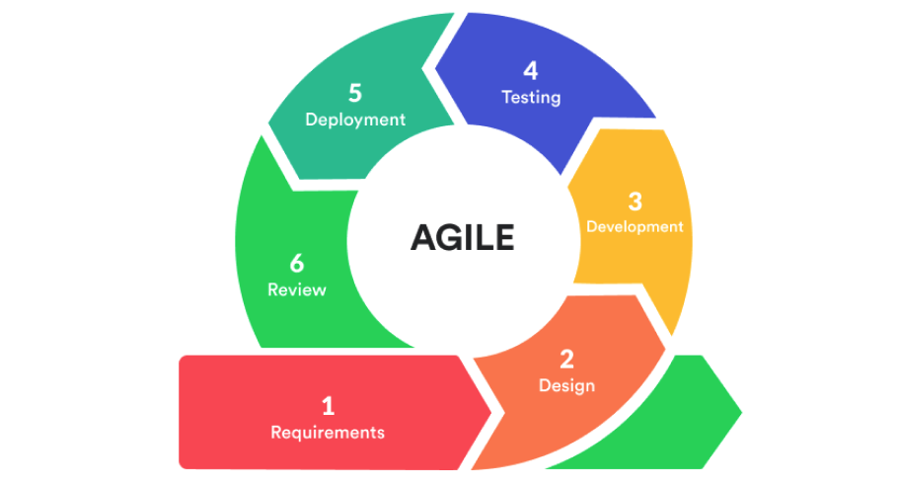
Figure 1: Agile Method
The proponents will use the Agile methodology as the development approach for the proposed system because it will allow continuous improvement, flexibility, and iterative development throughout the project. Agile will divide the development process into several phases that will enable the system to be designed, developed, tested, and refined in manageable stages. This approach will ensure that each module of the proposed Enterprise Resource Planning (ERP) system for Bella Erin Tube Ice Inc. Ice Manufacturing will be carefully planned, developed, and evaluated before proceeding to the next stage. The Agile methodology that will be used in this project will consist of the following phases: Requirements, Design, Development, Testing, Deployment, and Review.
Requirements. During this phase, the proponents will identify and analyze the operational needs of Bella Erin Tube Ice Inc. Ice Manufacturing. Information regarding the company’s current processes such as employee management, inventory recording, delivery monitoring, and customer order management will be gathered. These requirements will be used to determine the key functionalities of the system, including user authentication, attendance management, payroll computation, inventory monitoring, delivery tracking, and reporting dashboards.
Design. In this phase, the proponents will create the system architecture, database structure, and user interface layouts for the proposed system. The system design will include the arrangement of modules such as the Human Resource Information System, Inventory Management System, Supply Chain Management, Customer Relationship Management, and Business Intelligence module. Interface prototypes and wireframes will also be prepared to visualize how users such as administrators, employees, drivers, and customers will interact with the system.
Development. During the development phase, the proponents will begin coding the system based on the planned design and requirements. The frontend of the system will be developed to provide user dashboards and interfaces, while the backend will handle system logic, database operations, and API communication. Each module will be developed gradually to ensure that features function correctly before integration with other system components.
Testing. In the testing phase, the proponents will evaluate the system to identify errors, bugs, and functionality issues. Each module will be tested to verify that features such as login authentication, inventory updates, delivery monitoring, and data processing will operate correctly. Testing will ensure that the system performs according to specified requirements and produces accurate results during operation.
Deployment. After successful testing, the system will be prepared for deployment and implementation within the operational environment of Bella Erin Tube Ice Inc. Ice Manufacturing. This phase will involve configuring the system so that administrators, employees, drivers, and customers will be able to access the platform through their respective interfaces.
Review. The final phase will involve evaluating the performance and effectiveness of the system after implementation. The proponents will review the system’s features to ensure that it meets the operational needs of the client. Feedback gathered during this phase may be used to further improve system functionality, usability, and performance in future updates.

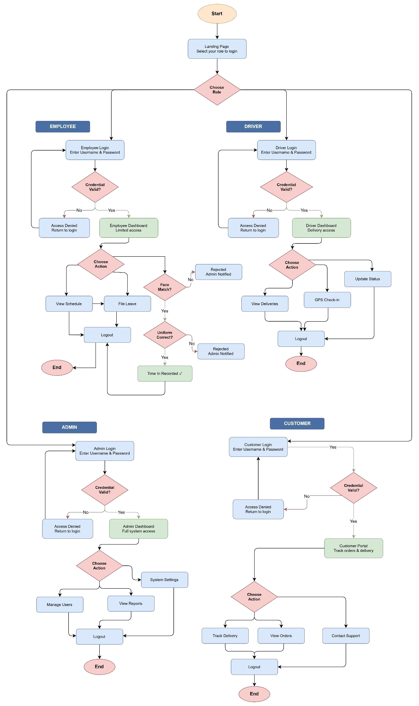
Figure 2: Flow Chart

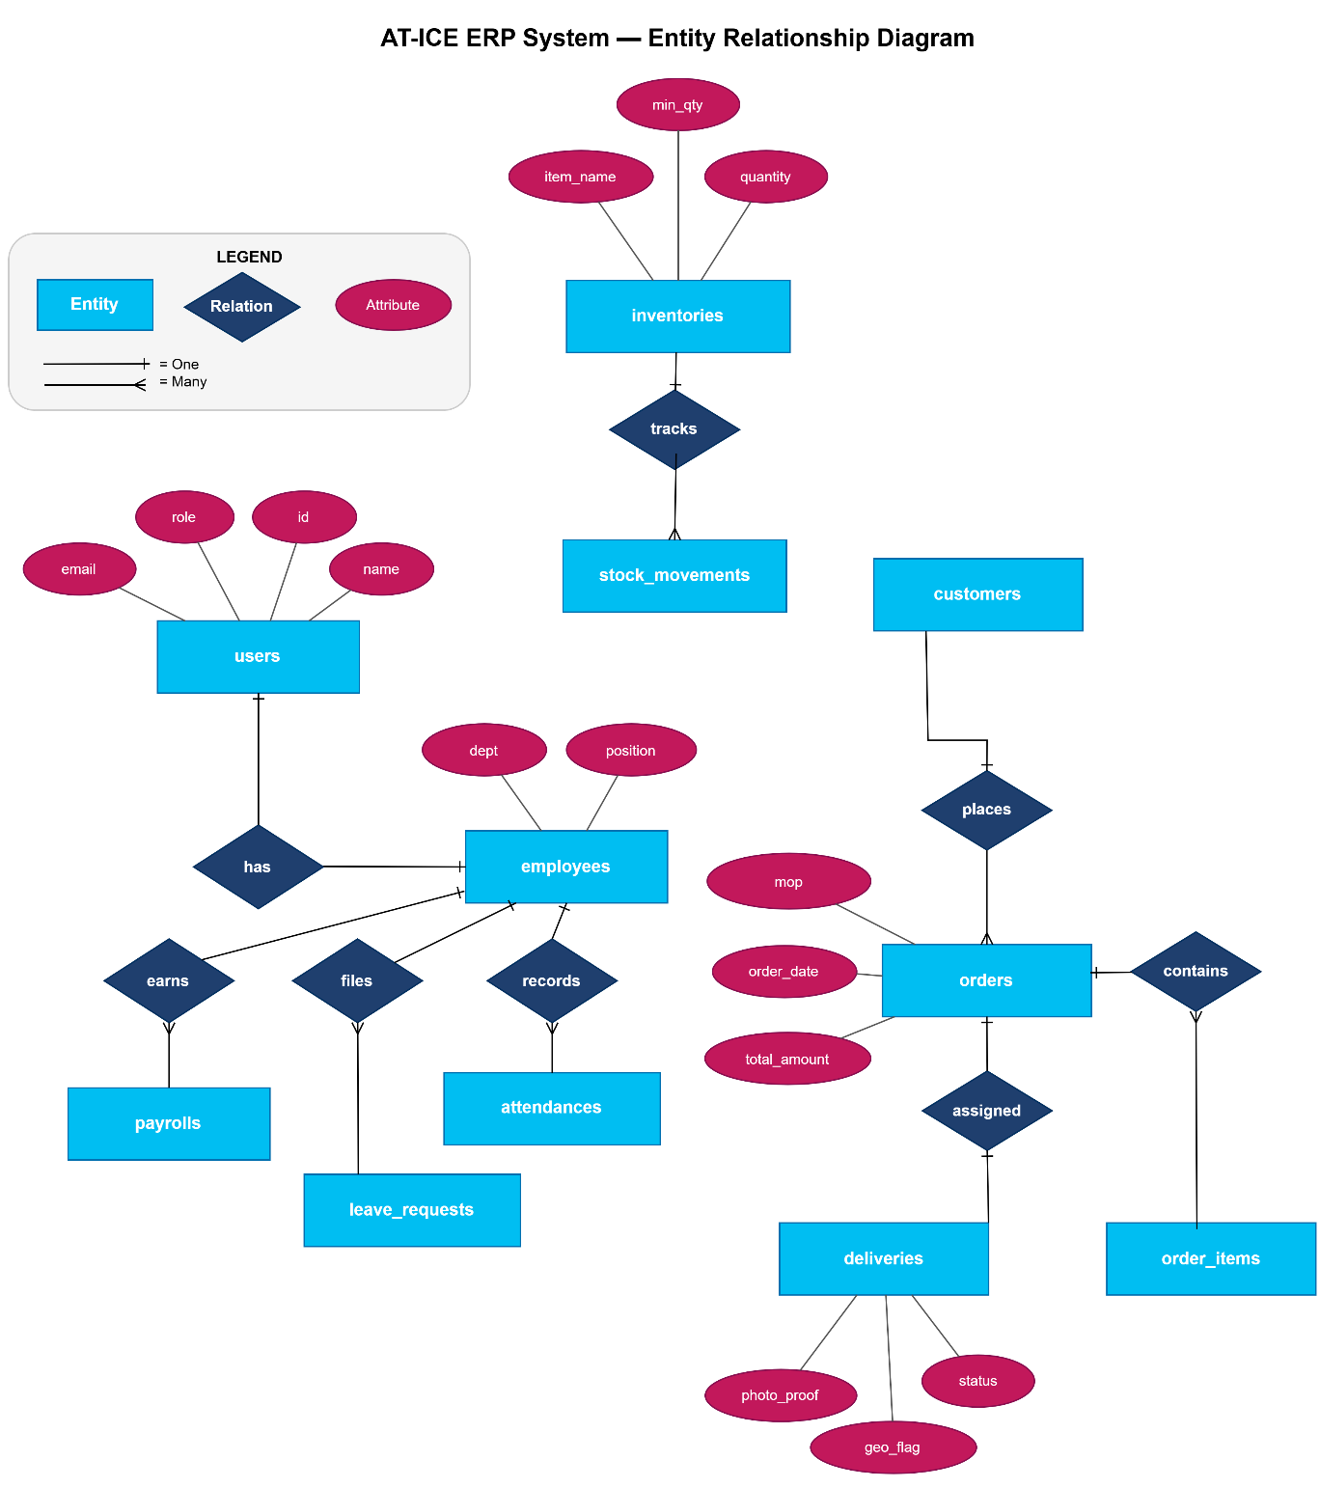Figure 3: Entity Relationship Diagram
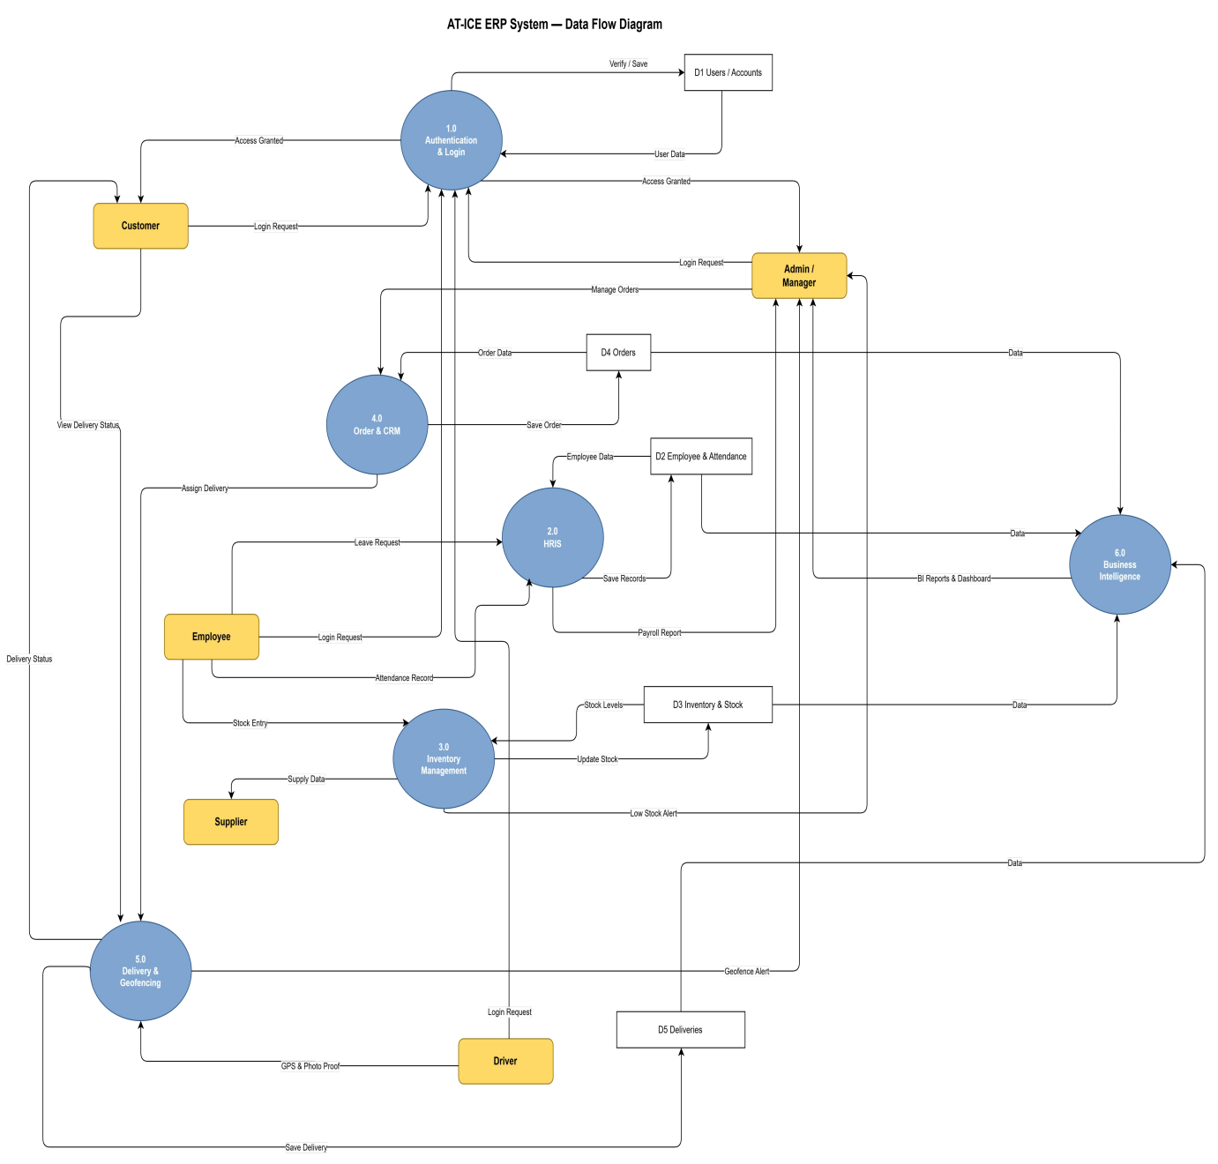
Figure 4: Data flow Diagram

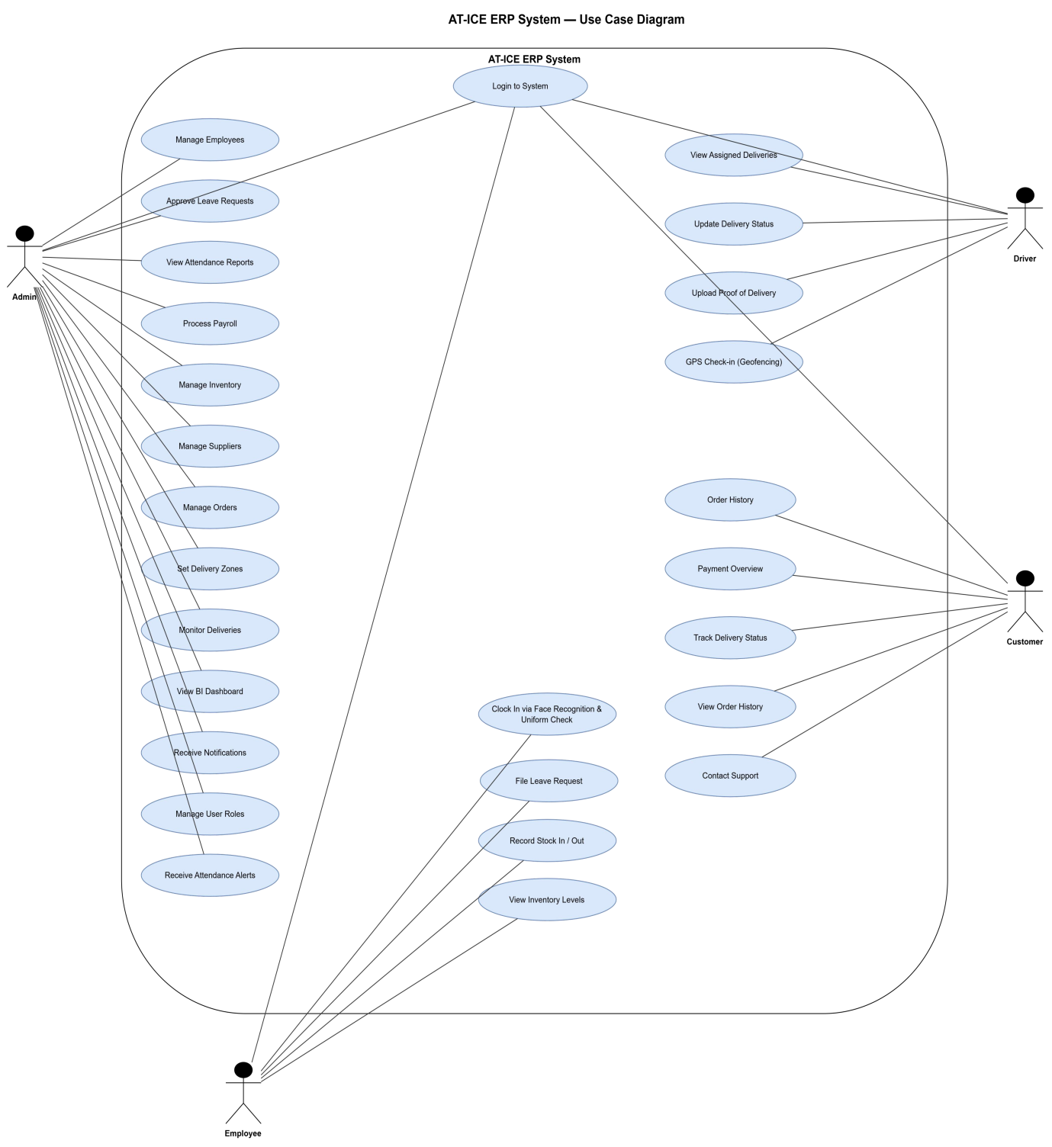
Figure 5: Use Case Diagram

Logo

Figure 6: Logo

Landing Page
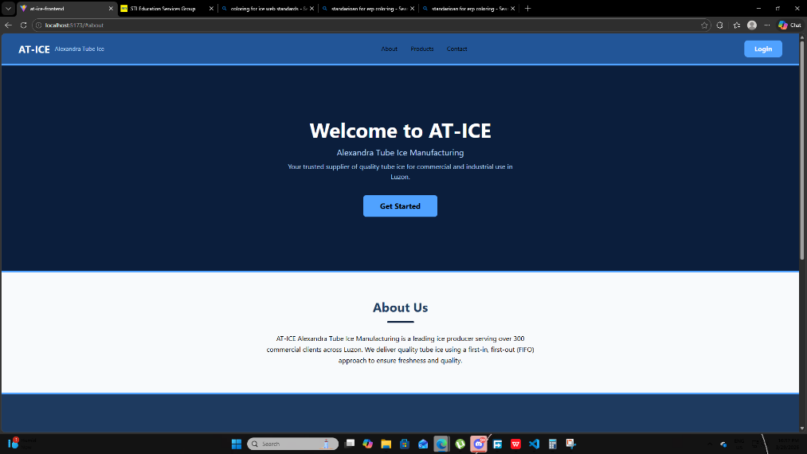
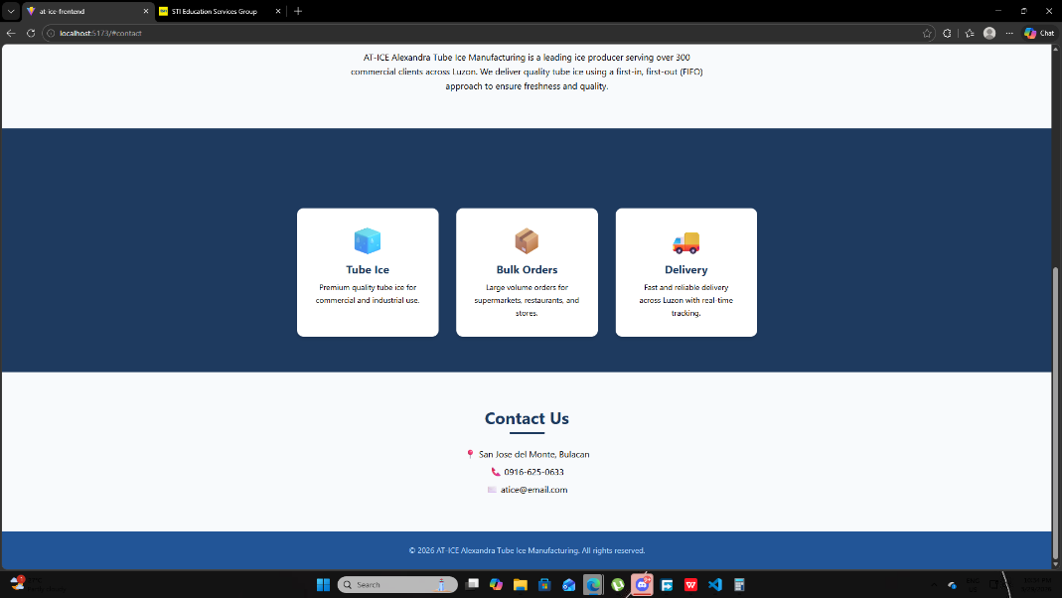

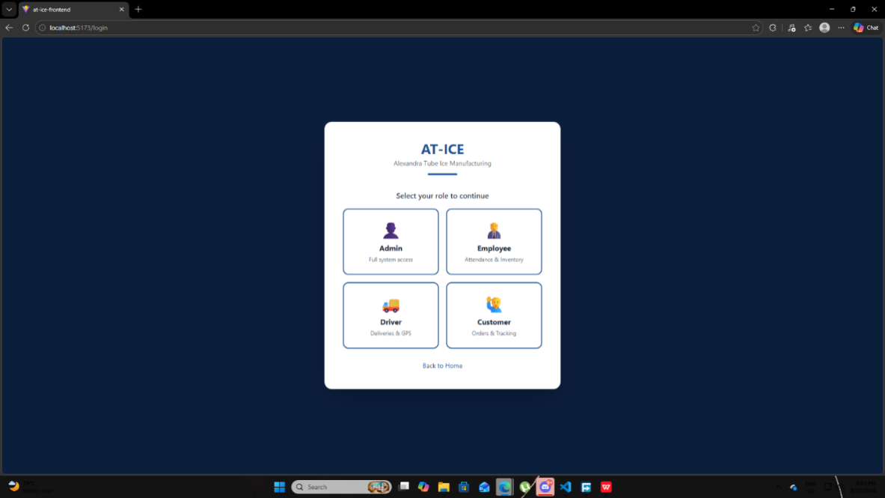
Figure 7: Landing Page

Log In Module for Desktop Website
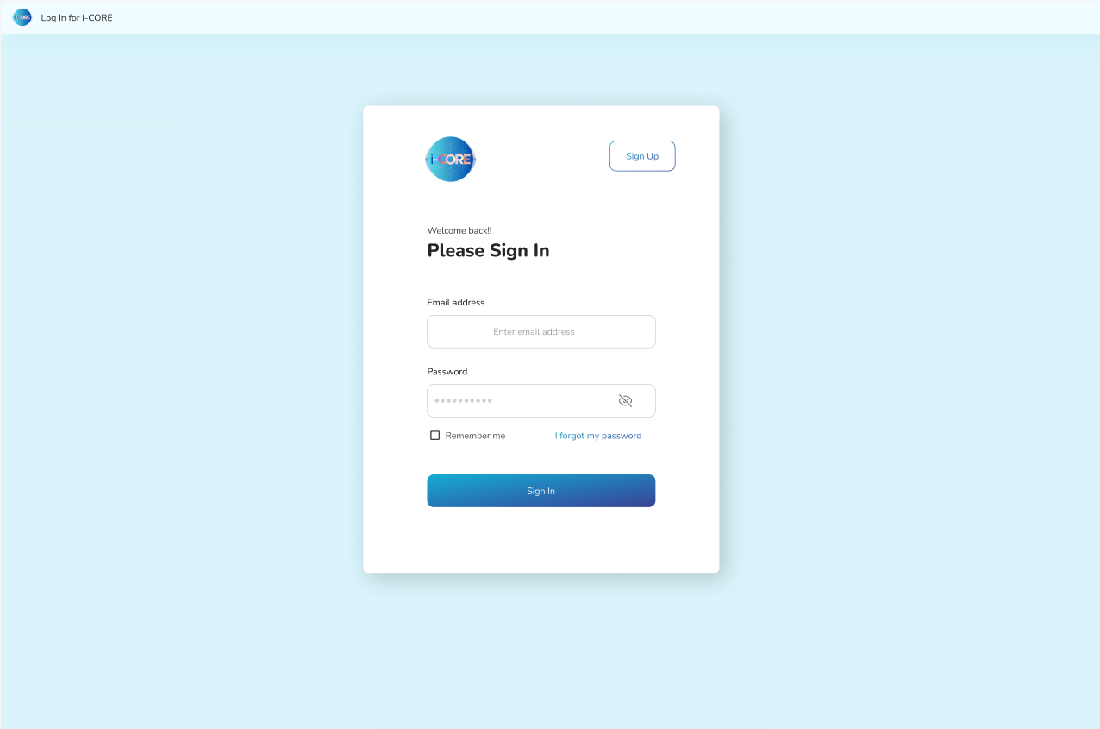
Figure 8: Log in Module for Desktop Website

Log In Module for Mobile Website
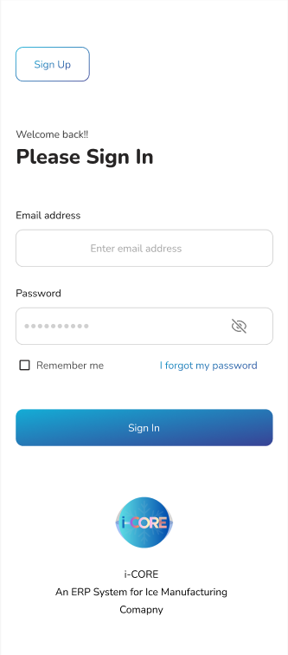
Figure 9: Log in Module for Mobile Website

Dashboard For Admin, Managers and Supervisors
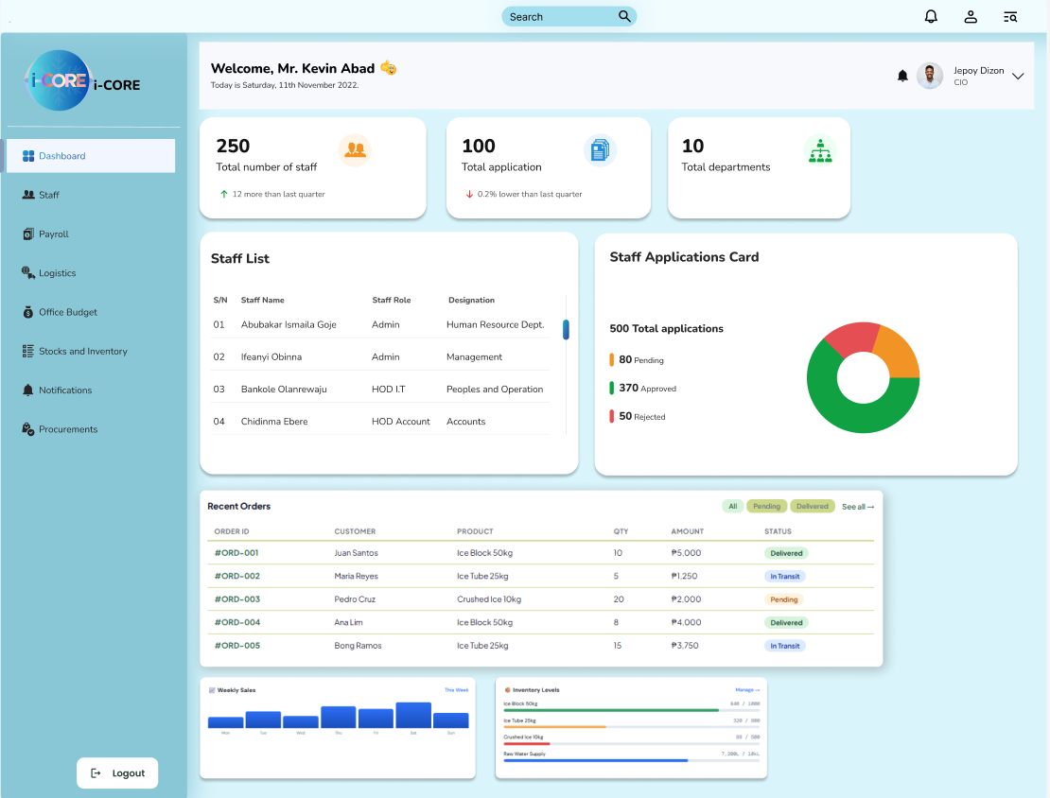
Figure 10: Dashboard

Human Resource Information System
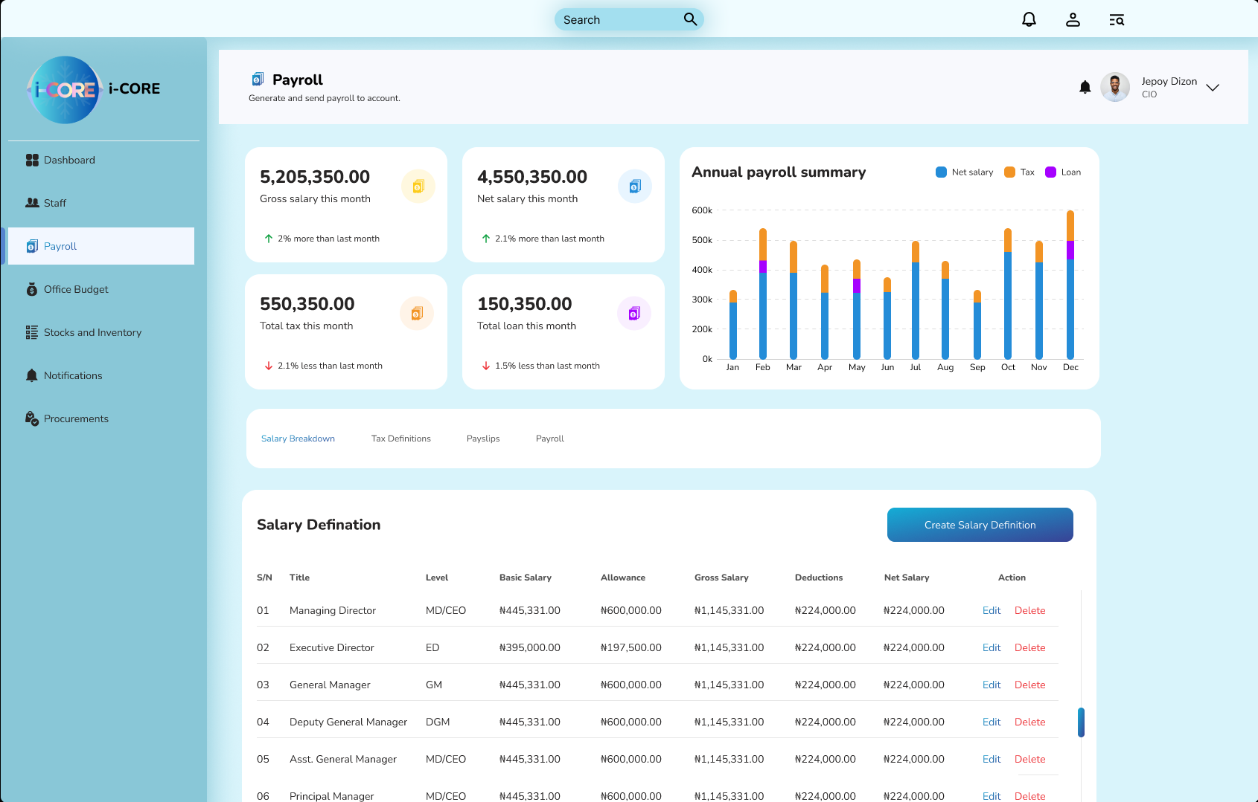

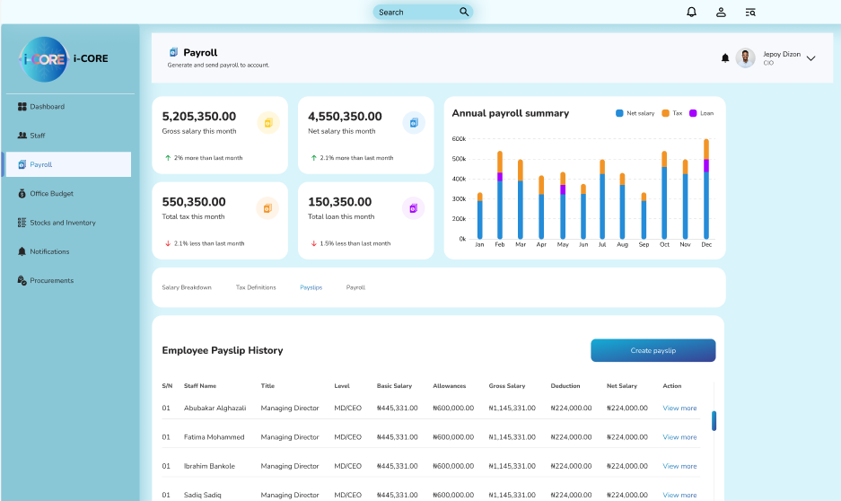
Figure 11: HRIS Module

Creation of Salary Definition
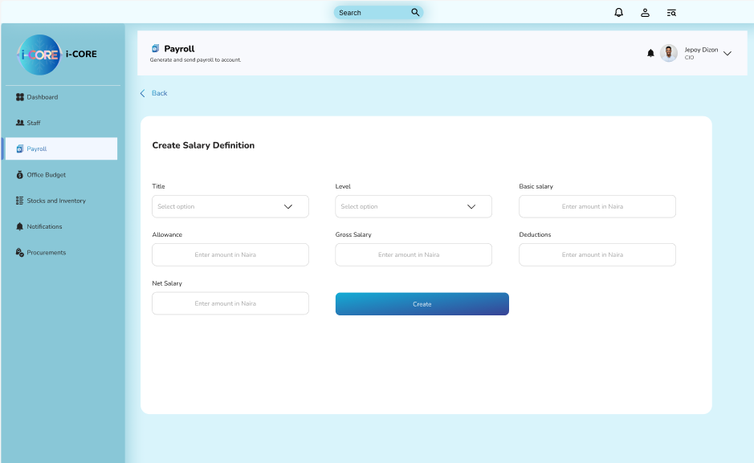

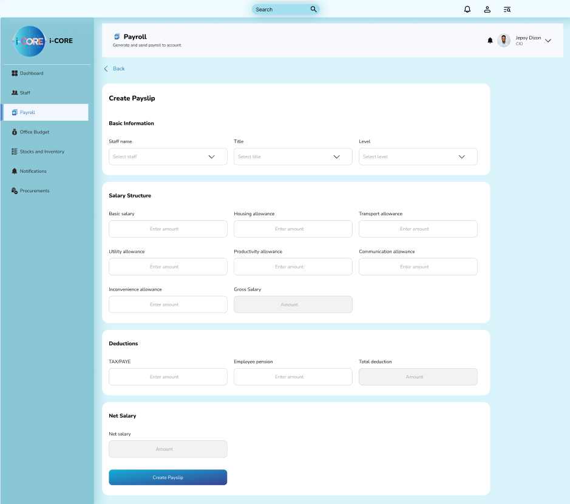
Figure 12: Creation of Salary Definition

Staff Assigning and Information ID
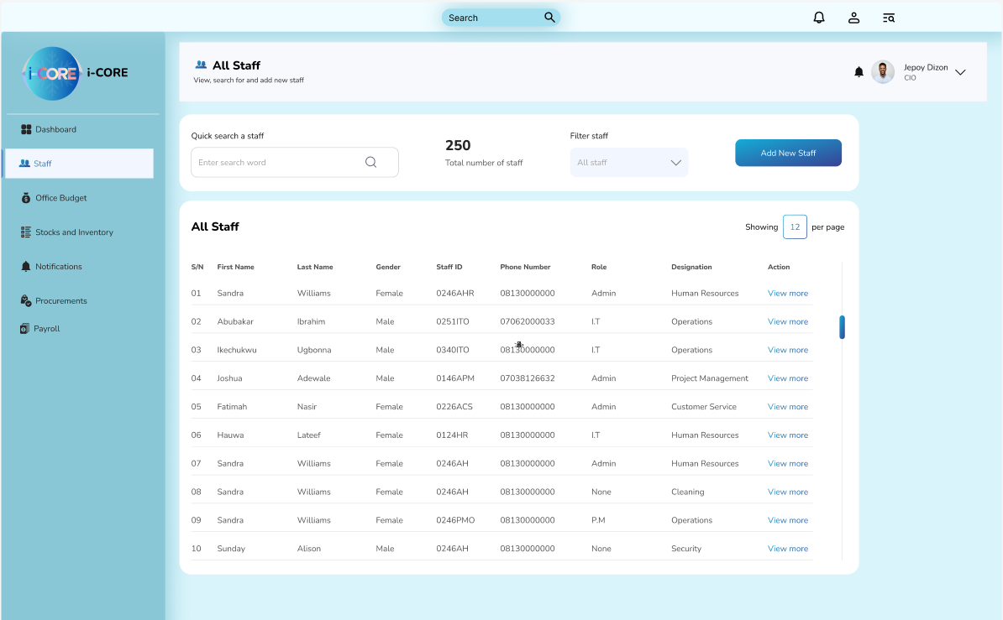
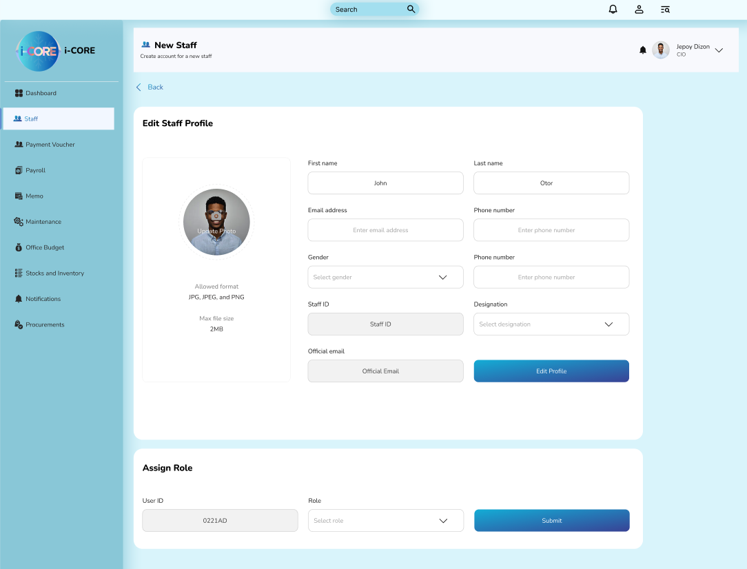
Figure 13: Staff Assigning and Information ID

Stocks and Inventory Management
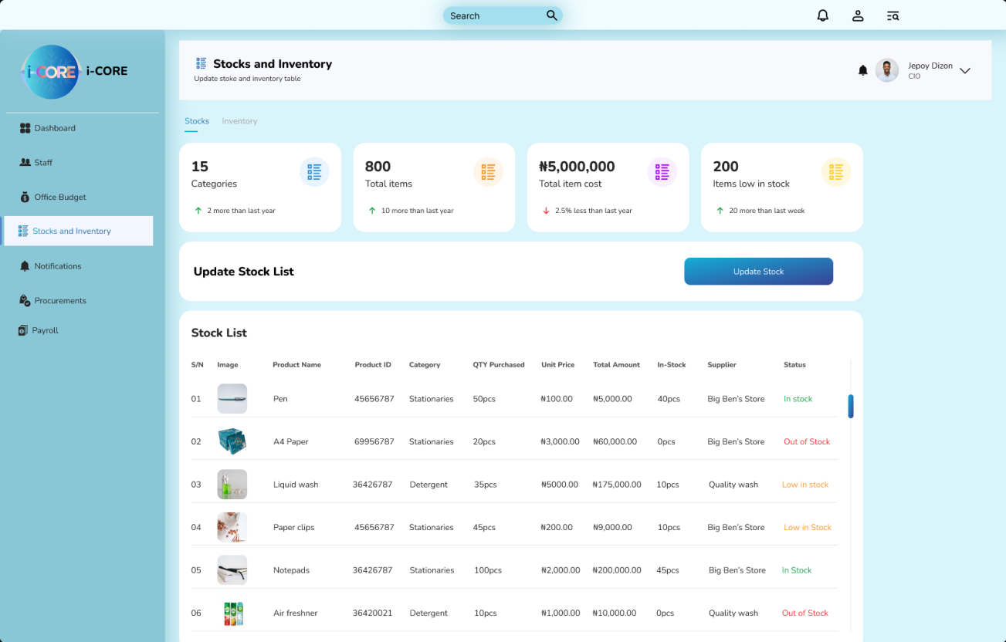
Figure 14: Stocks and Inventory Management

Admin Dashboard
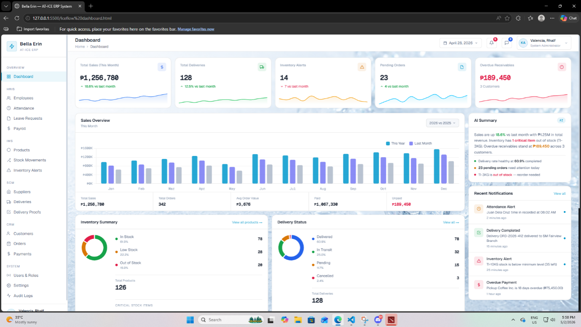
Figure 15: Admin Dashboard

References
Ahmad, M. M., & Cuenca, R. P. (2021). Critical success factors for ERP implementation in
SMEs. Journal of Enterprise Information Management, 34(1), 123–145. https://doi.org/10.1108/JEIM-02-2020-0067
Ahmed, S., Lee, J., & Park, H. (2023). Real-time delivery tracking in ERP systems.
International Journal of Logistics Management, 34(4), 847–868.
Al-Zubaidi, A. S. (2021). Designing business intelligence (BI) for production, distribution and
customer services: A case study of a UAE-based organization. Business Process Management Journal, 27(1), 154–178. https://doi.org/10.1108/BPMJ-01-2020-0033
ANSI Information Systems, Inc. (2025). SAP Business One channel partner Philippines.
https://ansi.ph/product-item/sap-business-one/
Bureau of Internal Revenue. (2021). Revenue Memorandum Circular No. 5-2021: Simplified
policies on computerized accounting systems. https://bir-cdn.bir.gov.ph/local/pdf/RMC%20No.%205-2021.pdf
Cabalquinto, J. D., & Jumao-as, A. S. (2024). Assessing ERP readiness in SMEs in Central
Luzon. Philippine Journal of Information Systems, 8(1), 22–36.
Chopra, R., Sawant, L., Kodi, D., & Terkar, R. (2022). Utilization of ERP systems in
manufacturing industry for productivity improvement. Materials Today: Proceedings, 62, 1238–1245. https://doi.org/10.1016/j.matpr.2022.04.529
Costa, C. J., Aparicio, M., & Raposo, J. (2023). Determinants of ERP adoption and its impact
on organizational performance. Information Systems Frontiers, 25(2), 789–804. https://doi.org/10.1007/s10796-021-10162-6
Dela Peña, R. B., & Villanueva, S. T. (2026). Centralized CRM systems and customer
satisfaction in Metro Manila service firms. Philippine Journal of Business Research, 15(1), 89–105.
Globe Business. (2023). Fleet management and GPS tracking solutions for Philippine
enterprises. https://www.globe.com.ph/business
Gonzales, P. R., & Bautista, N. A. (2025). Impact of integrated inventory systems on
operational costs. Journal of Industrial Management, 12(2), 101–120.
Jollibee Foods Corporation. (2022). Digital transformation and supply chain modernization
report. https://www.jollibeegroup.com
Kaur, G., & Singh, R. (2024). Decision support in ERP systems through BI. Journal of
Enterprise Information Management, 37(3), 512–529.
Mortiga, A. S., Segura, F., Rombaoa, J., & Dela Cruz, M. (2026). ERP implementation feasibility in a Philippine distribution firm.
Nguyen, T. H., Newby, M., & Macaulay, M. J. (2021). Information technology adoption in
ERP-enabled organizations: The role of business intelligence systems. Information & Management, 58(7), 103440. https://doi.org/10.1016/j.im.2021.103440
Oliverio, M. B. M., & Panes, D. E. T. (2023). Business process reengineering and ERP system
implementation plan for a manufacturing company: A case study. Journal of Namibian Studies, 35(S1), 4622–4643. https://namibianstudies.com/index.php/JNS/article/view/4569
OPSdesign Consulting. (2024). Utilizing geofencing technology in supply chain management.
https://opsdesign.com/geofencing-technology-in-supply-chain-management/
Oracle NetSuite Philippines. (2024). Cloud ERP solutions for growing Philippine businesses.
https://www.netsuite.com/portal/ph/home.shtml
Pabustan, S. I. D., Muldong, M. A. M., Yusi, D. T., Tan, K. M. D., Talplacido, E. P., Zuñiga,
J. M. B., & Jocson, J. C. (2021). Analyzing the impact of Enterprise Resource Planning (ERP) application to the business operations in SIA Engineering (Philippines) Corporation. International Journal of Progressive Research in Science and Engineering, 2(10), 45–49.
Pantelimon, F. V., Georgescu, T. M., & Posedaru, B. S. (2022). The impact of mobile
technologies on logistics and supply chain management performance. Sustainability, 14(3), 1456. https://doi.org/10.3390/su14031456
Pham, T. H., & Nguyen, L. T. (2023). Cloud-based ERP adoption and organizational
responsiveness. International Journal of Cloud Computing Studies, 12(2), 45–62.
Philippine Institute for Development Studies. (2023). The extent of innovation in Philippine
business and industry: Results of the 2021 PIDS Survey of Innovation Activities (PSIA). https://pidswebs.pids.gov.ph/CDN/document/pidsdps2311.pdf
Prasetyo, R. A., et al. (2023). Predictive business intelligence dashboard for food and beverage
business. Bulletin of Electrical Engineering and Informatics, 12(5), 3016–3026. https://www.researchgate.net/publication/374352418
QNE Software Philippines. (2022). ERP software solutions for SMEs in the Philippines.
https://qne.com.ph
QNE Software Philippines, Inc. (2025). Business software Philippines.
https://qne.cloud/ph/business-software-philippines-1/
QNE Software Philippines, Inc. (n.d.). QNE Optimum accounting software: The ERP for your
success. https://www.sheryna.ph/QNE-Optimum-Accounting-Software-The-ERP-for-Your-Success-Manila-717440
Ramos, L. M. (2025). Information flow bottlenecks in Philippine cold chain logistics. National
Journal of Logistics & Supply Chain, 4(3), 56–75.
Sprout Solutions. (2023). Human resource information system and payroll management
platform. https://sprout.ph
Straits Research. (2025). Geofencing market size, share & outlook to 2035.
https://straitsresearch.com/report/geofencing-market

SuperSpeed Philippines. (2025). SAP Business One software – Best ERP solution for PH SMEs.
https://superspeed-ph.com/sap-business-one-software/
Zhou, H., Xu, J., & Yang, W. (2022). Impact of integrated ERP on inventory accuracy.
International Journal of Production Economics, 243, 108396.

APPENDICES

APPENDIX A. RESOURCE PERSONS


Dr. Dave T. Co
President and Shareholder of Bella Erin Tube Ice Inc.
Jaleville Subdivision, 668 Quirino Ave, San Dionisio, Parañaque, 1700 Metro Manila
Client

APPENDIX B. PERSONAL TECHNICAL VITAE

Curriculum Vitae of
Kevin O. Abad
Blk 65 Lot 29 Nuvista Homes,
Santo Cristo, CSJDM, Bulacan
abad.367174@sjdelmonte.sti.edu.ph
+639948244051

EDUCATIONAL BACKGROUND
Level | Inclusive Dates | Name of school/ Institution
Tertiary | 2024 - Present | STI College San Jose Del Monte Bulacan
Vocational/Technical | N/A | N/A
High School | 2022 – 2024  2017-2022 | Arellano University, Pasig Campus.  Kapt. Eddie T. Reyes Integrated School
Elementary | 2015 – 2017  2014 – 2015  2013 – 2014  2011 - 2013 | Balmor Christian School  Dela Costa Learning Center  Balmor Christian School  St. Bernard Academy

PROFESSIONAL OR VOLUNTEER EXPERIENCE
Inclusive Dates | Nature of Experience/  Job Title | Name and Address of Company or Organization
N/A | N/A | N/A
AFFILIATIONS
Inclusive Dates  N/A | Name of Organization  N/A | Position  N/A
SKILLS
SKILLS | Level of Competency | Date Acquired
Java | Intermediate | 2023
C# | Intermediate | 2025
HTML/CSS  JavaScript | Intermediate  Intermediate | 2026  2026

TRAININGS, SEMINARS, OR WORKSHOPS ATTENDED
Inclusive Dates | Title of Training, Seminar, or Workshop
2024 | STI National Youth Convention
2024 | SAP Business One

Curriculum Vitae of
Carlo Jade W. Jayco
Block 29 Lot 1 Alibangbang
Street Amparo Subd. Caloocan City
jayco.288406@sjdelmonte.sti.edu.ph
+639164642126

EDUCATIONAL BACKGROUND
Level | Inclusive Dates | Name of school/ Institution
Tertiary | September 2022-Present | STI College San Jose Del Monte
Vocational/Technical | August 2018-June 2020 | APEC SCHOOLS North Fairview
High School | June 2014-March 2018 | APEC SCHOOLS North Fairview
Elementary | June 2008-March 2014 | Amparo Elementary School

PROFESSIONAL OR VOLUNTEER EXPERIENCE
Inclusive Dates | Nature of Experience/  Job Title | Name and Address of Company or Organization
N/A | N/A | N/A

AFFILIATIONS
Inclusive Dates | Name of Organization | Position
N/A | N/A | N/A

SKILLS
SKILLS | Level of Competency | Date Acquired
SAP Business One (Systems Integration and Architecture) | Beginner | February 2024
Computer Programming | Beginner | September 2022

TRAININGS, SEMINARS, OR WORKSHOP ATTENDED
Inclusive Dates | Title of Training, Seminar, or Workshop
December 2024 | GitHub Seminar
May 2024 | National Youth Convention: Mental Health Awareness
December 2023 | Systems Administration
October 2023 | Java Fundamentals

Curriculum Vitae of
Czar Aldrin S. Justo
366 Tialo St. Cristo
San Jose Del Monte, Bulacan, Philippines
justo.370942@sjdelmonte.sti.edu.ph
+639655762270

EDUCATIONAL BACKGROUND
Level | Inclusive Dates | Name of school/ Institution
Tertiary | September 2024 - Present | STI San Jose Del Monte
Vocational/Technical | June 2020-2022 | Ebenezer Christian Academy  La Concepcion College
High School | June 2015-2020 | Kaypian National High School
Elementary | June 2009-2015 | Minuyan Elementary School

PROFESSIONAL OR VOLUNTEER EXPERIENCE
Inclusive Dates | Nature of Experience/  Job Title | Name and Address of Company or Organization
N/A | N/A | N/A

AFFILIATIONS
Inclusive Dates | Name of Organization | Position
N/A | N/A | N/A
SKILLS
SKILLS | Level of Competency | Date Acquired
Microsoft Word, Excel, PowerPoint | Intermediate | August 2020
Typing Skill | Intermediate | September 2017
Canva / Basic graphic design | Intermediate | August 2022

TRAININGS, SEMINARS, OR WORKSHOPS ATTENDED
Inclusive Dates | Title of Training, Seminar, or Workshop
2024 | STI National Youth Convention
2024 | SAP Business One

Curriculum Vitae of
Valencia, Rhalf Thristan L.
Gumaoc East Lot#88 Blk 1, San Jose Del Monte, Bulacan
valencia.370075@sjdelmonte.sti.edu.ph
+639166250633

EDUCATIONAL BACKGROUND
Level | Inclusive Dates | Name of school/ Institution
Tertiary | 2024 - Present | STI College San Jose Del Monte Bulacan
Vocational/Technical
High School | 2015 - 2022 | National High School Yakal
Elementary | 2009 - 2015 | Gumaoc Elementary School

PROFESSIONAL OR VOLUNTEER EXPERIENCE
Inclusive Dates | Nature of Experience/  Job Title | Name and Address of Company or Organization
2024 | Work Immersion - Computer Repair Technician | Computer Repair Shop, San Jose Del Monte, Bulacan
2023-2024 | Customer Service Representative (Non-Voice) | ODIN Solutions | Non-Voice Outsourcing Services
2018-2019 | Computer Repair Technician | Family Business (under supervision)

AFFILIATIONS
Inclusive Dates | Name of Organization | Position
January 2025 | STI SJDM MLBB Tournament | Champion
Various | Mobile Legends Bang Bang - Competitive Tournaments (Online & F2F) | Competitive Player
Various | Dota 2 - Competitive Tournaments (Online & F2F) | Competitive Player
SKILLS
SKILLS | Level of Competency | Date Acquired
Customer Service (Non-Voice) | Intermediate | 2023
HTML/CSS | Intermediate | 2023
React | Intermediate | 2025
JavaScript  Python | Basic  Basic | 2025  2025

TRAININGS, SEMINARS, OR WORKSHOPS ATTENDED
Inclusive Dates | Title of Training, Seminar, or Workshop
2024 | SAP Business One

